Tables
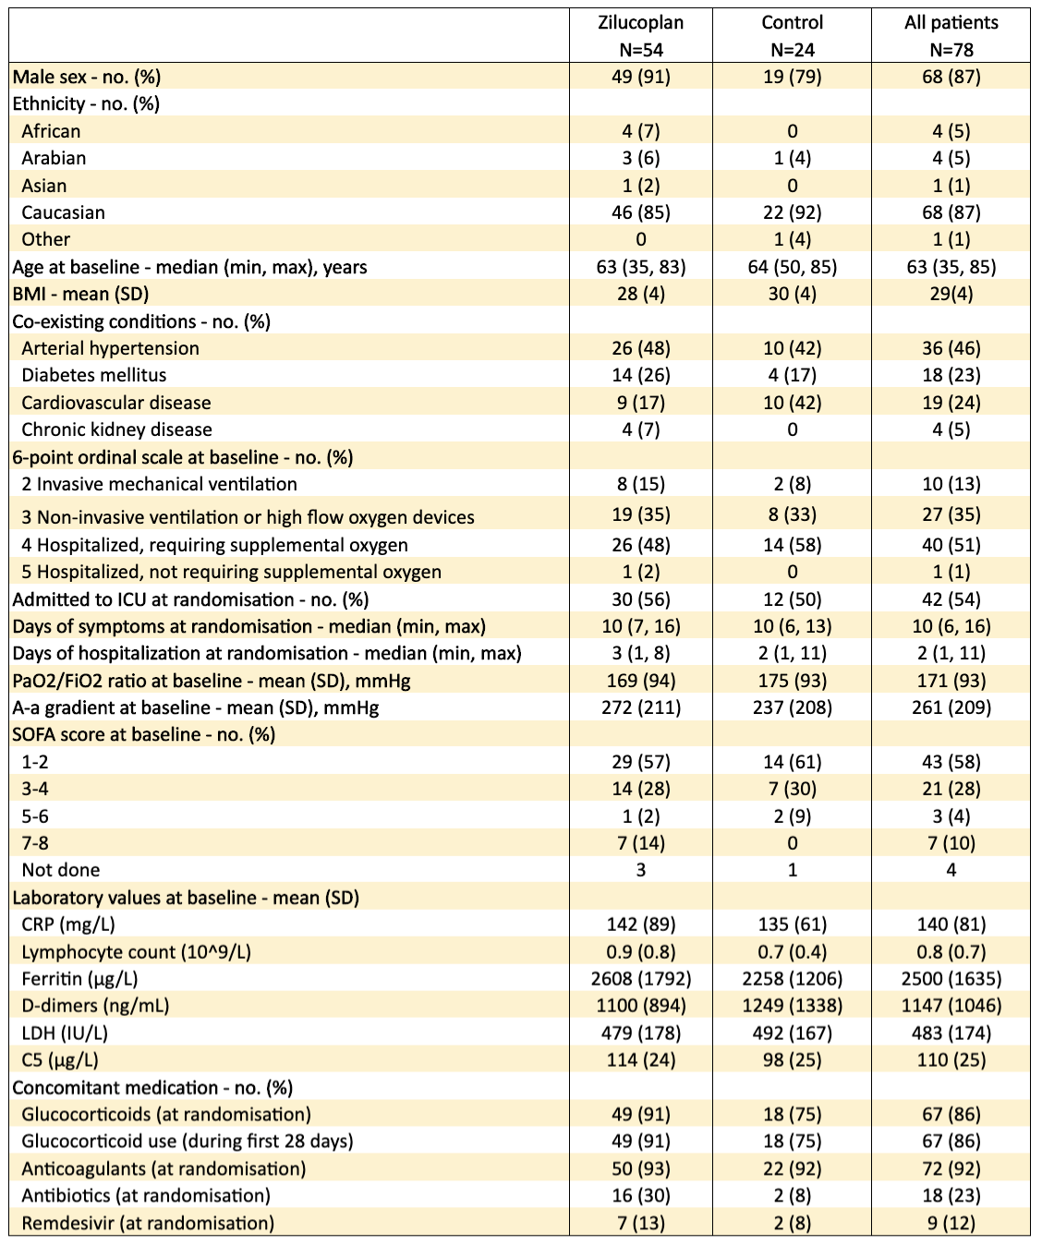
Table 1: Characteristics of the patients at baseline according to allocated treatment.
Body mass index (BMI) was calculated as weight in kilograms divided by height in meters squared. Sex and ethnicity were reported by study participant. Abbreviations: SD, standard deviation; CRP, C-reactive protein; LDH, lactate dehydrogenase; C5, complement 5; SOFA, severity of organ failure assessment; PaO₂, partial pressure of arterial oxygen; FiO₂, fraction of inspired oxygen.
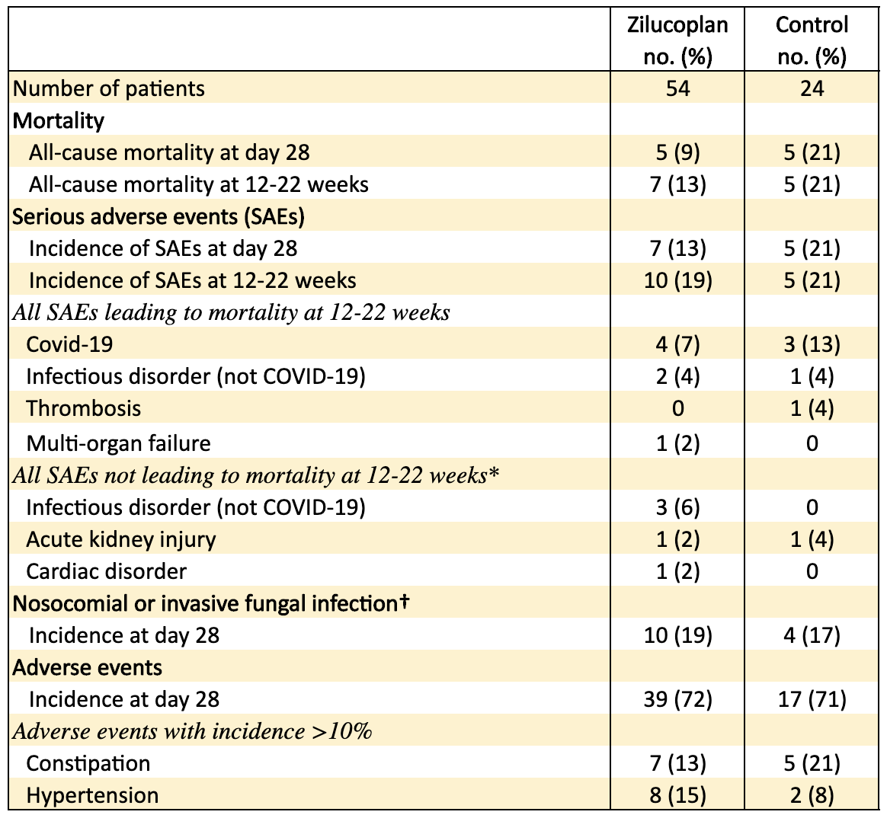
Table 2: Mortality and safety endpoints in the safety population.
SAE, serious adverse events; Covid-19, coronavirus-induced disease 2019.
*Progression and symptoms of Covid-19 were excluded from reporting.
†Requiring treatment

