Appendix 1a-1b: Nirmatrelvir flow chart showing cost estimations and bubble chart showing cost per kilogram over time throughout 2021 as reported by Panjiva
Appendix 1a:
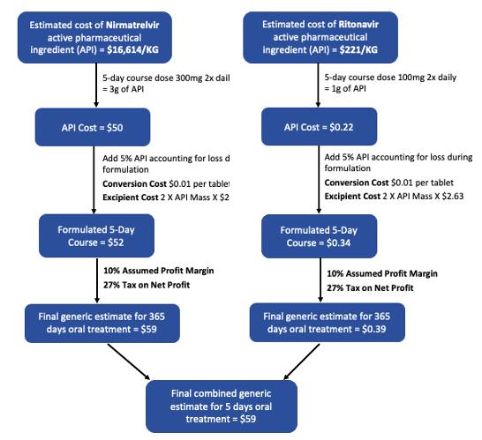

Appendix 1b:
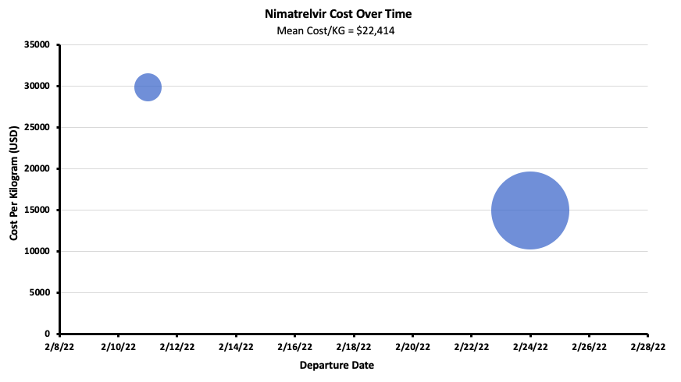

Appendix 2a: Baracitinib flow chart showing cost estimations
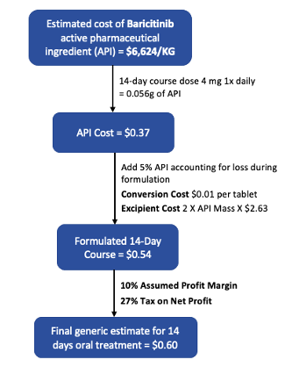

Appendix 3a-3b: Dexamethasone flow chart showing cost estimations and bubble chart showing cost per kilogram over time throughout 2021 as reported by Panjiva
Appendix 3a:
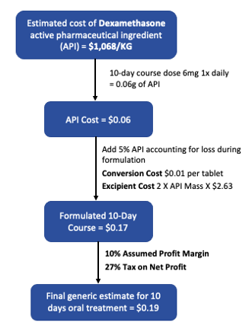

Appendix 3b:
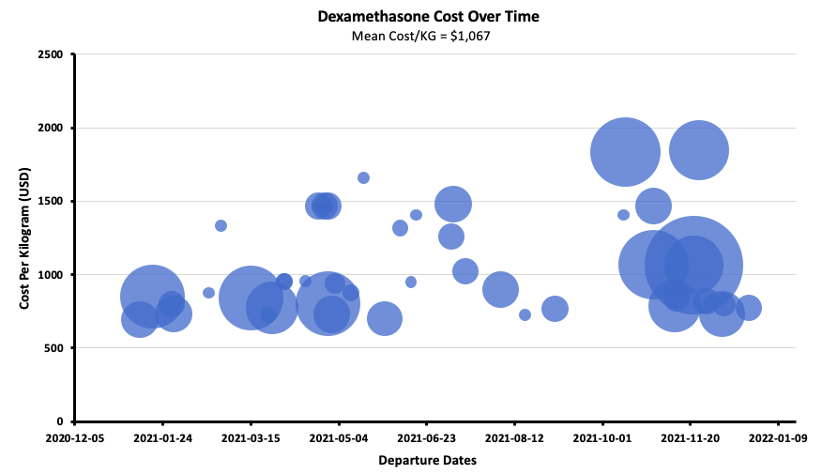

Appendix 4a-4d: TDF/FTC/DOL flow chart showing cost estimations and bubble charts showing cost per kilogram over time throughout 2021 as reported by Panjiva

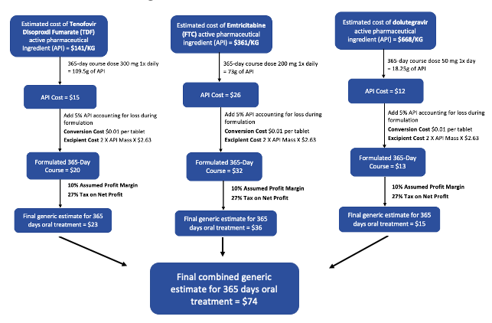
Appendix 4a:

Appendix 4b:
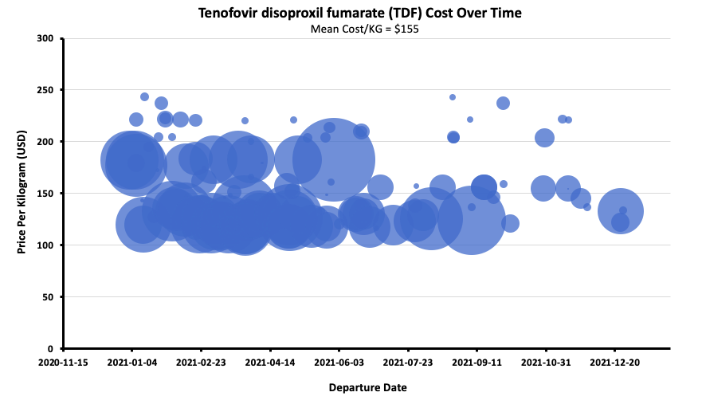

Appendix 4c:
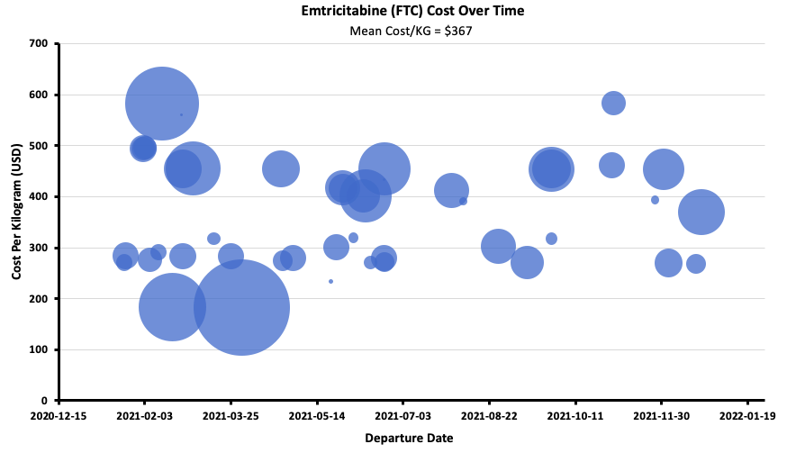
Appendix 4d:
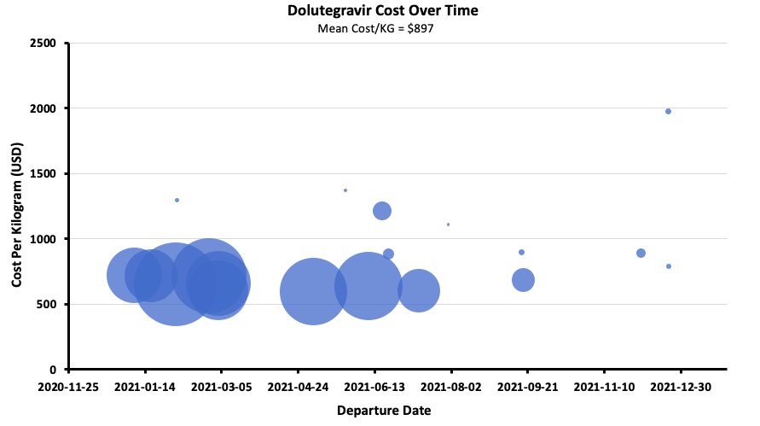

Appendix 5a-5b: TAF/FTC/DOL flow chart showing cost estimations and bubble charts showing TAF cost per kilogram over time throughout 2021 as reported by Panjiva
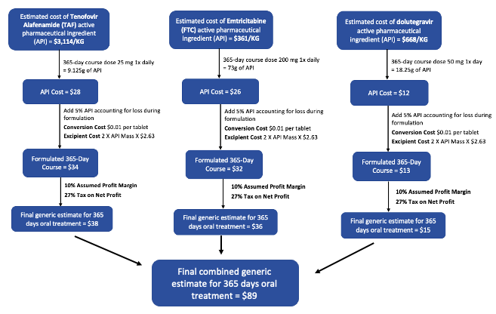
Appendix 5a:

Appendix 5b:
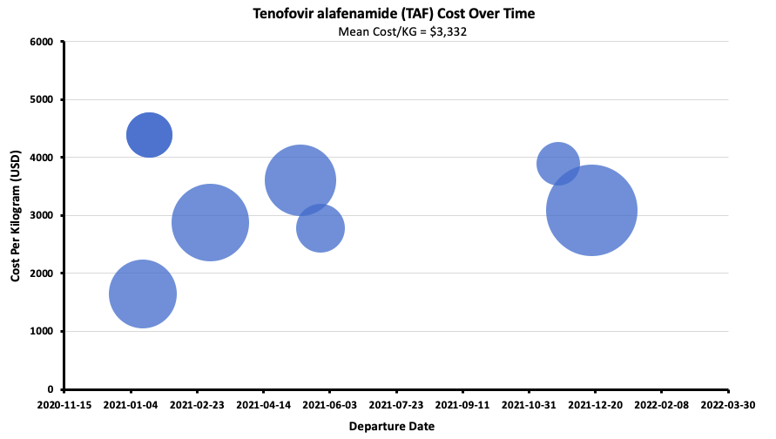

Appendix 6a: TDF/FTC flow chart showing cost estimations and bubble chart showing cost per kilogram over time throughout 2021 as reported by Panjiva
Appendix 6a:
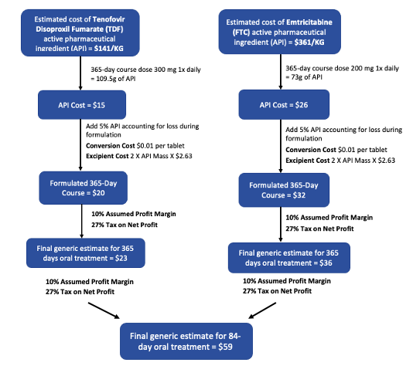

Appendix 7a-7c: Darunavir and Ritonavir flow chart showing cost estimations and bubble chart showing cost per kilogram over time throughout 2021 as reported by Panjiva
Appendix 7a:
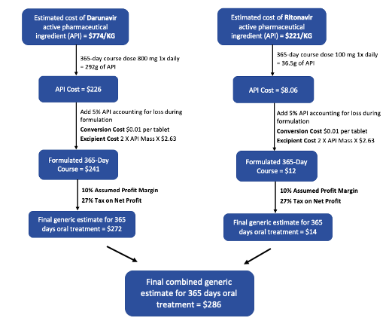

Appendix 7b:
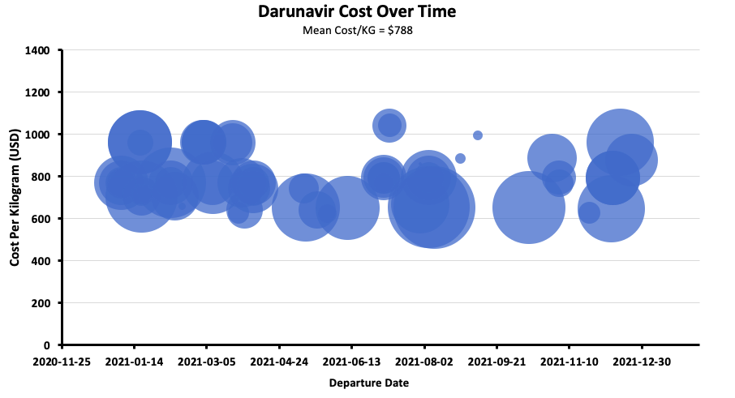
Appendix 7c:
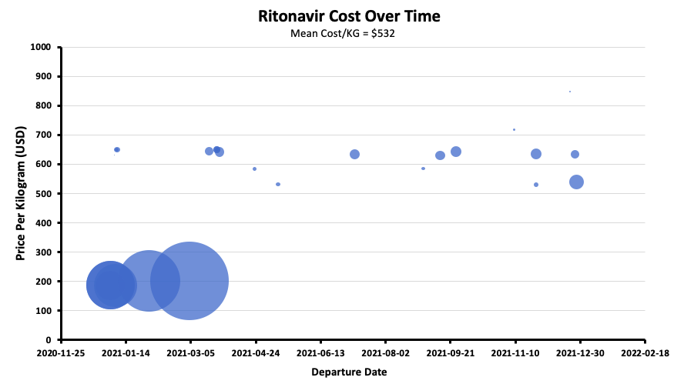

Appendix 8a-8b: Atazanavir and Darunavir flow chart showing cost estimations and Atazanavir bubble chart showing cost per kilogram over time throughout 2021 as reported by Panjiva

Appendix 8a:
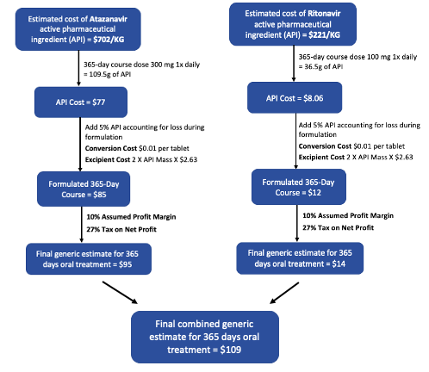

Appendix 8b:
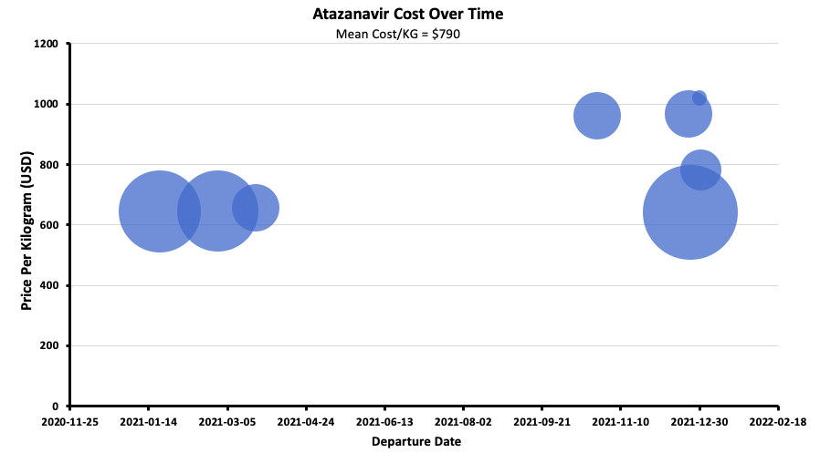

Appendix 9a-9b: SOF/DAC flow chart showing cost estimations and bubble charts showing SOF cost per kilogram over time throughout 2021 as reported by Panjiva
Appendix 9a:
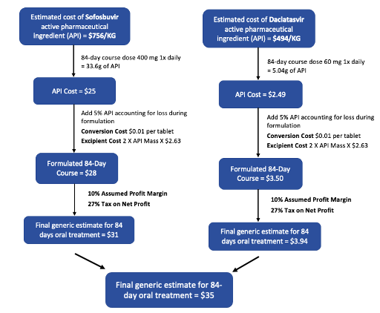

Appendix 9b
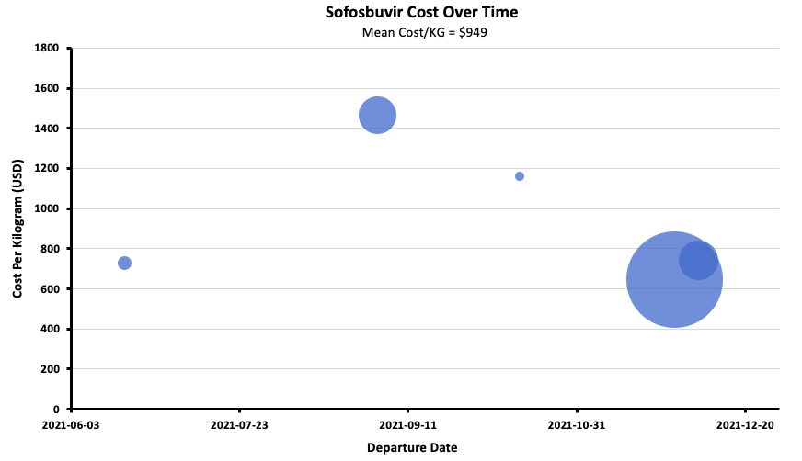

Appendix 10a-10b: SOF/VEL flow chart showing cost estimations and bubble charts showing VEL cost per kilogram over time throughout 2021 as reported by Panjiva

Appendix 10a:
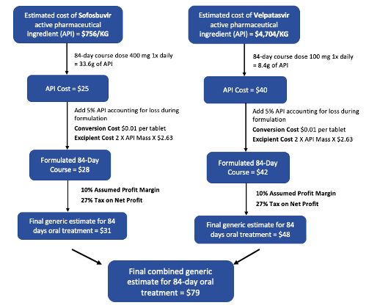

Appendix 10b:
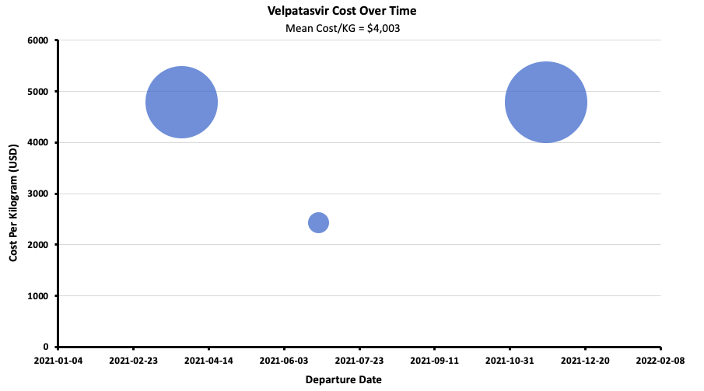

Supplementary Data:
Appendix 1a-1b: Nirmatrelvir flow chart showing cost estimations and bubble chart showing cost per kilogram over time throughout 2021 as reported by Panjiva

Appendix 2a: Baracitinib flow chart showing cost estimations

Appendix 3a-3b: Dexamethasone flow chart showing cost estimations and bubble chart showing cost per kilogram over time throughout 2021 as reported by Panjiva

Appendix 4a-4d: TDF/FTC/DOL flow chart showing cost estimations and bubble charts showing cost per kilogram over time throughout 2021 as reported by Panjiva

Appendix 5a-5b: TAF/FTC/DOL flow chart showing cost estimations and bubble charts showing TAF cost per kilogram over time throughout 2021 as reported by Panjiva

Appendix 6a: TDF/FTC flow chart showing cost estimations and bubble chart showing cost per kilogram over time throughout 2021 as reported by Panjiva

Appendix 7a-7c: Darunavir and Ritonavir flow chart showing cost estimations and bubble chart showing cost per kilogram over time throughout 2021 as reported by Panjiva

Appendix 8a-8b: Atazanavir and Darunavir flow chart showing cost estimations and Atazanavir bubble chart showing cost per kilogram over time throughout 2021 as reported by Panjiva

Appendix 9a-9b: SOF/DAC flow chart showing cost estimations and bubble charts showing SOF cost per kilogram over time throughout 2021 as reported by Panjiva

Appendix 10a-10b: SOF/VEL flow chart showing cost estimations and bubble charts showing VEL cost per kilogram over time throughout 2021 as reported by Panjiva

Appendix 1 – List of drug pricing sources

Bangladesh – https://medex.com.bd/brands/

France – http://base-donnees-publique.medicaments.gouv.fr/

India – https://www.1mg.com/drugs/

Kenya – https://www.pharmafinder.co.ke

Turkey – https://ilacabak.com/

United Kingdom – https://bnf.nice.org.uk/medicinal-forms/

USA (Pharm) – https://www.drugs.com/price-guide/

USA (Veterans) – https://www.vendorportal.ecms.va.gov/NAC/Pharma/

Vietnam- https://drugbank.vn/thuoc/

Appendix 2 – Drug pricing sources for molnupiravir

USA - https://www.openaccessgovernment.org/merck-covid-pill-2/121962/

Thailand - https://www.bangkokpost.com/thailand/general/2212563/cabinet-approves-purchase-of-molnupiravir

Bangladesh - https://www.reuters.com/business/healthcare-pharmaceuticals/asian-firm-beximco-sell-generic-version-merck-covid-19-pill-2021-11-09/

Japan - https://www.japantimes.co.jp/news/2021/11/10/national/science-health/japan-covid-pill/

Philippines - https://www.reuters.com/world/asia-pacific/philippines-receive-300000-courses-mercks-covid-19-pill-2021-10-27/

India - https://www.ndtv.com/india-news/game-changing-made-in-india-anti-covid-pills-could-be-cleared-for-use-in-days-2606341

