Supplementary information for
Title: Processes and mechanisms of phosphorus mobility among sediment, water and cyanobacteria under hydrodynamic conditions

Authors: Lingxiao Ren^{a,}*, Keqiang Dingª, Zhixin Huª, Huiya Wangª, Ning Qi^{b}, Wei Xuª

Institute or laboratory of origin:
ªCollege of Environmental Engineering, Nanjing Institute of Technology, 211167, Nanjing, PR China
^{b}College of Environment and Resources, Chongqing Technology and Business University, 400067, Chongqing, PR China

Contents of Supplementary Information

Procedures of sampling and experimental setup

Measurement of FLEA of M. aeruginosa

Fig. S1 Research area and the sampling site.

Fig. S2 Diagrams of the experimental design.

Fig. S3 Vertical distributions of turbidity under hydrodynamic conditions at different times: (a) during stirring, (b) 2 h after stirring, (c) 5 h after stirring, (d) 8 h after stirring.

Fig. S4 Modified sequential extraction procedure for P fractions in the sediment.

Fig. S5 Changes of (a) DO content and (b) redox potential near SWI, (c) pH in the overlying water in SAW system.

Table S1 Main parameters of the initial experimental sediment.

Table S2 F values of three-way ANOVA tests showing the effects of hydrodynamic intensity, experiment time and algal presence on the mobility of P fractions (p indicated the significance of effects of the factors or their interactions).

Procedures of sampling and experimental setup
The pretreated water and sediment during our incubation experiment were firstly sampled in Meiliang Bay, an area that exhibited frequent sediment resuspension and cyanobacteria blooms. The discrete water samples were collected at three depths from the surface (0.5, 1.0, and 1.5 m) by using a Friedinger water sampler, and the parameters of interest were recorded at the scene. After homogenization, the mixed water samples were filtered through 25-μm mesh (Nitex) and 0.45-μm filters (Whatman) to remove planktons, hydrophyte and other impurities, and then diverted into darkened carboys. The pretreated water samples were kept in portable refrigerator (4ºC) and delivered to the laboratory for incubation experiment within 6 h. Meanwhile, the surface sediment (top 15 cm) was collected using a sediment core sampler (Peterson ETC-200), sieved to remove large size gravels, and reserved after freeze drying (-80ºC).
The incubation experiment was conducted in unbreakable polyethylene cylindrical apparatus (diameter: 200 mm; height 500 mm) with electric stirrers (Fig. S2). Firstly, the pretreated sediment from Meiliang Bay was carefully removed and spread evenly on the bottom of cylindrical apparatus with a depth of 10 cm. Then, the pretreated lake water was slowly added to the apparatus with a depth of 30 cm. After 30 min of slight shake, the cylinders were kept stationary for 24 h and stored in the dark for our formal experiment. Based on our preliminary experiments and relevant results, the sediment hardly suspended, started to suspend and destabilized intensively under the rotation of 0-50, 50-125, 125-200 rpm, respectively, under our operating conditions. Accordingly, four rotation speeds (0, 50 rpm, 125 rpm and 200 rpm) were used to indicate different intensities of water disturbances. Meanwhile, the cylinders without rotation of the water served as static control treatment. The initial pH of overlying water was adjusted to 7.0, which approached the natural conditions in Lake Taihu.
The whole experiment lasted 14 days and the electric stirrers were daily operated at 8:00 am and 12:00 pm for 30 min, respectively. The facilities were placed indoor and the transparent film was used to cover the top of the equipment to prevent evaporation. The temperature of water was controlled at 25ºC under 60 μmol photons m⁻² s⁻¹ PAR with cool white fluorescent lamps (light/dark regime of 12 h: 12 h).

Measurement of FLEA of M. aeruginosa
Alkaline phosphatase activity (APA) has been reported to be important for algal utilization of DOP and its prosperity in the natural waters. However, the species-specific hydrolysis of DOP cannot be identified by routine methods, and the fluorescence-labeled enzyme activity (FLEA) technique can be used to directly detect which cells or which species were performing APA (Nedoma et al., 2003).
The method was referred to González-Gil et al. (1998) and Nedoma et al. (2003). In brief, the overlying water samples containing M. aeruginosa were directly incubated with the molecular probe ELF®97 phosphate (Molecular Probes, Waltham, MA, USA) at a final concentration of 25 μmol/L at the room temperature (37ºC). Meanwhile, the incubation sample was buffered with Tris-HCl solution (50 mmol/L, pH = 7.5) to ensure the precipitation of fluorescent ELF®97 alcohol (ELFA), which did not dissolve in the water and precipitated at the sites producing APA. M. aeruginosa was concentrated by centrifugation (5000 g) when necessary. After 3 hours of incubation, the reaction was terminated by filtering through membrane filters (0.45-μm pore size, Millipore). Then, filters with retained M. aeruginosa cells were stored at low temperature until mounting with the anti-fading reagent (Citiflor AF1) and algal cells were inspected by using an epifluorescence microscope (Zeiss).

[1] González-Gil, S., Keafer, B.A., Jovine, R.V.M., Aguilera, A., Lu, S.H., Anderson, D.M., 1998. Detection and quantification of alkaline phosphatase in single cells of phosphorus-starved marine phytoplankton. Mar. Ecol. Prog. Ser. 164, 21-35.
[2] Nedoma, J., Strojsova, A., Vrba, J., Komarkova, J., Simek, K., 2003. Extracellular phosphatase activity of natural plankton studied with ELF97 phosphate: fluorescence quantification and labelling kinetics. Environ. Microbiol. 5, 462-472.

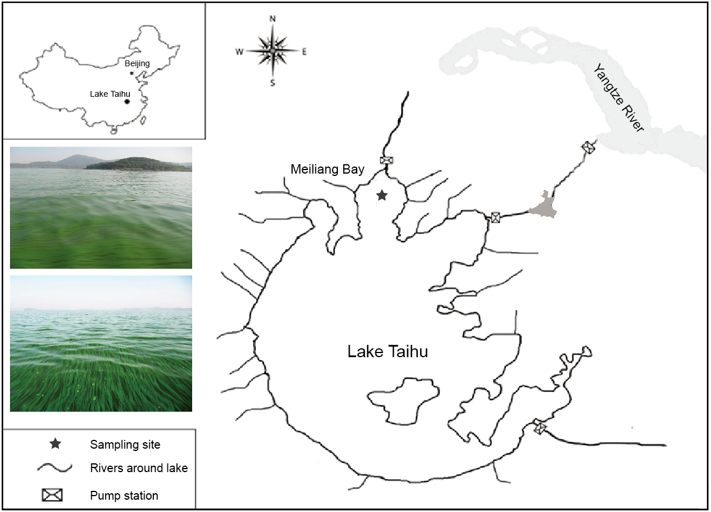
Fig. S1 Research area and the sampling site.

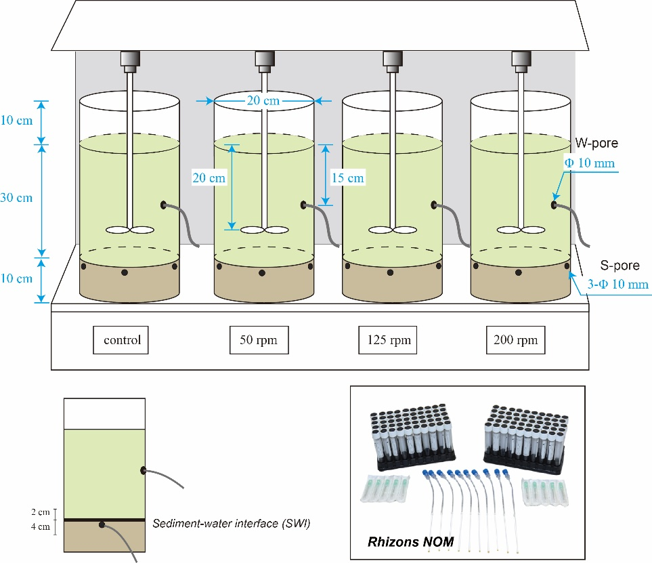
Fig. S2 Diagrams of the experimental design.

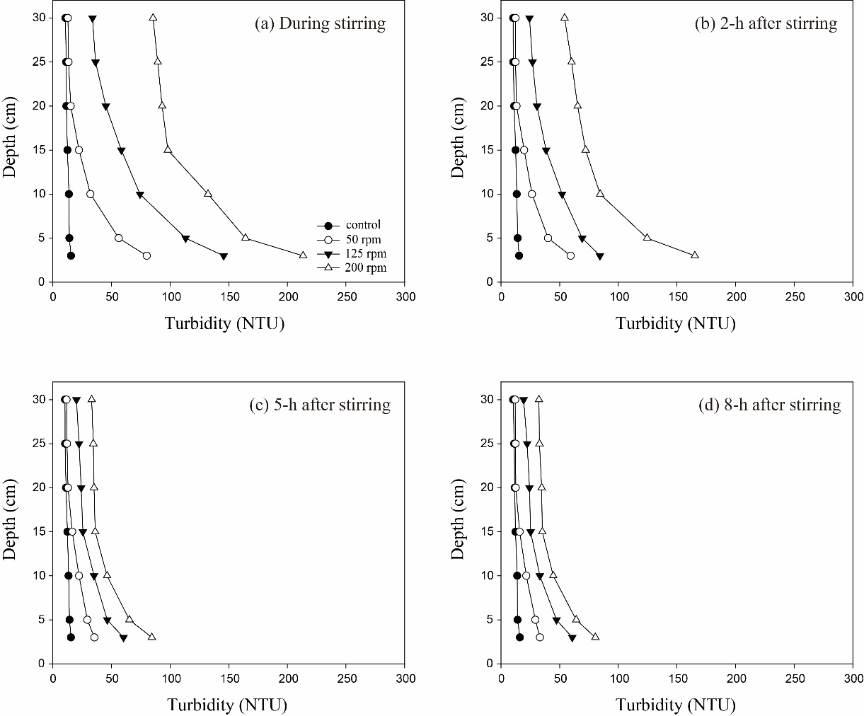
Fig. S3 Vertical distributions of turbidity under hydrodynamic conditions at different times: (a) during stirring, (b) 2-h after stirring, (c) 5-h after stirring, (d) 8-h after stirring.

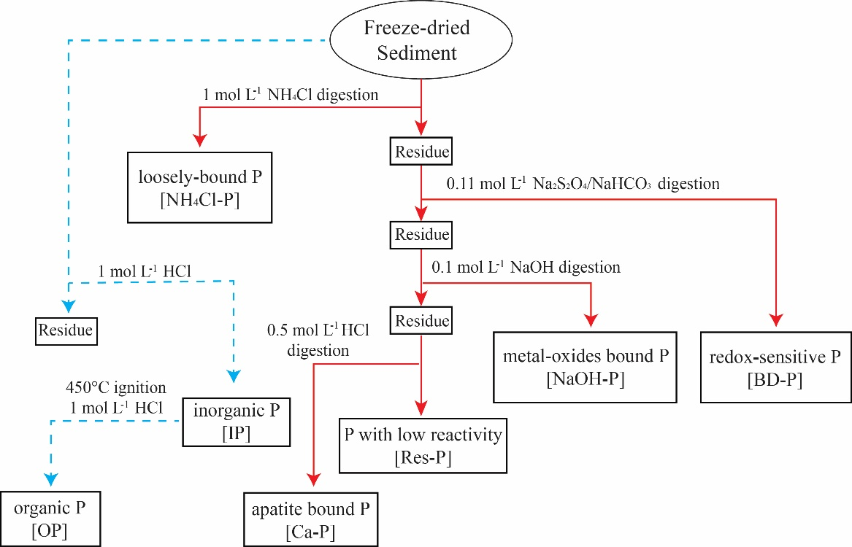
Fig. S4 Modified sequential extraction procedure for P fractions in the sediment.

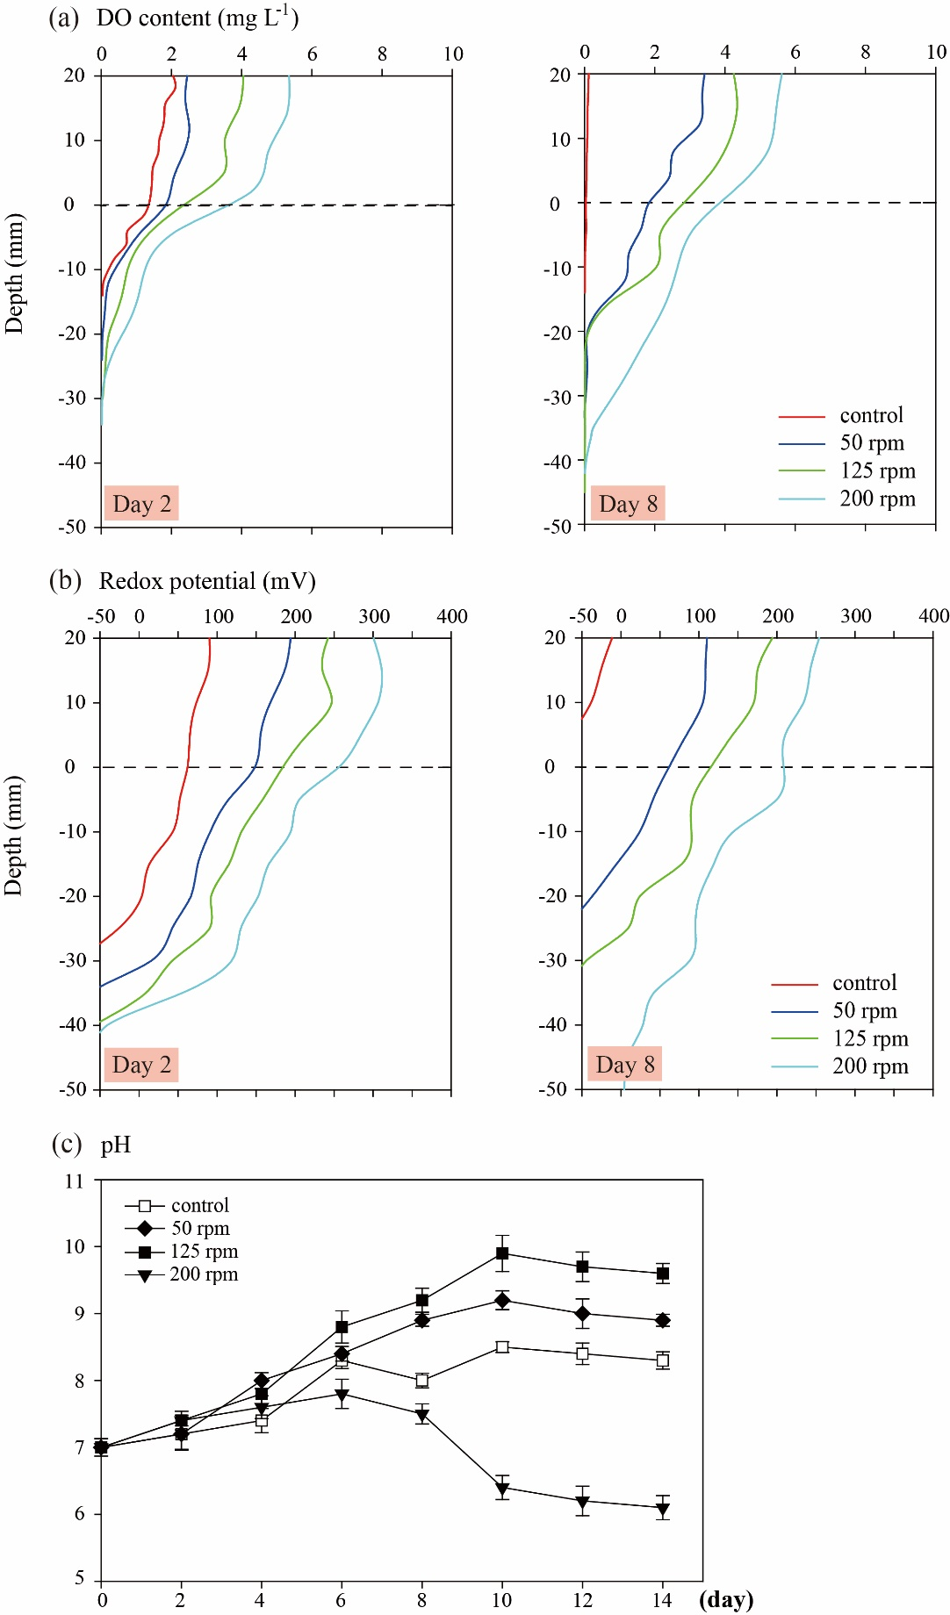
Fig. S5 Changes of (a) DO content and (b) redox potential near SWI, (c) pH in the overlying water under different hydrodynamic intensity conditions in SAW system.

Table S1 Main parameters of the initial experimental sediment.
Parameters of sediment
P fractions  (mg kg⁻¹ dw) | NaOH-P | 157.67 | IP | 519.4
 | BD-P | 150.67
 | NH₄Cl-P | 5.09 | OP | 81.67
 | HCl-P | 130.33
 | Res-P | 209.33
Metal contents  (mg g⁻¹ dw) | Fe_{T} | 36.58 | Fe_{a} 22.46 (61.40%)
 | Al_{T} | 39.25
 | Ca_{T} | 6.42 | Al_{a} 8.48 (21.61%)
 | Mn_{T} | 0.45
other index | LOI (% dw) |  | 11.25
 | TOC (% dw) |  | 1.32
Fe_{T}: total iron; Al_{T}: total aluminum; Ca_{T}: total calcium; Mn_{T}: total manganese.
Fe_{a}: active iron; Al_{a}: active aluminum.
LOI: loss of ignition.

Table S2 F values of three-way ANOVA tests showing the effects of hydrodynamic intensity, experiment time and algal presence on the mobility of P fractions (p indicated the significance of effects of the factors or their interactions).

Sources of variation | Dependent variables
 | TDP in the overlying water |  |  |  | PP in the overlying water |  |  |  |  | Changes of TP in sediment |  |  |  |  | Changes of BD-P in sediment |  |  |  |  | Changes of NaOH-P in sediment |  |  |  |  | DO near SWI |  |  |  |  | Redox potential  near SWI
 | F value | p |  |  |  | F value | p |  |  |  | F value | p |  |  |  | F value | p |  |  |  | F value | p |  |  |  | F value | p |  |  |  | F value | p
Treatment | 42.35 | <0.01 |  |  |  | 68.14 | <0.01 |  |  |  | 102.32 | <0.01 |  |  |  | 65.23 | <0.01 |  |  |  | 57.22 | <0.01 |  |  |  | 32.43 | <0.01 |  |  |  | 22.19 | <0.01
Time | 63.23 | <0.01 |  |  |  | 46.43 | 0.36 |  |  |  | 82.31 | <0.01 |  |  |  | 42.18 | <0.01 |  |  |  | 35.17 | <0.01 |  |  |  | 26.14 | <0.01 |  |  |  | 18.62 | <0.01
Algae | 26.71 | <0.01 |  |  |  | 20.12 | <0.01 |  |  |  | 26.83 | <0.01 |  |  |  | 20.17 | <0.01 |  |  |  | 19.35 | <0.01 |  |  |  | 14.22 | <0.01 |  |  |  | 8.24 | <0.05
Interaction
Treatment × Time | 7.34 | <0.05 |  |  |  | 2.43 | 0.35 |  |  |  | 11.43 | <0.01 |  |  |  | 8.23 | <0.05 |  |  |  | 8.13 | <0.05 |  |  |  | 2.12 | 0.18 |  |  |  | 7.45 | <0.05
Treatment × Algae | 9.24 | <0.05 |  |  |  | 14.52 | <0.01 |  |  |  | 9.35 | <0.05 |  |  |  | 10.12 | <0.05 |  |  |  | 7.35 | <0.05 |  |  |  | 5.23 | <0.05 |  |  |  | 5.62 | <0.05
Time × Algae | 6.13 | <0.05 |  |  |  | 8.21 | <0.05 |  |  |  | 5.43 | <0.05 |  |  |  | 5.93 | <0.05 |  |  |  | 4.23 | 0.104 |  |  |  | 6.64 | <0.05 |  |  |  | 3.34 | 0.076
Treatment × Time × Algae | 4.53 | 0.098 |  |  |  | 0.45 | 0.24 |  |  |  | 3.03 | 0.083 |  |  |  | 4.22 | <0.05 |  |  |  | 0.68 | 0.21 |  |  |  | 0.05 | 0.76 |  |  |  | 0.14 | 0.38

* Corresponding authors. E-mail address: rlxjht@gmail.com

