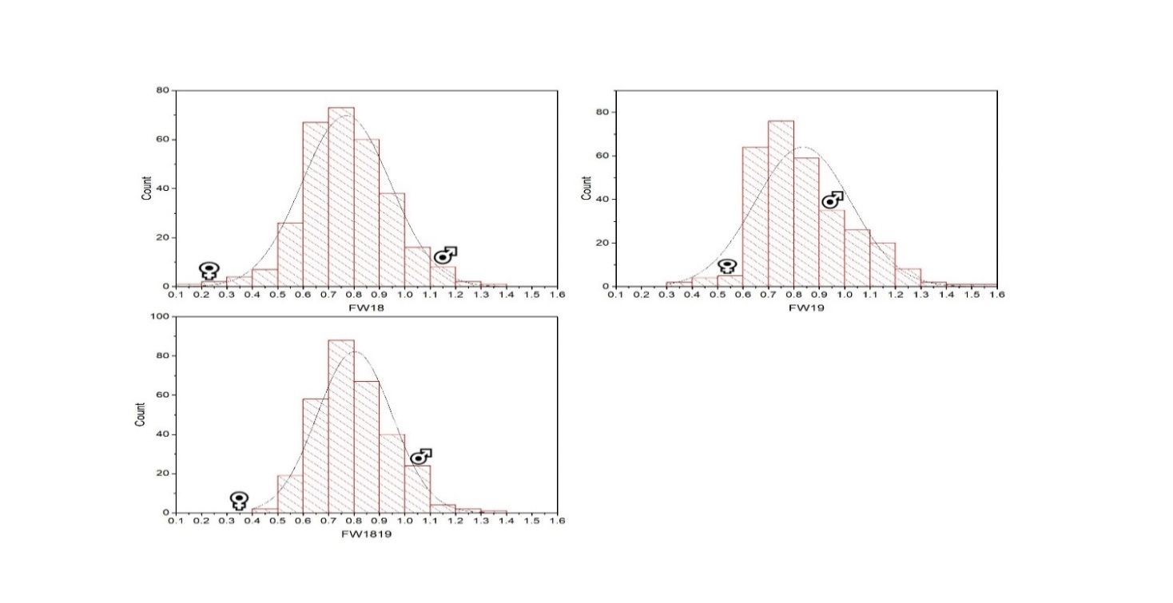

Figure S1a Frequency distribution histogram of 305 F₁ individuals for fruit weight (FW) based on two individual years (2018-2019) and extra year (1819) data. Each x-axis represents the value of the trait and y-axis shows the number of frequency corresponding with the value on x-axis. FW18, fruit weight (2018), FW19, fruit weight (2019), FW1819, fruit weight as extra year; ♀, indicate female parent position on the histogram, ♂, male parent position on the histogram.
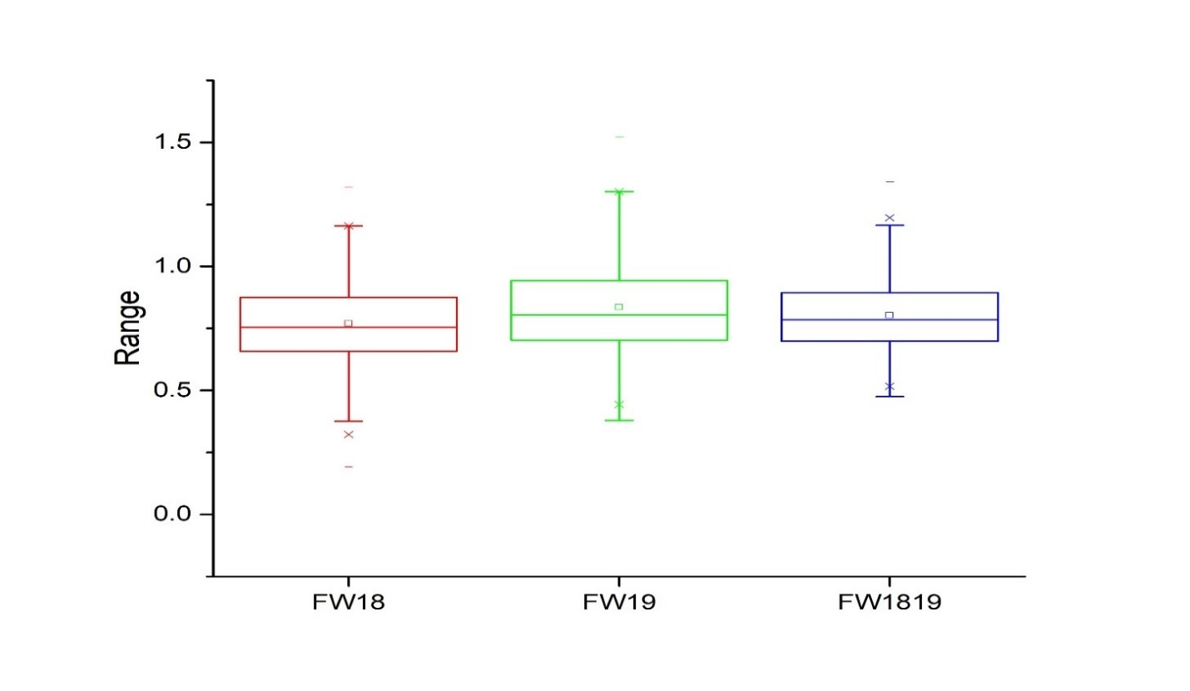

Figure S1b Box chart diagram of 305 F₁ individuals for fruit weight (FW) based on two individual years (2018-2019) and extra year (1819) data. Each x-axis represents the trait under different years and y-axis shows the frequency of ranges corresponding with the value on x-axis. In each box chart, the lower and upper lines represent first and third quartiles, respectively, and the middle line shows the median. FW18, fruit weight (2018), FW19, fruit weight (2019), FW1819, fruit weight as extra year.

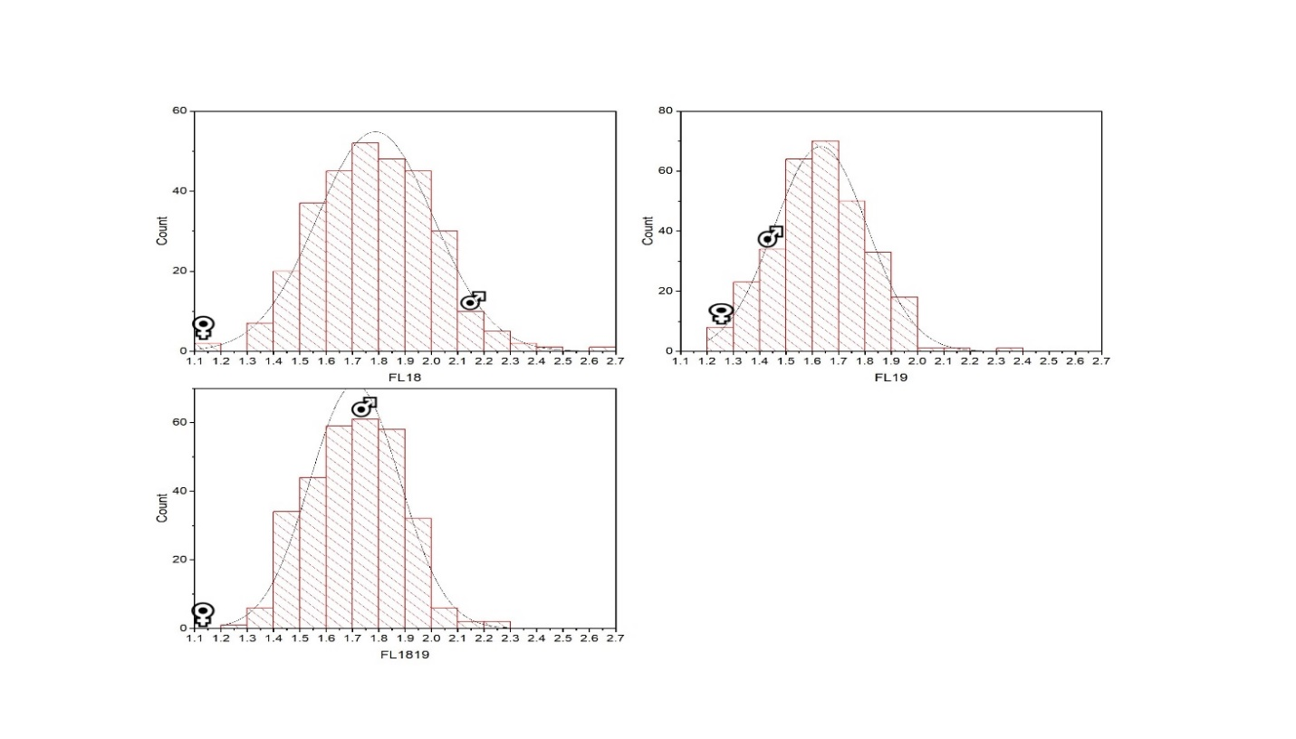

Figure S1c Frequency distribution histogram of 305 F₁ individuals for fruit length (FL) based on two individual years (2018-2019) and extra year (1819) data. Each x-axis represents the value of the trait and y-axis shows the number of frequency corresponding with the value on x-axis. FL18, fruit length (2018), FL19, fruit length (2019), FL1819, fruit length as extra year; ♀, indicate female parent position on the histogram, ♂, male parent position on the histogram.

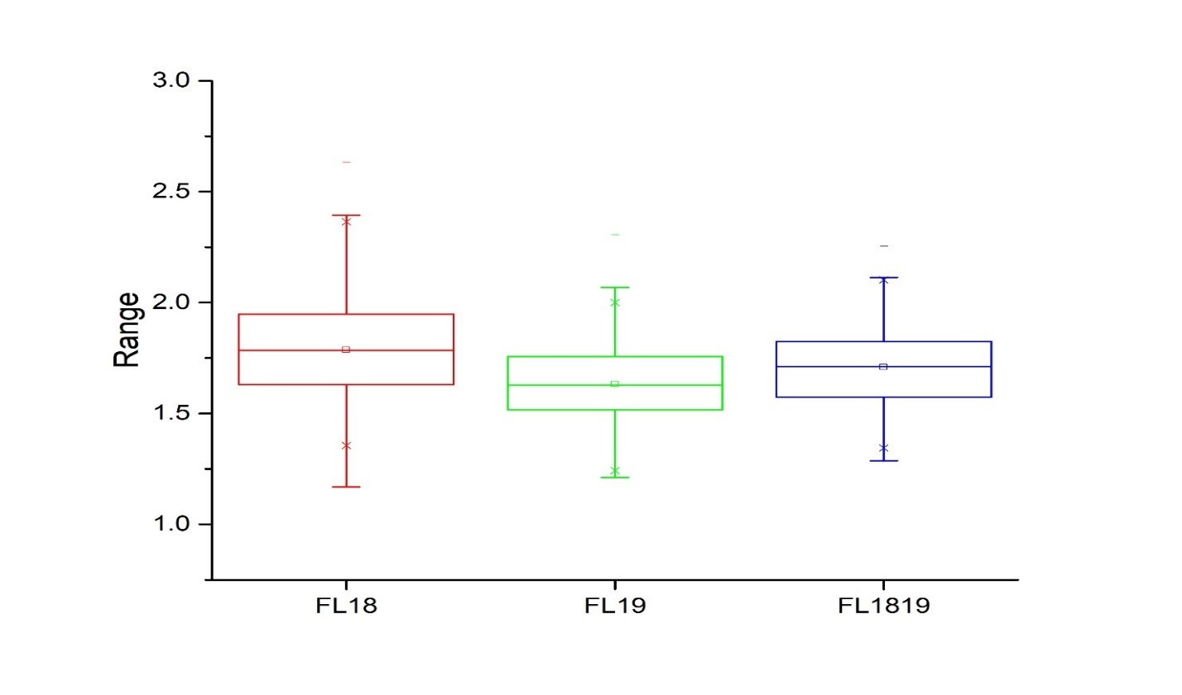
Figure S1d Box chart diagram of 305 F₁ individuals for fruit length (FL) based on two individual years (2018-2019) and extra year (1819) data. Each x-axis represents the trait under different years and y-axis shows the frequency of ranges corresponding with the value on x-axis. In each box chart, the lower and upper lines represent first and third quartiles, respectively, and the middle line shows the median. FL18, fruit length (2018), FL19, fruit length (2019), FL1819, fruit length as extra year.

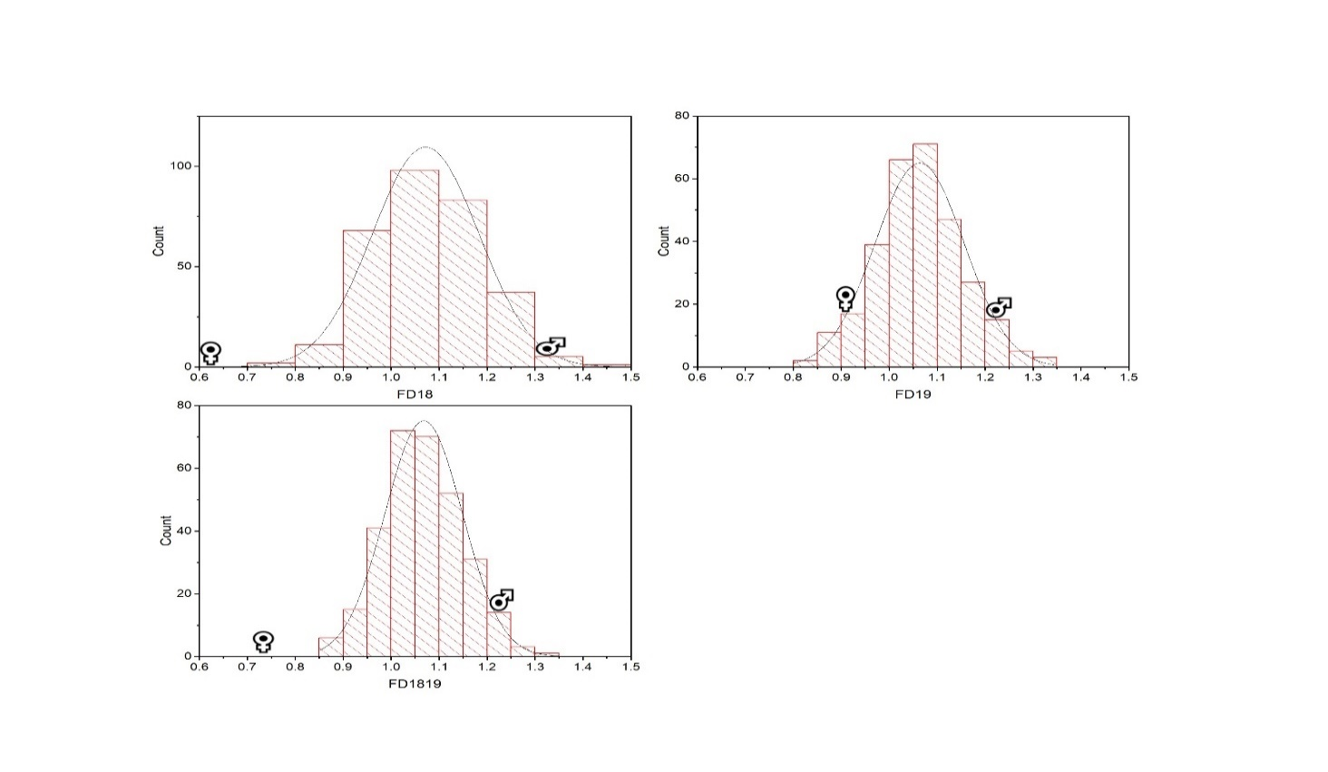

Figure S1e Frequency distribution histogram of 305 F₁ individuals for fruit diameter (FD) based on two individual years (2018-2019) and extra year (1819) data. Each x-axis represents the value of the trait and y-axis shows the number of frequency corresponding with the value on x-axis. FD18, fruit diameter (2018), FD19, fruit diameter (2019), FD1819, fruit diameter as extra year; ♀, indicate female parent position on the histogram, ♂, male parent position on the histogram.

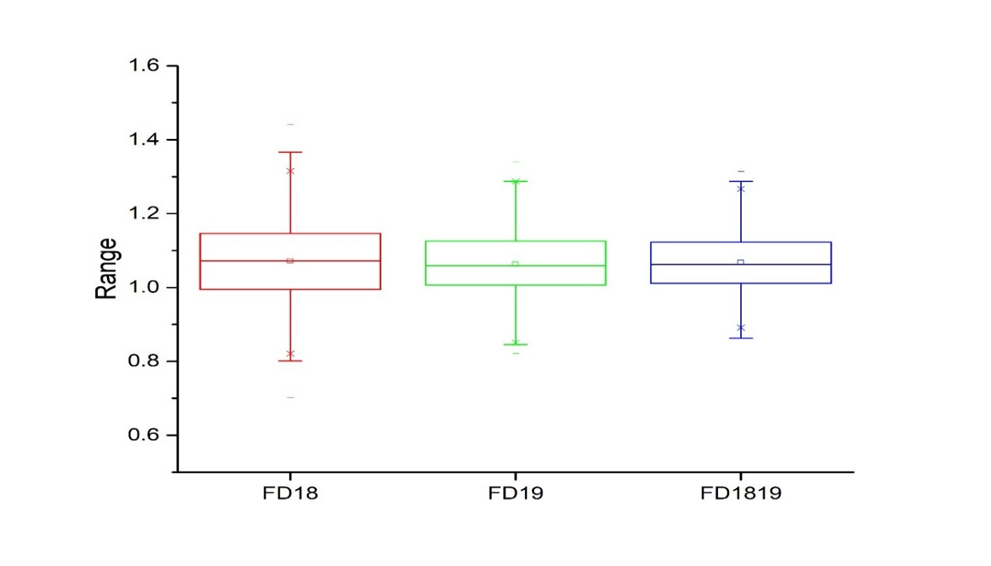

Figure S1f Box chart diagram of 305 F₁ individuals for fruit diameter (FD) based on two individual years (2018-2019) and extra year (1819) data. Each x-axis represents the trait under different years and y-axis shows the frequency of ranges corresponding with the value on x-axis. In each box chart, the lower and upper lines represent first and third quartiles, respectively, and the middle line shows the median. FD18, fruit diameter (2018), FD19, fruit diameter (2019), FD1819, fruit diameter as extra year.

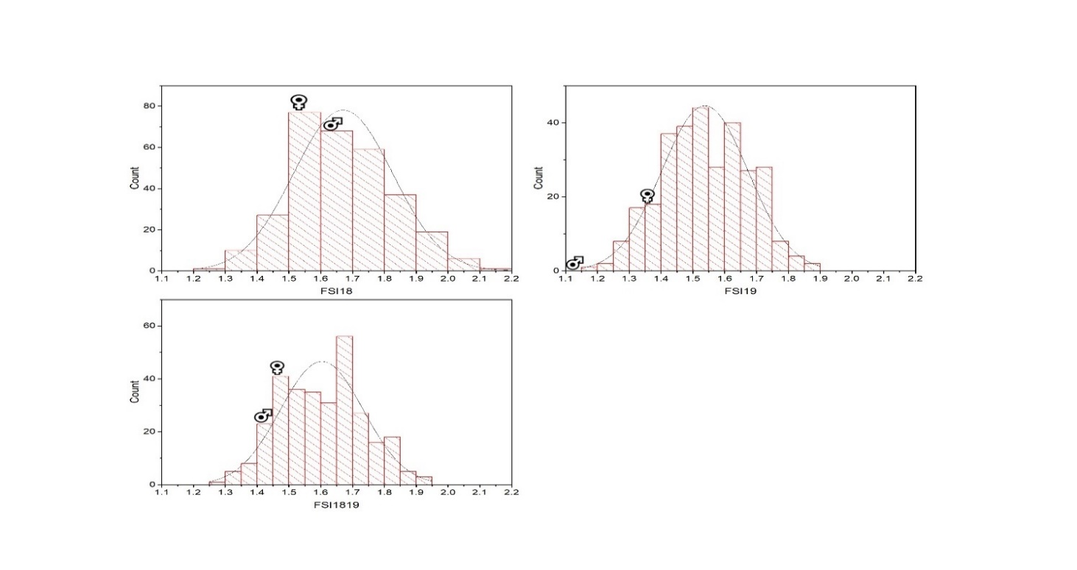

Figure S1g Frequency distribution histogram of 305 F₁ individuals for fruit shape index (FSI) based on two individual years (2018-2019) and extra year (1819) data. Each x-axis represents the value of the trait and y-axis shows the number of frequency corresponding with the value on x-axis. FSI18, fruit shape index (2018), FSI19, fruit shape index (2019), FSI1819, fruit shape index as extra year; ♀, indicate female parent position on the histogram, ♂, male parent position on the histogram.

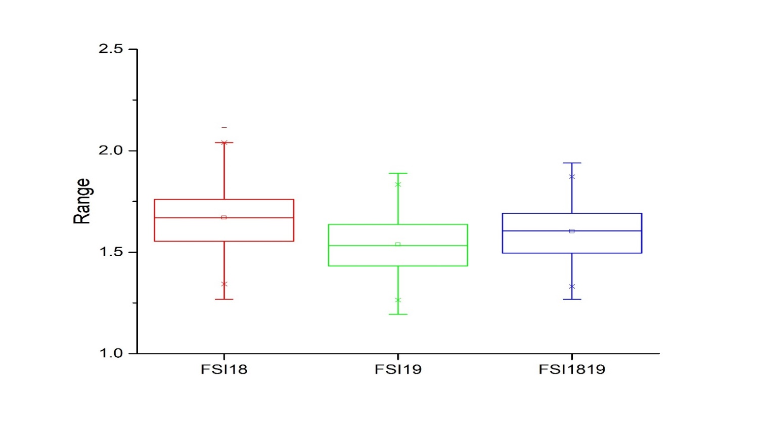

Figure S1h Box chart diagram of 305 F₁ individuals for fruit shape index (FSI) based on two individual years (2018-2019) and extra year (1819) data. Each x-axis represents the trait under different years and y-axis shows the frequency of ranges corresponding with the value on x-axis. In each box chart, the lower and upper lines represent first and third quartiles, respectively, and the middle line shows the median. FSI18, fruit shape index (2018), FSI19, fruit shape index (2019), FSI1819, fruit shape index as extra year.

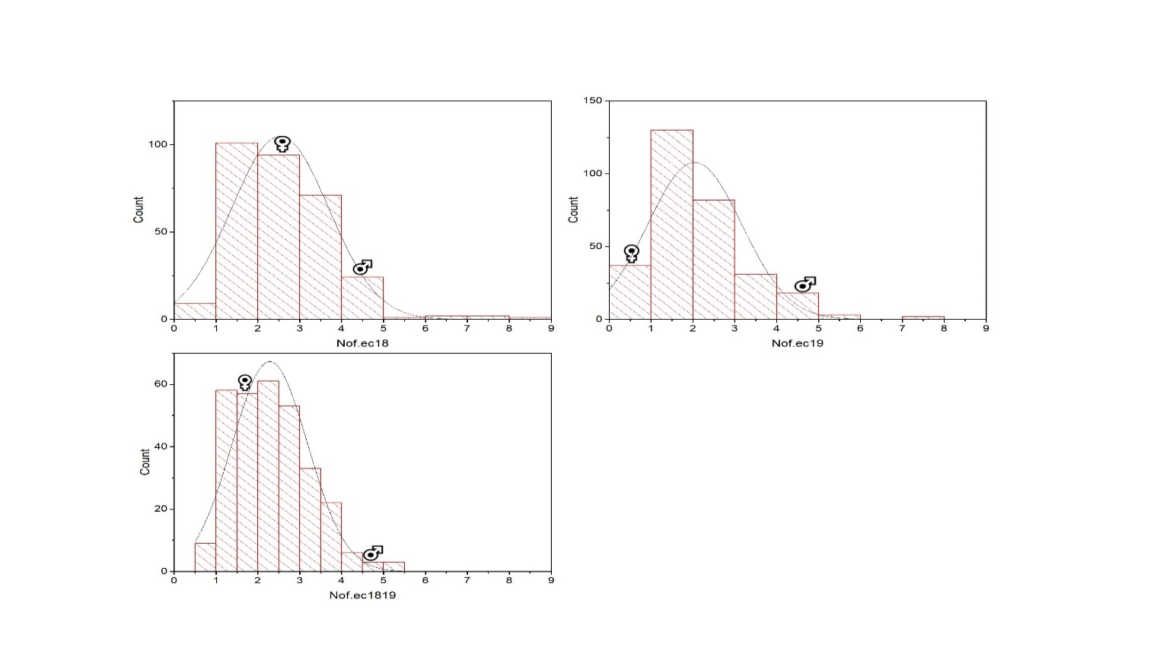

Figure S1i Frequency distribution histogram of 305 F₁ individuals for number of fruits per end cluster (Nof/ec) based on two individual years (2018-2019) and extra year (1819) data. Each x-axis represents the value of the trait and y-axis shows the number of frequency corresponding with the value on x-axis. Nof/ec18, number of fruits per end cluster (2018), Nof/ec19, number of fruits per end cluster (2019), Nof/ec1819, number of fruits per end cluster as extra year; ♀, indicate female parent position on the histogram, ♂, male parent position on the histogram.

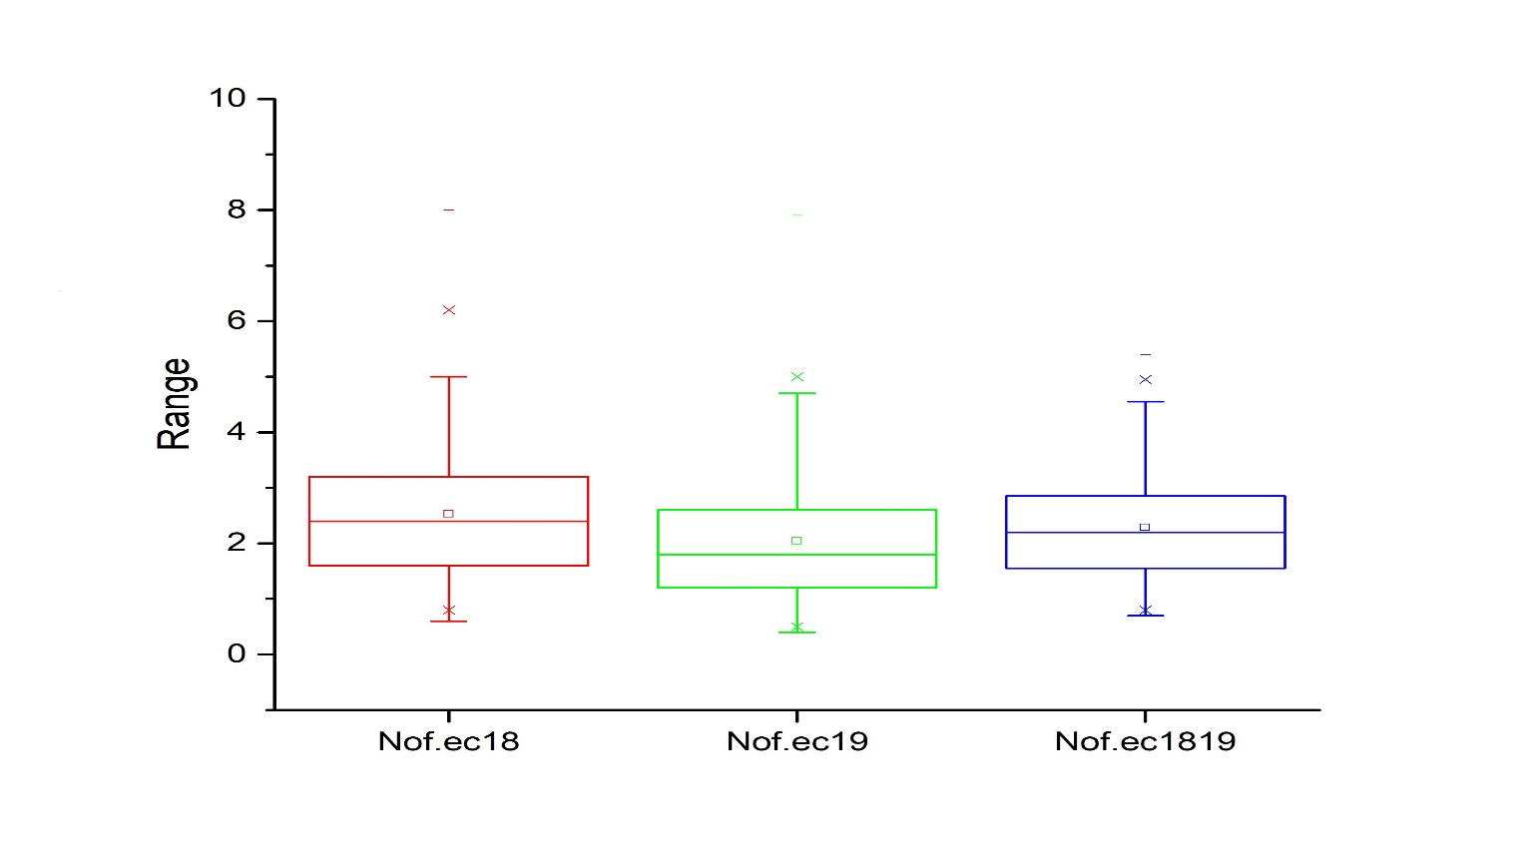

Figure S1j Box chart diagram of 305 F₁ individuals for number of fruits per end cluster (Nof/ec) based on two individual years (2018-2019) and extra year (1819) data. Each x-axis represents the trait under different years and y-axis shows the frequency of ranges corresponding with the value on x-axis. In each box chart, the lower and upper lines represent first and third quartiles, respectively, and the middle line shows the median. Nof/ec18, number of fruits per end cluster (2018), Nof/ec19, number of fruits per end cluster (2019), Nof/ec1819, number of fruits per end cluster as extra year.

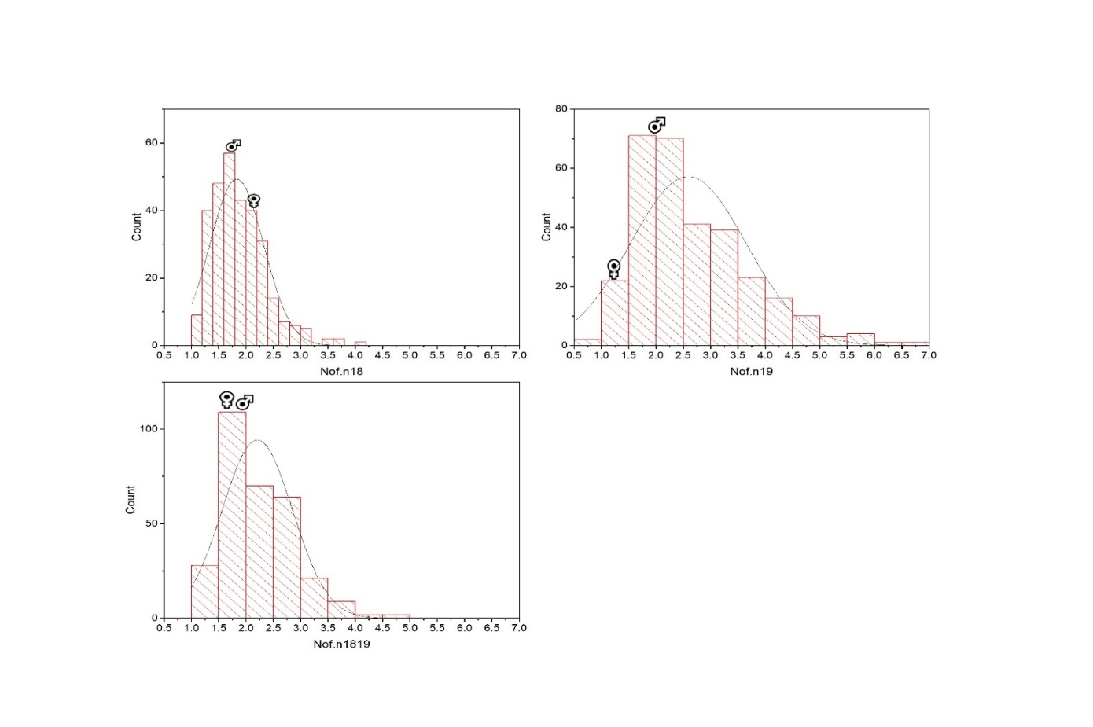

Figure S1k Frequency distribution histogram of 305 F₁ individuals for number of fruits per node (Nof/n) based on two individual years (2018-2019) and extra year (1819) data. Each x-axis represents the value of the trait and y-axis shows the number of frequency corresponding with the value on x-axis. Nof/n18, number of fruits per node (2018), Nof/n19, number of fruits per node (2019), Nof/n1819, number of fruits per node as extra year; ♀, indicate female parent position on the histogram, ♂, male parent position on the histogram.

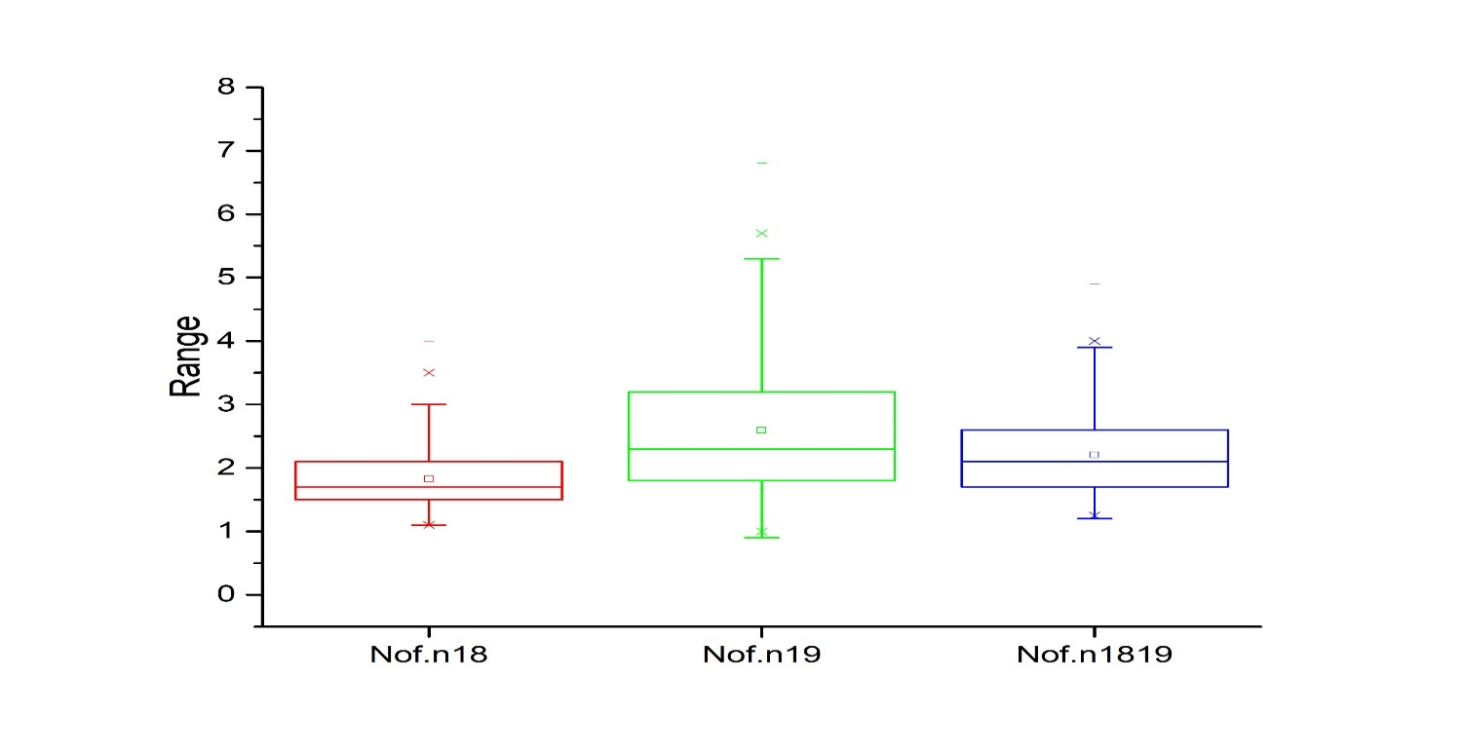

Figure S1l Box chart diagram of 305 F₁ individuals for number of fruits per node (Nof/n) based on two individual years (2018-2019) and extra year (1819) data. Each x-axis represents the trait under different years and y-axis shows the frequency of ranges corresponding with the value on x-axis. In each box chart, the lower and upper lines represent first and third quartiles, respectively, and the middle line shows the median. Nof/n18, number of fruits per node (2018), Nof/n19, number of fruits per node (2019), Nof/n1819, number of fruits per node as extra year.

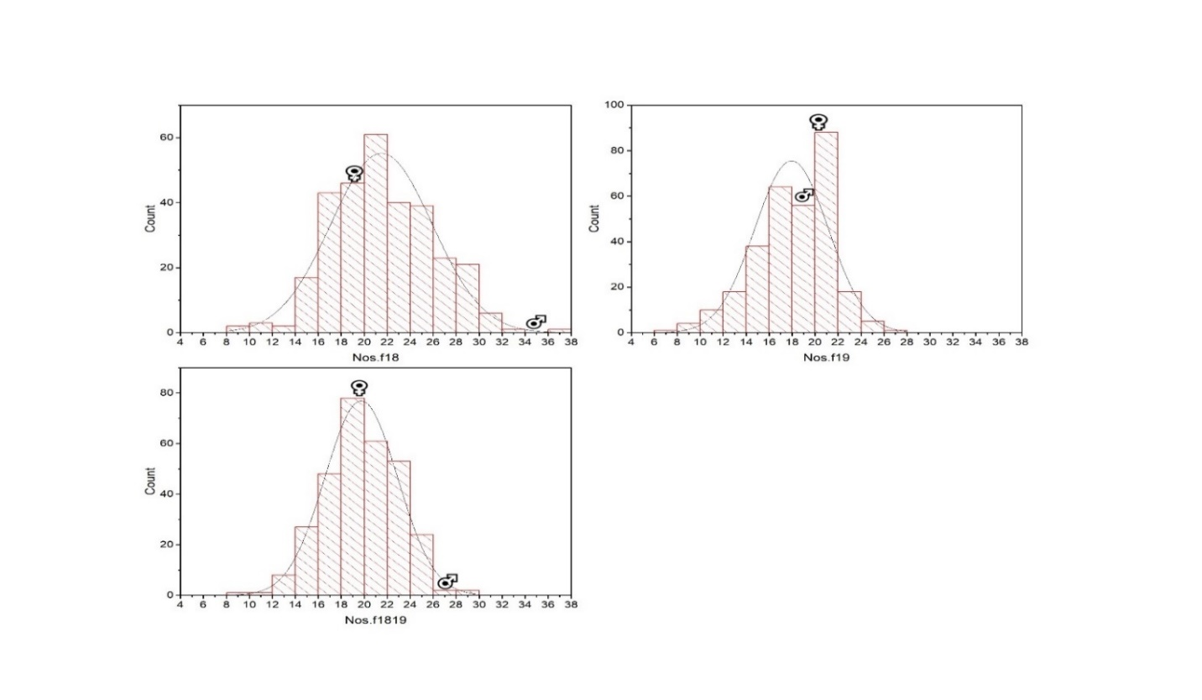

Figure S1m Frequency distribution histogram of 305 F₁ individuals for number of seeds per fruit (Nos/f) based on two individual years (2018-2019) and extra year (1819) data. Each x-axis represents the value of the trait and y-axis shows the number of frequency corresponding with the value on x-axis. Nos/f18, number of seeds per fruit (2018), Nos/f19, number of seeds per fruit (2019), Nos/f1819, number of seeds per fruit as extra year; ♀, indicate female parent position on the histogram, ♂, male parent position on the histogram.

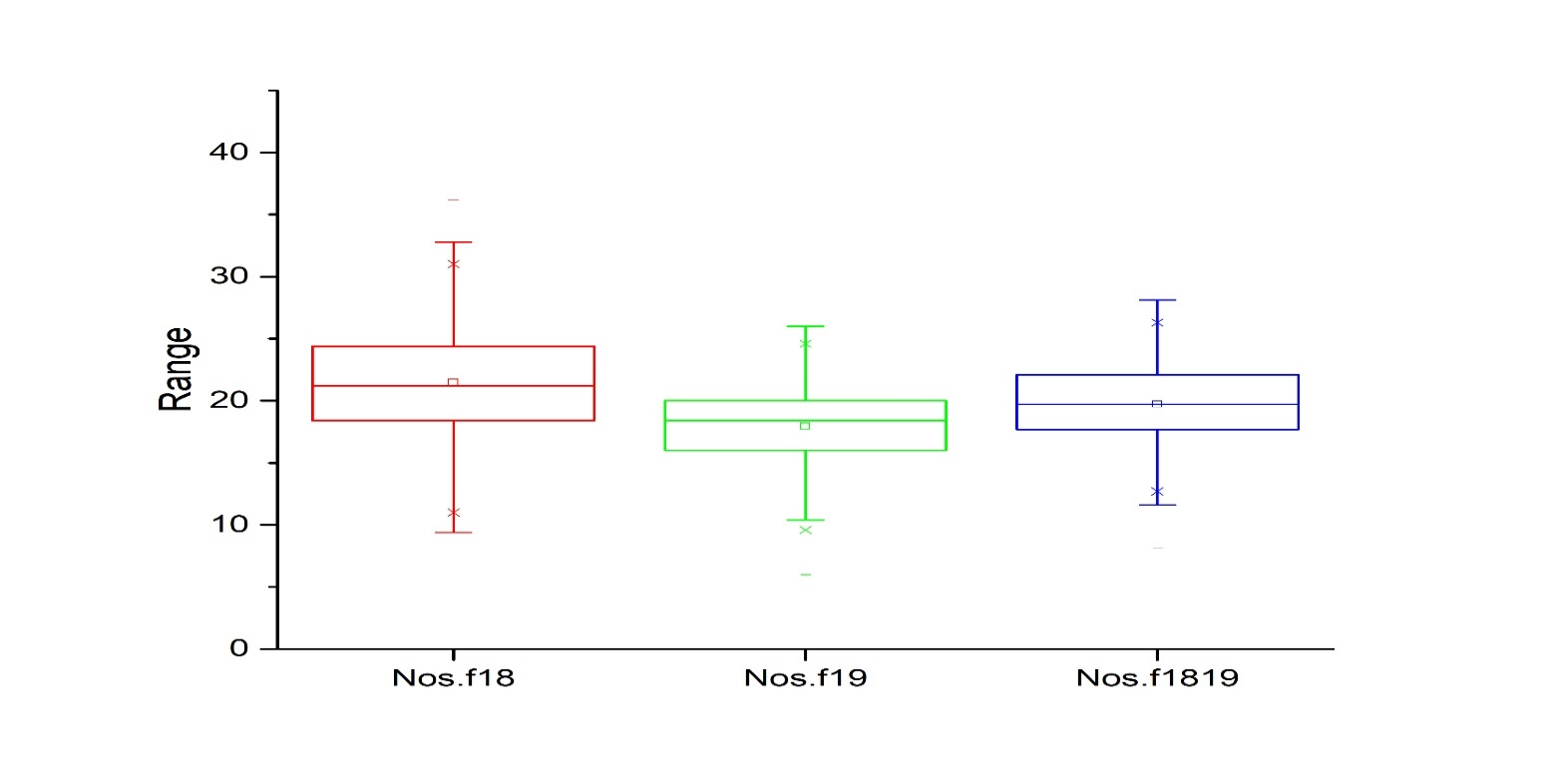

Figure S1n Box chart diagram of 305 F₁ individuals for number of seeds per fruits (Nos/f) based on two individual years (2018-2019) and extra year (1819) data. Each x-axis represents the trait under different years and y-axis shows the frequency of ranges corresponding with the value on x-axis. In each box chart, the lower and upper lines represent first and third quartiles, respectively, and the middle line shows the median. Nof/n18, number of seeds per fruit (2018), Nos/f19, number of seeds per fruit (2019), Nos/f1819, number of seeds per fruit as extra year.

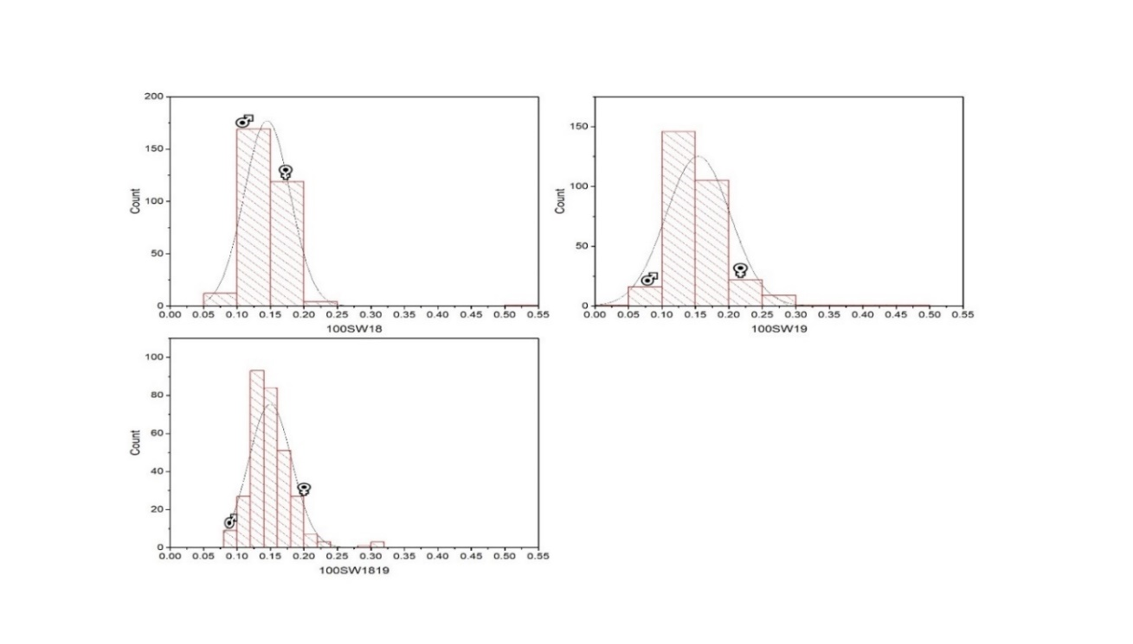

Figure S1o Frequency distribution histogram of 305 F₁ individuals for 100 seeds weight (100SW) based on two individual years (2018-2019) and extra year (1819) data. Each x-axis represents the value of the trait and y-axis shows the number of frequency corresponding with the value on x-axis. 100SW18, 100 seeds weight (2018), 100SW19, 100 seeds weight (2019), 100SW1819, 100 seeds weight as extra year; ♀, indicate female parent position on the histogram, ♂, male parent position on the histogram.
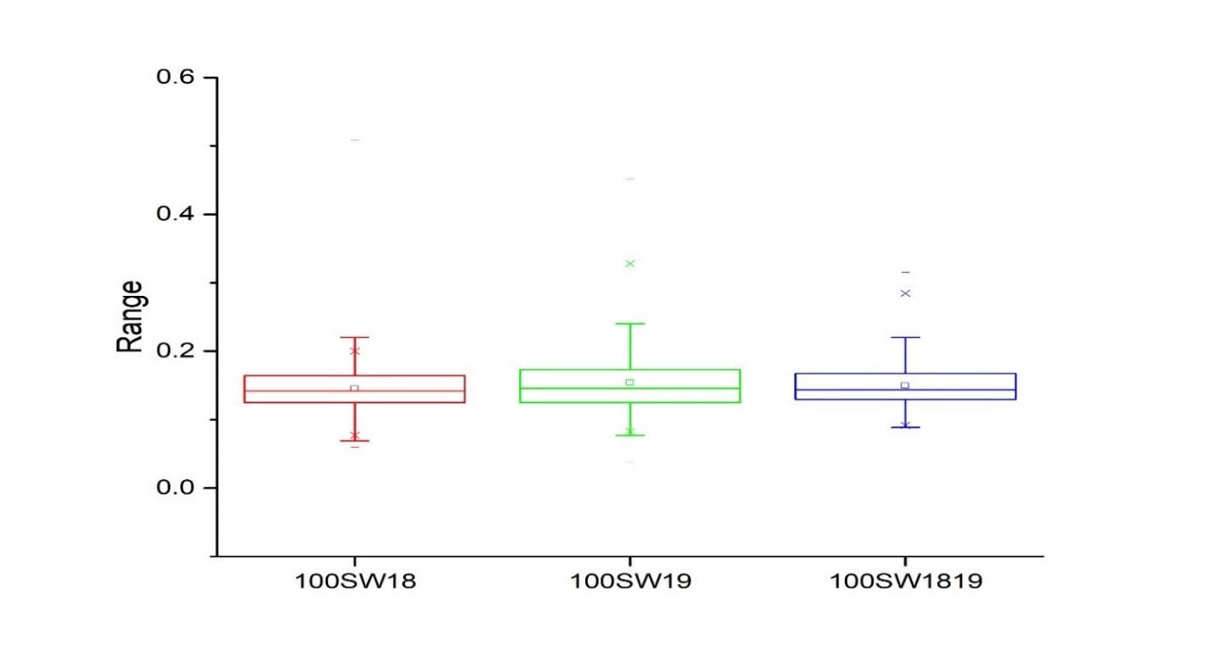

Figure S1p Box chart diagram of 305 F₁ individuals for 100 seeds weight (100SW) based on two individual years (2018-2019) and extra year (1819) data. Each x-axis represents the trait under different years and y-axis shows the frequency of ranges corresponding with the value on x-axis. In each box chart, the lower and upper lines represent first and third quartiles, respectively, and the middle line shows the median. 100SW18, 100 seeds weight (2018), 100SW19, 100 seeds weight (2019), 100SW1819, 100 seeds weight as extra year.

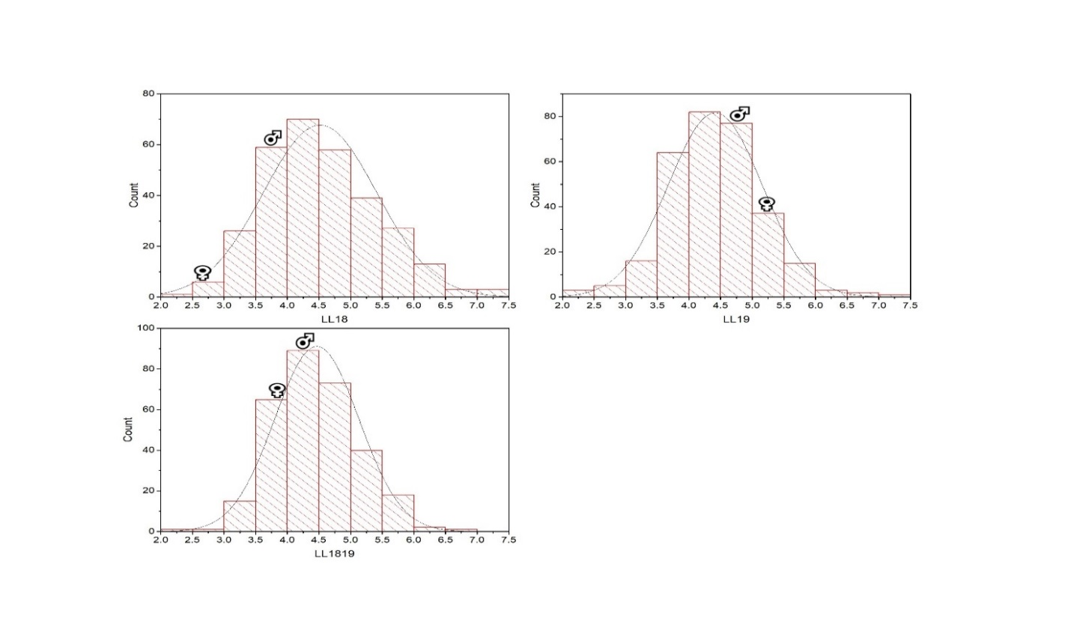

Figure S1q Frequency distribution histogram of 305 F₁ individuals for leaf length (LL) based on two individual years (2018-2019) and extra year (1819) data. Each x-axis represents the value of the trait and y-axis shows the number of frequency corresponding with the value on x-axis. LL18, leaf length (2018), LL19, leaf length (2019), LL1819, leaf length as extra year; ♀, indicate female parent position on the histogram, ♂, male parent position on the histogram.

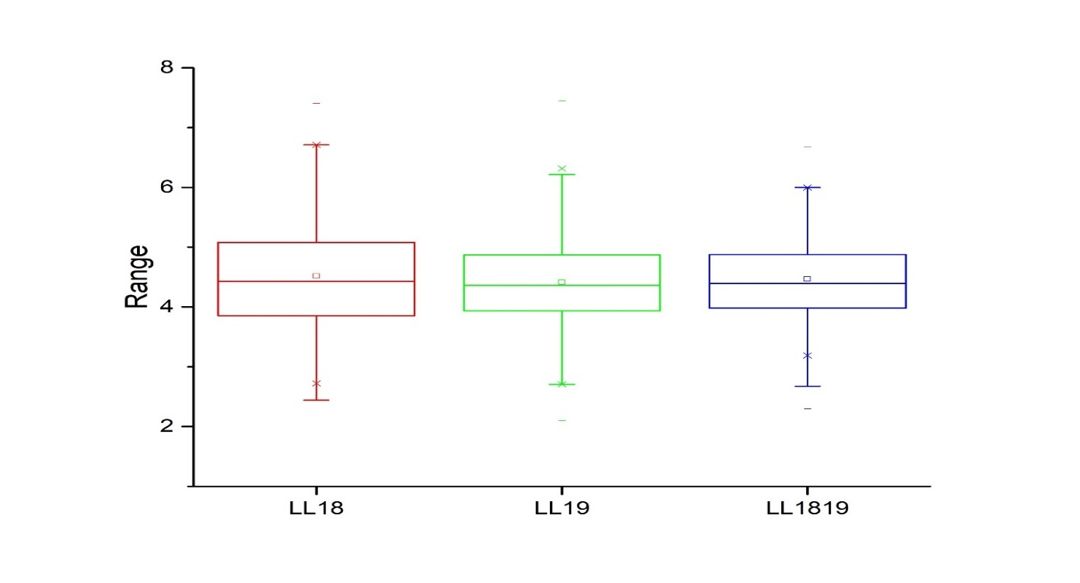

Figure S1p Box chart diagram of 305 F₁ individuals for leaf length (LL) based on two individual years (2018-2019) and extra year (1819) data. Each x-axis represents the trait under different years and y-axis shows the frequency of ranges corresponding with the value on x-axis. In each box chart, the lower and upper lines represent first and third quartiles, respectively, and the middle line shows the median. LL18, leaf length (2018), LL19, leaf length (2019), LL1819, leaf length as extra year.

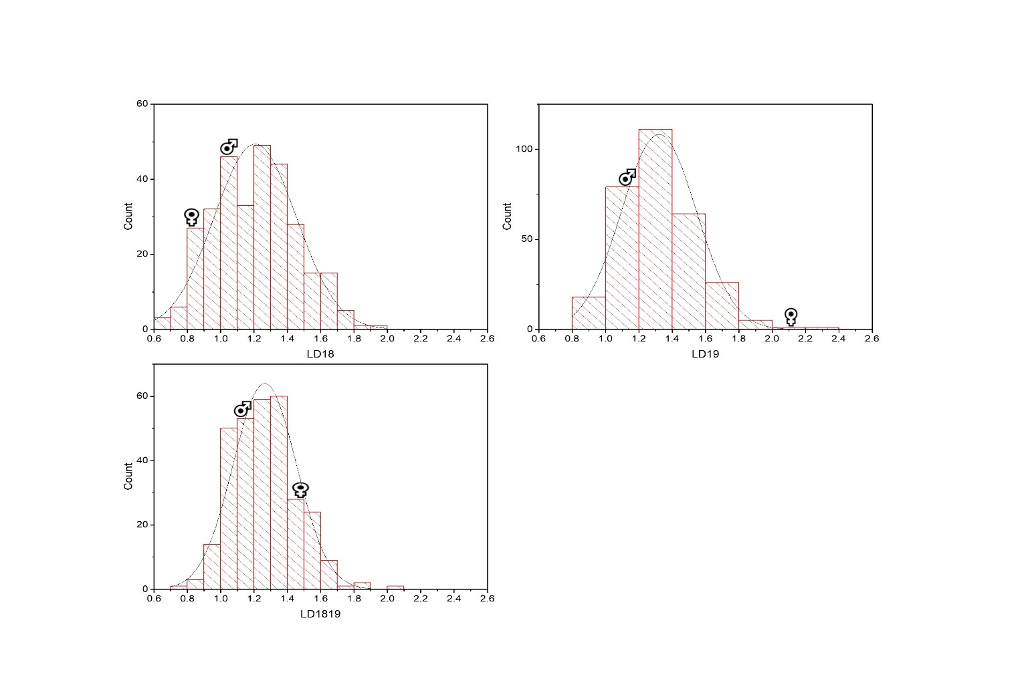

Figure S1r Frequency distribution histogram of 305 F₁ individuals for leaf diameter (LD) based on two individual years (2018-2019) and extra year (1819) data. Each x-axis represents the value of the trait and y-axis shows the number of frequency corresponding with the value on x-axis. LD18, leaf diameter (2018), LD19, leaf diameter (2019), LD1819, leaf diameter as extra year; ♀, indicate female parent position on the histogram, ♂, male parent position on the histogram.

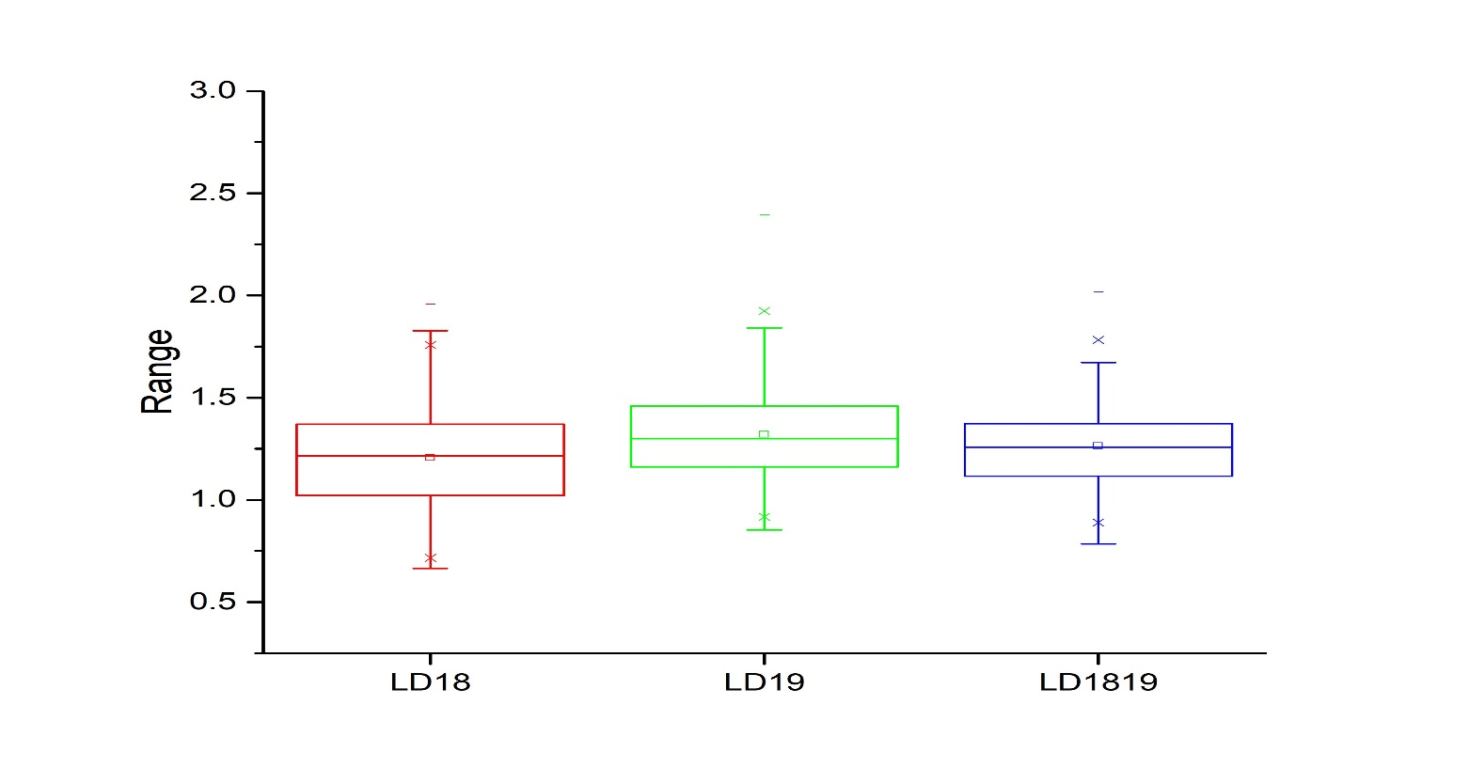

Figure S1t Box chart diagram of 305 F₁ individuals for leaf diameter (LD) based on two individual years (2018-2019) and extra year (1819) data. Each x-axis represents the trait under different years and y-axis shows the frequency of ranges corresponding with the value on x-axis. In each box chart, the lower and upper lines represent first and third quartiles, respectively, and the middle line shows the median. LL18, leaf diameter (2018), LD19, leaf diameter (2019), LD1819, leaf diameter as extra year.

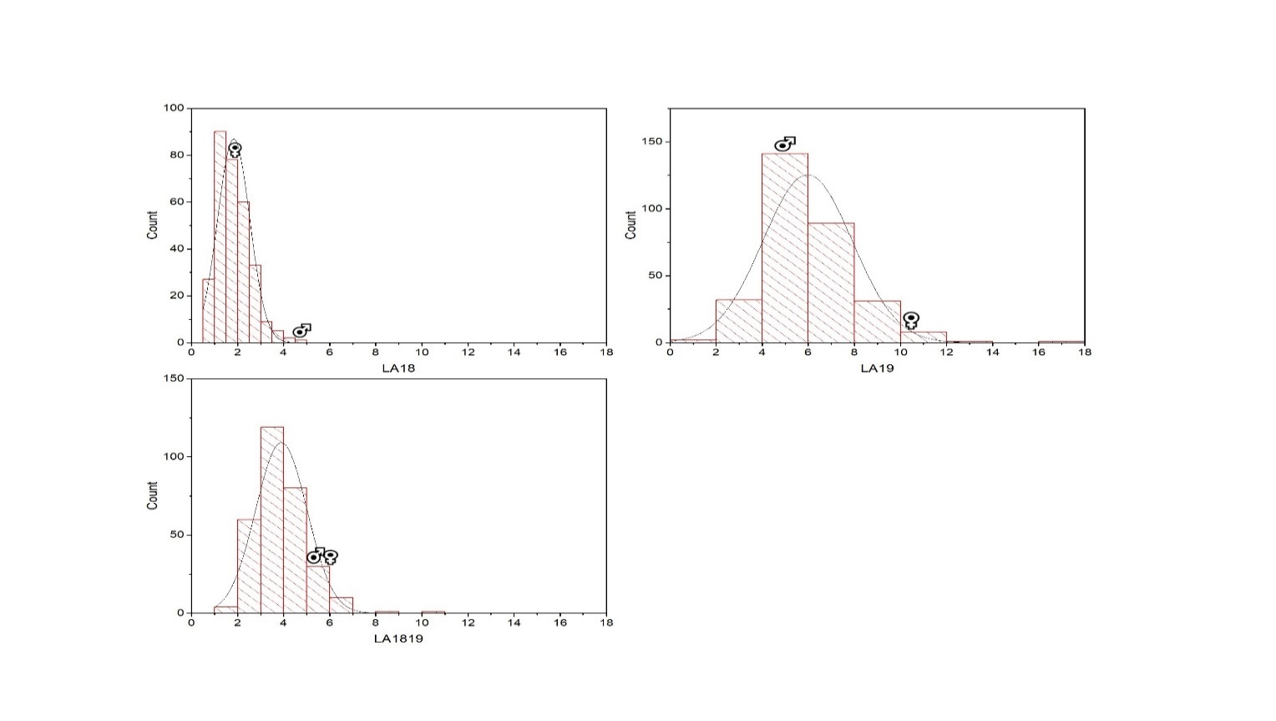

Figure S1w Frequency distribution histogram of 305 F₁ individuals for leaf area (LA) based on two individual years (2018-2019) and extra year (1819) data. Each x-axis represents the value of the trait and y-axis shows the number of frequency corresponding with the value on x-axis. LA18, leaf area (2018), LA19, leaf area (2019), LA1819, leaf area as extra year; ♀, indicate female parent position on the histogram, ♂, male parent position on the histogram.

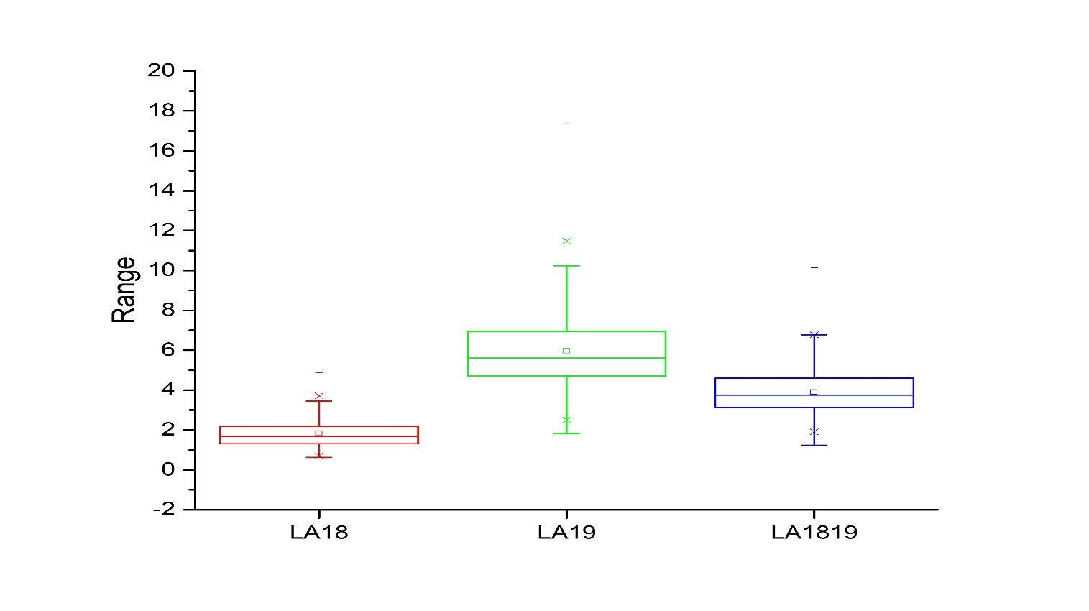
Figure S1x Box chart diagram of 305 F₁ individuals for leaf area (LA) based on two individual years (2018-2019) and extra year (1819) data. Each x-axis represents the trait under different years and y-axis shows the frequency of ranges corresponding with the value on x-axis. In each box chart, the lower and upper lines represent first and third quartiles, respectively, and the middle line shows the median. LA18, leaf area (2018), LA19, leaf area (2019), LA1819, leaf area as extra year.

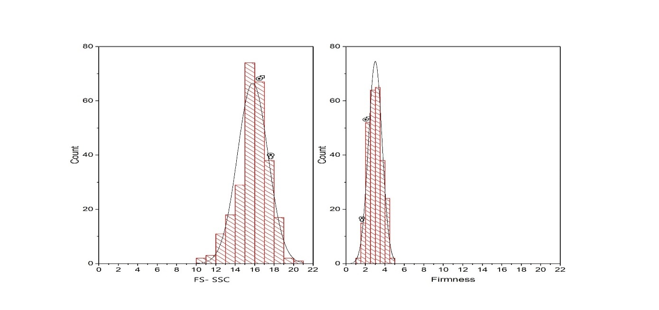

Figure S1y Frequency distribution histogram of 305 F₁ individuals for fruit sweetness- soluble solid contents (FS-SSC) and fruit firmness (FF) based on one years (2019) data. Each x-axis represents the value of the trait and y-axis shows the number of frequency corresponding with the value on x-axis. Left; FS-SSC, fruit sweetness- soluble solid contents (2019), Right; FF, fruit firmness (2019); ♀, indicate female parent position on the histogram, ♂, male parent position on the histogram.

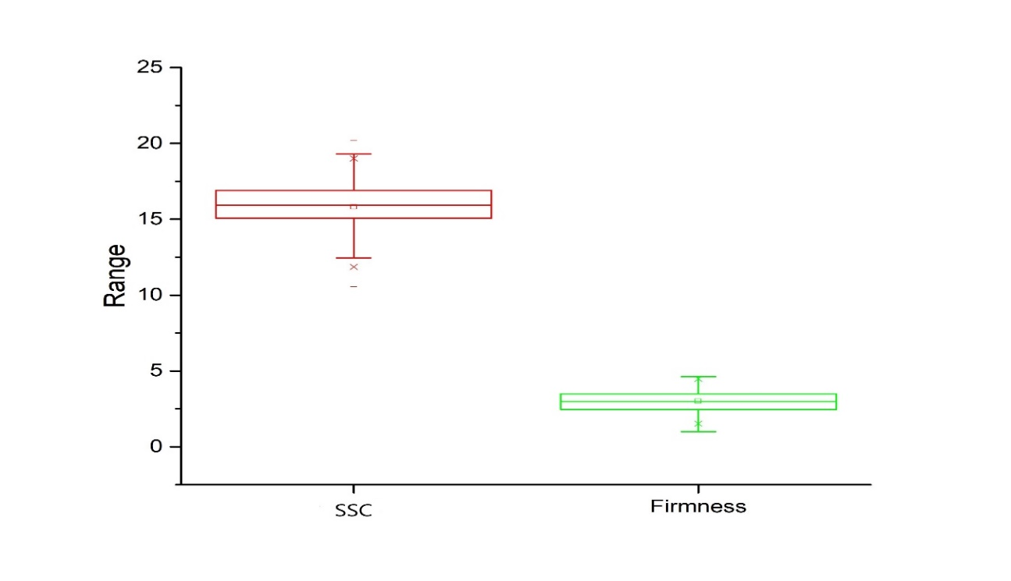

Figure S1z Box chart diagram of 305 F₁ individuals for fruit sweetness- soluble solid contents (FS-SSC) and fruit firmness (FF) based on one year (2019) data. Each x-axis represents the trait under different years and y-axis shows the frequency of ranges corresponding with the value on x-axis. In each box chart, the lower and upper lines represent first and third quartiles, respectively, and the middle line shows the median. FS-SSC, fruit sweetness- soulbe solid contents (2019), FF, fruit firmness (2019).

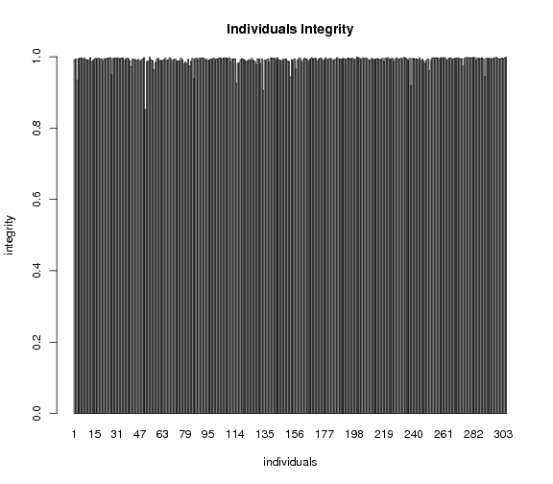
Figure S2 The marker integrities of each individual in mapping population. The x-axis indicates all 305 individuals along with the specific code name, while the y-axis shows markers integrity.

