Intensification of xylo-oligosaccharides production by hydrothermal treatment of brewer’s spent grains: Use of extremely low acid catalyst for reduction of degradation products associated with high solids loading

Lukas J. Swart¹ · Oscar K.K. Bedzo¹* · Eugéne van Rensburg¹ · Johann F. Görgens¹

¹Dept. of Process Engineering, Stellenbosch University, Private Bag X1 Stellenbosch 7602 South Africa
*Corresponding author - Email: 19123949@sun.ac.za

Table S1 Comparing autohydrolysis with mineral acid catalysed XOS production for BSG with 15% solids loading using 12.5 mg acid/g dm at 150 °C for 10 min.
Acid Catalyst | Acid loading  (mol H+/g dm) | XOS yield (wt%) | XOS%ª  (wt.%) | TDS yield^{b} (wt.%) | TRS^{c}  (g/100g) | CSF | Cost Acid $/kg dm
None | 0 | 41.7% | 96.9% | 26.8% | 1.77 | -1.71 | $0.00
H₂SO₄^{d} | 0.26 | 62.2% | 94.2% | 38.4% | 3.85 | -0.56 | $1.51
HCl | 0.34 | 69.6% | 88.0% | 51.3% | 6.49 | -0.27 | $5.75
H₃PO₄ | 0.38 | 56.8% | 96.6% | 35.8% | 2.73 | -1.15 | $2.17
HNO₃ | 0.20 | 71.7% | 94.7% | 42.0% | 4.03 | -0.87 | $4.96
ª XOS percentage of total xylan equivalent recovered
^{b} Total dissolved solids hydrolysate
^{c} Total reducing sugars per 100 gram dry feedstock
^{d} Mean of three replicates (This study)

ELA HTT results from full factorials with centre points, Table 0 2 for BSG-R (Run A1-A11) and Table 0 3 for BSG-SPD (Run B1-B11).
Table S2 Results for acid catalysed XOS production for BSG-R
Run | Independent variablesª |  |  | XOS (g/l) |  | XOS yield (wt%) |  | ArOS yield (wt%) | XOS%^{b}  (wt.%) |  |  | ArOS%^{c}(wt.%) | Inhibitors^{d} (g/100g) | TDS^{e} yield (wt.%) |  | TDS ND^{f} (g/100g) |  | Mass balance closure |  | CSF
 | AC | t | T
A-1 | 5 | 5 | 130 | 11.39 | 52.4% |  |  | 66.5% |  |  | 98.2% | 90.8% | 0.10 | 39.8% |  | 16.51 |  | 95.6% |  | -1.81
A-2 | 5 | 15 | 130 | 10.89 | 47.2% |  |  | 45.9% |  |  | 97.1% | 74.4% | 0.15 | 32.6% |  | 5.95 |  | 91.2% |  | -1.48
A-3 | 5 | 5 | 170 | 14.54 | 67.5% |  |  | 42.6% |  |  | 94.4% | 56.1% | 0.71 | 41.2% |  | 10.94 |  | 89.9% |  | -0.84
A-4 | 5 | 15 | 170 | 16.57 | 76.4% |  |  | 29.7% |  |  | 91.7% | 45.9% | 1.18 | 42.9% |  | 13.18 |  | 83.0% |  | -0.55
A-5 | 20 | 5 | 130 | 11.92 | 54.5% |  |  | 41.9% |  |  | 96.9% | 51.9% | 0.16 | 31.6% |  | 7.21 |  | 92.8% |  | -0.36
A-6 | 20 | 15 | 130 | 10.60 | 48.0% |  |  | 30.3% |  |  | 95.2% | 41.6% | 0.19 | 35.9% |  | 12.16 |  | 89.4% |  | -0.38
A-7 | 20 | 5 | 170 | 15.89 | 72.6% |  |  | 22.8% |  |  | 78.5% | 28.7% | 1.31 | 47.4% |  | 15.70 |  | 87.4% |  | 0.28
A-8 | 20 | 15 | 170 | 10.87 | 50.2% |  |  | 13.2% |  |  | 62.9% | 23.5% | 1.77 | 41.0% |  | 11.85 |  | 82.9% |  | 0.46
A-9 | 12.5 | 10 | 150 | 13.25 | 60.9% |  |  | 38.8% |  |  | 94.3% | 47.1% | 0.39 | 38.0% |  | 9.89 |  | 91.8% |  | -0.64
A-10 | 12.5 | 10 | 150 | 13.96 | 63.0% |  |  | 40.1% |  |  | 94.0% | 46.4% | 0.41 | 39.8% |  | 12.20 |  | 95.7% |  | -0.55
A-11 | 12.5 | 10 | 150 | 13.25 | 60.6% |  |  | 36.6% |  |  | 94.2% | 44.1% | 0.29 | 37.4% |  | 9.41 |  | 86.8% |  | -0.50
a AC, Acid loading (mg/100g dm); t, Time (min); T, Temperature (°C).
b XOS percentage of total xylan equivalent recovered
c ArOS percentage of total arabinan equivalent recovered
d Combined acetic acid, formic acid, furfural and HMF
e Total dissolved solids hydrolysate
f Dissolved solids excluding quantified oligomers, sugars and inhibitors

Table S3 Results for acid catalysed XOS production for BSG-SPD
Run | Independent variablesª |  |  | XOS (g/l) |  | XOS yield (wt%) |  | ArOS yield (wt%) | XOS%^{b}  (wt.%) |  |  | ArOS%^{c}(wt.%) | Inhibitors^{d} (g/100g) | TDS^{e} yield (wt.%) |  | TDS ND^{f} (g/100g) |  | Mass balance closure |  | CSF
 | AC | t | T
B-1 | 5 | 5 | 130 | 13.66 | 27.0% |  |  | 29.1% |  |  | 96.3% | 64.2% | 0.12 | 21.2% |  | 6.94 |  | 91.1% |  | -1.31
B-2 | 5 | 15 | 130 | 17.44 | 33.8% |  |  | 35.1% |  |  | 96.9% | 64.0% | 0.28 | 24.8% |  | 7.08 |  | 85.2% |  | -1.19
B-3 | 5 | 5 | 170 | 31.65 | 65.5% |  |  | 35.1% |  |  | 93.0% | 48.9% | 1.14 | 34.1% |  | 8.97 |  | 86.9% |  | -0.13
B-4 | 5 | 15 | 170 | 27.08 | 56.0% |  |  | 17.9% |  |  | 86.3% | 39.5% | 1.29 | 32.8% |  | 9.66 |  | 87.3% |  | 0.14
B-5 | 20 | 5 | 130 | 20.59 | 42.1% |  |  | 27.6% |  |  | 91.3% | 34.2% | 0.31 | 27.2% |  | 8.05 |  | 83.7% |  | 0.08
B-6 | 20 | 15 | 130 | 24.76 | 50.9% |  |  | 26.8% |  |  | 89.3% | 29.1% | 0.44 | 30.6% |  | 8.12 |  | 86.5% |  | 0.27
B-7 | 20 | 5 | 170 | 16.58 | 33.4% |  |  | 10.1% |  |  | 56.3% | 21.9% | 2.51 | 36.6% |  | 14.94 |  | 90.1% |  | 0.99
B-8 | 20 | 15 | 170 | 7.25 | 15.0% |  |  | 3.8% |  |  | 38.8% | 14.3% | 3.09 | 25.4% |  | 8.49 |  | 78.4% |  | 1.07
B-9 | 12.5 | 10 | 150 | 27.75 | 55.7% |  |  | 29.3% |  |  | 90.2% | 36.4% | 0.89 | 34.1% |  | 10.55 |  | 88.0% |  | 0.04
B-10 | 12.5 | 10 | 150 | 28.18 | 56.0% |  |  | 22.5% |  |  | 89.3% | 28.7% | 0.99 | 35.0% |  | 10.76 |  | 88.8% |  | 0.03
B-11 | 12.5 | 10 | 150 | 29.38 | 59.0% |  |  | 28.6% |  |  | 90.7% | 36.4% | 0.87 | 35.6% |  | 11.05 |  | 88.1% |  | 0.07
a AC, Acid loading (mg/100g dm); t, Time (min); T, Temperature (°C).
b XOS percentage of total xylan equivalent recovered
c ArOS percentage of total arabinan equivalent recovered
d Combined acetic acid, formic acid, furfural and HMF
e Total dissolved solids hydrolysate
f Dissolved solids excluding quantified oligomers, sugars and inhibitors

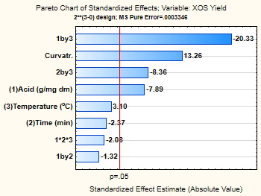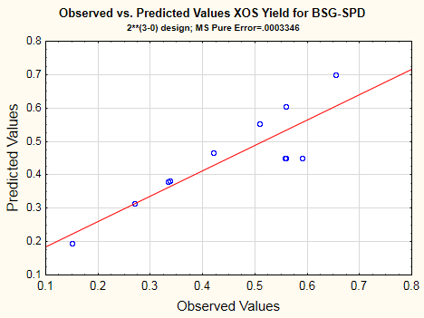
Fig. S1 Analysis of factorial results for BSG-SPD: standardised effects and regression model for XOS yield from BSG-SPD

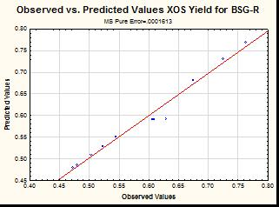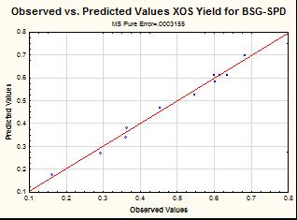
Fig. S2 Model response prediction for XOS yield vs. observed values (A) BSG-R and (B) BSG-SPD with quadratic term

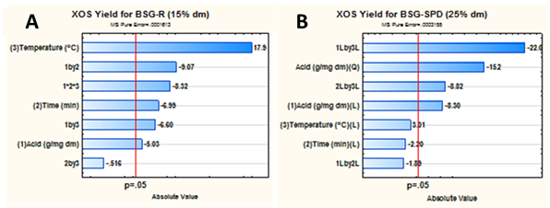
Fig. S4 Pareto chart of standardized effects, XOS yield (A) BSG-R (B) BSG-SPD

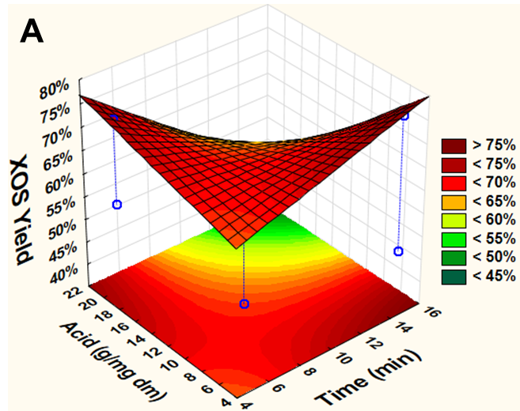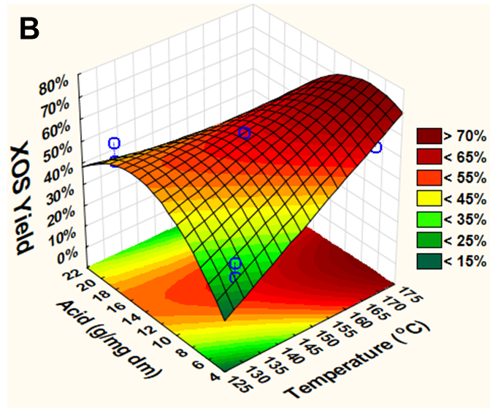
Fig. S5 Effect of acid loadings and treatment time in ELA HTT at 170 °C of BSG with XOS yields represented in surface plots for (A) BSG-R and (B) BSG-SPD with quadratic effect

Table S4 Regression coefficients and R2 assessing the correlation and significance of the fitted modelsa
 |  | BSG-R |  |  |  |  |  |  |  | BSG-SPD
Regression coefficients | XOS yield (wt.%) |  | Inhibitors (g/100g) |  | TDS yield^{b} (wt.%) |  |  |  | XOS yield (wt.%) |  | Inhibitors (g/100g) |  | TDS yield^{b} (wt.%)
a₀ | 0.59267 |  | -0.74538 |  | 0.83956 |  |  |  | 0.56891 |  | 0.91688 |  | 0.34891
a₁ | -0.04524 |  | -0.11249 |  | -0.06177 |  |  |  | -0.10211 |  | 0.88063 |  | 0.01722
a₂ | -0.06283 |  | -0.13141 |  | -0.06098 |  |  |  | -0.03074 |  | 0.25273 |  | -0.01384
a₃ | 0.16135 |  | 0.00537 |  | -0.00277 |  |  |  | 0.04014 |  | 1.71882 |  | 0.06249
a₁₂ | -0.08149 |  | -0.00016 |  | 0.00500 |  |  |  | -0.01720 |  | 0.10217 |  | -0.02525
a₁₃ | -0.05932 |  | 0.00090 |  | 0.00040 |  |  |  | -0.26305 |  | 0.70171 |  | -0.04189
a₂₃ | -0.00464 |  | 0.00106 |  | 0.00038 |  |  |  | -0.10819 |  | 0.11189 |  | -0.04883
a₁₂₃ | -0.07478 |  | 0.00000 |  | -0.00003 |  |  |  | 0.00000 |  | 0.00000 |  | 0.00000
a₁₁ | 0.00000 |  | 0.00000 |  | 0.00000 |  |  |  | -0.32865 |  | 0.46030 |  | -0.11617
R² | 0.97784 |  | 0.92095 |  | 0.98125 |  |  |  | 0.99146 |  | 0.99613 |  | 0.95160
ª ANOVA for XOS concentration and yields models given
^{b} Total dissolved solids yield in hydrolysate

Table S5 Analysis of variance of the fitted models for XOS yield from BSG-R
 | SSª | d.f.^{b} | MS^{c} | F-value | p-value
XOS yield (wt.%)
AC | 0.0040928 | 1 | 0.004093 | 25.38037 | 0.037215
t | 0.0078949 | 1 | 0.007895 | 48.95843 | 0.019820
T | 0.0520682 | 1 | 0.052068 | 322.8886 | 0.003083
AC*t | 0.0132805 | 1 | 0.013281 | 82.35597 | 0.011926
AC*T | 0.0070387 | 1 | 0.007039 | 43.64898 | 0.022152
t*T | 0.0000430 | 1 | 0.000043 | 0.266683 | 0.656993
AC*t*T | 0.0111830 | 1 | 0.011183 | 69.34848 | 0.014115
Lack of fit | 0.0018441 | 1 | 0.001844 | 11.43555 | 0.077427
Pure Error | 0.0003225 | 2 | 0.000161
Total SS | 0.0977677 | 10
ª sum of squares; ^{b} degrees of freedom; ^{c} mean of squares.

Table S6 Analysis of variance of the fitted models for XOS yield from BSG-SPD
 | SSª | d.f.^{b} | MS^{c} | F-value | p-value
XOS yield (wt.%)
AC | 0.020853 | 1 | 0.020853 | 62.3138 | 0.015672
t | 0.001890 | 1 | 0.001890 | 5.6487 | 0.140629
T | 0.003223 | 1 | 0.003223 | 9.6307 | 0.090032
AC*t | 0.000592 | 1 | 0.000592 | 1.7676 | 0.315053
AC*T | 0.138388 | 1 | 0.138388 | 413.5346 | 0.002409
t*T | 0.023410 | 1 | 0.023410 | 69.9559 | 0.013995
AC² | 0.058916 | 1 | 0.058916 | 176.0547 | 0.005632
Lack of fit | 0.001462 | 1 | 0.001462 | 4.3673 | 0.171812
Pure Error | 0.000669 | 2 | 0.000335
Total SS | 0.249403 | 10
ª sum of squares; ^{b} degrees of freedom; ^{c} mean of squares.

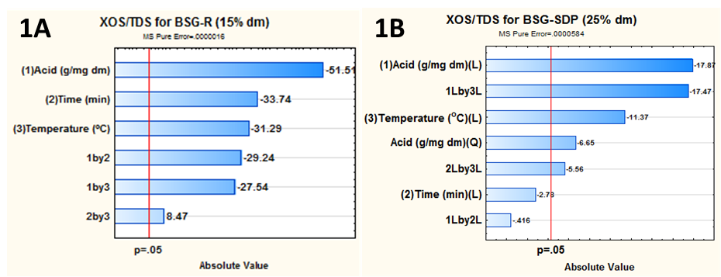
Fig. S6 Pareto standardised chart of effects for variable XOS/TDS (1A) BSG-R and (1B) BSG-SPD

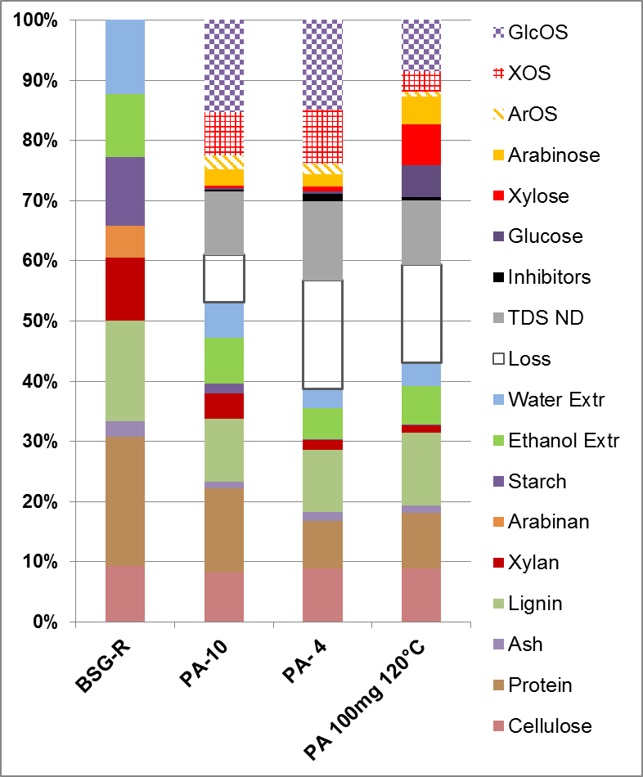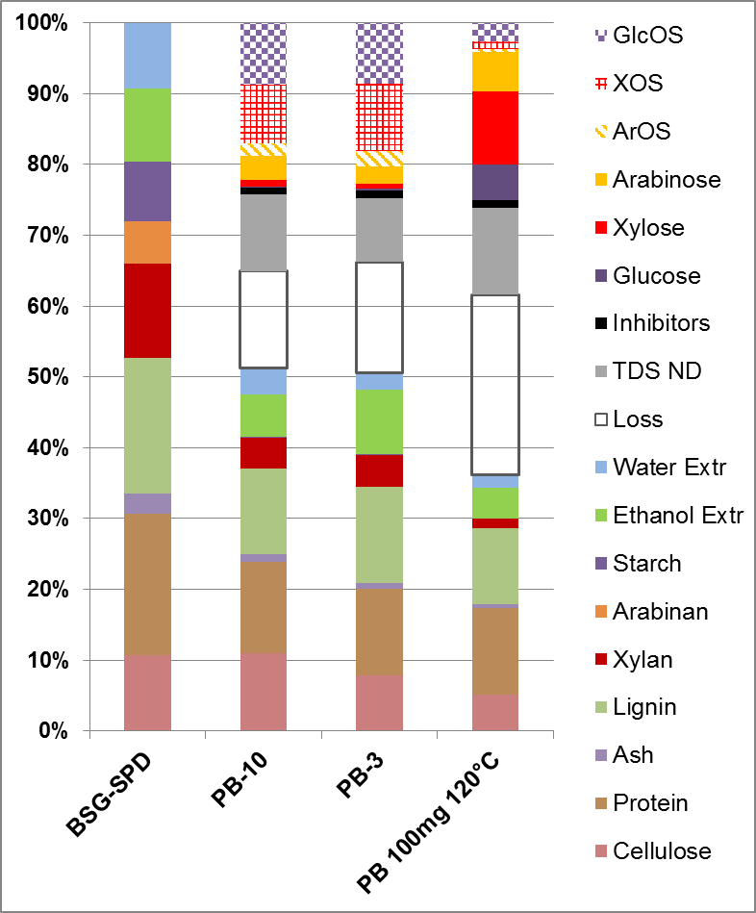
Fig. S7 Insoluble residue and hydrolysates obtained from hydrothermal treatments for (A) BSG-R and (B) BSG-SPD

Table S7 Protein analysis from BSG, press liquid and HTT solid residue
Amino acid  (wt.%) |  | Feedstock |  |  |  | Solid Residue
 |  | BSG-R |  | Screw press liquid-solid filtrate |  | A-4  170°C  15min 5mg |  | B-3  170°C  5min 5mg
Basic amino acids
Arginine |  | 6.5% |  | 5.6% |  | 3.1% |  | 3.3%
Histidine* |  | 3.2% |  | 1.5% |  | 2.8% |  | 2.7%
Lysine* |  | 2.3% |  | 3.5% |  | 0.9% |  | 1.0%
Subtotal |  | 12.0% |  | 10.5% |  | 6.9% |  | 7.0%
Hydrophobic amino acids
Alanine |  | 4.5% |  | 4.8% |  | 5.2% |  | 5.4%
Glycine |  | 4.9% |  | 4.4% |  | 4.8% |  | 5.0%
Isoleucine* |  | 3.7% |  | 4.1% |  | 4.2% |  | 4.7%
Leucine* |  | 7.8% |  | 7.8% |  | 9.1% |  | 9.4%
Methionine* |  | 2.4% |  | 2.2% |  | 2.8% |  | 2.4%
Phenylalanine* |  | 7.5% |  | 5.1% |  | 8.7% |  | 8.0%
Proline |  | 7.2% |  | 12.2% |  | 7.3% |  | 7.3%
Valine* |  | 5.8% |  | 5.4% |  | 6.3% |  | 6.5%
Subtotal |  | 43.8% |  | 46.0% |  | 48.4% |  | 48.7%
Hydrophilic amino acids
Asparagine |  | 6.3% |  | 7.3% |  | 5.2% |  | 5.9%
Glutamine |  | 23.2% |  | 24.4% |  | 24.5% |  | 23.8%
Serine |  | 5.8% |  | 4.6% |  | 5.6% |  | 5.5%
Threonine* |  | 4.6% |  | 3.8% |  | 4.6% |  | 4.7%
Tyrosine |  | 4.1% |  | 3.4% |  | 4.9% |  | 4.4%
Subtotal |  | 44.2% |  | 43.4% |  | 44.8% |  | 44.3%
Essential amino acids*
Subtotal included |  | 37.3% |  | 33.4% |  | 39.5% |  | 39.3%
Total amino acidsª |  | 23.3% |  | 43.0% |  | 25.9% |  | 22.2%
Crude Protein |  | 23.4% |  | 39.5% |  | 26.5% |  | 23.3%
a Tryptophan and Cysteine not determined

