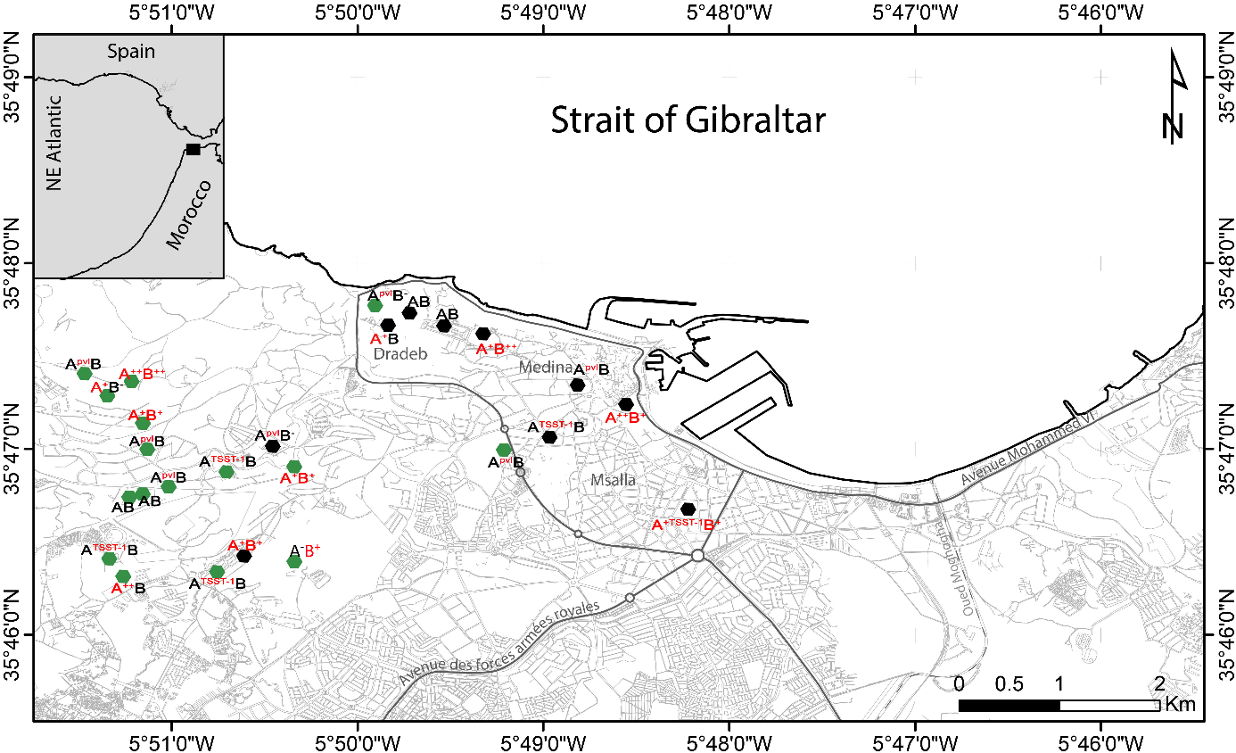

Figure 1. Geographical distribution of the 26 Livestock sampling areas in different regions of Tangier
Goats, sheep and breeders sampling in local areas
Goats, cattle, sheep and breeders sampling in farm areas
Abbreviations:
A⁻: Animal with no cases of S. aureus; A: Animal carrying multi-susceptible S. aureus; A⁺: Animal carrying S. aureus resistant to one antibiotic; A⁺⁺: Animal carrying S. aureus resistant to two antibiotics; B⁻: Breeder with no cases of S. aureus; B: Breeder carrying multi-susceptible S. aureus; B⁺: Breeder carrying S. aureus resistant to one antibiotic; B⁺⁺: Breeder carrying S. aureus resistant to two antibiotics; A/B^{PVL}: Animal/Breeder carrying Panton–Valentine leukocidin-positive (PVL) S. aureus; A/B^{TSST-1}: Animal/Breeder carrying Toxic Shock Syndrome Toxin (TSST-1)-positive S. aureus. The map was created by the authors using the q geographic information system (QGIS) version 2.2 and GNU Image Manipulation Program (GIMP) version 2.10.20 software.

