Supplementary Information for
Real-space observations of 60-nm skyrmion dynamics in an insulating magnet under low heat flow
Xiuzhen Yu^{1*}, Fumitaka Kagawa^{1, 2}, Shinichiro Seki^{2,3}, Masashi Kubota^{1†}, Jan Masell¹, Fehmi S. Yasin¹, Kiyomi Nakajima¹, Masao Nakamura¹, Masashi Kawasaki^{1, 2}, Naoto Nagaosa^{1, 2} and Yoshinori Tokura^{1,2, 4}
¹RIKEN Center for Emergent Matter Science (CEMS), Wako 351-0198, Japan
²Department of Applied Physics, University of Tokyo, Tokyo 113-8656, Japan
³ Institute of Engineering Innovation, University of Tokyo, Tokyo 113-0032, Japan
⁴Tokyo College, University of Tokyo, Tokyo 113-8656, Japan
*Correspondence to: yu_x@riken.jp
† Present affiliation: Technology and Business Development Unit, Murata Manufacturing Co., Ltd., Kyoto 617-8555, Japan

Skyrmion motions under various heater currents in the thin Cu₂OSeO₃
Supplementary Figure 1 shows skyrmion motions under various heater currents in the Cu₂OSeO₃. When the heater current I_{H} is 10 µA, i.e. $∇T$ ~ 0.4 mK/mm, the drift motions of skyrmions do not occur. When I_{H} is increased up to 50 µA, i.e. $∇T$ ~ 13 mK/mm, skyrmions move against the heat flow, and simultaneously a skyrmion Hall motion shows up. The in-situ Lorentz TEM images obtained by systematic observations with increasing I_{H} have clearly demonstrated that the velocity and Hall angle of skyrmions increase with increasing $∇T$, as shown in Fig. 3k.
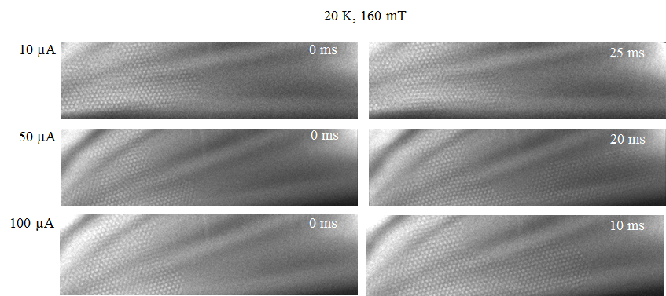
Supplementary Figure 1: Skyrmion motions with heat flows from the right to left sides of the plate. Left panels show initial magnetic configurations observed at 160-mT-normal field and 20 K. Right panels demonstrate magnetic structures during heat flows.
Characterization of thermometers on the thin Cu₂OSeO₃
We measured temperature dependences of thermometer resistances, as shown in supplementary Figure 2a, by using Physical Property Measurements System (PPMS, Quantum Design). Both resistances of R₁ and R₂ are the same value of ~ 3800 Ω at 20 K. Supplementary Figure 2b represent I-V curves measured in TEM chamber, indicating the same resistance for both R₁ and R2. Thus, the temperature gradients caused by such weak heater currents are hardly to be evaluated in the present device, at least corroborating such a small heat generation or a low heat flow as estimated by the above simulation.
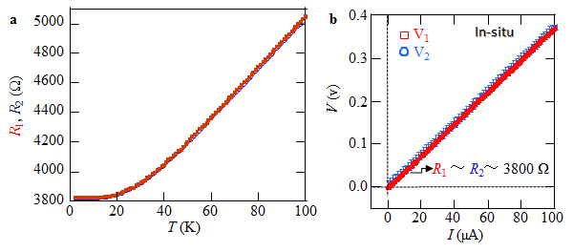
Supplementary Figure 2: Resistance curves (a) and I-V curves (b) of thermometers R₁ and R₂ in the thin Cu₂OSeO₃ plate. a. Resistance profiles of R₁ and R₂ with decreasing temperature obtained by Physical Properties Measurement System (PPMS) measurements with 1-µA current through the heater and thermometers. b. I-V curves of thermometers R₁ and R₂ under the same current flow through the heater measured in-situ in the TEM chamber.

