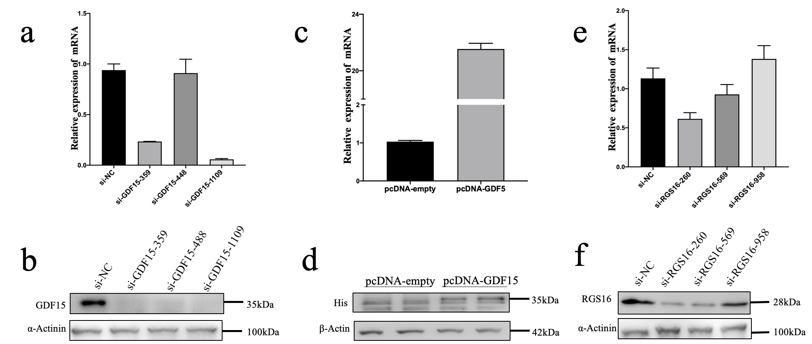
Supplementary Figure 2 (related to figures 6, 7). Transfection in HepG2 cells was assessed by qPCR or Western blot. a-b. GDF15 knockdown (KD) in HepG2 cells evaluated by qPCR or Western blot. c-d. GDF15 overexpression in HepG2 cells evaluated by qPCR or Western blot. e-f. RGS16 knockdown (KD) in HepG2 cells evaluated by qPCR or Western blot.

