SUPPORTING INFORMATION

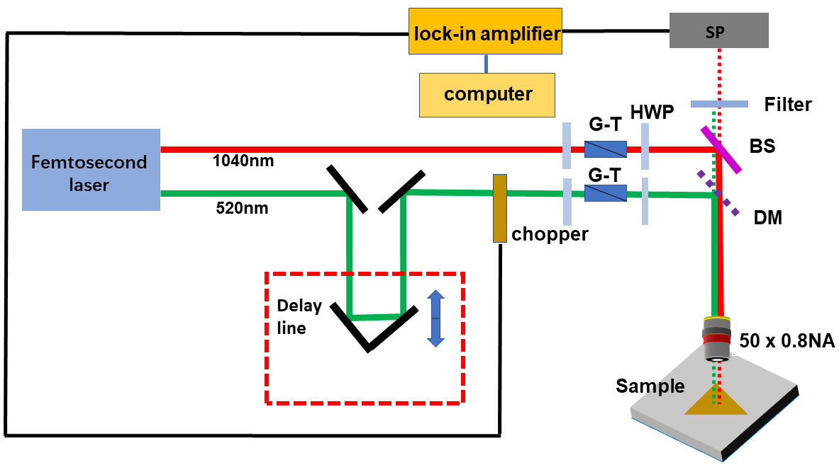
Figure S1. Schematic diagram for the time-resolved transient reflection measurement system. BS: beam-splitter; HWP: half-wave plate; DM: dichroic mirror; SP: Silicon photodiode detector; G-T: Glan-Taylor prism.
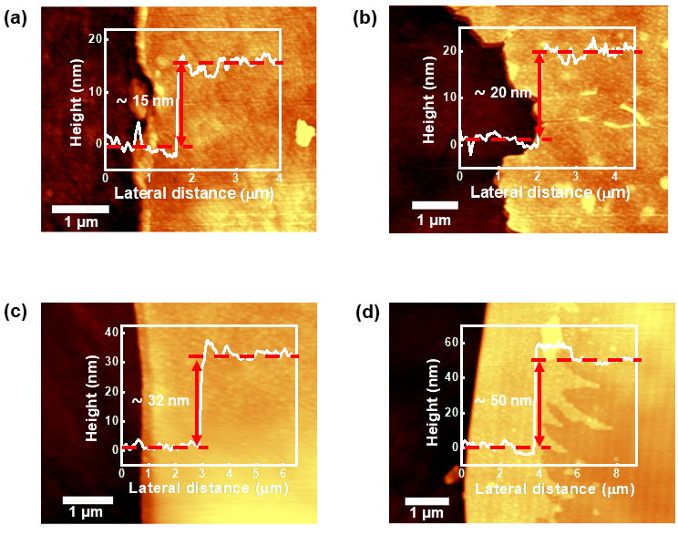
Figure S2. (a)–(d) AFM images and height profiles for NbTe₂ samples with different thicknesses.
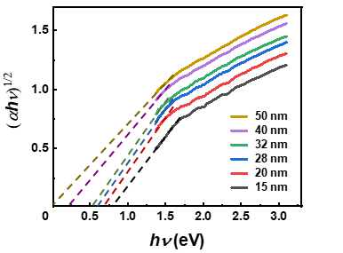
Figure S3. Tauc plots of NbTe₂ flakes with different thicknesses.
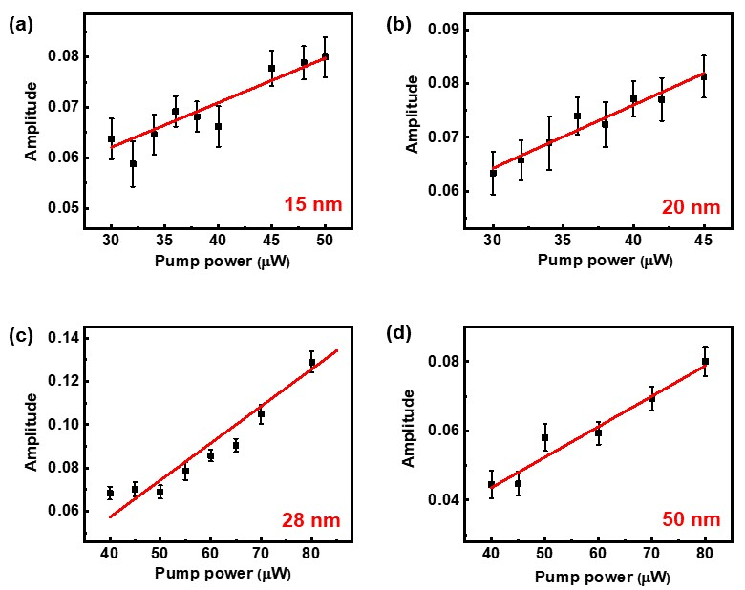
Figure S4. (a)–(d) Peak amplitudes of the ΔR curves as a function of the pump power for NbTe₂ flakes with different thicknesses. The black solid squares represent the experimental data, and the red solid line is the linear fit.
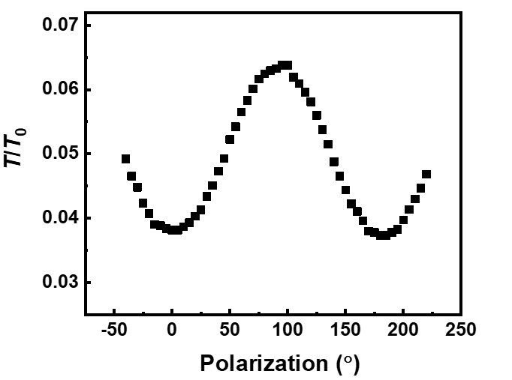
Figure S5. Polarization-resolved transmission of 520 nm pump light in NbTe₂ sample. T and T₀ are measured transmissions for the sample and quartz substrate, respectively.

