PD-1/PD-L1 inhibitors vs. chemotherapy for previously treated advanced gastroesophageal cancer: A meta-analysis of randomized controlled trials
Maoxi Zhong^{1,2,3}, Xiaozhu Zeng^{1,2,3}, Jinmin Xue^{1,2,3}, Yubing Yue^{1,2,3}, Yuxi Zhu^{1,2,3*}
¹ Department of Oncology, The First Affiliated Hospital of Chongqing Medical University, Chongqing, P.R. China
² Department of Oncology, Jinshan Hospital of The First Affiliated Hospital of Chongqing Medical University, Chongqing, P.R. China
³Chongqing Clinical Cancer Research Center, Chongqing, P.R. China
* Correspondence: Yuxi Zhu E-mail: zhuyuxi@hospital.cqmu.edu.cn

supplementary Fig.1 Forest plot of risk ratios for objective response rate (ORR) between PD-1/PD-L1 inhibitors and chemotherapy/placebo in subgroups
(a) ORR in the squamous cell carcinoma subgroup
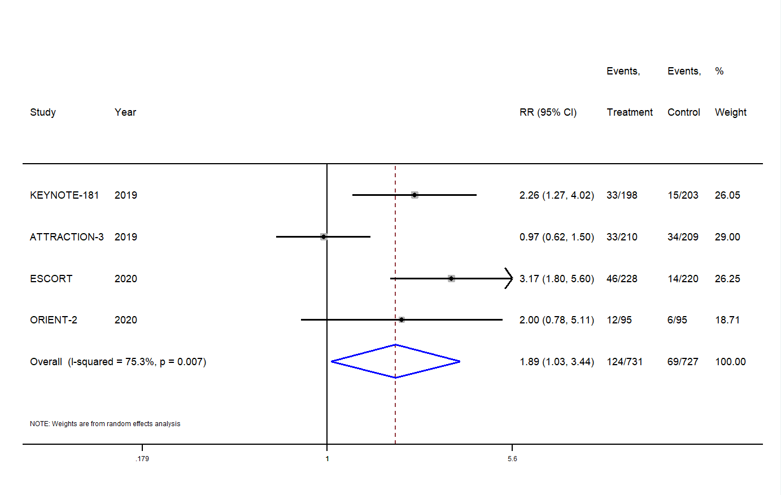
(b) ORR in the adenocarcinoma subgroup
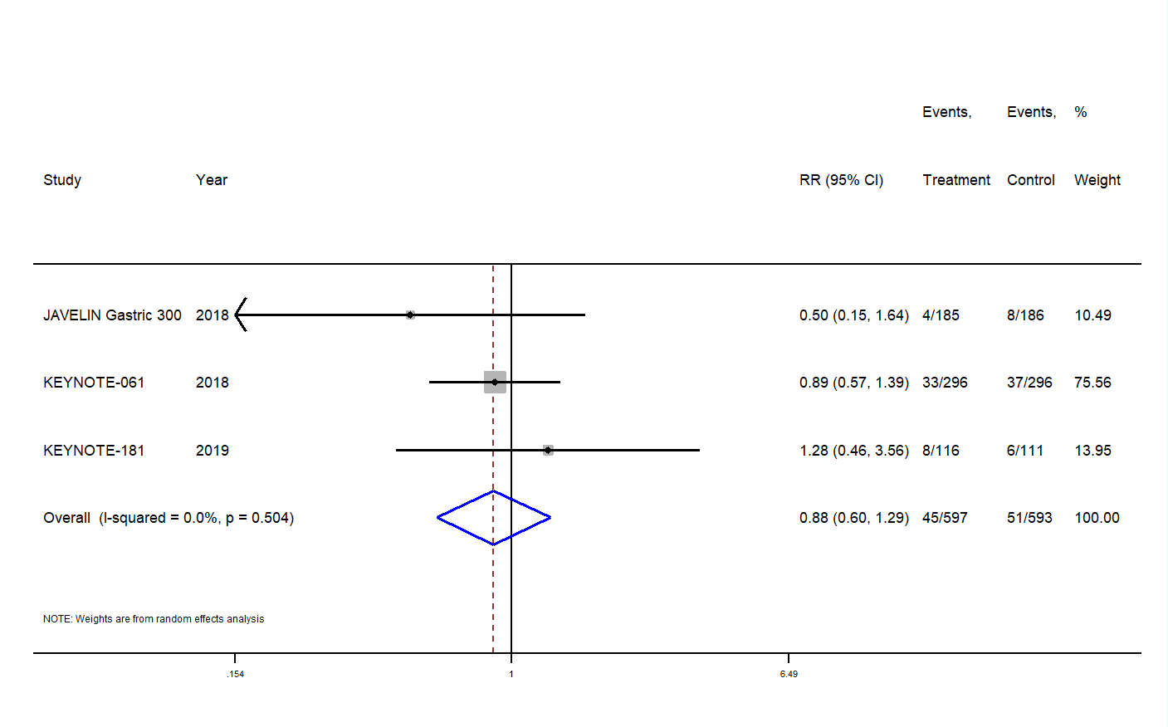
supplementary Fig.2 Forest plot of hazard ratios for progression-free survival (PFS) between PD-1/PD-L1 inhibitors and chemotherapy/placebo in subgroups
(a) PFS in the squamous cell carcinoma subgroup
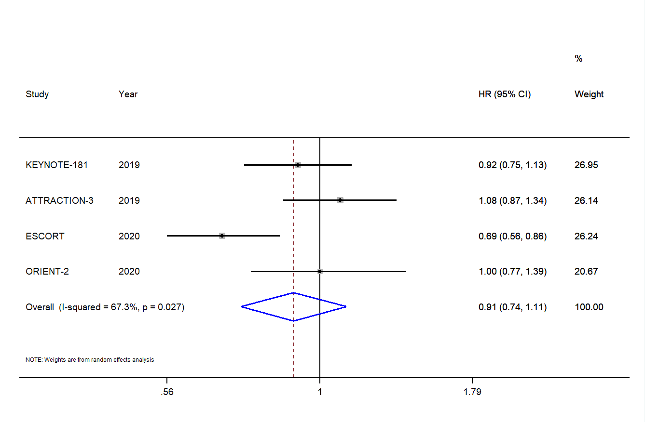
(b) PFS in the adenocarcinoma subgroup
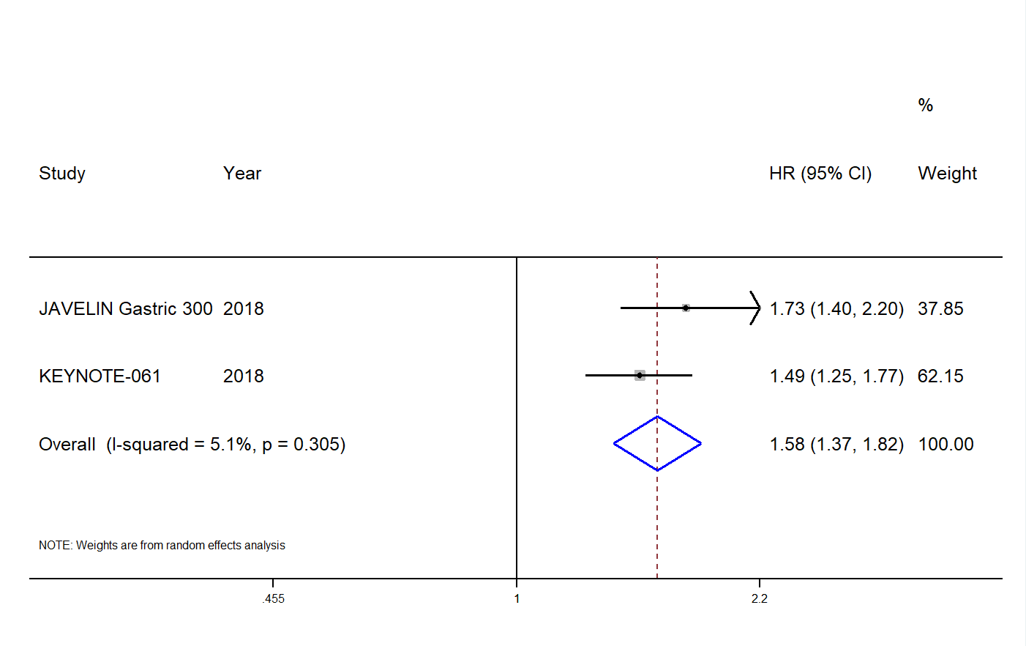
supplementary Fig.3 Forest plot of hazard ratios of overall survival (OS) between PD-1/PD-L1 inhibitors and chemotherapy/placebo in subgroups
(a) OS in the squamous cell carcinoma subgroup
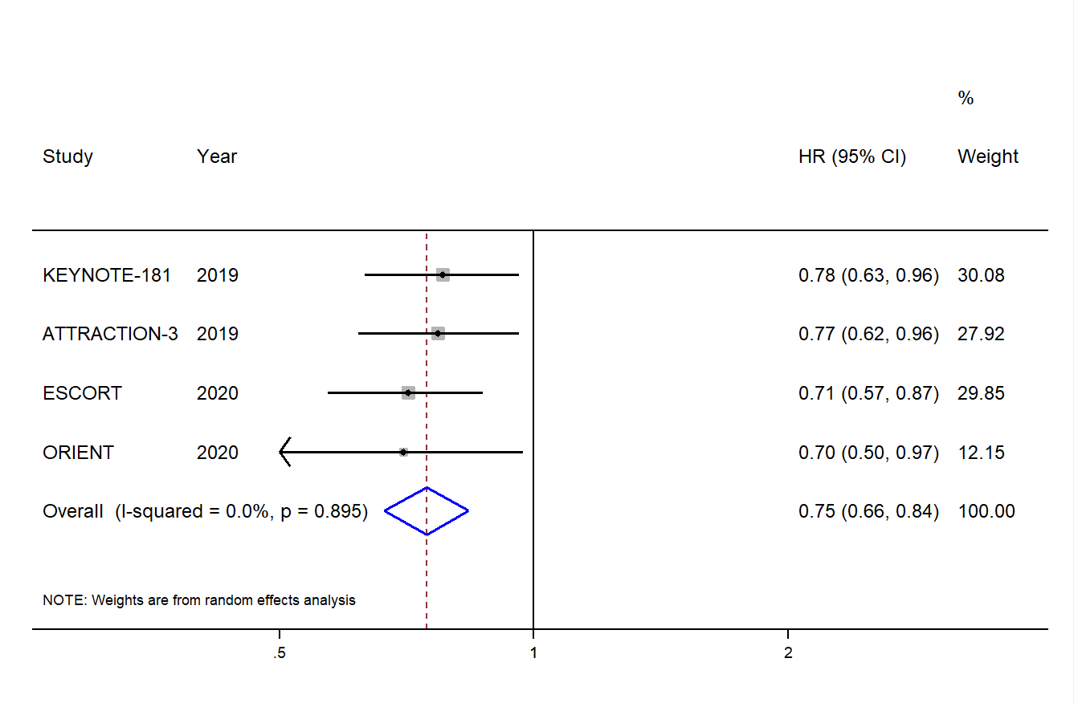
(b) OS in the adenocarcinoma subgroup
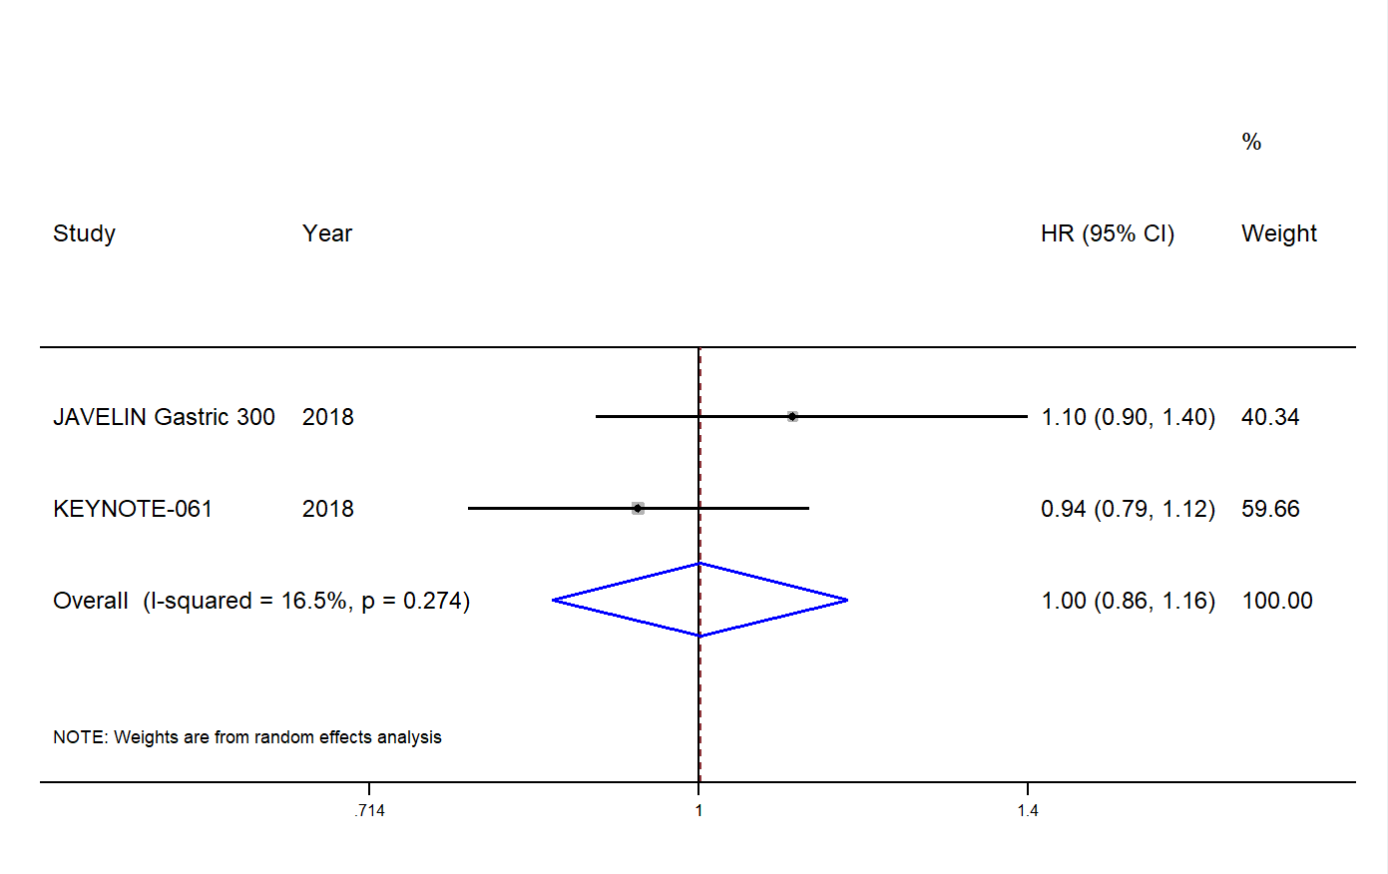

supplementary Table 1 Any grade treatment-related adverse events of the PD-1/PD-L1 inhibitor group vs. the chemotherapy group
TRAEs | No. of studies | No. of patients | RR | Min  95%CI | Max 95%CI | P-value
Fatigue | 5 | 2139 | 0.48 | 0.38 | 0.61 | 0.000
Nausea | 5 | 2406 | 0.19 | 0.10 | 0.34 | 0.000
Diarrhea | 6 | 2587 | 0.30 | 0.17 | 0.54 | 0.000
Anemia | 6 | 2587 | 0.16 | 0.09 | 0.26 | 0.000
Neutrophil count decreased | 6 | 2587 | 0.07 | 0.03 | 0.14 | 0.000
WBC count decreased | 5 | 2017 | 0.08 | 0.04 | 0.18 | 0.000
Bone marrow toxicity | 2 | 629 | 0.05 | 0.01 | 0.40 | 0.004
Hypothyroidism | 4 | 1809 | 7.85 | 4.14 | 14.86 | 0.000
Lung infection | 3 | 1199 | 3.08 | 0.22 | 43.16 | 0.404
Events leading to death | 4 | 1836 | 0.89 | 0.38 | 2.08 | 0.786

supplementary Table 2 Grade 3-5 treatment-related adverse events of the PD-1/PD-L1 inhibitor group vs. the chemotherapy group
TRAEs | No. of studies | No. of patients | RR | Min 95%CI | Max  95%CI | P-value
Fatigue | 5 | 2139 | 0.46 | 0.20 | 1.07 | 0.072
Nausea | 5 | 2406 | 0.17 | 0.05 | 0.59 | 0.005
Diarrhea | 6 | 2587 | 0.31 | 0.15 | 0.66 | 0.002
Anemia | 6 | 2587 | 0.28 | 0.15 | 0.53 | 0.000
Neutrophil count decreased | 5 | 1977 | 0.04 | 0.01 | 0.10 | 0.000
WBC count decreased | 4 | 1407 | 0.03 | 0.01 | 0.11 | 0.000
Bone marrow toxicity | 2 | 629 | 0.08 | 0.01 | 0.60 | 0.014
Hypothyroidism | 4 | 1809 | - | - | - | -
Lung infection | 3 | 1199 | 1.91 | 0.17 | 21.96 | 0.605

