Appendix
A: Pictures showing macroscopic and microscopic study.
A1: the adult shrub of V. auriculifera
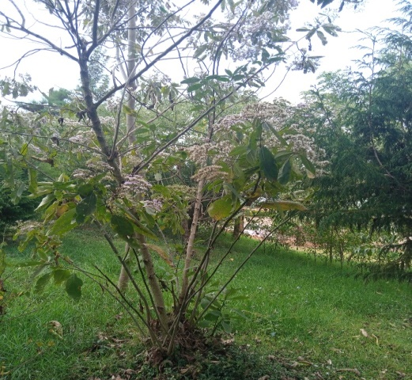
(a)

B: Extraction and phytochemical screening
B1: Maceration (a), Extraction (b), and Crude extracts (c) Hexane extract
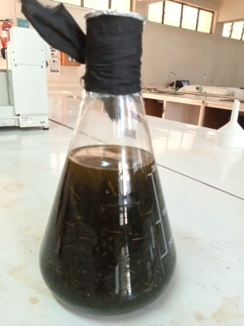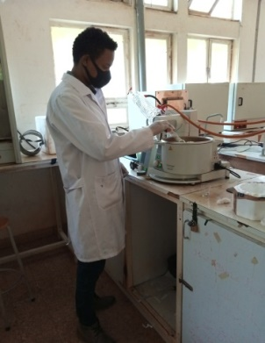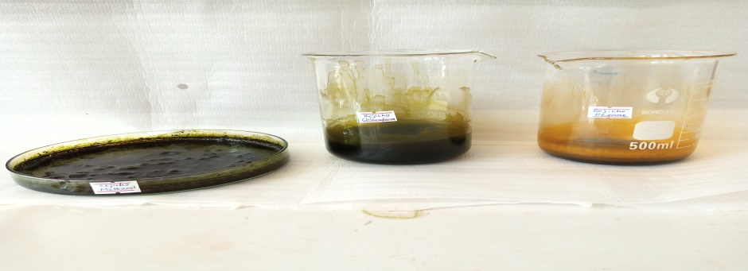
- (b) (c)
B2: phytochemical screening of n-hexane (e), chloroform (f) and methanol (g) extracts
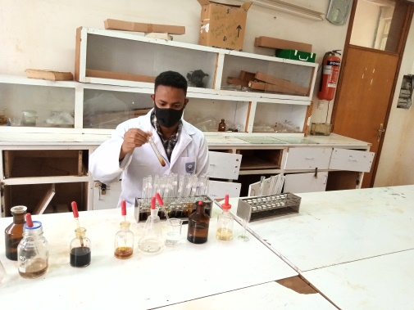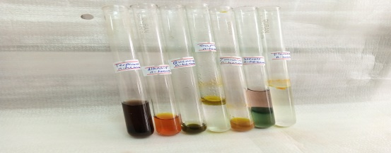
(d) (e)
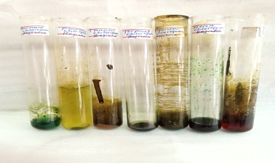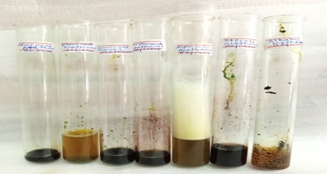
(f) (g)
C: pictures of microorganisms’ growth inhibition and MIC
C1: growth inhibition of E. coli (a), S. typhi(b), S. aureus(c) and C. albican(d)
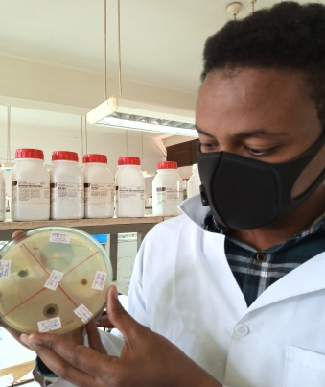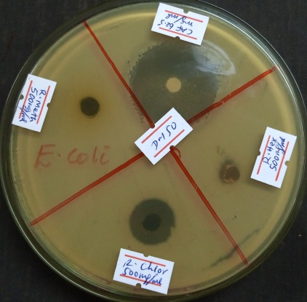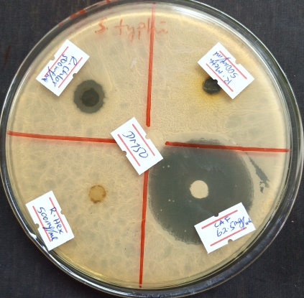
(a) (b)

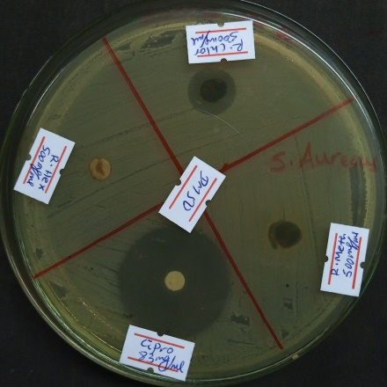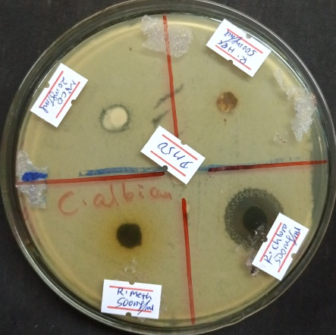
(c) (d)
C2: Minimum inhibitory concentration of three solvent extracts of V. auriculifera
