Supplement
Primer information:
The putative CpG islands of the FKBP5 gene were analyzed in an upstream 5000 bp to the downstream 1000 bp sequence of the TSS using the CpG islands searcher (http://www.ebi.ac.uk/Tools/seqstats/emboss_cpgplot/). The primer was designed by Agena EpiDesigner, and the primers of CpG islands in the promoter of the FKBP5 gene were presented in Figure S1-S2.
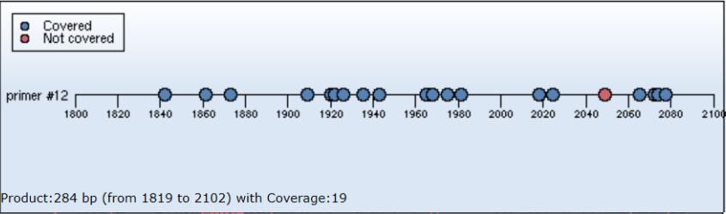
Supplementary Figure 1. The position of the DNA fragment corresponding to primer #12
Note: Each dot in the figure indicated one CpG site: the blue dots indicated covered CpG sites, and the red dot indicated uncovered CpG sites. 19 out of 20 CpG sites in this sequence are detected in our study.

Forward PCR primer:
5’ - aggaagagagGTTGGAGAGGGTTTATTGGGAGT - 3’ (lower case letters indicate T7 primers)
Reverse PCR primer:
5’- cagtaatacgactcactatagggagaaggctCCCCAATTACCTTAACATCAATAAC - 3’ (lower case letters indicate T7 primers)

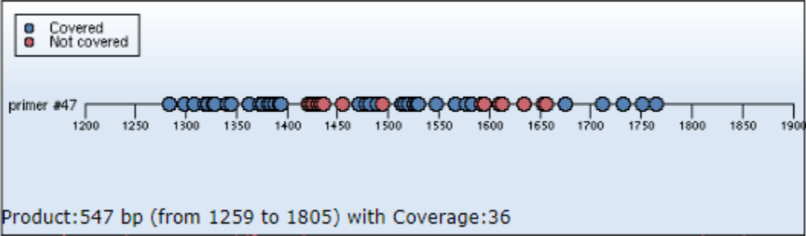
Supplementary Figure 2. The position of the DNA fragment corresponding to primer #47
Note: Each dot in the figure indicated one CpG site: the blue dots indicated covered CpG sites, and the red dot indicated uncovered CpG sites. 36 out of 51 CpG sites in this sequence are detected in our study.

Forward PCR primer:
5’ - aggaagagagGAGATTTTGAGAATTTGGGTTTAG - 3’ (lower case letters indicate T7 primers)
Reverse PCR primer:
5’ - cagtaatacgactcactatagggagaaggctACTTCCCTTACAAAAAACCAAAAAA - 3’
(lower case letters indicate T7 primers)

Table S1. Association of FKBP5 gene CpG sites methylation with depressive symptoms at follow-up.
CpG sites | Total methylation level | Depressive symptoms | Controls | P *
 | (mean ± SD, %) | (mean ± SD, %) | (mean ± SD, %)
FKBP5-12 CpG 1 | 0.77 ± 1.68 | 0.48 ± 0.93 | 0.94 ± 1.98 | 0.019
FKBP5-12 CpG 2 | 3.04 ± 2.37 | 3.05 ± 2.39 | 3.04 ± 2.37 | 0.989
FKBP5-12 CpG 3 | 2.78 ± 3.29 | 2.59 ± 3.47 | 2.89 ± 3.19 | 0.498
FKBP5-12 CpG 4 | 3.08 ± 5.43 | 2.91 ± 5.78 | 3.18 ± 5.22 | 0.725
FKBP5-12 CpG 5.6.7 | 40.58 ± 14.92 | 40.32 ± 15.56 | 40.74 ± 14.57 | 0.838
FKBP5-12 CpG 8 | 5.38 ± 5.49 | 5.57 ± 4.88 | 5.26 ± 5.84 | 0.669
FKBP5-12 CpG 9 | 5.25 ± 5.08 | 4.91 ± 4.75 | 5.45 ± 5.28 | 0.435
FKBP5-12 CpG 10.11 | 3.02 ± 1.26 | 3.09 ± 1.44 | 2.97 ± 1.14 | 0.486
FKBP5-12 CpG 12 | 16.53 ± 13.32 | 17.03 ± 14.07 | 16.22 ± 12.89 | 0.681
FKBP5-12 CpG 13 | 52.83 ± 21.48 | 50.10 ± 21.88 | 54.45 ± 21.16 | 0.138
FKBP5-12 CpG 14 | 3.16 ± 2.69 | 3.16 ± 2.90 | 3.17 ± 2.57 | 0.990
FKBP5-12 CpG 15 | 2.53 ± 3.35 | 2.10 ± 2.80 | 2.78 ± 3.63 | 0.115
FKBP5-12 CpG 17.18.19 | 14.17 ± 9.51 | 13.20 ± 9.02 | 14.75 ± 9.78 | 0.228
FKBP5-47 CpG 1 | 22.40 ± 11.99 | 21.21 ± 13.18 | 23.12 ± 11.19 | 0.245
FKBP5-47 CpG 2.3 | 3.39 ± 4.70 | 3.76 ± 5.21 | 3.16 ± 4.36 | 0.356
FKBP5-47 CpG 4.5.6.7 | 3.46 ± 3.58 | 3.30 ± 3.06 | 3.55 ± 3.86 | 0.616
FKBP5-47 CpG 8.9 | 12.27 ± 11.53 | 10.93 ± 9.64 | 13.12 ± 12.55 | 0.173
FKBP5-47 CpG 10 | 12.32 ± 10.05 | 12.22 ± 10.12 | 12.39 ± 10.05 | 0.911
FKBP5-47 CpG 11.12 | 4.19 ± 8.01 | 4.45 ± 7.91 | 4.06 ± 8.10 | 0.765
FKBP5-47 CpG 13.14.15 | 2.16 ± 3.16 | 1.90 ± 3.05 | 2.31 ± 3.23 | 0.346
FKBP5-47 CpG 16.17 | 3.78 ± 6.93 | 4.00 ± 6.87 | 3.65 ± 6.99 | 0.715
FKBP5-47 CpG 25.26 | 1.95 ± 4.07 | 1.99 ± 3.69 | 1.93 ± 4.31 | 0.928
FKBP5-47 CpG 27 | 3.15 ± 6.02 | 2.88 ± 5.40 | 3.34 ± 6.43 | 0.631
FKBP5-47 CpG 28 | 29.76 ± 26.87 | 26.83 ± 25.29 | 31.82 ± 27.92 | 0.331
FKBP5-47 CpG 30.31.32 | 4.66 ± 5.88 | 4.12 ± 4.08 | 4.99 ± 6.75 | 0.289
FKBP5-47 CpG 33.34.35 | 14.82 ± 6.28 | 13.81 ± 6.41 | 15.43 ± 6.15 | 0.061
FKBP5-47 CpG 36 | 6.67 ± 5.77 | 5.70 ± 4.68 | 7.26 ± 6.28 | 0.034
FKBP5-47 CpG 37 | 2.48 ± 4.38 | 2.19 ± 3.12 | 2.66 ± 5.00 | 0.384
FKBP5-47 CpG 39 | 11.81 ± 16.30 | 12.80 ± 17.90 | 11.14 ± 15.19 | 0.541
* P-values were derived from t-test for depressive symptoms.

