Table 1. Brief description of the 17 Sustainable Development Goals
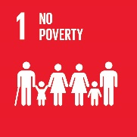 | Defeat poverty. End all forms of poverty in the world by 2030. Enabling people to lift them out of poverty require equal rights, access to economic and natural resources, technological resources, property and basic services. It is also necessary to guarantee all the necessary aid to communities affected by climate-related disasters.
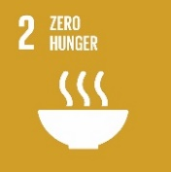 | Eradicating hunger: Ending hunger, achieving food security, improving nutrition and promoting sustainable agriculture.
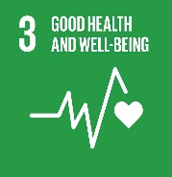 | Good health and well-being. Ensure health and promote well-being for all and at all ages. This objective focuses on different areas of intervention: reducing maternal and child mortality, eradicating epidemics, combating both communicable and chronic diseases by promoting well-being and mental health
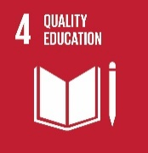 | Quality education. Provide quality, equitable and inclusive education and promote learning opportunities for all.
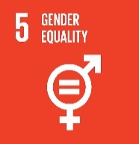 | Gender equality. Eliminate all forms of discrimination and violence for all women, of all ages; equal rights and access to economic, natural and technological resources; full and effective participation and equal leadership opportunities at all levels of political and economic decision-making
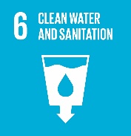 | Clean water and sanitation. Ensure the availability and sustainable management of water and sanitation facilities for all; improve water quality by reducing pollution; increase water efficiency in all sectors; protect and restore water-related ecosystems.
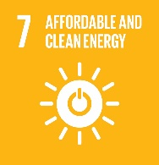 | Clean and affordable energy. Ensuring universal access to economical, reliable, sustainable and modern energy services: it is an objective of great importance to ensure inclusion and equity in the use of energy resources by the population and for the positive effects of an efficient use of energy on economic and social development and in terms of environmental sustainability.
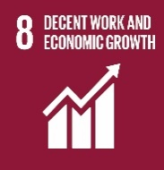 | Good employment and economic growth. Promotion of a new model of economic development that combines economic growth and environmental protection, guarantees equity in the distribution of economic resources, ensuring decent work for all, fair wages and safety conditions in the workplace and eliminating all forms of exploitation.
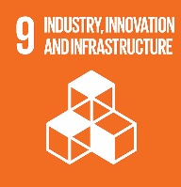 | Innovation and infrastructure. The strengthening of Infrastructure, innovation and industrialization, fundamental drivers of sustainable development, represents a transversal and preparatory objective for the achievement of many other objectives of the 2030 Agenda.
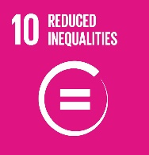 | Reduce inequalities. Reduce income inequality within and between nations, so as to decrease inequality between the richest and poorest.
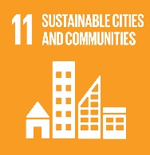 | Sustainable cities and communities. Making cities and human settlements inclusive, safe, resilient and sustainable. The factors to be managed in an integrated way: quality and safety of homes, air pollution, waste management, urban mobility, health and safety of people, access to services, impacts and adaptation to climate change
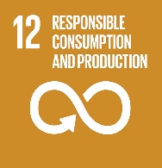 | Responsible consumption and production. "Do more and better with less." Promotion of production/consumption patterns that reduce the ecological footprint of socio-economic systems, combat poverty and improve living standards and economic development.
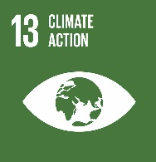 | Fight against climate change. Take urgent measures to combat climate change and its consequences. The fight against climate change is, in fact, a global challenge, which requires the transition to a low-carbon economy.
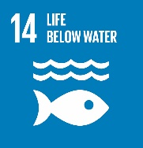 | Aquatic flora and fauna. Conserve and sustainably use the oceans, seas and marine resources for sustainable development. The climate, the availability, of fresh water and food, even the air we breathe are regulated by the sea. The protection of the sea is based on the protection and recovery and restoration of ecosystems, through the contrast of the negative effects caused by climate change, marine pollution from land activities and destructive fishing practices.
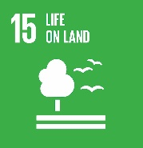 | Terrestrial flora and fauna. Protect, restore, and promote sustainable use of the earth's ecosystem, sustainably manage forests, combat desertification, halt and reverse land degradation and stop the loss of biological biodiversity.
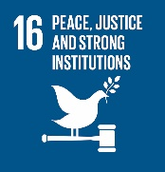 | Peace, justice, and solid institutions. Promote peaceful and inclusive societies for sustainable development, make access to justice available to all and create effective, accountable, and inclusive bodies at all levels.
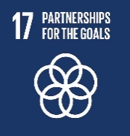 | Partnership for goals. Strengthen the means of implementation and renew the global partnership for sustainable development. Cooperation is the basic prerequisite for the implementation of the agenda: "All countries and all stakeholders, acting in collaborative association, will implement this program", with a particular focus on the least developed and developing countries.

