Supplementary Data
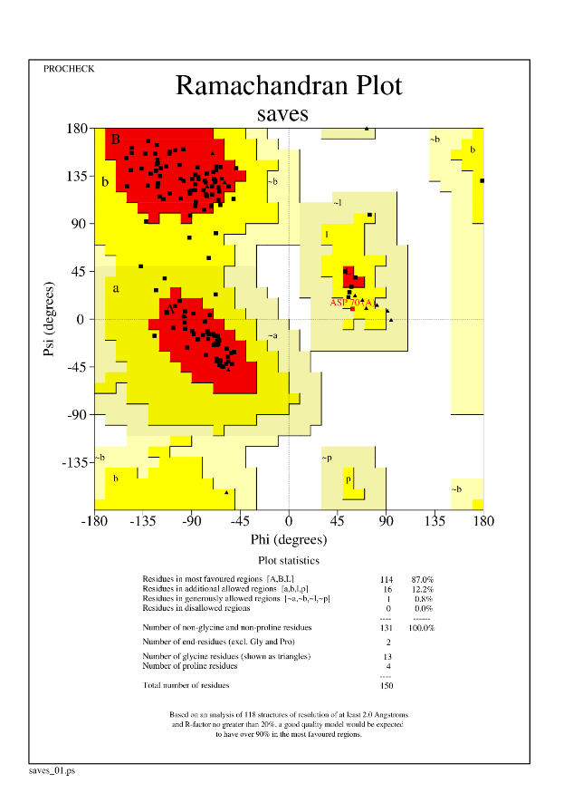
Figure S1:Ramachandran plot for Alphafold2 predicted hNECD model shows around 87% of residues in most favored regions and 12% in additional allowed regions.
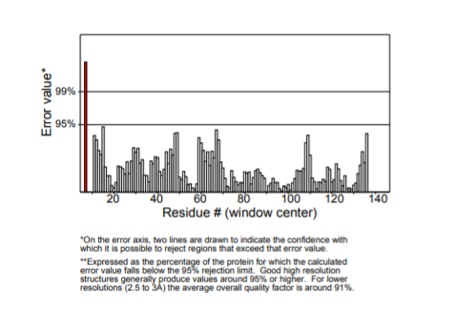
Figure S2: Errat plot for AlphaFold2 hNECD model showing 99% of protein residues falls below the 95% rejection limit.
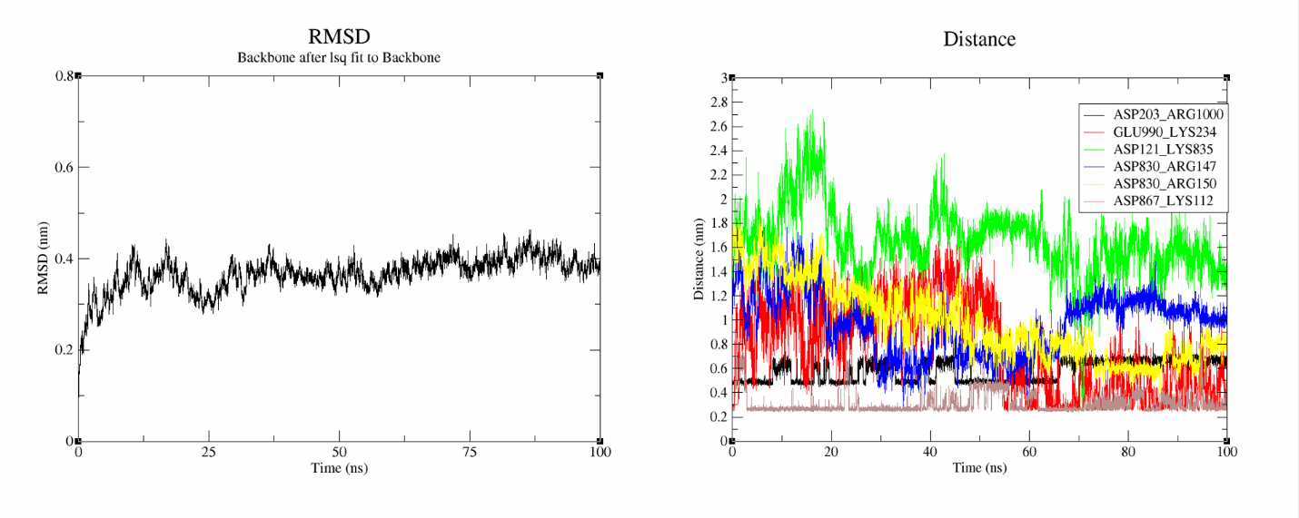
Figure S3: RMSD and distance between salt bridge forming atoms to check stability of hNECD-VS2’ complex.
Supplementary Table 1: List of interaction of hNECD interface residues with VS2’ interface residues in hNECD-VS2’ protein complex obtained through PPCheck protein-protein interaction prediction tool
hNECD residues | Type of Interaction | VS2’ interacting residues
B112LYS | E,E,V,V,V,V,V,V,V,V,V,V,V | A867ASP,A868GLU,A1056ALA,A1057PRO,A1058HIS,A1059GLY,A823PHE,A863PRO,A866THR,A867ASP,A868GLU,A869MET,A871ALA
B113CYS | V,V,V,V,V,V,V,V | A863PRO,A864LEU,A865LEU,A866THR,A867ASP,A868GLU,A869MET,A870ILE
B114SER | V,V,V,V,V,V,V,V | A864LEU,A866THR,A868GLU,A869MET,A870ILE,A871ALA,A872GLN,A873TYR
B115ASN | V,V,V,V,V,V | A864LEU,A865LEU,A866THR,A868GLU,A869MET,A872GLN
B116SER | V,V,V,V,V | A863PRO,A864LEU,A865LEU,A866THR,A869MET
B117GLY | H,V,V,V,V,V,V | A864LEU,A862PRO,A863PRO,A864LEU,A865LEU,A866THR,A869MET
B118ILE | V,V,V,V,V,V | A832GLY,A861LEU,A862PRO,A863PRO,A864LEU,A865LEU
B119GLU | E,V,V,V | A868GLU,A862PRO,A863PRO,A864LEU
B121ASP | V | A834ILE
B126CYS | V | A864LEU
B127ILE | V | A864LEU
B128ASN | V | A864LEU
B129PRO | V,V | A862PRO,A864LEU
B132TRP | V,V,V | A832GLY,A833PHE,A862PRO
B144ASP | V | A833PHE
B146ASN | V,V | A833PHE,A836GLN
B147ARG | E,V,V,V,V | A835LYS,A833PHE,A834ILE,A835LYS,A836GLN
B148CYS | V,V | A833PHE,A836GLN
B149VAL | V,V,V | A833PHE,A836GLN,A837TYR
B150ARG | E,V,V,V,V,V,V,V,V,V,V | A830ASP,A830ASP,A832GLY,A833PHE,A835LYS,A836GLN,A837TYR,A859THR,A860VAL,A861LEU,A862PRO
B151LEU | V,V,V,V,V,V,V,V | A833PHE,A836GLN,A837TYR,A838GLY,A839ASP,A854LYS,A857GLY,A859THR
B152TYR | V,V,V,V,V,V,V,V | A837TYR,A853GLN,A854LYS,A855PHE,A856ASN,A857GLY,A858LEU,A859THR
B153GLY | V,V,V,V,V,V,V,V,V | A837TYR,A841LEU,A853GLN,A854LYS,A855PHE,A856ASN,A857GLY,A858LEU,A859THR
B154PRO | V,V,V,V,V,V,V,V,V,V,V,V,V | A1000ARG,A841LEU,A842GLY,A854LYS,A855PHE,A856ASN,A857GLY,A966LEU,A967SER,A975SER,A976VAL,A977LEU,A978ASN
B155ASN | V,V,V,V,V,V,V,V,V | A1000ARG,A841LEU,A855PHE,A856ASN,A975SER,A976VAL,A977LEU,A978ASN,A979ASP
B156PHE | V,V,V,V,V,V,V,V,V,V | A837TYR,A838GLY,A839ASP,A840CYS,A841LEU,A854LYS,A855PHE,A856ASN,A857GLY,A978ASN
B159GLN | V,V | A837TYR,A859THR
B161TYR | V,V | A833PHE,A861LEU
B166LYS | V,V | A861LEU,A864LEU
B167SER | V | A861LEU
B168TRP | V,V,V,V,V,V | A833PHE,A836GLN,A859THR,A860VAL,A861LEU,A862PRO
B187ASP | V | A836GLN
B188MET | V,V,V | A833PHE,A836GLN,A837TYR
B189GLY | V | A836GLN
B190TYR | V,V,V,V,V,V | A835LYS,A836GLN,A837TYR,A838GLY,A839ASP,A840CYS
B198GLN | V | A978ASN
B199GLY | V,V | A978ASN,A981LEU
B200ILE | V,V,V,V,V,V | A976VAL,A977LEU,A978ASN,A979ASP,A981LEU,A993ILE
B201VAL | V,V,V,V,V,V,V,V | A977LEU,A978ASN,A981LEU,A986LYS,A989ALA,A990GLU,A993ILE,A997ILE
B202ASP | V,V,V,V | A1000ARG,A977LEU,A993ILE,A997ILE
B203ASP | E,V,V,V,V,V,V,V,V | A1000ARG,A1000ARG,A1001LEU,A1004LEU,A977LEU,A993ILE,A996LEU,A997ILE,A998THR
B204SER | V,V,V | A1000ARG,A1001LEU,A997ILE
B205GLY | V,V | A1001LEU,A997ILE
B234LYS | V,V | A986LYS,A990GLU
B238SER | V | A978ASN
B240ARG | V,V,V | A838GLY,A839ASP,A841LEU
B241CYS | V,V,V | A837TYR,A838GLY,A839ASP
B242ILE | V,V,V | A838GLY,A839ASP,A841LEU
B243ALA | V,V | A838GLY,A839ASP

Supplementary Table 2: List of interface residues of hNECD and VS2’ in hNECD-VS2’ complex
hNECD_interface residues | VS2’ interface residues
B112LYS | A823PHE
B113CYS | A830ASP
B114SER | A832GLY
B115ASN | A833PHE
B116SER | A834ILE
B117GLY | A835LYS
B118ILE | A836GLN
B119GLU | A837TYR
B121ASP | A838GLY
B126CYS | A839ASP
B127ILE | A840CYS
B128ASN | A841LEU
B129PRO | A842GLY
B132TRP | A853GLN
B144ASP | A854LYS
B146ASN | A855PHE
B147ARG | A856ASN
B148CYS | A857GLY
B149VAL | A858LEU
B150ARG | A859THR
B151LEU | A860VAL
B152TYR | A861LEU
B153GLY | A862PRO
B154PRO | A863PRO
B155ASN | A864LEU
B156PHE | A865LEU
B159GLN | A866THR
B161TYR | A867ASP
B166LYS | A868GLU
B167SER | A869MET
B168TRP | A870ILE
B187ASP | A871ALA
B188MET | A872GLN
B189GLY | A873TYR
B190TYR | A966LEU
B198GLN | A967SER
B199GLY | A975SER
B200ILE | A976VAL
B201VAL | A977LEU
B202ASP | A978ASN
B203ASP | A979ASP
B204SER | A981LEU
B205GLY | A986LYS
B234LYS | A989ALA
B238SER | A990GLU
B240ARG | A993ILE
B241CYS | A996LEU
B242ILE | A997ILE
B243ALA | A998THR
 | A1000ARG
 | A1001LEU
 | A1004LEU
 | A1056ALA
 | A1057PRO
 | A1058HIS
 | A1059GLY

