Supplemental Information
Quantum Disordered Ground State in the Heisenberg-Kitaev Candidate NaRuO₂
Brenden R. Ortiz, Paul Sarte, Alon Hendler Avidor, Aurland Hay, Eric Kenney, Alexander I. Kolisneikov, Adam A. Aczel, Craig M. Brown, Chennan Wang, M. J. Graf, Ram Seshadri, Leon Balents, Stephen D. Wilson

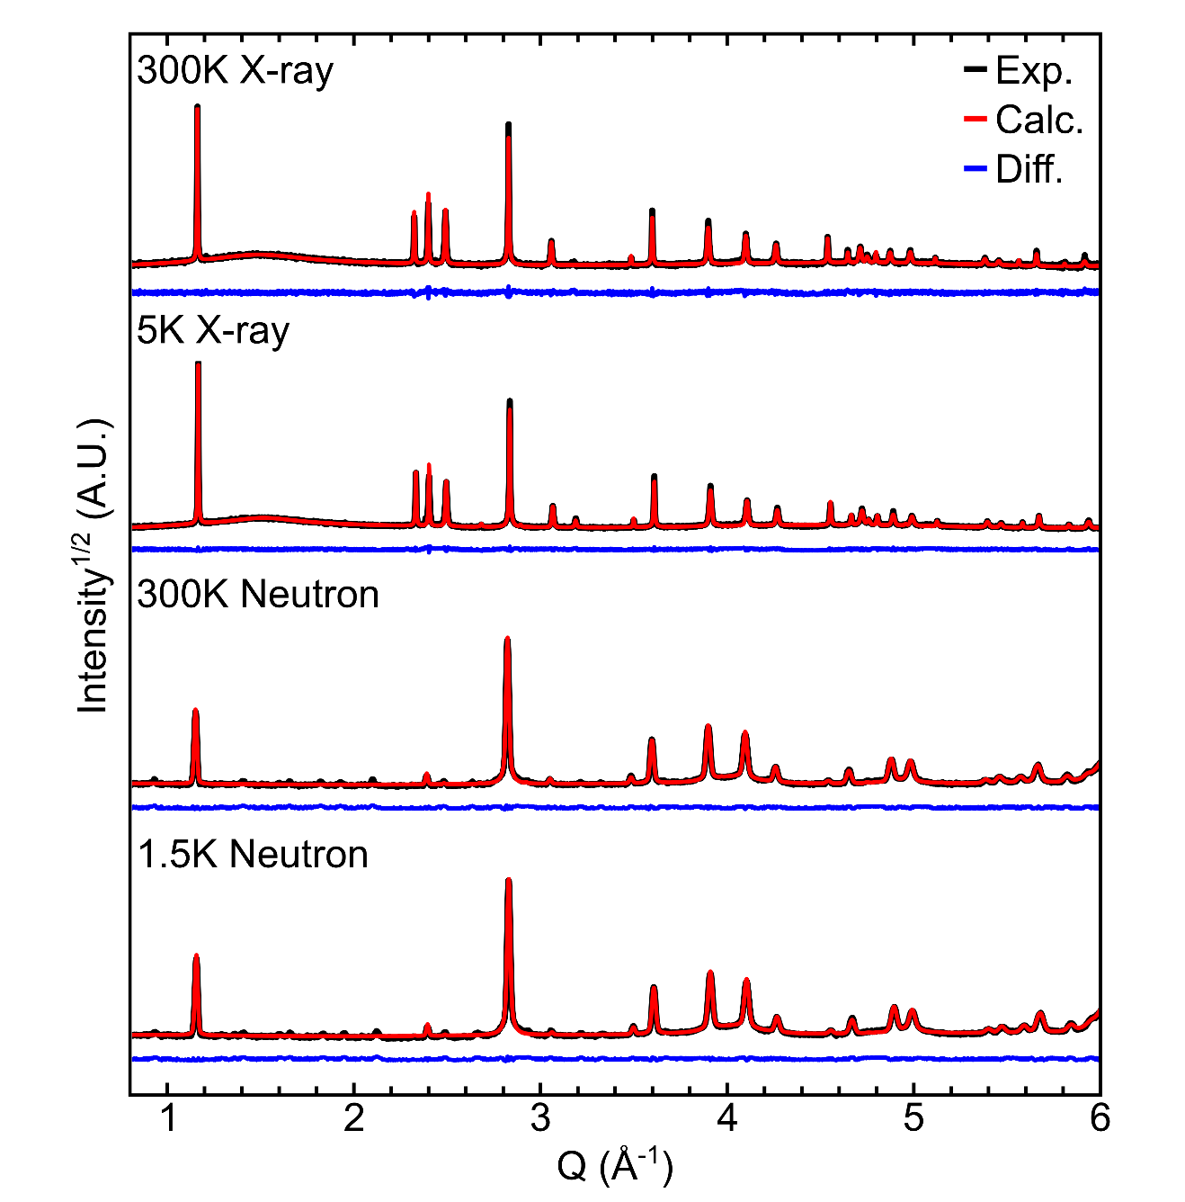
Supplemental Figure 1: X-ray and neutron diffraction data collected at 5 K and 300 K and 1.5 K and 300 K respectively. Red lines show the output of the structural refinement model and blue lines denote the difference between the model and the data. Neutron data were collected on BT-1 at the NIST Center for Neutron Research and synchrotron x-ray data were collected at 11-BM at the Advanced Photon Source.

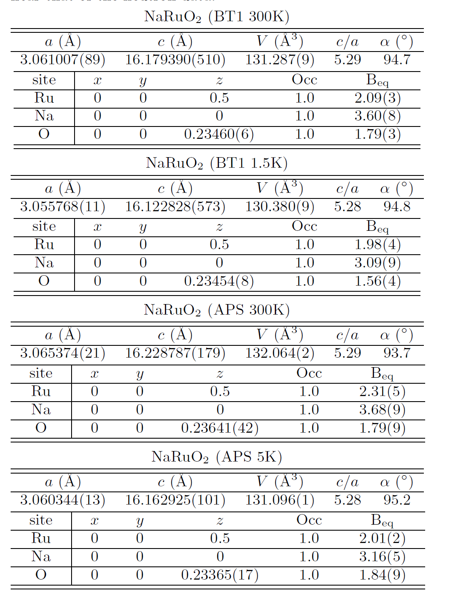
Supplemental Table 1: Crystallographic parameters for NaRuO₂ using both neutron and synchrotron diffraction data. Occupancy values refine to within unity and were fixed for later analysis. For synchrotron data, the B_{eq} for oxygen was constrained near that of the neutron data. Values in parenthesis are one standard deviation.
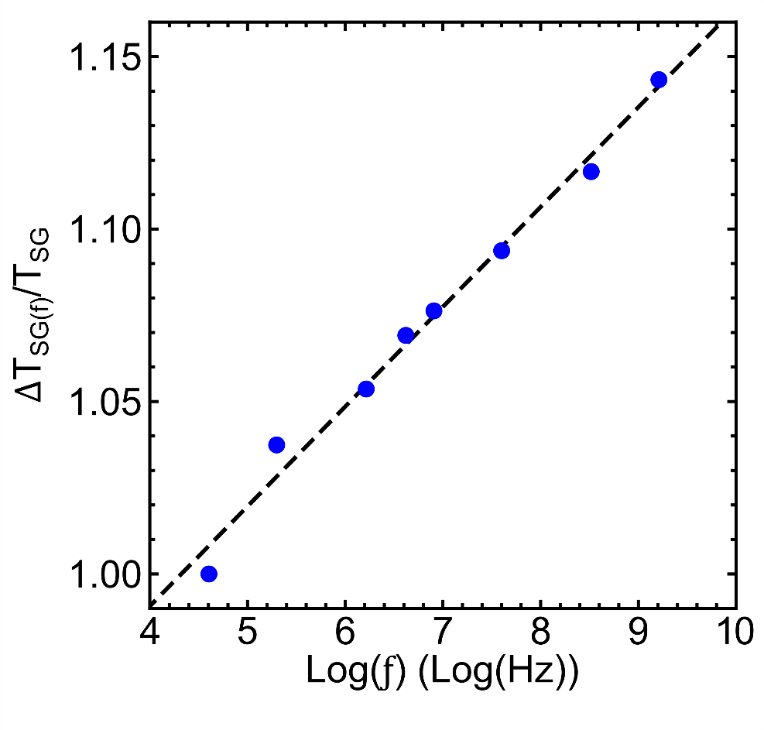
Supplemental Figure 2: Frequency dependence of the low-temperature cusp in the AC susceptibility of NaRuO₂. The resulting Mydosh parameter $K=\frac{ΔT_{f}}{T_{f}log⁡(Δf)}=0.029$ is an unusual intermediate value. It is significantly smaller than that expected for a superparamagnet and significantly larger than that expected for a conventional spin glass.^{1,2,3} This weak freezing represents a small amount of entropy and marks a crossover into a state with persistent spin fluctuations as described in the main text of the manuscript.

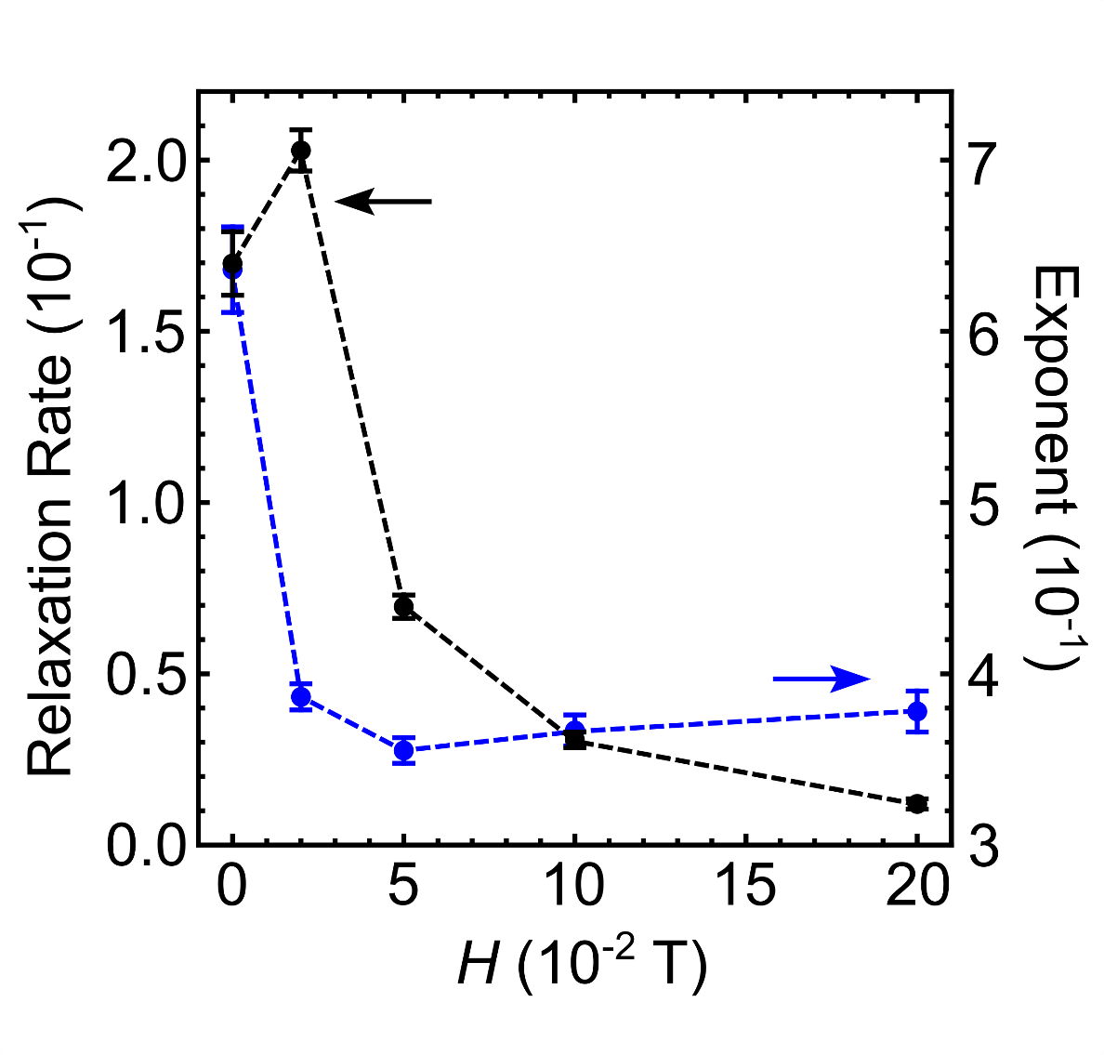
Supplemental Figure 3: Fit parameters resulting from the model of the longitudinal field muon spin polarization data at 1.5 K where the polarization is parameterized by the form $P(t)=GbG\left(Δ;R;t\right)e^{{{(-λ}_{GbG}t)}^{β}}$ . The relaxation rate λ_{GBG} (left axis) and stretched exponent β (right axis) are plotted as a function of the applied longitudinal magnetic field. Error bars represent one standard deviation.

References:
[1] H D Zhou, C R Wiebe, A Harter, N S Dalal, and J S Gardner “Unconventional spin glass behavior in the cubic pyrochlore Mn2Sb2O7” J. Phys.: Condens. Matter 20, 325201 (2008).
[2] Johannes Kroder,a) Johannes Gooth, Walter Schnelle, Gerhard H. Fecher, and Claudia Felser “Observation of spin glass behavior in chiral Mn₄₈Fe₃₄Si₁₈ with a β-Mn related structure” AIP Advances 9, 055327 (2019).
[3] J. A. Mydosh Spin Glasses: An Experimental Introduction (1993).

