Supporting Information

High dielectric 3D scaffold to suppress Li-dendrites and increase the reversibility of Li-metal anodes
Chao Wang¹, Ming Liu¹, Michel Thijs², Frans G.B. Ooms¹, Swapna Ganapathy¹ and Marnix Wagemaker^{1*}
¹ Section Storage of Electrochemical Energy, Radiation Science and Technology, Faculty of Applied Sciences, Delft University of Technology. E-mail: m.wagemaker@tudelft.nl
² Neutron & Positron Methods for Materials, Radiation Science and Technology,
Faculty of Applied Sciences, Delft University of Technology.

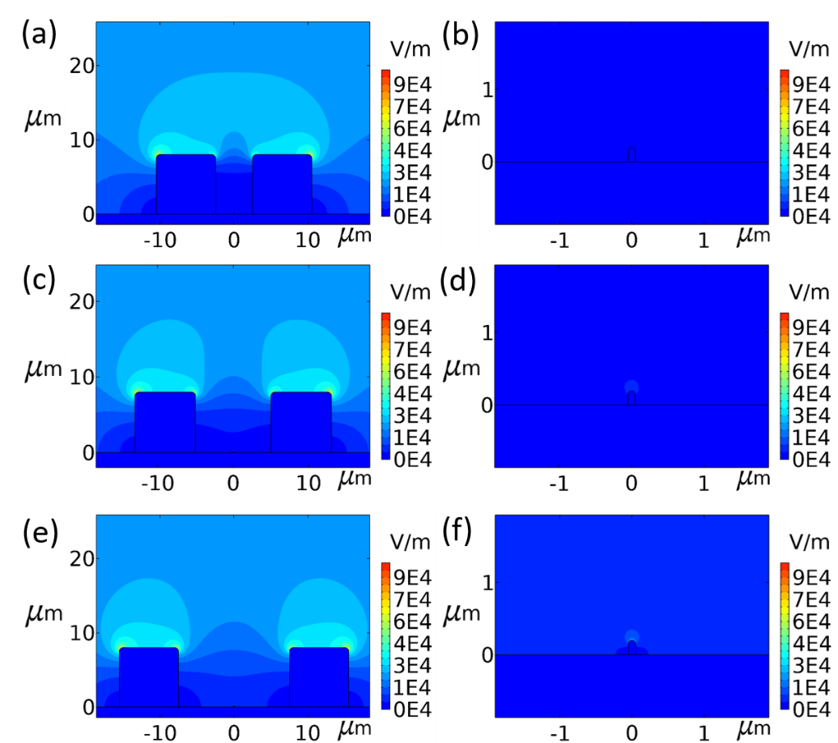
Figure S1 Schematic diagram of the electric field distribution of BaTiO₃ (BTO) coated Cu with different block gaps. (a, b) with distance of 5 μm between blocks and zoomed-in figure, (c, d) with distance of 10 μm between blocks and zoomed-in figure, (e, f) with distance of 15 μm between blocks and zoomed-in figure.

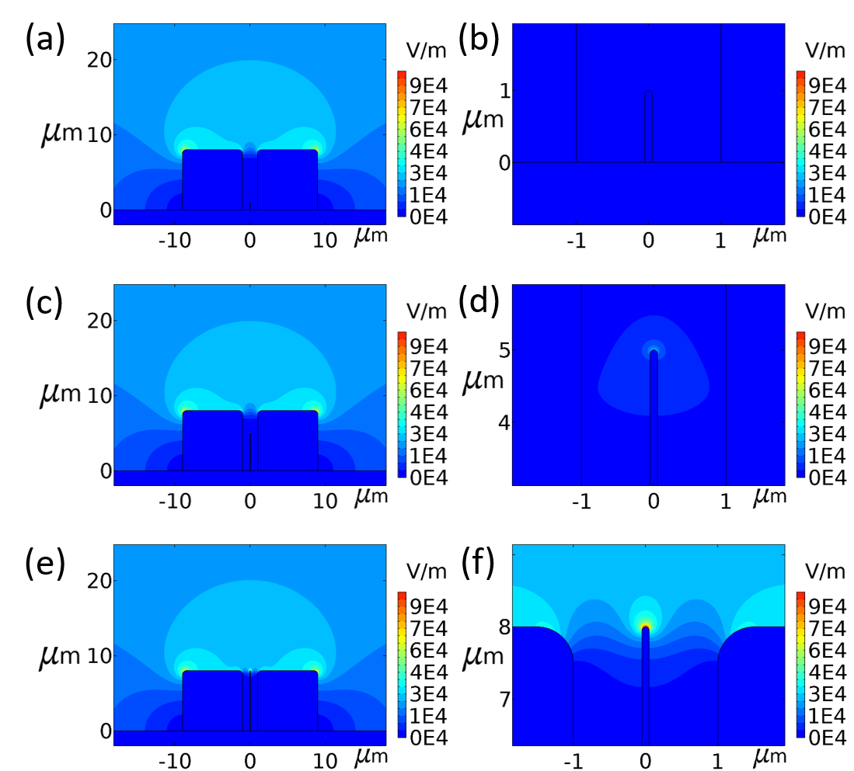
Figure S2 Schematic diagram of the electric field distribution of BaTiO₃ (BTO) coated Cu with different dendrite length. (a, b) with a dendrite length of 1 μm and zoomed-in figure, (c, d) with a dendrite length of 5 μm and zoomed-in figure, (e, f) with a dendrite length of 8 μm and zoomed-in figure.

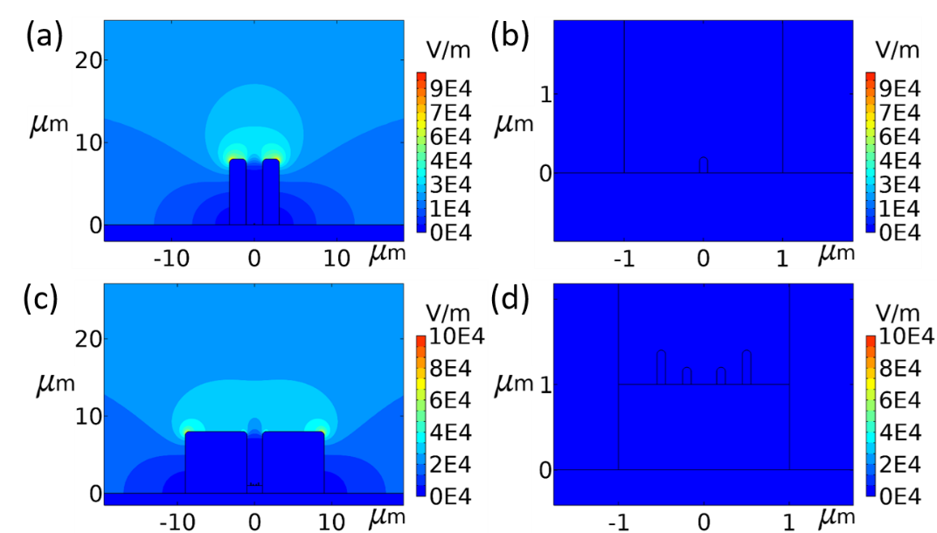
Figure S3 Schematic diagram of the electric field distribution of BaTiO₃ (BTO) coated Cu (a, b) with a block width of 2 μm and zoomed-in figure, (c, d) with multiple dendrites and zoomed-in figure.

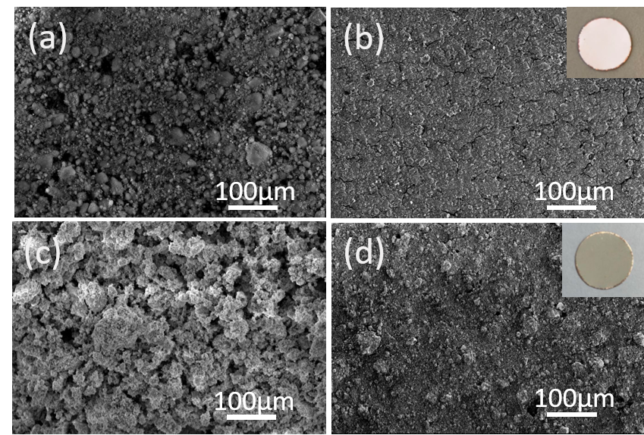
Figure S4 ball-milled starting materials and their coatings on copper. (a, b) AO and AO coated on Cu,(c, d) BTO and BTO coated on Cu. Insets are the digital image of the electrode.
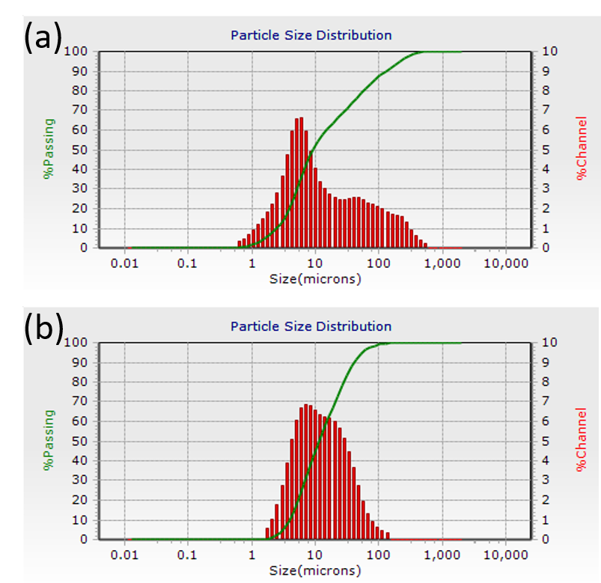
Figure S5 Particle size distribution of (a) BTO and (b) AO as obtained using the Dynamic Light Scattering technique.

Figure S6 Nitrogen adsorption/desorption isotherms at 77 K of BTO and AO materials.
Figure S7 Static ⁷Li NMR spectrum measured with a wide spectral window of a fresh BTO-LCO battery.

Figure S8 Cyclic voltammetry performance of different electrodes with a scan rate of 1mV s^{‑1} in the range of -0.5 V to 3 V.
Figure S9 XRD patterns of BTO raw material and BTO electrodes before and after 1st and 100th cycles.

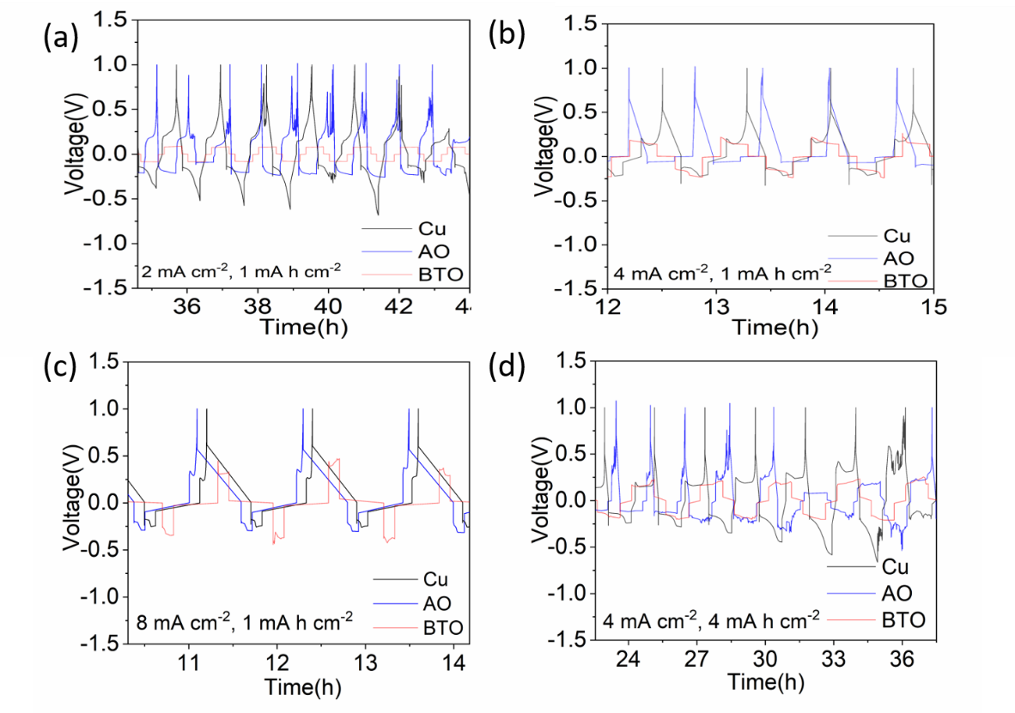
Figure S10 Detailed voltage profiles of the anode-less Cu, AO and BTO scaffolds vs a Li-metal anode. Evolution of the voltage during Li plating/stripping for the bare Cu and the AO and BTO scaffolds at different current densities (a) 2 mA cm⁻², (b) 4 mA cm⁻², (c) 8 mA cm⁻² with a fixed areal capacity of 1 mA h cm⁻², and (d) an increased areal capacity of 4 mA h cm⁻² at a current density of 4 mA cm⁻².

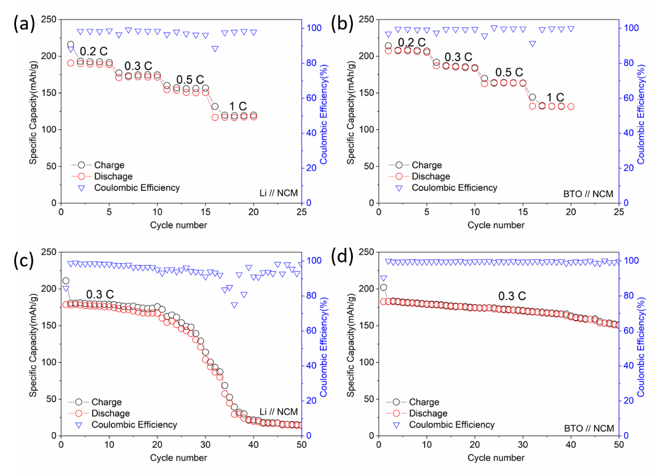
Figure S11 Cycling performances and coulombic efficiency of Li-metal and BTO scaffold when paired with NCM cathode.(a,b) Rate test from 0.2 C to 1 C. (c,d) Cycling test at 0.3 C.

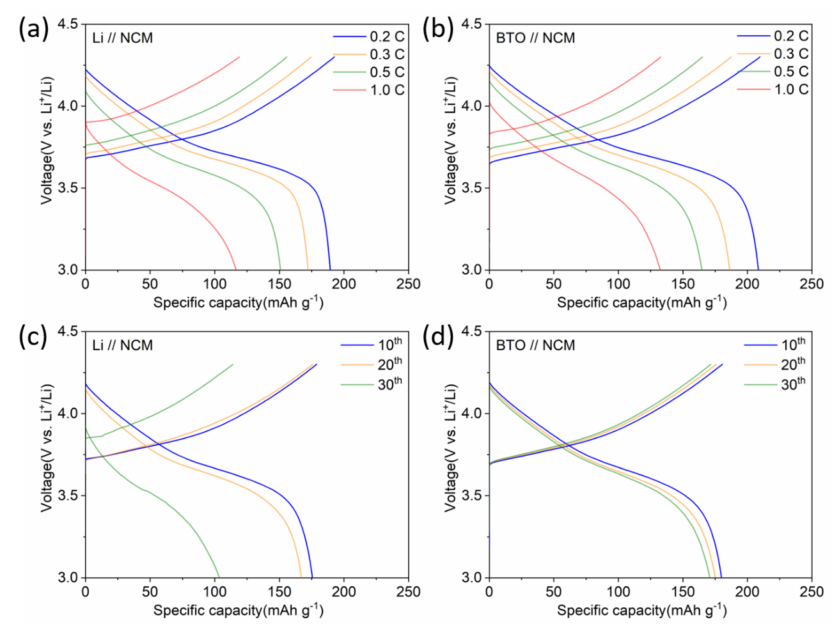
Figure S12 Voltage profiles of Li-metal and BTO scaffold when paired with NCM cathode.(a,b) Voltage profiles when cycled with different current densities. (c,d) Voltage profiles of different cycles when cycled at 0.3 C.

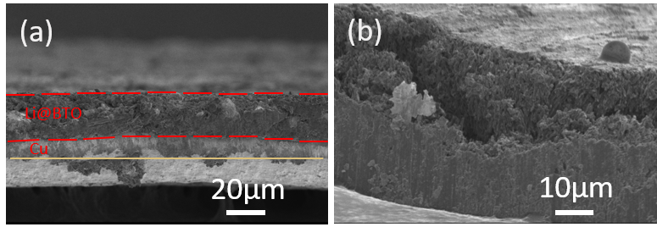
Figure S13 Cross-section of BTO (a) and Cu (b) electrode after depositing 1 mA h cm⁻² Li-metal at a current density of 2 mA cm⁻².

