Supplementary Information

Weaving a story: narrative formation over prolonged time scales relies on cortical cohesiveness of distributed brain networks
Amir Assouline & Avi Mendelsohn

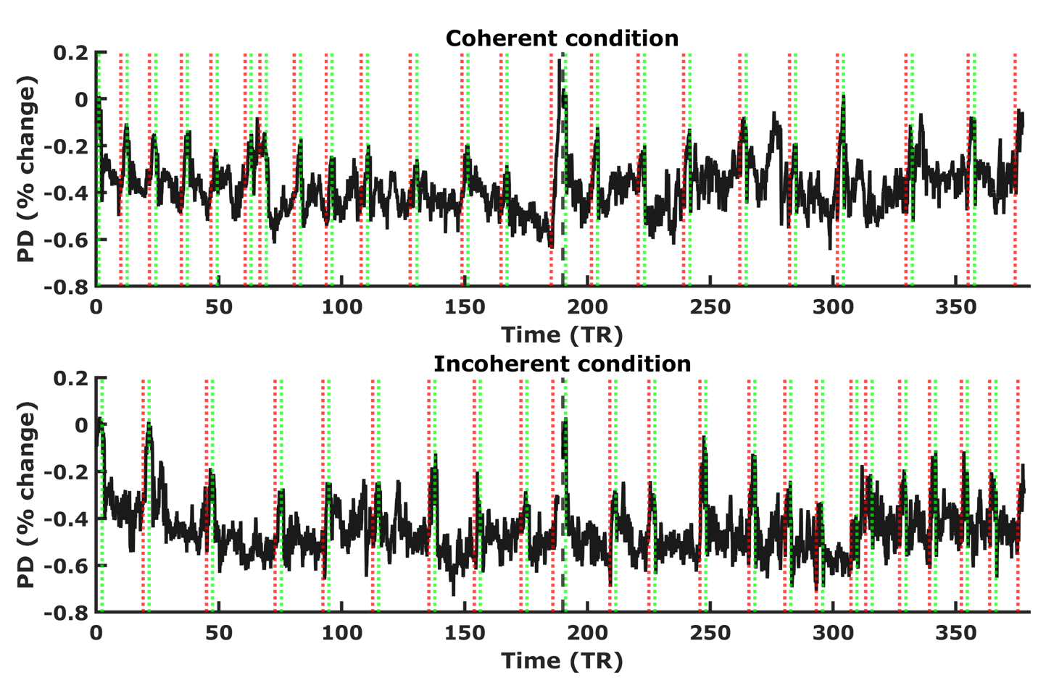
Figure S1. Mean pupil dilation percent change for the coherent (top panel) and incoherent (bottom panel) groups. Pupil size is shown in relation to a 500ms baseline at the beginning of each fMRI run. Dotted lines indicate scene onsets (green) and offsets (red). The black dashed line in the middle indicates the break between the two fMRI runs. Note that scene onsets are characterized by decreases in pupil dilation due to increased brightness of the presented stimuli. PD: pupil dilation, TR: time to repeat (repetition time).

