Table 1
Characteristics of each group.
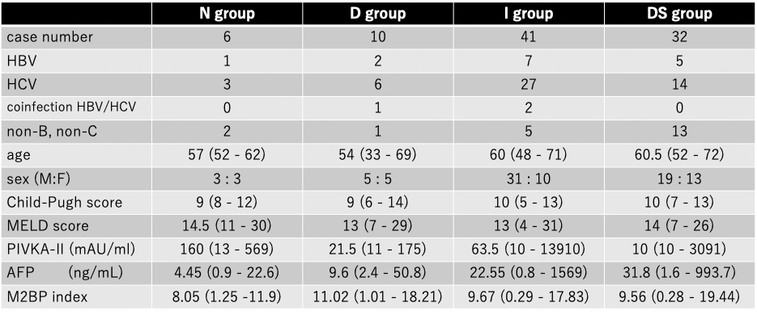
HBV, hepatitis B virus; HCV, hepatitis C virus; MELD score, a model for end-stage liver disease score; PIVKA-II, protein induced by vitamin K absence or antagonists-II, AFP: α-fetoprotein

