Supplementary Information
High-Temperature Flexible WSe₂ Photodetectors with Ultrahigh Photoresponsivity

Yixuan Zou¹, Zekun Zhang¹, Jiawen Yan¹, Linhan Lin¹, Guanyao Huang², Peng Li*¹
¹State Key Laboratory of Precision Measurement Technology and Instruments, Department of Precision Instruments, Tsinghua University, Beijing 100084, China.
²Key Laboratory for Thermal Science and Power Engineering of Ministry of Education, Beijing Key Laboratory of CO₂ Utilization and Reduction Technology, Department of Energy and Power Engineering, Tsinghua University, Beijing 100084, China.

Figure S1. Optical images of step-by-step transfer process of the stacked van der Waals heterostructures.
Figure S2. High Resolution Transmission electron microscope (HRTEM) images of the stacked structure and elemental analysis results of different areas.
Figure S3. Atomic force microscope (AFM) topographic image and height-position curve of h-BN.
Figure S4. Raman spectra of h-BN and graphene.
Figure S5. Optical images of WSe₂ FET before and after 700 ℃/750 ℃ burning in air.
Figure S6. Thermal stability of bare WSe₂ and WSe₂ covered with 100 nm Al₂O₃.
Figure S7. WSe₂ FET before and after 1000 ℃ burning in vacuum.
Figure S8. Atomic force microscope (AFM) images of HOPG ((highly oriented pyrolytic graphite), graphene, and Pt electrode.
Figure S9. Comparison of graphene and Pt as bottom encapsulation layer.
Figure S10. Photoluminescence spectroscopy image of WSe₂ in heat resistant structure from 150 ℃ to 500 ℃.
Figure S11. I_{ds}-V_{gs} curves (V_{ds}=0.8V) measured at room temperature before and after burning 15 min at 500 °C in air.
Figure S12. Conducting properties of graphene electrode at high-temperature.
Figure S13. Photo responsivity of WSe₂ device with mica encapsulation under 385 nm (purple), 440 nm (blue), and 520 nm (green) illumination at different temperatures (V_{ds}=0.4 V, V_{g}=0 V).
Figure S14. The I_{ds}-V_{ds} curves of bare WSe₂ with graphene electrodes (without top h-BN) under different light intensity and temperature.
Figure S15. The I_{ds}-V_{ds} curves of bare WSe₂ with Pt electrodes (without top h-BN) under different light intensity and temperature.
Figure S16. The I_{ds}-V_{ds} curves of WSe₂ with Pt electrodes and h-BN encapsulation (without top gate) under different light intensity and temperature.
Figure S17. Negative photoconductivity phenomenon at 400 ℃ and 500 ℃ under 0.2 W/m² 365 nm light illumination.

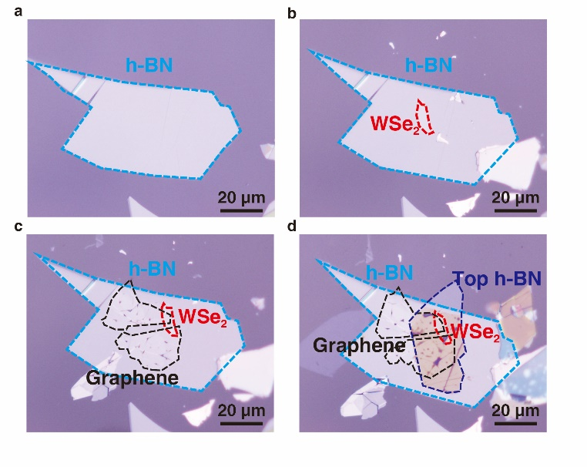
Figure S1. Optical images of step-by-step transfer process of the stacked van der Waals heterostructures. a, Transfer of the bottom h-BN. b, Transfer of the WSe₂. c, Transfer of the two graphene electrodes. d, Transfer of the top h-BN.

We exfoliated the mica sheet to about 100 μm thick to obtain clean, flat and flexible substrate. We cleaned the substrate using an ultrasonic cleaner to remove possible residues from the substrate surface. Then, mechanically exfoliated h-BN, WSe₂ and two pieces of graphene as electrodes were transferred to the substrate step by step, as shown in (a), (b), (c). Another h-BN was transferred to form fully encapsulation, as shown in (d).

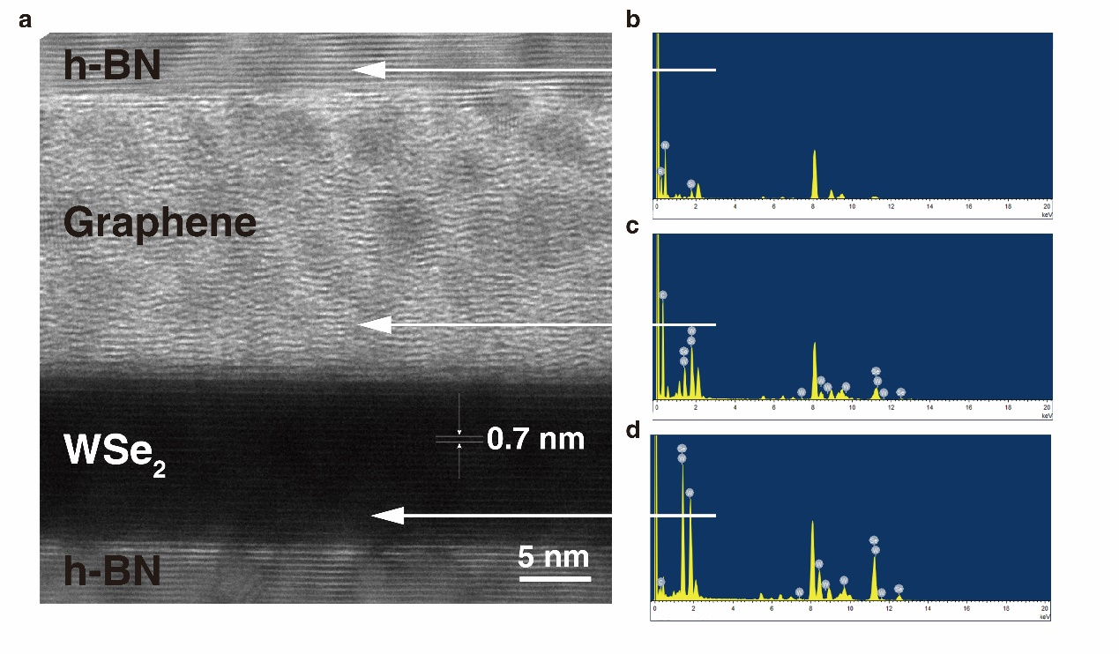
Figure S2. High Resolution Transmission electron microscope (HRTEM) images of the stacked structure and elemental analysis results of different areas. a, HRTEM image of the stacked structure. Clear lattice structure can be seen in the image, indicating excellent material quality. b, c, d are elemental analysis results of h-BN, graphene, WSe₂, respectively. According to the results of element analysis, we can well determine the type of material in each area.

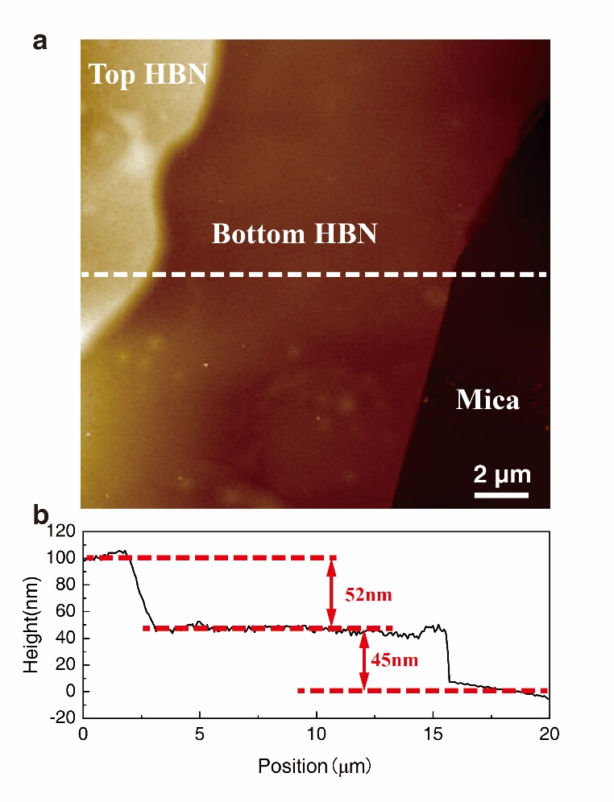
Figure S3. Atomic force microscope (AFM) topographic image and height-position curve of h-BN. a, AFM topographic image of bottom and top h-BN. b, Height-position curve along the dotted line in (a). The thickness of top h-BN is 52 nm and the bottom h-BN is 45 nm. Generally, 40-60 nm thick h-BN were preferred to be chosen considering both the thermal protection and gate dielectric isolation.

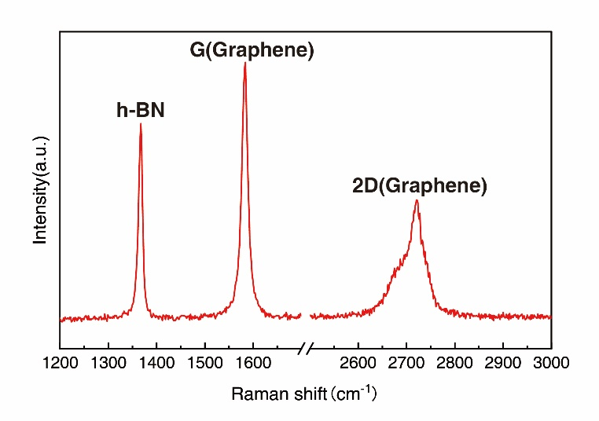
Figure S4. Raman spectra of h-BN and graphene. Three peaks at 1375 cm⁻¹, 1580 cm⁻¹ and 2720 cm⁻¹ corresponded to the h-BN, G peak and 2D band of graphene, respectively. The sharp peaks indicate that the materials are of high quality and have no major defects.

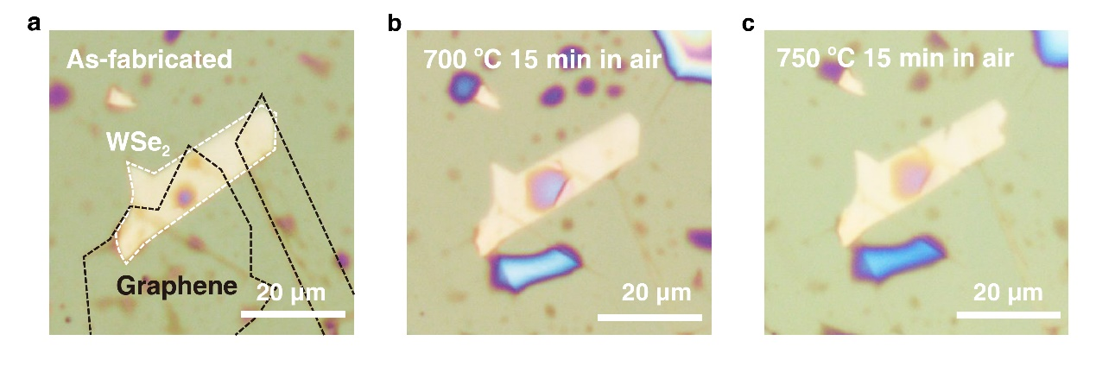
Figure S5. Optical images of WSe₂ FET before and after 700 ℃/750 ℃ burning. a, As-fabricated WSe₂ FET with h-BN encapsulation and graphene electrodes. b, WSe₂ FET after 700 ℃ heating for 15 min in air. No significant change of WSe₂ was observed. c, WSe₂ FET after 750 ℃ heating for 15 min in air. WSe₂ showed only very small defects at the edge.

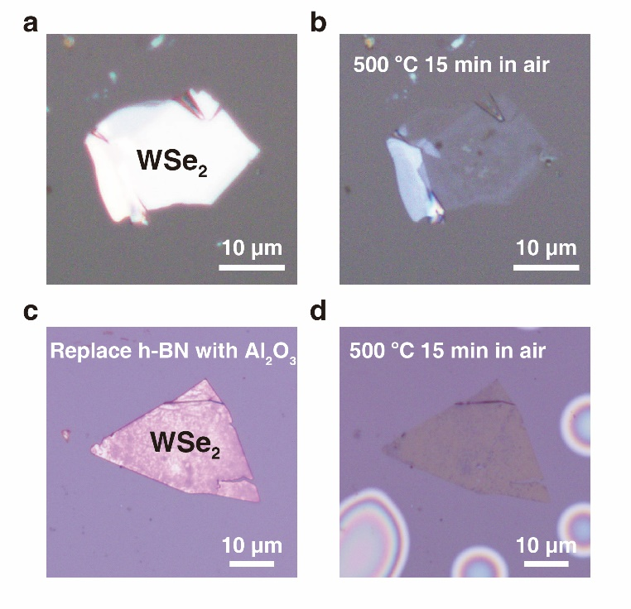
Figure S6. Thermal stability of bare WSe₂ and WSe₂ covered with 100 nm Al₂O₃. a, Optical image of exfoliated WSe₂ on mica substrate. b, Optical image of the same WSe₂ after 500 ℃ burning for 15 min in air. The WSe₂ flake was strongly oxidized and became nearly transparent inasmuch as WO₃ is transparent under visible light. c, Optical image of exfoliated WSe₂ on mica substrate covered with 100 nm Al₂O₃. d, Optical image of the WSe₂ covered with 100 nm Al₂O₃ after 500 ℃ burning for 15 min in air. The WSe₂ flakes were strongly oxidized and became nearly transparent.

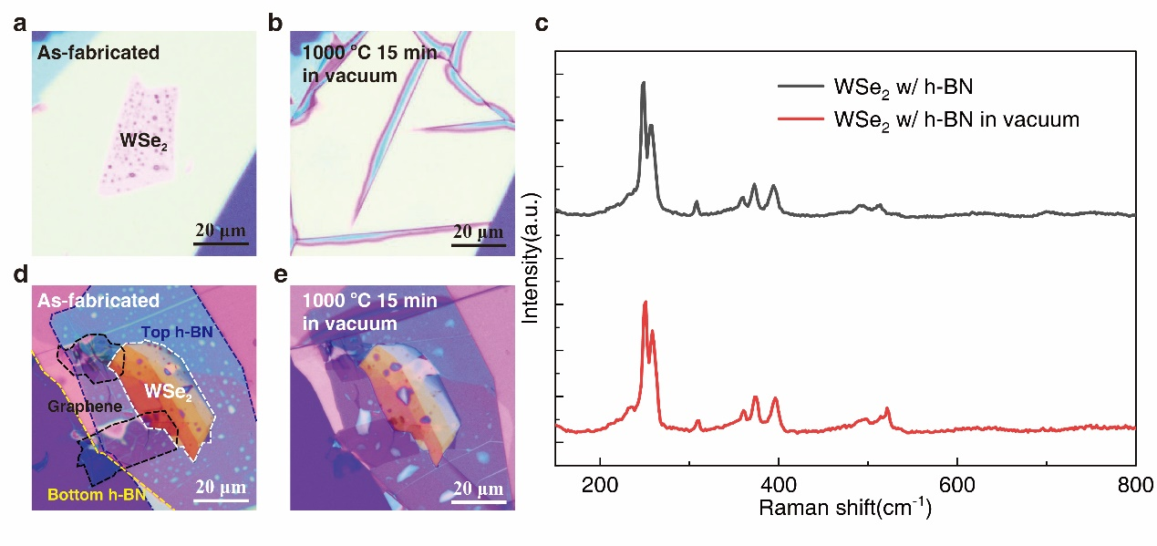
Figure S7. WSe₂ FET before and after 1000 ℃ burning in vacuum. a, Bare WSe₂ before 1000 ℃ burning. b, The WSe₂ is vanished after 1000℃ burning. c, Raman spectrum of WSe₂ after 1000℃ burning in vacuum. d, WSe₂ FET before 1000℃ burning. e, WSe₂ FET after 1000℃ burning in vacuum.

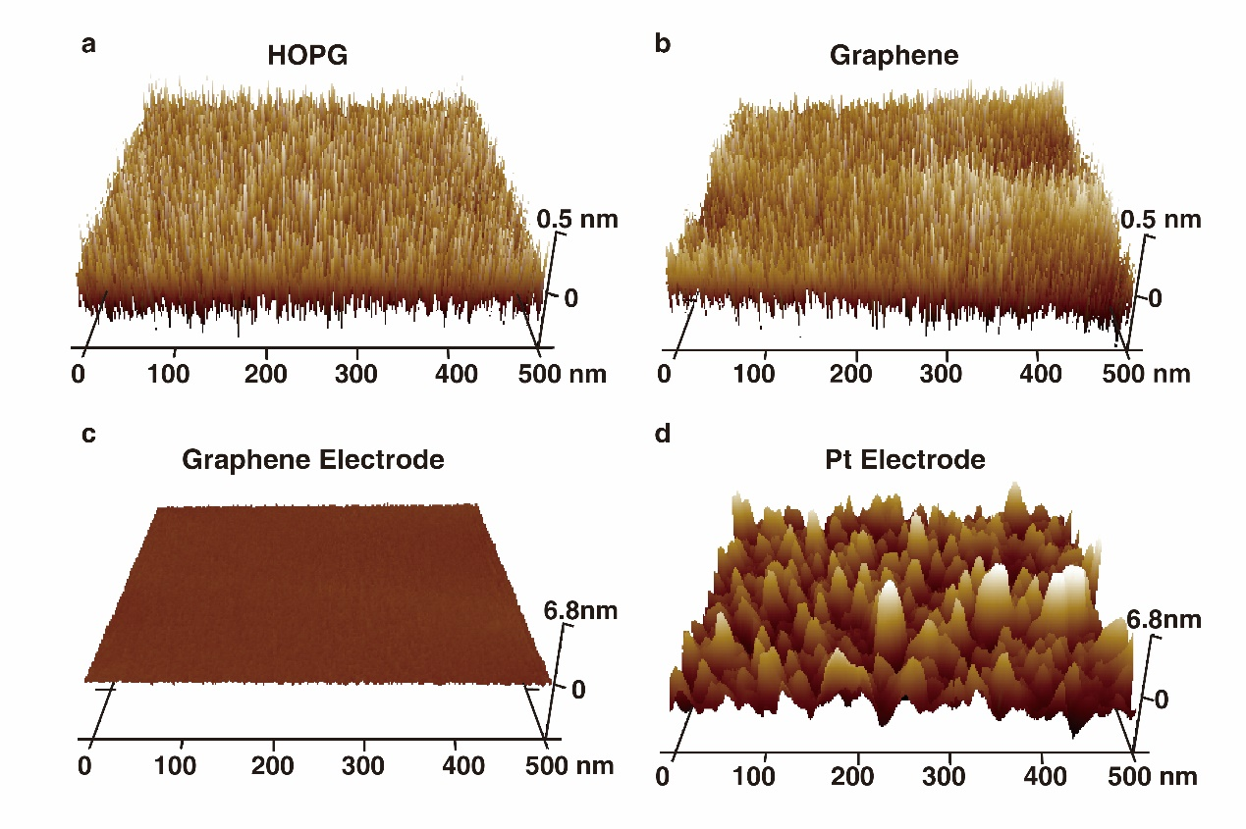
Figure S8. Atomic force microscope (AFM) images of HOPG ((highly oriented pyrolytic graphite), graphene, and Pt electrode. (a) AFM image of HOPG. (b), (c) AFM image of exfoliated graphene on h-BN in different Z direction scales. (d) AFM image of Pt electrode.

HOPG is reported to have atomic flat surface. The height variation of HOPG surface is ~0.5 nm and exfoliated graphene is ~0.6 nm, indicating that exfoliated graphene has a surface flatness close to that of HOPG. The height variation of Pt electrode is ~6.8 nm, much larger than that of graphene electrode (~0.6 nm). Instrument noise affected the measurement by approximately 0.4 nm, indicating that the height variation of graphene was mainly limited by instrument noise. The result demonstrated that exfoliated graphene had a much flatter surface than Pt electrodes. Consequently, good encapsulation can be formed between h-BN and graphene.

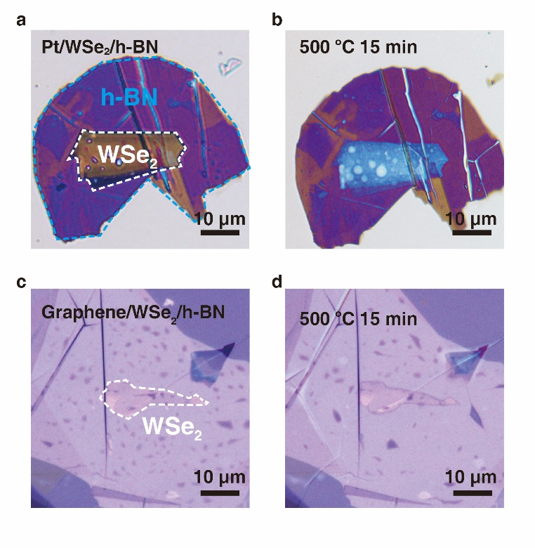
Figure S9. Comparison of graphene and Pt as bottom encapsulation layer. a, Optical images of Pt/WSe₂/h-BN structure using 30 nm thick Pt as bottom layer. b, Optical images of Pt/WSe₂/h-BN structure after burning 15 min at 500 °C. c, Optical images of graphene/WSe₂/h-BN structure using exfoliated graphene as bottom layer. d, Optical images of graphene/WSe₂/h-BN structure after burning 15 min at 500 °C.

The Pt/WSe₂/h-BN structure device using 30 nm thick Pt as bottom layer shown in (a). Mechanically exfoliated WSe₂ and h-BN were transferred to the Pt electrode sequentially. WSe₂ was heavily oxidized after burning 15 min at 500 °C, indicating the poor oxidation protection of Pt/WSe₂/h-BN structure, as shown in (b). Then we tested graphene/WSe₂/h-BN structure using exfoliated graphene as bottom layer in same experimental condition. Contrary to former structure, WSe₂ was well protected after burning 15 min at 500 °C, as shown in (d). The results demonstrated that graphene/WSe₂/h-BN structure is the better way to prevent WSe₂ from oxidation in high temperature.

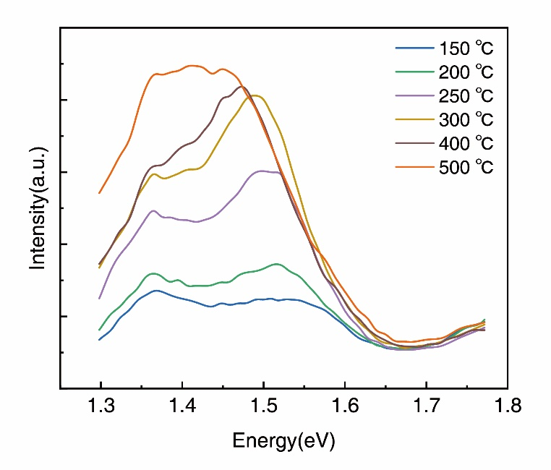
Figure S10. Photoluminescence spectroscopy image of WSe₂ in heat resistant structure from 150 ℃ to 500 ℃. The leftward shift of the PL peak with increasing temperature indicated a decreasing energy bandgap of WSe₂.

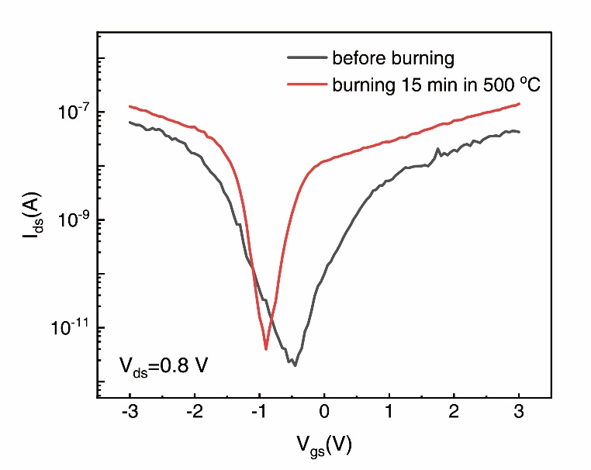
Figure S11. I_{ds}-V_{gs} curves (V_{ds}=0.8V) measured at room temperature before and after burning 15 min at 500 °C in air.

Both p-type and n-type currents were enhanced after burning at 500 °C in air, which may be due to improved contact by high temperature heating. The results further proved that heating at 500 °C will not cause significant damage to our devices, even improving the performance of the device as a result.

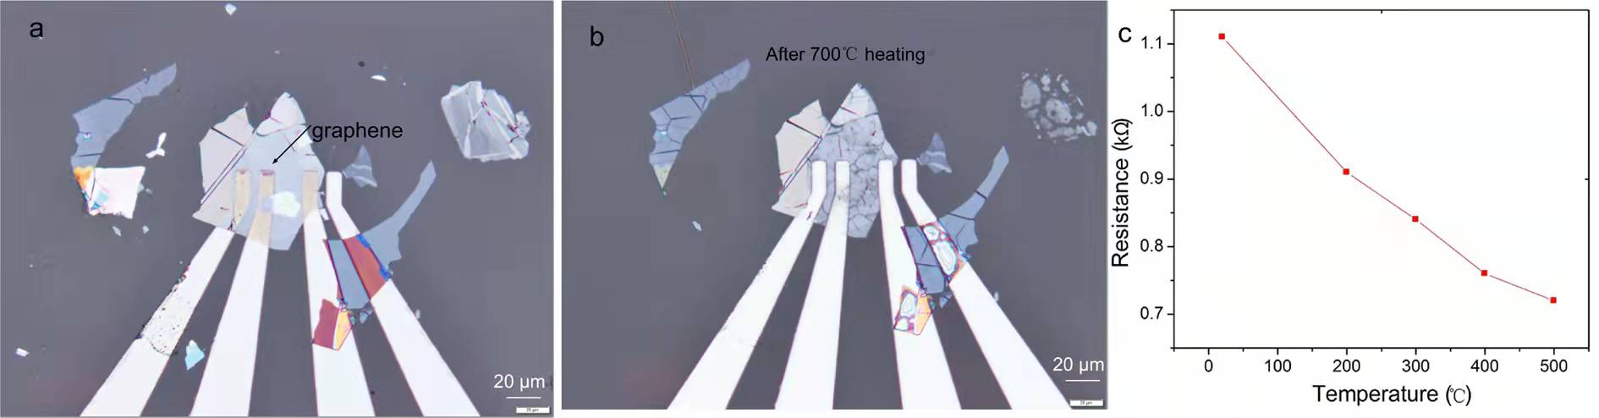
Figure S12. Conducting properties of graphene electrode at high-temperature. a, Graphene flake before heating. The resistance of the fresh graphene flake is 1.2 kΩ. b, Graphene flake after 700℃ heating for 15 min in air. The bare graphene without h-BN protection is still in good shape with smaller resistance of 0.6 kΩ at room temperature. c, The resistance of a typical graphene flake reduces from 1.1 kΩ to 0.7 kΩ as temperature varied from 20℃ to 500℃.

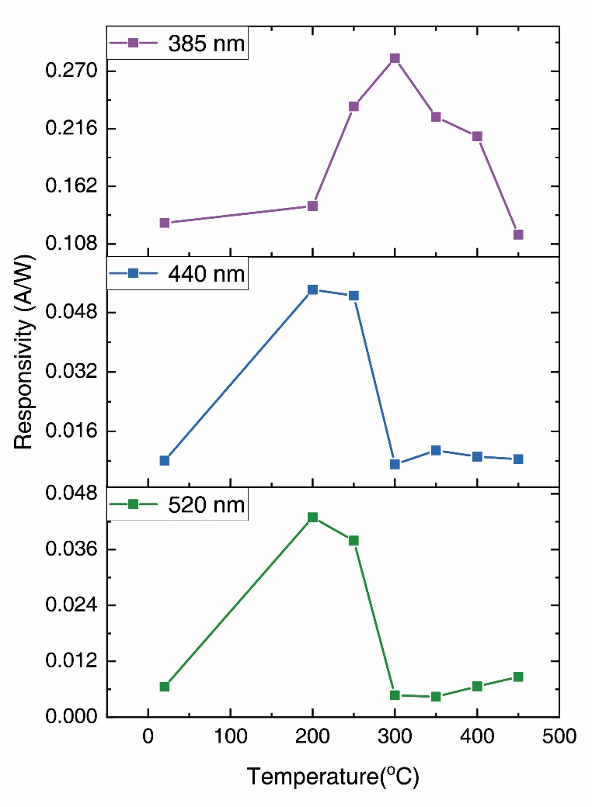
Figure S13. Photo responsivity of WSe₂ device with mica encapsulation under 385 nm (purple), 440 nm (blue), and 520 nm (green) illumination at different temperatures (V_{ds}=0.4 V, V_{g}=0 V). Under the illumination of three different lights, all the responsivity increased and then decreased with increasing temperature from 20 ℃ to 450 ℃ in air, but remains positive. The device with top mica exhibited positive photoconductivity in 400 ℃, indicating h-BN encapsulation contributed to the novel negative photoconductivity phenomenon in 400 °C.

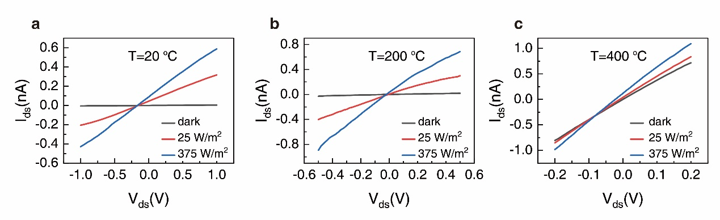
Figure S14. The I_{ds}-V_{ds} curves of bare WSe₂ with graphene electrodes (without top h-BN) under different light intensity and temperature. a, The I_{ds}-V_{ds} curves of bare WSe₂ with graphene electrodes under white light illumination at 20 °C. b, The I_{ds}-V_{ds} curves of bare WSe₂ with graphene electrodes under white light illumination at 200 °C. c, The I_{ds}-V_{ds} curves of bare WSe₂ with graphene electrodes under white light illumination at 400 °C.

At three different temperature, positive photoconductive effect was observed as illumination power increased, indicating that bare WSe₂ with graphene electrodes (without top h-BN) showed positive photoconductive effect under illumination. The contribution of WSe₂ and WSe₂/graphene electrode contact to the novel photoconductivity phenomenon in 400 °C have been excluded.

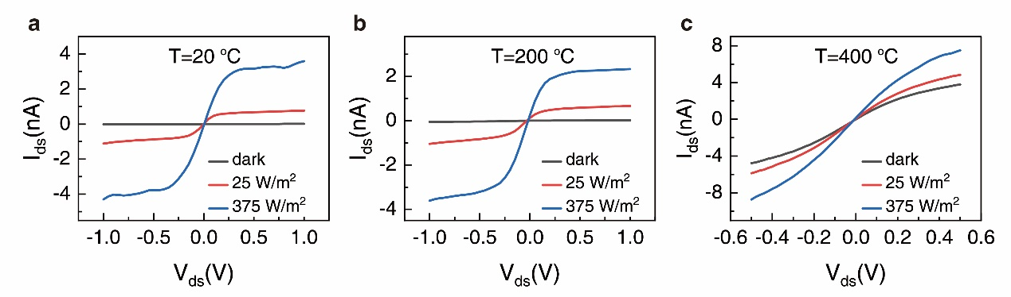
Figure S15. The I_{ds}-V_{ds} curves of bare WSe₂ with Pt electrodes (without top h-BN) under different light intensity and temperature. a, The I_{ds}-V_{ds} curves of bare WSe₂ with Pt electrodes under white light illumination at 20 °C. b, The I_{ds}-V_{ds} curves of bare WSe₂ with Pt electrodes under white light illumination at 200 °C. c, The I_{ds}-V_{ds} curves of bare WSe₂ with Pt electrodes under white light illumination at 400 °C.

In three different temperature, positive photoconductive effect was observed as illumination power increased, indicating that contact between WSe₂ and Pt is not the cause of the negative photoconductivity phenomenon in 400 °C.

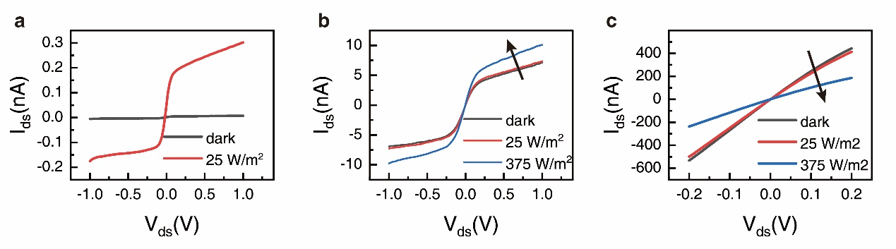
Figure S16. The I_{ds}-V_{ds} curves of WSe₂ with Pt S/D electrodes and h-BN encapsulation (without top gate) under different light intensity and temperature. a, The I_{ds}-V_{ds} curves of bare WSe₂ with Pt electrodes under white light illumination at 20 °C. b, The I_{ds}-V_{ds} curves of bare WSe₂ with Pt electrodes under white light illumination at 200 °C. c, The I_{ds}-V_{ds} curves of bare WSe₂ with Pt electrodes under white light illumination at 400 °C.

The current of WSe₂ device increased as light intensity increased from 25 W/m² to 375 W/m² at 20 °C and 400 °C. The current decreased with increasing light intensity, indicating negative photoconductivity.

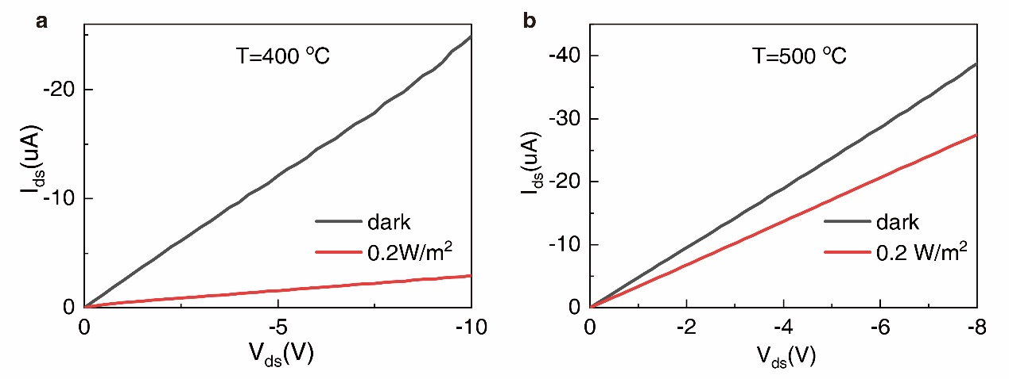

Figure S17. Negative photoconductivity phenomenon at 400 ℃ and 500 ℃ under 0.2 W/m² 365 nm light illumination. The photoresponsivity derived can reach 2.2×10⁶ A/W and 1.1×10⁶ A/W respectively.

