SUPPLEMENTARY MATERIAL S1
Assessing reintroduction outcome: comparison of the juvenile post-fledging dependence period between wild and reintroduced Bonelli’s eagles in two Mediterranean islands.
OLGA EGEA-CASAS*1, PASCUAL LÓPEZ-LÓPEZ*†1, ERNESTO ÁLVAREZ2, GIUSEPPE CORTONE3, MANUEL GALÁN2, JUAN JOSÉ IGLESIAS-LEBRIJA2, MARIO LO VALVO4, JUAN MARTÍNEZ2, STEFANIA MERLINO3, CARLOTA VIADA5, MASSIMILIANO DI VITTORIO3.
* both authors contributed equally to this paper
¹ Cavanilles Institute of Biodiversity and Evolutionary Biology. Movement Ecology Lab. University of Valencia. C/ Catedrático José Beltrán 2. E-46980. Paterna. Valencia. Spain.
² Grupo de Rehabilitación de la Fauna Autóctona y su Hábitat (GREFA), C/Monte del Pilar S/N. E-28220. Majadahonda, Madrid, Spain.
³ Ecologia Applicata Italia, Termini Imerese (PA), Italy.
⁴ Laboratorio di Zoologia applicata, Dipartimento di Scienze e Tecnologie Biologiche, Chimiche e Farmaceutiche, University of Palermo, Palermo, Italy.
⁵ COFIB-Servei de Protecció d'Espècies, LIFE Bonelli. Govern de les Illes Balears. Santa Eugènia. Mallorca. Balearic Islands. Spain.
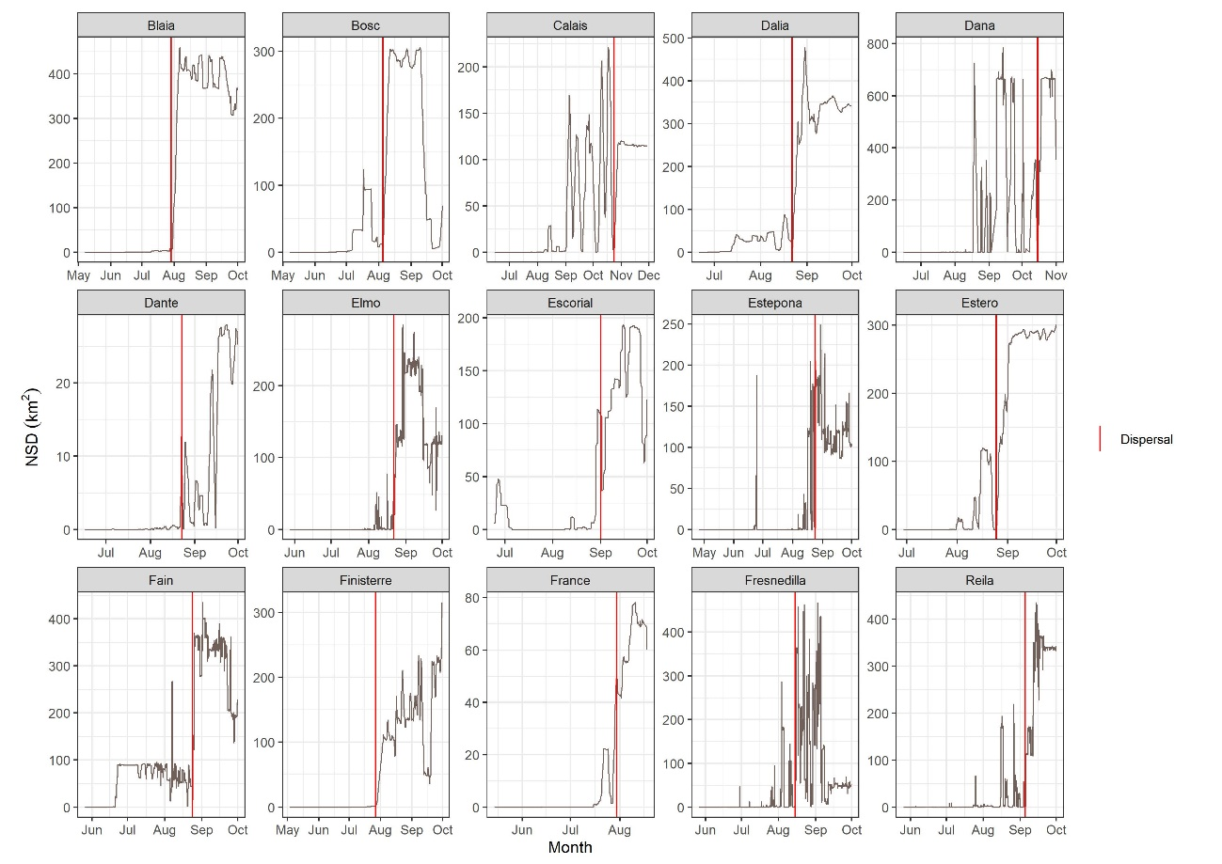
Figure S1: Net Squared Displacement (km²) computed by means of a moving average (n = 20 locations) from first location in the hacking of each of the reintroduced individuals in Mallorca. Red line indicates onset of dispersal.
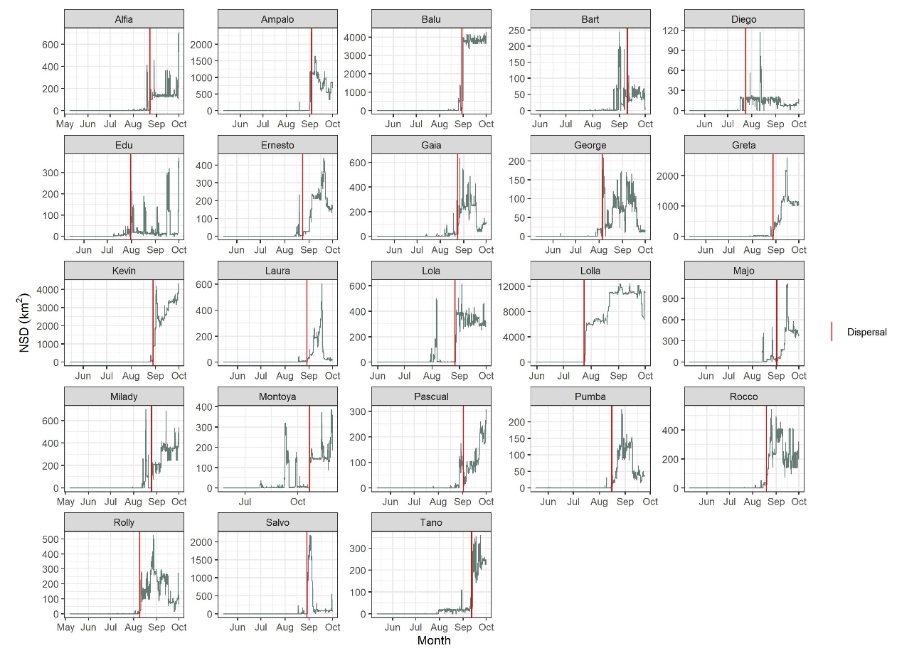
Figure S2: Net Squared Displacement (km²) computed by means of a moving average (n = 20 locations) from first location in the nest of the wild individuals from Sicily. Red line indicates onset of dispersal.

