Supplemental Information

**Engineering Surface Oxophilicity of Copper for Electrochemical CO2 Reduction to Ethanol**

Minhan Li,1 Nan Song,2 Fangzhou Zhang,1 Wei Luo,1,* Jun Chen,3 Wan Jiang,1 Jianping Yang1,4,*

1State Key Laboratory for Modification of Chemical Fibers and Polymer Materials, College of Materials Science and Engineering, Donghua University, Shanghai 201620, P. R. China

2State Key Laboratory of Chemical Engineering, East China University of Science and Technology, Shanghai, 200237, P. R. China

3ARC Centre of Excellence for Electromaterials Science, Intelligent Polymer Research Institute, Australian Institute of Innovative Materials, University of Wollongong, Innovation Campus, Wollongong, NSW 2522, Australia

4Lead Contact

*Correspondence: wluo@dhu.edu.cn; jianpingyang@dhu.edu.cn



**Figure S1** The oxophilicity of common transition metals and p-block metals determined by the bond dissociation enthalpies of metal oxides.1

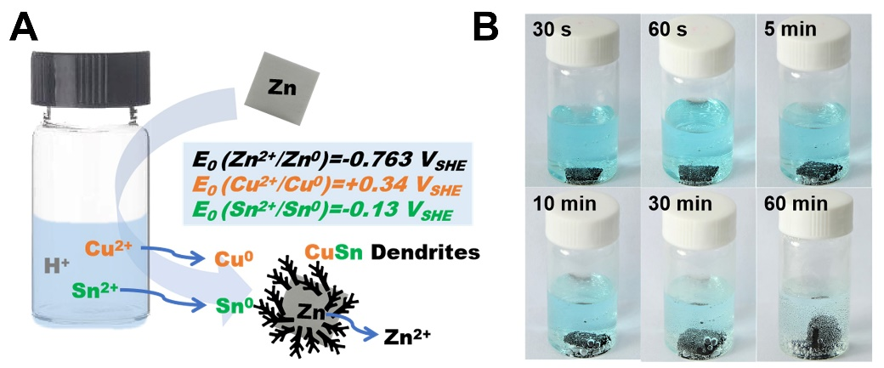

**Figure S2** Schematic diagram of the materials synthesis (a). Photographs illustrate the synthesis procedures (b).

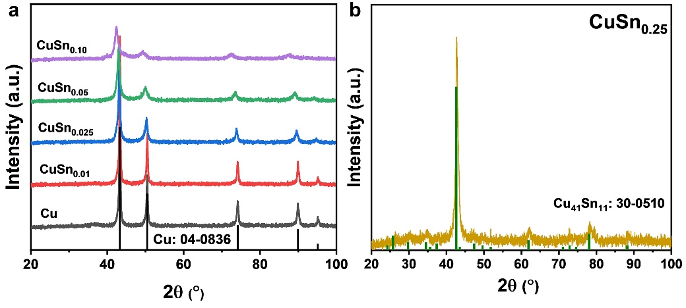

**Figure S3** XRD pattern of Cu to CuSn0.10 catalysts (a) and CuSn0.25 catalyst (b).

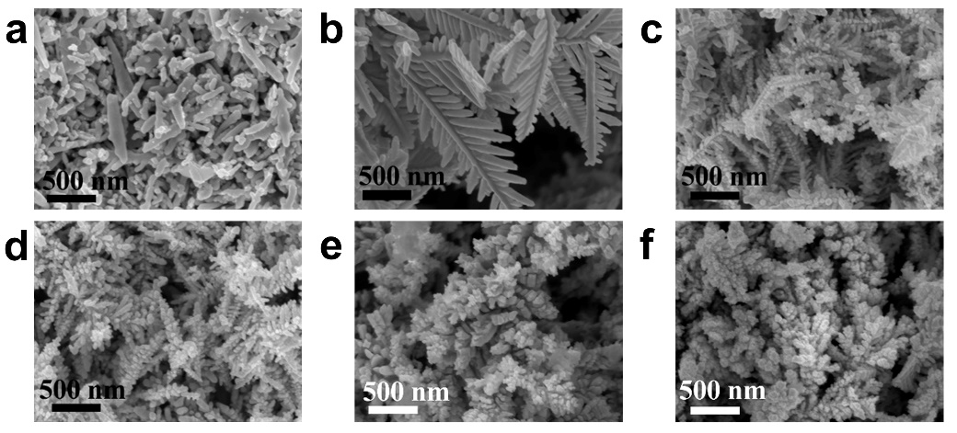

**Figure S4** SEM images of (a) bare Cu, (b) CuSn0.01, (c) CuSn0.025, (d) CuSn0.05, (e) CuSn0.10, and (f) CuSn0.25 catalysts.

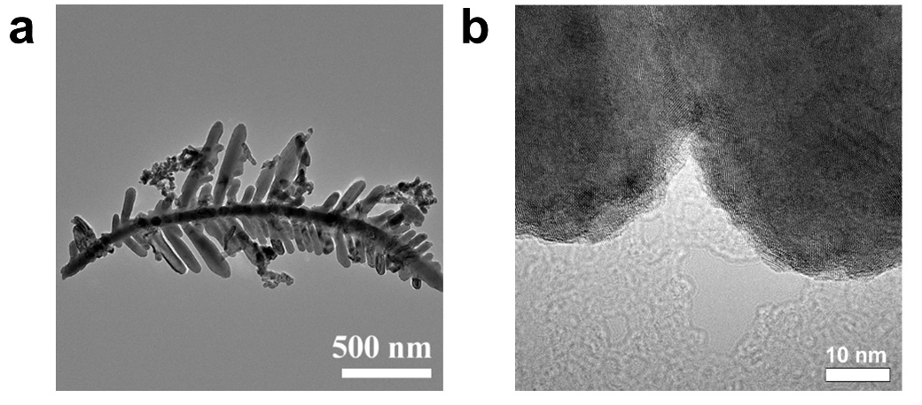

**Figure S5** (a)TEM and (b) HR-TEM images of CuSn0.01 catalyst.

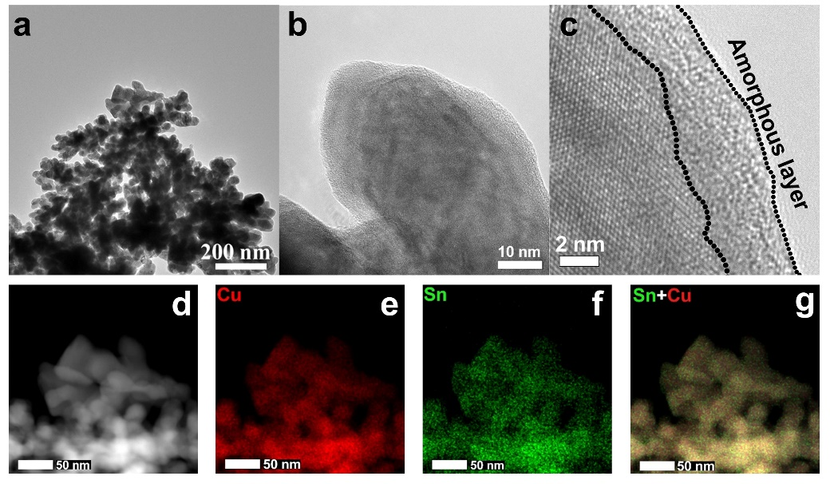

**Figure S6** Characterization of CuSn0.10 catalyst. (a) TEM image, (b-c) HR-TEM images, (d) HAADF-STEM image, and (e-g) EDS elemental mappings of CuSn0.10 catalyst.

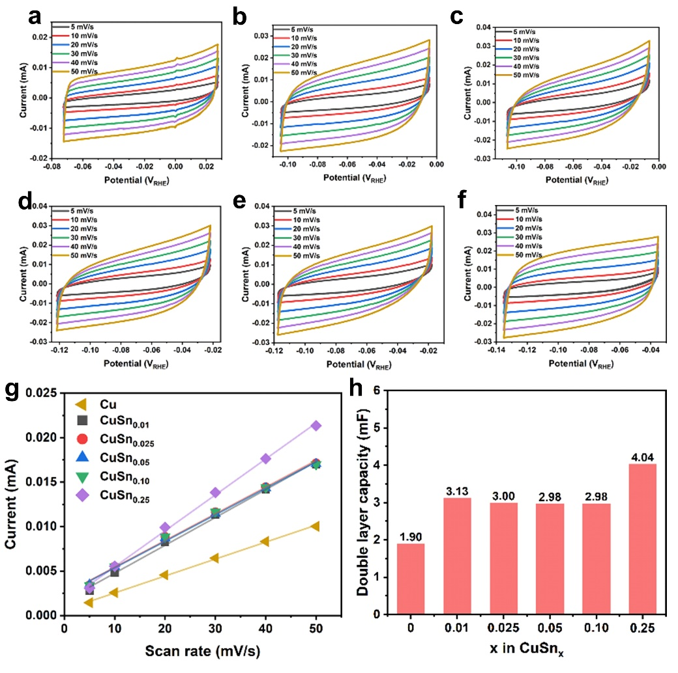

**Figure S7** ECSA measurements of CuSnx catalysts. (a-f) Double layer capacities (Cdl) measured by CV curves in CO2-saturated 0.1 M KHCO3 solution at around open circuit potential (EOC ± 50 mV) of Cu, CuSn0.01, CuSn0.025, CuSn0.05, CuSn0.10, and CuSn0.25 catalysts. (g) Charge current density in CV scans plotted against the scan rates for CuSnx catalysts. (h) ECSA values of CuSnx catalysts.

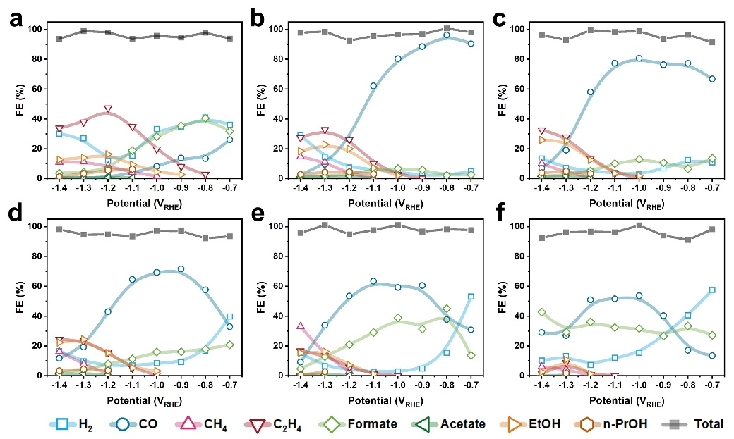

**Figure S8** The distribution of reduction products at applied potentials on CuSnx catalysts. (a) Cu, (b) CuSn0.01, (c) CuSn0.025, (d) CuSn0.05, (e) CuSn0.10, and (f) CuSn0.25.

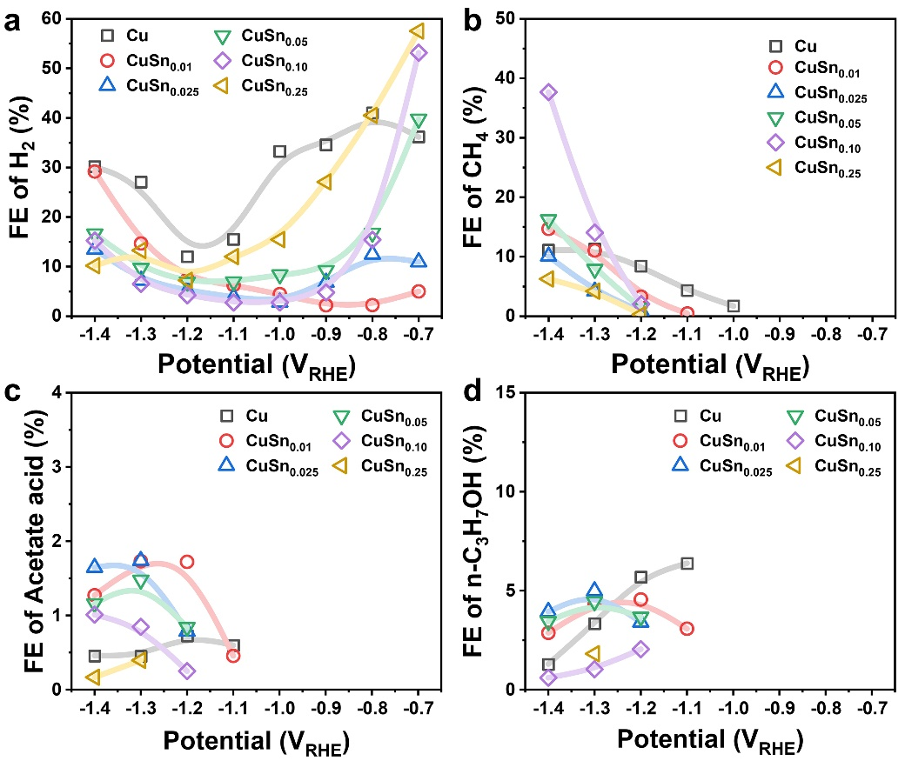

**Figure S9** The FEs of reduction products. (a) H2, (b) CH4, (c) acetate acid, (d) n-C3H7OH.

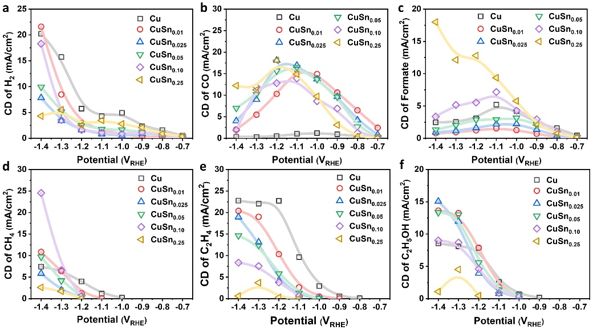

**Figure S10** Current density (CD) of the main reduction products. (a) H2. (b) CO. (c) formate. (d) CH4. (e) C2H4. (f) C2H5OH.

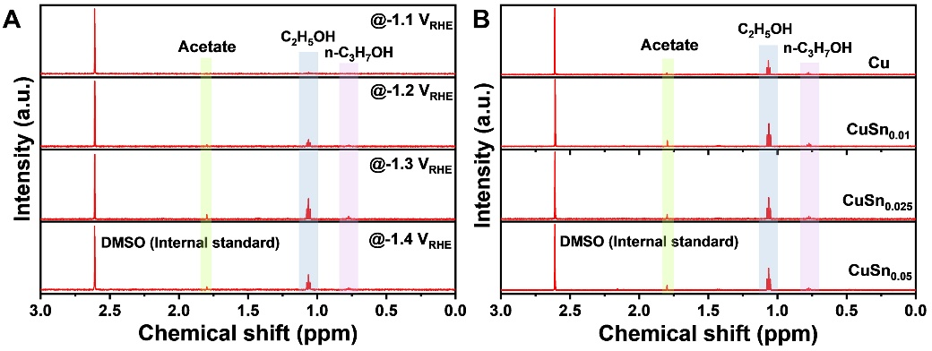

**Figure S11** The typical 1H NMR patterns that shows the peaks for multicarbon liquid products. (a) CuSn0.025 catalysts at different potentials. (b) Different catalysts at -1.3 VRHE.

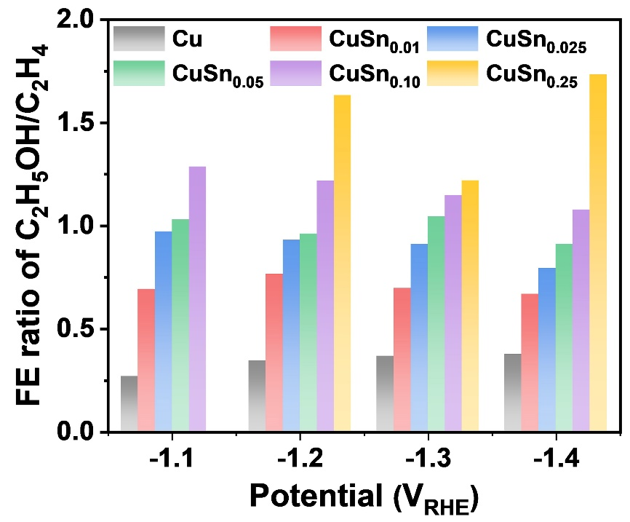

**Figure S12** The FE ratio of C2H5OH/C2H4 on CuSnx catalysts at different potentials.

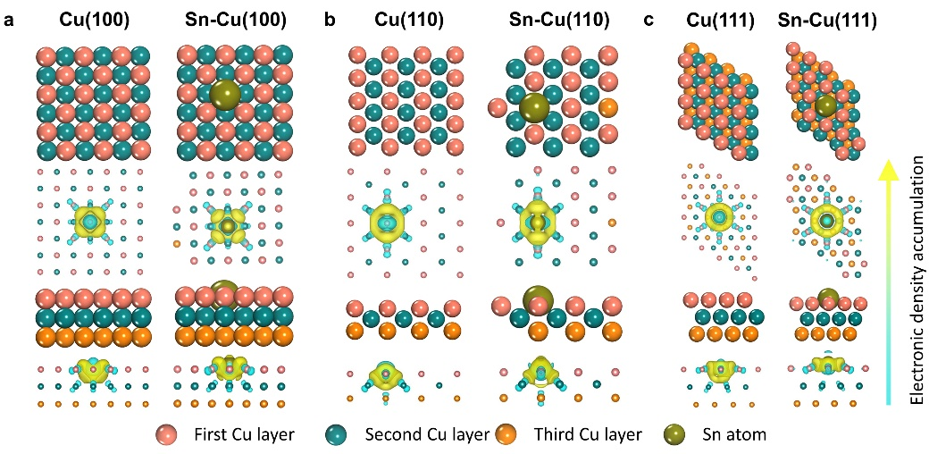

**Figure S13** The slab models of Sn modified Cu facets for calculation and the corresponding differential charge analysis.

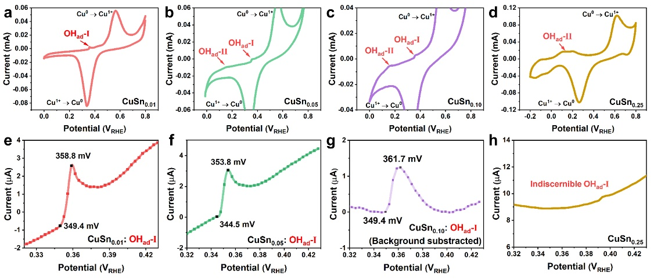

**Figure S14** CV curves of (a) CuSn0.01, (b) CuSn0.05, (c) CuSn0.10, and (d) CuSn0.25 catalysts. Enlarged CV curves showing OHad-I adsorption peaks for (e) CuSn0.01, (f) CuSn0.05, (g) CuSn0.10, and (h) CuSn0.25.

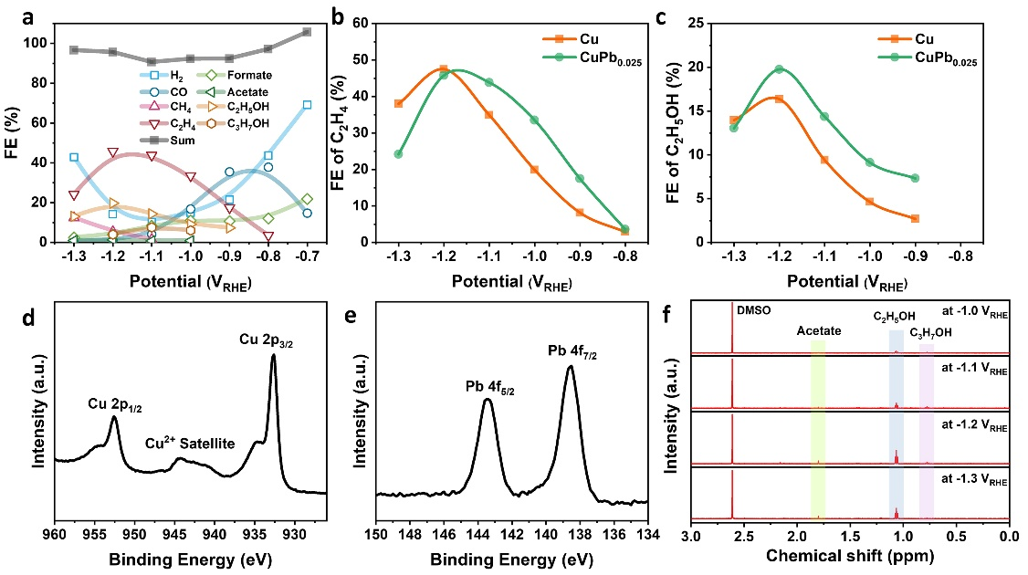

**Figure S15** CO2RR performance and characterization of CuPb0.025 catalyst. (a) FEs of all products at different potentials. (b) Comparison of FE of C2H4 between bare Cu and CuPb0.025 catalysts. (c) Comparison of FE of C2H5OH between bare Cu and CuPb0.025 catalysts. (d) Cu 2p spectra of CuPb0.025 catalysts. (e) Pb 4f spectra of CuPb0.025 catalysts. (f) 1H NMR patterns showing the peaks of multicarbon liquid products for CuPb0.025 catalyst.

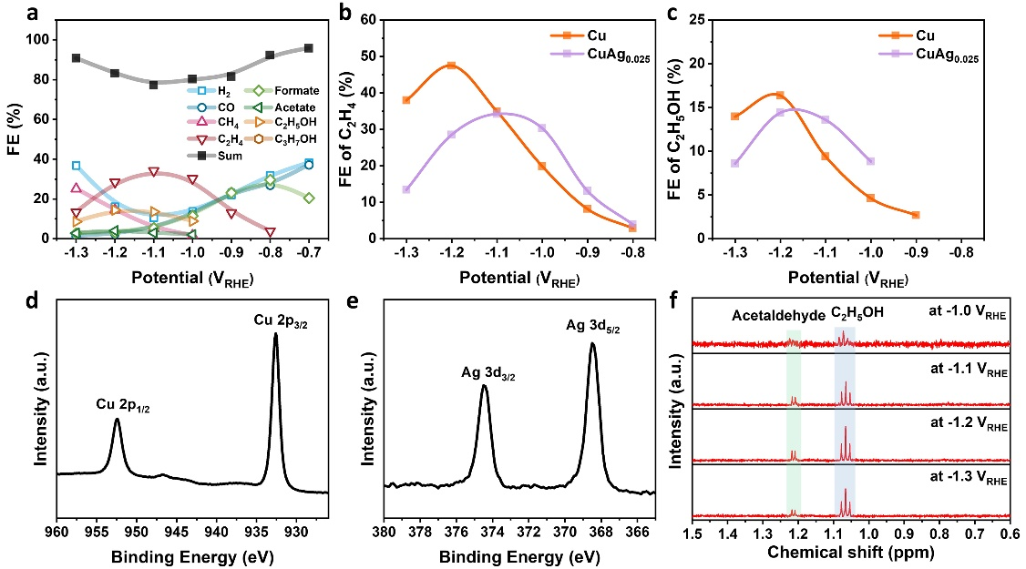

**Figure S16** CO2RR performance and characterization of CuAg0.025 catalyst. (a) FEs of all products at different potentials. (b) Comparison of FE of C2H4 between bare Cu and CuAg0.025 catalysts. (c) Comparison of FE of C2H5OH between bare Cu and CuPb0.025 catalysts. (d) Cu 2p spectra of CuAg0.025 catalysts. (e) Ag 3d spectra of CuAg0.025 catalysts. (f) 1H NMR patterns showing the peaks of multicarbon liquid products for CuAg0.025 catalyst.

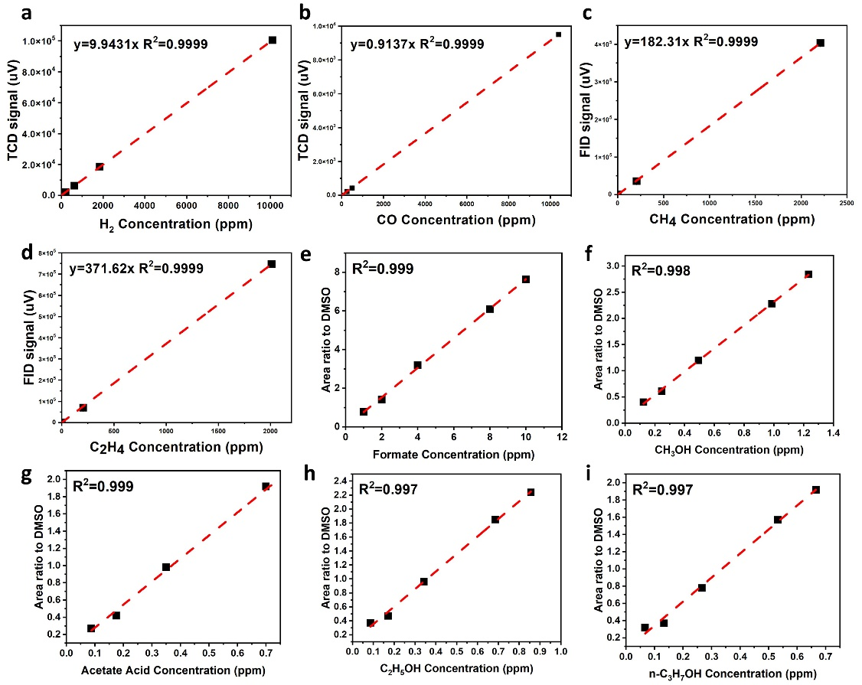

**Figure S17** Gas and liquid products calibration. (a-d) Gas products. (e-i) Liquid products.

**Table S1** Summary of CO2RR performance of the CuSnx catalysts in this work and the comparison of other Cu-Sn bimetallic catalysts in the literatures.

|  |  |  |  |  |  |  |
| --- | --- | --- | --- | --- | --- | --- |
| Catalyst | Reduction product | Faradic efficiency | Partial current density, mA/cm2 | Potential, VRHE | Electrolyte | Reference |
| **CuSn0.01** | **CO** | **96.36 %** | **6.51** | **-0.8** | **0.1 M KHCO3** | **This work** |
| **CuSn0.025** | **C2H5OH** | **25.93%** | **15.05** | **-1.4** | **0.1 M KHCO3** | **This work** |
| Sn/Cu2O | CO | 87.9 % | ~ 15 (total) | -1.3 | 0.1 M KHCO3 | 2 |
| Cu97Sn3 | CO | 98 % | ~ 30 (total) | -0.7 | 0.5 M KHCO3 | 3 |
| CuSn40 | CO | 90.9 % | ~ 3.3 (-0.8 VRHE) | -1.0 | 0.1 M KHCO3 | 4 |
| Cu-Sn form | CO | 93-94 % | 6.2 | -0.9 | 0.1 M KHCO3 | 5 |
| Cu–Sn20 | CO | 82 % | 0.96 | -0.7 | 0.1 M KHCO3 | 6 |
| Cu-Sn dendrite | CO | 74 % | 11.5 | -1.1 | 0.1 M KHCO3 | 7 |
| SnO2/CuS NSs | CO | ~70 % | 15.24 | -1.0 | 0.1 M KHCO3 | 8 |
| Sn/Cu-PVDF | CO | 80 % | 104 (gaseous CO2 feeding) | < -0.9 | 0.1 M KHCO3 | 9 |
| Cu−Sn | CO | 90 % | 1.0 | -0.6 | 0.1 M KHCO3 | 10 |
| C-Cu/SnO2-0.8 | CO | 93 % | 4.6 | -0.7 | 0.5 M KHCO3 | 11 |
| Cu87Sn13 | CO | 59.5 % | ~ 0.9 | -0.99 | 0.1 M KHCO3 | 12 |
| CuO+SnO2 | CO | ~ 90 % | ~ 0.5 | -0.6 | 0.1 M NaHCO3 | 13 |
| Cu/SnOx−CNT  (6.2 % SnOx) | CO | 89 % | 11.3 | -0.99 | 0.1 M KHCO3 | 14 |
| C-Cu/SnO2-1.8 | Formate | 85 % | n.a. | -0.9 | 0.5 M KHCO3 | 11 |
| Cu55Sn45 | Formate | 89.5 % | ~ 2.5 | -1.09 | 0.1 M KHCO3 | 12 |
| Cu/SnOx−CNT  (30.2 % SnOx) | Formate | 77 % | 4.0 | -0.99 | 0.1 M KHCO3 | 14 |
| CuSn0.175-NG | CO+Formate | 93 % | n.a. | -1.0 | 0.5 M KHCO3 | 15 |
| Cu@Sn | Formate | ~ 100 % | 16.52 | -0.93 | 0.5 M KHCO3 | 16 |
| CuSn NPs/C-A | CO | 70.1 % | 1.66 | -0.7 | 0.1 M KHCO3 | 17 |
| Formate | 71.5 % | 12.6 | -1.0 |
| Cu(1)Sn(4)-N-CC | Formate | 90.24 % | 15.56 | -0.97 | 0.5 M KHCO3 | 18 |
| Sn-Cu alloy | Formate | 82.3 % | 79 | -1.14 | 0.5 M KCl | 19 |
| CuSn–10C | Formate | 82 % | 18.9 | -1.0 | 0.1 M NaHCO3 | 20 |
| CuSn NWs/C-Air | Formate | 90.2 % | 17.33 | -1.0 | 0.5 M KHCO3 | 21 |

**Reference**

1. Kepp, K.P. (2016). A quantitative scale of oxophilicity and thiophilicity. Inorg. Chem. *55*, 9461-9470.

2. Zhang, W., He, P., Wang, C., Ding, T., Chen, T., Liu, X., Cao, L., Huang, T., Shen, X., Usoltsev, O.A., et al. (2020). Operando evidence of Cu+ stabilization via a single-atom modifier for CO2 electroreduction. J Mater. Chem. A *8*, 25970-25977.

3. Ren, W., Tan, X., Qu, J., Li, S., Li, J., Liu, X., Ringer, S.P., Cairney, J.M., Wang, K., Smith, S.C., and Zhao, C. (2021). Isolated copper–tin atomic interfaces tuning electrocatalytic CO2 conversion. Nat. Commun. *12*, 1449.

4. Zhang, S.-N., Li, M., Hua, B., Duan, N., Ding, S., Bergens, S., Shankar, K., and Luo, J.-L. (2019). A rational design of Cu2O-SnO2 core-shell catalyst for highly selective CO2-to-CO conversion. Chemcatchem *11*, 4147-4153.

5. Zeng, J., Bejtka, K., Ju, W., Castellino, M., Chiodoni, A., Sacco, A., Farkhondehfal, M.A., Hernández, S., Rentsch, D., Battaglia, C., and Pirri, C.F. (2018). Advanced Cu-Sn foam for selectively converting CO2 to CO in aqueous solution. Appl. Catal. B: Environ. *236*, 475-482.

6. Zhao, Y., Wang, C., and Wallace, G.G. (2016). Tin nanoparticles decorated copper oxide nanowires for selective electrochemical reduction of aqueous CO2 to CO. J Mater. Chem. A *4*, 10710-10718.

7. Ju, W., Zeng, J., Bejtka, K., Ma, H., Rentsch, D., Castellino, M., Sacco, A., Pirri, C.F., and Battaglia, C. (2019). Sn-Decorated Cu for Selective Electrochemical CO2 to CO Conversion: Precision Architecture beyond Composition Design. ACS Appl. Energy Mater. *2*, 867-872.

8. Wang, X., Lv, J., Zhang, J., Wang, X.-L., Xue, C., Bian, G., Li, D., Wang, Y., and Wu, T. (2020). Hierarchical heterostructure of SnO2 confined on CuS nanosheets for efficient electrocatalytic CO2 reduction. Nanoscale *12*, 772-784.

9. Ju, W., Jiang, F., Ma, H., Pan, Z., Zhao, Y.-B., Pagani, F., Rentsch, D., Wang, J., and Battaglia, C. (2019). Electrocatalytic Reduction of Gaseous CO2 to CO on Sn/Cu-Nanofiber-Based Gas Diffusion Electrodes. Adv. Energy Mater. *9*, 1901514.

10. Sarfraz, S., Garcia-Esparza, A.T., Jedidi, A., Cavallo, L., and c, K. (2016). Cu-Sn Bimetallic Catalyst for Selective Aqueous Electroreduction of CO2 to CO. ACS Catal. *6*, 2842-2851.

11. Li, Q., Fu, J., Zhu, W., Chen, Z., Shen, B., Wu, L., Xi, Z., Wang, T., Lu, G., Zhu, J.-j., and Sun, S. (2017). Tuning Sn-Catalysis for Electrochemical Reduction of CO2 to CO via the Core/Shell Cu/SnO2 Structure. J. Am. Chem. Soc. *139*, 4290-4293.

12. Morimoto, M., Takatsuji, Y., Yamasaki, R., Hashimoto, H., Nakata, I., Sakakura, T., and Haruyama, T. (2018). Electrodeposited Cu-Sn Alloy for Electrochemical CO2 Reduction to CO/HCOO-. Electrocatalysis *9*, 323-332.

13. Schreier, M., Héroguel, F., Steier, L., Ahmad, S., Luterbacher, J.S., Mayer, M.T., Luo, J., and Grätzel, M. (2017). Solar conversion of CO2 to CO using Earth-abundant electrocatalysts prepared by atomic layer modification of CuO. Nature Energy *2*, 17087.

14. Huo, S., Weng, Z., Wu, Z., Zhong, Y., Wu, Y., Fang, J., and Wang, H. (2017). Coupled Metal/Oxide Catalysts with Tunable Product Selectivity for Electrocatalytic CO2 Reduction. ACS Appl. Mater. Interfaces *9*, 28519-28526.

15. Xiong, W., Yang, J., Shuai, L., Hou, Y., Qiu, M., Li, X., and Leung, M.K.H. (2019). CuSn Alloy Nanoparticles on Nitrogen-Doped Graphene for Electrocatalytic CO2 Reduction. ChemElectroChem *6*, 5951-5957.

16. Hou, X., Cai, Y., Zhang, D., Li, L., Zhang, X., Zhu, Z., Peng, L., Liu, Y., and Qiao, J. (2019). 3D core-shell porous-structured Cu@Sn hybrid electrodes with unprecedented selective CO2-into-formate electroreduction achieving 100%. J Mater. Chem. A *7*, 3197-3205.

17. Wang, P., Qiao, M., Shao, Q., Pi, Y., Zhu, X., Li, Y., and Huang, X. (2018). Phase and structure engineering of copper tin heterostructures for efficient electrochemical carbon dioxide reduction. Nat. Commun. *9*, 4933.

18. Peng, L., Wang, Y., Masood, I., Zhou, B., Wang, Y., Lin, J., Qiao, J., and Zhang, F.-Y. (2020). Self-growing Cu/Sn bimetallic electrocatalysts on nitrogen-doped porous carbon cloth with 3D-hierarchical honeycomb structure for highly active carbon dioxide reduction. Appl. Catal. B: Environ. *264*, 118447.

19. Ye, K., Cao, A., Shao, J., Wang, G., Si, R., Ta, N., Xiao, J., and Wang, G. (2020). Synergy effects on Sn-Cu alloy catalyst for efficient CO2 electroreduction to formate with high mass activity. Science Bulletin *65*, 711-719.

20. Wang, J., Zou, J., Hu, X., Ning, S., Wang, X., Kang, X., and Chen, S. (2019). Heterostructured intermetallic CuSn catalysts: high performance towards the electrochemical reduction of CO2 to formate. J Mater. Chem. A *7*, 27514-27521.

21. Wang, J., Ji, Y., Shao, Q., Yin, R., Guo, J., Li, Y., and Huang, X. (2019). Phase and structure modulating of bimetallic CuSn nanowires boosts electrocatalytic conversion of CO2. Nano Energy *59*, 138-145.