Table S1: qPCR gene biomarkers included in the custom RT-qPCR assay
Marker types | Genes
Th1/Th17 | il2, il1beta, il-6, il-8, ifn-gamma, tnf-alpha, il17a
astrocyte reactivity | GFAP, STAT3, vimentin
M1/M2 macrophage activation/microgliosis | ccl2, il1β, il4, arg1, iNOS, cd206, il-10, and il-12
LPS-induced neuroinflammation | NF-kB

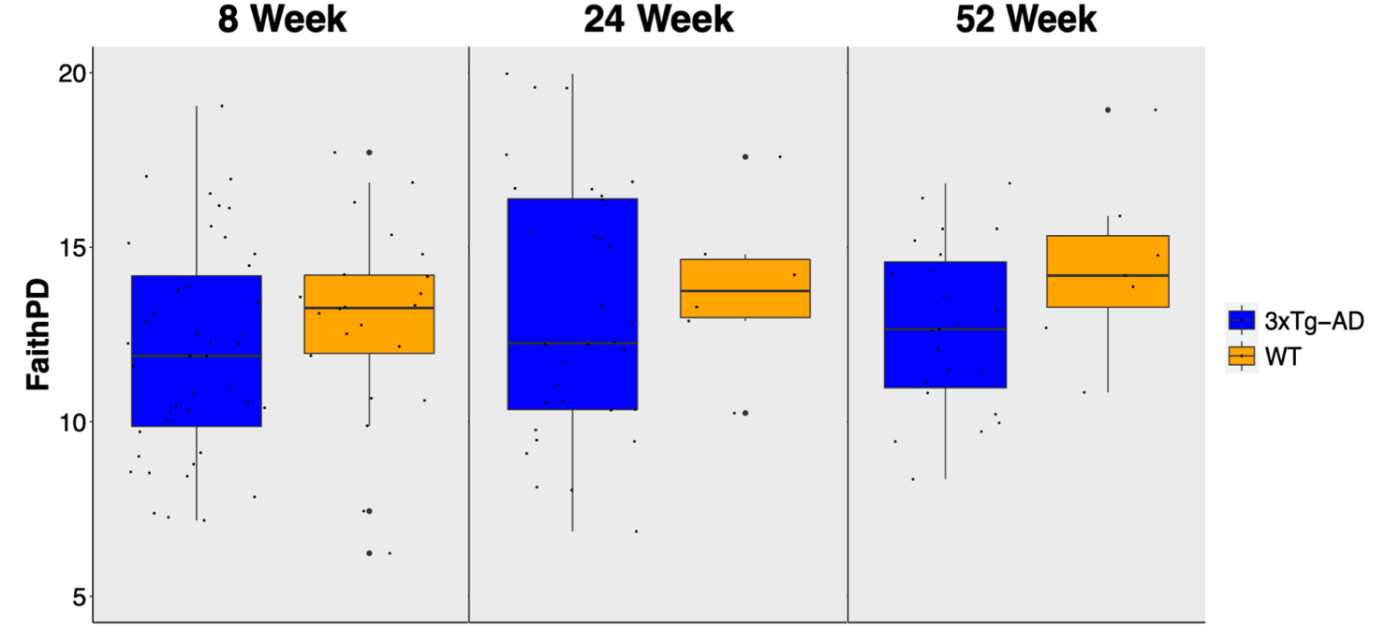
Figure S1: Faith’s Phylogenetic Diversity in 8, 24, and 52 week 3xTg-AD and WT mice. 3xTg-AD mice demonstrate a non-significant trend towards lower Faith’s Phylogenetic Diversity. A) 3xTg-AD and WT mice at 8 weeks (p-value = 0.098, Wilcoxon) B) 3xTg-AD and WT mice at 24 weeks (p-value = 0.63, Wilcoxon) C) 3xTg-AD and WT mice at 52 weeks (p-value = 0.17, Wilcoxon)
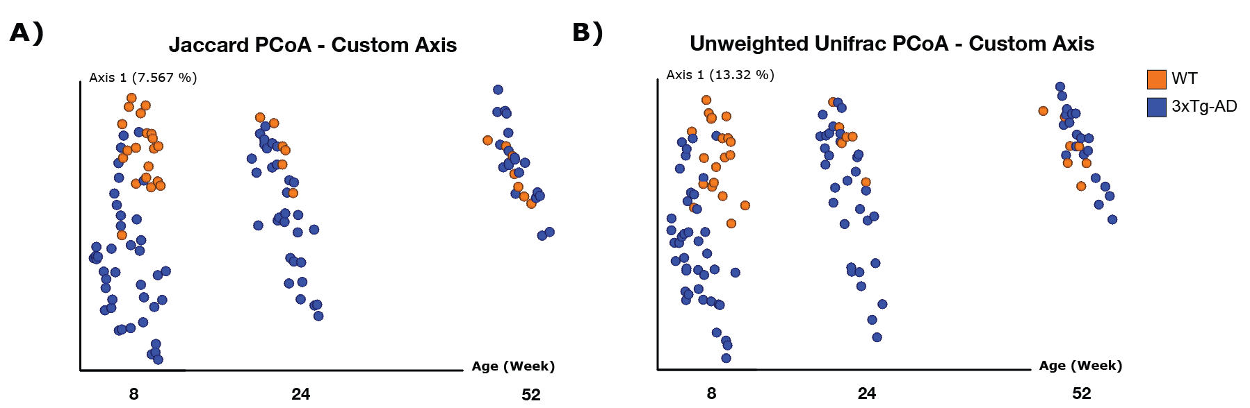Figure S2: Jaccard dissimilarity metric and Unweighted Unifrac PCoA 1 plotted against time of 3xTg-AD and WT mice from 4 to 52 weeks demonstrate distinct gut microbiota compositions in early life in 3xTg-AD mice compared to WT mice. A) PCoA of Jaccard dissimilarity metric, with key timepoints in pathology progression plotted as a PCoA 1 plotted against time (baseline: 8 weeks, amyloidosis: 24 weeks, tauopathy: 52 weeks). This demonstrates distinct gut microbiota compositions between 3xTg-AD and WT mice at 8 (PERMANOVA, p=0.001, f-statistic=5.56398) and 24 (PERMANOVA, p=0.025, f-statistic=1.38129) weeks of age, but not at 52 (PERMANOVA, p=0.054, f-statistic=1.33127) weeks of age B) PCoA of Unweighted UniFrac distance metric, with key timepoints in pathology progression plotted as a PCoA 1 plotted against time. This demonstrates distinct gut microbiota compositions between 3xTg-AD and WT mice at 8 (PERMANOVA, p=0.001, f-statistic=7.99616) and 24 (PERMANOVA, p=0.043, f-statistic=1.61199) weeks of age, but not at 52 (PERMANOVA, p=0.065, f-statistic=1.45748) weeks of age.

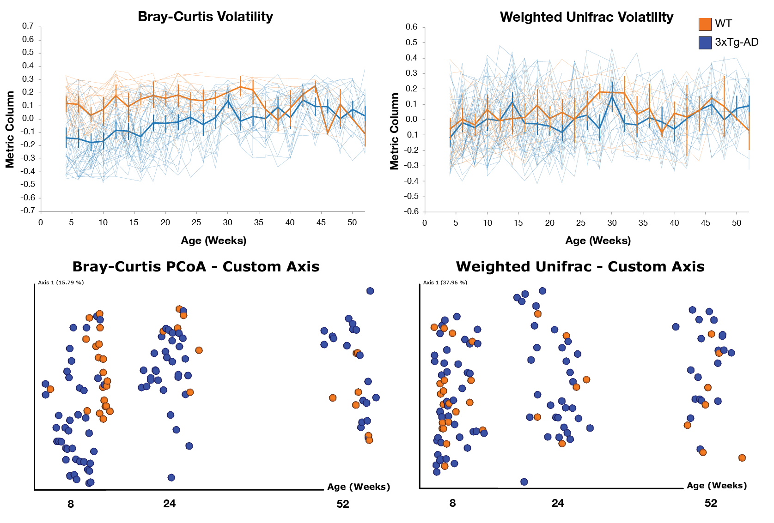
Figure S3: Beta-diversity metrics of 3xTg-AD and WT mice from 4 to 52 weeks of age and at 8, 24, and 52 weeks when comparing mouse strain. A) Bray-Curtis Axis 1 Volatility Plot from 4 to 52 weeks of age shows distinct gut microbiota compositions of 3xTg-AD and WT mice until 24 weeks of age. B) Weighted Unifrac Axis 1 Volatility Plot from 4 to 52 weeks of age. C) Bray-Curtis PCoA 1 plotted against time demonstrates distinct gut microbiota compositions between 3xTg-AD and WT mice at 8 (PERMANOVA, p=0.001, f-statistic=10.1743) and 24 (PERMANOVA, p=0.016, f-statistic=1.98555) weeks of age, but not at 52 (PERMANOVA, p=0.508, f-statistic=0.90456) weeks of age. D) Weighted Unifrac PCoA 1 plotted against time demonstrates distinct gut microbiota compositions between 3xTg-AD and WT mice at 8 (PERMANOVA, p=0.03, f-statistic=3.10426) , but not at 24 (PERMANOVA, p=0.566, f-statistic=0.717805) and 52 (PERMANOVA, p=0.066) weeks of age
Table S2: Differential abundance between 3xTg-AD and WT mice using Analysis of Composition of Microbiomes (ANCOM) at 8 weeks of age collapsed at genus level. W represents the number of features that the taxa is more abundant than.
Features Collapsed at Genus Level | W | Week
Bacteroides | 57 | 8
Akkermansia | 56 | 8
Turicibacter | 56 | 8
Sutterella | 53 | 8
Anaerostipes | 53 | 8
F. Coriobacteriaceae | 11 | 52
F. Mogibacteriaceae | 9 | 52
Adlecreutzia | 7 | 52
O. RF39 | 6 | 52
Prevotella | 6 | 52
F. Erysipelotrichaceae | 6 | 52
O. Streptophyta | 6 | 52
Clostridium | 5 | 52
Akkermansia | 5 | 52
Bacillus | 5 | 52

