Table S1 Demographics and clinical data of subjects
Characteristics | Active PTB  (n=103) | Inactive PTB  (n =16) | Characteristics | Active PTB  (n=103) | Inactive PTB  (n =16)
Gender (M/F) | 71/32 | 13/3 | IGRA (+) | 90/101† | 15/15
Age (Years old) | 44.7±15.5 | 50.2±12.6 | Sputum (+)
TB contact | 5 | 0 | Smearing | 25/100 | 0
Smoking | 29 | 6 | TB-DNA | 21/72 | 0/11
T2DM | 18 | 2 | Xpert test | 12/21 | 0/2
GHbA1C (%) | 6.53±0.24 | 5.95±0.33 | BALF (+)
WBC (10⁹/L) | 6.55±2.30 | 6.34±2.00 | Smearing | 29 | 0
ESR (mm/h) | 36.8±3.35 | 27.6±7.48 | TB-DNA | 36/100 | 0
CD4+T (10⁶/L) | 535±25.6 | 613±61.1 | Xpert test | 64/99 | 0/14
Cavitary lesion | 46 | 0 | Mtb Culture (+) | 59/101 | 0
PTB, pulmonary tuberculosis; IGRA, interferon-γ release assay; T2DM, type 2 diabetes; GHbA1C, glycated hemoglobin A1c; WBC, white blood cell; ESR, erythrocyte sedimentation rate; Xpert, GeneXpert MTB/RIF; Mtb, Mycobacterium tuberculosis; †Actual cases involved.

Table S2 Comparisons of BALF and blood levels of sCD14, IL-17 and IL-22 in 76 PTB patients
 | Active PTB |  |  |  | Inactive PTB  (n =6)
 | Total  (n=70) | Sputum-based  (n =20) | BALF-dependent  (n =37) | Clinical  (n =13)
sCD14
BALF | 3.13±0.20* | 3.48±0.33* | 3.41±0.30 | 1.80±0.21 | 2.30±0.44
serum | 2.57±0.15 | 2.50±0.23 | 2.77±0.24 | 2.12±0.14 | 1.99±0.21
IL-17
BALF | 2.43±0.20 | 3.14±0.35 | 2.55±0.30 | 1.02±0.13 | 1.95±0.66
serum | 2.07±0.22 | 2.15±0.41 | 2.27±0.33 | 1.35±0.32 | 1.06±0.37
Il-22
BALF | 3.50±0.26** | 4.39±0.44** | 3.77±0.36* | 1.37±0.25 | 2.60±0.76
serum | 2.52±0.15 | 2.55±0.26 | 2.67±0.24 | 2.04±0.17 | 1.95±0.26
PTB, pulmonary tuberculosis; BALF, bronchoalveolar lavage fluid; *P < 0.05, **P < 0.01 when compared with data in next line.

Table S3 Sensitivities and specificities of serum levels of sCD14, IL-17 and IL-22 in prediction of bacteriological confirmation in PTB patients
Items | Sensitivity†  (%) | Specificity  (%) | Cut-off value (μg or ng/mL)
Bacteriologically-unconfirmed
sCD14 | 92.3 | 24.6 | ≤2.91
IL-17 | 92.3 | 22.8 | ≤3.29
IL-22 | 92.3 | 24.6 | ≤2.93
† minimal requirement of WHO (≥ 90%).

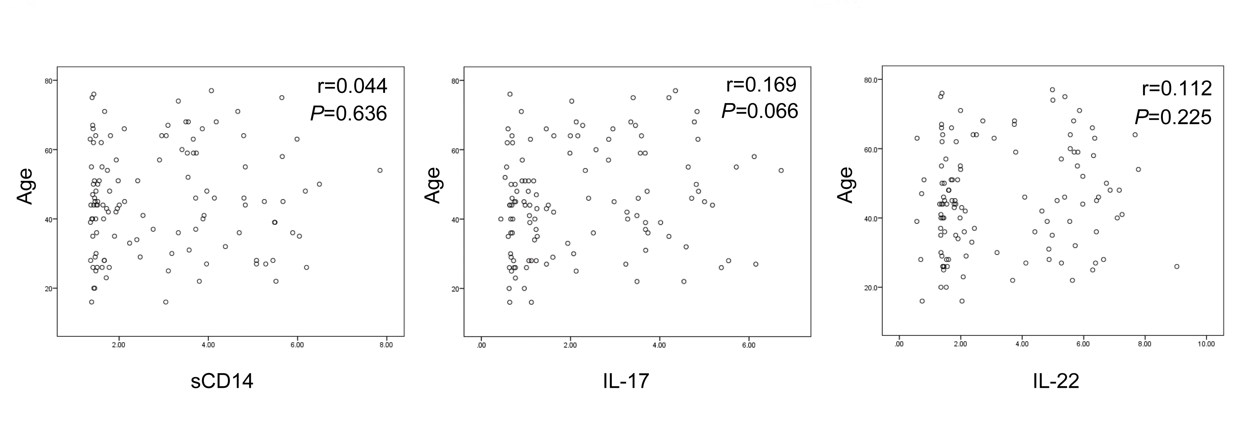

Fig. S1 Correlations between age and BALF levels of sCD14, IL-17 and IL-22 in PTB patients. The age was uncorrelated with sCD14, IL-17 and IL-22.

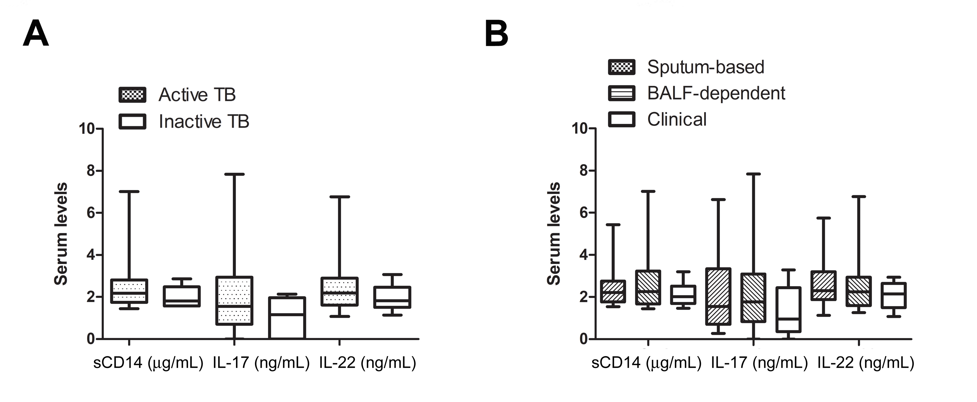
Fig. S2 Serum levels of sCD14, IL-17 and IL-22 in PTB patients. Serum levels of sCD14, IL-17 and IL-22 were comparable in patients with active and inactive PTB (A), and were not associated with bacteriological conformation manners (B).

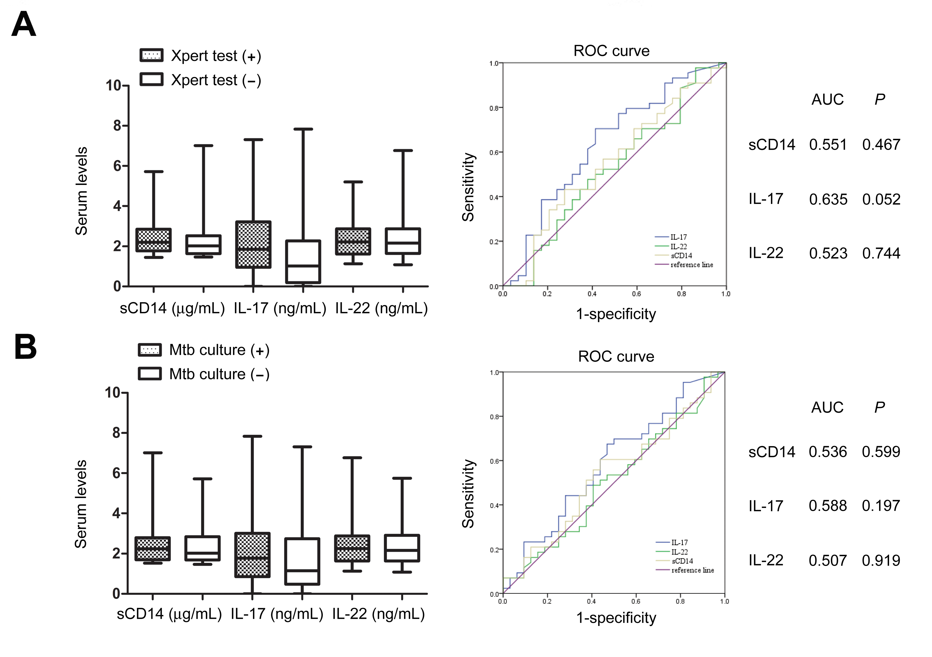
Fig. S3 Significance of serum levels of sCD14, IL-17 and IL-22 in PTB patients. Xpert, GeneXpert MTB/RIF; Mtb, Mycobacterium tuberculosis; ROC, receiver operating characteristic curve; AUC, area under roc curve; Serum levels of sCD14, IL-17 and IL-22 were unable to predict the results of Xpert (A) and Mtb culture (B).

