Supplementary Information for
Disorganization of Intercalated Discs in Dilated Cardiomyopathy

Yukinobu Ito, Makoto Yoshida *, Hirotake Masuda, Daichi Maeda, Yukitsugu Kudo-Asabe, Michinobu Umakoshi, Hiroshi Nanjo, Akiteru Goto

*Corresponding author:
Makoto Yoshida, MD, PhD
E-mail: myoshida@gipc.akita-u.ac.jp

Fig. S1
Fig. S1 Immunohistochemical findings in Hypertrophic cardiomyopathy.
Immunohistologically, in HCM, we observed no decrease in N-cadherin immunostaining (N-cadherin immunostaining; scale bar, 5 µm; original magnification, ×1000). In addition, ICDs were dyed in a band shape, with no evidence of deterioration or disorganization. Similar findings were obtained in the control and CHF groups.

Fig. S2
Fig. S2 A case diagnosed as DCM was considered to be CHF based on the results of N-cadherin immunostaining and ICD scattering.
This case was clinically diagnosed as DCM, and an autopsy was performed. Histologically, characteristic findings such as cardiomyocyte atrophy, nuclear pleomorphism, and interstitial fibrosis were not observed (A: H-E staining; scale bar, 20 µm; original magnification, ×400). ICDs were visible (B: H-E staining; scale bar, 10 µm; original magnification, ×1000).
Immunohistochemistry revealed that N-cadherin immunostaining was not reduced in ICDs, and the ICDs had a band-like appearance (C–F: N-cadherin immunostaining; scale bar, 5 µm; original magnification, ×1000). ICD scattering was not observed. Based on these findings, we classified this case as CHF. Because this patient was receiving adriamycin, we suspected adriamycin cardiomyopathy.
Fig. S3
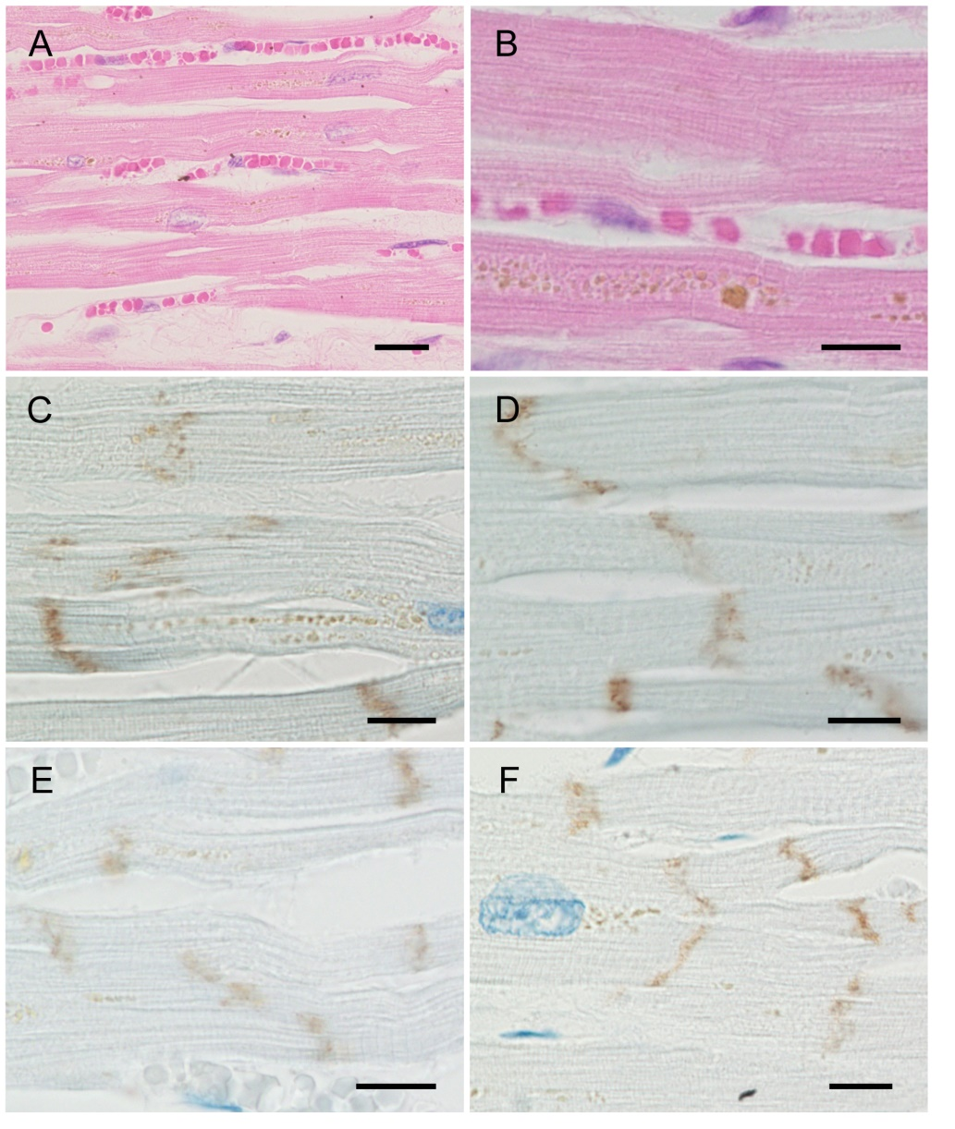
Fig. S3 A case diagnosed as CHF was considered to be DCM based the results of N-cadherin immunostaining and ICD scattering
This case was clinically diagnosed as CHF, and an autopsy was performed. Histologically, cardiomyocyte atrophy, nuclear pleomorphism, and interstitial fibrosis were observed (A: H-E staining; scale bar, 20 µm; original magnification, ×400). ICDs were not clearly visible (B: H-E staining; scale bar, 10 µm; original magnification, ×1000).
In immunohistochemistry, N-cadherin immunostaining was reduced in many ICDs, and ICD disintegration was observed (C–F: N-cadherin immunostaining; scale bar, 5 µm; original magnification, ×1000). ICD scattering was apparent. Based on these findings, we have classified this case as DCM.

