Uncovering a miltiradiene biosynthetic gene cluster in the Lamiaceae reveals a dynamic evolutionary trajectory

Abigail E. Bryson, Emily R. Lanier, Kin H. Lau, Davis Mathieu, Alan E. Yocca, Garret P. Miller, Patrick P. Edger, C. Robin Buell, Bjӧrn Hamberger.

Species | Publication | Estimated Genome size (Mb) | Assembly coverage (%) | BUSCO  (% complete) | N50 contig | N50 scaffold
Callicarpa americana | Hamilton et al, 2020 ¹ | 538 | 94.0% | 93.8% | 7.5 Mb | 29 Mb
Hyssopus officinalis | Lichman et al, 2020 ² | 341 | -- | 91.4% | n.r. | 29 Mb
Lavendula angustifolia | Malli et al, 2019 ³ | 870 | 79.1% | 89.7% | n.r. | 96 Kb
 | Li et al, 2021 ⁴ | 1016 | 90.0% | 91.4% | 1.2 Mb | 36 Mb
Mentha longifolia | Vining et al, 2017 ⁵ | 400 | 88.0% | 71.0% | n.r. | 4 Kb
Nepta cataria | Lichman et al, 2020 ² | 493 | -- | 91.4% | n.r. | 296 Kb
Nepta mussini | Lichman et al, 2020 ² | 232 | -- | 90.2% | n.r. | 503 Kb
Ocimum basilicum | Bornowski et al, 2020 ⁶ | 2360 | 87.6% | 86.7% | 48 Kb | 1.5 Mb
Ocimum sanctum | Rastogi et al, 2015 ⁷ | 386 | -- | n.r. | 12 Kb | 303 Kb
Ocimum tenuiflorum | Upadhyay et al, 2015 ⁸ | 612 | 61.0% | n.r. | n.r. | 27.1 Kb
Origanum majorana | Bornowski et al, 2020 ⁶ | 858 | 88.8% | 89.5% | 35 Kb | 1.3 Mb
Origanum vulgare | Bornowski et al, 2020 ⁶ | 705 | 89.4% | 90.1% | 26 Kb | 157 Kb
Perilla citriodora | Y. Zhang et al, 2021 ⁹ | -- | -- | 92.6% | 68 Kb | 1.2 Mb
Perilla frutescens | Y. Zhang et al, 2021 ⁹ | 1379 | 97.5% | 92.7% | 3.21 Mb | 62.64 Mb
Pogostemon cablin | He et al, 2018 Nature ¹⁰ | 2080 | 91.8% | 90.6% | 34 Kb | 699 Kb
 | He et al, 2016 Nature ¹¹ | 1576 | 73.0% | n.r. | 416 bp | 1 Kb
Rosmarinus officinalis | Bornowski et al, 2020 ⁶ | 1180 | 85.8% | 90.1% | 21 Kb | 368 Kb
Saliva miltiorrhiza | H. Xu et al, 2016 ¹² | 615 | 87.5% | n.r. | 12 kb | 51 Kb
 | G. Zhang et al, 2015 ¹³ | 645 | 99.2% | n.r. | 82 kb | 1.2 Mb
 | Song et al, 2020 ¹⁴ | 600 | 99.1% | 92.5% | 2.7 Mb | 69 Mb
 | Ma et al, 2021 ¹⁵ | 557 | 91.5% | 91.1% | 500 Kb | 1.2 Mb
Salvia splendens | Dong et al, 2018 ¹⁶ | 711 | 92.2% | 92.1% | 2.2 Mb | 3.1 Mb
 | Jia et al, 2021 ¹⁷ | 807 | 95.0% | 92.0% | 3.8 Mb | 35.1 Mb
Scutellaria baicalensis | Q. Zhao et al, 2019 ¹⁸ | 408 | 93.0% | 94.0% | 1.3 Mb | 33.2 Mb
 | Z. Xu et al, 2020 ¹⁹ | 440 | 85.3% | 91.5% | 2.1 Mb | 40.8 Mb
Scutellaria barbata | Z. Xu et al, 2020 ¹⁹ | 405 | 87.2% | 93.0% | 2.5 Mb | 23.7 Mb
Tectona grandis | Yasodha et al, 2018 ²⁰ | 465 | 79.8% | n.r. | 277 Kb | 357 Kb
 | D. Zhao et al, 2019 ²¹ | 325 | 104.0% | 92.3% | 3 Mb | 16 Mb
Supplemental Table 1. A collection of Lamiaceae genomes published to date.
 | Number of Scaffolds | Total Size of Scaffolds (bp) | Total Size of Scaffolds (Mb) | N50 Contig Length (bp) | Number of Ns (Percent Ns) | Totals Gaps (Consecutive Ns) | Largest Scaffold (bp) | Largest Scaffold (Mb)
Leonotis leonurus | 23,651 | 585,264,293 | 585.26 | 1,094,942 | 40,883,810 (7.0%) | 15,483 | 11,593,990 | 11.59
Plectranthus barbatus | 62,959 | 1,249,907,925 | 1,249.91 | 258,138 | 70,313,430 (5.6%) | 30,507 | 3,093,914 | 3.09
Prunella vulgaris | 46,736 | 820,275,670 | 820.28 | 444,240 | 38,970,920 (4.8%) | 20,293 | 5,268,047 | 5.27

Supplemental Table 2. Assembly statistics for Leonotis leonurus, Plectranthus barbatus, and Prunella vulgaris.

 | Complete BUSCOs (C) | Complete Single-Copy BUSCOs (S) | Complete Duplicate BUSCOs (D) | Fragmented BUSCOs (F) | Missing BUSCOs (M)
Leonotis leonurus | 98.5% | 80.0% | 18.5% | 0.5% | 1.0%
Plectranthus barbatus | 97.8% | 84.4% | 13.4% | 1.0% | 1.2%
Prunella vulgaris | 97.1% | 91.8% | 5.3% | 1.5% | 1.4%

Supplemental Table 3. BUSCO results for Leonotis leonurus, Plectranthus barbatus, and Prunella vulgaris. BUSCO run in genome mode with lineage dataset 'embryophyta_odb10.'

Enzyme Family | Enzyme Name | GenBank Accession | Species Name | Enzyme Function
TPS-c (Class II) | CamTPS2 | QMW69082.1 | Callicarpa americana | (-)-kolavenyl diphosphate synthase
TPS-c (Class II) | CamTPS1 | QMW69081.1 | Callicarpa americana | ent-copalyl diphosphate synthase
TPS-c (Class II) | CamTPS3 | QMW69080.1 | Callicarpa americana | ent-copalyl diposphate synthase
TPS-c (Class II) | PcTPS1 | AZB50385.1 | Pogostemon cablin | 10R-lambda-8,13E-dienyl diphosphate synthase
TPS-c (Class II) | ArTPS2 | AZB50378.1 | Ajuga reptans | cleroda-4(18),13E-dienyl diphosphate synthase
TPS-c (Class II) | LlTPS1 | AZB50381.1 | Leonotis leonurus | peregrinol diphosphate synthase
TPS-c (Class II) | ArTPS1 | AZB50377.1 | Ajuga reptans | (+)-copalyl diphosphate synthase
TPS-c (Class II) | PbTPS16 | AZB50379.1 | Plectranthus barbatus | (+)-copalyl diphosphate synthase
TPS-c (Class II) | SyTPS1 | AZB50384.1 | Salvia yangii | (+)-copalyl diphosphate synthase
TPS-c (Class II) | NrTPS1 | AZB50382.1 | Nepeta racemosa | (+)-copalyl diphosphate synthase
TPS-c (Class II) | OmTPS1 | AZB50383.1 | Ocimum basilicum | (+)-copalyl diphosphate synthase
TPS-c (Class II) | MsTPS1 | AZB50380.1 | Mesosphaerum suaveolens | lambda-7,13E-dienyl diphosphate synthase
TPS-c (Class II) | MvCPS3 | A0A075FA51.1 | Marrubium vulgare | (+)-copalyl diphosphate synthase
TPS-c (Class II) | PbTPS1 | AHW04046.1 | Plectranthus barbatus | (+)-copalyl diphosphate synthase
TPS-c (Class II) | SdCPS1 | APH81399.1 | Salvia divinorum | ent-copalyl diphosphate synthase
TPS-c (Class II) | SmCPS1 | AHJ59321.1 | Salvia miltiorrhiza | (+)-copalyl diphosphate synthase
TPS-c (Class II) | SmCPS2 | AHJ59322.1 | Salvia miltiorrhiza | (+)-copalyl diphosphate synthase
TPS-c (Class II) | SmCPS4 | AKN91186.1 | Salvia miltiorrhiza | copal-8-ol diphosphate synthase
TPS-c (Class II) | SmCPS5 | AHJ59324.1 | Salvia miltiorrhiza | ent-copalyl diphosphate synthase
TPS-c (Class II) | PbTPS2 | AHW04047.1 | Plectranthus barbatus | hydroxy-labdane diphosphate synthase
TPS-c (Class II) | SdKPS2 | A0A1S5RW73.1 | Salvia divinorum | (-)-kolavenyl diphosphate synthase
TPS-c (Class II) | IrCPS1 | A0A1X9IRQ7.2 | Isodon rubescens | (+)-copalyl diphosphate synthase
TPS-c (Class II) | VacTPS3 | A0A2K9RFZ8.1 | Vitex agnus-castus | Syn-copalyl diphosphate synthase
TPS-c (Class II) | IeCPS2 | G3E4M4.1 | Isodon eriocalyx | ent-copalyl diphosphate synthase
TPS-c (Class II) | VacTPS5 | A0A2K9RG07.1 | Vitex agnus-castus | (-)-kolavenyl diphosphate synthase
TPS-c (Class II) | IeCPS1 | G3E4M6.1 | Isodon eriocalyx | ent-copalyl diphosphate synthase
TPS-c (Class II) | SsLPS | AET21247.1 | Salvia sclarea | 13-labden-8,15-diol diphosphate synthase
TPS-c (Class II) | MvCPS1 | AIE77090.1 | Marrubium vulgare | peregrinol diphosphate synthase
TPS-e (Class I) | SmKSL1 | ABV08817.1 | Salvia miltiorrhiza | miltiradiene synthase
TPS-e (Class I) | SmKSL2 | AHJ59325.1 | Salvia miltiorrhiza | ent-kaurene synthase
TPS-e (Class I) | LlTPS4 | AZB50368.1 | Leonotis leonurus | sandaracopimaradiene synthase
TPS-e (Class I) | SdKSL1 | AOZ15897.1 | Salvia divinorum | ent-pimara-8(14),15-diene synthase
TPS-e (Class I) | VacTPS2 | A0A2K9RFZ2.1 | Vitex agnus-castus | (13S)-vitexifolin A synthase; 9,13-epoxylabda-14-ene synthase; Viteagnusin D synthase
TPS-e (Class I) | IrKSL6 | A0A1Z3GCD1.1 | Isodon rubescens | isopimaradiene synthase
TPS-e (Class I) | MsTPS1 | AZB50369.1 | Mentha spicata | sandaracopimaradiene/ labd-13(16),14-diene-9-ol/ ent-13-epi-manoyl oxide synthase
TPS-e (Class I) | NrTPS2 | AZB50370.1 | Nepeta racemosa | ent-kaurene synthase
TPS-e (Class I) | IrKSL3 | A0A1X9ISH5.2 | Isodon rubescens | nezukol synthase; kaurene synthase, miltiradiene synthase
TPS-e (Class I) | IrKSL4 | A0A1Z3GBK8.1 | Isodon rubescens | ent-atiserene synthase; kaurene synthase
TPS-e (Class I) | PbTPS3 | AHW04048.1 | Plectranthus barbatus | miltiradiene synthase
TPS-e (Class I) | PbTPS4 | AHW04049.1 | Plectranthus barbatus | miltiradiene synthase
TPS-e (Class I) | SsScS | G8GJ94.1 | Salvia sclarea | sclareol synthase
TPS-e (Class I) | MvELS | AIE77094.1 | Marrubium vulgare | 9,13-epoxy-labd-14-en synthase
TPS-e (Class I) | OmTPS3 | AZB50371.1 | Ocimum basilicum | trans-abienol synthase
TPS-e (Class I) | OmTPS4 | AZB50372.1 | Ocimum basilicum | manool synthase
TPS-e (Class I) | OmTPS5 | AZB50373.1 | Ocimum basilicum | palustradiene synthase
TPS-e (Class I) | SyTPS3 | AZB50374.1 | Salvia yangii | miltiradiene synthase
TPS-e (Class I) | PvTPS1 | AZB50375.1 | Prunella vulgaris | miltiradiene synthase
TPS-e (Class I) | SoTPS1 | AZB50376.1 | Salvia officinalis | miltiradiene synthase
TPS-e (Class I) | ArTPS3 | AZB50367.1 | Ajuga reptans | miltiradiene synthase
TPS-e (Class I) | PbEKS | AGN70881.1 | Plectranthus barbatus | ent-kaurene synthase
CYP76AK/AH | SmCYP76AH1 | AGN04215.1 | Salvia miltiorrhiza | ferruginol synthase
CYP76AK/AH | SmCYP76AK1 | A0A125QZE2.1 | Salvia miltiorrhiza | 11-hydroxysugiol 20-monooxygenase
CYP76AK/AH | SmCYP76AK2 | AJD25182.1 | Salvia miltiorrhiza | Involved in terpenoid biosynthesis
CYP76AK/AH | SmCYP76AK3 | AJD25183.1 | Salvia miltiorrhiza | Involved in terpenoid biosynthesis
CYP76AK/AH | SmCYP76AH3 | AMB36496.1 | Salvia miltiorrhiza | ferruginol oxidase
CYP76AK/AH | RoCYP76AK7 | A0A1D8QMD2.1 | Rosmarinus officinalis | carnosic acid synthase
CYP76AK/AH | RoCYP76AK8 | A0A1D8QMG4.1 | Rosmarinus officinalis | carnosic acid synthase
CYP76AK/AH | RoCYP76AH23 | KP091844.1 | Rosmarinus officinalis | ferruginol synthase
CYP76AK/AH | RoCYP76AH22 | A0A0C5Q4Y6 | Rosmarinus officinalis | ferruginol synthase
CYP76AK/AH | SpCYP76AK6 | A0A0S1TPC7.1 | Salvia pomifera | carnosic acid synthase
CYP76AK/AH | SfCYP76AK6 | A0A1D8QMD1.1 | Salvia fruticosa | carnosic acid synthase
CYP76AK/AH | SfCYP76AH24 | A0A0C5QRZ2 | Salvia fruticosa | ferruginol synthase
CYP76AK/AH | SdCYP76AH39 | QMS79243.1 | Salvia divinorum | crotonolide G synthase
CYP76AK/AH | PbCYP76AH15 | AMZ03402.1 | Plectranthus barbatus | 11-oxo-13R-manoyl oxide synthase
CYP76AK/AH | PbCYP76AH17 | AMZ03404.1 | Plectranthus barbatus | 11-oxo-13R-manoyl oxide synthase; 1,11-dihydroxy-13R-manoyl oxide synthase
CYP76AK/AH | PbCYP76AH9 | AMZ03391.1 | Plectranthus barbatus | keto-13R- manoyl oxide (8,13-epoxy-labd-14-ene-1 1 -one) synthase or hydroxy- 13R-manoyl oxide synthase
CYP76AK/AH | PbCYP76AH8 | AMZ03392.1 | Plectranthus barbatus | 11-oxo-13R-manoyl oxide synthase; 1,11-dihydroxy-13R-manoyl oxide synthase
CYP76AK/AH | PbCYP76AH11 | AMZ03393.1 | Plectranthus barbatus | 6,7-dihydroxy-11-keto-manoyl oxide synthase; 11-oxo-13R-manoyl oxide synthase
CYP71D | SmCYP71D375 | AWD93836.1 | Salvia miltiorrhiza | miltirone/4-methylenemiltirone 16-hydroxylase
CYP71D | SmCYP71D411 | AJD25164.1 | Salvia miltiorrhiza | 11-hydroxysugiol 20-monooxygenase
CYP71D | MgCYP71D18 | Q6WKZ1.1 | Mentha x gracilis | (-)-(4S)-Limonene-6-hydroxylase
CYP71D | MpCYP71D13 | Q9XHE7.1 | Mentha x piperita | (-)-(4S)-Limonene-6-hydroxylase
CYP71D | PbCYP71D381 | KT382342.1 | Plectranthus barbatus | 13R-manoyl oxide oxidase
CYP71D | AtCYP71B2 | OAP13205.1 | Arabidopsis thaliana | nf
CYP71D | AtCYP71B3 | OAP05595.1 | Arabidopsis thaliana | nf
CYP71D | ZzCYP71BA1 | BAJ39893.1 | Zingiber zerumbet | 8-hydroxy-alpha-humulene synthase
CYP71D | VvCYP71BC1 |  | Vitis vinifera
CYP71D | VvCYP71BE1 | BAT70339.1 | Vitis vinifera | Sesquiterpene oxidase
CYP71D | NtCYP71D16 | AAD47832.1 | Nicotiana tabacum | Cembratriene‐diol hydroxylase
CYP71D | SpCYP71BE52 | ALM25794.1 | Salvia pomifera | Salviol synthase
CYP71D | SmCYP71D373 | Ma et al 2021 | Salvia miltiorrhiza | 2-isopropyl-8-methylphenanthrene-3,4-dione
CYP71D | SmCYP71D464 | Ma et al 2021 | Salvia miltiorrhiza | nf
CYP71D | SmCYP71D410 | AJD25163.1 | Salvia miltiorrhiza | nf
Supplemental Table 4. Species, enzyme names, GenBank accessions, and listed functions for reference enzymes used in the phylogenies in this study.

Gene | Direction | Sequence, 5’-3’
CamCYP76AH64 | F | TCTAAATGGATTTCTTTGCTCTT
CamCYP76AH64 | R | GGAGAGAATGTCTATGGTTCAC
CamCYP76AH65 | F | ATGGATCTCTTTGAGCTCCTCGTT
CamCYP76AH65 | R | TCAGAGCTTGATCGGAGTAGCCTT
CamCYP76AH66 | F | ATGGATTTCTTTGCATTTTTTATTG
CamCYP76AH66 | R | TCATGGTTTGATAGGAATTGC
CamCYP76AH67 | F | GAACAAATTGAGATGGATCT
CamCYP76AH67 | R | CATATTTCATAAGATCAAGGCT
CamCYP76AH68 | F | ATGGATCTCTATGCCCTTTT
CamCYP76AH68 | R | ATATTTCACAAAATCATCAGGG
CamCYP76AH69 | F | CACTAGTCTCATGGAGTTT
CamCYP76AH69 | R | ATAATCATTTGACCTGCTTGAAA
CamCYP71D716 | F | TTTGTCAACCTTATGGAGTTT
CamCYP71D716 | R | AAAAGGTCTCCTAACAGTG
CamCYP71D717 | F | ATGGAGTTTGAGTTCCCATC
CamCYP71D717 | R | TCATTTGACCTGCTTGAAAG
CamTPS7 | F | ATGACCTCTATATCCACTGTTCT
CamTPS7 | R | TCATACAACTGGTTCAAATAGTACT
CamTPS9 | F | ATGTCACTCAGTTTCAACCTCA
CamTPS9 | R | GCTTCATGAGGAGGAAGGAAGT
CamTPS10 | F | ACCAATCCCATGAAACTTTCAT
CamTPS10 | R | TATACATAAACCAAAATACCCAAATCG
Supplemental Table 5. Primers used in this study.

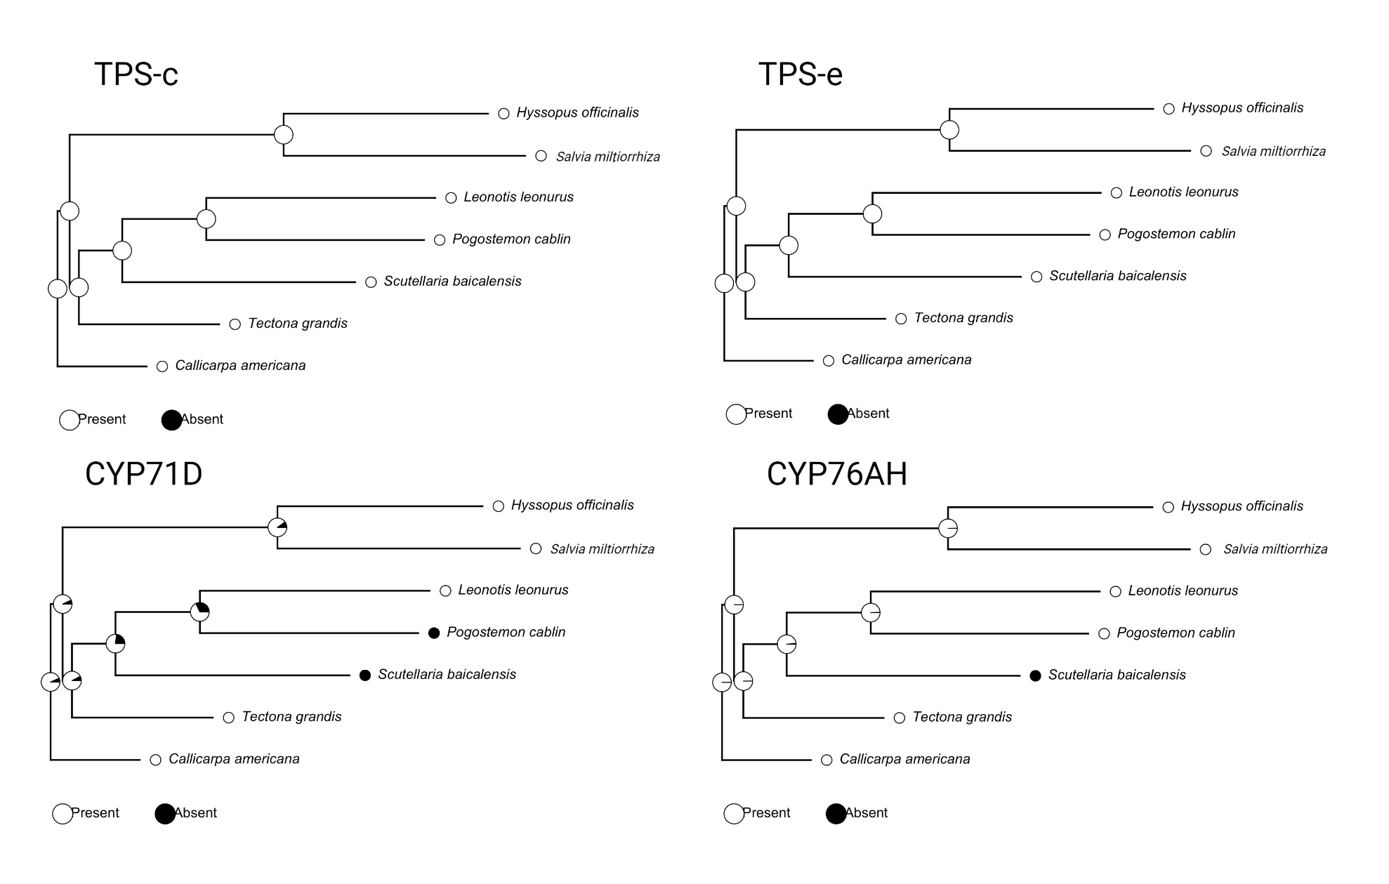
Supplemental Fig. 1. Ancestral reconstruction of syntenic genes present across all examined species. Circles at each node represent presence/absence (white/black, respectively) of each gene. Analysis was performed using the R package phytools.

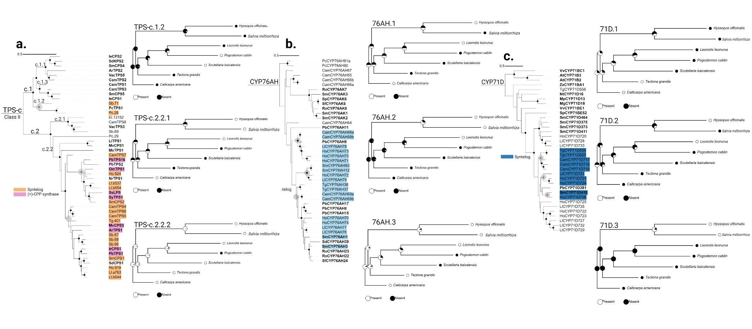Supplemental Fig. 2. Ancestral reconstruction of syntenic genes present across all examined species in a lineage-central manner. Circles at each node represent presence/absence (white/black, respectively) of each gene. Each ancestral reconstruction is represented by gray nodes on the main enzyme phylogeny. Analysis was performed using the R package phytools.

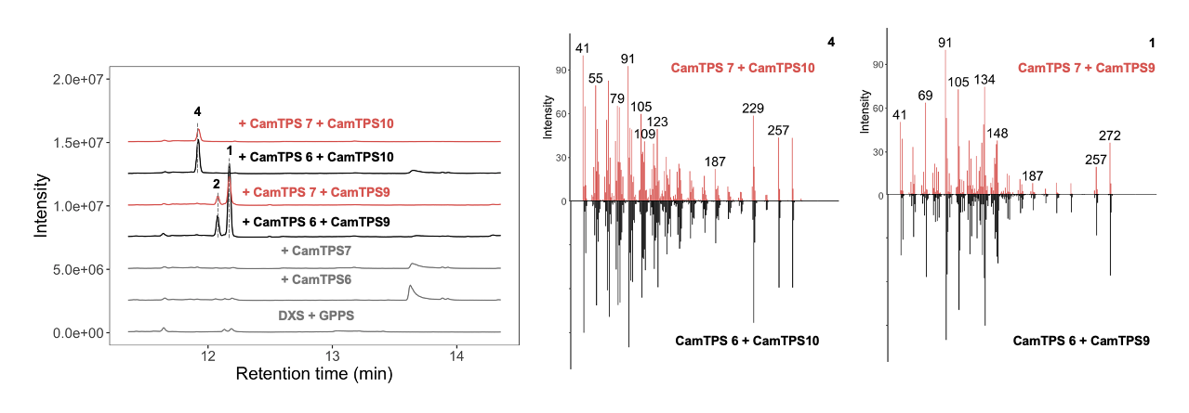Supplemental Fig. 3. Characterization of CamTPS7 as a (+)-CPP synthase by comparison with CamTPS6. Both produce 1 & 2 when paired with CamTPS9 (miltiradiene synthase) and 4 when paired with CamTPS10 ((+)-kaurene synthase).

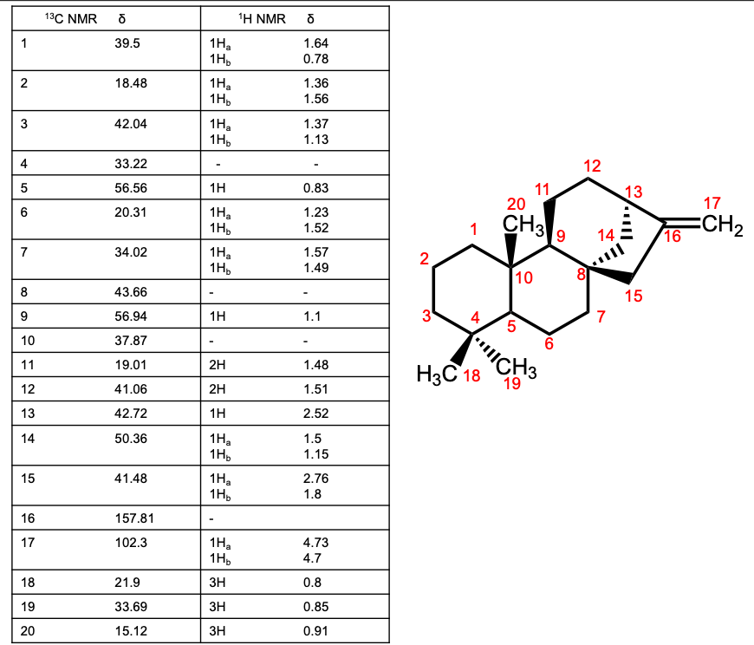
Supplemental Fig. 4. NMR analysis confirms that 4 is (+)-kaurene. Connectivity was deduced from ¹ H, ¹³C, HSQC, HMBC, and COESY correlations. CDCl3 was used as the solvent, and CDCl3 peaks were referenced to 7.26 and 77.00 ppm for ¹H and ¹³C spectra, respectively. Relative stereochemistry was assigned based on NOESY correlations. Selected NOESY correlations are shown on a 3D representation of (+)-kaurene generated with the Cahn–Ingold–Prelog CIP Tool ²². Absolute stereochemistry was assigned based on the configuration of (+)-CPP, the precursor of 4. Continued on following pages.

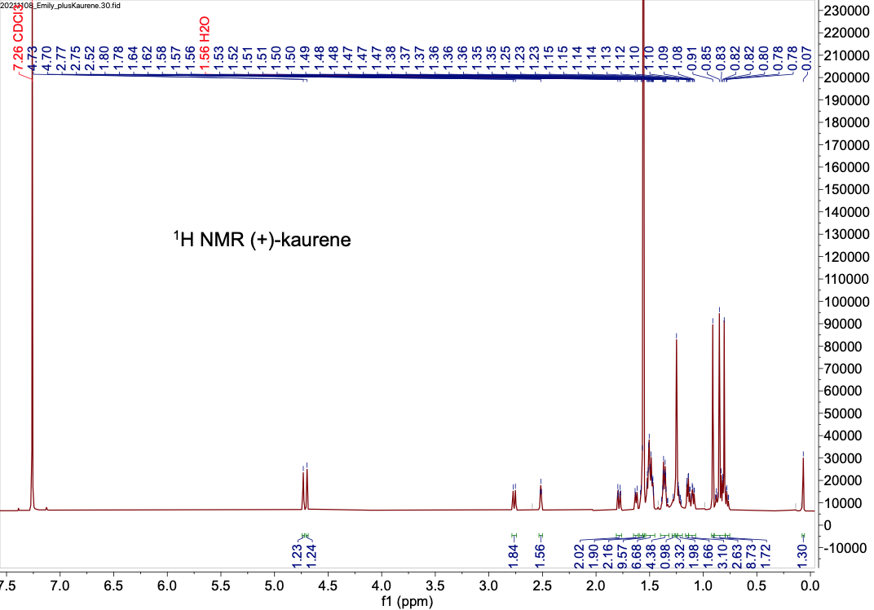
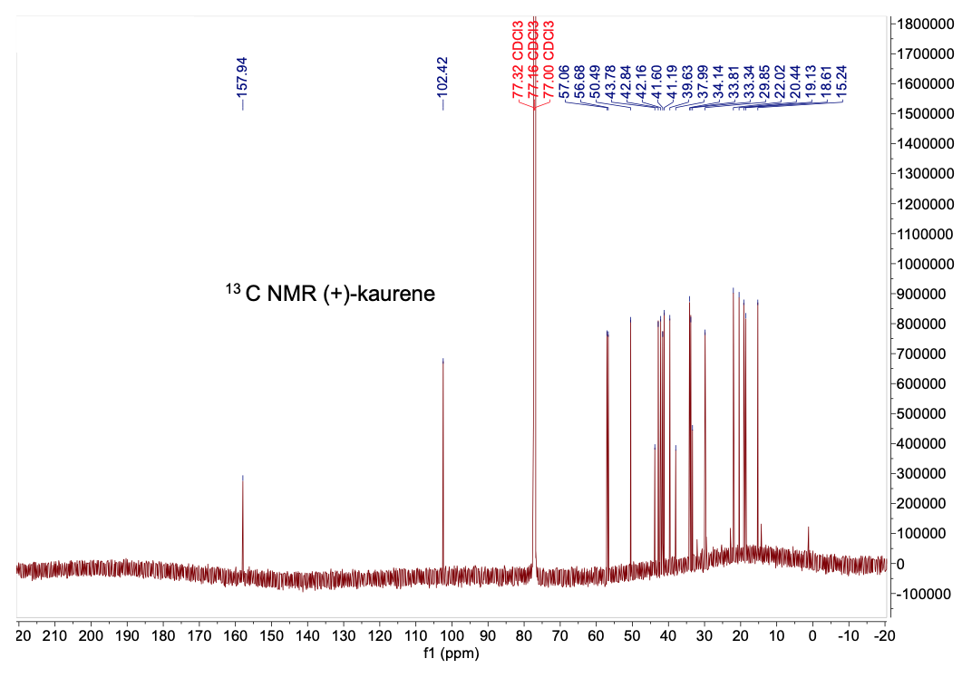
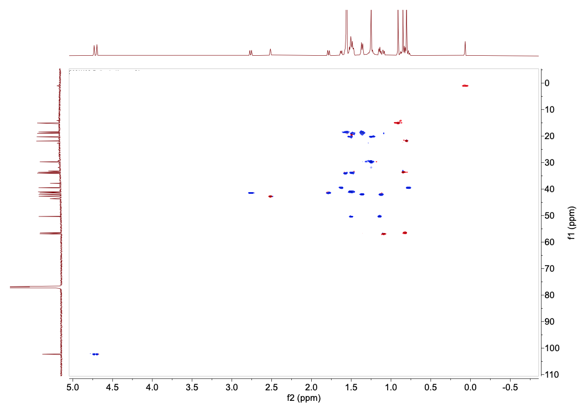
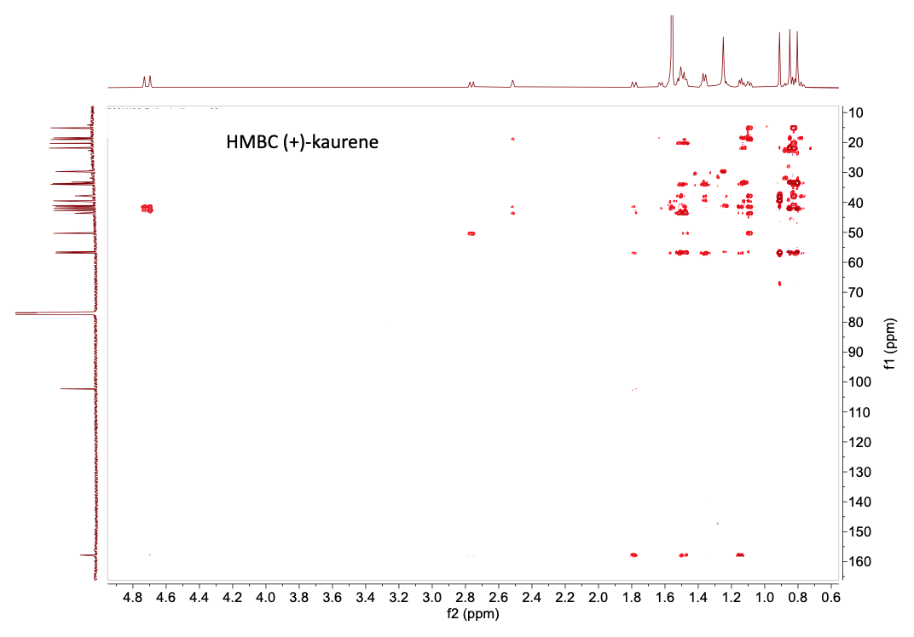
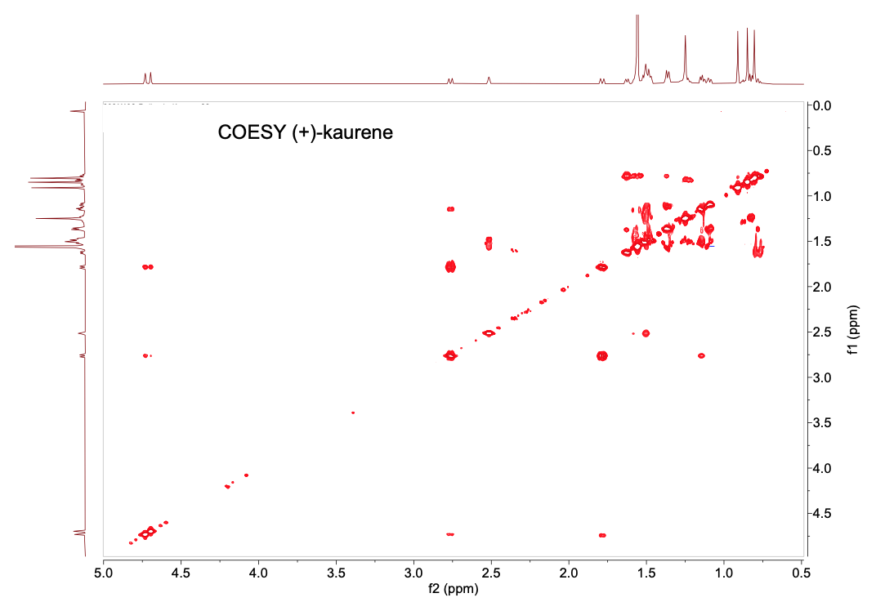
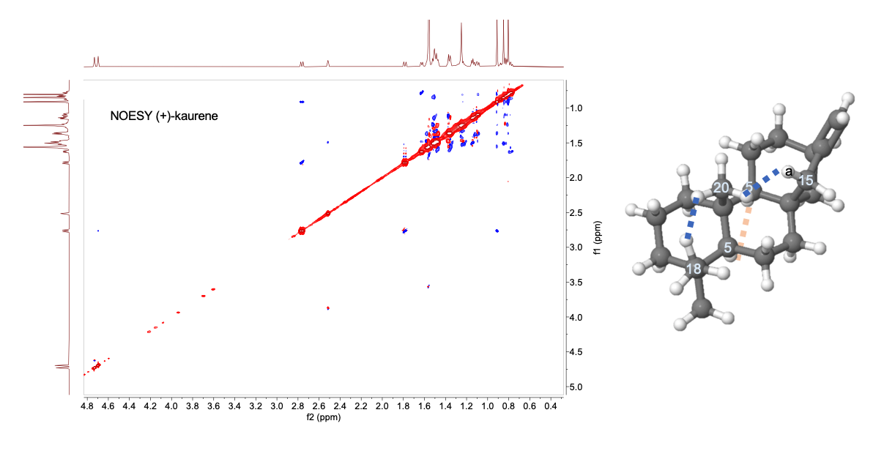

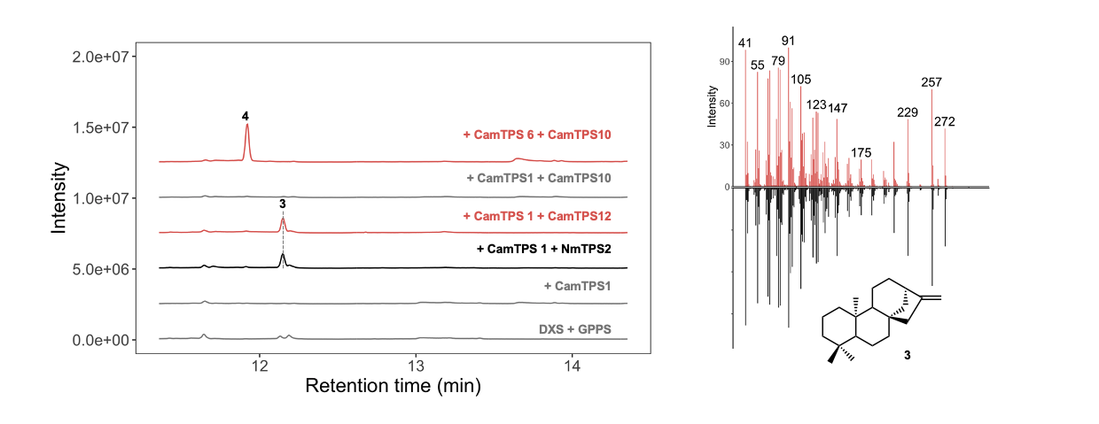
Supplemental Fig. 5. Characterization of CamTPS12 as an ent-kaurene synthase by comparison with the product of NmTPS2²³ when combined with the ent-CPP synthase CamTPS1¹.

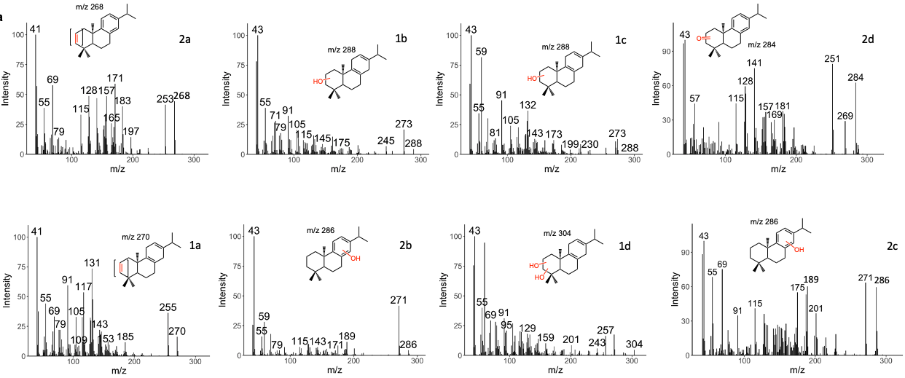
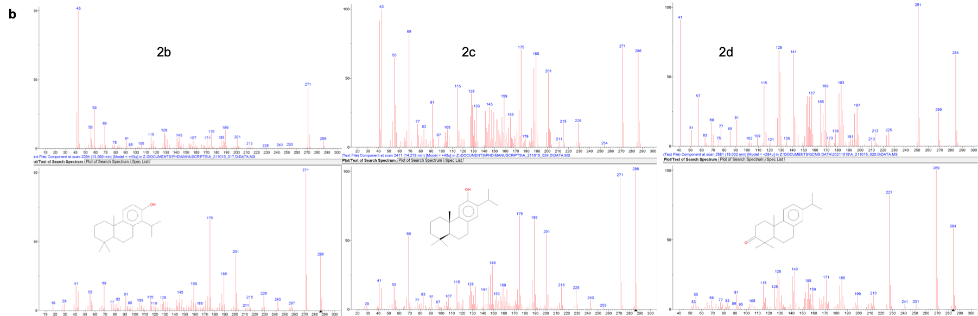
Supplemental Fig. 6. Mass spectra of the CYP76AH oxidation products (a) and information for relevant NIST database hits (b). Analysis of the mass spectra led to tentative assignment of 1a and 2a as miltiradiene and abietatriene respectively with an additional desaturation, possibly due to water loss, based on observed loss of 2 m/z compared with the parent spectrum. 1b and 1c display molecular ions consistent with a single oxidation of miltiradiene while 1d is apparently a doubly hydroxylated analog. 2b and 2c have characteristic m/z values of the aromatic abietatriene backbone (high intensity 271 and 286) and are good matches to single hydroxylation on the c-ring. 2d has a molecular ion that would correspond to keto-abietatriene and shows a similar spectrum to abietatrien-3-one from the NIST database.

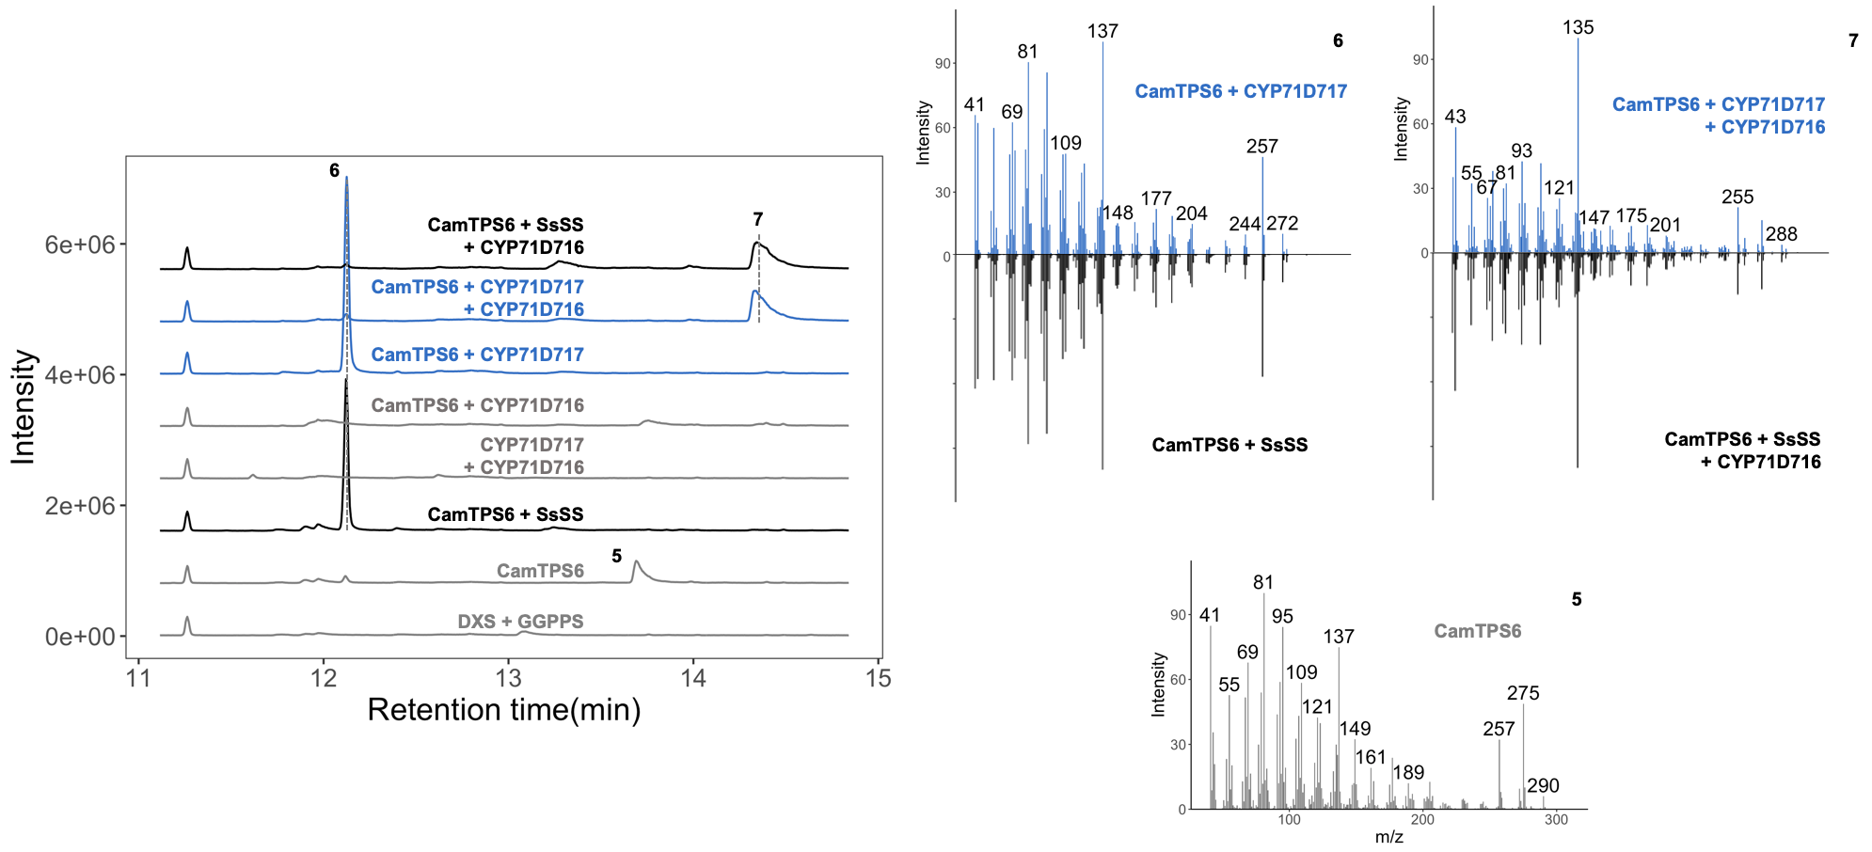
Supplemental Fig. 7. Further analysis of CamCYP71D717 shows that it unexpectedly functions as a (+)-manool synthase when expressed in N. benthamiana. We compared retention times and mass spectra of products when SsSS, a promiscuous class I TPS known to afford (+)-manool from (+)-CPP²⁴, was substituted for CamCYP71D17. Based on recent work demonstrating CYP oxidation of kolavenol but not kolavenyl diphosophate²⁵, we suggest that CamCYP71D717 is catalyzing an isomerization of (+)-copalol (6) which is produced by endogenous phosphatases in N. benthamiana when a (+)-CPP synthase is expressed.

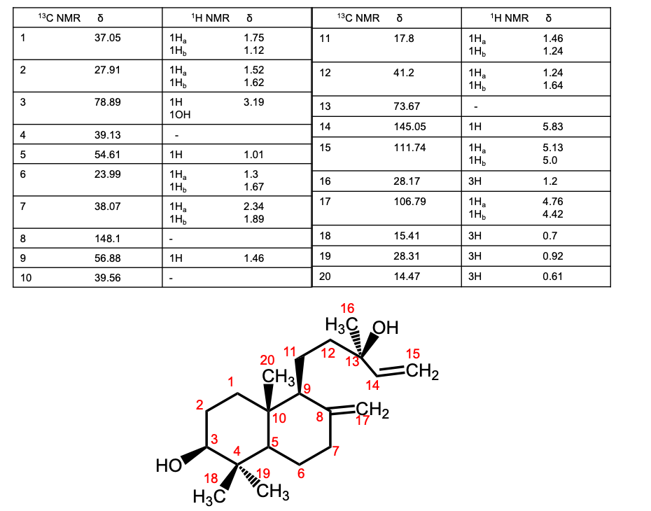
Supplemental Fig 8. NMR analysis of 3(S)-hydroxy-(+)-manool (7). Connectivity was deduced from ¹ H, ¹³C, HSQC, HMBC, and COESY correlations. CDCl3 was used as the solvent, and CDCl3 peaks were referenced to 7.26 and 77.00 ppm for ¹H and ¹³C spectra, respectively. Selected NOESY correlations are shown to support assignment of relative stereochemistry. Absolute stereochemistry was assigned based on the configuration of (+)-CPP, the precursor of 7. Continued on the following pages.
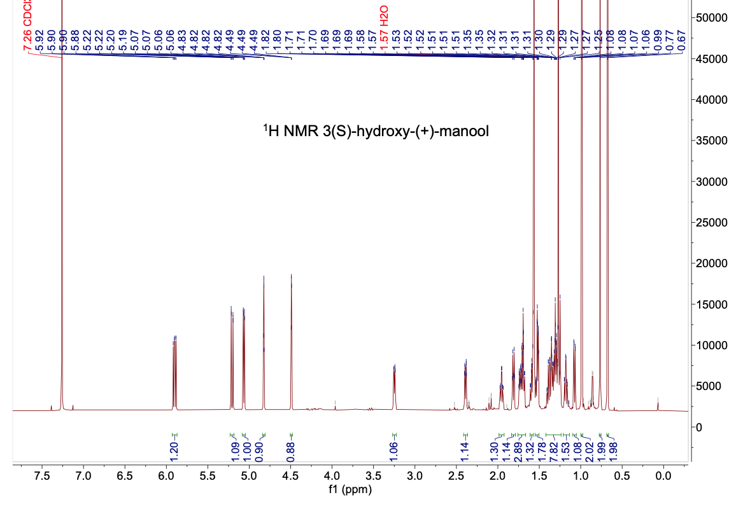

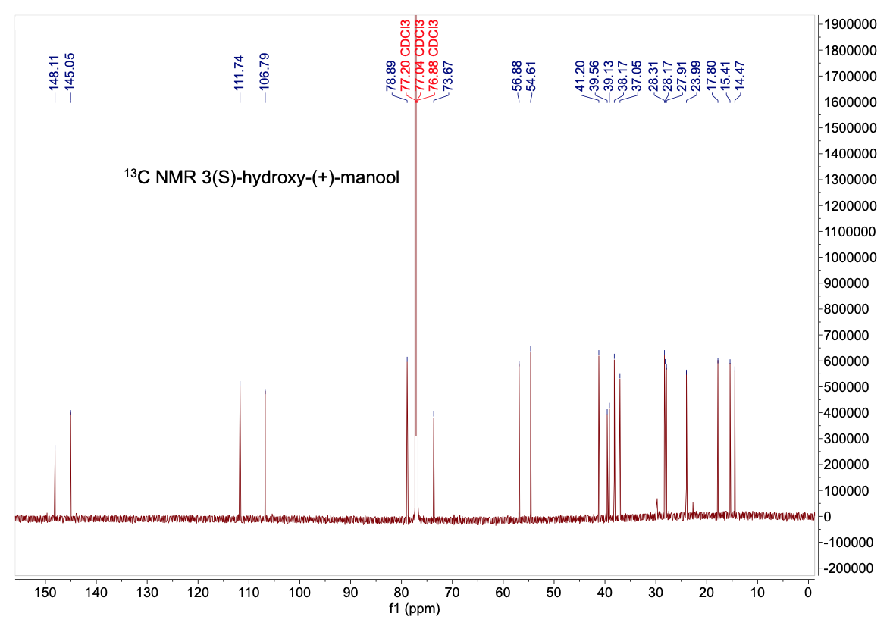
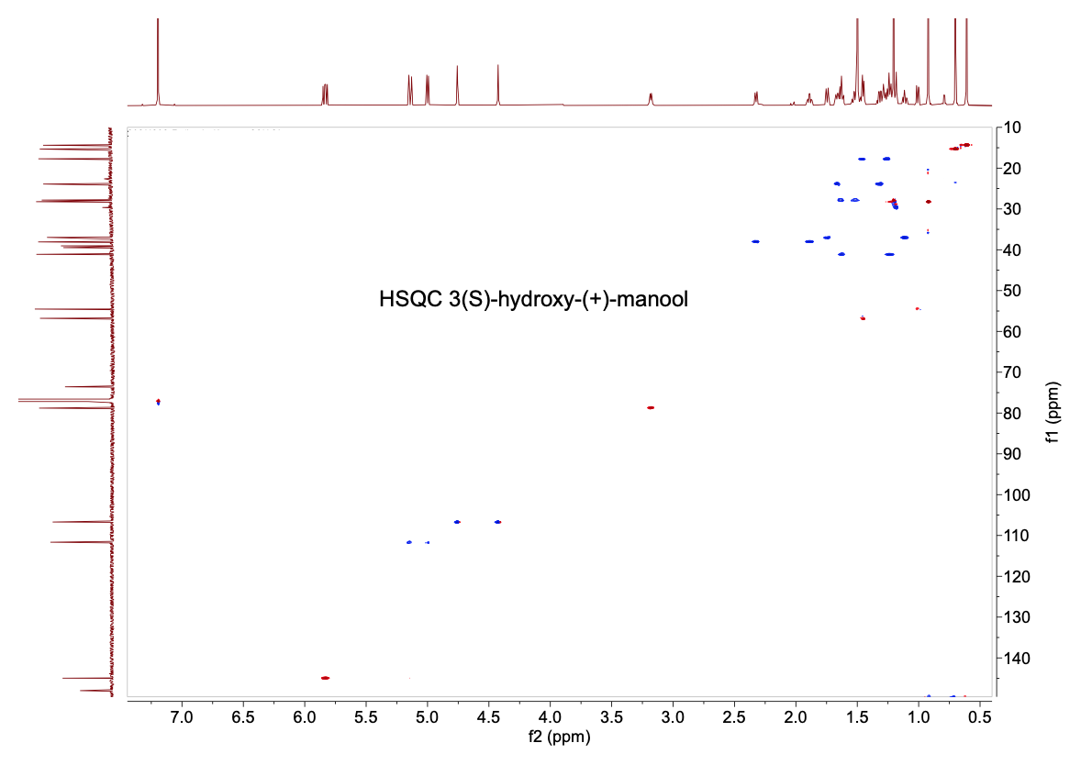
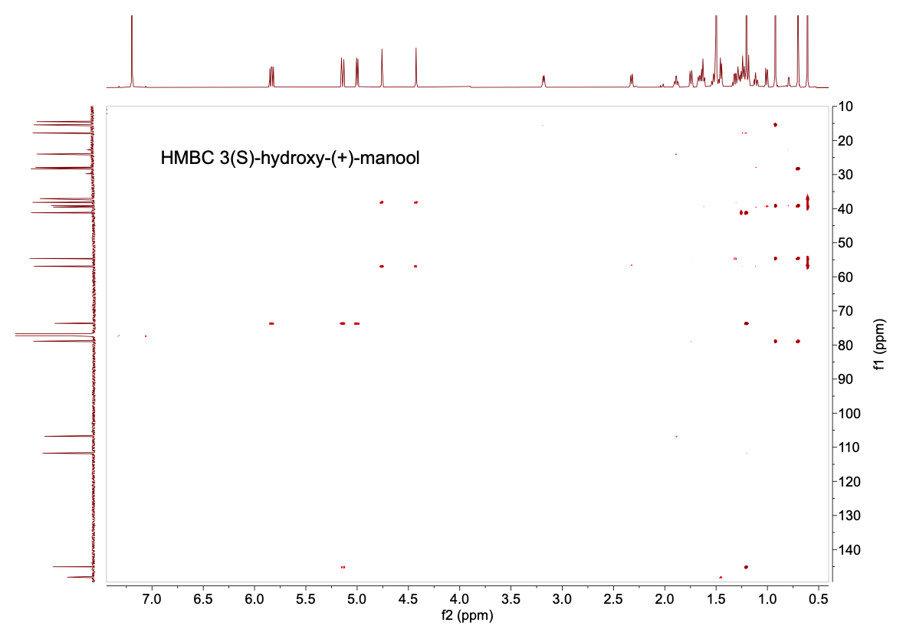

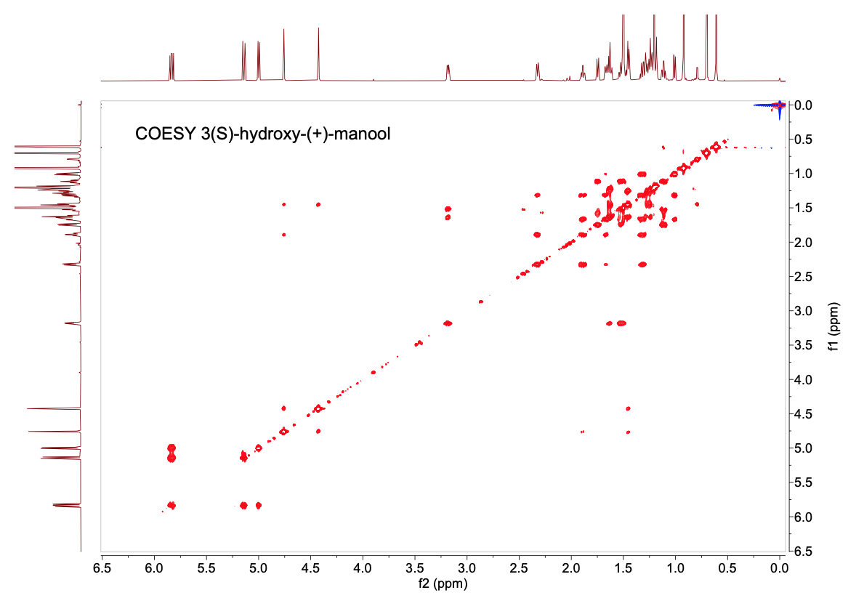
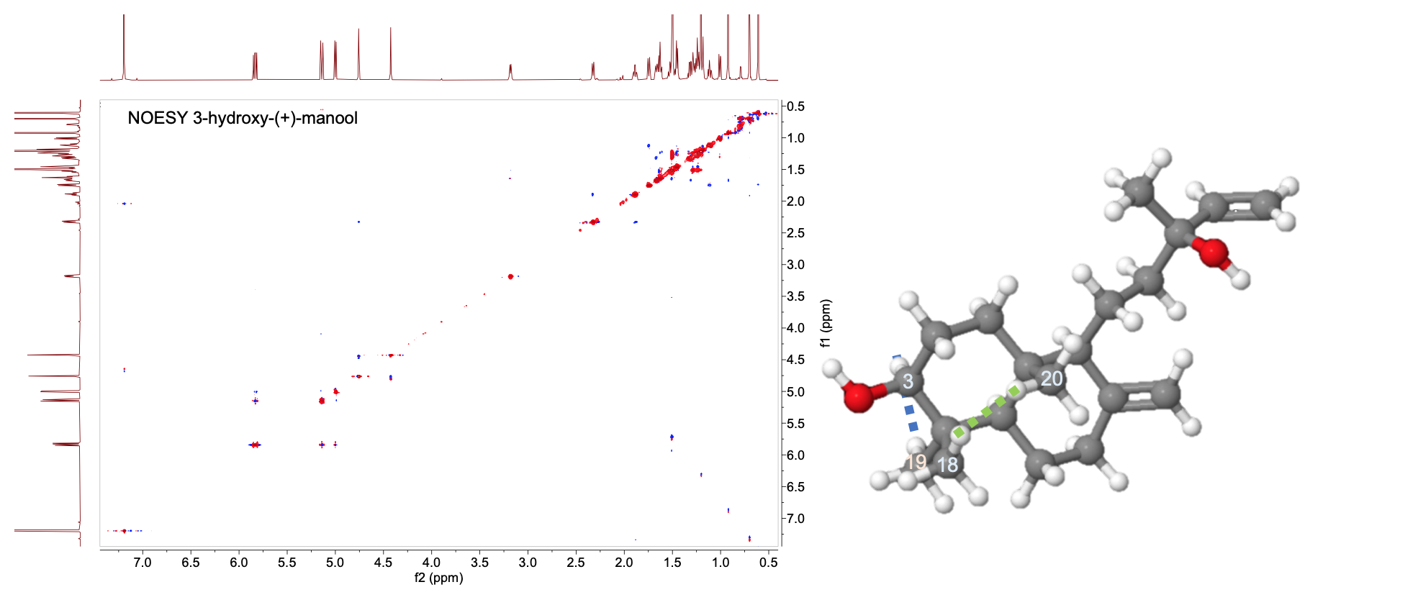

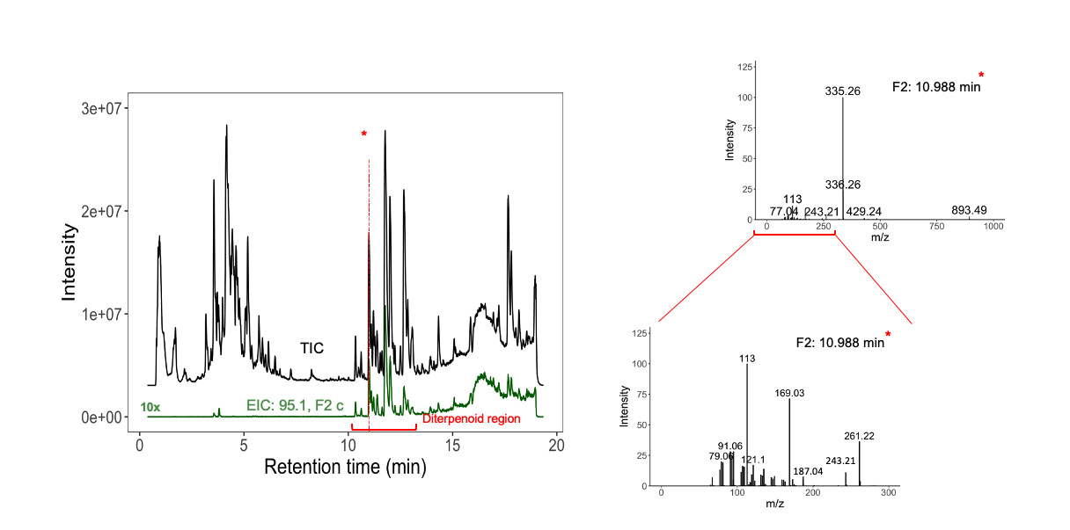

Supplemental Fig. 9. LC-MS/MS analysis of a methanol root extract from C. americana. The total ion chromatogram compared with an extracted ion chromatogram of m/z 95.1 (function 2 (F2), MS/MS), a characteristic fragment ion of diterpenes, show that most diterpenoids elute around 10-12 minutes with this method. Inspection of the mass spectrum of F2, the MS^{e} spectrum, shows a characteristic diterpenoid fragmentation pattern.

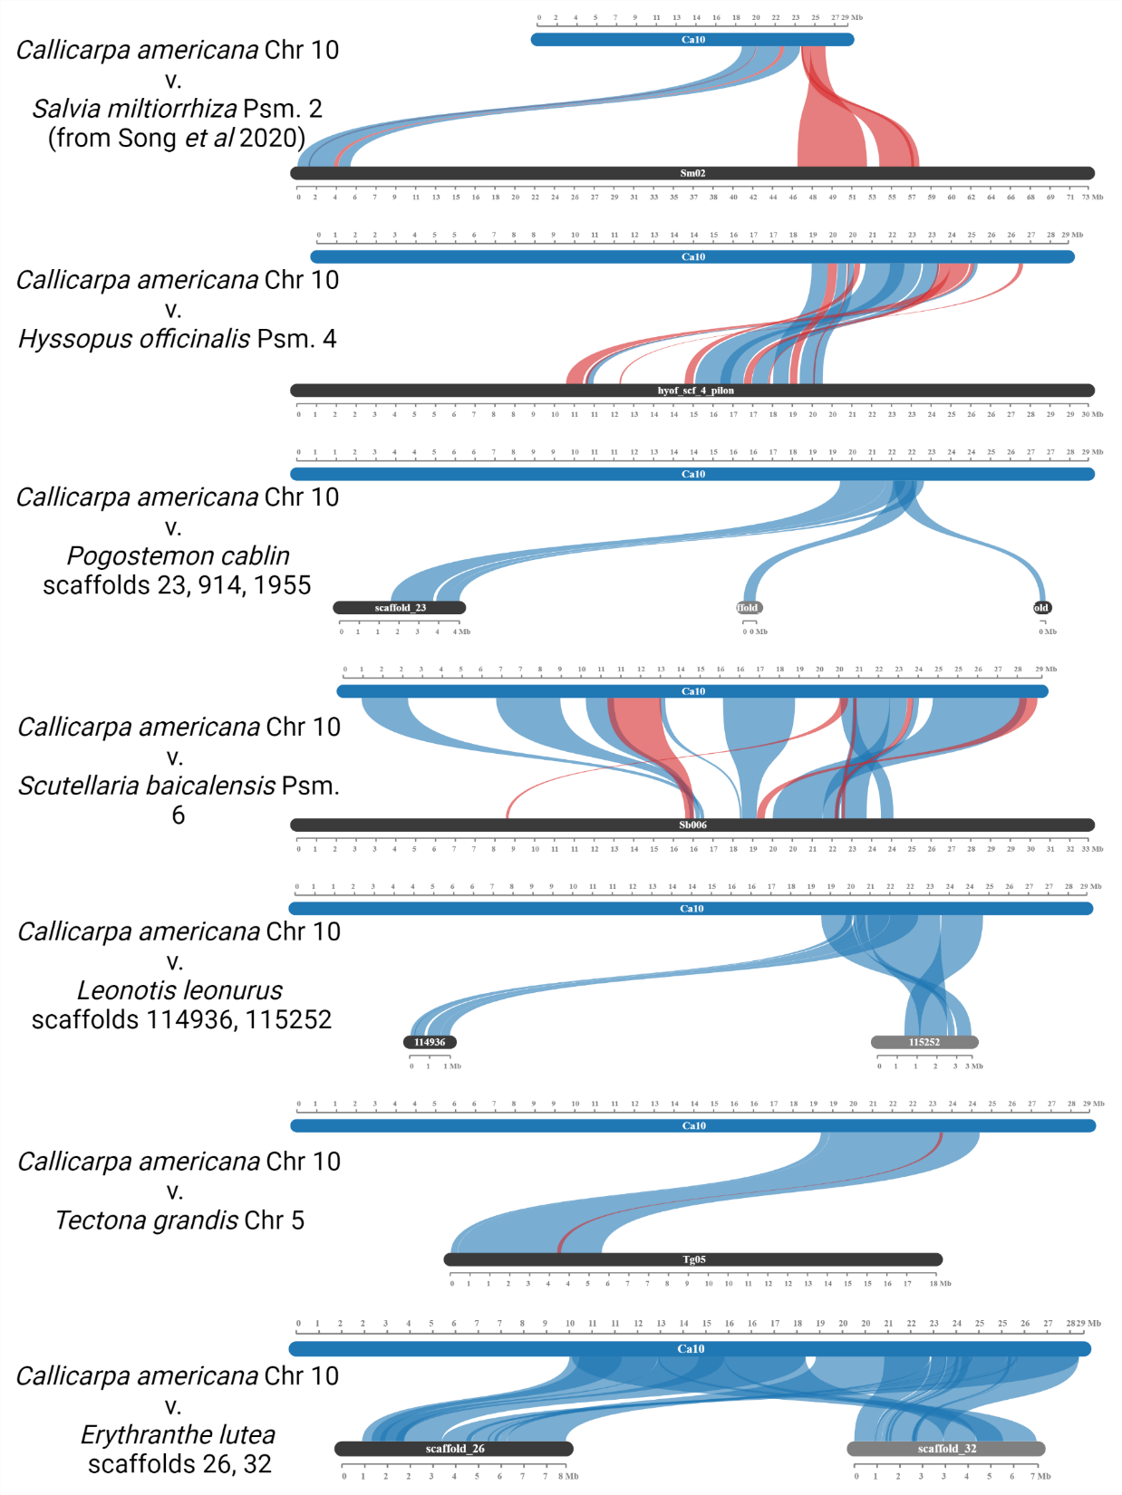
Supplemental Fig. 10. Synteny of chromosomes and scaffolds containing the miltiradiene BGC. This cluster ranges from approximately 21.92-22.33 Mb on the Callicarpa americana chromosome 10, represented here as the top chromosome in each comparison. Blue lines represent collinear blocks, red lines represent inverted collinear blocks. Analysis was performed using MCScanX software and visualized using SynVisio.
SUPPLEMENTAL REFERENCES
1. Hamilton, J. P. et al. Generation of a chromosome-scale genome assembly of the insect-repellent terpenoid-producing Lamiaceae species, Callicarpa americana. GigaScience 9, giaa093 (2020).
2. Lichman, B. R., Godden, G. T. & Buell, C. R. Gene and genome duplications in the evolution of chemodiversity: perspectives from studies of Lamiaceae. Curr. Opin. Plant Biol. 55, 74–83 (2020).
3. Malli, R. P. N., Adal, A. M., Sarker, L. S., Liang, P. & Mahmoud, S. S. De novo sequencing of the Lavandula angustifolia genome reveals highly duplicated and optimized features for essential oil production. Planta 249, 251–256 (2019).
4. Li, J. et al. The chromosome-based lavender genome provides new insights into Lamiaceae evolution and terpenoid biosynthesis. Hortic. Res. 8, 1–14 (2021).
5. Vining, K. J. et al. Draft genome sequence of Mentha longifolia and development of resources for mint cultivar improvement. Mol. Plant 10, 323–339 (2017).
6. Bornowski, N. et al. Genome sequencing of four culinary herbs reveals terpenoid genes underlying chemodiversity in the Nepetoideae. DNA Res. 27, dsaa016 (2020).
7. Rastogi, S. et al. Unravelling the genome of Holy basil: an “incomparable” “elixir of life” of traditional Indian medicine. BMC Genomics 16, 413 (2015).
8. Upadhyay, A. K. et al. Genome sequencing of herb Tulsi (Ocimum tenuiflorum) unravels key genes behind its strong medicinal properties. BMC Plant Biol. 15, 212 (2015).
9. Zhang, Y. et al. Incipient diploidization of the medicinal plant Perilla within 10,000 years. Nat. Commun. 12, 5508 (2021).
10. He, Y. et al. Building an octaploid genome and transcriptome of the medicinal plant Pogostemon cablin from Lamiales. Sci. Data 5, 180274 (2018).
11. He, Y. et al. Survey of the genome of Pogostemon cablin provides insights into its evolutionary history and sesquiterpenoid biosynthesis. Sci. Rep. 6, 26405 (2016).
12. Xu, H. et al. Analysis of the genome sequence of the medicinal plant Salvia miltiorrhiza. Mol. Plant 9, 949–952 (2016).
13. Zhang, G. et al. Hybrid de novo genome assembly of the Chinese herbal plant danshen (Salvia miltiorrhiza Bunge). GigaScience 4, s13742-015-0104–3 (2015).
14. Song, Z. et al. A high-quality reference genome sequence of Salvia miltiorrhiza provides insights into tanshinone synthesis in its red rhizomes. Plant Genome 13, e20041 (2020).
15. Ma, Y. et al. Expansion within the CYP71D subfamily drives the heterocyclization of tanshinones synthesis in Salvia miltiorrhiza. Nat. Commun. 12, 685 (2021).
16. Dong, A.-X. et al. High-quality assembly of the reference genome for scarlet sage, Salvia splendens, an economically important ornamental plant. GigaScience 7, giy068 (2018).
17. Jia, K.-H. et al. Chromosome-scale assembly and evolution of the tetraploid Salvia splendens (Lamiaceae) genome. Hortic. Res. 8, 1–15 (2021).
18. Zhao, Q. et al. The reference genome sequence of Scutellaria baicalensis provides insights into the evolution of wogonin biosynthesis. Mol. Plant 12, 935–950 (2019).
19. Xu, Z. et al. Comparative genome analysis of Scutellaria baicalensis and Scutellaria barbata reveals the evolution of active flavonoid biosynthesis. Genomics Proteomics Bioinformatics 18, 230–240 (2020).
20. Yasodha, R. et al. Draft genome of a high value tropical timber tree, Teak (Tectona grandis L. f): Insights into SSR diversity, phylogeny and conservation. DNA Res. 25, 409–419 (2018).
21. Zhao, D. et al. A chromosomal-scale genome assembly of Tectona grandis reveals the importance of tandem gene duplication and enables discovery of genes in natural product biosynthetic pathways. GigaScience 8, (2019).
22. Mistry, N., Singh, R. & Ridley, J. A web-based stereochemistry tool to improve students’ ability to draw newman projections and chair conformations and assign R/S labels. J. Chem. Educ. 97, 1157–1161 (2020).
23. Johnson, S. R. et al. A database-driven approach identifies additional diterpene synthase activities in the mint family (Lamiaceae). J. Biol. Chem. 294, 1349–1362 (2019).
24. Caniard, A. et al. Discovery and functional characterization of two diterpene synthases for sclareol biosynthesis in Salvia sclarea (L.) and their relevance for perfume manufacture. BMC Plant Biol. 12, 119 (2012).
25. Kwon, M. et al. Cytochrome P450-catalyzed biosynthesis of a dihydrofuran neoclerodane in magic mint ( Salvia divinorum ). ACS Catal. 12, 777–782 (2022).

