Supplemental Figures and Legends
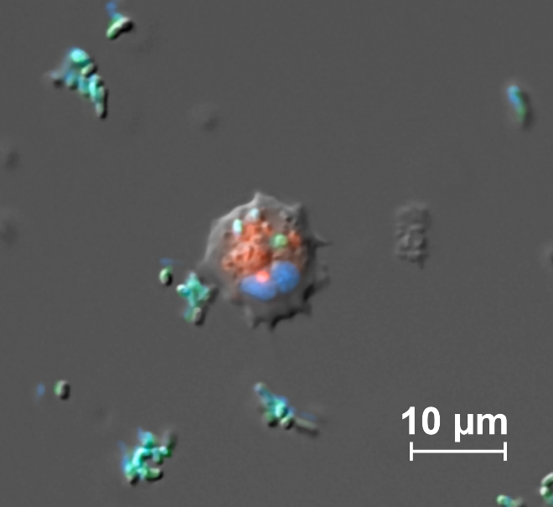
Supp. Figure 1: Merged brightfield and fluorescent image of a live Mnemiopsis motile, stellate cell that has phagocytosed fluorescent E. coli (green). Nuclei are labeled with Hoechst (blue). Lysosomes are labeled with Lysotracker-redDND99 (red). Scale bar is 10 μm.

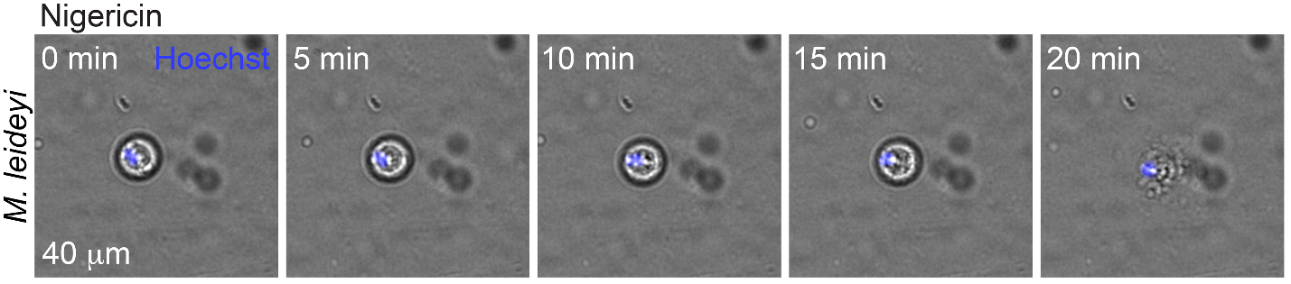
Supp. Figure 2: Merged brightfield and fluorescent images of video stills of a live Mnemiopsis motile, stellate cell undergoing ETosis following exposure to the K+ ionophore nigericin. Time stamps denote how long the expulsion of nuclear material occurs. Nuclei are labeled with Hoechst (blue).

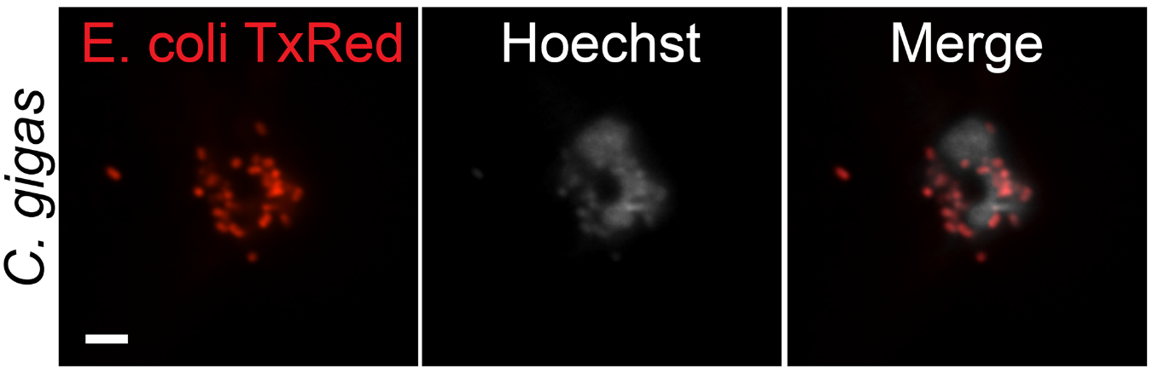
Supp. Figure 3: Confocal image of a C. gigas hemocyte that has undergone ETosis in response to exposure to Tx-red-E. coli. Individual bacteria are entangled in the expelled nuclear material. Scale bar is 5 μm.

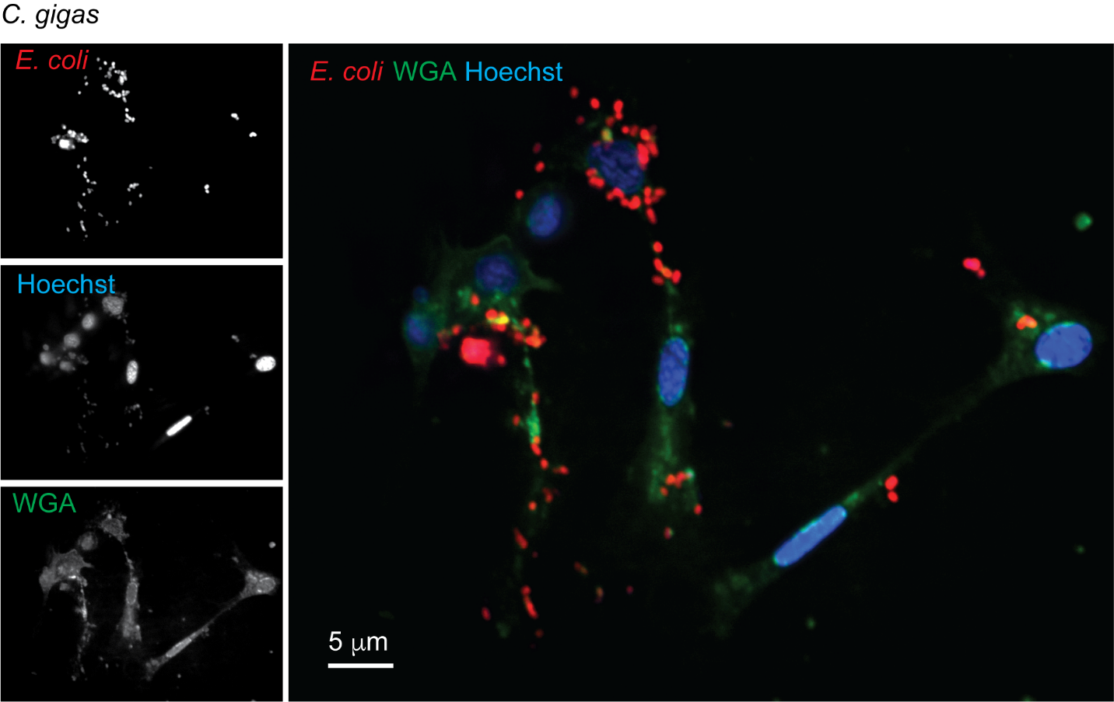
Supp. Figure 4: Confocal image of phagocytic C. gigas hemocytes that have engulfed Tx-red-labeled E. coli. Hemocyte cell membranes are labeled with WGA (green). Nuclei are labeled with Hoechst (blue). Scale bar is 5 μm.

