Supplementary Figures and Tables

Identification and preclinical development of kinetin as a safe error-prone SARS-CoV-2 antiviral and anti-inflammatory therapy

Thiago Moreno L. Souza^{1,2,*#}, Vagner D. Pinho³, Cristina F. Setin⁴; Carolina Q. Sacramento^{1,2}, Rodrigo Marcon⁴, Natalia Fintelman-Rodrigues^{1,2}, Melina Heller⁴, Jairo R. Temerozo^{1,5,6}, André C. Ferreira^{1,2,7}, Mayara Mattos^{1,2}, Patrícia B. Momo³, Suelen S. G. Dias¹, João Gesto^{1,2}, Filipe Pereira-Dutra¹, João Viola⁸, Dumith C. Bou-Habib^{5,6}, Patrícia T. Bozza¹, Anderson R. Aguillón³, Jarbas Siqueira-Junior⁴, Sergio Macedo-Junior⁴, Edineia L. Andrade⁴,; Guilherme P. Fadanni⁴; Sara E. Tolouei⁴; Francine B. Potrich⁴; Adara A. Santos⁴, Naiani F. Marques⁴; João B. Calixto^{4,*,#}, Jaime A. Rabi^{3,}*,#
#These authors contributed equally to this work

1 – Laboratório de Imunofarmacologia, Oswaldo Cruz Institute, Fundação Oswaldo Cruz (Fiocruz), Rio de Janeiro, RJ, Brazil.
2 - National Institute for Science and Technology on Innovation in Diseases of Neglected Populations (INCT/IDPN), Center for Technological Development in Health (CDTS), Fiocruz, Rio de Janeiro, RJ, Brazil.
3 - Microbiológica Química e Farmacêutuca, Doutor Nicanor, 238 Inhaúma, Rio de Janeiro, RJ, Brazil.
4- Centro de Inovação e Ensaios Pre-clinicos and National Institute for Science and Technology on Innovation in Medicines and Identification of New Therapeutics Targets (INCT-INOVAMED). Avenida Luiz Boiteux Piazza, 1302 Cachoeira do Bom Jesus, 88056-000 Florianópolis, SC Brazil.
5 – National Institute for Science and Technology on Neuroimmunomodulation (INCT/NIM), Oswaldo Cruz Institut, Fiocruz, Rio de Janeiro, RJ, Brazil.
6 – Laboratory on Thymus Research, Oswaldo Cruz Institute, Fiocruz, Rio de Janeiro, RJ, Brazil.
7 - Universidade Iguaçu, Nova Iguaçu, RJ, Brazil.
8 - Program of Immunology and Tumor Biology, Brazilian National Cancer Institute (INCA), Rua André Cavalcanti 37, 5th floor, Centro, Rio de Janeiro, Brazil;

*Correspondent authors: Thiago Moreno L. Souza (thiago.moreno@fiocruz.br), João B. Calixto (joao.calixto@cienp.org.br ), Jaime A. Rabi (jrabi@microbiologica.ind.br).

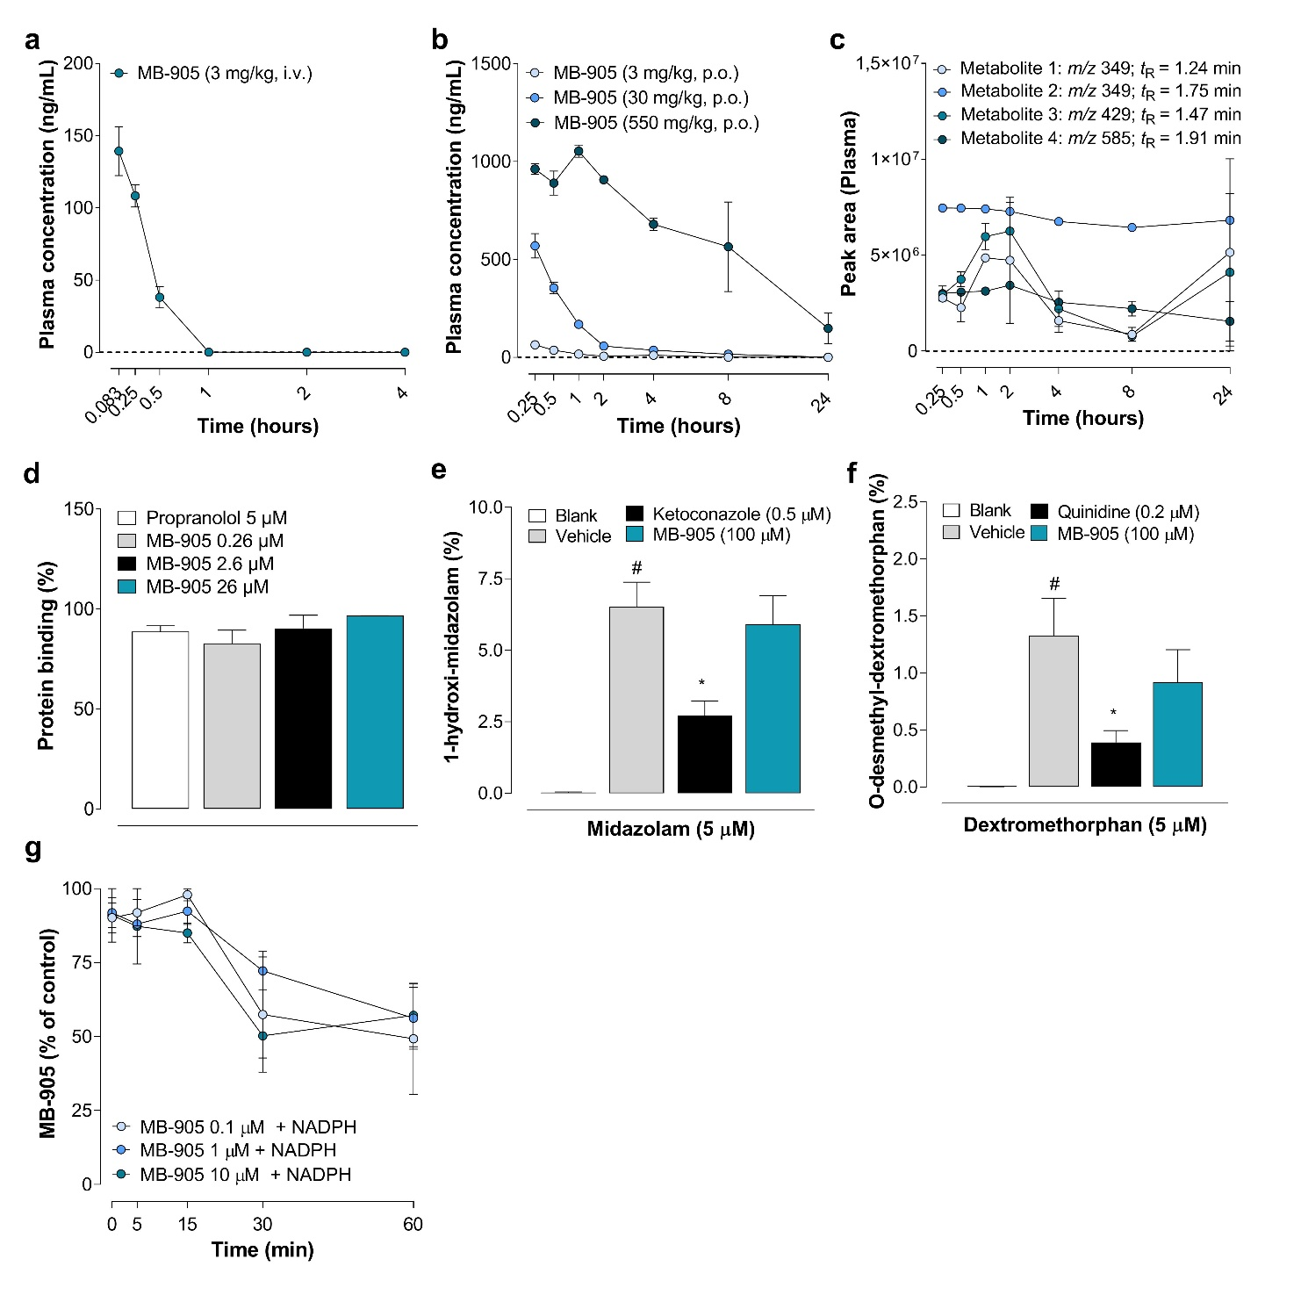
Supplementary Figure 1: Pharmacokinetics in mice, protein binding, CYP inhibition and metabolites. a, Single intravenous dose (3 mg/kg bodyweight) pharmacokinetics properties of MB-905 in mouse plasma (n = 6); b, Single oral doses (3, 30 and 550 mg/kg bodyweight) pharmacokinetics properties of MB-905 in mouse plasma (n = 2-6); c, Plasma putative metabolites after treatment with MB-905 (550 mg/kg, p.o.) (n=3); d, Evaluation of in vitro protein binding percentage of MB-905 (0.26 – 26 µM) in mouse plasma (n = 3); e, MB-905 (100 µM) or ketoconazole (0.5 µM- an inhibitor of CYP3A4) were incubated with recombinant human CYP3A4 and midazolam and evaluated the production of 1-hydroxy-midazolam (n = 3); f, MB-905 or quinidine (0.2 µM- an inhibitor of CYP2D6) were incubated with recombinant human CYP2D6 and dextromethorphan and evaluated the production of O-demethyl-dextromethorphan (n = 3); g, MB-905 (0.1, 1 and 10 µM) was incubated with human liver microssome (HLM) in the presence and in the absence of NADPH following analysis of MB-905 concentrations at 0, 5, 15, 30 and 60 minutes after NADPH (n = 2-3). Data were expressed as mean ± SEM (Standard Error of the Mean). (e, f) #p<0.05 significantly different from the negative control (blank); *p<0.05 significantly different from the vehicle. One-way ANOVA followed by the Tukey Test were performed. Noncompartmental data analysis was performed using Phoenix WinNonlin®.

Supplementary Table 1: Pharmacokinetic parameters for MB-905 in mice.
Compound | MB-905
Dose and Route | 3 mg/kg (i.v.) | 30 mg/kg (p.o.) | 550 mg/kg (p.o.)
C_{max} (ng/mL) | 155.16 | 569.97 | 1053.37
T_{max} (h) | 0.083 | 0.083 | 0.5
T_{1/2} (h) | 0.22 | 1.11 | 2.72
CL (mL/min/kg) | 918.38 | 1060.15 | 1843.18
Vz (L/kg) | 19.04 | 102.21 | 434.2
AUC_{last} (h*ng/mL) | 55.48 | 355.63 | 4392.27
AUC_{all} (h*ng/mL) | 66.41 | 355.63 | 4392.27
Ke (1/h) | 3.09 | 0.62 | 0.25
F(%) | 100% | 53.50% | 36.10%
C_{max}: Peak concentration; T_{max}: Time to reach C_{max}; T_{1/2}: Half-life; CL: Clearance; V_{z}: Volume of distribution; AUC_{last}: Area under de curve (last); AUC_{all} area under de curve (all); K_{e}: elimination rate constant; F: bioavailability. Noncompartmental data analysis was performed using Phoenix WinNonlin®. Data represents the mean values of 3-6 animals per group.

Supplementary Figure 2: Pharmacokinetic and putative metabolites of MB-905 in rats. a, Single intravenous dose (1 mg/kg bodyweight) pharmacokinetics properties of MB-905 in rat plasma (n = 6); b, Single oral dose (30 mg/kg bodyweight) pharmacokinetics properties of MB-905 in rat plasma (n = 5); c, Plasma metabolites (5 metabolites) after treatment with MB-905 (30 mg/kg, p.o.) (n = 3); d, Single oral dose (30 mg/kg bodyweight) pharmacokinetics properties of MB-905 in lung plasma (n = 3); e, Lung metabolites (5 metabolites) after treatment with MB-905 (30 mg/kg, p.o.) (n = 3); f, Single oral dose (30 mg/kg bodyweight) pharmacokinetics properties of MB-905 in rat urine (n = 3); g, Urine metabolites (5 metabolites) after treatment with MB-905 (30 mg/kg, p.o.) (n = 3). Data were expressed as mean ± SEM (Standard Error of the Mean). Noncompartmental data analysis was performed using Phoenix WinNonlin®.

Supplementary Table 2: Pharmacokinetic parameters for MB-905 in rats.
Compound | MB-905
Dose and Route | 1 mg/kg (i.v.) | 30 mg/kg (p.o.)
C_{max} (ng/mL) | 123.61 | 370.47
Tmax (h) | 0.083 | 0.25
T_{1/2} (h) | 0.56 | 3.81
CL (mL/min/kg) | 213.63 | 330.53
Vz (L/kg) | 10.4 | 109.18
AUC_{last} (h*ng/mL) | 77.12 | 1498.08
AUC_{all} (h*ng/mL) | 77.12 | 1498.08
Ke (1/h) | 1.23 | 0.18
F(%) | 100% | 64.70%
C_{max}: Peak concentration; T_{max}:Time to reach C_{max}; T_{1/2}: Half-life; CL: Clearance; V_{z}: Volume of distribution; AUC_{last}: Area under de curve (last); AUC_{all}: area under de curve (all); K_{e}: elimination rate constant; F: bioavailability. Noncompartmental data analysis was performed using Phoenix WinNonlin®. Data represents the mean values of 5-6 animals per group.

Supplementary Figure 3. hERG channel assay in vitro and cardiovascular safety pharmacology in vivo. a, Concentration-response curve of MB-905 on the hERG channel inhibition assay (% of hERG relative inhibition). Data are expressed as mean ± SEM (n=3) through non-linear regression; b, Systolic Blood Pressure in millimeter of mercury (mmHg); c, Diastolic Blood Pressure in mmHg; d, Heart Rate expressed as beats per minute (bpm); e, QT-interval in millisecond (ms) in rats treated with vehicle (5 ml/Kg, p.o.) or MB-905 (50 or 250 mg/Kg, p.o.) administered orally once a day for 7 consecutive days. Data were expressed as mean ± SEM (n= 4-6). c-f: statistical analyses were performed using mixed effects model followed by the Dunnet’s test.

Supplementary Figure 4 – Kinetin-ribose-5’-monophosphate as a substrate for 5’-nucleotidase. Liver extracts from untreated Swiss webster mice, 20-week old, were incubated with MB-711 (Kinetin-ribose-5’-monophosphoramidate) or AMP as a substrate for a commercial reaction to detect 5’-nucletidase activity. Liver extracts enzymes cathepsin A or carboxylesterase 1 and histidine triad nucleotide-binding protein 1 (HINT1) released nucleotide monophosphate from MB-711, to be further used by 5’-nucleotidase (#ab235945 from www.abcam.com). Each column represents the means ± SEM of three independent experiments.

