Materials and Methods
The model represents simplified geometry and dynamics of an arbitrary limb segment, e.g. the tibia of a human’s leg rotating about the knee or the tibia of an insect’s leg rotating about its femur-tibia joint (Figure 1A). The limb segment is assumed to be moved by an antagonistic pair of actuators, e.g. flexors and extensors, each with inherent elastic stiffness $k_{elas}$ and viscous damping $c$ (Figure 1B). These actuators deliver the active force $F$ to the limb segment only while they shorten. In animals, these actuators are muscle; however, some human-made actuators also fit this description (e.g. antagonistic braided pneumatic actuators (1)). The actuators connect to the limb with moment arm $r$. The limb segment itself is assumed to have mass $m$, length $L$, and a corresponding moment of inertia $J$. The limb is assumed to operate in a gravitational field with acceleration $g$. The horizontal displacement of the center of mass is measured by $x$, and the rotation of the limb segment is measured by $θ$.

1. Equations of motion for the model

1.1. Equations for motion for a linear path
Figure 1C describes the dynamics of the model. The dynamics are first written in a familiar form in terms of the linear displacement of the actuator $x$. The actuator force $F$ is equal to the sum of the passive dynamics: Mass times acceleration, $m\ddot{x}$; damping times velocity, $c\dot{x}$; and elastic stiffness times displacement, $k_{elas}x$, with all terms resulting in the following equation of motion:
$∑F_{applied}=F_{inertial}+F_{viscous}+F_{potential}$ (1)
where
$F_{inertial}=m⋅\ddot{x}$,
$F_{viscous}=c⋅\dot{x}$, and
$F_{potential}=F_{elastic}=k_{elas}⋅x$.
$x$ is the linear displacement of the mass, with units of $meter$; $c$ is the viscous damping coefficient, with units of $Newton⋅\frac{second}{meter}$; and $k_{elas}$ is the elastic stiffness of the spring, with units $\frac{Newton}{meter}$.

1.2. Equations of motion for rotation about a point
To better model rotation around rotary joints, we write Equation 1 expressed in terms of moments applied around the joint:
$∑M_{applied}=M_{inertial}+M_{viscous}+M_{potential}$, (2)
where
$$M_{inertial}=J⋅\ddot{θ}$$
$$M_{viscous}=c_{r}⋅\dot{θ}$$
$M_{potential}=M_{elastic}+M_{grav}=k_{r,elas}⋅θ+k_{r,grav}⋅θ$. (3)
$θ$ is the angular displacement of the joint, with units of radian; $J$ is the mass moment of inertia, with units of $kilogram⋅{meter}^{2}$; $c_{r}$ is the rotary damping coefficient, with units of $Newton⋅meter⋅second$; $k_{r,elas}$ is the rotary elastic stiffness of the joint, with units of $Newton⋅m$eter; and $k_{r,grav}$ is the rotary gravitational stiffness of the joint (i.e. the pendulum-like restoring moment causing it to hang down with gravity), with units of $Newton⋅meter$. The coefficient $J$ is defined by the following integral:
$J=∫ρ^{2}⋅dm$,
where $ρ$ is the location of differential mass $dm$ relative to the point of rotation. We model a limb segment as a uniform rigid rod of mass $m$ and length $L$, such that the integral becomes
$J=\int_{0}^{L}{ρ^{2}⋅\frac{m}{L}⋅dρ}=\frac{1}{3}⋅m⋅L^{2}$. (4)
The coefficients $c_{r}$ and $k_{r,elas}$ are calculated via the principle of virtual work (2). This technique enables a parameter from one coordinate (e.g. $m$, which is the inertia in the $x$ direction) to be converted to another coordinate (e.g. $J$, which is the inertia in the $θ$ direction) if a holonomic constraint (e.g. integrable kinematic relationship) exists between the two coordinates. Such a conversion enables us to use the stiffness of muscle as it stretches (a linear motion) to approximate the rotary stiffness of the joint (a rotary motion).
To simplify our calculations of rotary terms $k_{r,elas}$, $c_{r}$, and $k_{r,grav}$, we rely on a small angle approximation. The illustration in Figure 1B in the manuscript suggests straight-line muscle geometry, such that the muscles’ moment arms change with the angle of the joint. However, we linearized the action of a muscle around a joint, assuming that $\sin{θ}≈θ$ (in units of radians). We believe this is justified in this context because small angle approximation introduces minimal error depending on the joint excursion (Figure S1A). The error is less than 5% for a joint excursion of $±{30}^{∘}$; less than 10% for $±{45}^{∘}$; and less than 20% for $±{60}^{∘}$. The motion of leg joints in walking animals across many orders of magnitude of size falls within this range, with most in the $±{30}^{∘}$ range (Elephant: (3); Horse: (4); Human: (5); Small mammals: (6); Stick insects (7); Discoid cockroaches: (8)). Furthermore, it has been shown that nonlinear elastic and geometric effects of leg joints in some species are balanced to produce linear joint dynamics (9), and in some systems muscle wrapping around the joint maintains a nearly constant moment arm as the joint rotates (10). Thus, we believe ignoring the trigonometric geometry of the joint is justified. Consequences of this assumption are discussed at the end of this section.
The small angle assumption is that for small rotations, $x=r⋅sin⁡θ≈r⋅θ$. We assume straight-line muscle geometry. To find $k_{r,elas}$, let us equate the energy of the spring in terms of $x$ to that in terms of $θ$:
$\frac{1}{2}⋅k_{r,elas}⋅θ^{2}=\frac{1}{2}⋅k_{elas}⋅x^{2}=\frac{1}{2}⋅k_{elas}⋅{\left(r⋅θ\right)}^{2}=\frac{1}{2}⋅k_{elas}⋅r^{2}⋅θ^{2}$,
$k_{r,elas}=k_{elas}⋅r^{2}$. (5)
By the same argument,
$c_{r}=c⋅r^{2}$. (6)
To compute $k_{r,grav}$, we consider the restoring moment about the joint in response to rotating the limb segment (rod of uniform density) away from hanging parallel to gravity. In this case, the moment due to gravity is:
$M_{grav}=m⋅g⋅\frac{L}{2}⋅\sin{θ}$,
where $g$ is gravitational acceleration, 9.81 meter/second². Applying the small angle approximation again, $M_{grav}$ can be linearized to
$M_{grav}=m⋅g⋅\frac{L}{2}⋅θ$.
The stiffness due to gravity relates the moment to the angular deflection, meaning that
$k_{r,grav}=m⋅g⋅\frac{L}{2}$. (7)
The small angle approximation enables the substitution of Equations 5 and 7 into Equation 3, and for like terms to be grouped,
$M_{potential}=\left(k_{elas}⋅r^{2}+m⋅g⋅\frac{L}{2}\right)⋅θ$. (8)
Substituting Equation 8 into Equation 2,
$∑M_{applied}=J⋅\ddot{θ}+c_{r}⋅\dot{θ}+\left(k_{elas}⋅r^{2}+m⋅g⋅\frac{L}{2}\right)⋅θ$, (9)
How much error does our small angle approximation introduce to the dynamics in Equation 9? In reality, geometry may reduce the impact of muscle stiffness and damping at extreme angles (11). However, the small angle approximation prevents it from diminishing, possibly making the model stiffer and more viscous than reality (stiffness equal to $k_{0}s^{2}$ instead of $k_{0}s^{2}\cos^{2}{θ}$). As a result, the apparent inertia of the model is lower than in reality when the limb rotates to extreme angles. Figure S1B plots how the apparent inertia in our linearized model varies with respect to the “complete” nonlinear model. Our estimate causes the model’s inertia to be about 90% of the true value when the joint is at $±{30}^{∘}$, 80% when the joint is at $±{45}^{∘}$, and 70% when the joint is at ${60}^{∘}$. However, these errors are spread over the entire angular excursion; for example, the error is 0% when the joint is at $0^{∘}$, and 20% when the joint is at ${45}^{∘}$. Averaging the inertia scaling error across the entire range of motion produces the plot in Figure S1C, which shows that even for a joint excursion of $±{90}^{∘}$, the error in the inertia of the limb is less than 25% due to our small angle approximation. Because Figures 2-4 have logarithmic axes, a 25% error due to a small angle approximation leads to change of 12% of the base 10 log of the value.

1.3. Equations of motion expressed in terms of energy
Because energy is a critical currency underlying animal behavior, the rotary equation of motion is converted into a work-energy equation by integrating the equation of motion with respect to $θ$. The work performed by a force is defined as its integral over its path, which in this case is the angular excursion, $θ$:
$W≡\int{M⋅dθ}$. (10)
We will integrate each of the three terms in Equation 9 over $θ$. Each integral requires applying a special approach. First, kinetic energy is the integral of the inertial moment over the angular excursion,
$E_{kinetic}=∫J⋅\ddot{θ}⋅dθ$. (11)
The variable $\ddot{θ}$ cannot be directly integrated in terms of $θ$. Instead, we will seek to express $\ddot{θ}$ and $dθ$ in terms of a common variable, $\dot{θ}$. The time derivatives of $θ$ are defined as:
$\dot{θ}=\frac{dθ}{dt}$,
$\ddot{θ}=\frac{d\dot{θ}}{dt}$.
Equating $dt$ and rearranging,
$\ddot{θ}⋅dθ=\dot{θ}⋅d\dot{θ}$. (12)
Substituting Equation 12 into Equation 11,
$E_{kinetic}=∫J⋅\dot{θ}⋅d\dot{θ}=\frac{1}{2}⋅J⋅{\dot{θ}}^{2}$. (13)
This is the familiar form of the kinetic energy of a rigid body rotating about a fixed point. Note that $J$ is the moment of inertia of the limb about its point of rotation, not about its center of mass.
To compute the energy dissipated by viscous forces, we extract the damping moment from Equation 9 and integrate it according to Equation 10:
$E_{viscous}=∫c_{r}⋅\dot{θ}⋅dθ$. (14)
Again observing that $\dot{θ}=dθ/dt$,
$E_{viscous}=c_{r}⋅∫{\dot{θ}}^{2}⋅dt$.
While this integral form may appear inconvenient, it has the intuitive interpretation that the energy dissipated by viscous effects increases both with the speed of a motion and its duration.
To compute the potential energy of the system, we integrate the elastic and gravitational forces over the angular excursion of the joint,
$E_{potential}=∫\left(k_{r,elas}+k_{r,grav}\right)⋅θ⋅dθ$.
This integral can be computed directly as
$E_{potential}=\frac{1}{2}⋅\left(k_{r,elas}+k_{r,grav}\right)⋅θ^{2}$. (15)
These energy terms are summarized in Figure 1C of the manuscript. Figure 1C also establishes the color code to be used throughout the manuscript: Kinetic energy is shaded yellow, viscous energy is shaded orange, and potential energy is shaded red.

2. Characterizing oscillatory motion: Primer on linear vibration theory
To better understand the motion of this simple limb model, we can apply linear vibration theory (12). This topic is a field in its own right; however, we briefly present four quantities that will facilitate our analysis of this system: the natural frequency, $ω_{n}$, at which the system resonates; the damping ratio, $ζ$, which indicates whether the system vibrates when perturbed (i.e. its transient response); the amplitude of steady state vibration, $X$; and the phase angle lag of the steady state vibration relative to the input force, $ϕ$.
To compute the transient motion when the limb is not actuated, consider again the linear second-order differential equations in Equation 1 or Equation 9. Let us write them generally here, in terms of an equivalent mass, $m_{equiv}$; an equivalent damping, $c_{equiv}$; and an equivalent stiffness, $k_{equiv}$. The source of these terms is irrelevant (e.g. $k$ from elastic or gravitational force). All that matters is that they are the coefficients for $\ddot{x}$, $\dot{x}$, and $x$, respectively. The equation of motion would be
$0=m_{equiv}⋅\ddot{x}+c_{equiv}⋅\dot{x}+k_{equiv}⋅x$. (16)
Let us normalize each term by mass,
$0=\ddot{x}+\frac{c_{equiv}}{m_{equiv}}⋅\dot{x}+\frac{k_{equiv}}{m_{equiv}}⋅x$. (17)
Let us define
$ω_{n}=\sqrt{\frac{k_{equiv}}{m_{equiv}}}$ (18)
$2⋅ζ⋅ω_{n}=\frac{c_{equiv}}{m_{equiv}}$ (19)
where $ω_{n}$ is the natural frequency of oscillation measured in radians per second, and $ζ$ is the damping ratio. Substituting Equations 18 and 19 into Equation 17,
$0=\ddot{x}+2⋅ζ⋅ω_{n}⋅\dot{x}+ω_{n}^{2}⋅x$. (20)
Solutions to Equation 20 can be found in any vibrations or systems engineering textbook (12). Here we present the underdamped and overdamped transient solutions:
$$x\left(t\right)=\left\{\begin{matrix}e^{-ζω_{n}t}⋅\left(A⋅\sin\left(ω_{n}⋅\sqrt{1-ζ^{2}}⋅t\right)+B⋅\cos\left(ω_{n}⋅\sqrt{1-ζ^{2}}⋅t\right)\right), if ζ∈\left(0,1\right) (21) \\ A⋅e^{-\left(ζω_{n}+ω_{n}\sqrt{ζ^{2}-1}\right)⋅t}+B⋅e^{-\left(ζω_{n}-ω_{n}\sqrt{ζ^{2}-1}\right)⋅t}, if ζ>1 (22)\end{matrix}\right.$$
The coefficients $A$ and $B$ are calculated from initial conditions. Based on the form of these equations, the solution oscillates if $0<ζ<1$ (i.e. the system is underdamped), but does not if $ζ>1$ (i.e. the system is overdamped). Example solutions are plotted in Figure S2A. In section 3.7, we will show that $ζ$ of the limb, and thus its transient motion when perturbed, is related to the length scale of the actuated limb.
Let us consider the response of the mass-normalized system in Equation 17 to a periodic force with amplitude $F_{0}$, frequency $ω$, and arbitrary phase,
$F_{0}⋅\cos\left(ωt\right)=m_{equiv}⋅\ddot{x}+c_{equiv}⋅\dot{x}+k_{equiv}⋅x$. (23)
In steady state (i.e. after the transient response from Eq. 21 or 22 decays), the limb will oscillate at the same frequency as the periodic force, at magnitude $X$ and a phase angle $ϕ$ behind the force,
$x_{ss}\left(t\right)=X⋅cos⁡(ωt-ϕ)$, (24)
where
$X=\frac{F_{0}}{\sqrt{{\left(k_{equiv}-m_{equiv}⋅ω^{2}\right)}^{2}+{\left(c_{equiv}⋅ω\right)}^{2}}}=\frac{{F_{0}}/{k_{equiv}}}{\sqrt{{\left(1-{\left(\frac{ω}{ω_{n}}\right)}^{2}\right)}^{2}+{\left(2⋅ζ⋅\frac{ω}{ω_{n}}\right)}^{2}}}$ (25)
$ϕ=\tan^{-1}\left(\frac{c_{equiv}⋅ω}{k_{equiv}-m_{equiv}⋅ω^{2}}\right)=\tan^{-1}\left(\frac{2⋅ζ⋅\frac{ω}{ω_{n}}}{1-{\left(\frac{ω}{ω_{n}}\right)}^{2}}\right)$. (26)
Equation 25 describes the relationship between the magnitude of the actuator force and the magnitude of the resulting limb motion. Figure S2B plots $X$ as a function of $ω$ for several values of $ζ$. If $ζ$ is sufficiently small, $X→∞$ as $ω→ω_{n}$, which represents resonance. For the limb to oscillate at resonance, very little actuation force is required. Figure S2B indicates that $X→0$ as $ω→∞$, meaning that as the rate of oscillation increases, more actuator force is required for the same amplitude of motion. Finally, $X→F_{0}/k_{equiv}$ as $ω→0$, e.g. the applied force does not depend strongly on $ω$ when $ω$ is small. These trends indicate that if a limb is moved slowly relative to its natural frequency, then a finite amount of force $F_{0}$ is required; if a limb is moved at a frequency near its natural frequency, then almost no force is required; and if a limb is moved at a frequency above its natural frequency, then the force $F_{0}$ required increases with the movement speed (Figure S2C).
Equation 26 describes the phase angle of the actuator force relative to the resulting limb motion. Figure S2D plots how $ϕ$ depends on $ω$ for a variety of $ζ$ values: when $ω≪ω_{n}$, $ϕ≈0^{∘}$; when $ω≫ω_{n}$, $ϕ≈{180}^{∘}$. To more deeply investigate how $ϕ$ describes the balance between inertial, viscous, and elastic and gravitational forces (and by extension, the balance between kinetic, viscous, and potential energy), Figure S3 provides a visualization of how $ϕ$ is calculated. Consider the system with the parameter values in Figure S3A. These values can be used to plot each force as a vector. Because these forces must sum to the applied force (Equation 19), the angle of the resultant force vector relative to the displacement vector defines $ϕ$. Figure S3B illustrates this process, also called phasor analysis.
Based on the steady-state limb response $x_{ss}$ in Equation 24, we can compute both the amplitude and phase angle of each force. Because the elastic and gravitational forces depend on $x_{ss}$ itself, the corresponding force has magnitude $k_{equiv}X$ and phase $0^{∘}$, indicated by the green vector along the x-axis in Figure S3B. Differentiating $x_{ss}$ with respect to time, we obtain
${\dot{x}}_{ss}=-ωX\sin\left(ωt-ϕ\right)=ωX\cos\left(ωt-ϕ-{90}^{∘}\right)$,
indicating that the viscous force has magnitude $c_{equiv}ωX$ and phase ${90}^{∘}$. The viscous force is plotted as a red vector ${90}^{∘}$ from the x-axis. Differentiating ${\dot{x}}_{ss}$ with respect to time, we obtain
${\ddot{x}}_{ss}=-ω^{2}X\cos\left(ωt-ϕ\right)=ω^{2}X\cos\left(ωt-ϕ-{180}^{∘}\right)$,
indicating that the inertial force has magnitude $m_{equiv}ω^{2}X$ and phase ${180}^{∘}$. The inertial force is plotted as a blue vector ${180}^{∘}$ from the x-axis. Summing these three vectors results in the applied force, plotted as a black dashed vector with the phase angle $ϕ$ called out. Based on Figure S3B, we conclude that elastic and gravitational force dominates the dynamics of this limb when moving at this frequency, and predict that the limb displacement should be nearly in phase with the actuator force. Figure S3C plots simulation data showing that this is true.
The phasor analysis enables us to determine which force (or form of energy) dominates a motion given its system parameters $\left(k_{equiv}, c_{equiv}, and m_{equiv}\right)$ and the forcing frequency $ω$. Figure S3D-F shows the phasor diagram and simulation for a system in which $c_{equiv}$ is larger than the other parameters. Viscous force is the largest vector and the limb displacement is about ${90}^{∘}$ behind the applied force. Figure S3G-I shows the phasor diagram and simulation for a system in which $m_{equiv}$ is larger than the other parameters. Inertial force is the largest vector and the limb displacement is about ${180}^{∘}$ behind the applied force, as predicted.
Equation 26 indicates that the forcing frequency also contributes to which force (or form of energy) dominates a motion. Figure S3J-L shows the phasor diagram and simulation for a system with the same parameters as Figure S3D-F, but forced at 1/20th the original frequency. Because $ω$ is lower in this case, the viscous force magnitude $c_{equiv}ωX$ is smaller, changing the resultant force. Figure S3K shows that elastic and gravitational force dominate motion at this frequency (e.g. longest vector), and Figure S3L confirms that the limb displacement is nearly in phase with the force. Figure S3M-O shows results from the same system driven at a frequency 20 times higher than the original frequency. Now, Figure S3N shows that the inertial force is largest, producing motion that is almost ${180}^{∘}$ behind the applied force. This analysis enables us to predict which force (or form of energy) will dominate a motion based solely on the limb’s mechanical parameters $\left(k_{equiv}, c_{equiv}, and m_{equiv}\right)$ and the frequency at which it moves. We will show in the next section that the parameter values depend on an animal’s length scale.
To facilitate the application of these ideas to the motion of jointed limbs, we make two remarks. First, all the equations in this section have been expressed in terms of the frequencies $ω$ and $ω_{n}$. However, they can also be expressed in terms of periods $T$ and $T_{n}$, respectively, where
$T=\frac{2π}{ω}$
and
$T_{n}=\frac{2π}{ω_{n}}$.
Using these terms, we can discuss the impact of the duration of a motion $T$ rather than the speed of a motion $ω$. Furthermore, time can be nondimensionalized by expressing it in terms of the natural period $T_{n}$. The second remark is that despite all the ideas in this section being presented in terms of linear motion for simplicity, they can be generalized to rotary motion.

3. Scaling of model parameters
Parameter values in this model do not depend on scale uniformly. Consequently, at different size and time ranges, the relative importance of each term changes, which further changes the response measures $X$ and $ϕ$. First, we will establish and justify the scaling of the parameters that relate to linear motion: $m$, $c$, and $k$. In practice, calculating $c$ is facilitated by measuring $m$ and $k$, and therefore scaling laws for $m$ and $k$ will be presented first, followed by those for $c$. Next, we will leverage these scaling relationships to establish the scaling of the parameters that relate to rotary motion: $J$, $k_{r,elas}$, $k_{r,grav}$, $r$, and $c_{r}$.

3.1. Scaling of linear inertia (mass)
Mass is often assumed to scale with volume (13, 14), that is,
$m=m_{0}⋅{\left(\frac{L}{L_{0}}\right)}^{3}$, (27)
where $L$ represents the characteristic length of an animal and $m_{0} (kilograms)$ is the mass of an animal for which $L_{0}=1 meter$. One might assume that $m_{0}=1000 kilograms$, the mass of a 1-meter cube with the density of water $\left(1000\frac{kg}{m^{3}}\right)$. However, using this value predicts that an animal that is 1 meter long (e.g. a large dog) would weigh 1000 kg, which is far too massive. Empirical collections of body mass versus length over size orders of magnitude indicate that mass scales in proportion to the volume of a cylinder, not a cube, such that $m_{0}$ is about 12 (15), much lower than the value of 1000 that one might assume from a simple cube volume calculation.

3.2. Scaling of linear stiffness
Muscle stiffness is often assumed to scale with the cross-sectional area of the muscle, i.e. ${k∝\left(\frac{L}{L_{0}}\right)}^{2}$ (16). However, we assume that muscle stiffness varies with its length,
$k=k_{0}⋅\frac{L}{L_{0}}$, (28)
as suggested by other recent studies (17, 18). This assumption is supported by two independent lines of reasoning, one from first principles of the mechanics of materials and one from empirical data of muscle force.
First, one of the fundamental equations of the field of mechanics of materials is that a body strains proportionally to the stress applied to it,
$σ=E⋅ϵ$, (29)
where $σ$ is the applied stress, $ϵ$ is the strain, and $E$ is Young’s modulus (19). The stress $σ=F/A$, force per area (i.e. pressure). The strain $ϵ=ΔL/L$, the change in length normalized to the resting length. To reframe Equation 29 in terms of force rather than pressure, we will multiply by the cross-sectional area of the muscle. A muscle that is 1 meter long does not have a cross-sectional area of 1 meter squared (see argument in previous section), but rather approximately 12 x 10⁻³ meters squared (15). Accordingly, let us substitute $A_{0}=12×{10}^{-3}⋅{\left(\frac{L}{L_{0}}\right)}^{2}$ into Equation 29,
$F=\left(12×{10}^{-3}⋅E⋅\frac{L}{L_{0}}\right)⋅ΔL$. (30)
Equation 30 is Hooke’s Law describing how a spring produces force proportional to its stretch. The proportionality constant, $k_{0}=12×{10}^{-3}⋅E⋅\frac{L}{L_{0}}$ in Equation 30, is the spring stiffness. Since $E$ is a constant bulk property of the material, Equation 30 implies that the stiffness of the muscle should increase proportional to its length, not $L^{2}$.
The second justification for assuming that $k=k_{0}⋅\frac{L}{L_{0}}$ comes from empirical studies of how maximum muscle force scales with body size (20). The author of (20) finds an animal’s muscle force is proportional to its body mass to the negative one-thirds power, implying that the maximum force scales with length to the two-thirds power. The author of (20) states that this limit is near the maximal stress of the muscle, implying that its passive elastic properties determine this upper limit (measurements of maximal stress are reported in that author’s previous work (21)). Combining these observations with Hooke’s Law,
$F_{maximum}=F_{0}⋅{\left(\frac{L}{L_{0}}\right)}^{2 }=k⋅ΔL_{maximum}$,
where $F_{0}$ is an arbitrary constant that relates $F_{maximum}$ and ${\left(\frac{L}{L_{0}}\right)}^{2}$. Based on dimensional analysis, we must conclude that $k=k_{0}⋅\frac{L}{L_{0}}$; otherwise, the units of the equation do not equate.
Comparing Equations 28 and 30, we observe that $k_{0}=12×{10}^{-3}⋅E$ for muscle. Muscle has a Young’s modulus on the order of 1 MPa (20, 21). Because serial elastic elements (e.g. tendon and apodeme) are several orders of magnitude stiffer than muscle (22), they appear rigid in comparison. Thus, we set $k_{0}=12×{10}^{3}\frac{N}{m}$ in our model.

3.3. Scaling of linear damping
Few studies measure joint damping due to the difficulty of measurement. As a result, it is uncertain how damping scales with length (23). However, we propose that damping should be proportional to length, as argued by a recent study (17). We will justify this assertion using first principles. Below, in the section entitled “scaling of rotary damping”, we provide further support for this assumption by demonstrating that it fits the available empirical data, spanning two orders of magnitude of length across insects and vertebrates.
The viscous force acting on a solid body, e.g. the viscous drag on a muscle as it contracts through the surrounding fascia, is
$F_{viscous}=\frac{1}{2}⋅ρ_{fluid}⋅{\dot{x}}^{2}⋅C_{d}⋅L^{2}$, (31)
where $ρ_{fluid}$ is the density of the fluid, $\dot{x}$ is the relative speed of the body through the fluid, $C_{d}$ is the empirically determined coefficient of drag, and $L$ is the characteristic length of the system. We assume that the fluid is water (or a water-based solution, e.g. blood).
Let us introduce the Reynold’s number, $Re$, a dimensionless ratio between the inertia and viscosity of a fluid,
$Re=\frac{ρ_{fluid}⋅\dot{x}⋅L}{μ_{fluid}}$, (32)
where $μ_{fluid}$ is the dynamic viscosity of the fluid. Flow is laminar if $Re$ is small and flow is turbulent if $Re$ is large. Because we assume joint damping is due to water-based solutions (i.e. large $μ_{fluid}$) being squeezed through tiny spaces (i.e. small $L$), we further assume that $Re$ is small. Empirical studies show that when $Re$ is small, then $C_{d}$ in Equation 31 is inversely proportional to $Re$ (24),
$C_{d}=a⋅{\left(Re\right)}^{-1}$, (33)
where $a$is a constant. Substituting Equations 32 and 33 into Equation 31 and simplifying, we find that
$F_{viscous}=c_{0}⋅\frac{L}{L_{0}}⋅\dot{x}$, (34)
where $c_{0}=\frac{1}{2}⋅μ_{fluid}⋅a$. Thus, Equation 34 shows that viscous force scales with length given our assumptions, and we must use empirical data to determine $c_{0}$.

3.4. Scaling of rotary inertia (mass moment of inertia)
Substituting the mass scaling relationship from Equation 27 into the expression for mass moment of inertia of a rigid rod from Equation 5, we obtain
$J=\frac{1}{3}⋅m_{0}⋅\frac{L^{5}}{L_{0}^{3}}$. (35)

3.5. Scaling of rotary elastic stiffness
Substituting the linear elastic stiffness relationship from Equation 28 into the expression for equivalent rotary elastic stiffness, we obtain
$k_{r,elas}=k_{0}⋅r^{2}⋅\frac{L}{L_{0}}$. (36)
Recall that $r$ corresponds to the lever arm of the muscle acting about the joint. Let us express $r$ as some fraction of the limb length,
$r=s⋅L$, (37)
where $0<s≤1$. Substituting Equation 37 into Equation 36,
$k_{r,elas}=k_{0}⋅s^{2}⋅\frac{L^{3}}{L_{0}}$. (38)
Based on muscle attachments in dogs (25), rats (26), stick insects (11), and cockroaches (27), $0.01≤s≤0.1$. Like $k_{r,elas}$, many equations will include an $s^{2}$ term, so for convenience, we set $s=\sqrt{1×{10}^{-3}}≈0.032$ for this study.
Scaling $r$ in this way raises two concerns. First, empirical studies of mammalian species indicate that $r$ scales slightly faster than $L$ (i.e. $L^{1.3}$, (13)). However, for simplicity, we assume that $r$ scales exactly with $L$ (i.e. we assume $s$ is constant). Because $k_{r,elas}$ depends on $r$ but $J$ does not, scaling $r$ according to (13) would increase the importance of elastic potential energy within our framework, increasing the size of the quasi-static region. However, it should not affect the overall conceptual conclusions of our study. The second concern is that scaling $r$ with $L$ assumes that muscles are “wrapped” around leg joints such that their moment arms do not change with joint angle. While in some insect leg joints angle-dependent moment arms do impact the dynamics (11), in other leg joints the nonlinear properties of muscle compensate for the variable moment arms, maintaining constant stiffness over most of the joint’s range of motion (9). Furthermore, vertebrate muscles do wrap around their joints to maintain relatively constant muscle moment arms (10). Therefore, we believe our choice to model $r∝L$ is justified, and leave it to future studies to consider different scaling relationships for $r$.

3.6. Scaling of rotary gravitational stiffness
When large animals walk, the pendulum-like dynamics during a leg’s swing phase impact motor output (16). As shown in Equation 7, the moment due to gravity acting on the limb can be treated as an equivalent spring. To calculate how this equivalent spring’s stiffness should scale with $L$, we substitute Equation 27 into Equation 7, to obtain
$k_{r,grav}=\frac{1}{2}⋅m_{0}⋅g⋅\frac{L^{4}}{L_{0}^{3}}$. (39)
Note that $k_{r,grav}$ scales with $L^{4}$, but $k_{r,elas}$ scales with $L^{3}$. This difference supports the assertion (16) that the moment due to gravity should drive the swing phase of a large animal, but the moment due to elastic forces should initially drive (and eventually resist (28)) the swing phase of a small animal.
To illustrate this difference across length scale, Figure S4 plots the fraction of a limb’s potential energy stored as gravitational energy and elastic energy versus length scale. At length scales of 2 cm and smaller, more than 90% of the potential energy is stored as elastic energy. Such a bias toward elastic potential energy explains the gravity-independent rest posture observed in stick insects (16). Furthermore, this balance explains why the joints of insects including cockroach (16), stick insect (16, 29) and locust (28) return to a particular equilibrium angle independent of the direction of gravity. Figure S4 also predicts that larger animals store potential energy primarily as gravitational potential energy. When a patient passively hangs their tibia and foot off of a table and an experimenter raises it about the knee, about 75% of the potential energy stored in the system is stored as gravitational energy in the tibia and foot, and the rest is stored as elastic potential energy in the femoral muscles (30). Our model makes the same prediction (75% gravitational when $L$ = 60 cm).
The difference in potential energy storage across scales has implications for control and dynamical scaling in general. Dimensionless parameters are often used to compare the motion of two differently-sized agents, for example two differently-sized animals, or an animal and a differently-sized robotic model (14, 31). One example is the Strouhal number, which is the ratio between the natural period of a system and the period of a force applied to the system (32). A simple example of the logic behind such a comparison is that two differently sized pendula will resonate at different periods, and thus to achieve dynamically similar behaviour, each pendulum’s forcing period and natural period should have the same ratio.
Our assertion that elastic potential energy dominates in small animals and gravitational potential energy dominates in large animals complicates dynamical scaling. Figure S5 shows that for large, massive animals, the natural period $T_{n}∝\sqrt{L}$; but for small, less massive animals, the natural period $T_{n}∝L$. We believe this poses a challenge and an opportunity. These two regions of natural period scaling preclude using one simple ratio such as the Strouhal number to compare the motion of animals of drastically different size. However, by observing that these two regions exist, we expect that more insightful comparisons may be made between motions of differently sized animals or robots.

3.7. Scaling of rotary damping
The rotary damping of a joint is calculated from the linear damping of the muscles in the same way that the rotary spring stiffness is calculated. Substituting Equation 37 into Equation 6, we obtain,
$c_{r}=c_{0}⋅s^{2}⋅\frac{L^{3}}{L_{0}}$. (40)
Some studies report the damping ratio, $ζ$, instead of the absolute damping parameter, $c_{r}$. Therefore, we derive a scaling law for $ζ$ based on how $J$, $c_{r}$, $k_{r,elas}$, and $k_{r,grav}$ scale with $L$. Inserting these terms into Equation 19 and simplifying, we obtain
$ζ=\frac{1}{L}⋅\frac{c_{0}⋅s^{2}}{2⋅\sqrt{k_{0}⋅s^{2}+\frac{1}{2}⋅m_{0}⋅g⋅\frac{L}{L_{0}^{2}}}⋅\sqrt{\frac{1}{3}⋅\frac{m_{0}}{L_{0}^{2}}}}$. (41)
Equation 41 indicates that when $L$ is small, $ζ∝L^{-1}$. This is consistent with a related study that predicted the scaling of damping for small insects (17). However, Equation 41 indicates that when $L$ becomes large, $ζ∝L^{- \frac{3}{2}}$. To support Equations 40 and 41, we found five studies that measured the damping ratio in six leg joints across two orders of magnitude of $L$ (cockroach femur-tibia joint, (23); locust femur-tibia joint, (9); human finger, (33); human ankle, (34); human knee and hip, (30)). Figure S6 shows the range of damping ratio presented for each study as a function of the length scale of the actuated limb. An approximate inverse relationship is apparent. To calculate the baseline damping parameter $c_{0}$ for our model, we performed a least-squares fit of Equation 41 to these data. Using $m_{0}=12$ and $k_{0}=12×{10}^{3}$, we calculated $c_{0}=1.3×{10}^{3}$. Figure S6 shows this curve of best fit. The goodness of fit supports our scaling law for joint damping, which was based on first principles of fluid mechanics. Future measurements of joint damping in diverse species across a broad length scale will deepen understanding of how biomechanical systems dissipate energy.

4. Phase angle depends strongly on length and time scale of motion
To predict which energy term (kinetic, viscous, or potential) dominates steady state periodic motion at different size and time scales, we combine the phase angle analysis from section 2 and the parameter scaling laws from section 3. We will divide motions into three regions: Quasi-static, where $0^{∘}<ϕ<{60}^{∘}$; Viscous, where ${60}^{∘}<ϕ<{120}^{∘}$; and Kinetic, where ${120}^{∘}<ϕ<{180}^{∘}$. The boundaries between these regions are functions of the period of motion $T$ and the length scale of the limb $L$. To determine these boundaries, we will substitute scaling laws for $J$, $c_{r}$, $k_{r,elas}$ and $k_{r,grav}$ into Equation 26, set $ϕ$ equal to the boundary values, and solve for $T$ in terms of $L$ and the parameters of our model (i.e. $m_{0}$, $c_{0}$, $k_{0}$, $L_{0}$, and $s$).
To compute $ϕ$ as a function of $T$ and $L$, we substitute the scaling laws from Equations 35, 38, 39, and 40 into equation 26,
$ϕ=\tan^{-1}\left(\frac{c_{0}s^{2}⋅\frac{L^{3}}{L_{0}}⋅\frac{2π}{T}}{k_{0}s^{2}⋅\frac{L^{3}}{L_{0}}+\frac{1}{2}m_{0}g⋅\frac{L^{4}}{L_{0}^{3}}-\frac{1}{3}m_{0}⋅\frac{L^{5}}{L_{0}^{3}} ⋅{\left(\frac{2π}{T}\right)}^{2}}\right)$. (42)
To solve for the boundary between the quasi-static and viscous region, we could set $ϕ={60}^{∘}$ and solve. However, the tangent is a transcendental function, which will complicate analysis. Thus, we instead set $ϕ≈{63}^{∘}$, such that $\tan{ϕ}=2$. Making this substitution into Equation 42 and solving for $T$,
$T_{qv}=\frac{πc_{0}s^{2}L^{3}+π\sqrt{{\left(c_{0}s^{2}L^{3}\right)}^{2}+16\left(k_{0}s^{2}L^{3}+\frac{1}{2}m_{0}g⋅\frac{L^{4}}{L_{0}^{2}}\right)\left(\frac{1}{3}m_{0}⋅\frac{L^{5}}{L_{0}^{2}}\right)}}{2\left(k_{0}s^{2}L^{3}+\frac{1}{2}m_{0}g⋅\frac{L^{4}}{L_{0}^{2}} \right)}$, (43)
where the subscript “qv” represents the quasi-static/viscous transition. Figure S7 plots this continuous curve in the $\left(T,L\right)$ space. To derive a simplified boundary with which to rapidly check if a motion is quasi-static or viscous, we observe that the curve approaches an asymptote as $T$ becomes small. We calculate this boundary to be
$\lim_{L→0}{T_{qv}}=π\frac{c_{0}}{k_{0}}$. (44)
Remarkably, Equation 44 suggests that for small limbs (i.e. less than 1 cm), periodic motions with a period shorter than $π\frac{c_{0}}{k_{0}}$ should be viscous, no matter how small the limb.
To solve for the boundary between the viscous and kinetic region, we could set $ϕ={120}^{∘}$ and solve. However, by a similar argument as above, we set $ϕ≈{117}^{∘}$, such that $\tan{ϕ}=-2$. Making this substitution into Equation 42 and solving for $T$,
$T_{vk}=\frac{-πc_{0}s^{2}L^{3}+π\sqrt{{\left(c_{0}s^{2}L^{3}\right)}^{2}+16\left(k_{0}s^{2}L^{3}+\frac{1}{2}m_{0}gL^{4}\right)\left(\frac{1}{3}m_{0}⋅\frac{L^{5}}{L_{0}^{2}}\right)}}{2\left(k_{0}s^{2}L^{3}+\frac{1}{2}m_{0}g⋅\frac{L^{4}}{L_{0}^{2}}\right)}$, (45)
Where the subscript “vk” represents the viscous/kinetic transition. Figure S7 plots this continuous curve in the $(T,L)$ space. To derive a simplified boundary with which to rapidly check if a motion is viscous or kinetic, we observe that the curve approaches an asymptote as $L→0$. Taking this limit,
$\lim_{L→0}{T_{vk}}=4π\frac{\frac{1}{3}m_{0}L_{0}^{2}}{c_{0}s^{2}}L^{2}$. (46)
Equation 46 provides an approximate boundary that can be used to quickly test if the motion of a small limb (i.e. smaller than 1 cm) is viscous ($T>4π\frac{\frac{1}{3}m_{0}L_{0}^{2}}{c_{0}s^{2}}L^{2}$) or kinetic ($T<4π\frac{\frac{1}{3}m_{0}L_{0}^{2}}{c_{0}s^{2}}L^{2}$).
To solve for the boundary between the quasi-static and kinetic region, we recognize that this boundary describes resonance, where $ϕ={90}^{∘}$, and thus the denominator of Equation 42 must equal 0. Setting the denominator equal to 0 and solving for $T$,
$T_{qk}=2π\sqrt{\frac{\frac{1}{3}m_{0}⋅\frac{L^{5}}{L_{0}^{2}}}{k_{0}s^{2}L^{3}+\frac{1}{2}m_{0}g⋅\frac{L^{4}}{L_{0}^{2}}}}$. (47)
Figure S7 plots each of the boundaries derived in this section and their approximations. These boundaries predict whether kinetic, viscous, or potential energy dominates a limb’s motion based on the length of the limb and the temporal period of the motion.

5. Simulations
To calculate how an appendage responds to a perturbation, we numerically simulated the appendage’s dynamics using Matlab’s ode15s function (The Mathworks, Natick, MA). To quickly and clearly reveal the impact of perturbation, each simulation’s initial displacement and velocity were calculated such that the appendage began in steady state. Each perturbation was applied as a “step” with a magnitude 20% of the driving moment and a duration of one half of one period, $T/2$. It was applied when the appendage reached its greatest negative velocity. The code to run these simulations and generate Figures 2, 3, and 4 can be downloaded https://github.com/nss36/rotaryJointScaling.git.

6. Animal behaviors
To populate Figure 4 in the manuscript with animal behaviors, we located studies that took measurements of an animal’s motion “across all behavioral speeds”. For example, a study that measured how a species’ interleg coordination varies with walking speed inherently reported the behaviorally relevant range of walking speeds that the animal exhibits. Table 1 lists the species we included, their minimum and maximum cycle periods, the reference for these values, and the figure or table from which the values were extracted. The data listed primarily apply to legged locomotion, with exceptions noted in the species column.

Figures
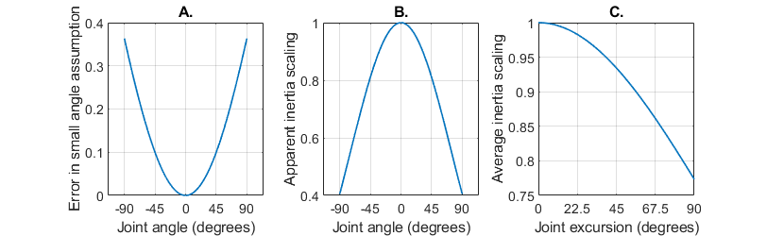
Figure S1 – Plots quantifying error introduced into our model by small angle approximation. A. Plot of the percent error between $θ$ and $\sin{θ}$, $f=\left(\frac{θ-\sin{θ}}{θ}\right)$. B. Multiplicative impact on the model’s inertia of assuming $\sin{θ}=θ$. By approximating the rotary elastic potential energy as $V_{r,elas}=\frac{1}{2}k_{0}s^{2}θ^{2}$ instead of $\frac{1}{2}k_{0}s^{2}\sin^{2}{θ}$, and computing the kinetic energy exactly as $T=\frac{1}{2}J_{0}{\dot{θ}}^{2}$, the model underestimates the inertia present in the system at extreme angles, $f={\left(\frac{\sin{θ}}{θ}\right)}^{2}$. C. The underestimation of inertia averaged over the entire range of motion, $f=\frac{1}{2θ}⋅\int_{-θ}^{θ}{{\left(\frac{\sin{x}}{x}\right)}^{2}⋅dx}$, reveals that the model approximates limb inertia to within 75% of its actual value for large amplitude oscillations, and is much more accurate for smaller ranges of motion.

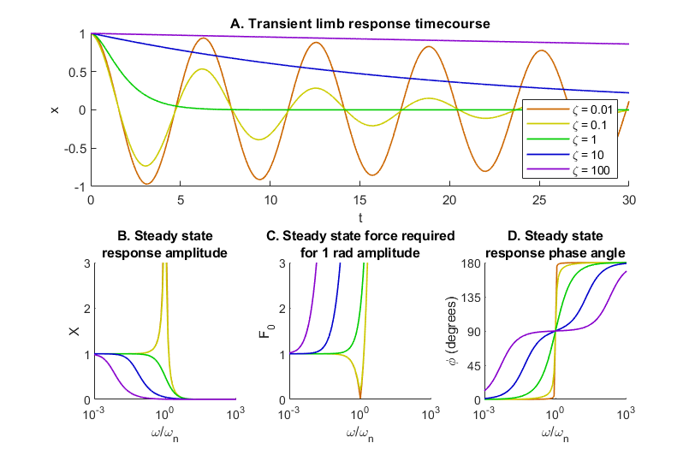
Figure S2 – The transient and steady state responses of the limb depend heavily on the damping ratio $ζ$. A. If $ζ<1$, the transient response contains oscillation. If $ζ≥1$, the transient response contains no oscillation. The larger $ζ$ becomes, the more slowly the system returns to equilibrium. B. If $ζ<1$, the motion in response to periodic forcing near the natural frequency is amplified. If $ζ≥1$, no such amplification takes place. For all values of $ζ$, motions much slower than the natural frequency are proportional to the applied force (i.e. $X→1$ as $ω→0$). Furthermore, the amplitude in response to forcing faster than the natural frequency approaches 0. C. Inverting $X$ as plotted in B. reveals the force required for oscillation with 1 radian amplitude. Forcing the limb faster than the natural frequency requires ever-increasing force, explaining why rapid motions are limited by muscle and bone stress, whereas slow motions are not (See Figure 4 in the manuscript). D. For all values of $ζ$, $ϕ→0^{∘}$ as $ω→0$ and $ϕ→{180}^{∘}$ as $ω→∞$. As $ζ$ increases, the range of $ω$ over which $ζ≈{90}^{∘}$ increases, indicating a larger viscous region.

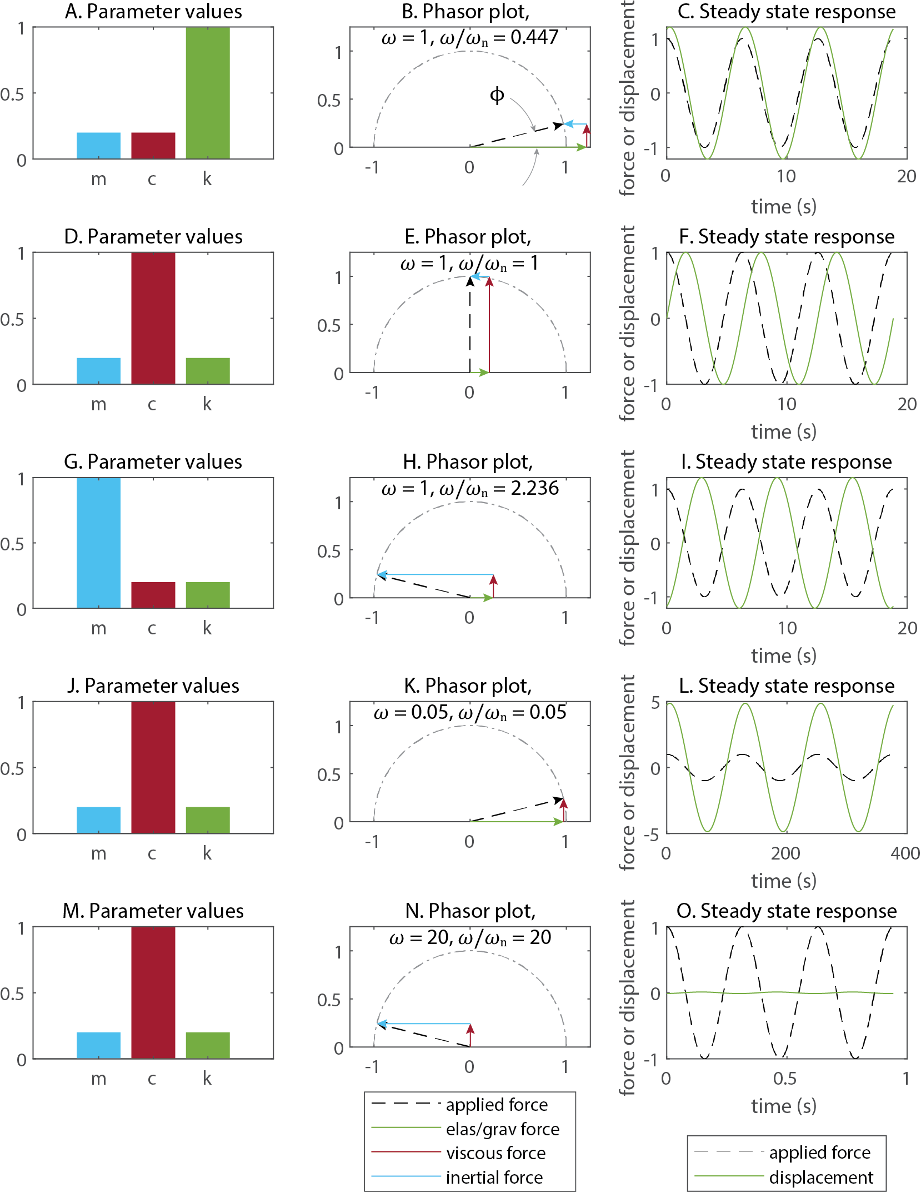
Figure S3 – The dominant force in a behavior depends on both the system parameters and the speed (i.e. frequency) of motion. A. Stiffness is greater than mass and damping. B. When forced at 1 radian/second, elastic force dominates, predicting motion in phase with the force. C. Simulation confirms that motion is in phase with the force. D. Damping is greater than mass and stiffness. E. When forced at 1 radian/second, viscous force dominates, predicting motion that lags 90 degrees behind the force. F. Simulation confirms that motion lags 90 degrees behind the force. G. Mass is greater than damping and stiffness. H. When forced at 1 radian/second, inertial force dominates, predicting motion out of phase with the force. I. Simulation confirms that motion is out of phase with the force. J. Damping is greater than mass and stiffness, as in D. K. When forced at 0.05 radians/second (20 times slower than the frequency in D), elastic force dominates, predicting motion in phase with the force. L. Simulation confirms that motion is in phase with the force. M. Damping is greater than mass and stiffness, as in D. and J. N. When forced at 20 radians/second (20 times faster than the frequency in D), inertial force dominates, predicting motion out of phase with the force. O. Simulation confirms that motion is out of phase with the force.

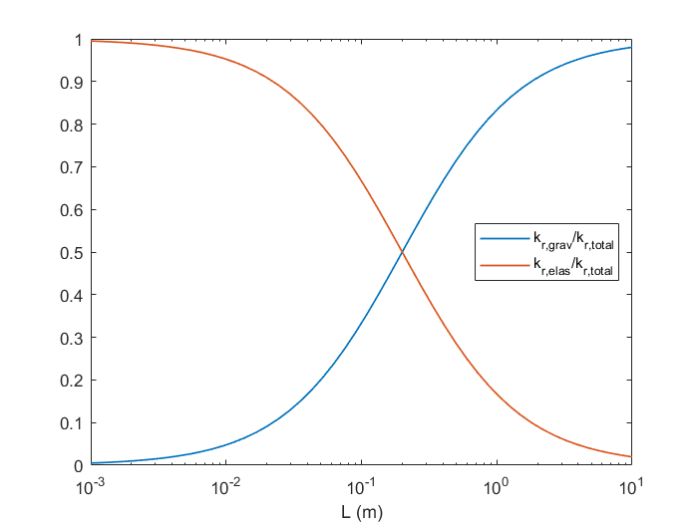
Figure S4 – Plot of the relative contribution of elastic (red) and gravitational (blue) potential energy to a system as a function of its length $L$. For small animals, most of the limb’s potential energy is stored in elastic elements; for large animals, most of the limb’s potential energy is stored in the posture of the leg.

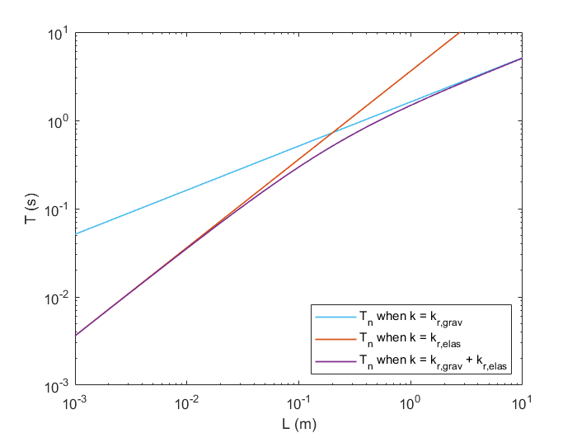
Figure S5 – The natural period $T_{n}$ does not scale uniformly with $L$. When potential energy is stored primarily as elastic potential energy ($L<{10}^{-1}$), $T_{n}∝L$. In contrast, when potential energy is stored primarily as gravitational energy ($L>{10}^{0}$), $T_{n}∝\sqrt{L}$.

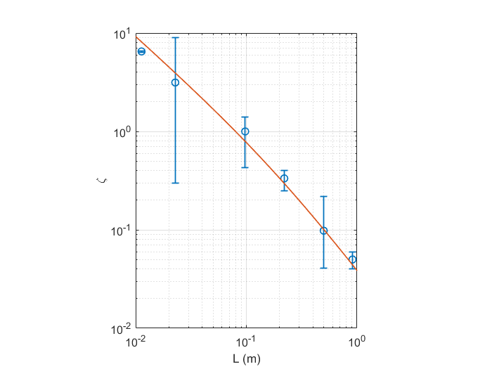
Figure S6 – Our scaling law for $ζ$ from Equation 41 captures the trend of reported values for joint damping in several species and leg joints. Each reported value is plotted as a blue circle; the range of reported values is plotted as error bars; the model prediction is plotted as a red line. Published measurements, from left to right: Cockroach femur-tibia joint (23); Locust femur-tibia joint (9); human finger (33); human ankle (34); human knee (30); and human hip (30).

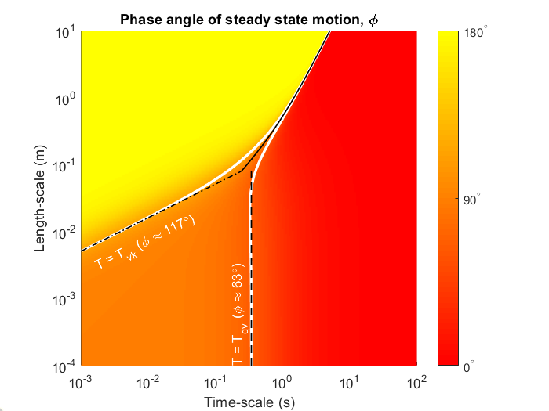
Figure S7 – Plot illustrating boundaries between quasi-static (red, $ϕ≈0$), viscous (orange, $ϕ≈{90}^{∘}$), and kinetic (yellow, $ϕ≈{180}^{∘}$) regions. The level curve at which $ϕ≈{63}^{∘}$, computed by Equation 43, is plotted in white. The level curve at which $ϕ≈{117}^{∘}$, computed by Equation 45 is also plotted in white. The approximations of these boundaries (Equations 44, 46 and 47) are plotted in black. These approximations are useful because their formulations are much simpler than the exact boundaries, enabling one to evaluate the region of a behavior without complicated calculations. The boundary between the quasi-static and viscous regions in the limit as $L→0$, computed by Equation 44, is plotted as a dashed black line. The boundary between the viscous and kinetic regions in the limit as $L→0$, computed by equation 46, is plotted as a dash-dotted black line. The boundary between the quasi-static and kinetic regions, computed by equation 47, is plotted as a solid black line.

Tables
Table 1 – Table of rhythmic animal motions and their period. Each row contains data from walking unless otherwise indicated. Each species has a minimum and maximum period of motion, reported in seconds. The reference and the figure or table from which each value was drawn is listed for each value.
Species | Min $T$ (s) | Max $T$ (s) | Reference | Location
Elephant | 500 x 10⁻³ | 5 | (35) | Tab. 2
Horse | 440 x 10⁻³ | 900 x 10⁻³ | (36) | Body text
Emu | 250 x 10⁻³ | 1 | (37) | Fig. 4
Human | 500 x 10⁻³ | 1 | (38) | Fig. 1
Red kangaroo | 450 x 10^{-3‡} | - | (39) | Fig. 9.3
Cat | 250 x 10⁻³ | 700 x 10⁻³ | (40) | Fig. 2
Spring hare | 330 x 10^{-3‡} | - | (41) | Fig. 11
Kangaroo rat | 285 x 10^{-3‡} | - | (39) | Fig. 9.5
Human (finger tap) | 37 x 10⁻³* | 1** | (42) | Fig. 3
Rat | 200 x 10⁻³ | 600 x 10⁻³ | (43) | Fig. 6
Stick insect | 600 x 10⁻³ | 1.8 | (7) | Tab. 1
Hopping mouse | 160 x 10^{-3‡} | - | (39) | Fig. 9.4
Mouse | 100 x 10⁻³ | 330 x 10⁻³ | (44) | Fig. 2
Sea slug (grasp) | 1.25 | 5 | (45) | Fig. 15
Discoid cockroach | 67 x 10⁻³ | 250 x 10⁻³ | (46) | Fig. 5
American cockroach | 44 x 10⁻³ | 667 x 10⁻³ | (47) | Figs. 1, 4
Tiger beetle | 56 x 10⁻³ | 200 x 10⁻³ | (48) | Body text
Mite | 25 x 10^{-3†} | 200 x 10⁻³ | (49) | Fig. 2
Fruit fly | 50 x 10⁻³ | 130 x 10⁻³ | (50) | Fig. 3

* World’s fastest telegrapher, Teddy McElroy, is recorded as transmitting 77 words per minute (51). Assuming an average of 6 characters per word with one space between words and 3 taps per letter, we calculate $\frac{1 minute}{77 words}⋅\frac{60 seconds}{1 minute}⋅\frac{1 word}{7 char}⋅\frac{1 char}{3 taps}=37×{10}^{-3}\frac{seconds}{tap}$.
** A human can volitionally drive their finger at an arbitrarily long period, but we chose 1 second as a functionally relevant maximum value. Figure 4 in the manuscript demonstrates that any motions with a longer period would exist in the quasi-static region.
† The authors of this study report that this species can step at higher frequencies when artificially heated high temperatures. To better compare naturalistic behaviors, we only use data at temperatures below 30 degrees Celsius.
‡ Because this species hops at a preferred resonant frequency, this value ±5% was plotted in Figure 4.

References Cited
1. D. G. Caldwell, A. Razak, M. Goodwin, Braided Pneumatic Muscle Actuators. IFAC Proc. Vol. 26, 522–527 (1993).
2. D. T. Greenwood, Principles of Dynamics (Cambridge University Press, 2006).
3. L. Ren, M. Butler, C. Miller, H. Paxton, D. Schwerda, M. S. Fischer, J. R. Hutchinson, The movements of limb segments and joints during locomotion in African and Asian elephants. J. Exp. Biol. 211, 2735–2751 (2008).
4. L. Roepstorff, A. Egenvall, M. Rhodin, A. Byström, C. Johnston, P. R. van Weeren, M. Weishaupt, Kinetics and kinematics of the horse comparing left and right rising trot. Equine Vet. J. 41, 292–296 (2009).
5. M. P. Kadaba, H. K. Ramakrishnan, M. E. Wootten, Measurement of lower extremity kinematics during level walking. J. Orthop. Res. 8, 383–392 (1990).
6. M. S. Fischer, N. Schilling, M. Schmidt, D. Haarhaus, H. Witte, Basic limb kinematics of small therian mammals. J. Exp. Biol. 205, 1315–38 (2002).
7. H. Cruse, C. Bartling, Movement of joint angles in the legs of a walking insect, Carausius morosus. J. Insect Physiol. 41, 761–771 (1995).
8. J. A. Bender, E. M. Simpson, R. E. Ritzmann, Computer-assisted 3D kinematic analysis of all leg joints in walking insects. PLoS One. 5 (2010), doi:10.1371/journal.pone.0013617.
9. J. Zakotnik, T. Matheson, V. Dürr, Co-Contraction and Passive Forces Facilitate Load Compensation of Aimed Limb Movements. J. Neurosci. 26, 4995–5007 (2006).
10. B. A. Garner, M. G. Pandy, The Obstacle-Set Method for Representing Muscle Paths in Musculoskeletal Models. Comput. Methods Biomech. Biomed. Engin. 3, 1–30 (2000).
11. C. Guschlbauer, H. Scharstein, A. Buschges, The extensor tibiae muscle of the stick insect: biomechanical properties of an insect walking leg muscle. J. Exp. Biol. 210, 1092–1108 (2007).
12. S. S. Rao, Mechanical Vibrations (Prentice Hall, ed. 5, 2011), vol. 33.
13. A. A. Biewener, Biomechanics of mammalian terrestrial locomotion. Science (80-. ). 250, 1097–1103 (1990).
14. S. L. Hooper, Body size and the neural control of movement. Curr. Biol. 22, R318–R322 (2012).
15. T. McMahon, Size and Shape in Biology: Elastic criteria impose limits on biological proportions, and consequently on metabolic rates. Science (80-. ). 179, 1201–1204 (1973).
16. S. L. Hooper, C. Guschlbauer, M. Blümel, P. Rosenbaum, M. Gruhn, T. Akay, A. Büschges, Neural control of unloaded leg posture and of leg swing in stick insect, cockroach, and mouse differs from that in larger animals. J. Neurosci. 29, 4109–19 (2009).
17. K. Jayaram, J. M. Mongeau, A. Mohapatra, P. Birkmeyer, R. S. Fearing, R. J. Full, Transition by head-on collision: mechanically mediated manoeuvres in cockroaches and small robots. J. R. Soc. Interface. 15 (2018), doi:10.1098/rsif.2017.0664.
18. M. Ilton, M. Saad Bhamla, X. Ma, S. M. Cox, L. L. Fitchett, Y. Kim, J. sung Koh, D. Krishnamurthy, C. Y. Kuo, F. Z. Temel, A. J. Crosby, M. Prakash, G. P. Sutton, R. J. Wood, E. Azizi, S. Bergbreiter, S. N. Patek, The principles of cascading power limits in small, fast biological and engineered systems. Science (80-. ). 360 (2018), doi:10.1126/science.aao1082.
19. J. M. Gere, B. J. Goodno, Mechanics of Materials 5th. Brooks Cole, 780 (2001).
20. R. M. N. Alexander, Operation of the system for development of force, speed and power. J. Exp. Biol. 115, 231–238 (1985).
21. R. M. Alexander, H. C. Bennet-Clark, Storage of elastic strain energy in muscle and other tissues. Nature. 265, 114–117 (1977).
22. F. E. Zajac, Muscle and tendon: properties, models, scaling, and application to biomechanics and motor control. Crit. Rev. Biomed. Eng. 17 (1989), pp. 359–411.
23. M. S. Garcia, A. D. Kuo, A. Peattie, P. Wang, R. J. Full, Damping And Size: Insights And Biological Inspiration. Int. Symp. Adapt. Motion Anim. Mach., 1–7 (2000).
24. L. J. Clancy, Aerodynamics, John Wiley and Sons. New York (1975).
25. S. B. Williams, A. M. Wilson, L. Rhodes, J. Andrews, R. C. Payne, Functional anatomy and muscle moment arms of the pelvic limb of an elite sprinting athlete: The racing greyhound (Canis familiaris). J. Anat. 213, 361–372 (2008).
26. E. C. Greene, Anatomy of the Rat (Hafner Publishing Co., New York, NY, 1955).
27. R. Full, A. Ahn, Static forces and moments generated in the insect leg: comparison of a three-dimensional musculo-skeletal computer model with experimental measurements. J. Exp. Biol. 198, 1285–98 (1995).
28. J. M. Ache, T. Matheson, Passive joint forces are tuned to limb use in insects and drive movements without motor activity. Curr. Biol. 23, 1418–1426 (2013).
29. A. von Twickel, C. Guschlbauer, S. L. Hooper, A. Büschges, Swing Velocity Profiles of Small Limbs Can Arise from Transient Passive Torques of the Antagonist Muscle Alone. Curr. Biol. 29, 1-12.e7 (2019).
30. R. B. Stein, E. P. Zehr, M. K. Lebiedowska, D. B. Popovic, A. Scheiner, H. J. Chizeck, Estimating mechanical parameters of leg segments in individuals with and without physical disabilities. IEEE Trans. Rehabil. Eng. 4, 201–211 (1996).
31. P. Holmes, R. J. Full, D. E. Koditschek, J. Guckenheimer, The Dynamics of Legged Locomotion: Models, Analyses, and Challenges. Challenges. 48, 207–304 (2006).
32. V. Strouhal, Über eine besondere Art der Tonerregung. Ann. Phys. 241, 216–251 (1878).
33. A. Z. Hajian, R. D. Howe, Identification of the Mechanical Impedance at the Human Finger Tip. J. Biomech. Eng. 119, 109–114 (1997).
34. P. L. Weiss, I. W. Hunter, R. E. Kearney, Human ankle joint stiffness over the full range of muscle activation levels. J. Biomech. 21, 539–544 (1988).
35. J. R. Hutchinson, D. Schwerda, D. J. Famini, R. H. I. Dale, M. S. Fischer, R. Kram, The locomotor kinematics of Asian and African elephants: Changes with speed and size. J. Exp. Biol. 209, 3812–3827 (2006).
36. M. Hildebrand, Motions of the Running Cheetah and Horse. J. Mammal. 40, 481 (1959).
37. M. A. Daley, A. J. Channon, G. S. Nolan, J. Hall, Preferred gait and walk-run transition speeds in ostriches measured using GPS-IMU sensors. J. Exp. Biol. 219, 3301–3308 (2016).
38. S. Grillner, J. Halbertsma, J. Nilsson, A. Thorstensson, The adaptation to speed in human locomotion. Brain Res. 165, 177–182 (1979).
39. T. J. Dawson, K. N. Webster, in Macropods: The Biology of Kangaroos, Wallabies, and Rat-kangaroos (2010), pp. 99–108.
40. S. Grillner, Locomotion in vertebrates: central mechanisms and reflex interaction. Physiol. Rev. 55, 247–304 (1975).
41. G. A. Cavagna, N. C. Heglund, C. R. Taylor, Mechanical work in terrestrial locomotion: Two basic mechanisms for minimizing energy expenditure. Am. J. Physiol. 233, R243–R261 (1977).
42. T. Aoki, S. Furuya, H. Kinoshita, Finger-tapping ability in male and female pianists and nonmusician controls. Motor Control. 9, 23–39 (2005).
43. R. E. Hruska, S. Kennedy, E. K. Silbergeld, Quantitative aspects of normal locomotion in rats. Life Sci. 25, 171–179 (1979).
44. M. Herbin, R. Hackert, J.-P. Gasc, S. Renous, Gait parameters of treadmill versus overground locomotion in mouse. Behav. Brain Res. 181, 173–179 (2007).
45. K. M. Shaw, D. N. Lyttle, J. P. Gill, M. J. Cullins, J. M. McManus, H. Lu, P. J. Thomas, H. J. Chiel, The significance of dynamical architecture for adaptive responses to mechanical loads during rhythmic behavior. J. Comput. Neurosci. 38, 25–51 (2015).
46. J. A. Bender, E. M. Simpson, B. R. Tietz, K. A. Daltorio, R. D. Quinn, R. E. Ritzmann, Kinematic and behavioral evidence for a distinction between trotting and ambling gaits in the cockroach Blaberus discoidalis. J. Exp. Biol. 214, 2057–2064 (2011).
47. F. Delcomyn, The Locomotion of the Cockroach Periplaneta Americana. J. Exp. Biol. 54, 443–452 (1971).
48. A. F. Haselsteiner, C. Gilbert, Z. J. Wang, Tiger beetles pursue prey using a proportional control law with a delay of one half-stride. J. R. Soc. Interface. 11, 20140216 (2014).
49. G. C. Wu, J. C. Wright, D. L. Whitaker, A. N. Ahn, Kinematic evidence for superfast locomotory muscle in two species of teneriffiid mites. J. Exp. Biol. 213, 2551–2556 (2010).
50. A. Wosnitza, T. Bockemühl, M. Dübbert, H. Scholz, A. Büschges, Inter-leg coordination in the control of walking speed in Drosophila. J. Exp. Biol. 216, 480–491 (2013).
51. T. French, McElroy, World’s Champion Radio Telegrapher (Artifax Books, 1993).

