Supplementary Material

Supplementary Tables
Supplementary Table S1 – Summary statistics of individual fits of viral load data. c: viral clearance, δ: infected cell clearance, p: viral production rate, E_{max,immunity}: maximum acquired immunity effect on viral clearance, SD: standard deviation, %CV: coefficient of variation (100*mean/SD).

 | c | δ | p | E_{max,immunity}
mean | 5.07 | 0.54 | 10.2 | 57.0
SD | 2.18 | 0.16 | 4.3 | 23.4
%CV | 43% | 30% | 42% | 41%

Supplementary Table S2 - Viral kinetics model parameters. EC₅₀: half maximal effective concentration; IC₅₀: half maximal inhibitory concentration; HCQ: hydroxychloroquine; IVM: ivermectin; NTZ: nitazoxanide; ART: artemisinin; LPV: lopinavir
Parameter | Definition | Value | Reference
β | Cellular infection rate | $$β=\frac{R_{0}cδ}{T_{0}(p-R_{0}δ)}$$ | Calculated
δ | Infected cell death rate | 0.54 | Estimated
p | Viral production rate | 10.2 | Estimated
c | Viral clearance | 5.07 | Estimated
R₀ | Within-host reproduction number | 3.79 | (Li et al., 2020)
T₀ | Initial target cells | 10⁵ | Fixed by authors
V₀ | Initial virus load (inoculum) | 10⁰ | Fixed by authors
EC_{50, immunity} | EC₅₀ for immune response | 10.2 | Estimated from (Long et al., 2020)
Hill _{immunity} | Slope of dose-response curve | 3.4 | Estimated from (Long et al., 2020)
E_{max}, _{immunity} | Maximum effect on viral clearance | 57.0 | Estimated
HCQ | EC₅₀ _{viral entry} | 8.51 µM | (Liu et al., 2020) (averaged)
 | Protein binding | 50% | (Furst, 1996)
IVM | IC_{50 helicase} | 0.1 µM | Fixed by authors
 | IC_{50 nAChR} | 0.156 µM | (Degani-Katzav et al., 2017)
 | Protein binding | 93% | (Klotz et al., 1990)
 | Lung accumulation | 2.6 | (Lifschitz et al., 2000)
NTZ | EC₅₀ | 2.12 µM | (Wang et al., 2020)
 | Protein binding | 99% | (FDA, 2005)
 | Lung accumulation | 0.7 | (Rajoli et al., 2020)
ART | EC₅₀ | 70 µM | (Nair et al., 2021)
 | Protein binding | 88% | (Jagdev S. Sidhu, 1997)
LPV | IC₅₀ _{protease} | 26.63 µM | (Choy et al., 2020)
 | Protein binding | 99% | (Boffito et al., 2004)
 | Lung accumulation | 1.78 | (Atzori et al., 2003)
Supplementary Table S3 - Summary results of viral load simulations. dpi: days post infection; d: day; min Ct: minimum serial cycle threshold values; tmax: time to peak concentration; ΔAUC%: percentage difference in area under the curve; HCQ: hydroxychloroquine; ART: artemisinin; IVM: ivermectin; LPV/r: lopinavir/ritonavir; NTZ: nitazoxanide. Treatments were initiated either on positivity (5.4 dpi) or on peak (10.2 dpi). Dosing of different modeled treatment regimens: HCQ 200 mg every 8h for 10 days; HCQ 800 mg every 12h for 1 day, then 400 mg every 12h for 9 days; IVM 300 µg/kg every 24h for 3 days; IVM 600 µg/kg every day for 3 days; NTZ 1200 mg every 6h for 5 days; NTZ 2900 mg every 12h for 5 days; ART 500 mg once a day for 5 days; LPV/r 400/100 mg every 12h for 14 days.

Treatment | Timing | Dosage | Start positivity | Duration | Ct_{min} | T_{max} | ΔAUC%
ART 500 | on positivity | 500 mg qd 5d | 5.4 | 13.5 | 28.4 | 10.2 | 0.0
ART 500 | on peak | 500 mg qd 5d | 5.4 | 13.5 | 28.4 | 10.2 | 0.0
HCQ 200 | on positivity | 200 mg q8h 10d | 5.4 | 14.1 | 28.6 | 10.5 | -4.6
HCQ 200 | on peak | 200 mg q8h 10d | 5.4 | 13.5 | 28.4 | 10.2 | -0.3
HCQ 800 | on positivity | 800 mg q12h 1d,  400 mg q12h 9d | 5.4 | 14.5 | 28.8 | 10.9 | -8.2
HCQ 800 | on peak | 800 mg q12h 1d,  400 mg q12h 9d | 5.4 | 13.6 | 28.4 | 10.2 | -0.6
IVM 300 | on positivity | 300 µg/kg q24h 3d | 5.4 | 14.2 | 28.7 | 10.9 | -8.8
IVM 300 | on peak | 300 µg/kg q24h 3d | 5.4 | 13.6 | 28.4 | 10.2 | -3.4
IVM 600 | on positivity | 600 µg/kg q24h 3d | 5.4 | 15.6 | 29.0 | 12.3 | -22.3
IVM 600 | on peak | 600 µg/kg q24h 3d | 5.4 | 14.0 | 28.4 | 10.2 | -13.2
LPV/r 400/100 | on positivity | 400/100 mg q12h 14d | 5.4 | 13.5 | 28.4 | 10.2 | -0.4
LPV/r 400/100 | on peak | 400/100 mg q12h 14d | 5.4 | 13.5 | 28.4 | 10.2 | 0.0
NTZ 1200 | on positivity | 1200 mg q6h 5d | 5.4 | 13.5 | 28.4 | 10.2 | 0.0
NTZ 1200 | on peak | 1200 mg q6h 5d | 5.4 | 13.5 | 28.4 | 10.2 | 0.0
NTZ 2900 | on positivity | 2900 mg q12h 5d | 5.4 | 13.5 | 28.4 | 10.2 | 0.0
NTZ 2900 | on peak | 2900 mg q12h 5d | 5.4 | 13.5 | 28.4 | 10.2 | 0.0
No treatment | NA | - | 5.4 | 13.5 | 28.4 | 10.2 | 0.0

Supplementary Figures
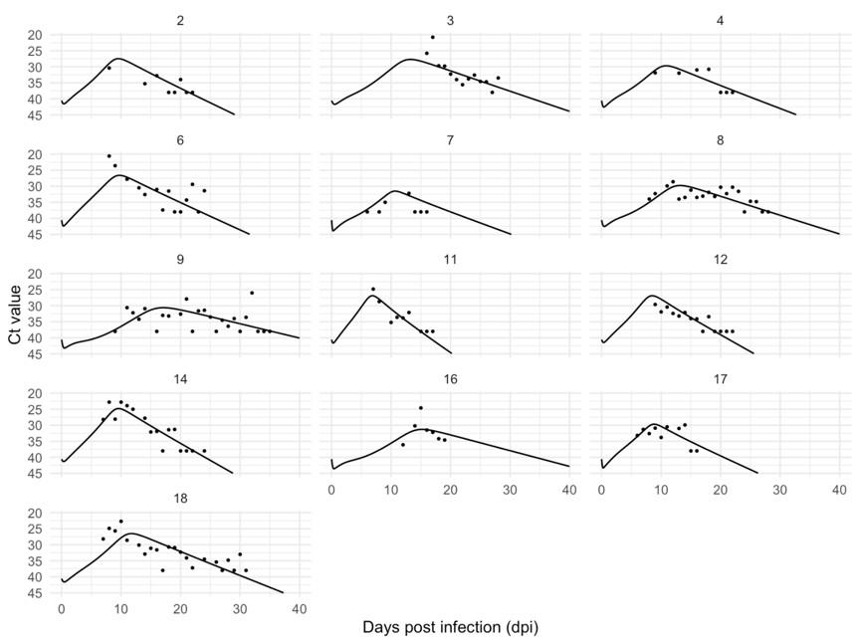
Supplementary Figure S1 - Individual plots of serial cycle threshold (Ct) values by days post infection in SARS-CoV-2 of patients included in the analysis (n=13, dots) and model fit (line).

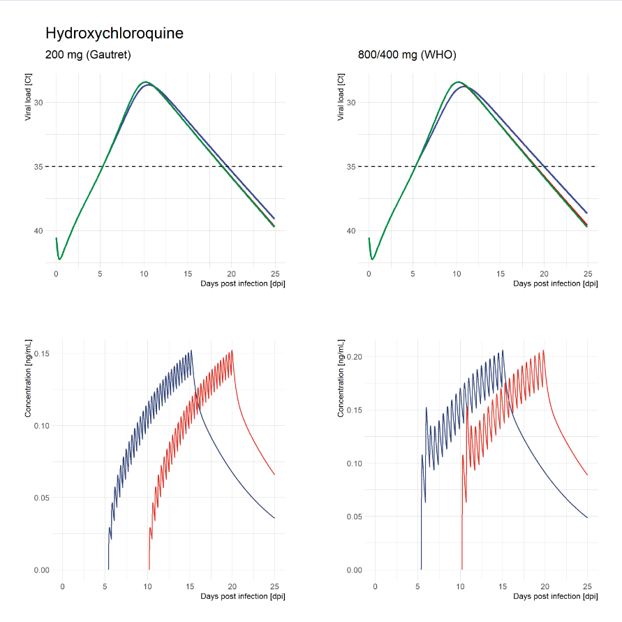
Supplementary Figure S2 – Effect of Hydroxychloroquine pharmacokinetic on SARS-CoV-2 viral kinetics (blue: treatment on positivity, red: treatment on peak, green: untreated)

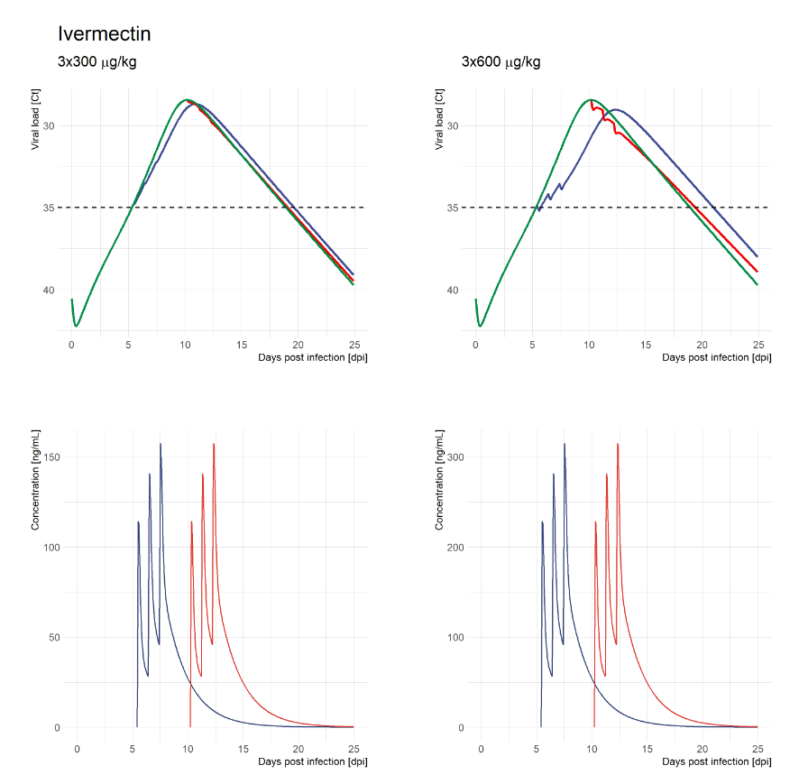
Supplementary Figure S3 – Effect of ivermectin pharmacokinetic on SARS-CoV-2 viral kinetics (blue: treatment on positivity, red: treatment on peak, green: untreated)

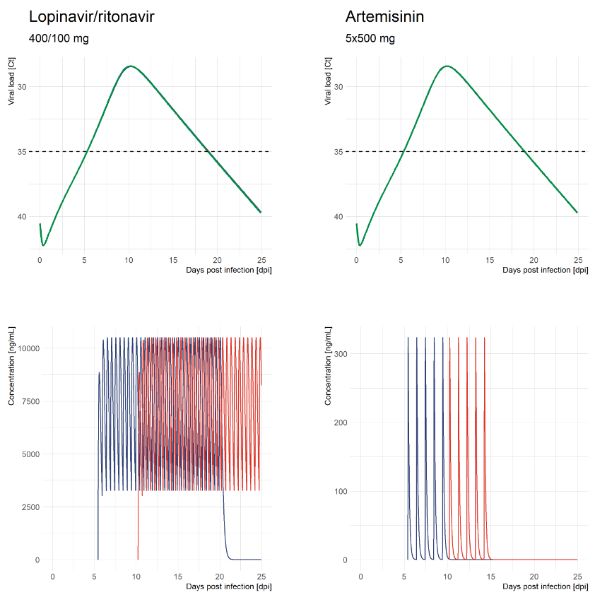
Supplementary Figure S4 – Effect of lopinavir/ritonavir and Artemisinin pharmacokinetic on SARS-CoV-2 viral kinetics (blue: treatment on positivity, red: treatment on peak, green: untreated)
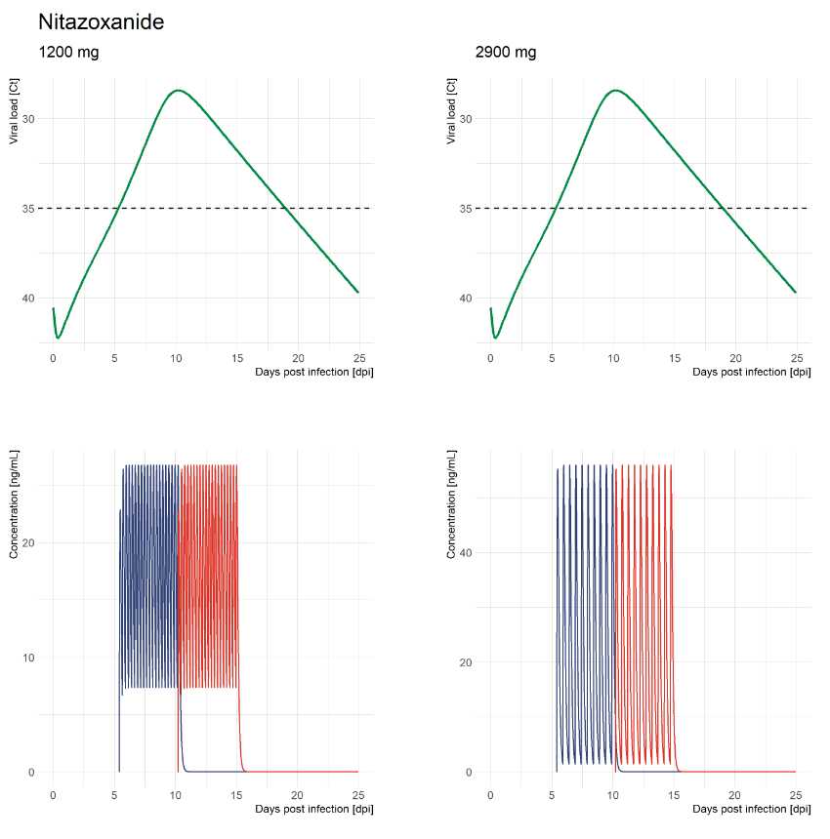
Supplementary Figure S5 – Effect of nitazoxanide pharmacokinetic on SARS-CoV-2 viral kinetics (blue: treatment on positivity, red: treatment on peak, green: untreated)

References
Atzori, C., Villani, P., Regazzi, M., Maruzzi, M., and Cargnel, A. (2003). Detection of intrapulmonary concentration of lopinavir in an HIV-infected patient. AIDS (London, England) 17, 1710-1711.
Boffito, M., Hoggard, P.G., Lindup, W.E., Bonora, S., Sinicco, A., Khoo, S.H., Di Perri, G., and Back, D.J. (2004). Lopinavir protein binding in vivo through the 12-hour dosing interval. Ther Drug Monit 26, 35-39.
Choy, K.-T., Wong, A.Y.-L., Kaewpreedee, P., Sia, S.F., Chen, D., Hui, K.P.Y., Chu, D.K.W., Chan, M.C.W., Cheung, P.P.-H., Huang, X., Peiris, M., and Yen, H.-L. (2020). Remdesivir, lopinavir, emetine, and homoharringtonine inhibit SARS-CoV-2 replication in vitro. Antiviral research 178, 104786-104786.
Degani-Katzav, N., Klein, M., Har-Even, M., Gortler, R., Tobi, R., and Paas, Y. (2017). Trapping of ivermectin by a pentameric ligand-gated ion channel upon open-to-closed isomerization. Scientific Reports 7, 42481.
Fda (2005). "PRESCRIBING INFORMATION: Alinia® (nitazoxanide) Tablets (nitazoxanide) for Oral Suspension ".).
Furst, D.E. (1996). Pharmacokinetics of hydroxychloroquine and chloroquine during treatment of rheumatic diseases. Lupus 5 Suppl 1, S11-15.
Jagdev S. Sidhu, M.A. (1997). Single-Dose, Comparative Study of Venous, Capillary and Salivary Artemisinin Concentrations in Healthy, Male Adults. The American Journal of Tropical Medicine and Hygiene 56.
Klotz, U., Ogbuokiri, J.E., and Okonkwo, P.O. (1990). Ivermectin binds avidly to plasma proteins. Eur J Clin Pharmacol 39, 607-608.
Li, C., Xu, J., Liu, J., and Zhou, Y. (2020). The within-host viral kinetics of SARS-CoV-2. MBE 17, 2853–2861.
Lifschitz, A., Virkel, G., Sallovitz, J., Sutra, J.F., Galtier, P., Alvinerie, M., and Lanusse, C. (2000). Comparative distribution of ivermectin and doramectin to parasite location tissues in cattle. Veterinary Parasitology 87, 327-338.
Liu, J., Cao, R., Xu, M., Wang, X., Zhang, H., Hu, H., Li, Y., Hu, Z., Zhong, W., and Wang, M. (2020). Hydroxychloroquine, a less toxic derivative of chloroquine, is effective in inhibiting SARS-CoV-2 infection in vitro. Cell Discovery 6, 16.
Long, Q.-X., Liu, B.-Z., Deng, H.-J., Wu, G.-C., Deng, K., Chen, Y.-K., Liao, P., Qiu, J.-F., Lin, Y., Cai, X.-F., Wang, D.-Q., Hu, Y., Ren, J.-H., Tang, N., Xu, Y.-Y., Yu, L.-H., Mo, Z., Gong, F., Zhang, X.-L., Tian, W.-G., Hu, L., Zhang, X.-X., Xiang, J.-L., Du, H.-X., Liu, H.-W., Lang, C.-H., Luo, X.-H., Wu, S.-B., Cui, X.-P., Zhou, Z., Zhu, M.-M., Wang, J., Xue, C.-J., Li, X.-F., Wang, L., Li, Z.-J., Wang, K., Niu, C.-C., Yang, Q.-J., Tang, X.-J., Zhang, Y., Liu, X.-M., Li, J.-J., Zhang, D.-C., Zhang, F., Liu, P., Yuan, J., Li, Q., Hu, J.-L., Chen, J., and Huang, A.-L. (2020). Antibody responses to SARS-CoV-2 in patients with COVID-19. Nature Medicine 26, 845-848.
Nair, M.S., Huang, Y., Fidock, D.A., Polyak, S.J., Wagoner, J., Towler, M.J., and Weathers, P.J. (2021). Artemisia annua L. extracts prevent in vitro replication of SARS-CoV-2. bioRxiv, 2021.2001.2008.425825.
Rajoli, R.K., Pertinez, H., Arshad, U., Box, H., Tatham, L., Curley, P., Neary, M., Sharp, J., Liptrott, N.J., Valentijn, A., David, C., Rannard, S.P., Aljayyoussi, G., Pennington, S.H., Hill, A., Boffito, M., Ward, S.A., Khoo, S.H., Bray, P.G., O'neill, P.M., Hong, W.D., Biagini, G., and Owen, A. (2020). Dose prediction for repurposing nitazoxanide in SARS-CoV-2 treatment or chemoprophylaxis. medRxiv : the preprint server for health sciences, 2020.2005.2001.20087130.
Wang, M., Cao, R., Zhang, L., Yang, X., Liu, J., Xu, M., Shi, Z., Hu, Z., Zhong, W., and Xiao, G. (2020). Remdesivir and chloroquine effectively inhibit the recently emerged novel coronavirus (2019-nCoV) in vitro. Cell Research 30, 269-271.

