List Supplementary Figures and Tables
Supplementary Figure 1 The number of provinces and municipalities with effective TE, PTE and SE from 2012 to 2014 2
Supplementary Figure 2 The Malmquist productivity of nursing homes in China and its general evolution trend from 2012 to 2016 3
Supplementary Figure 3 An evolution trend of TE among nursing homes in different regions in China 3
Supplementary Table 1 Description of inputs and outputs 3
Supplementary Table 2 Summary statistics of input-output variables (from 2012 to 2016) 5
Supplementary Table 3 The TE evaluation among nursing homes in 31 provinces and municipalities 7
Supplementary Table 4 Summary of TE, PTE, SE scores according to the different regions (2012-2016) 7
Supplementary Table 5 Adjusted volume and proportion of input indicators in 2016 8
Supplementary materials: DEA classification formula 9

Figures
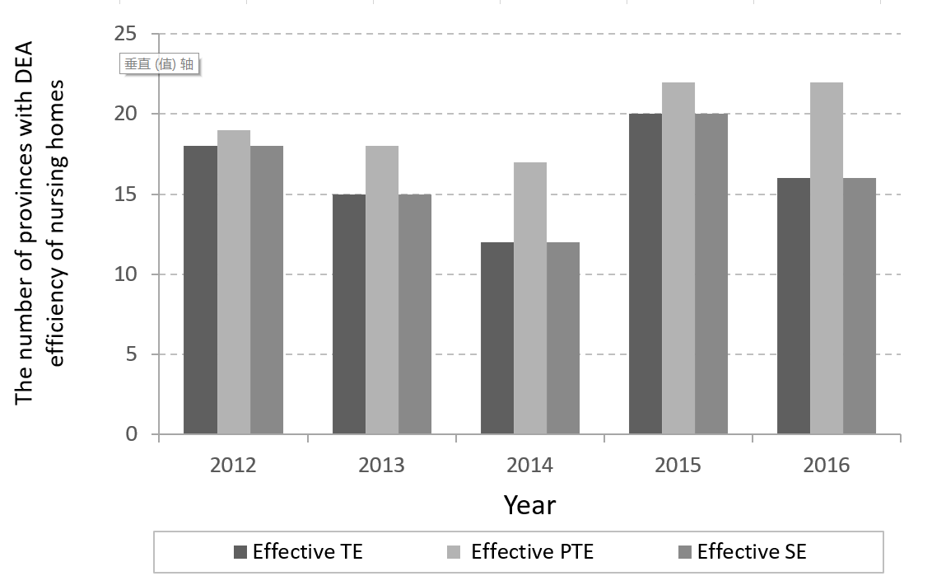

Supplementary Figure 1 The number of provinces with effective TE, PTE and SE (2012-2014)

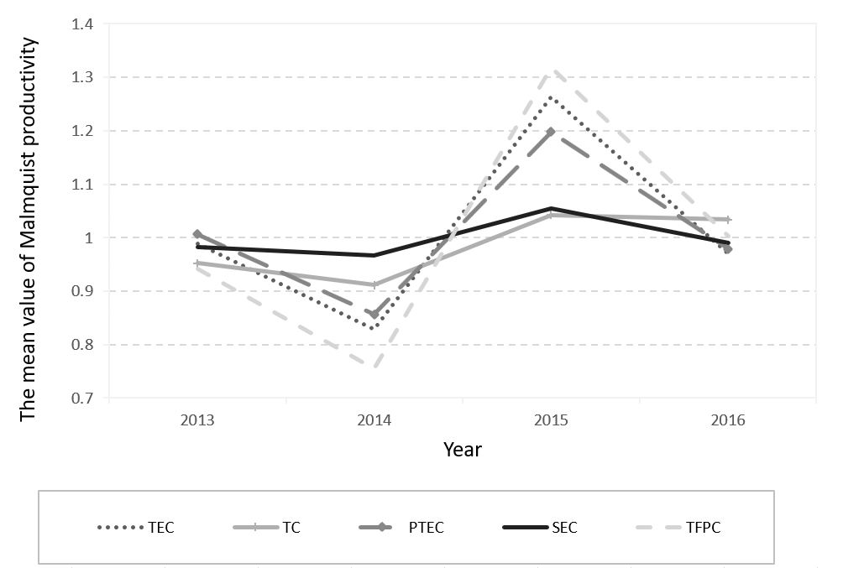

Supplementary Figure 2 The Malmquist productivity of nursing homes in China and its general evolution trend (2012-2016)
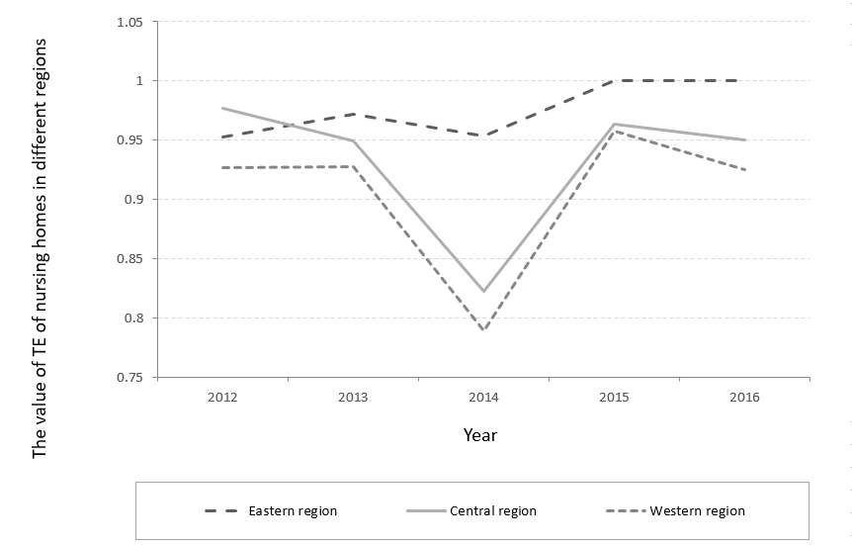

Supplementary Figure 3 An evolution trend of TE among nursing homes in different regions in China

Tables

Supplementary Table 1 Description of inputs and outputs
Primary index | Secondary index | Tertiary index
Inputs | Financial capital | The number of institutions
 |  | The original price of fixed assets
 |  | The number of beds at the end of the year
 | Human capital | The number of employees
 |  | The number of social workers
Outputs | Financial capital | Operating income
 | Quality of the older people care | The number of disabled
 |  | The number of partially disabled
 |  | The number of independents
 |  | The number of rehabilitation and medical outpatients

Supplementary Table 2 Summary statistics of input-output variables (from 2012 to 2016)
 | Outputs |  |  |  |  |  | Inputs
 | O1 | O2 | O3 | O4 | O5 |  | I1 | I2 | I3 | I4 | I5
2012
Mean | 152148 | 65453 | 14604 | 7221 | 218607 |  | 1429 | 10671 | 239816 | 63 | 127989
Min | 12908 | 2049 | 418 | 5 | 15 |  | 79 | 513 | 10158 | 1 | 7199
Max | 961553 | 225829 | 44380 | 30246 | 1074797 |  | 3386 | 29491 | 1041701 | 209 | 365270
2013
Mean | 169846 | 67221 | 15904 | 7865 | 241950 |  | 1370 | 11481 | 274530 | 75 | 138552
Min | 3774 | 3389 | 392 | 258 | 105 |  | 78 | 601 | 26545 | 4 | 7935
Max | 497703 | 232059 | 48926 | 28246 | 1720412 |  | 3336 | 30914 | 858955 | 223 | 399449
2014
Mean | 142765 | 55502 | 14800 | 7606 | 208109 |  | 2978 | 15359 | 290807 | 96 | 180558
Min | 3696 | 2574 | 440 | 105 | 350 |  | 86 | 627 | 20523 | 3 | 6943
Max | 470109 | 240348 | 52511 | 29134 | 955228 |  | 22305 | 54869 | 1193418 | 290 | 554479
2015
Mean | 138312 | 44347 | 12948 | 7600 | 269197 |  | 895 | 10266 | 234295 | 100 | 115528
Min | 2176 | 1181 | 217 | 16 | 3605 |  | 35 | 381 | 8897 | 3 | 5022
Max | 492278 | 180009 | 46398 | 29471 | 1436994 |  | 2547 | 30717 | 851817 | 353 | 388561
2016
Mean | 157470 | 44035 | 14124 | 8463 | 244204 |  | 922 | 10929 | 260846 | 132 | 122186
Min | 11630 | 815 | 22 | 29 | 3535 |  | 7 | 91 | 22070 | 4 | 1124
Max | 524550 | 174632 | 48365 | 32577 | 1187467 |  | 2573 | 33463 | 1008513 | 664 | 410441
Note: O1,operating income; O2, the number of independents; O3, the number of partially disabled; O4, the number of the disabled;O5, the number of rehabilitation and medical outpatients; I1the number of institutions; I2, the number of employees at the end of the year; I3, the original price of fixed assets; I4, the number of social workers;I5 the number of beds at the end of the year.

Supplementary Table 3 The TE evaluation among nursing homes in 31 provinces
 | TE | PTE | SE
2012 | 0.932 | 0.939 | 0.992
2013 | 0.922 | 0.944 | 0.977
2014 | 0.799 | 0.843 | 0.948
2015 | 0.959 | 0.965 | 0.994
2016 | 0.933 | 0.947 | 0.985
Mean | 0.909 | 0.928 | 0.979
Mean rank | 4.600 | 6.800 | 12.600
χ² | 8.54
P | 0.014
Note: TE, technical efficiency; PTE, pure technical efficiency; SE, scale efficiency

Supplementary Table 4 Summary of TE, PTE, SE scores according to the different regions (2012-2016)
 | East | Central | West
TE
2012 | 0.9527979 | 0.9764228 | 0.9267942
2013 | 0.971567 | 0.9488472 | 0.9274889
2014 | 0.9529572 | 0.8219322 | 0.7887823
2015 | 1 | 0.9635217 | 0.9577605
2016 | 1 | 0.9498861 | 0.9253417
Mean | 0.975464 | 0.932122 | 0.905234
PTE
2012 | 0.9634443 | 0.9847335 | 0.9375137
2013 | 0.9817871 | 0.962965 | 0.9450924
2014 | 0.9583564 | 0.8465335 | 0.9211046
2015 | 1 | 0.9699101 | 0.9618286
2016 | 1 | 0.964072 | 0.9339631
Mean | 0.98071756 | 0.945643 | 0.9399
SE
2012 | 0.98894965 | 0.99156 | 0.988566
2013 | 0.98959031 | 0.985339 | 0.981374
2014 | 0.99436619 | 0.970939 | 0.856344
2015 | 1 | 0.993413 | 0.99577
2016 | 1 | 0.985285 | 0.990769
Mean | 0.99464315 | 0.985702 | 0.963117
Note: TE, technical efficiency; PTE, pure technical efficiency; SE, scale efficiency

Supplementary Table 5 Adjusted volume and proportion of input indicators in 2016
DMU | The number of institutions |  | The number of employees |  | The original price of fixed assets |  | The number of social workers |  | The number of beds at the end of the year
 | *NA | % | *NA | % | *NA | % | *NA | % | *NA | %
Hebei | 205.6 | 19.5 | 6400.8 | 34.1 | 190282.4 | 35.3 | 25.4 | 19.5 | 3145.2 | 19.5
Shanxi | 293.4 | 50.8 | 2681.6 | 42.1 | 41806.9 | 30.1 | 23.6 | 26.5 | 13533.9 | 26.5
Inner Mongolia | 236.9 | 33.2 | 2374.9 | 33.2 | 63201.8 | 36.7 | 27.5 | 33.2 | 28617.2 | 33.2
Liaoning | 421.8 | 29.15 | 1319.5 | 7.9 | 21801.2 | 7.9 | 58.1 | 27.0 | 18039.6 | 10.7
Heilongjiang | 0.8 | 0.1 | 9.2 | 0.1 | 28513.9 | 10.9 | 0.1 | 0.1 | 793.7 | 0.7
Jiangsu | 145.9 | 6.2 | 2083.3 | 6.2 | 172907.5 | 17.1 | 23.1 | 6.2 | 87739.5 | 21.4
Anhui | 271.1 | 23.3 | 3072.6 | 28.3 | 56644.1 | 23.3 | 27.0 | 23.3 | 50081.0 | 334
Fujian | 132.3 | 38.2 | 686.6 | 16.4 | 20236.4 | 17.4 | 24.3 | 27.0 | 14236.6 | 29.7
Shandong | 8.1 | 0.4 | 8019.6 | 29.0 | 2980.9 | 0.4 | 117.1 | 17.6 | 86740.7 | 27.0
Henan | 217.8 | 19.0 | 3948.0 | 31.1 | 12386.6 | 6.8 | 27.8 | 22.6 | 8022.1 | 6.8
Hunan | 753.7 | 42.2 | 1858.9 | 13.4 | 148558.3 | 35.3 | 22.2 | 12.2 | 17156.9 | 12.2
Guangxi | 240.0 | 50.0 | 1114.6 | 16.2 | 3903.8 | 5.1 | 90.4 | 64.1 | 2119.7 | 5.1
Guizhou | 392.5 | 45.1 | 1201.5 | 26.7 | 82944.7 | 45.6 | 18.1 | 26.7 | 19734.4 | 26.7
Yunnan | 40.0 | 9.7 | 357.6 | 9.4 | 11998.6 | 9.5 | 3.9 | 9.4 | 4859.8 | 9.4
Gansu | 105.0 | 42.1 | 337.2 | 15.2 | 12214.6 | 15.2 | 8.2 | 15.2 | 5218.6 | 19.7
Total | 3464.9 | 27.26 | 35465.9 | 20.62 | 870381.7 | 19.77 | 496.8 | 22.04 | 360038.9 | 38.84
*NA: the number of adjustments

Supplementary materials: DEA classification formula
$\min{ξ}$ (1.1)
$$s.t. \sum_{k}{λ_{k}}x_{mk}-ξx_{k_{0}}≤0 ∀_{m}，k_{0}=1,…,k, (1.2)$$
$$\sum_{k}{λ_{k}}=1, (1.3)$$
$$λ_{k}≥0 ∀k (1.4)$$
The efficient frontier is formed by the subset of p ($p≤k$) DMUs that have a value of$ξ=1$. All the inefficient ($k-p$)DMUs have a value of $ξ<1$. Although model formulation (1.1) – (1.4) appears different from the Troutt et al.35.
The dual of model (1.1) – (1.4) can be written as:
$\max{ { β}_{0}}$ (1.5)
$$s.t. \sum_{m}{β_{m}x_{mk}} -β_{0} ≥0 , (1.6)$$
$\sum_{m}{β_{m}}x_{mk_{0}}=1, { β}_{m} ≥0 and β_{0} is unrestricted$（1.7）
For every m (m = k − p) inefficient DMUs, a projection point on the efficient frontier can be obtained. For an inefficient DMU$j∈\left\{1,2,...,m\right\}, if \left\{x_{1j, }x_{2j,...,} x_{mj}\right\}$ represent the actual inputs then the projections$if \left\{X_{1j, }X_{2j,...,} X_{mj}\right\}$ on the efficient frontier can be represented as follows:
$X_{mj}=\sum_{k}{λ_{k}x_{mk}} ∀m (1.8)$
The $λ_{k}$ values are obtained by setting k₀ =j in model (1.1) – (1.4). Under the conditional monotonicity assumption, it can be shown that${ X}_{mj}<x_{mj }∀m$, and for all inefficient cases. Since $X_{mj}$’s provides a projection point for an inefficient case j on the efficient frontier, and all the cases on efficient frontier are also accepted, the vector $\left\{δ_{1j,...,}δ_{mj}\right\}$ is the solution to the inverse classification problem for an inefficient case j, where $δ_{mj}$is defined as follows:
$δ_{mj}=X_{mj}-ε$ (1.9)
The variable $ε$ is an infinitesimally small number. Thus, for an inefficient case j to be classified into a different and a desirable class, each of the input${ x}_{mj}$’s is decreased by a parameter ($X_{mj}$+$ε$). For an efficient case $t∈\left\{1,...,k\right\}$, the solution vector $\left\{δ_{1t},...,δ_{mt}\right\}$ can be defined as follows:
$δ_{mt}=x_{mt}-ε (2.0)$
For an efficient case to be classified into a different and a desirable class, all the inputs $x_{mj}$’s are only decreased by a parameter $ε$. In practice, for an inefficient case j, any solution vector $\left\{δ_{1j,...,}δ_{mj}\right\}$ is a solution to the inverse classification problem as long as the following inequality is satisfied:
$δ_{mj} <X_{mj} ∀m$ （2.1）
The solution represented in (1.9), however, may be the best economic solution. A similar argument could be made for efficient case t. In general, we call the projections $X_{mj}$’s (for an inefficient case j) and $x_{mt}$’s (for an efficient case t) threshold values for inputs $m∈\left\{1,…,m\right\}$. When all the values of inputs are decreased below the individual threshold values, a DMU (case) is automatically classified into a different and desirable class.

