Revisit Electrolyte Chemistry of Hard Carbon in Ether for Na Storage

Jun Pan^{1,2}, Yi-yang Sun², Yehao Yan³, Lei Feng¹, Yifan Zhang², Aming Lin², Fuqiang Huang^{2,4}*, Jian Yang¹*

¹ Key Laboratory of Colloid and Interface Chemistry Ministry of Education School of Chemistry and Chemical Engineering, Shandong University, Jinan 250100, China.
² State Key Laboratory of High Performance Ceramics and Superfine Microstructure, Shanghai Institute of Ceramics, Chinese Academy of Science, Shanghai 200050, China
³ Department of Public Health, Jining Medical University, Jining 272013, China
⁴ State Key Laboratory of Rare Earth Materials Chemistry and Applications, College of Chemistry and Molecular Engineering, Peking University, Beijing 100871, China

Correspondence and requests for materials should be addressed to F.Q.H. (email: huangfq@mail.sic.ac.cn); J.Y. (email: yangjian@sdu.edu.cn).

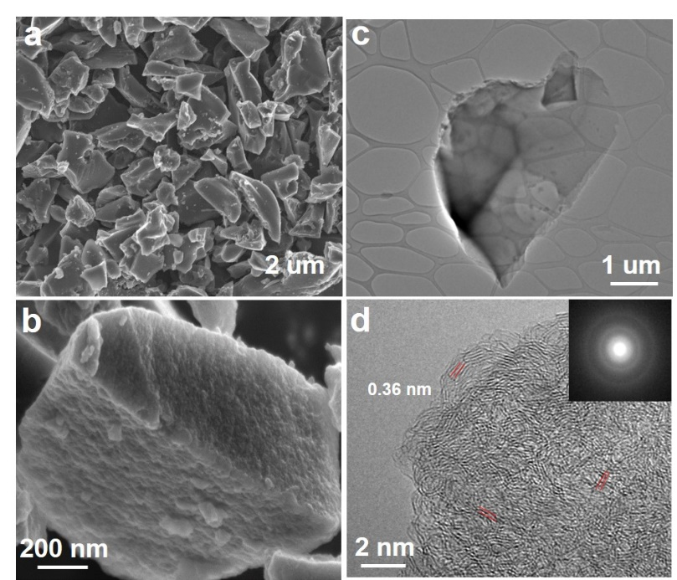
Figure S1. Morphology of hard carbon. (a, b) FESEM images, (c) TEM image, (d) HRTEM image.

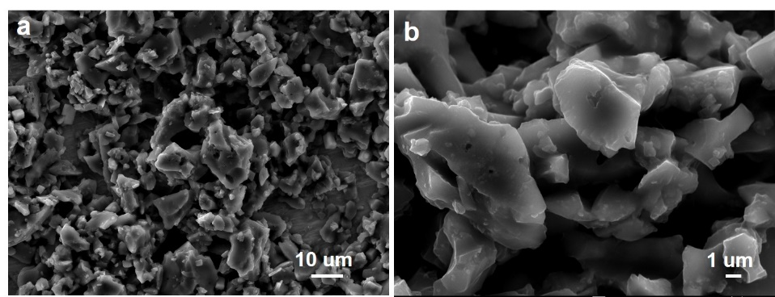
Figure S2. (a, b) Ex-situ FESEM of hard carbon after 3500 cycles in DGM.

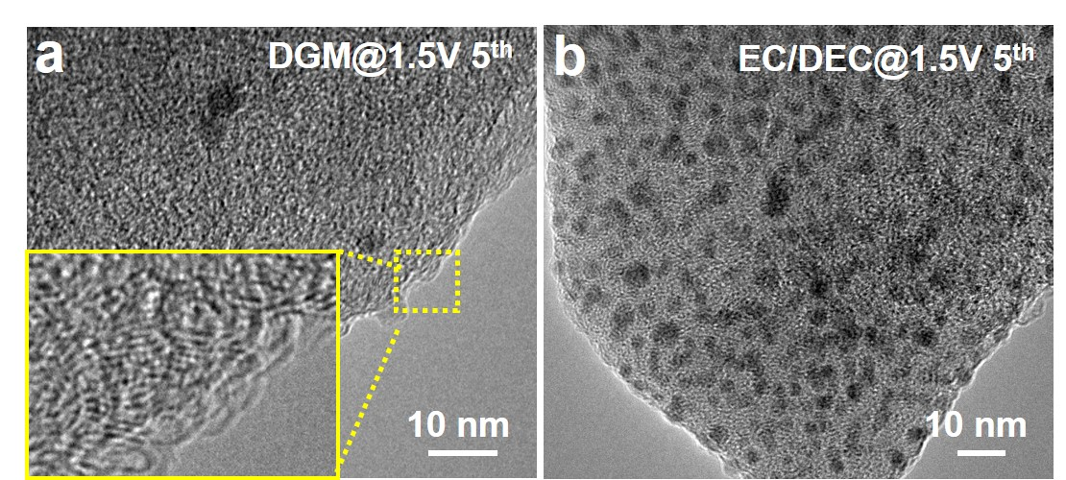
Figure S3. HRTEM images of hard carbon in DGM (a) and EC/DEC (b) at C1.5 V for the fifth cycle.

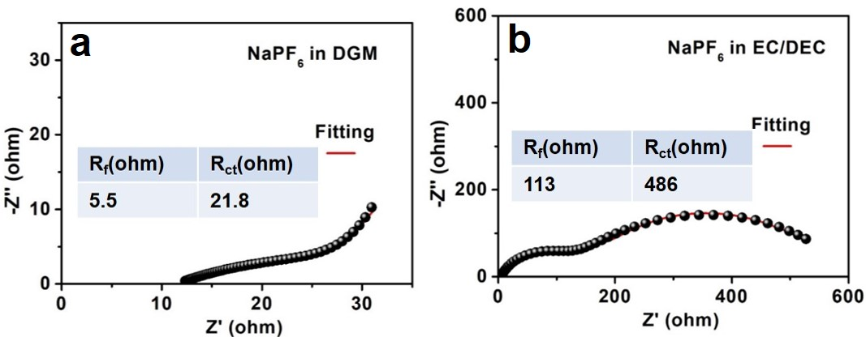
Figure S4. EIS spectra of hard carbon in DGM (a) and EC/DEC (b) at C1.5 V for the fifth cycle.

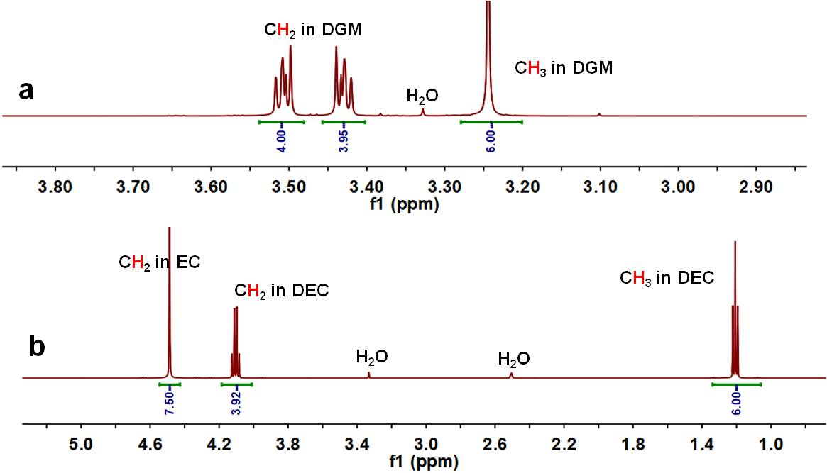
Figure S5. ¹H NMR of pure electrolytes. (a) NaPF₆ in DGM. (b) NaPF₆ in EC/DEC.

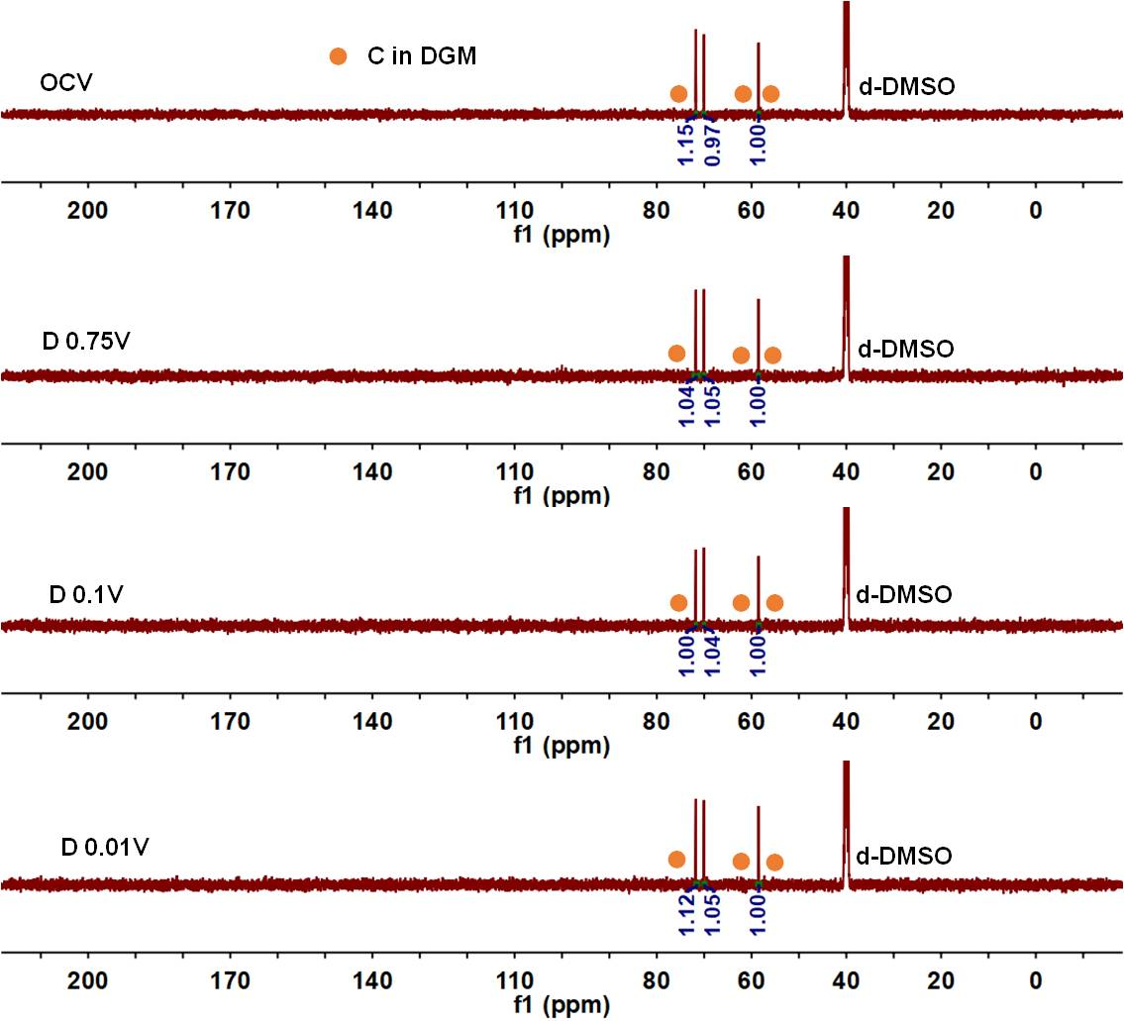
Figure S6. ¹³C NMR of NaPF₆ in DGM.

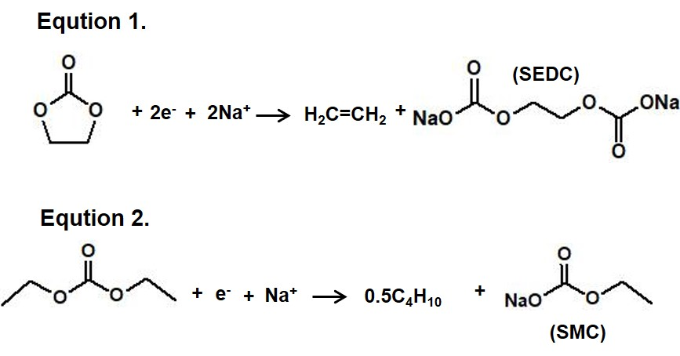
Figure S7. Equtions of EC and DEC reacted with Na⁺ during discharge process.

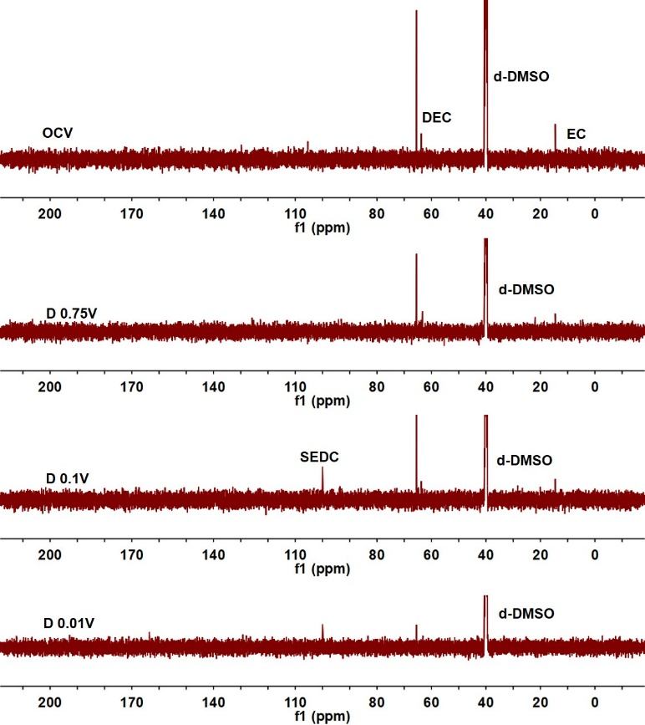
Figure S8. ¹³C NMR of NaPF₆ in EC/DEC.

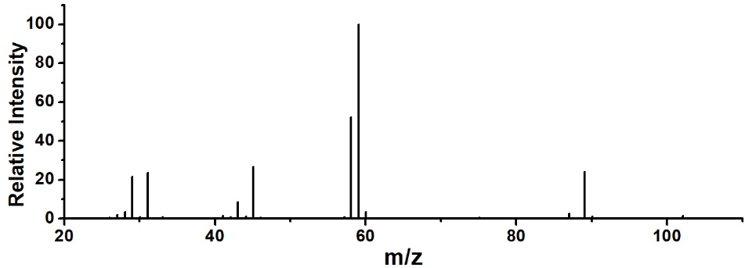
Figure S9. Standard spectrum of MS of DGM in chloroform.

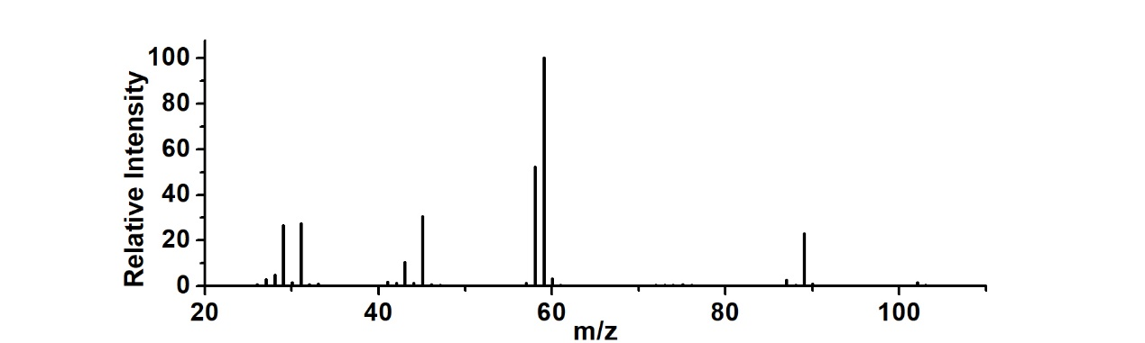
Figure S10. MS of NaPF₆ in DGM discharged to 0.01 V for the third cycle.

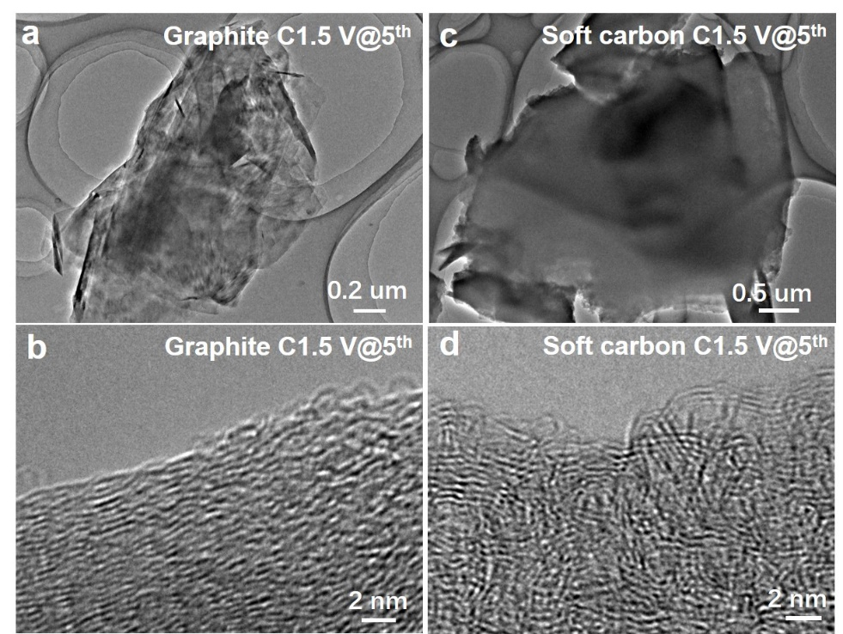
Figure S11. TEM and HRTEM images of carbon materials at C 1.5 V@5th in DGM. (a,b) Graphite. (c,d) Soft carbon..

Table S1. The sodium-storage properties of reported hard carbon anodes.
Hard carbon anode | Capacity  [mA h g⁻¹] | Cycle life |  | Capacity retention [%] | Ref.
LHC_opc | 205 at 0.2 A g⁻¹ |  | 500 | 100 | 1
RSS-700 | 143 at 0.1 A g⁻¹ |  | 200 | 72 | 2
OPDHC-A | 210 at 2.0 A g⁻¹ |  | 3000 | 99 | 3
HCNPs | 207 at 0.05 A g⁻¹ |  | 500 | 77 | 4
LS1400 | 330 at 0.1 A g⁻¹ |  | 450 | 91.6 | 5
RPC-600 | 135 at 0.1A g⁻¹ |  | 1000 | 90 | 6
LJ-1300 | 288 at 0.1 A g⁻¹ |  | 200 | 91.8 | 7
CPP | 203 at 0.1 A g⁻¹ |  | 200 | 98 | 8
CP | 131.5 at 0.5 A g⁻¹ |  | 500 | 89.8 | 9
SGHC-1000 | 136 at 1 A g⁻¹ |  | 1000 | 86 | 10
HC | 180 at 0.1 A g⁻¹ |  | 500 | 95 | 11
HC | 70 at 0.2 A g⁻¹ |  | 1500 | 84 | 12
HC | 196 at 1 A g⁻¹ |  | 2000 | 90 | 13
HC | 200 at 0.5 A g⁻¹ |  | 1000 | 100 | 14
CEM-G-8h | 140 at 0.5 A g⁻¹ |  | 2000 | 98 | 15
S-HC | 323 at 0.02 A g⁻¹ |  | 200 | 98 | 16
HC-P15 | 386 at 0.02 A g⁻¹ |  | 100 | 98.2 | 17
MV-HC | 150 at 0.2 A g⁻¹ |  | 1100 | 85 | 18
CNB | 128 at 0.5 A g⁻¹ |  | 1000 | 68 | 19
Hard carbon | 224.4 at 1.0 A g⁻¹ |  | 3500 | 88 | Ours

References
1. Dou, X. W. et al. Impact of the acid treatment on lignocellulosic biomass hard carbon for sodium-ion battery Anodes. ChemSusChem 11, 3276-3285 (2018).
2. Cao, L. Y. et al. Rape seed shuck derived-lamellar hard carbon as anodes for sodium-ion batteries. J. Alloys Compd. 695, 632-637 (2017).
3. Xiang, J. Y., Lv, W. M., Mu, C. P., Zhao, J. & Wang, B. C. Activated hard carbon from orange peel for lithium/sodium ion battery anode with long cycle life. J. Alloys Compd. 701, 870-874 (2017).
4. Xiao, L. F. et al. Hard carbon nanoparticles as high-capacity, high-stability anodic materials for Na-ion batteries. Nano Energy 19, 279-288 (2016).
5. Zhang, N. et al. High capacity hard carbon derived from lotus stem as anode for sodium ion Batteries, J. Power Sources 378, 331-337 (2018).
6. Li, W. B. et al. Controlled synthesis of macroscopic three-dimensional hollow reticulate hard carbon as long-life anode materials for Na-ion batteries. J. Alloys Compd. 716, 210-219 (2017).
7. Wang, P., Fan, L. P., Yan, L. & Shi, Z. Q. Low-cost water caltrop shell-derived hard carbons with high initial coulombic efficiency for sodium-ion battery anodes. J. Alloys Compd. 775, 1028-1035 (2019).
8. Zhang, Y. J. et al. Honeycomb-like hard carbon derived from pine pollen as high-performance anode material for sodium-ion batteries. ACS Appl. Mater. Interfaces 10, 42796-42803 (2018).
9. Zhu, Z. Y. et al. Expanded biomass-derived hard carbon with ultrastable performance in sodium-ion batteries. J. Mater. Chem. A 6, 1513-1522 (2018).
10. Wang, K. et al. Sodium storage in hard carbon with curved graphene platelets as the basic structural units. J. Mater. Chem. A 7, 3327-3335 (2019).
11. Patra, J. et al. Moderately concentrated electrolyte improves solid-electrolyte interphase and sodium storage performance of hard carbon. Energy Storage Mater. 16, 146-154 (2019).
12. Liu, X. W. et al. High capacity and cycle-stable hard carbon anode for nonflammable sodium-ion batteries. ACS Appl. Mater. Interfaces 10, 38141-38150 (2018).
13. He, Y. W., Bai, P. X., Gao, S. Y. & Xu, Y. H. Marriage of an ether-based electrolyte with hard carbon anodes creates superior sodium-ion batteries with high mass loading. ACS Appl. Mater. Interfaces 10, 41380-41388 (2018).
14. Bai, P. X. et al. Long cycle life and high rate sodium-ion chemistry for hard carbon anodes. Energy Storage Mater. 13, 274-282 (2018).
15. Zhao, X., Ding, Y., Xu, Q., Liu, & Y. Shen, H. Low-temperature growth of hard carbon with graphite crystal for sodium-ion storage with high initial coulombic efficiency: a general method. Adv. Energy Mater. 9, 1803648 (2019).
16. Yi, Z. F. et al. Mechanism of Na-ion storage in hard carbon anodes revealed by heteroatom doping. Adv. Energy Mater. 7, 1602894 (2017).
17. Li, Y. et al. Insights into the Na⁺ storage mechanism of phosphorus-functionalized hard carbon as ultrahigh capacity anodes. Adv. Energy Mater. 8, 1702781 (2018).
18. Li, Z. F. et al. Defective hard carbon anode for Na-ion batteries. Chem. Mater. 30, 4536-4542 (2018).
19. Chen, Y. X., Li, J., Lai, Y. Q., Li, J. M. & Zhang, Z. A. Tailoring graphitic nanostructures in hard carbons as anode materials achieving efficient and ultrafast sodium storage. J Mater Sci 53, 10313-10326 (2018).

