Supplementary Materials

Tunable Topological Dirac Surface States and Van Hove Singularities

in Kagome Metal GdV₆Sn₆

Yong Hu^{1,#,*}, Xianxin Wu^{2,#}, Yongqi Yang³, Nicholas C. Plumb¹, Andreas P. Schnyder², Weiwei Xie³, Junzhang Ma^{4,5,6*}, and Ming Shi^{1,*}
¹Swiss Light Source, Paul Scherrer Institute, CH-5232 Villigen PSI, Switzerland
²Max-Planck-Institut für Festkörperforschung, Heisenbergstrasse 1, D-70569 Stuttgart, Germany
³Department of Chemistry and Chemical Biology, Rutgers University, 08854, Piscataway, USA
⁴Department of Physics, City University of Hong Kong, Kowloon, Hong Kong, China
⁵City University of Hong Kong Shenzhen Research Institute, Shenzhen, China
⁶Hong Kong Institute for Advanced Study, City University of Hong Kong, Kowloon, Hong Kong, China

#These authors contributed equally to this work.
*To whom correspondence should be addressed:
Y.H. (yonghphysics@gmail.com); J.-Z.M. (junzhama@cityu.edu.hk); M.S. (ming.shi@psi.ch)

Contents
1. p-type and m-type VHSs in GdV₆Sn₆
2. Density functional theory calculations for surface states in GdV₆Sn₆
3. Analysis of the two terminations based on XPS spectra
4. Dirac cone and VHS endemic to the kagome lattice of GdV₆Sn₆
5. Detailed comparison between the experimental and theoretical band dispersions
6. Photon energy-dependent measurements on the surface states
7. Projections of surface states on GdSn₂ and kagome terminated surface
8. Momentum-dependent dispersions of the TDSSs
9. Spin texture of the TDSSs from DFT calculations
10. Electronic structure of GdV₆Sn₆ in ferromagnetism
1. p-type and m-type VHSs in GdV₆Sn₆
The vanadium kagome lattice of the kagome metal GdV₆Sn₆ hosts three distinct sublattices located at 3f Wyckoff positions, as illustrated in Fig. S1a. The toy band of the kagome lattice features two different types of van Hove singularities (VHSs): p-type and m-type. For the p-type VHS, the eigenstates near the three M points are contributed by mutually different sublattices [Fig. S1b(i)], while the states of the m-type VHS are equally distributed over mutually different sets of two sublattices for each M point [Fig. S1b(ii)]. The orbitally decomposed electronic structure of GdV₆Sn₆ from DFT calculations is displayed in Fig. S1c, where four VHS points occur at M in the vicinity of E_{F} (indicated by the red arrows and labeled as VHS1-4). The states of VHS1, VHS2 and VHS3 at M point are characterized by V d_{xz}, d_{xy} and d_{z2} orbitals, and are solely attributed to one sublattice in the V kagome lattice. Thus, the three VHSs are of p-type, while the states of VHS4 at M point are attributed to a mixture of two sublattices and VHS4 is of m-type.
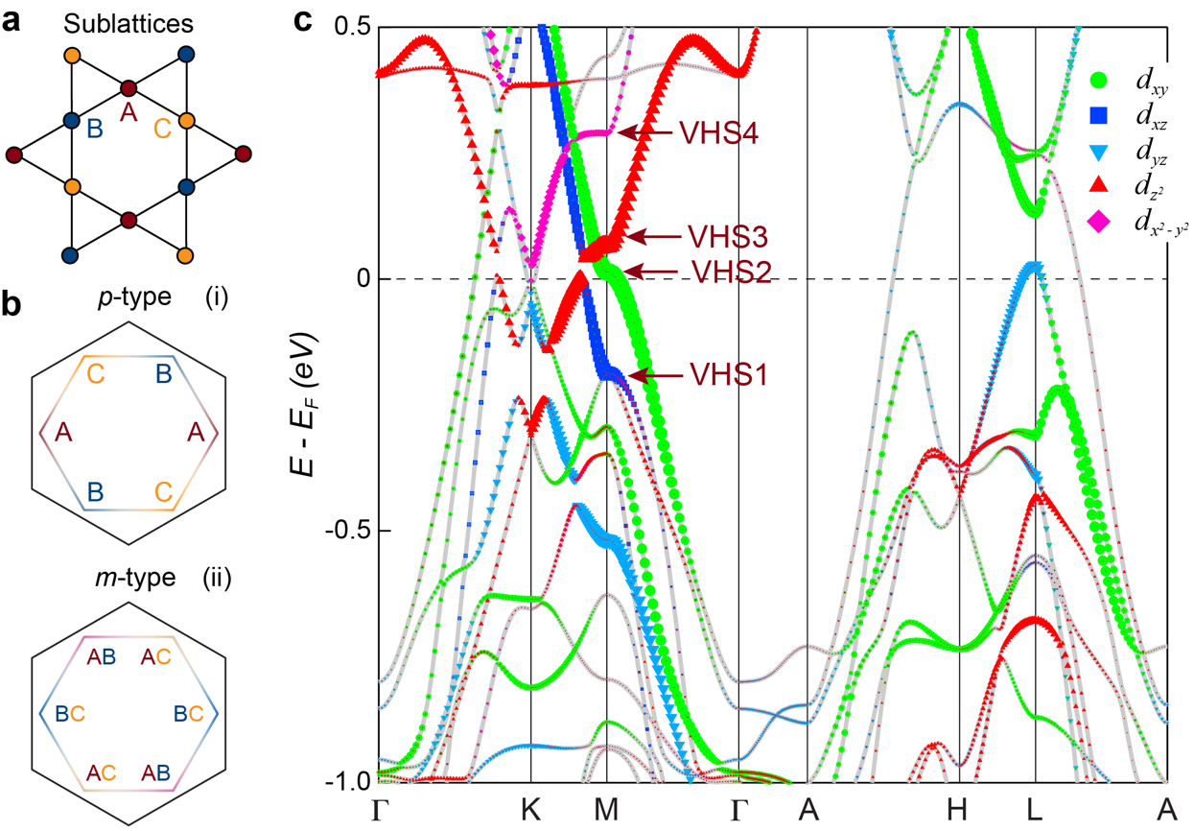
Fig. S1|Sublattice feature and van Hove singularities in kagome metals GdV₆Sn₆. a Real space structure of the vanadium kagome planes. The red, blue and green coloring indicates the three kagome sublattices. b Two distinct types of sublattice decorated van Hove singularities (VHSs), labeled as p-type [sublattice pure, (i)] and m-type [sublattice mixing, (ii)]. c DFT calculations for the orbital character resolved band structure of GdV₆Sn₆.
2. Density functional theory calculations for surface states in GdV₆Sn₆
We have directly studied the surface states on (001) surface of GdV₆Sn₆ by performing calculations on a slab with two kind of surface terminations, which contains 10 V kagome layers and 5 GdSn₂ layers. As shown in Fig. S2, the electronic structure of GdV₆Sn₆ exhibits distinct surface states on the GdSn₂ (the red curves in Figs. S2a and S2b) and kagome terminations (the blue curves in Figs. S2a and S2c). More interestingly, the Dirac surface states on the GdSn₂ layer bridge the large local band gap at Γ, which represent the topologically non-trivial Dirac surface states (TDSSs) originating from a ℤ₂ bulk topology. The general shape of this surface state is in good agreement with ARPES measurements.
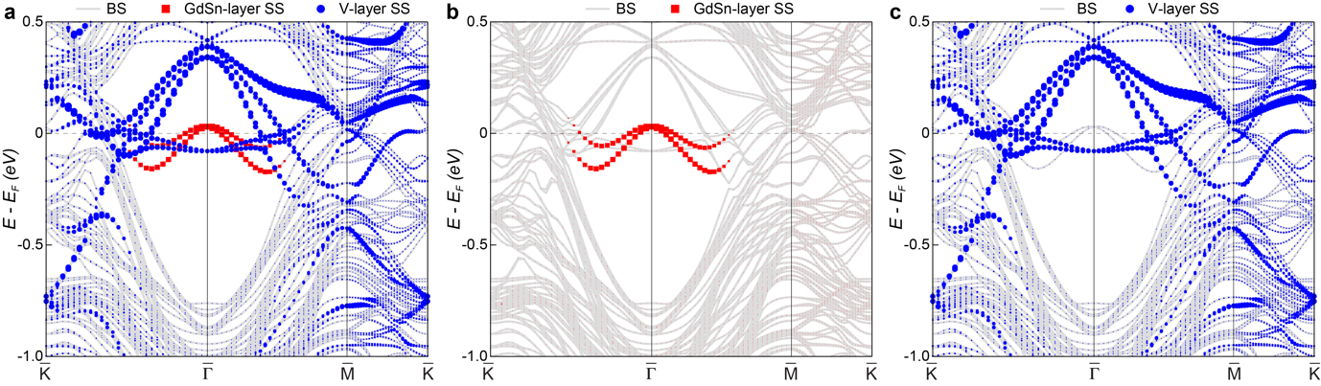
Fig. S2|Surface states decomposed band structure of GdV₆Sn₆ from DFT calculations. a Band structure of GdV₆Sn₆, with bulk states (BS) and surface states (SS) decomposed. b,c Electronic structure on GdSn₂ layer (b) and V kagome layer (c). Red and blue curves indicate the SS on GdSn₂ layer and kagome layer, respectively.
3. Analysis of the two terminations based on XPS spectra
By using a small beam spot, we have resolved two sets of representative photoemission spectra (Fig. 2 in the main text) associated with the two types of terminations on the cleaved sample surface of GdV₆Sn₆ (as illustrated in Figs. S3a and S3e). As shown in Figs. S3b and S3f, the X-ray photoelectron spectroscopy (XPS) clearly shows the characteristic 3s, 3p peaks of V, 4f peak of Gd, and 4d peaks of Sn, exhibiting two distinct spectra on the Sn 4d core level (Figs. S3c and S3g). Following the strategy in the kagome lattice FeSn [1], the XPS spectra of the Sn-4d peaks are used to determine the surface terminations of the sample. It has been found in FeSn that Sn atoms in different local environments can contribute 4d peaks with different binding energies [1,2]. Since Sn atoms near the kagome termination (Fig. S3a) have more complex local environments, they should in principle exhibit prominent side peaks of Sn. Therefore, we assign the XPS spectra showing more Sn-4d peaks to the kagome termination (Figs. S3a-d), while another set of spectra represents the GdSn₂ termination (Figs. S3e-h).

Intriguingly, the intensity of the Gd-4f peak in the determined GdSn₂ termination (Fig. S3h) is stronger than that in the kagome termination (Fig. S3d). Moreover, the observed TDSSs on the determined GdSn₂ termination are excellent agreement with the DFT calculations for GdSn₂ layer (see Fig. 3 and Fig. 4 in the main text), further confirming the assignments of the terminations. While all results show good agreement, the unambiguous determination of the surface termination should come from a combination of in-situ scanning tunneling microscopy (STM) and ARPES techniques, which is not very necessary for the present work. The termination assignments do not affect the main conclusions of the tunable TDSSs and VHSs in GdV₆Sn₆.
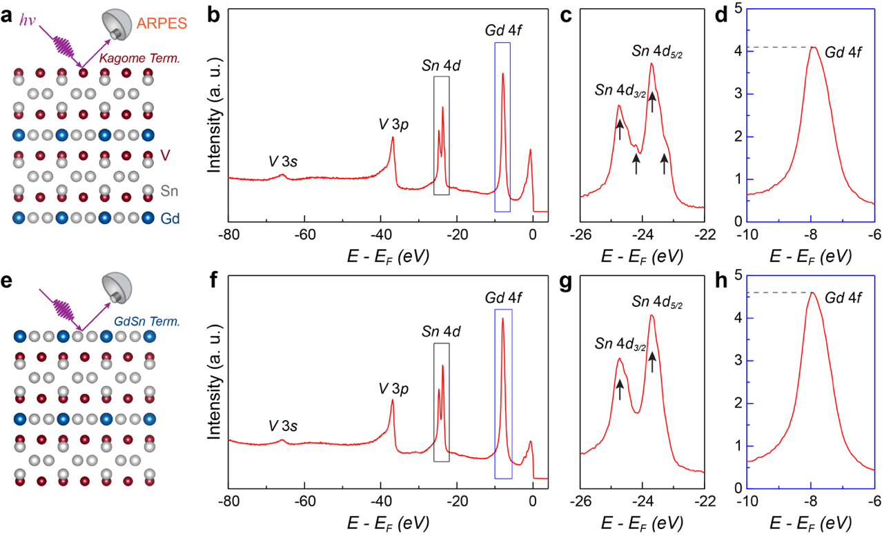
Fig. S3|Determination of surface terminations of GdV₆Sn₆ using XPS. a Schematics of the kagome termination in GdV₆Sn₆. b Wide-energy-range XPS spectrum of GdV₆Sn₆ measured with 170 eV photon. c,d Zoom-in plot of the spectrum highlighting Sn-4d peaks (c) and Gd-4f peak (d) in selected energy regions in (b), as indicated by the black and blue box, respectively. e-h, Same as (a-d), but for the GdSn₂ termination.
4. Dirac cone and VHS endemic to the kagome lattice of GdV₆Sn₆
The kagome structural motif could naturally give rise to kagome-derived electronic bands with Dirac cone and VHS. Indeed, we have identified the characteristic Dirac cone and VHS point of the kagome lattice on the kagome termination of GdV₆Sn₆ (Fig. S4). As shown in Fig. S4a, the Dirac cone is clearly observed around‾K point, at the binding energy (E_{B}) around 200 meV (see the red arrow). Interestingly, after surface potassium deposition, the Dirac cone persists while trivial surfaces are killed (Fig. S4b), indicating the bulk origin and robustness of the Dirac fermions. Moreover, VHS is also revealed near‾M point (Fig. S4c), as confirmed by the calculations (Fig. S4d). The identified Dirac cone and VHS on the kagome termination are consistently observed on the GdSn₂ termination, unambiguously confirming that they are bulk states native to the kagome lattice of GdV₆Sn₆ (for details, see Fig. S5).
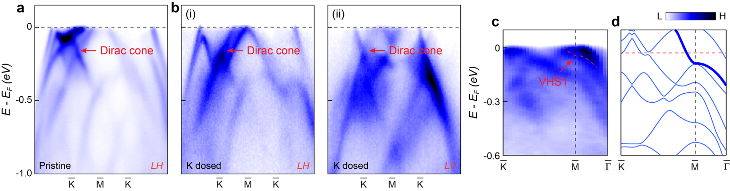
Fig. S4|Dirac cone and VHS in GdV₆Sn₆. a ARPES spectra taken along the‾K -‾M -‾K direction, on the pristine kagome surface, measured with 76 eV linear horizontal (LH) polarization. b Same as (a), but collected on the K dosed kagome surface, measured with 76 eV LH (i) and linear vertical (LV) (ii) polarizations. Red arrow highlights the Dirac cone. Arrow indicates the VHS1 band. f Same as (e), but measured on the K dosed kagome surface. c ARPES spectrum along the‾K -‾M -‾Γ path showing the VHS1 at the‾M point, obtained on kagome surface. d Same as (c), but from DFT calculations.
5. Detailed comparison between the experimental and theoretical band dispersions
We compare the ARPES spectra obtained on the GdSn₂ termination with the DFT calculated energy band dispersions in Fig. S5. Figures S5a and S5b display the band structure of GdV₆Sn₆ in the paramagnetic phase from DFT calculations. We next focus on two high symmetry cuts along the‾Γ -‾K -‾M -‾K direction (the momentum path is represented by the blue line in Fig. S5c, as marked as Cut#1) and the‾Γ -‾M direction (Cut#2 in Fig. S5c), as shown in Figs. S5d,5e and Figs. S5f,5g, respectively. The experimental and calculated bands show good overall agreement, although there are discrepancies in Fermi levels between the experimental (the red dashed line in Figs. S5e, S5g) and calculated (the black dashed line in Fig. S5e, S5g) results. The agreement between experiments and calculations allows us to determine that the identified VHS (Fig. 2k in the main text, and Figs. S5h,5i) is corresponding to the VHS1 (Figs. S5a and S5j).

The experimentally determined oribital character of the bands that form the VHS1 is also consistent with the DFT calculations. Under our ARPES geometry (for details, see Refs. 3,4), according to the selection rules, the bands with d_{xz} character along the‾Γ -‾K and‾Γ -‾M paths are favored under the linear vertical (LV) and linear horizontal (LH) polarizations, respectively. Indeed, the VHS1 bands are observable under the LV polarization in Fig. S5d(iii) and the LH polarization in Fig. S5f(i). Therefore, the experimental VHS1 bands are contributed by Vanadium d_{xz} orbital (as indicated in Figs. S5h,5i) and derived from kagome bulk states, which are in line with the DFT calculations for the orbital character resolved band structure (Figs. S5b and S5j).
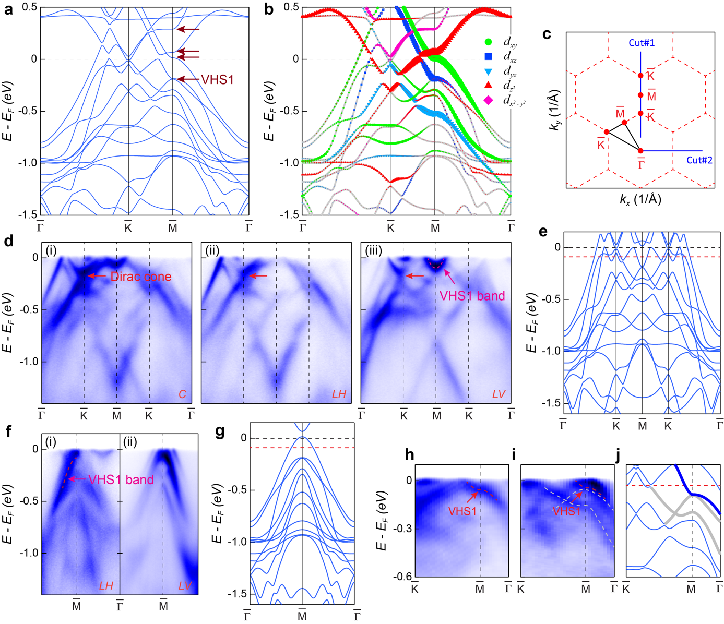
Fig. S5|Comparison between the experimental and theoretical dispersions in GdV₆Sn₆. a DFT calculated electronic structure, with VHSs indicated. b Orbitally decomposed electronic structure. c Brillouin zone (BZ) of GdV₆Sn₆, with high symmetry points marked. d ARPES spectra taken along the‾Γ -‾K -‾M direction, on the pristine surface, measured with 76 eV circular (C) (i), LH (ii), LV (iii) polarizations. The momentum path for (d) is indicated by the blue line in (c). e Theoretical dispersion along the‾Γ -‾K -‾M direction. f ARPES spectra taken along the‾Γ -‾M direction, measured with 76 eV LH (i), LV (ii) polarizations. g Theoretical bands along the‾Γ -‾M direction. h-j Band dispersion from the GdSn₂ termination (h), kagome termination (i), and DFT calculations (j), along the‾K -‾M -‾Γ path showing the VHS1 at the‾M point.
6. Photon energy-dependent measurements on the surface states
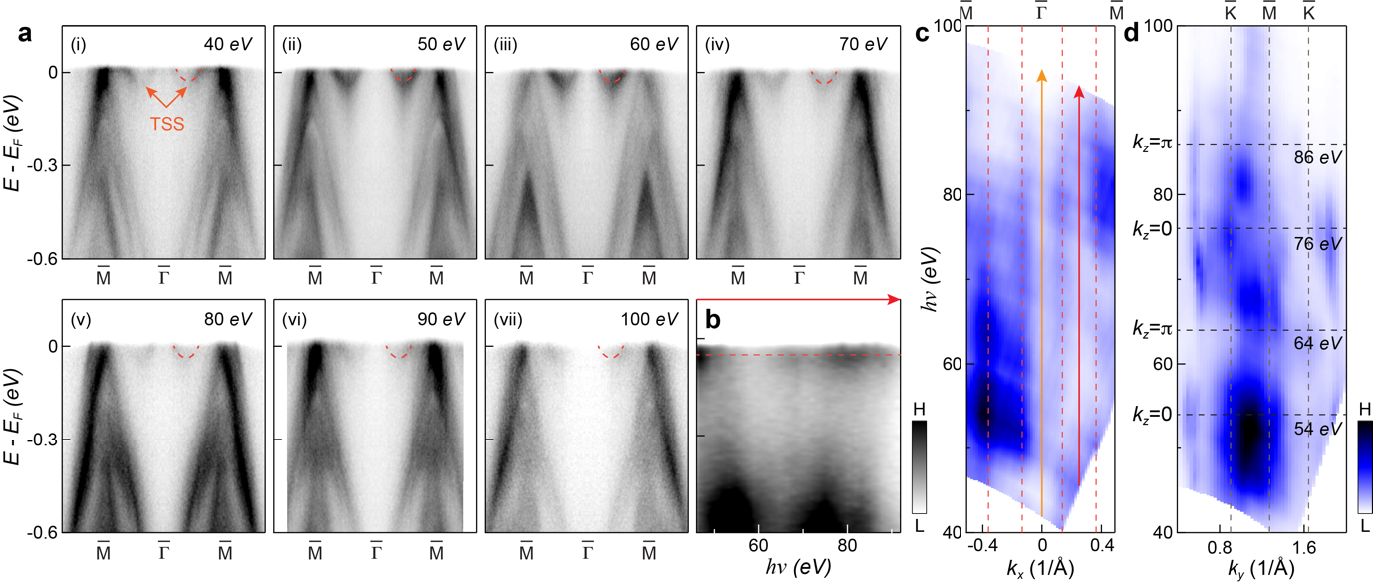
Fig. S6|Photon energy-dependent measurements on the GdSn₂ termination. a Photon energy-dependent AREPS spectra along the‾M -‾Γ -‾M direction. Red dashed curves and arrows highlight the V-shaped TDSSs. In contrast to the bulk states, the V-shaped bands around‾Γ does not disperse with photon energies, reflecting their surface nature. b ARPES spectral intensity as a function of photon energy along the Γ - A direction. c Photon energy-dependent ARPES spectral intensity map at E_{F} along the‾M -‾Γ -‾M direction, where the red dashed lines indicate the TDSSs that show no dispersion along the energy (and thus k_{z}) direction. Red and yellow arrows mark the momentum direction of the spectrum in (b) and Fig. S8(c) respectively. d Same as (c), but measured along the‾K -‾M -‾K direction. In contrast to the TDSSs in (c), the bulk states exhibit pronounced k_{z} dispersions.
7. Projections of surface states on GdSn₂ and kagome terminated surface
Figure S7 shows the spectra of bulk, GdSn₂ terminated surface and V terminated surface. In the GdSn₂ termination, the topological Dirac surface states can be clearly identified.
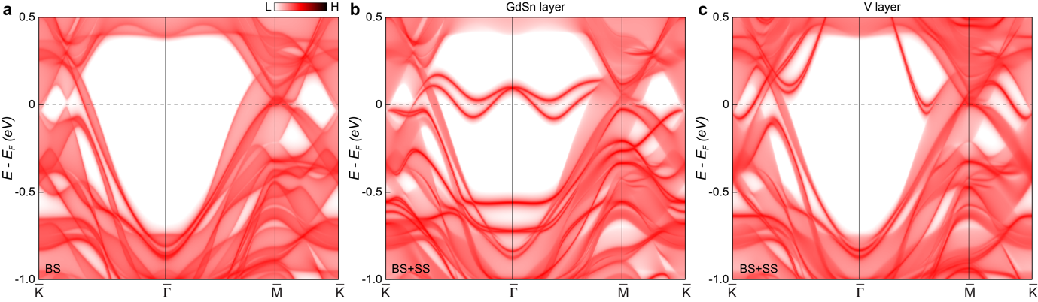
Fig. S7|(001) surface states of GdV₆Sn₆ from DFT calculations. a-c The (001) surface Green’s function projection of pure bulk states (BS)(a), the states [BS and surface states (SS)] on GdSn₂ termination (b), and the states (BS+SS) on Vanadium kagome termination (c).
8. Momentum-dependent dispersions of the TDSSs
Revealing the details of the TDSSs in GdV₆Sn₆, Figure S8 displays the momentum dependence and photon energy dependence of the doped TDSSs on the K-dosed GdSn₂ surface. Figure S8a plots the constant energy contours and their evolution with binding energy (E_{B}). With increasing E_{B}, the TDSSs contributed hexagonal-shaped pockets near the zone center (‾Γ point) shrink (Fig. S8a), reflecting their electron-like nature. Momentum-dependent dispersions of the TDSSs are shown in Fig. S8b. The Dirac point of TDSSs is clearly identified at the E_{B} around 260 meV (Figs. S8a and S8b). In addition, photon energy-dependent measurement was also performed on the K-dosed GdSn₂ surface. The ARPES spectrum along the Γ - A direction reveals a non-dispersive feature at the E_{B} of the Dirac point, exhibiting the intrinsic two-dimensional nature the TDSSs. Remarkably, the lower branch of the TDSSs merges into the bulk bands [see Fig. 4d(iii) in the main text, and the red box selected region in Fig. S8d], and only the upper branch crosses the E_{F}, which reverses the chirality of the spin texture at the Fermi surfaces, as we will demonstrate further in the next section.
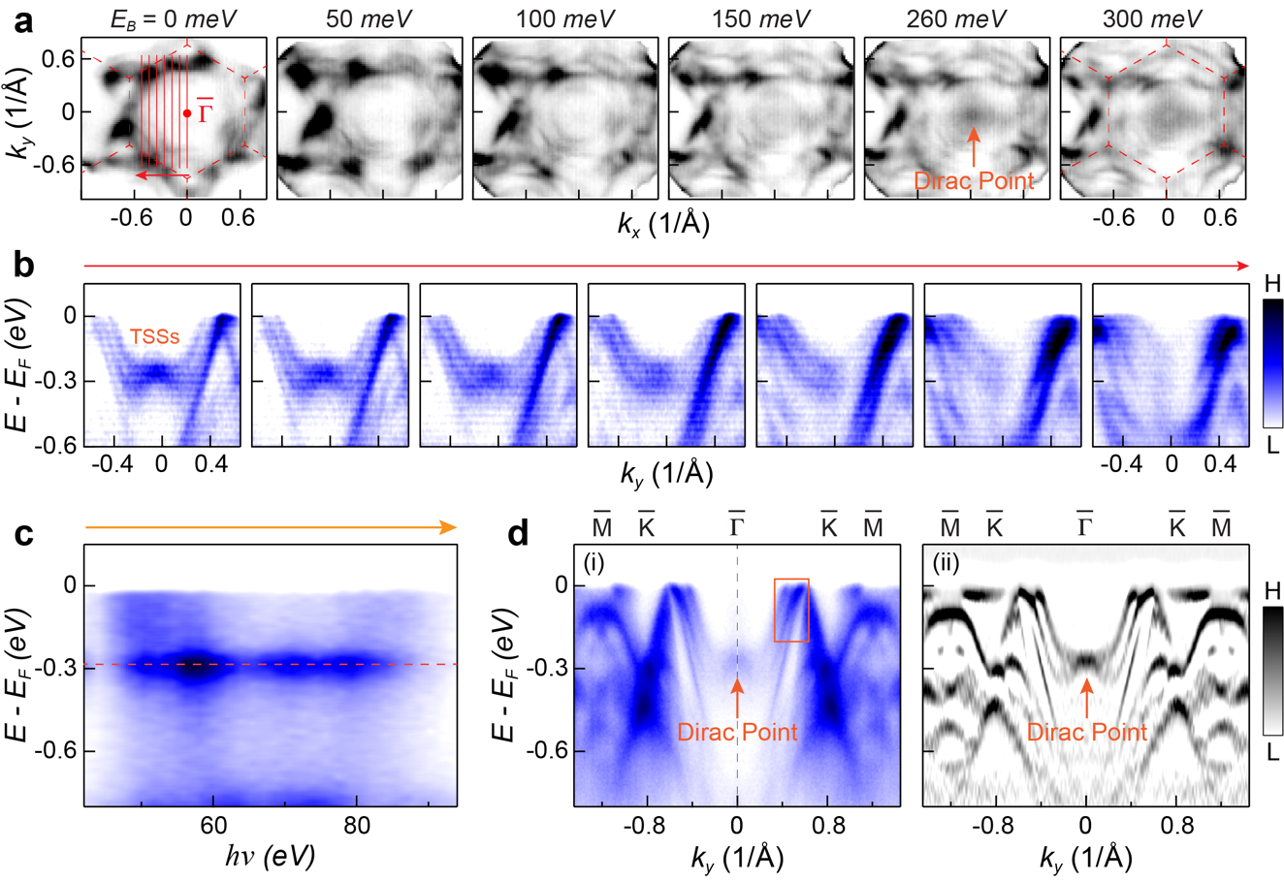
Fig. S8|Momentum dependence and photon energy dependence of the doped TDSSs in GdV₆Sn₆. a Constant energy contours at binding energies. b Momentum-dependent dispersions of the TDSSs. The corresponding momentum paths are indicated by the red lines in (a). c ARPES spectral intensity as a function of photon energy along the Γ - A direction. The momentum direction of the spectrum is marked by the yellow arrow in Fig. S6(c). d ARPES spectra taken along the‾Γ -‾K -‾M direction, measured with 86 eV C polarization. All data were collected on the K-dosed GdSn₂ layer, at 20 K.
9. Spin texture of the TDSSs from DFT calculations
We examined spin textures of the TDSSs on the pristine and doped GdSn₂ surface by the DFT calculations. Figure S9 plots the spin-resolved Fermi surfaces of the GdSn₂ layer. On the pristine GdSn₂ surface, only the lower branch of the TDSSs contributes to the Fermi surfaces, i.e., the circular-shaped and hexagonal-shaped pockets around‾Γ point (Fig. S9a, and Figs. 3e,3f in the main text). Our calculations suggest that the circular-shaped and hexagonal-shaped Fermi surfaces have clockwise spin texture chirality (Fig. S9a). Upon sufficient electron doping [Fig. 4c(iii) in the main text, and Fig. S8], the Dirac point of the TDSSs can be tuned below the E_{F}. Therefore, both the lower and upper branches of the doped TDSSs contribute to the Fermi surfaces. However, the lower branch merges into the bulk bands [Fig. 4d(iii) in the main text, Figs. S8d and S9b], so that the corresponding Fermi surface has counterclockwise spin texture chirality (Fig. S9b). These results clearly demonstrate the spin polarization reversal on the Fermi surfaces of GdV₆Sn₆ with doping.
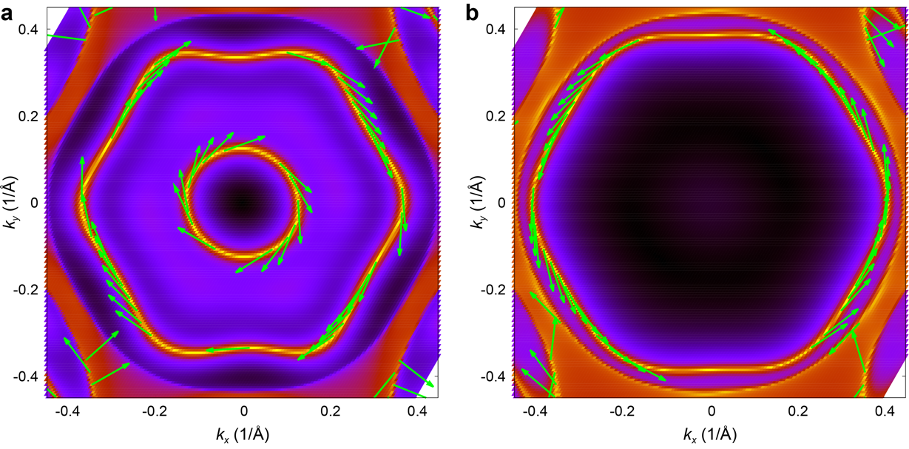
Fig. S9|Spin texture of the TDSSs from DFT calculations. a,b Spin textures of the TDSSs on the pristine (a) and doped (b) GdSn₂ surface. Green arrow indicates the spin-polarization direction of the TDSSs.
10. Electronic structure of GdV₆Sn₆ in ferromagnetism
Figure S10 shows the electronic structure in the ferromagnetic state. The magnetic moment of Gd atom is about 7 μB. As the states near the Fermi level is dominated by V d orbitals, the magnetic splitting originating from the coupling between V kagome and Gd layers is relatively small but visible.
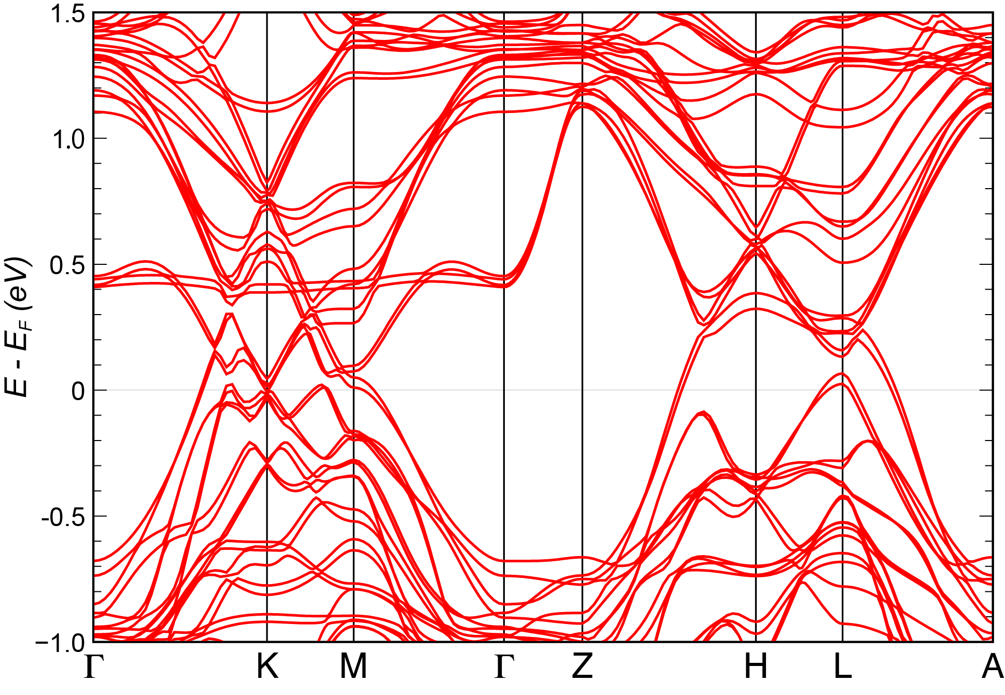
Fig. S10|DFT calculated electronic structure of GdV₆Sn₆ in ferromagnetism.
References
[1] M. Kang, L. Ye, S. Fang, J.-S. You, A. Levitan, M. Han, J. I. Facio, C. Jozwiak, A. Bostwick, E. Rotenberg, M. K. Chan, R. D. McDonald, D. Graf, K. Kaznatcheev, E. Vescovo, D. C. Bell, E. Kaxiras, J. Brink, M. Richter, M. P. Ghimire, J. G. Checkelsky, and R. Comin, Dirac fermions and flat bands in the ideal kagome metal FeSn, Nat. Mater. 19, 163–169 (2020).
[2] S. Peng, Y. Han, G. Pokharel, J. Shen, Z. Li, M. Hashimoto, D. Lu, B. R. Ortiz, Y. Luo, H. Li, M. Guo, B. Wang, S. Cui, Z. Sun, Z. Qiao, S. D. Wilson, and J. He, Realizing Kagome Band Structure in Two-Dimensional Kagome Surface States of RV₆Sn₆ (R=Gd,Ho), Phys. Rev. Lett. 127, 266401 (2021).
[3] Y. Hu, X. Wu, B. R. Ortiz, S. Ju, X. Han, J. Z. Ma, N. C. Plumb, M. Radovic, R. Thomale, S. D. Wilson, A. P. Schnyder, and M. Shi, Rich nature of van Hove singularities in kagome superconductor CsV₃Sb₅, Preprint at arXiv:2106.05922 (2021).
[4] Y. Hu, X. Wu, B. R. Ortiz, X. Han, N. C. Plumb, S. D. Wilson, A. P. Schnyder, and M. Shi, Coexistence of Tri-Hexagonal and Star-of-David Pattern in the Charge Density Wave of the Kagome Superconductor AV₃Sb₅, Preprint at arXiv:2201.06477 (2022).

