Supplementary figures and tables
Supplementary Table 1. Alpha diversity in bulk soil and roots samples across the crop × N fertilizer effects with two-way ANOVA in 2019 and 2020.

 |  | Soil |  | Roots
 |  | 2019
Parameter | Treatment | F-value | P-value | F-value | P-value
Chao1 | Crop | 0.1277 | 0.8809 | 1.5972 | 0.2350
 | Fertilizer | 0.0286 | 0.8677 | 0.0000 | 1.0000
 | Crop: Fertilizer | 1.8561 | 0.1904 | 6.2173 | <0.05*
Evenness | Crop | 0.127 | 0.8809 | 1.1698 | 0.3342
 | Fertilizer | 0.0286 | 0.8677 | 0.1282 | 0.7247
 | Crop: Fertilizer | 0.6214 | 0.5505 | 0.5653 | 0.5799
Shannon | Crop | 0.1277 | 0.8809 | 1.7151 | 0.2097
 | Fertilizer | 0.0286 | 0.8677 | 0.1706 | 0.6847
 | Crop: Fertilizer | 0.1875 | 0.8310 | 1.8105 | 0.1975
InvSimpson | Crop | 0.1277 | 0.8809 | 1.3639 | 0.2822
 | Fertilizer | 0.0286 | 0.8677 | 0.2454 | 0.6267
 | Crop: Fertilizer | 0.1460 | 0.8653 | 1.9728 | 0.1735
 |  | 2020
Chao1 | Crop | 0.7225 | 0.4999 | 0.6277 | 0.5457
 | Fertilizer | 0.0069 | 0.9348 | 0.8229 | 0.3770
 | Crop: Fertilizer | 0.9727 | 0.4007 | 0.7605 | 0.4846
Evenness | Crop | 0.400 | 0.6762 | 2.9941 | 0.0769
 | Fertilizer | 1.839 | 0.1928 | 2.9000 | 0.1068
 | Crop: Fertilizer | 0.432 | 0.6573 | 0.0587 | 0.9432
Shannon | Crop | 0.0366 | 0.9641 | 4.9846 | <0.05*
 | Fertilizer | 1.3474 | 0.2618 | 1.0715 | 0.3151
 | Crop: Fertilizer | 1.264 | 0.3110 | 0.2116 | 0.8166
InvSimpson | Crop | 0.0218 | 0.9785 | 2.90686 | 0.0821
 | Fertilizer | 0.9228 | 0.3502 | 0.40540 | 0.5328
 | Crop: Fertilizer | 0.7504 | 0.4891 | 0.50203 | 0.6151
Number of degree freedom (NumDF) is [Crop = 2, Fertilizer = 1, Crop: Fertilizer = 2].
Denominator of Degree of freedom (denDF) is 15 and 17, in soil and roots, respectively.

Supplementary Table 2. PERMANOVA across combination cropping systems (crop × N fertilizer) and root compartments (bulk soil vs. roots).

 |  |  | 2019 |  |  | 2020
Treatment |  | F.model | R² | Pr(>F) | F.model | R² | Pr(>F)
 |  |  |  | Bulk soil
Crop |  | 0.728 | 0.067 | 0.743 | 1.012 | 0.092 | 0.276
Fertilizer |  | 0.658 | 0.030 | 0.762 | 0.640 | 0.029 | 0.802
Crop : Fertilizer |  | 0.810 | 0.074 | 0.639 | 0.635 | 0.0579 | 0.923
 |  |  |  | Roots
Crop |  | 14.92 | 0.592 | <0.001*** | 6.483 | 0.400 | <0.001***
Fertilizer |  | 0.254 | 0.005 | 0.906 | 0.524 | 0.016 | 0.698
Crop : Fertilizer |  | 1.134 | 0.045 | 0.379 | 0.451 | 0.027 | 0.878
 |  |  |  | Root
Compartment |  | 39.179 | 0.460 | <0.001*** | 16.241 | 0.261 | <0.001***
Significance codes: P<0.05, *; P<0.01, **; P<0.001, ***.

Supplementary Table 3. AMF alpha diversity. Average and standard errors (n=24) of soil and root samples from 2019 and 2020 across treatments. Metrics include Chao1 richness, Peilou’s evenness, Shannon’s diversity, and inverse Simpson’s diversity. Italics indicate the P-value.
Treatment | Chao1 | Evenness | Shannon | InvSimpson
 | 2019
Bulk soil | 24.12±1.08a¶ | 0.67±0.02b | 2.10±0.06b | 5.49±0.38b
Roots | 26.81±0.86b | 0.56±0.02a | 1.83±0.05a | 4.42±0.28a
 | <0.05* | <0.001*** | <0.001*** | <0.01**
 | 2020
Bulk soil | 39.10±1.07b | 0.75±0.01b | 2.76±0.04b | 10.62±0.50b
Roots | 32.80±1.06a | 0.59±0.01a | 2.05±0.05a | 5.31. ±0.34a
 | <0.001*** | <0.001*** | <0.001*** | <0.001***

¶Pairwise comparisons were performed with Tukey’s HSD test after ANOVA.
Lowercase letters signify significant difference between treatments based on Tukey HSD test after ANOVA
Supplementary Table 4. Differential abundance in genus rank impacted by treatments (crop × N fertilizer) in soil compartment in 2019.

Genus | logFC | logCPM | LR | P-value | FDR
 | Crop
 | Oat vs. Pea
Acaulospora | 0.0000 | 6.6919 | 0.0000 | 1.0000 | 1.0000
Ambispora | -0.1827 | 14.4043 | 0.0593 | 0.8076 | 1.0000
Archaeospora | 0.3378 | 16.6234 | 0.5555 | 0.4561 | 1.0000
Claroideoglomus | -0.1858 | 16.0487 | 0.0503 | 0.8225 | 1.0000
Diversispora | 0.3296 | 12.8606 | 0.0267 | 0.8703 | 1.0000
Geosiphon | 6.7054 | 9.1622 | 0.7148 | 0.3979 | 1.0000
Glomus | 0.3810 | 16.7911 | 0.9856 | 0.3208 | 1.0000
Paraglomus | -0.1210 | 19.3964 | 0.8122 | 0.3675 | 1.0000
Scutellospora | 0.2404 | 12.7747 | 0.0051 | 0.9432 | 1.0000
 | Oat vs. Oat-Pea
Acaulospora | 0.0000 | 6.9199 | 0.0000 | 1.0000 | 1.0000
Ambispora | -0.4891 | 14.2243 | 0.4162 | 0.5189 | 0.7542
Archaeospora | -0.2405 | 16.2658 | 0.3292 | 0.5661 | 0.7542
Claroideoglomus | -0.4853 | 15.7479 | 0.4994 | 0.4798 | 0.7542
Diversispora | 1.1069 | 13.2736 | 0.4184 | 0.5177 | 0.7542
Geosiphon | 0.0000 | 6.9199 | 0.0000 | 1.0000 | 1.0000
Glomus | 0.8955 | 17.0283 | 7.5819 | 0.0059 | 0.0531
Paraglomus | 0.1025 | 19.4419 | 0.5779 | 0.4471 | 0.7542
Scutellospora | -2.3916 | 11.2163 | 0.2957 | 0.5866 | 0.7542
 | Pea vs. Oat-Pea
Acaulospora | 0.0000 | 6.6198 | 0.0000 | 1.0000 | 1.0000
Ambispora | -0.5033 | 14.1489 | 0.5275 | 0.4676 | 0.7173
Archaeospora | -0.4822 | 16.3873 | 2.5040 | 0.1136 | 0.5110
Claroideoglomus | -0.2404 | 15.6921 | 0.2484 | 0.6182 | 0.7782
Diversispora | 0.5859 | 13.3669 | 0.1573 | 0.6917 | 0.7782
Geosiphon | -6.4775 | 8.9165 | 0.6698 | 0.4131 | 0.7173
Glomus | 0.4702 | 17.1270 | 2.8194 | 0.0931 | 0.5110
Paraglomus | 0.1491 | 19.4316 | 0.5030 | 0.4782 | 0.7173
Scutellospora | -2.6625 | 13.1324 | 1.8339 | 0.1757 | 0.5270
 | N Fertilizer
Acaulospora | 0.0000 | 6.7347 | 0.0000 | 1.0000 | 1.0000
Ambispora | 0.5864 | 14.2646 | 1.1714 | 0.2791 | 0.5243
Archaeospora | -0.0989 | 16.4048 | 0.1031 | 0.7482 | 0.9094
Claroideoglomus | -1.0752 | 15.8327 | 4.2421 | 0.0394 | 0.1774
Diversispora | 1.4918 | 13.2102 | 1.1136 | 0.2913 | 0.5243
Geosiphon | 5.9028 | 8.5833 | 0.6269 | 0.4285 | 0.6427
Glomus | 0.0711 | 17.0027 | 0.0588 | 0.8084 | 0.9094
Paraglomus | -0.1983 | 19.4435 | 1.4910 | 0.2221 | 0.5243
Scutellospora | 4.4595 | 12.8212 | 5.0883 | 0.0241 | 0.1774
Note: LogFC designates log fold change; LogCPM, log counts per million; LR, likelihood ratio; FDR, false discovery rate.
*, **, and *** show statistical significance at P <0.05, P <0.01, P <0.001, respectively.
Supplementary Table 5. Differential abundance in genus rank impacted by treatments (crop × N fertilizer × compartment) in soil compartment in 2020.

Genus | logFC | logCPM | LR | P-value | FDR
 | Crop
 | Oat vs. Pea
Acaulospora | -0.8035 | 7.9600 | 0.0243 | 0.8762 | 0.8762
Ambispora | 1.3911 | 12.7442 | 1.9456 | 0.1631 | 0.3669
Archaeospora | -0.4631 | 16.8018 | 2.3644 | 0.1241 | 0.3669
Claroideoglomus | -0.0751 | 16.4194 | 0.0321 | 0.8577 | 0.8762
Diversispora | 1.0663 | 14.6686 | 2.2826 | 0.1308 | 0.3669
Geosiphon | -1.2063 | 8.8371 | 0.0833 | 0.7728 | 0.8762
Glomus | -0.2243 | 18.6496 | 1.1247 | 0.2889 | 0.4334
Paraglomus | 0.2100 | 18.4620 | 1.2367 | 0.2661 | 0.4334
Scutellospora | -5.2554 | 12.6132 | 4.3738 | 0.0365 | 0.3285
 | Oat vs. Oat-Pea
Acaulospora | -2.0251 | 7.8935 | 0.1519 | 0.6967 | 0.8405
Ambispora | 1.1497 | 12.5062 | 0.7125 | 0.3986 | 0.7175
Archaeospora | 0.6636 | 17.3084 | 4.1327 | 0.0421 | 0.3174
Claroideoglomus | 0.8312 | 16.7974 | 3.2705 | 0.0705 | 0.3174
Diversispora | 1.2925 | 14.4156 | 1.6542 | 0.1984 | 0.5188
Geosiphon | 0.2545 | 9.7585 | 0.0069 | 0.9337 | 0.9337
Glomus | -0.2533 | 18.4851 | 1.4373 | 0.2306 | 0.5188
Paraglomus | 0.0762 | 18.3246 | 0.1040 | 0.7471 | 0.8405
Scutellospora | -2.5044 | 13.1511 | 0.2928 | 0.5884 | 0.8405
 | Pea vs. Oat-Pea
Acaulospora | -1.5681 | 7.3397 | 0.1979 | 0.6564 | 0.8440
Ambispora | -0.3632 | 13.0798 | 0.2636 | 0.6077 | 0.8440
Archaeospora | 1.0840 | 17.1833 | 13.7664 | 0.0002 | P<0.01**
Claroideoglomus | 0.7903 | 16.7608 | 5.0433 | 0.0247 | 0.1112
Diversispora | 0.1498 | 14.8059 | 0.0423 | 0.8371 | 0.9295
Geosiphon | 0.9734 | 9.5768 | 0.0078 | 0.9295 | 0.9295
Glomus | -0.2126 | 18.4218 | 1.7160 | 0.1902 | 0.5706
Paraglomus | -0.1168 | 18.4252 | 0.5477 | 0.4593 | 0.8440
Scutellospora | 2.3645 | 11.5246 | 0.4666 | 0.4945 | 0.8440
 | N Fertilizer
Acaulospora | -0.7035 | 7.7010 | 0.0242 | 0.8765 | 0.9273
Ambispora | 0.3361 | 12.7365 | 0.2220 | 0.6376 | 0.8490
Archaeospora | -0.2095 | 17.1126 | 0.5014 | 0.4789 | 0.8490
Claroideoglomus | -0.3184 | 16.6616 | 0.8260 | 0.3634 | 0.8177
Diversispora | -0.6853 | 14.5830 | 1.1800 | 0.2773 | 0.8177
Geosiphon | 0.4407 | 9.3635 | 0.0083 | 0.9273 | 0.9273
Glomus | -0.2528 | 18.5733 | 1.6210 | 0.2030 | 0.8177
Paraglomus | -0.1462 | 18.3868 | 1.0832 | 0.2980 | 0.8177
Scutellospora | 1.4579 | 12.4333 | 0.1931 | 0.6603 | 0.8490
Note: LogFC designates log fold change; LogCPM, log counts per million; LR, likelihood ratio; FDR, false discovery rate.
*, **, and *** show statistical significance at P <0.05, P <0.01, P <0.001, respectively.
Supplementary Table 6. Differential abundance in genus rank impacted by treatments (crop × N fertilizer) roots compartment in 2019.

Genus | logFC | logCPM | LR | P-value | FDR
 | Crop
 | Oat vs. Pea
Acaulospora | 0.0000 | 5.4251 | 0.0000 | 1.0000 | 1.0000
Ambispora | 0.4397 | 9.4917 | 0.0613 | 0.8044 | 1.0000
Archaeospora | 1.4919 | 14.1683 | 3.4482 | 0.0633 | 0.1425
Claroideoglomus | 1.9763 | 16.8508 | 11.0531 | 0.0009 | <0.01**
Diversispora | 4.2749 | 14.5509 | 10.4065 | 0.0013 | <0.01**
Geosiphon | 0.0000 | 5.4251 | 0.0000 | 1.0000 | 1.0000
Glomus | 0.4968 | 18.1753 | 1.1880 | 0.2757 | 0.4963
Paraglomus | -0.6351 | 19.1178 | 3.9704 | 0.0463 | 0.1389
Scutellospora | -0.1931 | 10.9673 | 0.0065 | 0.9355 | 1.0000
 | Oat vs. Oat-Pea
Acaulospora | 0.0000 | 5.5051 | 0.0000 | 1.0000 | 1.0000
Ambispora | -0.1349 | 9.3792 | 0.0060 | 0.9382 | 1.0000
Archaeospora | 0.1549 | 13.2765 | 0.0532 | 0.8176 | 1.0000
Claroideoglomus | 0.7652 | 15.9601 | 2.5889 | 0.1076 | 0.4843
Diversispora | 1.0324 | 11.7888 | 0.4610 | 0.4972 | 1.0000
Geosiphon | 0.0000 | 5.5051 | 0.0000 | 1.0000 | 1.0000
Glomus | 0.0422 | 17.9462 | 0.0084 | 0.9271 | 1.0000
Paraglomus | -0.1901 | 19.4004 | 0.5745 | 0.4485 | 1.0000
Scutellospora | -5.6064 | 8.8917 | 3.6738 | 0.0553 | 0.4843
 | Pea vs. Oat-Pea
Acaulospora | 0.0000 | 5.3631 | 0.0000 | 1.0000 | 1.0000
Ambispora | -0.4987 | 9.6272 | 0.0665 | 0.7965 | 1.0000
Archaeospora | -0.8562 | 14.0865 | 1.2727 | 0.2593 | 0.3889
Claroideoglomus | -0.7357 | 16.9400 | 2.4024 | 0.1212 | 0.2726
Diversispora | -2.2442 | 14.4101 | 3.7358 | 0.0533 | 0.1728
Geosiphon | 0.0000 | 5.3631 | 0.0000 | 1.0000 | 1.0000
Glomus | -0.5461 | 18.1151 | 1.6018 | 0.2056 | 0.3702
Paraglomus | 1.0818 | 19.2547 | 8.0149 | 0.0046 | <0.05*
Scutellospora | -5.0267 | 11.6952 | 3.6051 | 0.0576 | 0.1728
 | N Fertilizer
Acaulospora | 0.0000 | 5.4648 | 0.0000 | 1.0000 | 1.0000
Ambispora | -0.6643 | 9.4827 | 0.1700 | 0.6801 | 1.0000
Archaeospora | 0.4050 | 14.0053 | 0.3659 | 0.5452 | 1.0000
Claroideoglomus | -0.3611 | 16.7550 | 0.4797 | 0.4885 | 1.0000
Diversispora | -1.4589 | 14.1711 | 1.5484 | 0.2134 | 1.0000
Geosiphon | 0.0000 | 5.4648 | 0.0000 | 1.0000 | 1.0000
Glomus | 0.1082 | 18.1213 | 0.0695 | 0.7920 | 1.0000
Paraglomus | -0.2918 | 19.1779 | 1.3498 | 0.2453 | 1.0000
Scutellospora | -0.0588 | 10.4827 | 0.0010 | 0.9742 | 1.0000
Note: LogFC designates log fold change; LogCPM, log counts per million; LR, likelihood ratio; FDR, false discovery rate.
*, **, and *** show statistical significance at P <0.05, P <0.01, P <0.001, respectively.
Supplementary Table 7. Differential abundance in genus rank impacted by treatments (crop × N fertilizer × compartment) in the roots compartment in 2020.

Genus | logFC | logCPM | LR | P-value | FDR
 | Crop
 | Oat vs. Pea
Acaulospora | 1.3400 | 5.7791 | 0.4181 | 0.5179 | 0.7769
Ambispora | 0.3758 | 8.8405 | 0.0480 | 0.8265 | 0.8265
Archaeospora | 0.2148 | 15.4236 | 0.1393 | 0.7090 | 0.8265
Claroideoglomus | 0.1373 | 16.3185 | 0.0664 | 0.7966 | 0.8265
Diversispora | 4.9308 | 13.8508 | 14.1982 | 0.0002 | <0.001***
Geosiphon | -2.9298 | 7.1943 | 1.1140 | 0.2912 | 0.5242
Glomus | 0.9078 | 18.6071 | 5.7419 | 0.0166 | 0.0497
Paraglomus | -0.9956 | 18.8468 | 15.3313 | 0.0001 | <0.001***
Scutellospora | -4.1443 | 10.5788 | 1.7651 | 0.1840 | 0.4140
 | Oat vs. Oat-Pea
Acaulospora | 0.0000 | 5.7105 | 0.0000 | 1.0000 | 1.0000
Ambispora | 0.7853 | 9.1257 | 0.2531 | 0.6149 | 0.9731
Archaeospora | 0.0805 | 15.7239 | 0.0187 | 0.8912 | 1.0000
Claroideoglomus | 0.2639 | 16.5379 | 0.2075 | 0.6487 | 0.9731
Diversispora | 2.9417 | 12.3120 | 2.2484 | 0.1338 | 0.6019
Geosiphon | -2.9781 | 7.3468 | 1.0293 | 0.3103 | 0.9310
Glomus | -0.3128 | 18.1497 | 0.4128 | 0.5206 | 0.9731
Paraglomus | -0.9081 | 19.1818 | 9.3501 | 0.0022 | <0.05*
Scutellospora | -1.7704 | 11.4713 | 0.0845 | 0.7712 | 0.9916
 | Pea vs. Oat-Pea
Acaulospora | -1.2608 | 5.7162 | 0.4546 | 0.5002 | 0.6431
Ambispora | 0.8375 | 9.3984 | 0.3100 | 0.5777 | 0.6499
Archaeospora | 0.4090 | 15.7980 | 0.5193 | 0.4712 | 0.6431
Claroideoglomus | 0.7278 | 16.7840 | 1.5738 | 0.2097 | 0.4721
Diversispora | -1.3748 | 14.0178 | 1.5728 | 0.2098 | 0.4721
Geosiphon | 0.0000 | 5.5822 | 0.0000 | 1.0000 | 1.0000
Glomus | -0.6857 | 18.7090 | 2.6929 | 0.1008 | 0.4536
Paraglomus | 0.7613 | 18.6467 | 6.5095 | 0.0107 | 0.0966
Scutellospora | 3.2193 | 10.5885 | 0.8959 | 0.3439 | 0.6190
 | N Fertilizer
Acaulospora | 1.2060 | 5.7364 | 0.4907 | 0.4836 | 0.9652
Ambispora | 0.3215 | 9.1175 | 0.0633 | 0.8013 | 0.9652
Archaeospora | 0.1353 | 15.6430 | 0.0819 | 0.7747 | 0.9652
Claroideoglomus | -0.0237 | 16.7823 | 0.0019 | 0.9652 | 0.9652
Diversispora | -0.5084 | 13.6338 | 0.2227 | 0.6370 | 0.9652
Geosiphon | -3.6210 | 6.8385 | 1.3155 | 0.2514 | 0.9652
Glomus | -0.5601 | 18.4693 | 2.2882 | 0.1304 | 0.9652
Paraglomus | -0.0612 | 18.8838 | 0.0533 | 0.8173 | 0.9652
Scutellospora | -0.6344 | 11.0411 | 0.0105 | 0.9185 | 0.9652
Note: LogFC designates log fold change; LogCPM, log counts per million; LR, likelihood ratio; FDR, false discovery rate.
*, **, and *** show statistical significance at P <0.05, P <0.01, P <0.001, respectively.
Supplementary Table 8. Differential abundance in genus rank impacted by compartment (bulk soil vs. roots) in 2019 and 2020.
Genus | logFC | logCPM | LR | P-value | FDR
 | Compartment (bulk soil vs. roots)
 | 2019
Acaulospora | 0.0000 | 5.8542 | 0.0000 | 1.0000 | 1.0000
Ambispora | -4.5508 | 13.2972 | 45.3874 | 0.0000 | <0.001***
Archaeospora | -2.2978 | 15.5694 | 46.1072 | 0.0000 | <0.001***
Claroideoglomus | 1.1599 | 16.2402 | 13.6099 | 0.0002 | <0.001***
Diversispora | 0.7006 | 13.4025 | 0.6320 | 0.4266 | 0.5485
Geosiphon | -5.4037 | 7.2650 | 1.1047 | 0.2932 | 0.5278
Glomus | 1.5399 | 17.7457 | 35.8181 | 0.0000 | <0.001***
Paraglomus | 0.1307 | 19.5759 | 0.2346 | 0.6282 | 0.7067
Scutellospora | -1.5090 | 12.1991 | 0.8303 | 0.3622 | 0.5433
 | 2020
Acaulospora | -1.7607 | 6.7716 | 0.6778 | 0.4104 | 0.4617
Ambispora | -3.4070 | 11.7094 | 33.1994 | 0.0000 | <0.001***
Archaeospora | -0.9622 | 16.5093 | 12.2553 | 0.0005 | <0.01**
Claroideoglomus | 0.3499 | 16.6182 | 1.5912 | 0.2072 | 0.2663
Diversispora | -0.7920 | 14.0620 | 1.6896 | 0.1936 | 0.2663
Geosiphon | -3.2432 | 8.4337 | 3.3329 | 0.0679 | 0.1222
Glomus | 0.3701 | 18.4968 | 3.6675 | 0.0555 | 0.1222
Paraglomus | 1.0221 | 18.7609 | 38.7068 | 0.0000 | <0.001***
Scutellospora | -1.1254 | 11.9039 | 0.3896 | 0.5325 | 0.5325
Note: LogFC designates log fold change; LogCPM, log counts per million; LR, likelihood ratio; FDR, false discovery rate.
*, **, and *** show statistical significance at P <0.05, P <0.01, P <0.001, respectively.

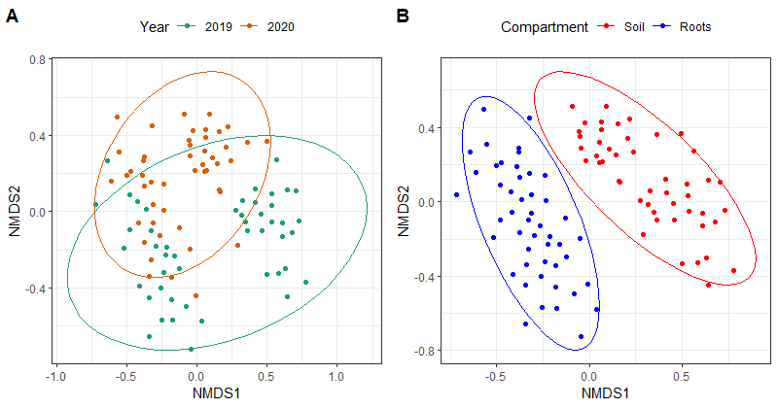
Supplementary Fig. 1. Non-metric multidimensional scaling (NMDS) plots of AMF communities based on Bray-Curtis distances. Circles are 95 % confidence ellipses of the comparison, community composition significantly differs between; (A) years and (B) compartment (bulk soil vs. roots).

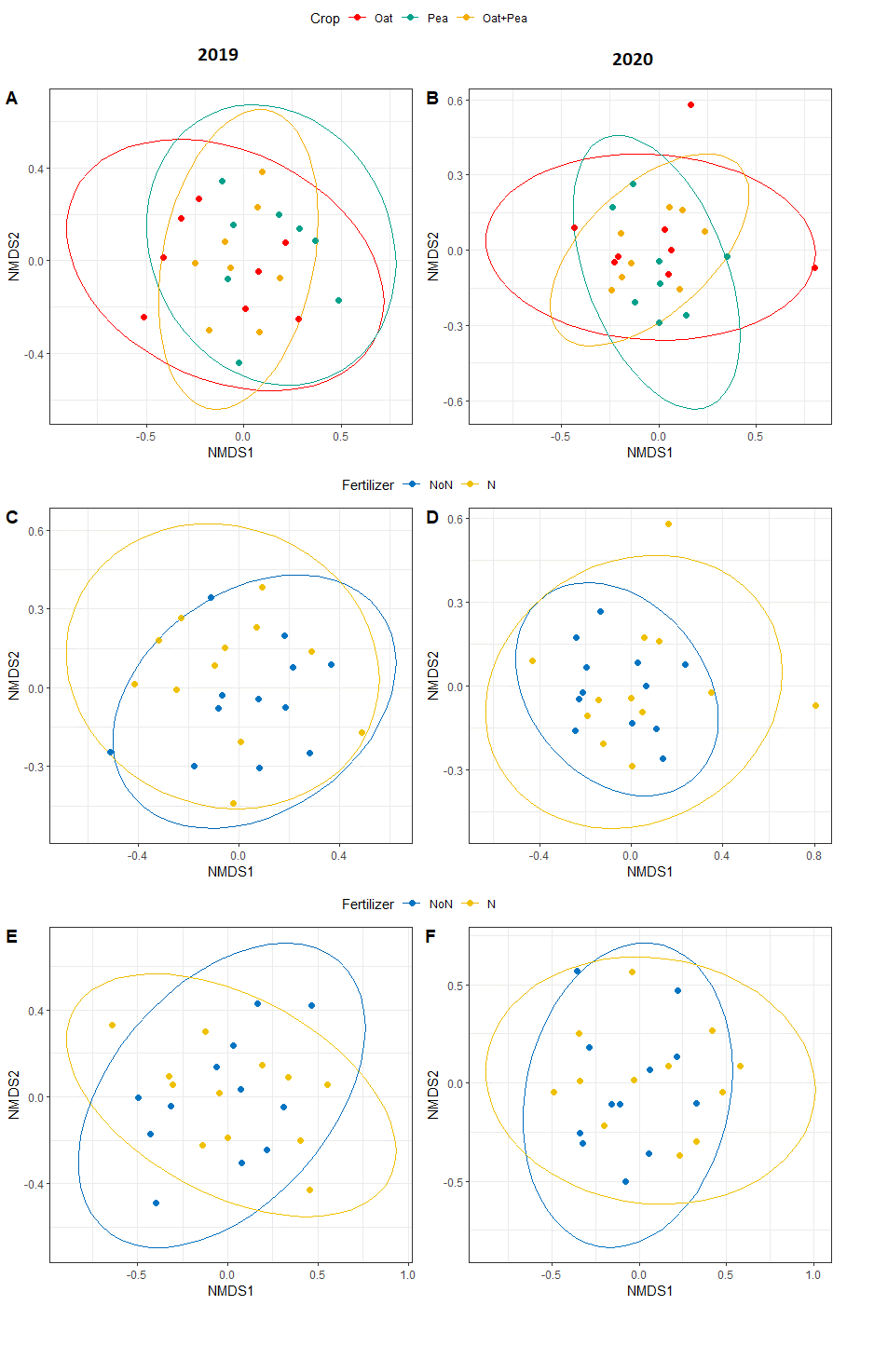
Supplementary Fig. 2. Non-metric multidimensional scaling (NMDS) plots of AMF communities based on Bray-Curtis distances. Circles are 95 % confidence ellipses of the comparison, soil community composition significantly differs between; cropping systems (A and B) and N fertilizer treatment (C, D, E and F). Left panels indicate 2019 data while right panels show 2020 data.

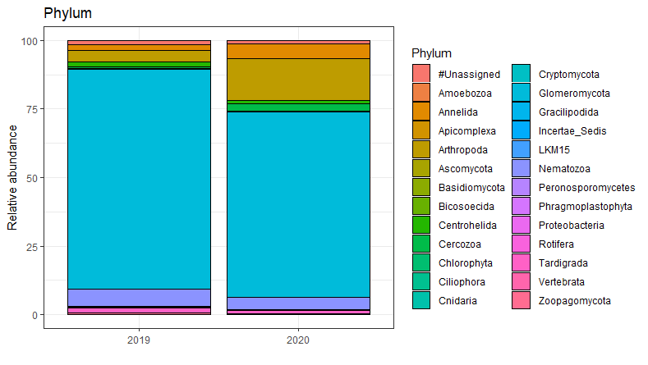

Supplementary Fig. 3. Proportional composition of AMF communities. The panel indicates proportional sequence abundance in each of the two study years. Legend shows phylogenetic level to identified AMF phylum.

2019: 80.14 % assigned to Glomeromycota, 1.50% not assigned to any Phylum
2020: 67.74 % assigned to Glomeromycota 1.23% not assigned to any Phylum

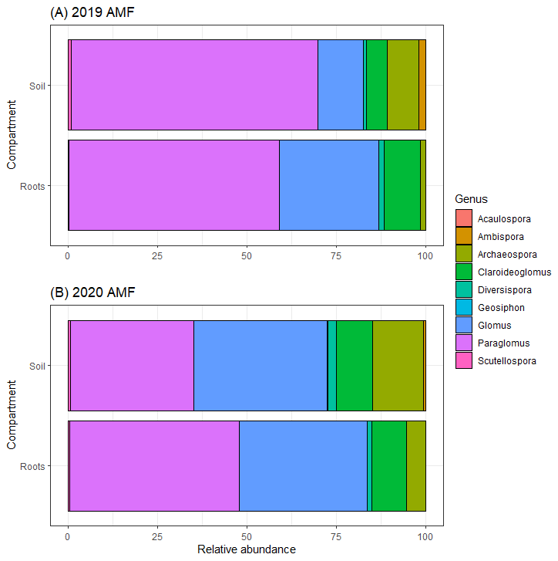

Supplementary Fig. 4. Proportional composition of AMF root and bulk soil communities in 2019 (A) and 2020 (B). Legend shows phylogenetic level to identified AMF genus.

