TITLE PAGE
Title: Performance of a score to characterize adequate contact among the social network of persons with tuberculosis
Running Title: Performance score to measure contact TBI
María Eugenia Castellanos^{1,2}, Sarah Zalwango³, Trang Quach^{1,2,4}, Robert Kakaire^{1,2}, Leonardo Martínez^{5,6}, Mark H. Ebell², Kevin K. Dobbin², Noah Kiwanuka³ and Christopher C. Whalen^{1,2}
¹ Global Health Institute, College of Public Health, University of Georgia, Athens, Georgia, 30602, United States
² Department of Epidemiology and Biostatistics, College of Public Health, University of Georgia, Athens, Georgia, 30602, United States
³ Makerere University College of Health Sciences, School of Public Health, Kampala, Uganda
⁴Faculty of Pharmacy, Ho Chi Minh City University of Technology (HUTECH), Vietnam
⁵Division of Infectious Diseases and Geographic Medicine, Stanford University School of Medicine, Stanford, California, 94305, United States
⁶ Department of Epidemiology, School of Public Health, Boston University, Boston, Massachusetts, 02118, United States.
Corresponding author: María Eugenia Castellanos, M.Sc., Ph.D., Global Health Institute, College of Public Health, University of Georgia, Athens, GA 30602. E-mail: mecastellanos@uga.edu
ABSTRACT WORD COUNT. 298
TEXT WORD COUNT. 3,134
APPENDIX
Appendix. Estimation and performance of the combined setting and relationship score (named as the ‘combined score’).

Method. To estimate the combined score, we computed the euclidic distance (See Examples) from the setting/relationship point to the coordinates of 0,0.

Examples of calculation:
- Case 1: Setting: 14 units, Relationship: 2 units
- Case 2: Setting: 8 units, Relationship: 8 units

c
c

Formula for the euclidian distance-From the setting/relationship point to the coordinates of 0,0:
c² = (x_{A} − x_{B})² + (y_{A} − y_{B})²
So, XB= 0 and YB=0
a is (x_{A} − x_{B})=XA
b is (y_{A} − y_{B})=YA

Case 1:
c²=14² + 2² = 200
c=14.1

Case 2:
c²=8² + 8² = 128
c=11.3

Results.
The combined score was positively associated with tuberculous infection in contacts (Figure A1). When we categorized the combined contact scores into quartiles, we found a rise in the risk of infection with each increasing quartile. In very low, low, medium, and high combined-contact quartiles, the prevalence of tuberculous infection was 44%, 40%, 52% and 69, respectively (Table A1, P_{trend} <0.0001). This corresponded to a crude prevalence ratio of 0.94 (95% CI 0.75-1.17), 1.25 (95% CI 1.004-1.56) and 1.58 (95% CI 1.29-1.92) for each quartile compared to the very low quartile.
Among household contacts, the majority had combined scores in the medium and high quartiles and the prevalence of tuberculous infection was highest in the highest quartile (70%, P_{trend} <0.0001) (Figure A2). Among extra-household contacts, the prevalence of tuberculous infection tended to increase across quartiles from very low (45%), low (40%) medium (54%), to high (68%) (P_{trend}=0.0704).
Among contacts exposed to index cases with a high-smear grade, the prevalence of tuberculous infection increased from 45% in the lowest quartile of the combined score to 69% in the highest quartile (P_{trend} <0.0001) (Figure A3). Among contacts of index cases with a low smear grade, the prevalence of tuberculous infection did not differ markedly among contacts in the lowest three quartiles (41%, 47%, 37%, respectively). However, it continued to be highest among contacts in the highest quartile of the combined score (75%) (P_{trend} =0.1353).
After adjustment for covariates, we found that the combined score continued to be associated with the prevalence of tuberculous infection in contacts (Figure A4). The results were similarly to the ones found for the setting score. In the contacts 0-4 years old, the prevalence ratio for infection was 1.12 (95% CI, 1.05-1.19). For contacts 5-14 years old, the adjusted prevalence ratio was 1.22 (95% CI, 1.13-1.31). Among adults, the adjusted prevalence ratio was 1.03 (95% CI 1.02,1.05).
Table Legends

Table A1. Prevalence and crude prevalence ratio (95% CI) for tuberculous infection among social contacts of tuberculosis cases by the combined score.

Table A1. Prevalence and crude prevalence ratio (95% CI) for tuberculous infection among social contacts of tuberculosis cases by the combined score.

 | Score range | N | Prevalence tuberculous infection |  | Crude prevalence ratio  (95% CI)
Category |  |  | N | % (95% CI)
Overall |  | 955 | 493 | 52 (48-55)
Combined score (continuous) | 7.3-23.2 | 955 |  |  | 1.05 (1.03-1.07)
Combined score (categorical)
Very low | 7.3-10.0 | 237 | 106 | 45 (38-51) | 1
Low | 10.0-13.2 | 240 | 96 | 40 (34-46) | 0.94 (0.75-1.17)
Medium | 13.2-17.1 | 239 | 125 | 52 (46-59) | 1.25 (1.00-1.56)
High | 17.1-23.2 | 239 | 166 | 69 (64-75) | 1.58 (1.29-1.92)

Figure Legends

Figure A1. Probability of tuberculous infection among contacts of tuberculosis cases, according to the combined scores. Nonparametric smoothed curve showing the probability of tuberculous infection against the combined score, using a loess (locally weighted scatterplot smoothing) model. The dotted vertical lines indicate the limits of each of the quartiles.

Figure A2. Prevalence of tuberculous infection among contacts of tuberculosis cases, according to combined scores quartile. Prevalence of tuberculosis (%) shown in overall population (left panel), household contacts (center panel) and extra-household contacts (right panel).

Figure A3. Prevalence of tuberculous infection among contacts of tuberculosis cases, according to combined score quartiles. Prevalence of tuberculosis (%) show stratified by smear result of the index case: 0 or 1+ (top panel), 2 or 3+ (bottom panel).

Figure A4. Adjusted prevalence ratio for the association between increasing scores in the setting, relationship and combined scores and tuberculous infection. Overall and stratified by age of contact. An adjusted prevalence ratio > 1 indicates that for each increasing unit of the scores, there is a higher prevalence of tuberculous infection , after adjustment by other covariates (age, sex, HIV status, BCG vaccination status of contact; age, sex, HIV status, microscopy status and BMI of index case; knowledge of tuberculosis status of the contact by the index case and knowledge of cough status of the contact by the index case).

Figure A1. Probability of tuberculous infection among contacts of tuberculosis cases, according to the combined scores. Nonparametric smoothed curve showing the probability of tuberculous infection against the combined score, using a loess (locally weighted scatterplot smoothing) model. The dotted vertical lines indicate the limits of each of the quartiles.

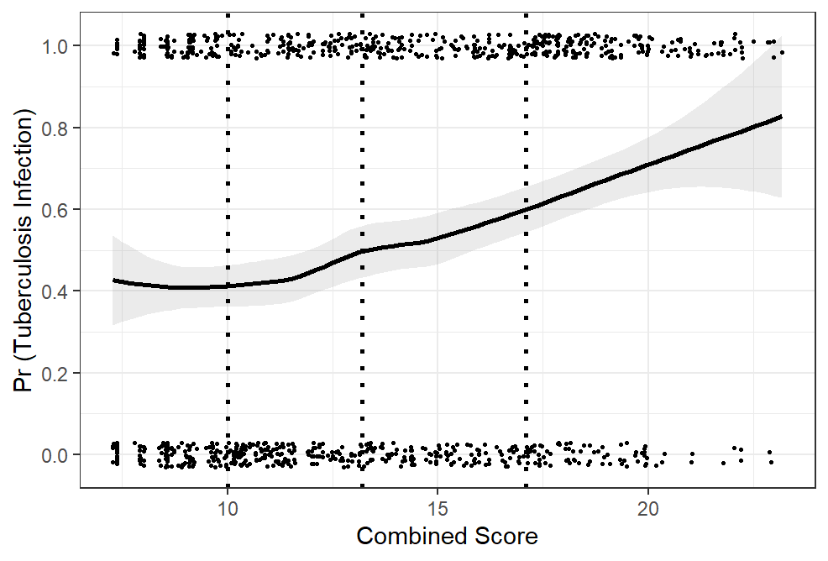
Figure A2. Prevalence of tuberculous infection among contacts of tuberculosis cases, according to combined scores quartile. Prevalence of tuberculosis (%) shown in overall population (left panel), household contacts (center panel) and extra-household contacts (right panel).

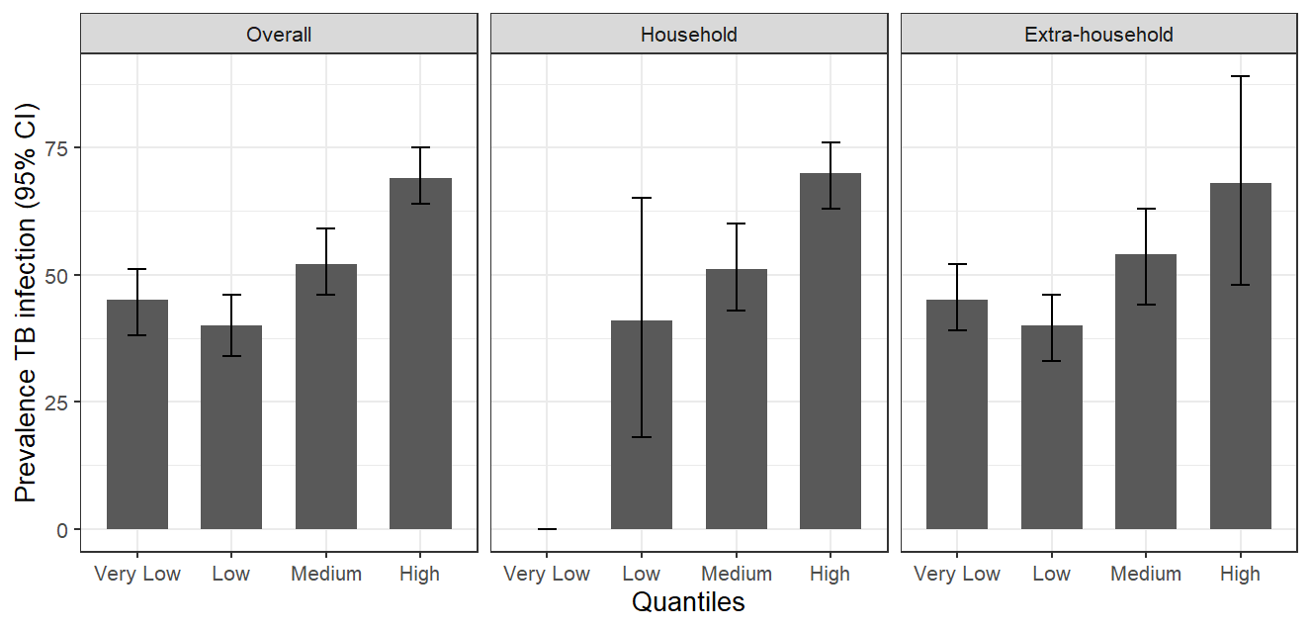
Figure A3. Prevalence of tuberculous infection among contacts of tuberculosis cases, according to combined score quartiles. Prevalence of tuberculosis (%) show stratified by smear result of the index case: 0 or 1+ (left panel), 2 or 3+ (right panel).

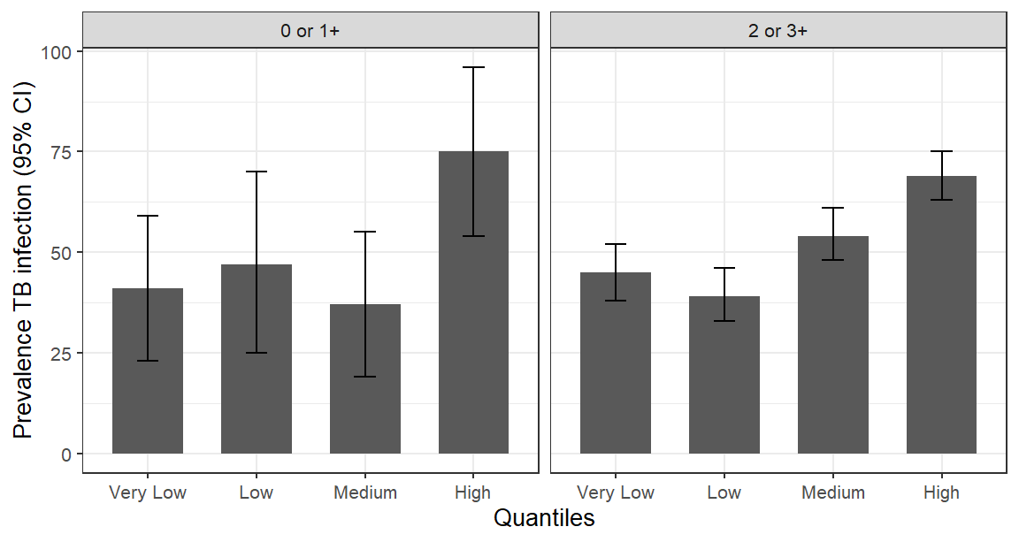

Figure A4. Adjusted prevalence ratio for the association between increasing scores in the setting, relationship and combined scores and tuberculous infection. Overall and stratified by age of contact. An adjusted prevalence ratio > 1 indicates that for each increasing unit of the scores, there is a higher prevalence of tuberculous infection , after adjustment by other covariates (age, sex, HIV status, BCG vaccination status of contact; age, sex, HIV status, microscopy status and BMI of index case; knowledge of tuberculosis status of the contact by the index case and knowledge of cough status of the contact by the index case).
