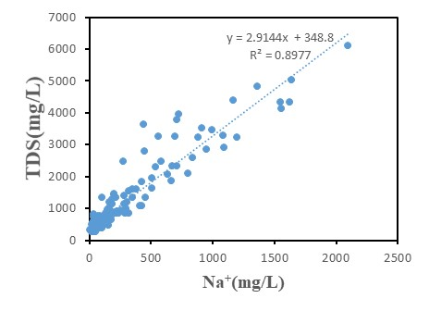
Figure 1 Na⁺-TDS relationship of shallow groundwater
Table 1 Different ion concentrations in five zones
Zone I  （n=34） | Ca²⁺  （mg/L） | Na⁺  （mg/L） | Mg²⁺  （mg/L） | HCO₃⁻  （mg/L） | SO₄²⁻  （mg/L） | pH | TDS  （mg/L） | Fe  （mg/L）
Max | 158 | 137 | 56.8 | 454 | 165 | 8.68 | 818 | 4.40
Min | 45.0 | 9.93 | 12.1 | 215 | 12.1 | 7.28 | 262 | 2.00×10⁻²
Average | 77.4 | 49.8 | 26.0 | 304 | 74.6 | 7.82 | 480 | 0.480
Median | 69.7 | 33.7 | 23.3 | 282 | 56.1 | 7.75 | 477 | 9.00×10⁻²
Zone II  （n=42） | Ca²⁺  （mg/L） | Na⁺  （mg/L） | Mg²⁺  （mg/L） | HCO₃⁻  （mg/L） | SO₄²⁻  （mg/L） | pH | TDS  （mg/L） | Fe  （mg/L）
Max | 151 | 1.64×10³ | 268 | 1.23×10³ | 963 | 8.88 | 5.03×10³ | 1.00
Min | 11.3 | 21.3 | 2.7.20 | 210 | 6.24 | 7.25 | 271 | 2.00×10⁻²
Average | 43.0 | 349 | 71.5 | 545 | 227 | 7.77 | 1.33×10³ | 0.192
Median | 40.7 | 165 | 45.2 | 382 | 110 | 7.67 | 763 | 8.00×10⁻²
Zone III  （n=15） | Ca²⁺  （mg/L） | Na⁺  （mg/L） | Mg²⁺  （mg/L） | HCO₃⁻  （mg/L） | SO₄²⁻  （mg/L） | pH | TDS  （mg/L） | Fe  （mg/L）
Max | 72.9 | 114 | 68.7 | 400 | 118 | 8.63 | 651 | 3.60
Min | 38.2 | 13.3 | 20.3 | 168 | 31.3 | 7.33 | 274 | 2.00×10⁻²
Average | 57.0 | 40.8 | 31.7 | 282 | 60.1 | 7.88 | 401 | 0.516
Median | 60.1 | 35.8 | 26.4 | 284 | 55.0 | 7.75 | 369 | 0.240
Zone IV  （n=19） | Ca²⁺  （mg/L） | Na⁺  （mg/L） | Mg²⁺  （mg/L） | HCO₃⁻  （mg/L） | SO₄²⁻  （mg/L） | pH | TDS  （mg/L） | Fe  （mg/L）
Max | 151 | 300 | 121 | 833 | 233 | 8.68 | 1.33×10³ | 2.80
Min | 8.01 | 45.9 | 14.4 | 195 | 4.53 | 7.46 | 326 | 2.00×10⁻²
Average | 52.7 | 137 | 53.4 | 494 | 76.2 | 7.96 | 708 | 0.684
Median | 42.5 | 117 | 45.5 | 436 | 56.0 | 7.86 | 689 | 0.500
Zone V  （n=39） | Ca²⁺  （mg/L） | Na⁺  （mg/L） | Mg²⁺  （mg/L） | HCO₃⁻  （mg/L） | SO₄²⁻  （mg/L） | pH | TDS  （mg/L） | Fe  （mg/L）
Max | 156 | 2.10×10³ | 276 | 2.12×10³ | 730 | 8.57 | 6.11×10³ | 6.40
Min | 5.70 | 29.6 | 7.85 | 313 | 1.99 | 7.26 | 342 | 2.00×10⁻²
Average | 34.8 | 443 | 73.0 | 899 | 129 | 7.72 | 1.52×10³ | 1.06
Median | 28.2 | 215 | 45.8 | 791 | 37.0 | 7.65 | 901 | 0.48
Zone VI  （n=21） | Ca²⁺  （mg/L） | Na⁺  （mg/L） | Mg²⁺  （mg/L） | HCO₃⁻  （mg/L） | SO₄²⁻  （mg/L） | pH | TDS  （mg/L） | Fe  （mg/L）
Max | 260 | 838 | 417 | 1.12×10³ | 1.55×10³ | 9.05 | 3.95×10³ | 12.0
Min | 23.6 | 23.6 | 16.0 | 117 | 12.3 | 7.31 | 270 | 6.00×10⁻²
Average | 88.9 | 298 | 120 | 463 | 390 | 7.81 | 1.61×10³ | 1.17
Median | 64.3 | 203 | 94.6 | 430 | 324 | 7.68 | 1.41×10³ | 0.200

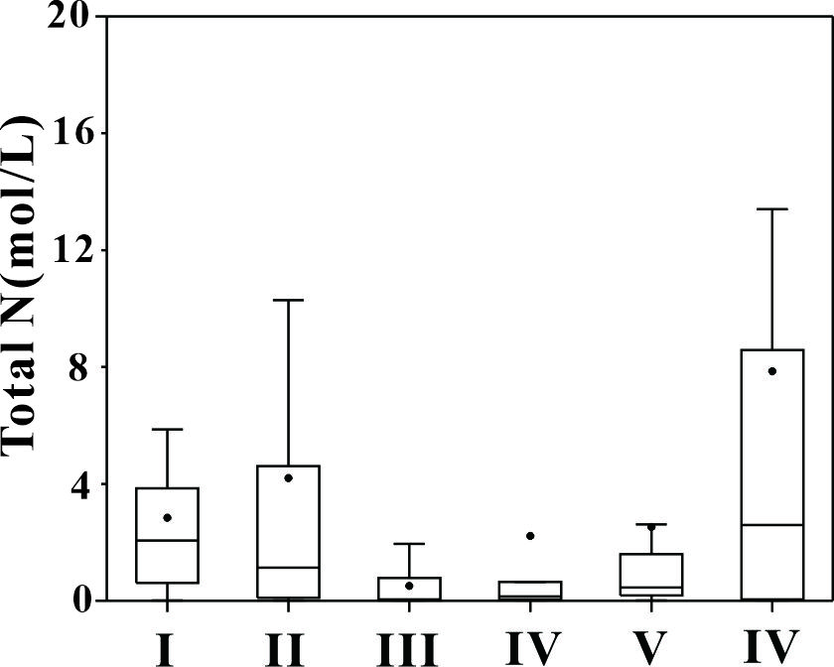
Figure 2 Total N in six different zones

