Curtobacterium allii sp. nov., the actinobacterial pathogen causing onion bulb rot

Manzeal Khanal^{1,2}, Bed Prakash Bhatta^{1,2}, Sujan Timilsina^{3,+}, Sudeep Ghimire⁴, Kimberly Cochran^{2,5}, and Subas Malla^{1,2*}
¹Department of Horticultural Sciences, Texas A&M University, College Station, Texas, 77843, USA;
²Texas A&M AgriLife Research and Extension Centre, Uvalde, Texas, 78801, USA;
³ Department of Plant Pathology, University of Florida, Gainesville, Florida, 32611, USA;
⁴Department of Pathology, University of Iowa, Iowa City, Iowa, 54442, USA;
⁵Department of Plant Pathology and Microbiology, Texas A&M University, College Station, Texas, 77843, USA;
⁺ Current address: Charles River Laboratories, Newark, DE, USA.

Corresponding author
*Subas Malla, subas.malla@ag.tamu.edu

Supplementary figures and table

Fig. S1. A symptomatic rotting onion bulb from Texas, USA, from which the pathogenic strain 20TX0166^{T} of Curtobacterium was isolated.
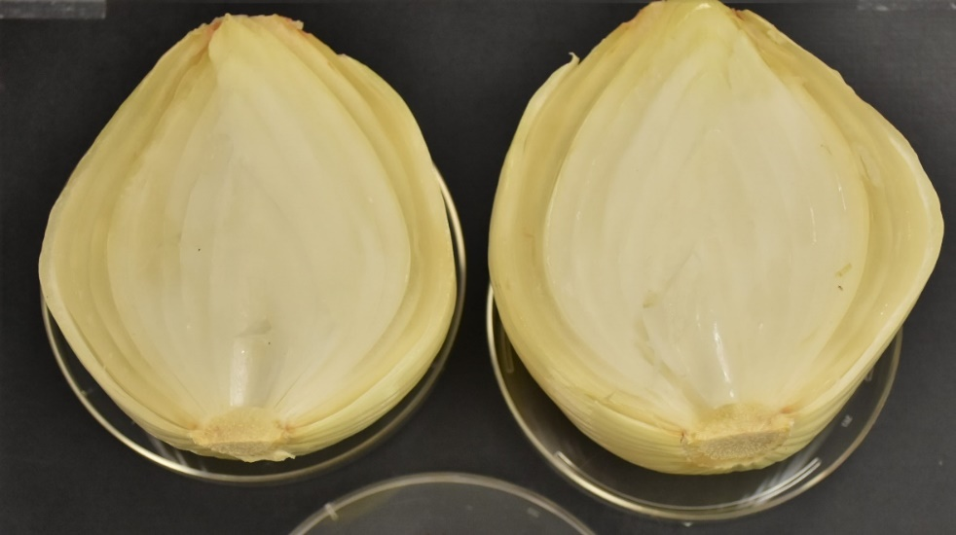

Fig. S2. Graphic visualization of the 20TX0166^{T} genome of a Curtobacterium isolate obtained from a rotting onion bulb in Texas, USA, constructed using DNAplotter v18.1.0. Progressing from the outer ring inwards, brown, green, and blue coloured circles represent the total coding sequences (CDSs) present in the double strand, forward strand, and reverse strand, respectively, of the bacterial strain. The fourth circle comprised of red marks denotes the positions of tRNAs in the genome. The fifth circle represents the average G+C content, and the innermost circle represents the GC skewness. Teal and purple colours represent GC content above and below the average, respectively.
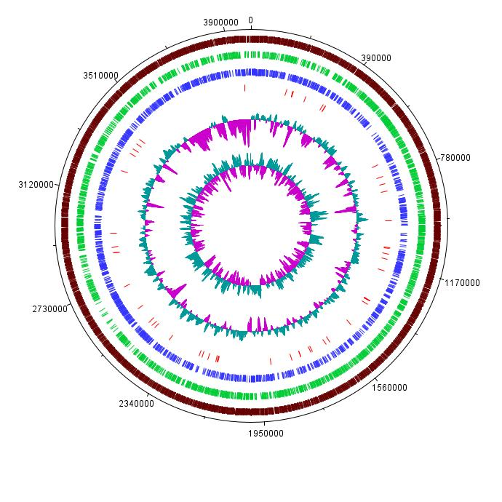

Fig. S3. Necrotic rotting observed on red onion scales 10 d post-inoculation with strain 20TX0166^{T} of Curtobacterium isolated from a rotten onion bulb in Texas, USA. A suspension of the bacterium (10 µl of 10⁸ CFU/ml) was placed on the scale (~3 cm x 4 cm) after making a wound at the centre of the scale with a sterile needle. The inoculated scales were incubated at 25 °C.
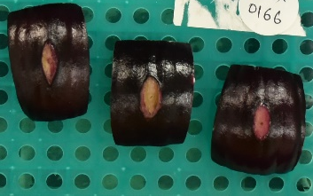

Fig. S4. Phylogenetic tree based on whole genome sequences of Curtobacterium allii 20TX0166^{T}, C. flaccumfaciens LMG 3645^{T}, and 35 strains deposited as C. flaccumfaciens in the NCBI Genome database. The tree was constructed using the TYGS webserver. The type strains of the species used are indicated in parenthesis.
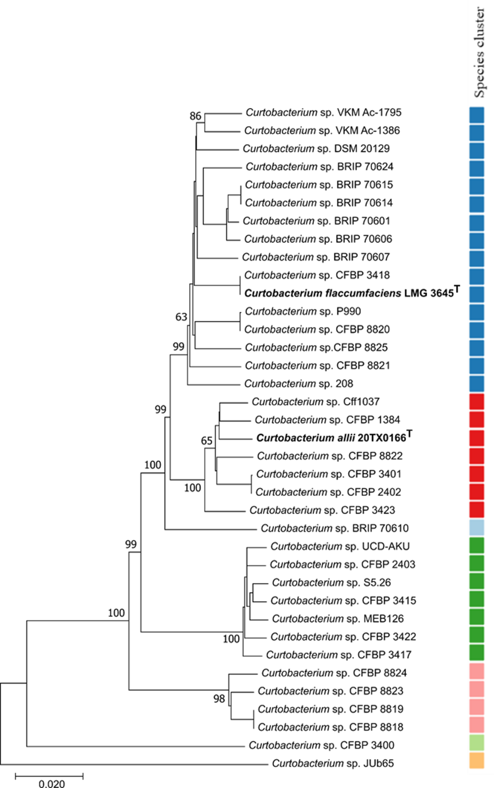
Fig. S5. Gram stain of strain 20TX0166^{T} of Curtobacterium isolated from a rotten onion bulb in Texas, USA. The purple color resulting from the stain indicates the bacterium to be Gram positive.
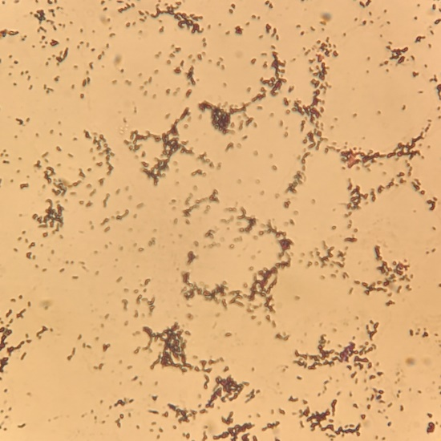
Fig. S6. Endospore staining of strain 20TX0166^{T} of Curtobacterium isolated from a rotten onion bulb in Texas, USA, to determine if the strain can form endospores. Bacterial cells stained red (absence of green), which confirmed the bacterium does not form endospores.
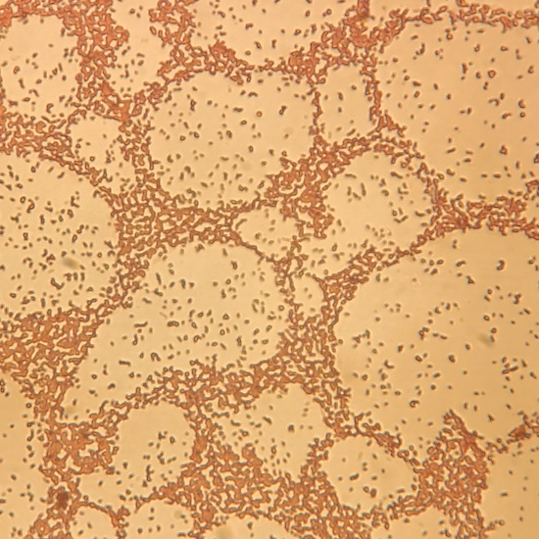
Fig. S7. A 3-d-old culture of strain 20TX0166^{T} of Curtobacterium isolated from a rotten onion bulb in Texas, USA, on YPGA medium (A) and NBYA medium (B) grown at 25 °C.
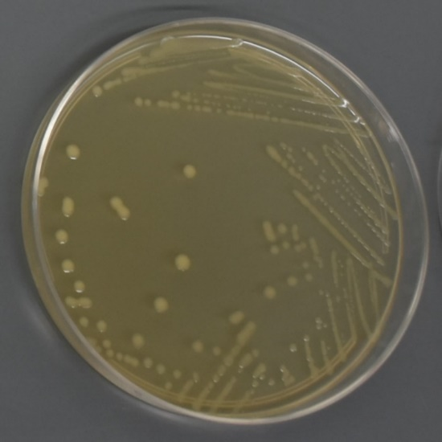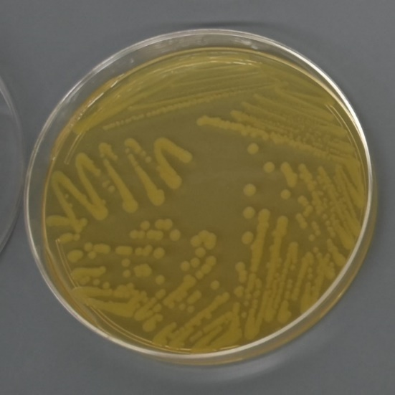
B
A
Table S1. Comparison of selected physiological and phenotypic characteristics of strain 20TX0166^{T} of Curtobacterium isolated from a rotten onion bulb in Texas, USA, and closely related Curtobacterium type strains.
Reactions | Strains of Curtobacterium†
 | 1‡ | 2‡ | 3§ | 4§ | 5§ | 6§ | 7§
Biolog:
Negative control | -¶ | - | ND | ND | ND | ND | ND
Dextrin | + | + | - | + | + | - | -
D-Maltose | + | + | + | + | + | + | ND
D-Trehalose | + | + | ND | ND | ND | ND | ND
D-Cellobiose | + | + | - | + | + | + | -
Gentiobiose | + | + | ND | ND | ND | ND | ND
Sucrose | + | + | ND | ND | ND | ND | ND
D-Turanose | + | + | + | - | - | + | +
Stachyose | + | + | ND | ND | ND | ND | ND
P. control | + | + | ND | ND | ND | ND | ND
pH 6 | + | + | ND | ND | ND | ND | ND
pH 5 | + | + | ND | ND | ND | ND | ND
D-Raffinose | + | + | - | - | - | + | -
alpha-D-Lactose | + | + | - | + | + | + | +
D-Melibiose | + | + | - | + | + | w | +
beta-Methyl-D-Glucoside | + | + | + | - | - | w | -
D-Salicin | + | + | ND | ND | ND | ND | ND
N-Acetyl-DGlucosamine | + | + | - | + | + | w | -
N-Acetyl-beta-D-Mannosamine | w | w | ND | ND | ND | ND | ND
N-Acetyl-DGalactosamine | + | + | - | - | - | - | -
N-Acetyl Neuraminic Acid | w | - | ND | ND | ND | ND | ND
1% NaCl | + | + | ND | ND | ND | ND | ND
4% NaCl | + | + | ND | ND | ND | ND | ND
8% NaCl | + | + | ND | ND | ND | ND | ND
alpha-D-Glucose | + | + | ND | ND | ND | ND | ND
D-Mannose | + | + | ND | ND | ND | ND | ND
D-Fructose | + | + | ND | ND | ND | ND | ND
D-Galactose | + | + | ND | ND | ND | ND | ND
3-Methyl Glucose | + | + | ND | ND | ND | ND | ND
D-Fucose | + | + | ND | ND | ND | ND | ND
L-Fucose | + | + | - | + | + | - | -
L-Rhamnose | + | + | + | + | + | + | ND
Inosine | + | + | ND | ND | ND | ND | ND
1% Sodium Lactate | + | + | ND | ND | ND | ND | ND
Fusidic Acid | - | - | ND | ND | ND | ND | ND
D-Serine | - | - | ND | ND | ND | ND | ND
D-Sorbitol | + | + | + | - | - | + | +
D-Mannitol | + | + | + | - | - | w | +
D-Arabitol | + | + | w | - | - | - | -
myo-Inositol | + | + | - | - | - | - | -
Glycerol | + | + | ND | ND | ND | ND | ND
D-Glucose6-PO4 | + | w | ND | ND | ND | ND | ND
D-Fructose6-PO4 | + | w | ND | ND | ND | ND | ND
D-Aspartic Acid | w | w | ND | ND | ND | ND | ND
D-Serine | - | - | ND | ND | ND | ND | ND
Troleandomycin | - | - | ND | ND | ND | ND | ND
Rifamycin SV | - | - | ND | ND | ND | ND | ND
Minocycline | - | - | ND | ND | ND | ND | ND
Gelatin | + | w | ND | ND | ND | ND | ND
Glycyl-L-Proline | + | + | ND | ND | ND | ND | ND
L-Alanine | + | + | - | - | - | w | -
L-Arginine | + | + | ND | ND | ND | ND | ND
L-Aspartic Acid | + | + | ND | ND | ND | ND | ND
L-Glutamic Acid | + | + | - | + | - | - | -
L-Histidine | - | - | ND | ND | ND | ND | ND
L-Pyroglutamic Acid | + | w | ND | ND | ND | ND | ND
L-Serine | + | + | ND | ND | ND | ND | ND
Lincomycin | - | - | ND | ND | ND | ND | ND
Guanidine HCl | + | + | ND | ND | ND | ND | ND
Niaproof 4 | - | - | ND | ND | ND | ND | ND
Pectin | + | + | ND | ND | ND | ND | ND
D-Galacturonic Acid | w | w | ND | ND | ND | ND | ND
L-Galactonic Acid Lactone | + | w | ND | ND | ND | ND | ND
D-Gluconic Acid | + | + | + | - | - | + | +
D-Glucuronic Acid | + | + | - | - | - | - | -
Glucuronamide | + | + | ND | ND | ND | ND | ND
Mucic Acid | - | - | ND | ND | ND | ND | ND
Quinic Acid | - | - | ND | ND | ND | ND | ND
D-Saccharic Acid | - | - | ND | ND | ND | ND | ND
Vancomycin | - | - | ND | ND | ND | ND | ND
Tetrazolium Violet | - | - | ND | ND | ND | ND | ND
Tetrazolium Blue | - | - | ND | ND | ND | ND | ND
p-HydroxyPhenylacetic Acid | - | - | ND | ND | ND | ND | ND
Methyl Pyruvate | w | - | ND | ND | ND | ND | ND
D-Lactic Acid Methyl Ester | - | - | ND | ND | ND | ND | ND
L-Lactic Acid | w | w | - | w | w | - | +
Citric Acid | + | + | ND | ND | ND | ND | ND
alpha-Keto-Glutaric Acid | - | - | ND | ND | ND | ND | ND
D-Malic Acid | - | w | ND | ND | ND | ND | ND
L-Malic Acid | - | + | ND | ND | ND | ND | ND
Bromo-Succinic Acid | - | + | - | w | - | - | -
Nalidixic Acid | + | + | ND | ND | ND | ND | ND
Lithium Chloride | + | + | ND | ND | ND | ND | ND
Potassium Tellurite | + | + | ND | ND | ND | ND | ND
Tween 40 | + | + | - | w | w | + | -
gamma-Amino-Butryric Acid | - | w | ND | ND | ND | ND | ND
alpha-HydroxyButyric Acid | - | w | ND | ND | ND | ND | ND
beta-Hydroxy-D,LButyric Acid | - | - | ND | ND | ND | ND | ND
alpha-Keto-Butyric Acid | w | w | ND | ND | ND | ND | ND
Acetoacetic Acid | + | + | ND | ND | ND | ND | ND
Propionic Acid | w | w | ND | ND | ND | ND | ND
Acetic Acid | + | + | ND | ND | ND | ND | ND
Formic Acid | - | - | ND | ND | ND | ND | ND
Aztreonam | + | + | ND | ND | ND | ND | ND
Sodium Butyrate | + | + | ND | ND | ND | ND | ND
Sodium Bromate | + | + | ND | ND | ND | ND | ND
API Coryne:
Nitrate Reduction | - | - | ND | ND | ND | ND | -
Pyrazinamidase | + | + | ND | - | - | ND | ND
Pyrolidonyl arylamidase | + | + | ND | ND | ND | ND | ND
Alkaline Phosphatase | + | - | ND | ND | ND | ND | ND
β-Glucuronidase | - | - | ND | ND | ND | ND | ND
β-Galactosidase | + | + | ND | ND | ND | ND | ND
α-Glucosidase | + | + | ND | ND | ND | ND | ND
N-Acetyl-β-Glucosaminidase | + | + | ND | ND | ND | ND | ND
Esculin/β-glucosidase | + | + | + | + | - | + | +
Urease | - | - | ND | ND | ND | ND | -
Gelatin hydrolysis/protease | - | - | + | - | - | + | -
Negative control (Fermentation) | + | - | ND | ND | ND | ND | ND
D-glucose (Fermentation) | - | - | ND | ND | ND | ND | ND
L-ribose (Fermentation) | + | - | + | + | + | - | +
D-xylose (Fermentation) | - | - | ND | ND | ND | ND | ND
D-mannitol (Fermentation) | + | - | ND | ND | ND | ND | ND
D-maltose (Fermentation) | - | - | + | + | + | + | ND
D-lactose (Fermentation) | + | - | ND | ND | ND | ND | ND
D-saccharose (Fermentation) | - | - | ND | ND | ND | ND | ND
glycogen (Fermentation) | + | - | - | + | + | - | -
API 20NE:
Nitrate Reduction | - | - | ND | ND | ND | ND | ND
L-tryptophane | - | - | ND | ND | ND | ND | ND
D-glucose (fermentation) | - | - | ND | ND | ND | ND | ND
Arginine DiHydrolase | - | - | ND | ND | ND | ND | ND
Urease | - | - | ND | ND | ND | ND | ND
Esculin/β-glucosidase | + | + | + | - | + | + | +
Gelatin hydrolysis/protease | - | - | + | - | - | + | -
β-galactosidase | + | + | ND | ND | ND | ND | ND
D-glucose (Assimilation) | + | + | ND | ND | ND | ND | ND
L-arabinose (Assimilation) | + | + | ND | ND | ND | ND | ND
D-mannose (Assimilation) | + | + | ND | ND | ND | ND | ND
D-mannitol (Assimilation) | - | + | ND | + | - | ND | ND
N-acetyl-glucosamine (Assimilation) | - | + | + | + | - | - | -
D-maltose (Assimilation) | + | + | + | + | + | + | ND
Potassium gluconate (Assimilation) | + | + | - | - | - | - | +
Capric acid (Assimilation) | - | - | ND | ND | ND | ND | ND
Adipic acid (Assimilation) | - | - | ND | ND | ND | ND | ND
Malic acid/Malate (Assimilation) | - | + | ND | + | + | ND | ND
Trisodium citrate (Assimilation) | - | w | ND | ND | ND | ND | ND
Phenylacetic acid (Assimilation) | - | - | ND | ND | ND | ND | ND
† Strains: 1, 20TX0166^{T}; 2, C. flaccumfaciens LMG 3645^{T}; 3, C. pusillum JCM 1350^{T}; 4, C. citreum JCM 1345^{T}; 5, C. luteum JCM 1480^{T}; 6, C. albidum NBRC 15078^{T}; 7, C. ammoniigenes B55^{T}.
‡ Data are from this study.
§ Data are from Aizawa et al. 2007.
¶ +, Positive reaction; –, negative reaction; w, weakly positive reaction; ND, No data available.

