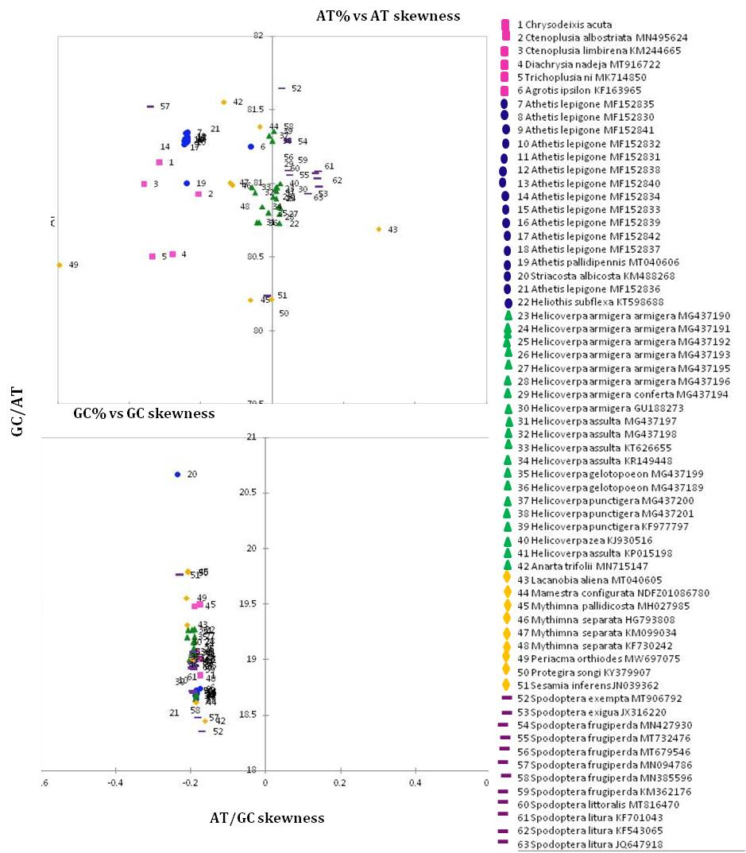
Supplementary Figure 1. AT% vs AT-skew and GC% vs GC-skew in the 63 Noctuidae family species including Chrysodeixis acuta from this study. Values are calculated on J-strands for full length of mt genomes. The X-axis provides the skews values, while the Y axis provides the A+T/G+C values. Names of species are colored according to their taxonomic placement.

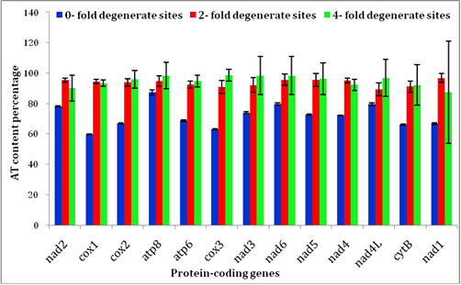
Supplementary Figure 2. The AT content percentage of 0-fold degenerate sites, 2-fold degenerate sites and 4-fold degenerate sites in each protein coding gene of 55 mitochondrial genome sequences of Noctuidae family species including C. acuta from this study. The black line with short line on the top of each bar represents the standard deviation value (SD).

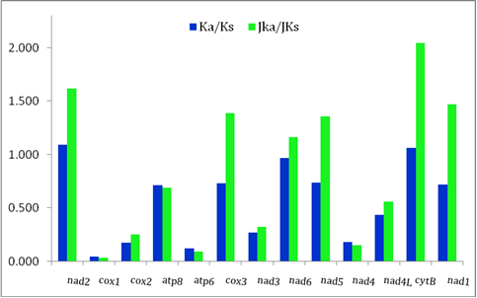
Supplementary Figure 3. Ratio of non-synonymous substitutions (Ka, pi modified) & synonymous substitutions (Ks, pi modified) (Ka/Ks) as well as Jukes-Cantor adjusted (JKa/JKs) ratio in each PCG of 55 mitogenome sequences of Noctuidae family species including C. acuta from this study.
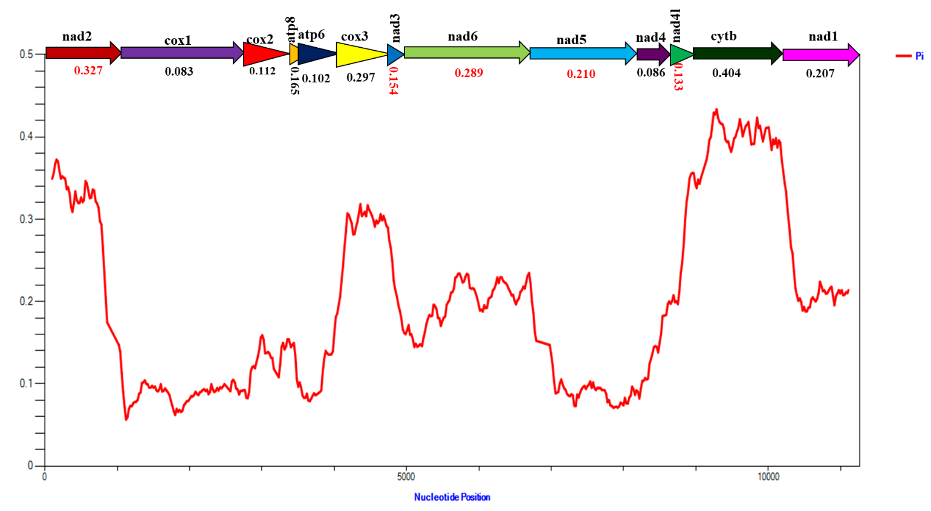
Supplementary Figure 4. Sliding window analysis of protein-coding genes among 55mitogenome sequences of Noctuidae family species including Chrysodeixis acuta from this study. The red curve shows the value of nucleotide diversity.

