Supplementary Materials

Table S1. Epidemiological characteristics of dengue cases in Singapore from 2012-2019
 | Host |  |  |  |  | Virus |  |  |  | Vector
Year | Number of cases | Incidence per 100,000 | Number of imported cases | Total deaths | Case-fatality rate | Serotype 1 (%) | Serotype 2 (%) | Serotype 3 (%) | Serotype 4 (%) | Aedes House Index (%) | Clusters as major breeding sites (10 or more cases)
2012 | 4,632 | 82.2 | 263 | 2 | 0.0 | 19.4 | 74.1 | 5.7 | 0.8 | 0.28 | 328 (21)
2013 | 22,170 | 404.9 | 307 | 8 | 0.1 | 61.8 | 24.6 | 11.6 | 2.0 | 0.30 | 1,475 (188)
2014 | 18,326 | 325.6 | 514 | 6 | 0.1 | 79.4 | 18.0 | 2.5 | 0.2 | 0.26 | 1,418 (137)
2015 | 11,294 | 196.1 | 438 | 6 | 0.1 | 43.2 | 44.5 | 11.2 | 1.1 | 1.24 | 1,114 (108)
2016 | 13,085 | 229.1 | 195 | 12 | 0.2 | 29.0 | 51.1 | 18.4 | 1.5 | 1.2 | 1,432 (104)
2017 | 2,767 | 44.9 | 249 | 2 | 0.04 | 24.1 | 45.1 | 21.3 | 9.5 | 0.58 | 197 (11)
2018* | 3,283 | 54.4 | 215 | 5 | 0.1 | NR | NR | NR | NR | 0.96 | 243 (29)
2019# | 16,100 | 282.3 | NR | 20 | 0.12 | NR | NR | NR | NR | NR | NR
*NR figures were not reported due to a change in the Ministry of Health’s annual communicable diseases report
#NR figures as the 2019 communicable disease report has not been published at the time of writing this paper. Incidence per 100,000 calculated using population figures from Singapore’s Department of Statistics

Table S2: Parameters of predictive model using 2012-2018 data as training set
Meteorological Factor | QAIC | Max Lag Number | $$δ_{1}$$ | $$δ_{2}$$ | MAE | RMSE
PSI | 4439.404 | 16 | 3 | 2 | 51.63 | 59.61
Total Rainfall | 4399.869 | 20 | 5 | 1 | 48.35 | 64.31
Mean Temperature | 4513.536 | 17 | 1 | 3 | 43.15 | 51.39
Max Temperature | 4447.598 | 20 | 5 | 3 | 46.42 | 53.84
Min Temperature | 4369.164 | 19 | 5 | 3 | 53.42 | 61.83
Wind Speed | 4257.981 | 20 | 4 | 3 | 108.64 | 127.73

Note: MAE = Mean Absolute Error; RMSE = Root Mean Squared Error

ARIMA Model

With an obvious trend detected in the time series data, differencing technique was conducted to make the time series stationary and stabilize the variance using logarithm transformation. Autocorrelation function graph and partial autocorrelation function suggested significant autocorrelation at lag 1 (Figure S1). Hence, the final model turns to be ARIMA (1, 1, 0). Residual diagnostics was conducted through Figure S2. P-value of ‘Ljung-Box’ test at significance level 0.05 with 10 lags was 0.3686.

However, some significant signals appeared at lag 43 and lag 49 (Figure S1). These spikes might imply some seasonal patterns of dengue. From Figure 1, peaks were observed around mid-year period during 2012-2015, 2019. In 2016, peak appeared at start of year. Although seasonal patterns were apparent, the seasonal period was not strictly 52 weeks (one year). ${SARIMA (0, 1, 1)(0, 1, 1)}_{52}$ was tried but Ljung-Box test was not passed after lag 43 (Figure S2). Thus seasonal patterns in this weekly data should be captured by a more sophisticated model.

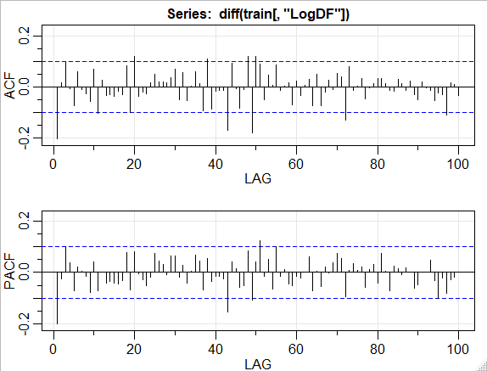
Figure S1: Acf & Pacf graphs of differenced time series of weekly dengue cases with logarithm transformation

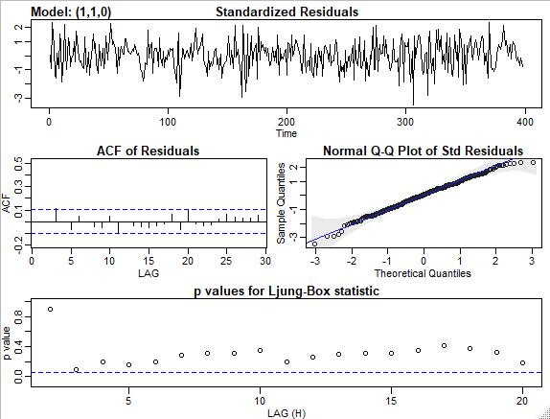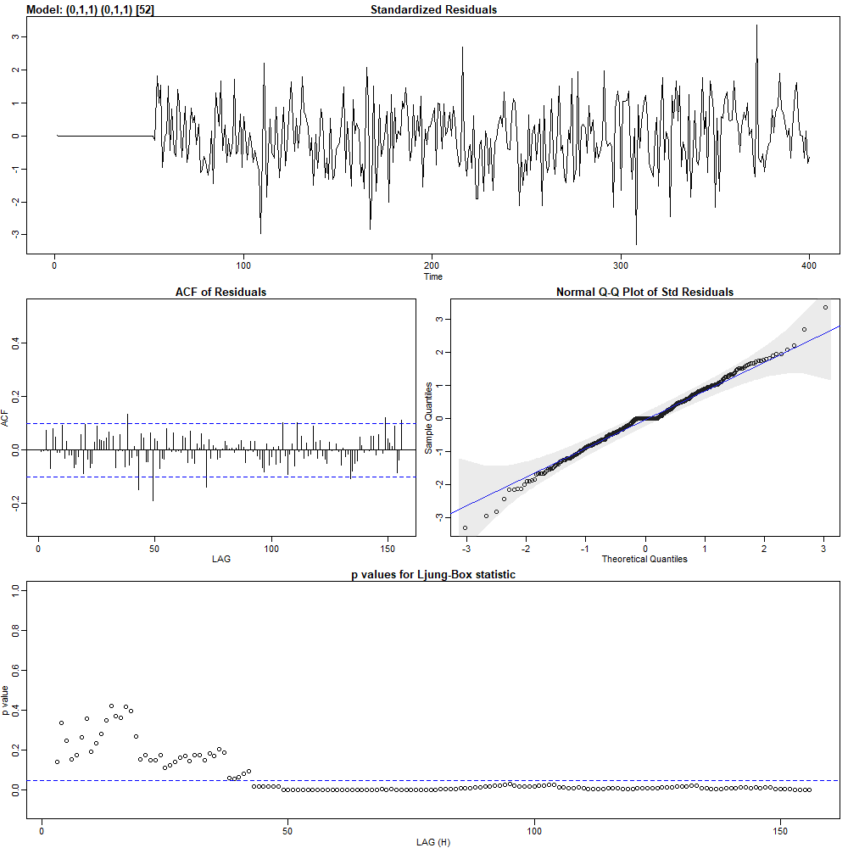
Figure S2: Residual plots and Ljung-Box tests (Residual Diagnostics): Left panel is ARIMA(1, 1, 0) and right panel is ${SARIMA (0, 1, 1)(0, 1, 1)}_{52}$

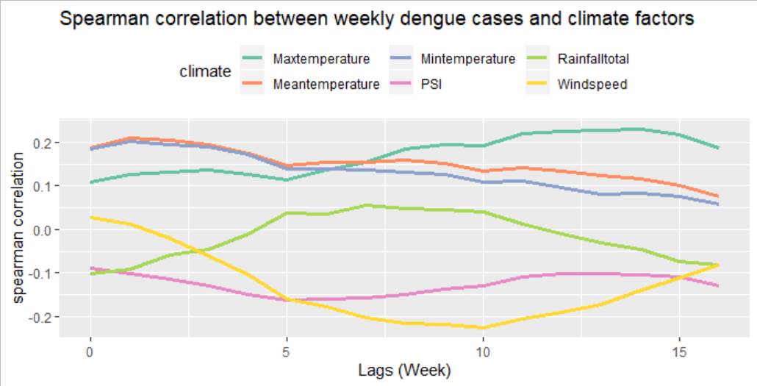
Figure S3: Time-lagged Spearman correlation between climate factors and dengue incidence

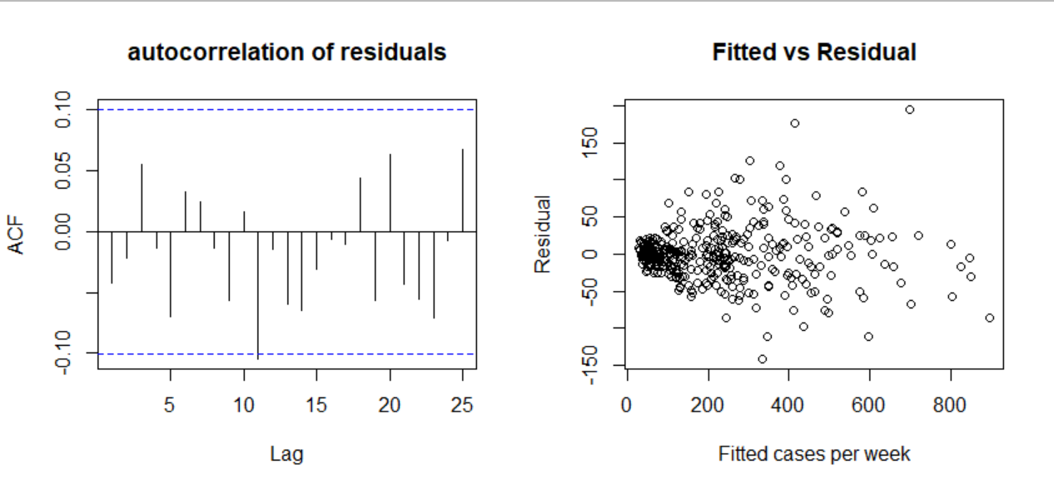
Figure S4: Diagnosis of the residual autocorrelation and overdispersion

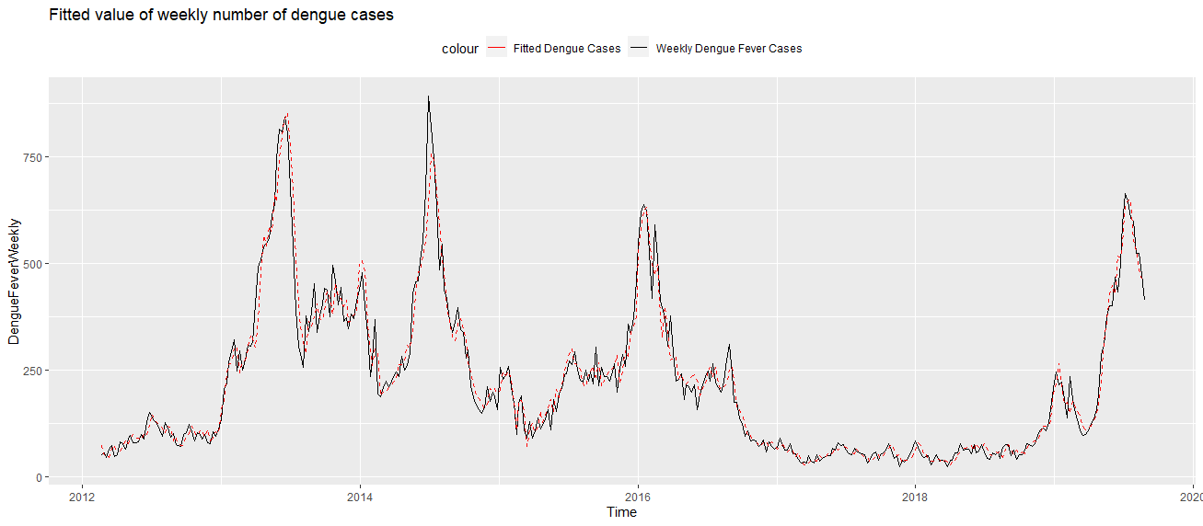
Figure S5: The estimated number of dengue cases (DLNM with wind speed) juxtaposed against original dengue time series

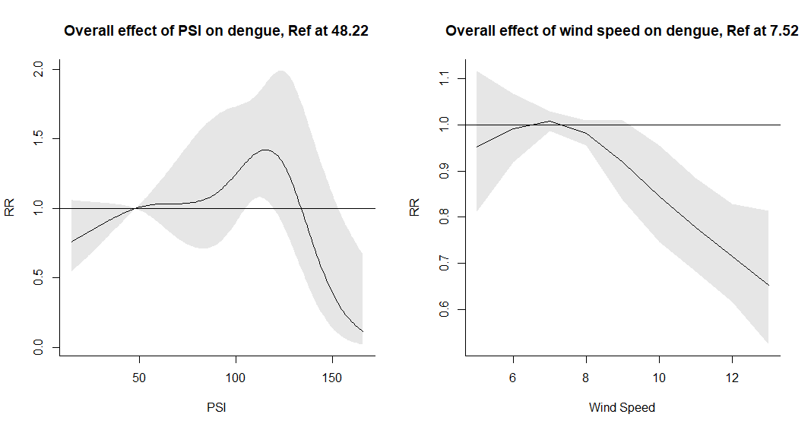
Figure S6: Overall effect of PSI and Wind Speed in multivariate model

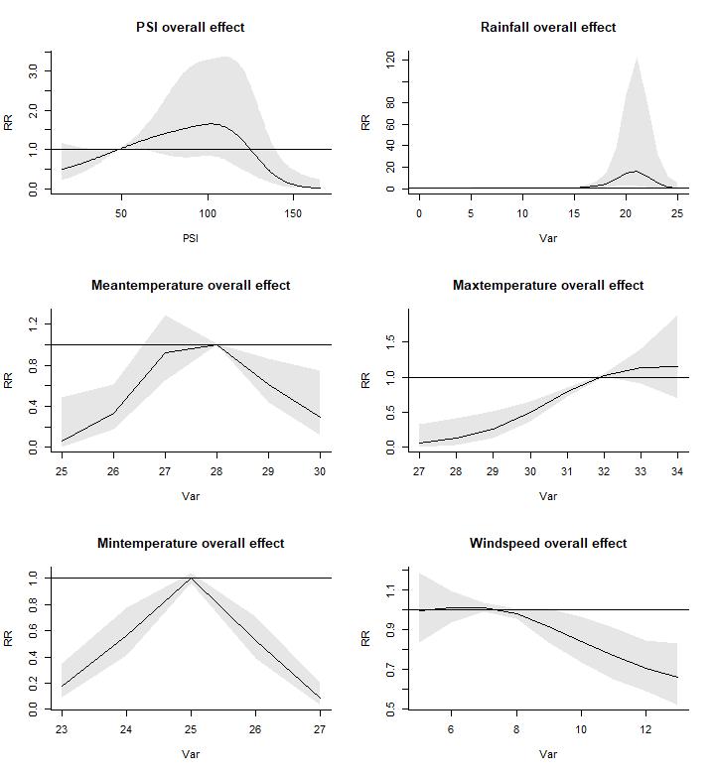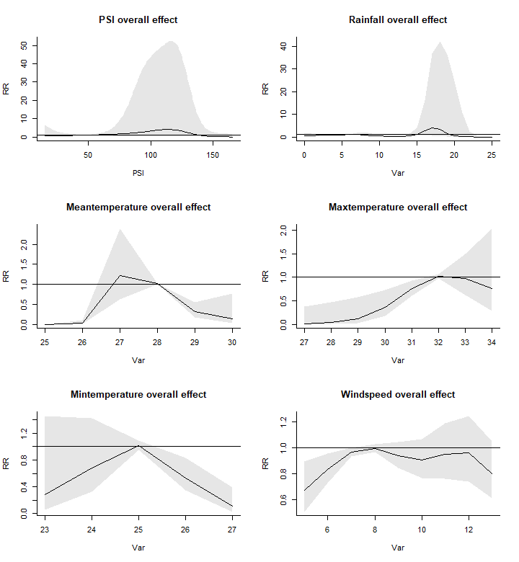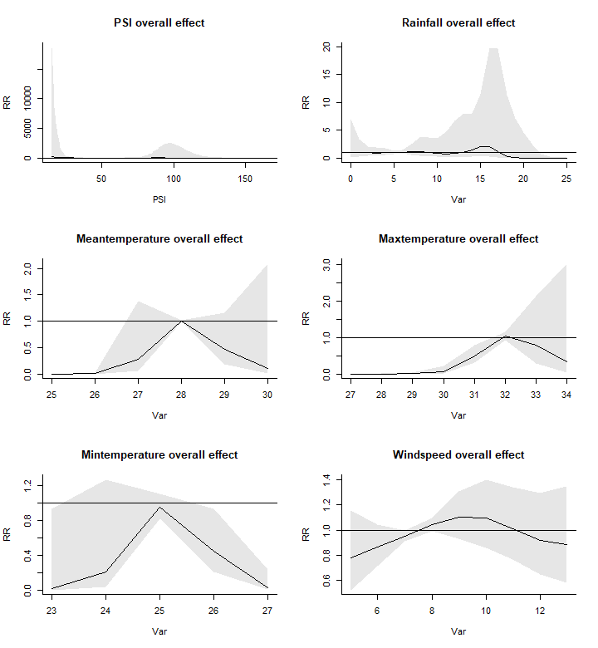
- (b) (c)

Figure S7: Overall effect with variation in $δ$. (a) $δ$ = 8*3 (b) $δ$ = 8*5 (c) $δ$ = 8*7
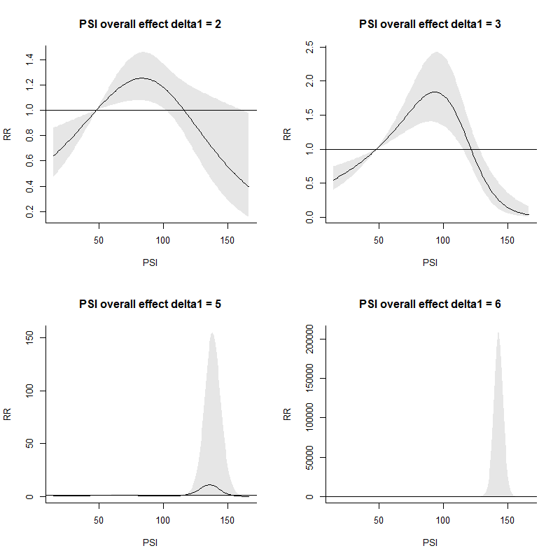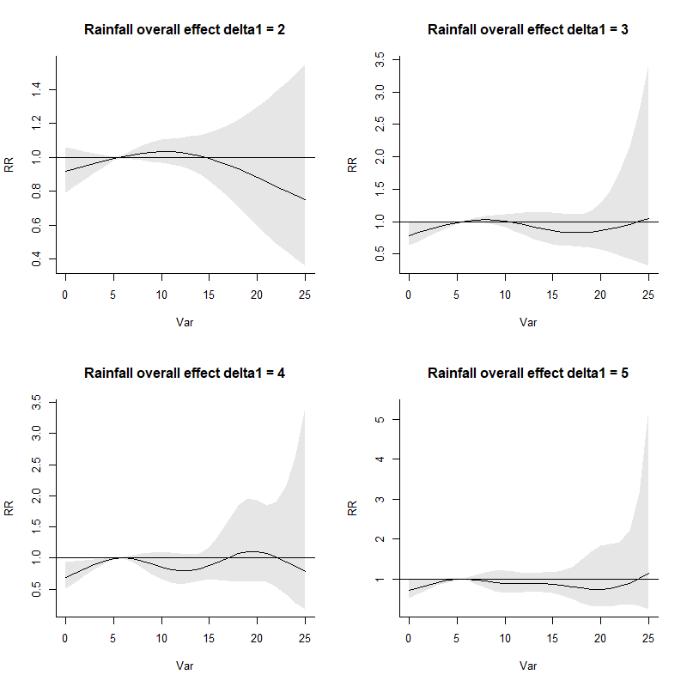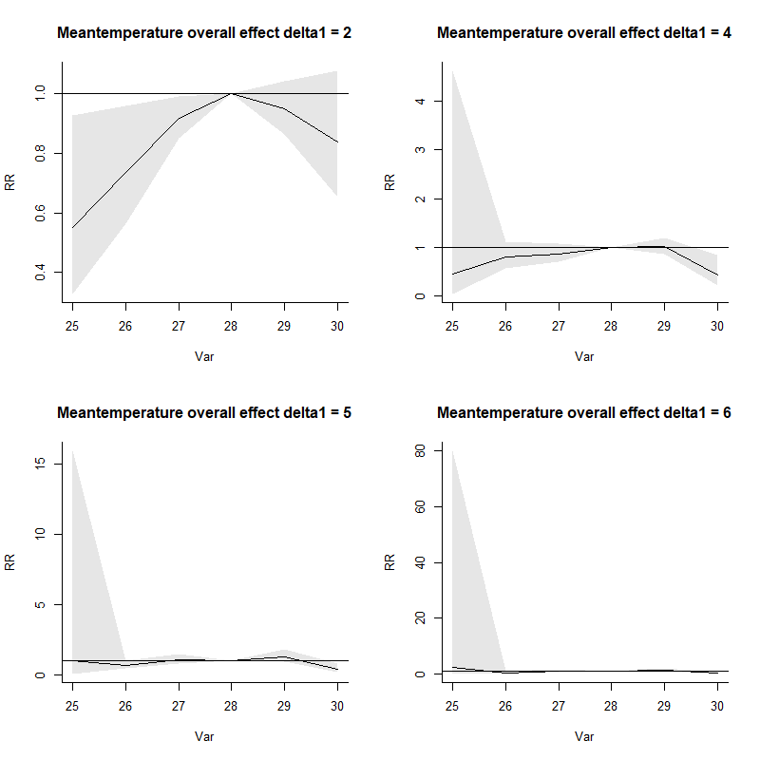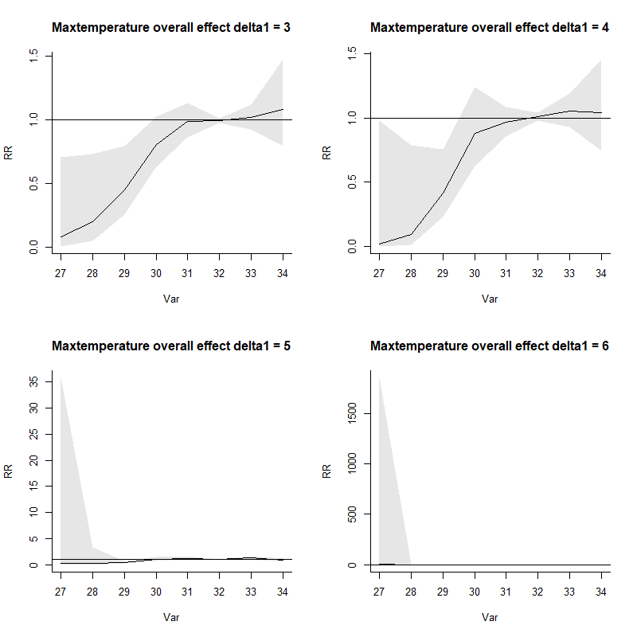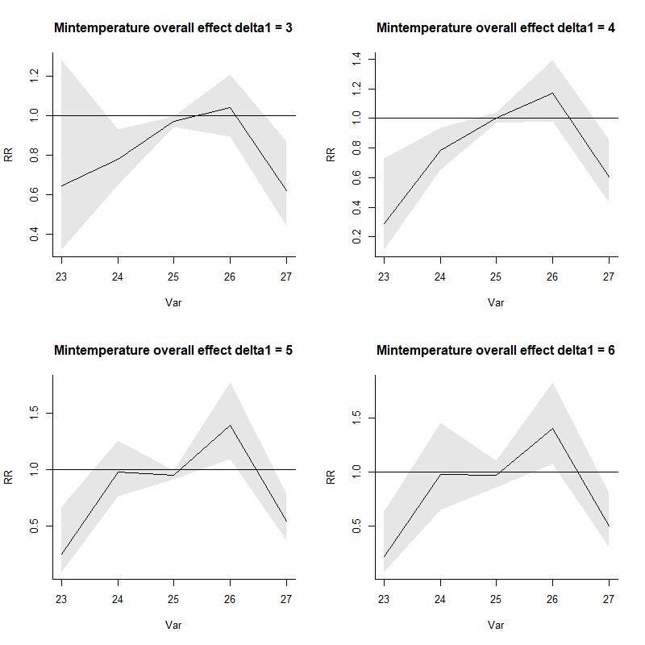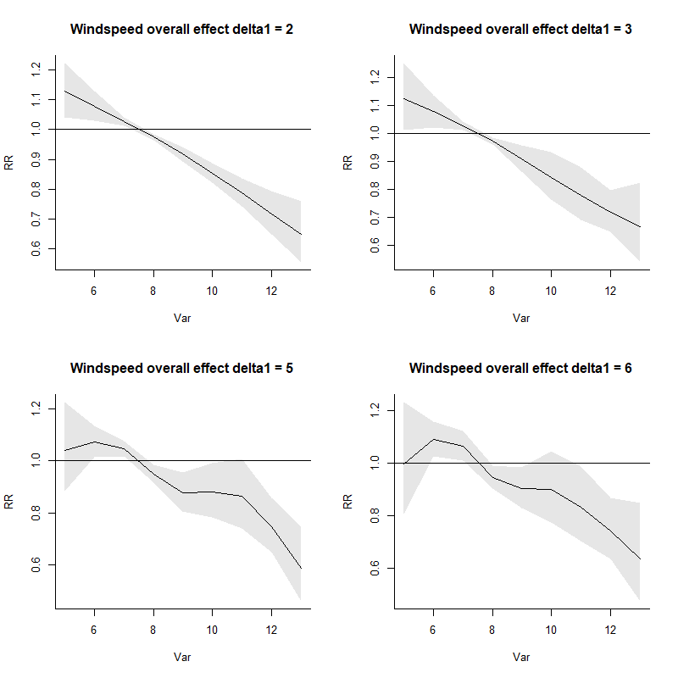
Figure S8: Overall effect of 6 weather variables with different $δ_{1}$ ranging from 2-6 (Exclude optimal one based on QAIC)
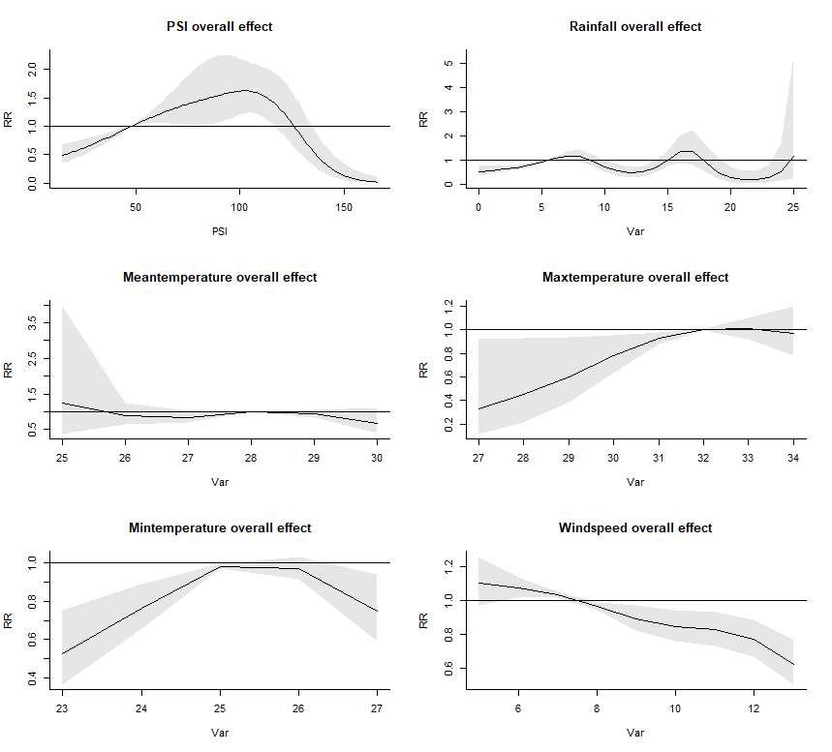
Figure S9: Overall effect of 6 weather variables with equal knots method applied in lag-dimension (Original setting is log knots method)

