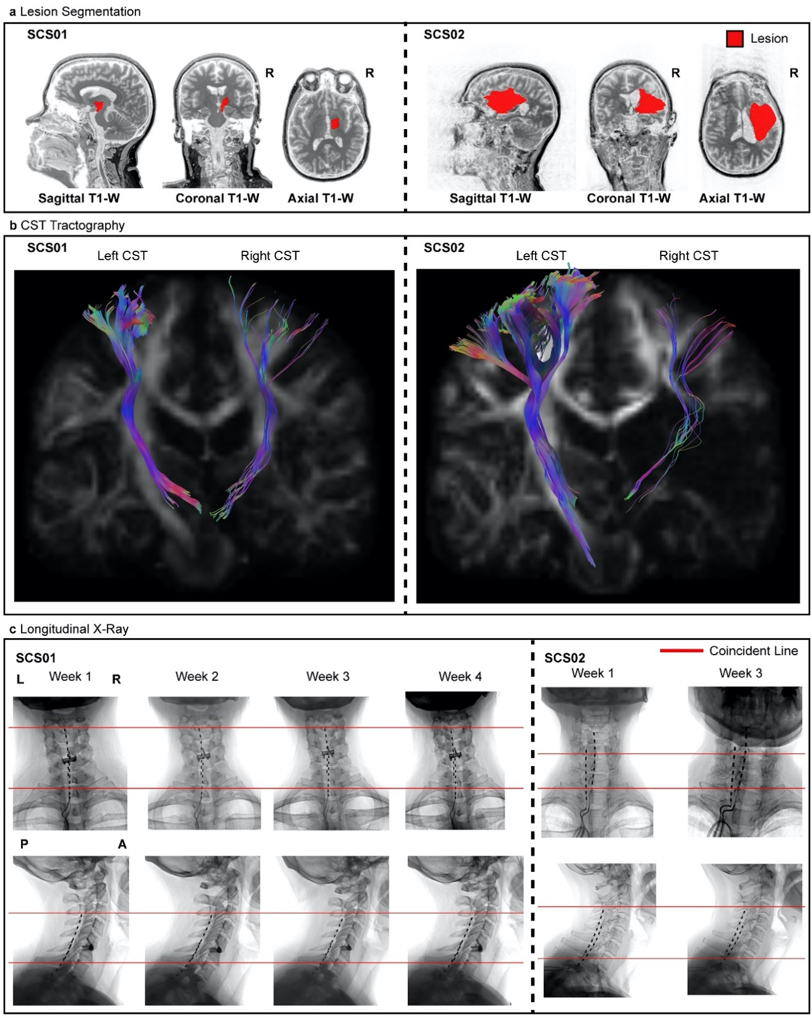
Extended Data Figure 1 | Lesion characterization and Lead position over time. (a) sagittal, coronal, and axial T1- weighted MRI 2D projections for SCS01 and SCS02. The segmented lesion is shown in red for both participant. R indicates the Right hemisphere. (b) High-definition fiber tracking of the corticospinal tract (CST) for SCS01 and SCS2. Colored fibers represent estimated CTS axons from the affected (right) and unaffected (left) hemisphere. Significant reduction in number of tracked fibers in the right hemisphere is clear in both participants in consequence of the stroke. (c) Repeated X-rays for SCS01 (left) and SCS02 (right) showing the position of the spinal leads. The red lines mark the same anatomical location across the X-rays to facilitate interpretation. Minimal displacement occured after initial implantation.
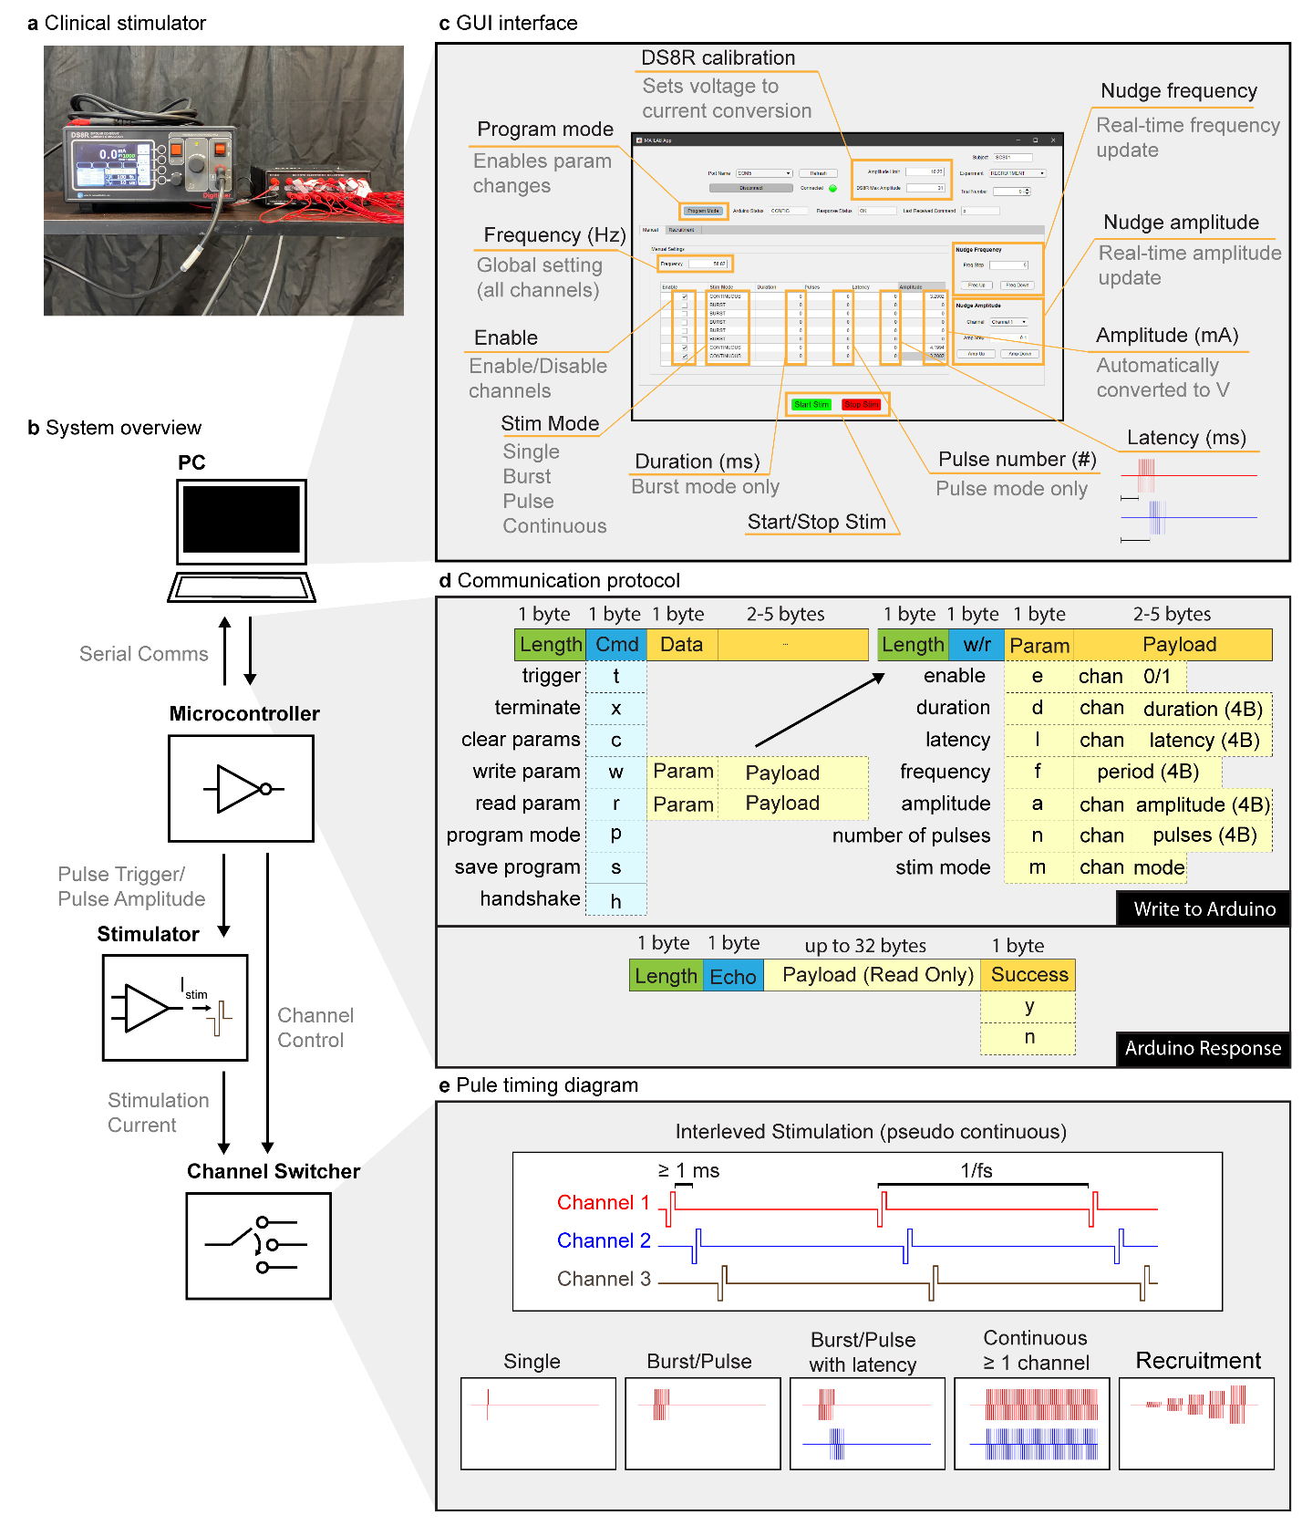
Extended Data Figure 2 | SCS parameters set using a custom-built controller. (a) An image of the stimulator (DS8R, left) and 1-to-8 channel multiplexer (D188, right) used to deliver stimulation pulses. (b) An overview of the control scheme used to deliver patterns of stimulation. A PC running a (c) MATLAB based GUI communicated with a microcontroller using a custom (d) communication protocol over a virtual serial port. The microcontroller’s firmware delivered pulse triggers and amplitude control signals to the stimulator as well as an 8 bit parallel channel selection signal to the multiplexer in order to control pulse timing, amplitude, and output channel. Current was delivered from the stimulator through the multiplexer and ultimately to the selected electrode on the implanted spinal array. (c) The GUI interface allowed for configuring all stimulation parameters including active channels, stimulation frequency, pulse train duration (or continuous), pulse train latency, and stimulation amplitude for each active channel. Once configured, stimulation was initiated or terminated via the software interface. The software also allowed for rapid changes in either global stimulation frequency (nudge frequency) or channel amplitude (nudge amplitude). (d) A custom command protocol layer was developed on top of a UART serial interface to enable communication between the GUI and microcontroller. Each packet from the master (PC) to the slave (microcontroller) comprised a 1 byte packet length, 1 byte command, and 0-6 bytes of payload. A payload comprised a 1 byte parameter (to be read or written), a 1 byte channel number (when appropriate), and the value to be written (when ‘write’ command was used). Microcontroller response packets comprised a 1 byte packet length, 1 byte command echo, 0-32 bytes of payload (used to return parameter values during ‘read’ command), and a 1 byte success flag. (e) The microcontroller firmware allowed for pseudo-synchonous stimulation across multiple channels by interleaving pulses on all active channels. A delay of at least 1 ms between each pulse allowed enough time for the multiplexer to fully switch channels. The same pattern of pulses was delivered every period as defined by the stimulation frequency. Each channel could also be configured to deliver a single pulse, a pulse train with finite duration and/or latency, continuous stimulation, or a ‘recruitment curve’ in which the amplitude was gradually increased for successive pulse trains of specified length.

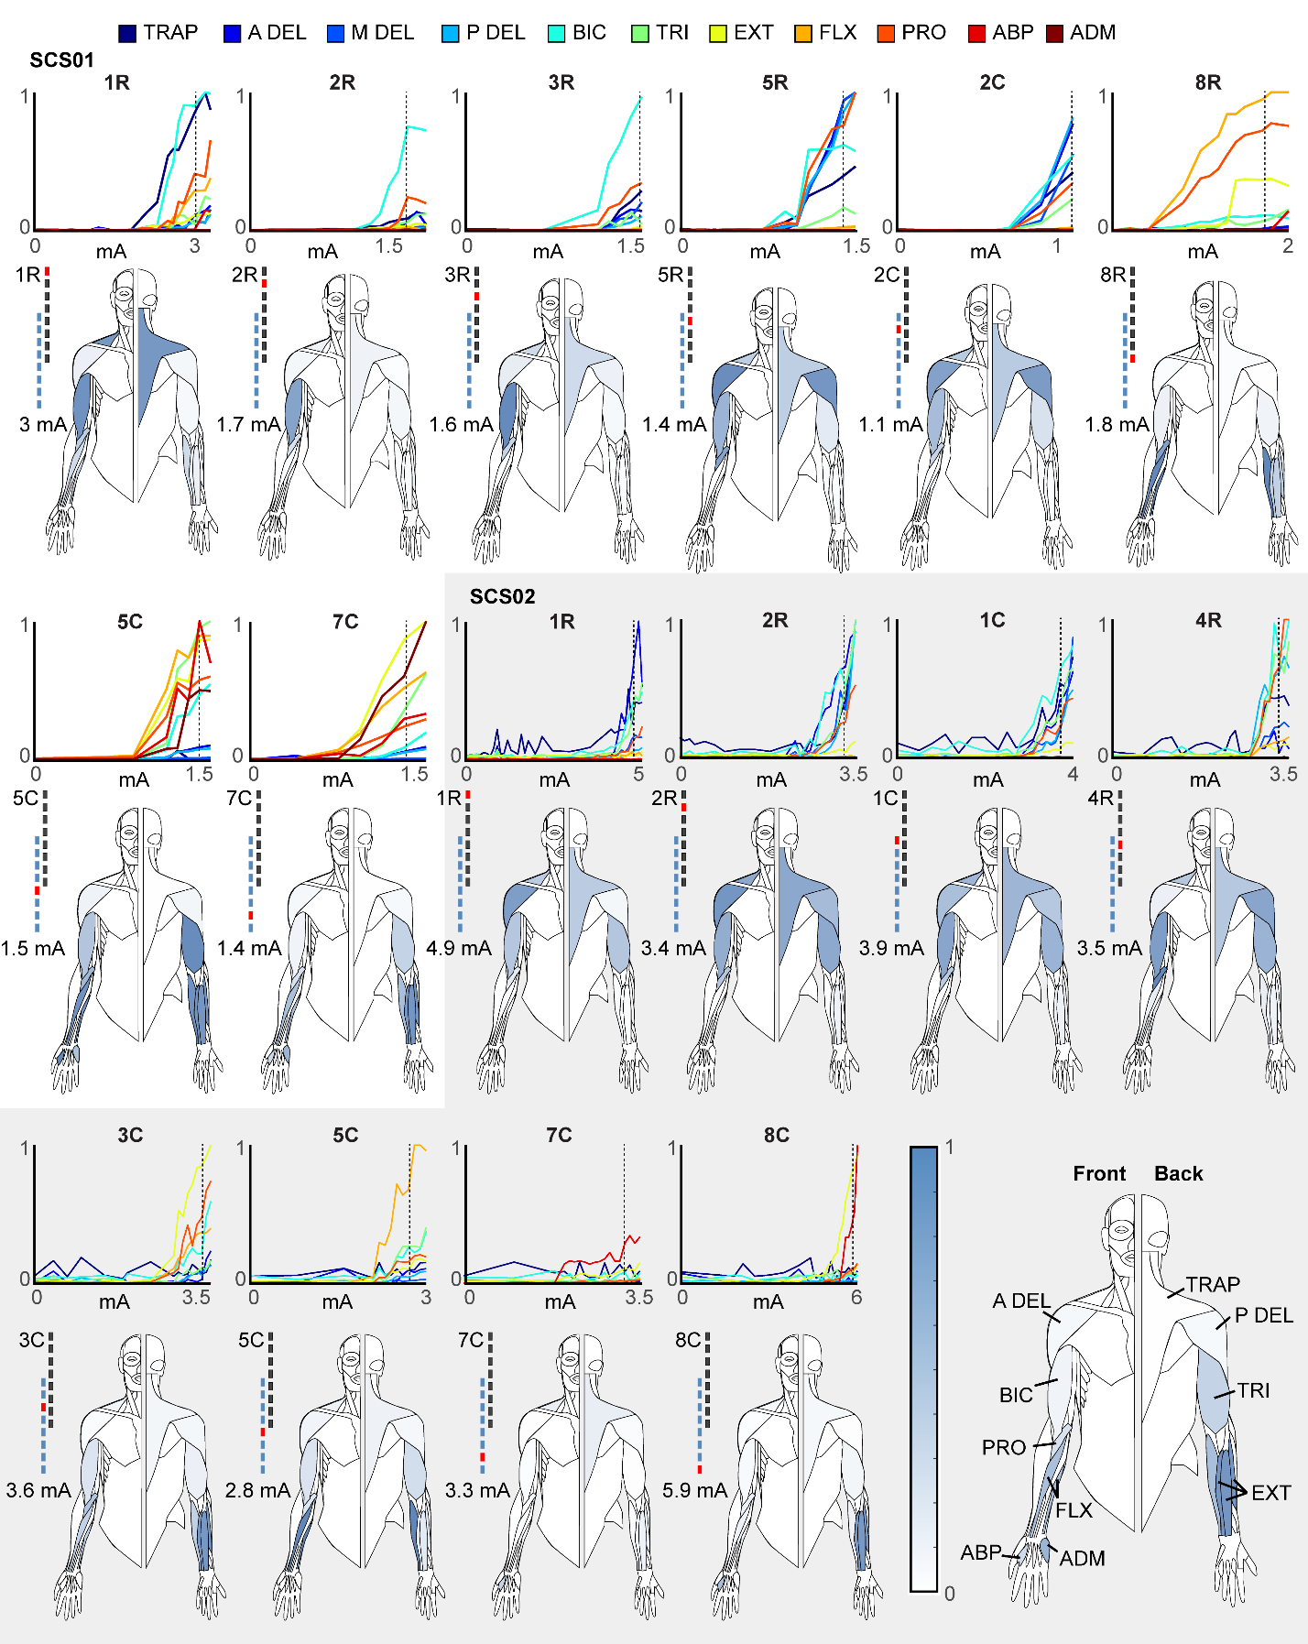
Extended Data Figure 3 | Muscle recruitment curves. In each panel we show the recruitment curves obtained with stimulation at 1 Hz at increasing current amplitude for 11 arm and hand muscles: TRAP: trapezius, A, P, M DEL: anterior, posterior and medial deltoid respectively, BIC: biceps, TRI: triceps, EXT: Extensor carpi, FLX: flexor carpi, PRO: pronator teres, ABP: abductor pollicis and ADM: abductor digiti minimi. Below each set of recruitment curves we report the graphical representation of the muscle activation obtained at the amplitude indicated on the left of each human figurine. Interpretation of human figurines is reported in the bottom right. Each muscle is colored with a color scale (on the left) representing the normalized peak-to-peak amplitude of EMG reflex responses obtained at the stimulation amplitude indicated on the left. Peak-to-peak values for each muscle are normalized to the maximum value obtained for that muscle across all contacts and all current amplitudes.
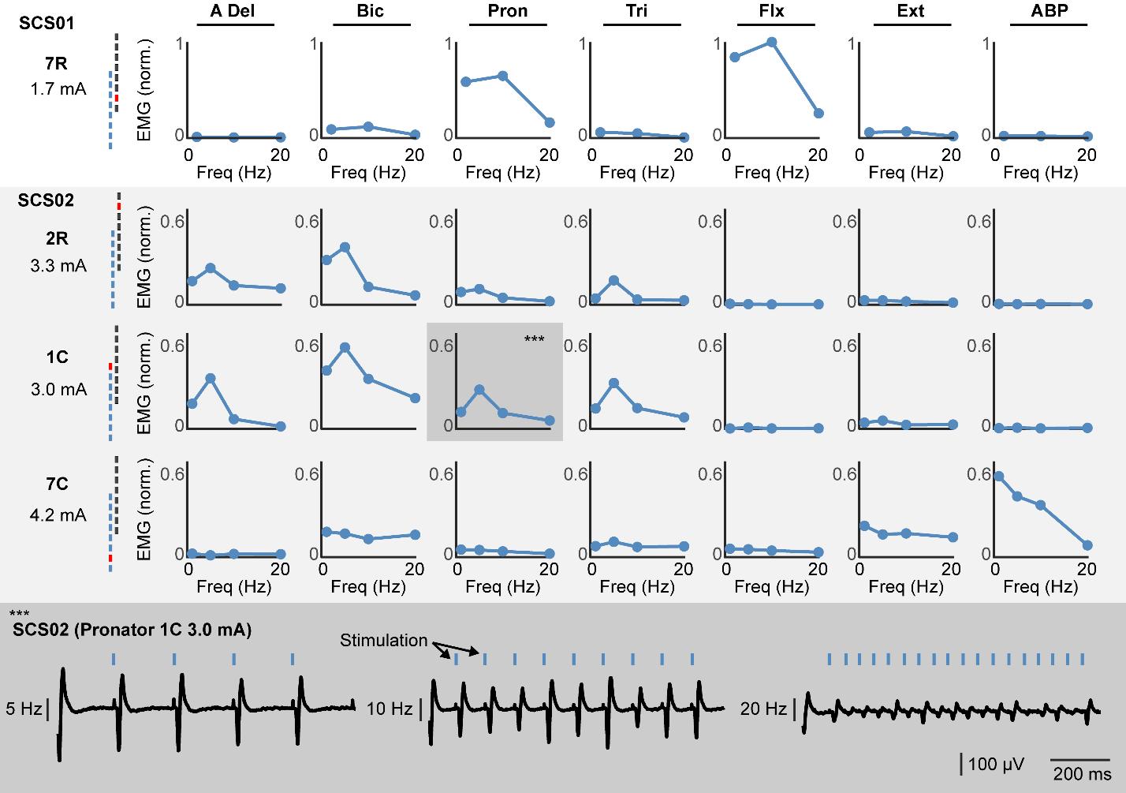
Extended Data Figure 4 | Frequency dependent suppression. To demonstrate that SCS recruits arm and hand muscles via direct activation of the primary afferents we performed stimulation at multiple frequency. The figure reports the spinal reflexes obtained when stimulating at 1, 5, 10 and 20Hz from multiple contact and multiple muscle. Each plot on the top shows the normalized peak-to-peak reflex amplitude as a function of frequency showing in the muscles that respond to the specific contact substantial frequency dependent suppression at stimulation frequencies greater than 10Hz. On the bottom, we report raw EMG traces that show the classic phenomenon. At 5Hz each pulse of stimulation corresponds to a clear evoked potential in the EMG albeit amplitude slightly diminishes at each pulse. At 10Hz, modulation of peak-to-peak amplitudes becomes more evident, at 20Hz almost complete suppression of EMG evoked responses subsequent to the first is shown. Example is taken from Pronator muscles, contact 1C, (highlighted in darker grey in the top panel).

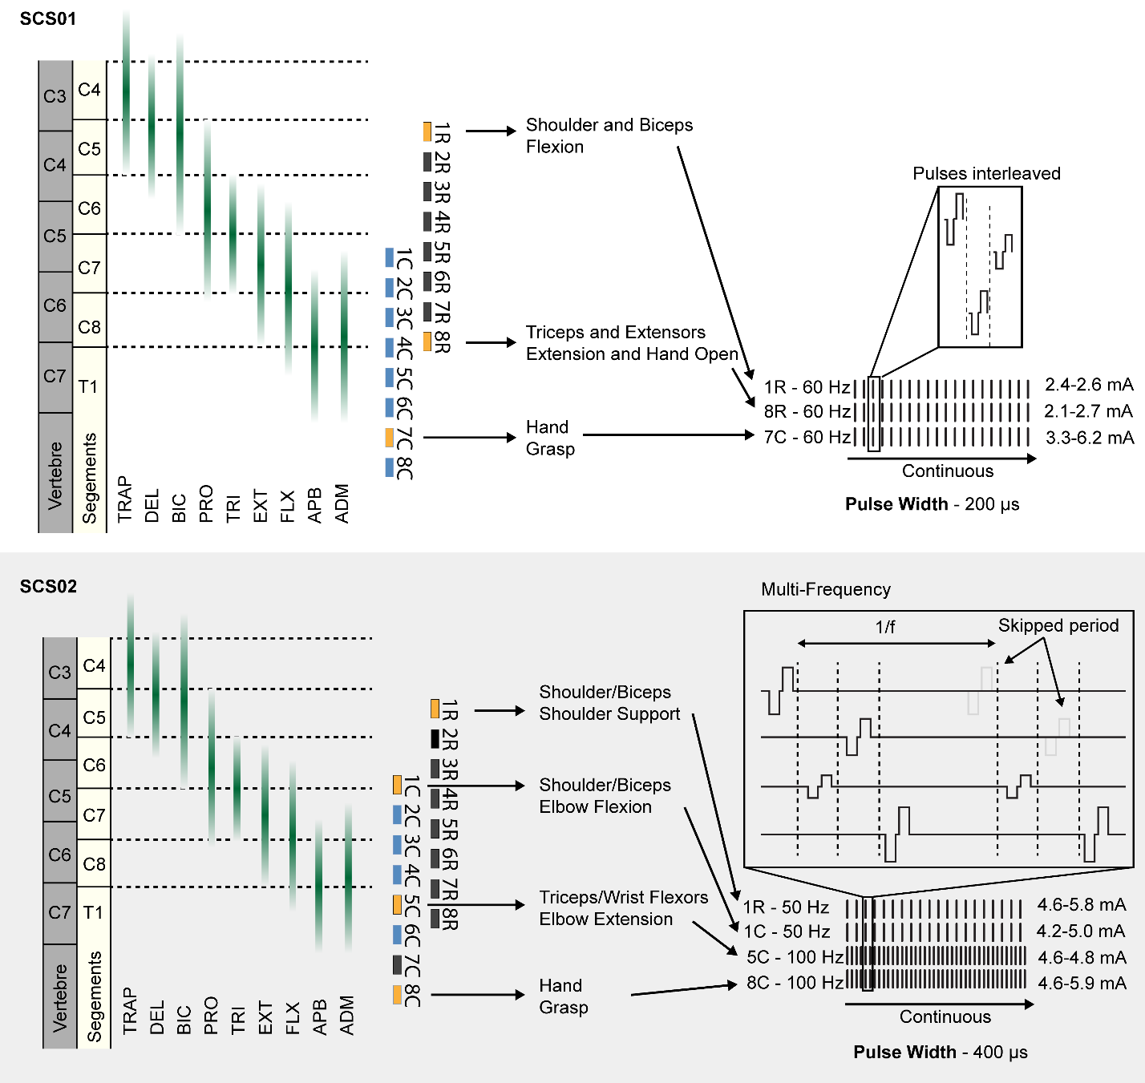
Extended Data Figure 5 | Optimized continuous stimulation protocols. Stimulation protocol used to achieve maximum assistive benefit for SCS01 (top) and SCS02 (bottom). (top) For SCS01, contacts 1R and 8R on the rostral lead and 7C on the caudal lead were simultaneously and continuously activated at a fixed 60 Hz frequency and 200 µs pulse width. These electrodes corresponded shoulders and biceps (1R); triceps, extensors, and hand opening (8R); and hand grasp (7C). Amplitudes were changed daily based on participant preference and were set to 2.4-2.6 mA (1R), 2.1-2.7 mA (8R), and 3.3-6.2 mA (7C). (bottom) For SCS02, contacts 1R on the rostral lead, and 1C, 5C, and 8C on the caudal lead were simultaneously and continuously stimulated. These electrodes corresponded to muscles related to shoulder support (1R); elbow flexion (1C); elbow extension and wrist flexion (5C); and hand grasp (8C). Contacts 1R and 1C were stimulated at 50 Hz while 5C and 8C were stimulated at 100 Hz all at a fixed pulse width of 400 µs. A reduced frequency was used on contacts corresponding to elbow flexion to bias the assistive benefit of stimulation toward elbow extension. Multi-frequency stimulation was achieved by skipping every other period of a 100 Hz stimulation protocol on channels stimulating at 50 Hz.

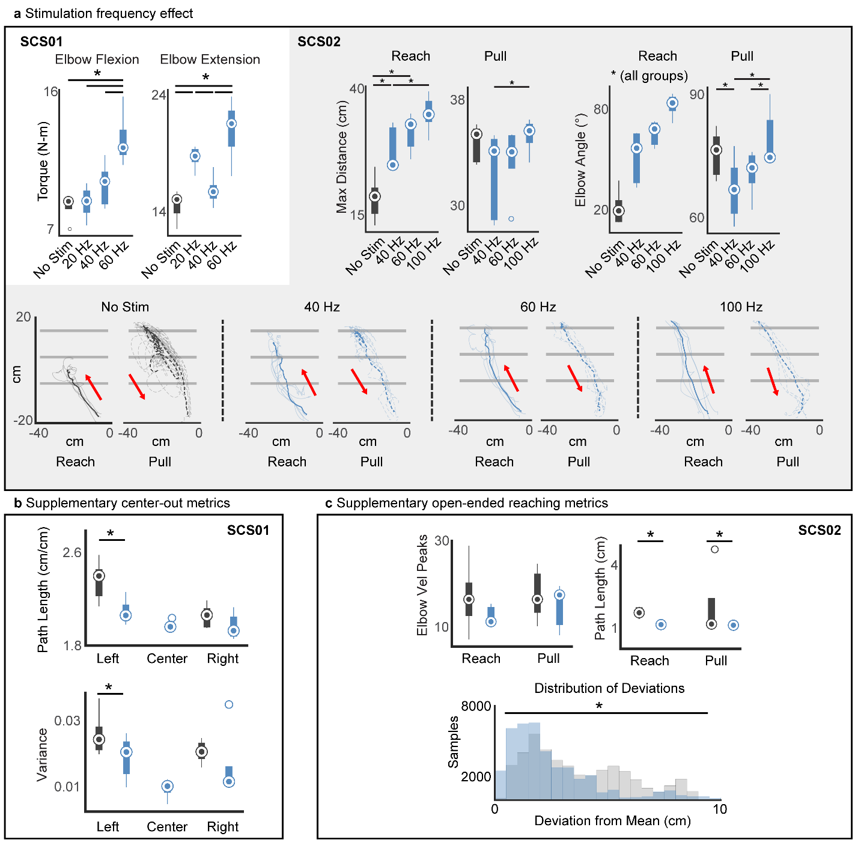
Extended Data Figure 6 | SCS improves arm kinematics supplementary metrics. (a) Effect of stimulation frequency shown for SCS01 and SCS02. In SCS01, quantification of isometric torques during single joint flexion and extension is shown for the elbow during no stim (dark grey), 20 Hz (blue), 40 Hz (blue), and 60 Hz (blue). In SCS02, maximum reached distance and elbow angle excursion (max-min) are reported during reach and pull of the reach-out task for no stim (dark grey), 20 Hz (blue), 40 Hz (blue), and 60 Hz (blue). Raw endpoint trajectories for SCS02 are shown in the reach out task during no stim (dark grey), 20 Hz (blue), 40 Hz (blue), and 60 Hz (blue). where SCS02 was tasked to reach beyond the third horizontal line to complete the task. Reach and pull trajectories are represented in separate plots. (b) Quantification of kinematic features for SCS01, path length for completed reach and pull of three targets in cm and variance of the path between trials are reported for no-stim (dark grey) and stim condition (blue). Center target could not be calculated for no-stim condition because SCS01 did not complete the task. (c) Quantification of kinematic features for SCS02, movement smoothness (velocity peaks) and path length in cm for reach and pull separately are reported for no-stim (dark grey) and stim condition (blue). The distribution of deviations from the mean path trajectory is shown in cm (equivalent to variance in SCS01). Inference on mean differences is performed by bootstrapping the n=5 repetitions obtained for each measurement, with n=10,000 bootstrap samples; * difference is outside the resulting 95% confidence interval.
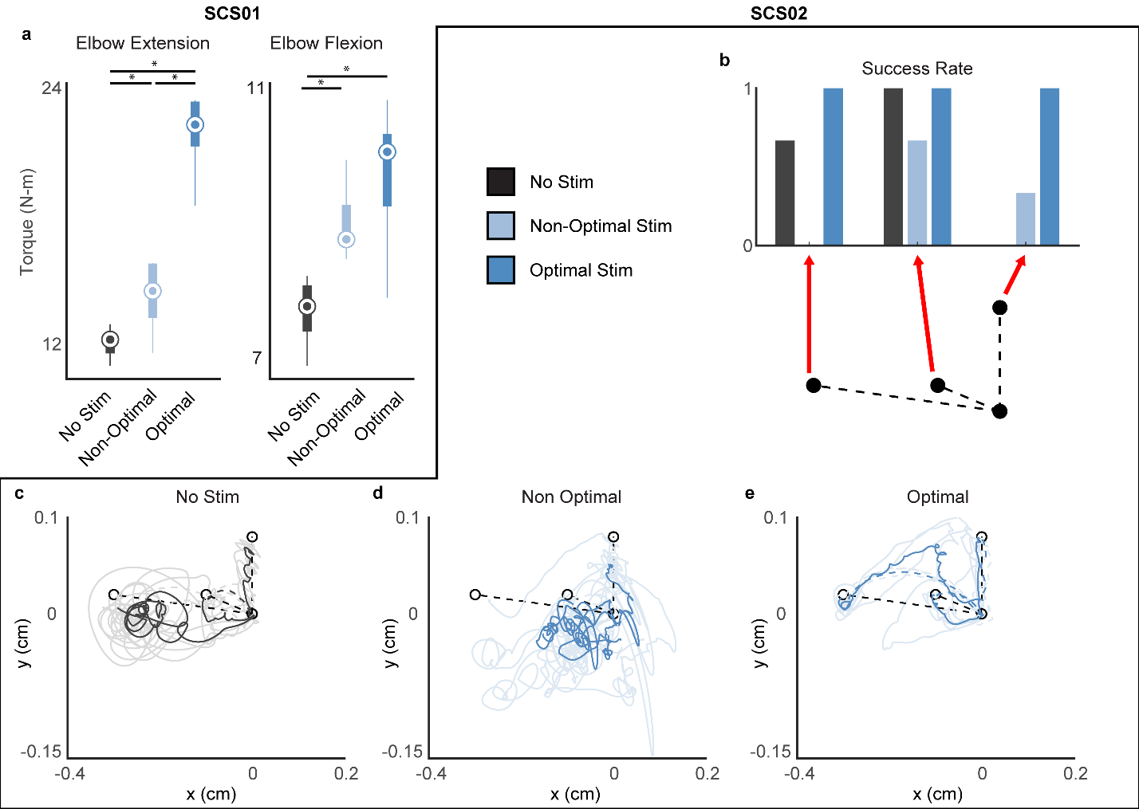

Extended Data Figure 7 | Optimized SCS leads to best improvement. (a) Quantification of isometric torques during single joint flexion and extension of the elbow during no stim (dark grey), non-optimal stim (light blue), and optimal stim (blue) for SCS01. (b) Quantification of performance for three targets of the center-out task during no stim (dark grey), non-optimal stim (light blue), and optimal stim (blue) normalized from 0 (SCS02 never reached target) and 1 (SCS02 reached target in all trials). n=3 (c-e) Raw endpoint trajectories by SCS02 for three targets of the center-out task during no stim (dark grey), non-optimal stim (light blue), and optimal stim (blue). Inference on mean differences for (a) were performed by bootstrapping the n=5 repetitions obtained for each measurement, with n=10,000 bootstrap samples; * difference is outside the resulting 95% confidence interval.

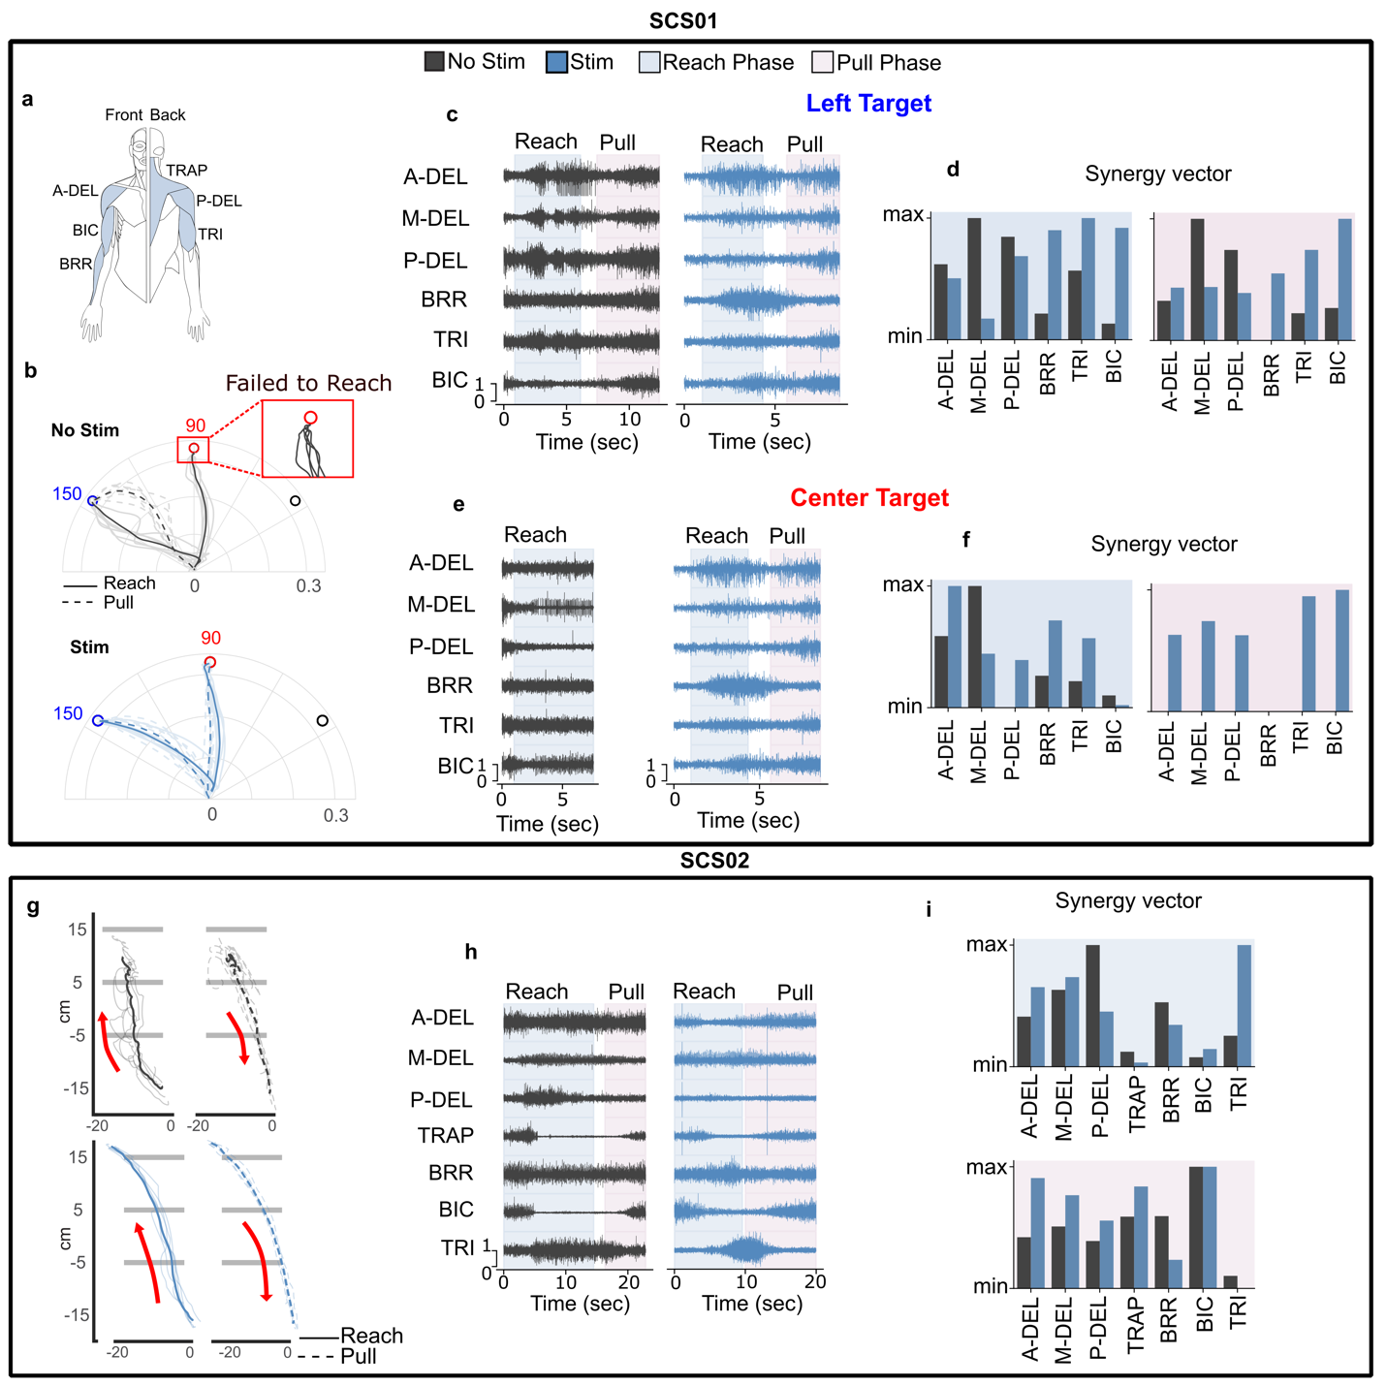Extended Data Figure 8 | Muscle activation pattern during planar movement. a) Muscle label abbreviation used in the figure (b) Kinematic trajectories during planar center-out task for two different targets (left and center) for stimulation off (dark grey) and on(blue) condition. The inset block shows the inability of SCS01 to reach to the center target without stimulation (c) EMG signals for the left target during reach (light blue highlight) and pull phase (pink highlight) without (dark grey) and with stimulation(blue). (d) synergy vector(c) for left target corresponding to the increasing timeseries synergy activation. (e) EMG signals for the center target during reach (light blue highlight) and pull phase (pink highlight) for the Center target without (dark grey) and with stimulation(blue). (f) Synergy vector for the center target with(blue) and without stimulation (dark grey) for reach (light blue highlight) and pull phase (pink highlight). (g) Kinematic trajectories for reaching-out task with(blue) and without (dark grey) stimulation for reach (solid line) and pull phase (dashed line) (h) Muscle activity with(blue) and without (dark grey) stimulation during reach(blue highlight) and pull phase(pink highlight) for planar reaching-out task. (i) Synergy vector corresponding to the reach (blue highlight) and pull phase (pink highlight) of the movement with(blue) and without(dark grey) stimulation.

Extended Data Table 1 | Fugl-Meyer Assessment longitudinal breakdown. A breakdown table of the scores for each of the 7 FM-UE assessment categories. In bold, is the total score for the motor function subcategory which is the sum of the Motor Upper Extremity, Motor Wrist, Motor Hand, and Motor coordination/speed sections. The rightmost column indicates the maximum possible score for each category.
 | Pre-Study | Mid Study | End Study | 1 mo. Post Study | Total Possible
SCS01
Passive Joint Motion | 21 | - | 21 | 21 | 24
Joint Pain | 24 | - | 24 | 24 | 24
Motor Upper extremity | 19 | 20 | 27 | 26 | 36
Motor Wrist | 3 | 3 | 5 | 5 | 10
Motor Hand | 9 | 7 | 11 | 11 | 14
Motor coordination/speed | 4 | 4 | 4 | 4 | 6
Total Motor Function | 35 | 34 | 47 | 46 | 66
Sensation | 11 | 11 | 11 | 11 | 12
SCS02
Passive Joint Motion | 22 | 20 | 20 | 20 | 24
Joint Pain | 24 | 23 | 23 | 24 | 24
Motor Upper extremity | 11 | 14 | 13 | 12 | 36
Motor Wrist | 0 | 0 | 0 | 0 | 10
Motor Hand | 0 | 0 | 1 | 1 | 14
Motor coordination/speed | 4 | 4 | 4 | 4 | 6
Total Motor Function | 15 | 18 | 18 | 17 | 66
Sensation | 2 | 1 | 1 | 2 | 12

Extended Data Table 2 | Modified Ashworth Scale longitudinal breakdown. A breakdown table of the individual MAS scores for each joint tested across all days of the trial. In each case, a score of 0 corresponds to no spasticity, and a score of 4 indicates no mobility at all.
Study Day | Elb Flx | Dig Flx | Shld ER | Shld IR | Shld ABD | FA Sup | Wr Flx | Pron | Elb Ext
SCS01
1 | 1.5 | 1.5 | 1.5 | 1.5 | 1.5 | 2 | - | - | -
2 | 1.5 | 1 | 1.5 | 1.5 | 1.5 | 1.5 | - | - | -
3 | 1.5 | 1.5 | 1.5 | 1.5 | 1.5 | 1.5 | - | - | -
4 | 1 | 1 | 1.5 | 1.5 | 1.5 | 2 | - | - | -
7 | 1.5 | 1.5 | 1.5 | 1.5 | 1.5 | 1.5 | - | - | -
8 | 1 | 1 | 1.5 | 1.5 | 1 | 2 | - | - | -
9 | 1 | 1.5 | 1.5 | 1.5 | 1 | 2 | - | - | -
10 | 1 | 1 | 1 | 1 | 1 | 1.5 | - | - | -
11 | 1 | 1 | 1.5 | 1 | 1 | 2 | - | - | -
14 | 1 | 1 | 1 | 1 | 1.5 | 1.5 | - | - | -
15 | 1.5 | 1.5 | 1.5 | 1.5 | 1 | 2 | - | - | -
16 | 0 | 1 | 1.5 | 1.5 | 1 | 1.5 | - | - | -
17 | 1 | 1.5 | 1.5 | 1 | 1 | 1.5 | - | - | -
18 | 1 | 1.5 | 1 | 1 | 1.5 | 2 | - | - | -
22 | 1 | 1 | 1.5 | 1.5 | 1.5 | 1.5 | - | - | -
23 | 1 | 1.5 | 1.5 | 1.5 | 1.5 | 2 | - | - | -
24 | 1 | 1.5 | 1 | 1 | 1 | 2 | - | - | -
Post study 52 | 1 | 1.5 | 1.5 | 1.5 | 1 | 1.5 | - | - | -
SCS02
1 | 2 | 1.5 | 2 | 0 | - | - | 3 | 1.5 | -
2 | 2 | 1.5 | 2 | 1.5 | 2 | - | 3 | 1.5 | -
3 | 2 | 1.5 | 2 | 1 | 2 | - | 3 | 1.5 | 1.5
4 | 2 | 1.5 | 2 | 1.5 | 1.5 | - | 3 | 2 | 1
7 | 2 | 1.5 | 2 | 1 | 1.5 | - | 3 | 1.5 | 1.5
8 | 2 | 2 | 2 | 1.5 | 1.5 | - | 3 | 0 | 0
9 | 2 | 2 | 1.5 | 0 | 1.5 | - | 3 | 0 | 0
10 | 2 | 1.5 | 2 | 1.5 | 2 | - | 3 | 2 | 1
11 | 2 | 2 | 2 | 0 | 1 | - | 3 | 1 | 1
14 | 2 | 1 | 1.5 | 0 | 1.5 | - | 3 | 0 | 0
15 | 2 | 1.5 | 2 | 1.5 | 1.5 | - | 3 | 1 | 1
16 | 2 | 1.5 | 1.5 | 1 | 1.5 | - | 3 | 1.5 | 1
18 | 2 | 1.5 | 2 | 1.5 | 2 | - | 3 | 2 | 1
21 | 1.5 | 1 | 1 | 0 | 0 | - | 3 | 1 | 0
22 | 2 | 1 | 1.5 | 0 | 0 | - | 3 | 1 | 2
23 | 2 | 1.5 | 1.5 | 1 | 1.5 | - | 3 | 1.5 | 0
24 | 2 | 1.5 | 2 | 1 | 1 | - | 3 | 1.5 | 1

