Synthesis, antimicrobial and antioxidant activity of triazole, pyrazole contain thiazole Derivatives and Molecular docking studies on COVID-19
Matta Raghavender¹, Jalapathi Pochampally¹, Bala Narsimha Dhoddi¹, Bhookya Shankar², Sampath Bitla³, Anjini Gayatri Akkiraju⁴
¹ Department of Chemistry, Osmania University, Hyderabad, Telangana, 500007, India
²School of Chemistry, University of Hyderabad, Central University, Telangana, 500046 India
³ Department of Chemistry, Nizam College, Osmania University, Hyderabad, Telangana, 500001, India
⁴Molecular Medicine Lab, Dept. of Genetics & Biotechnology, Osmania University, Hyderabad, Telangana, 500007, India
Corresponding author Email: pochampalli.ou.chemi@gmail.com

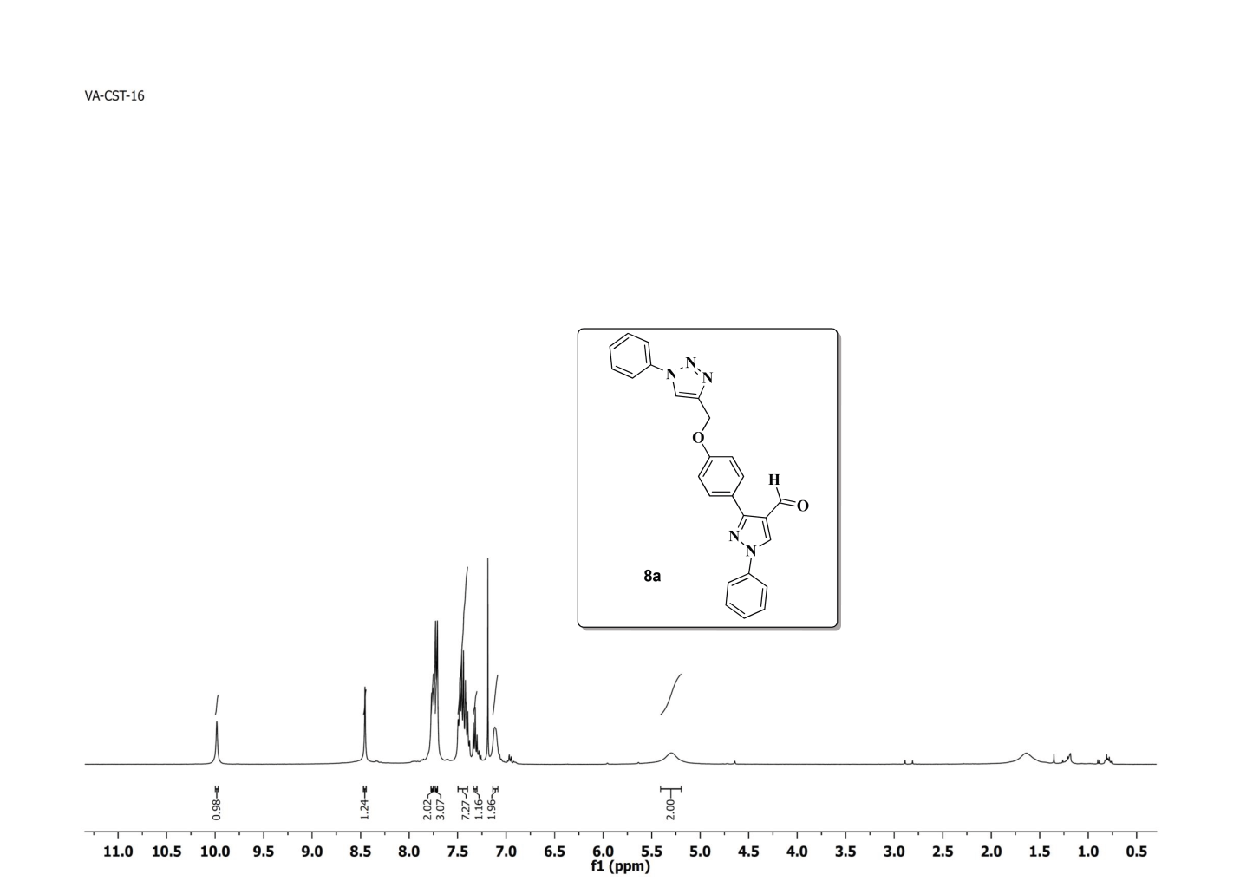
¹H NMR Spectrum of compound 8a (400 MHz, CDCl₃)
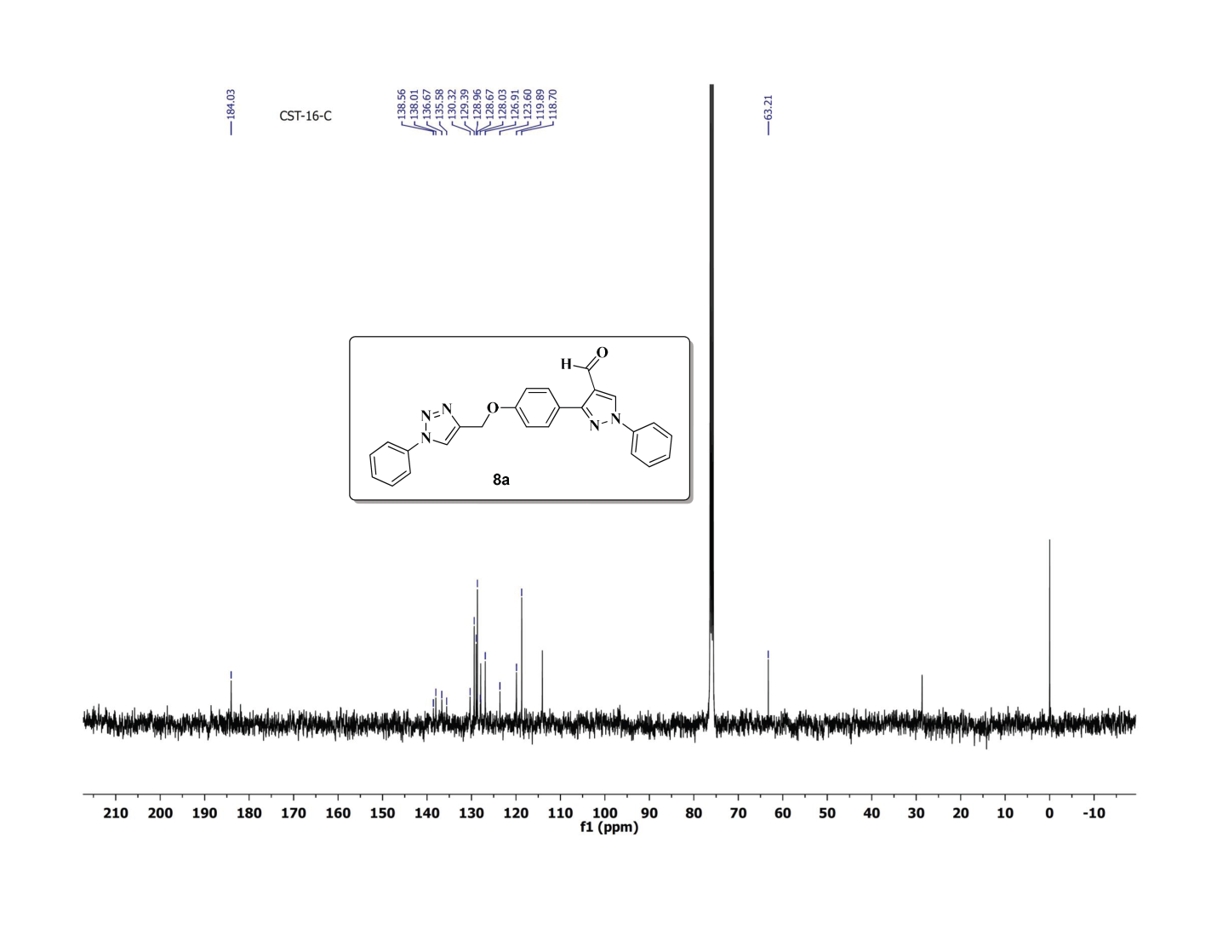
¹³C NMR Spectrum of compound 8a (100 MHz, CDCl₃)
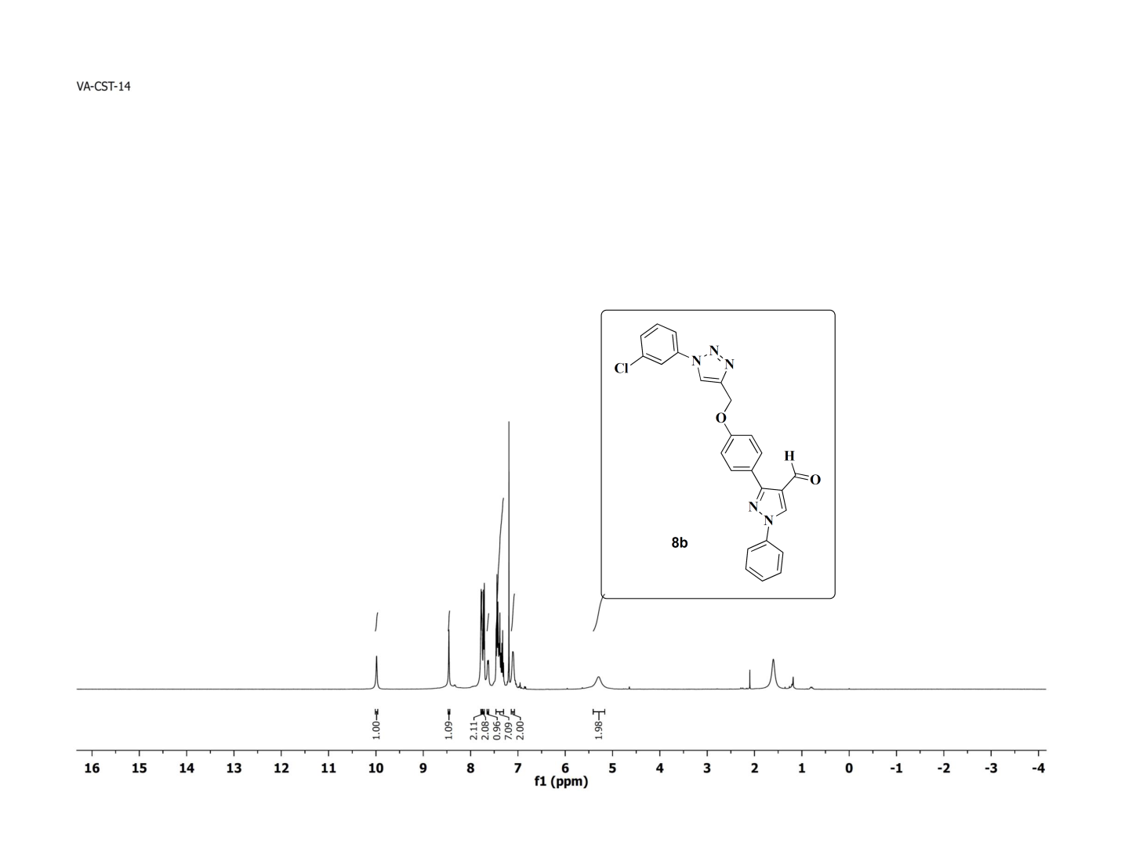
¹H NMR Spectrum of compound 8b (400 MHz, CDCl₃)
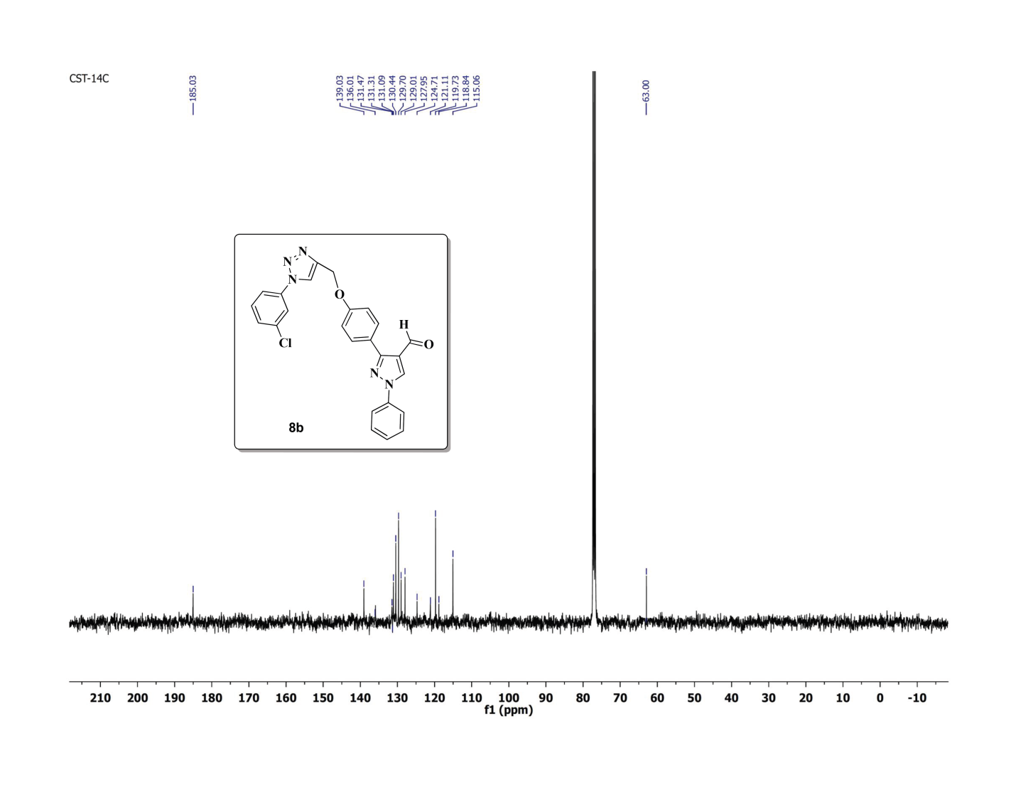
¹³C NMR Spectrum of compound 8b (100 MHz, CDCl₃)
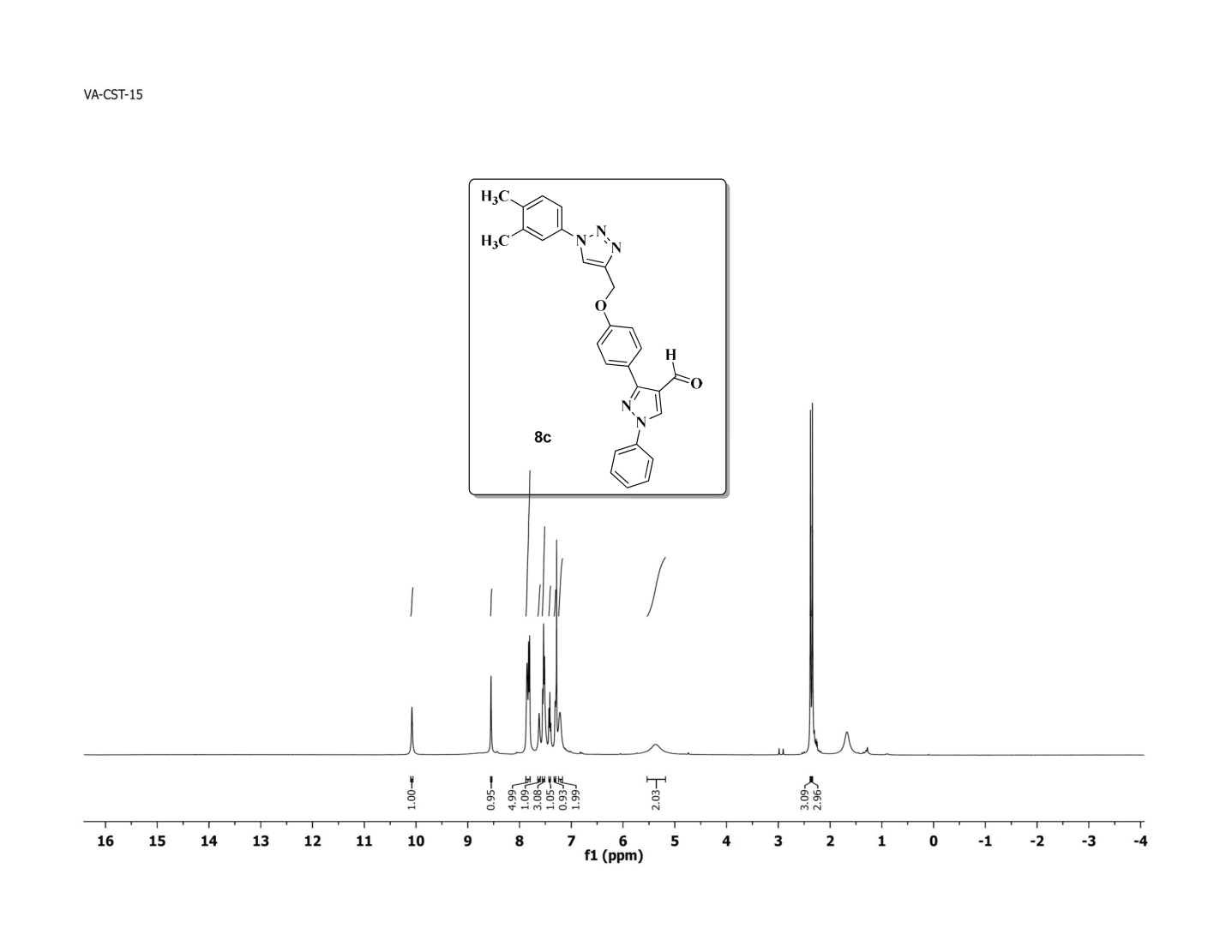
¹H NMR Spectrum of compound 8c (400 MHz, CDl₃)
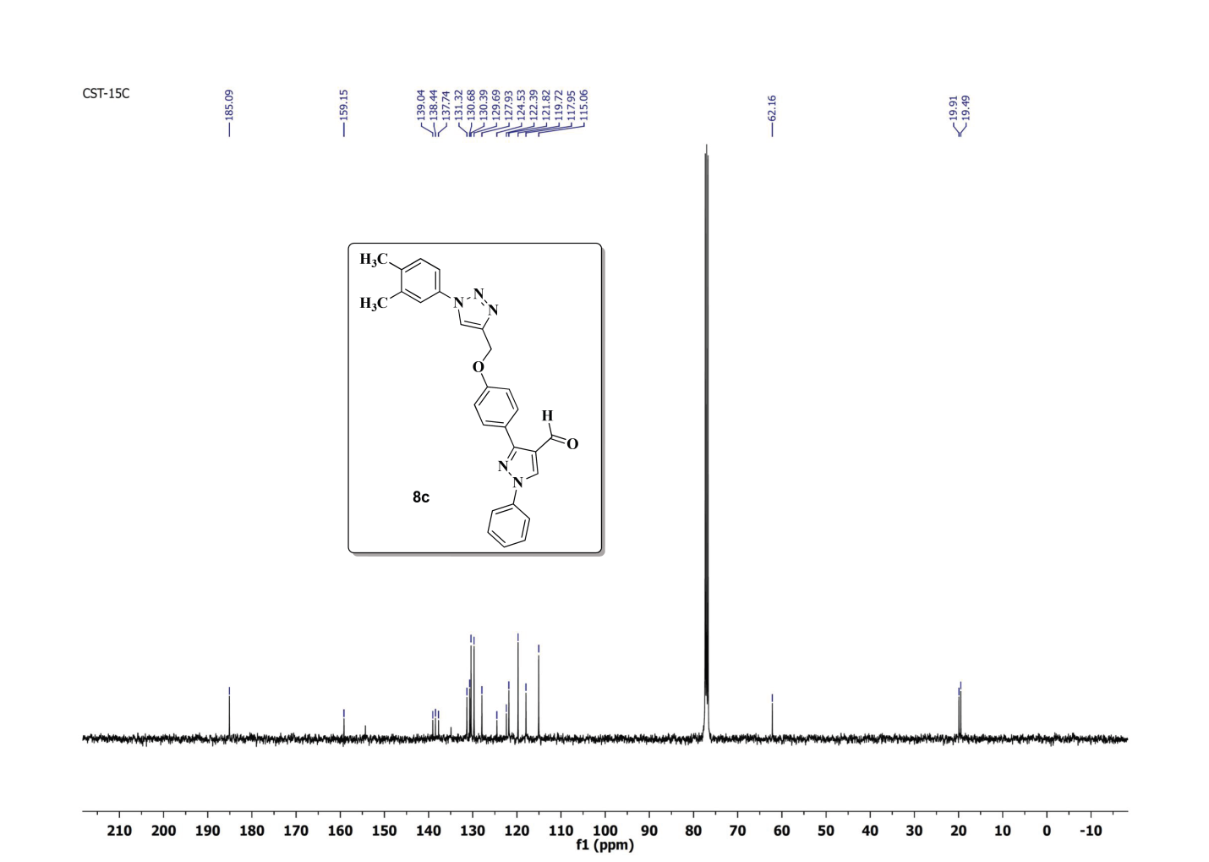¹³C NMR Spectrum of compound 8c (100 MHz, CDCl₃)
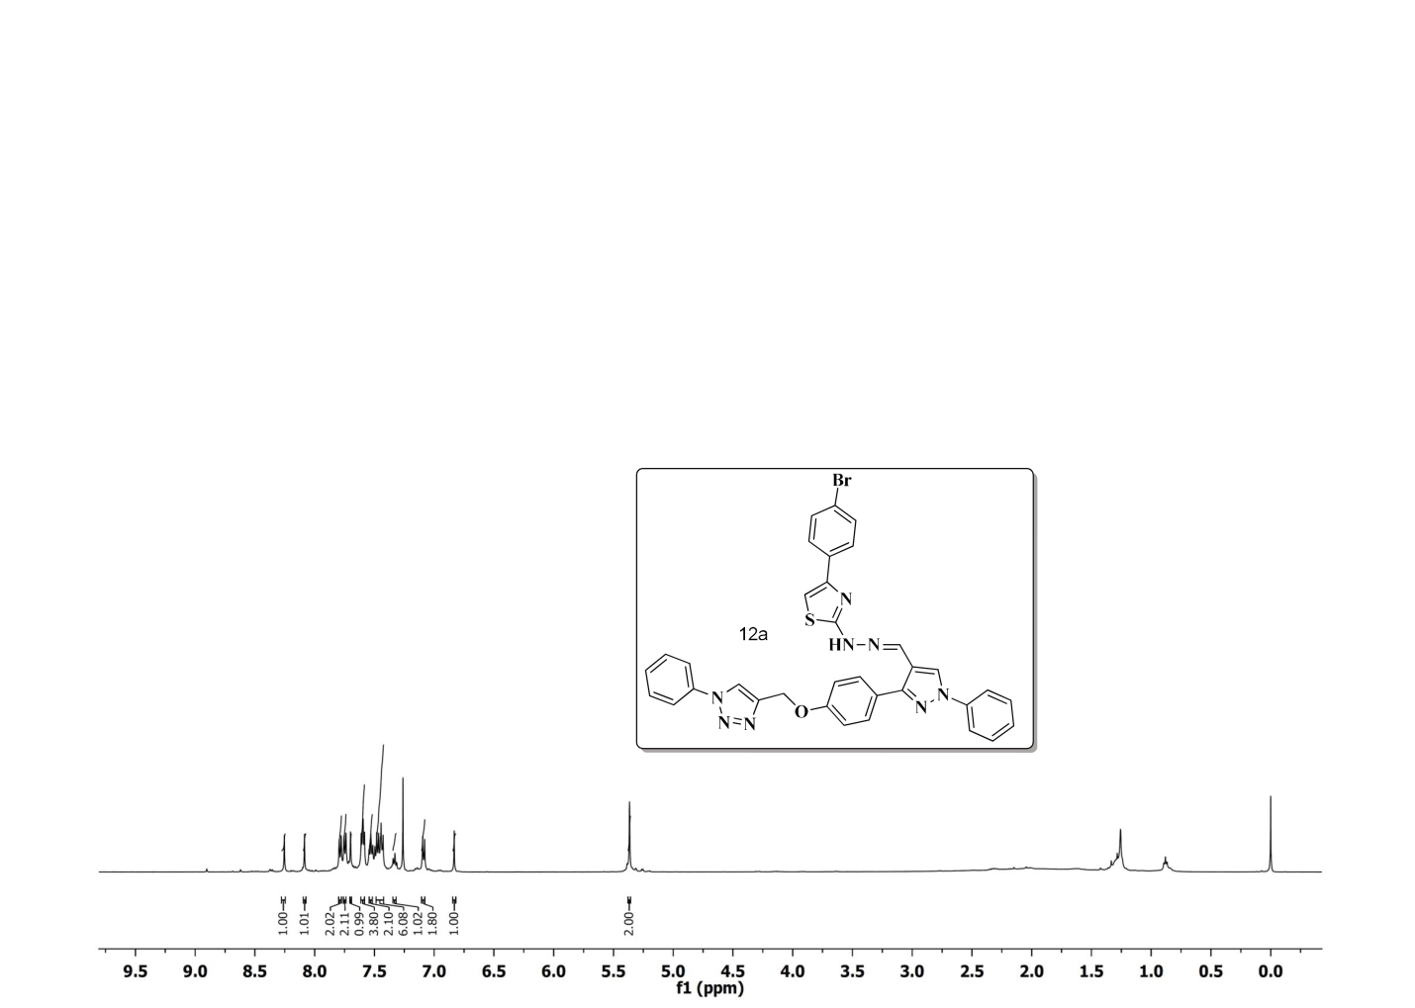
¹H NMR Spectrum of compound 12a (400 MHz, CDCl₃)
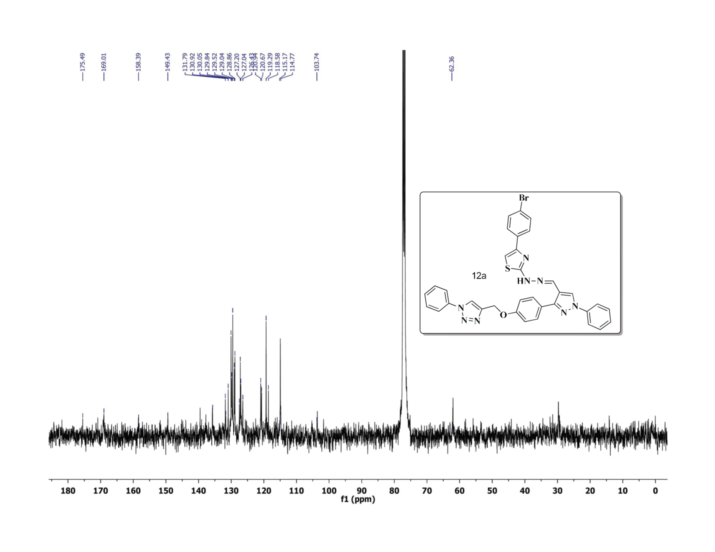
¹³C NMR Spectrum of compound 12a(100 MHz, CDCl₃)
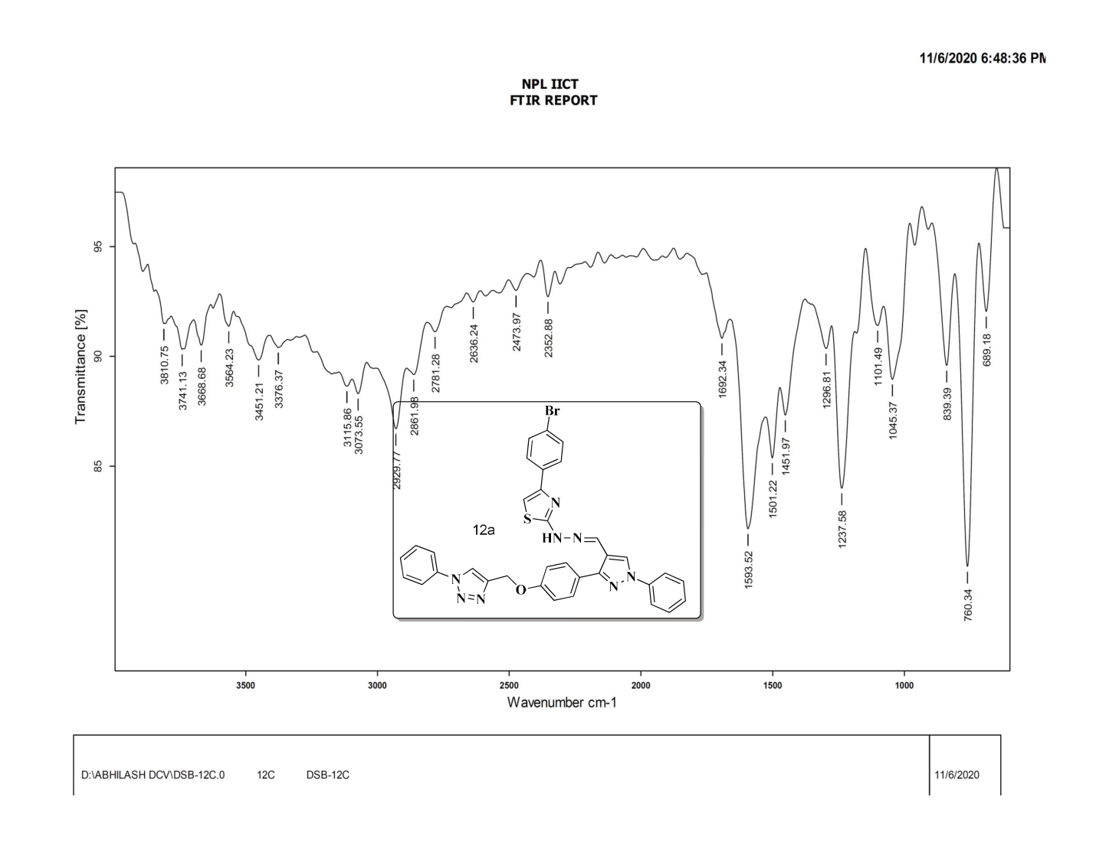
FT-IR Spectrum of compound 10a
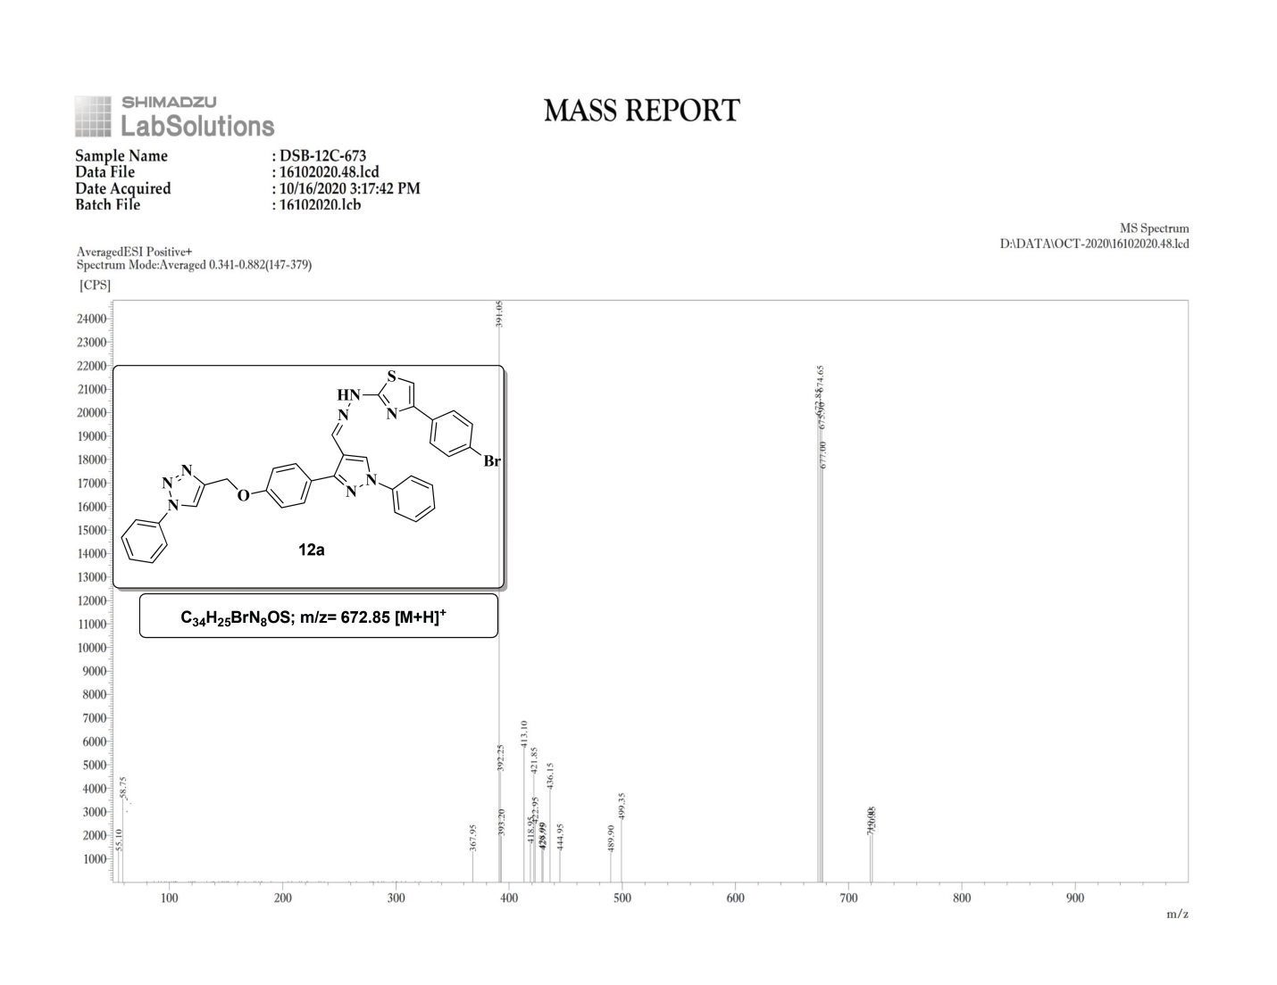
ESI-Mass Spectrum of compound 12a
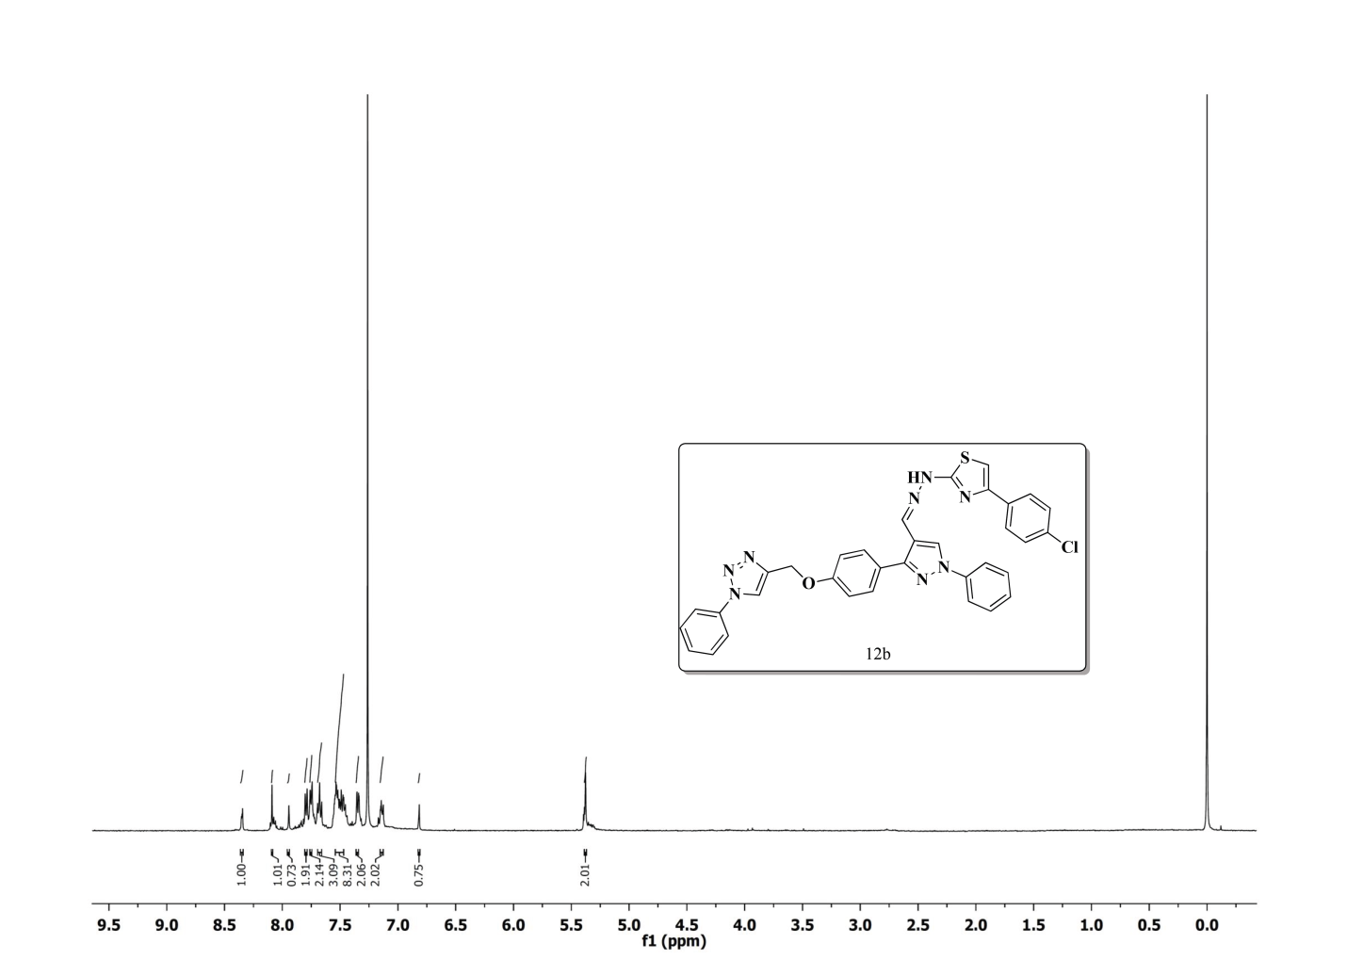
¹H NMR Spectrum of compound 12b (400 MHz, CDCl₃)
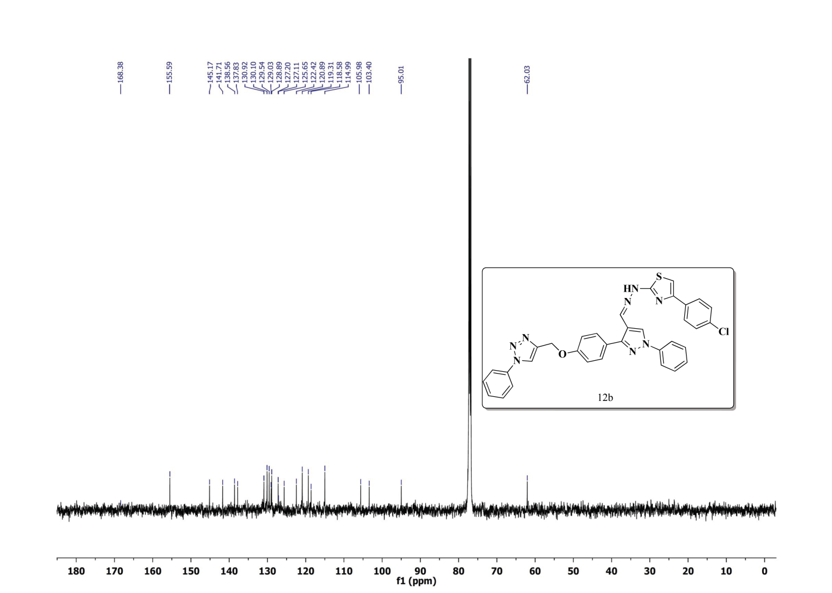
¹³C NMR Spectrum of compound 12b (100 MHz, CDCl₃)
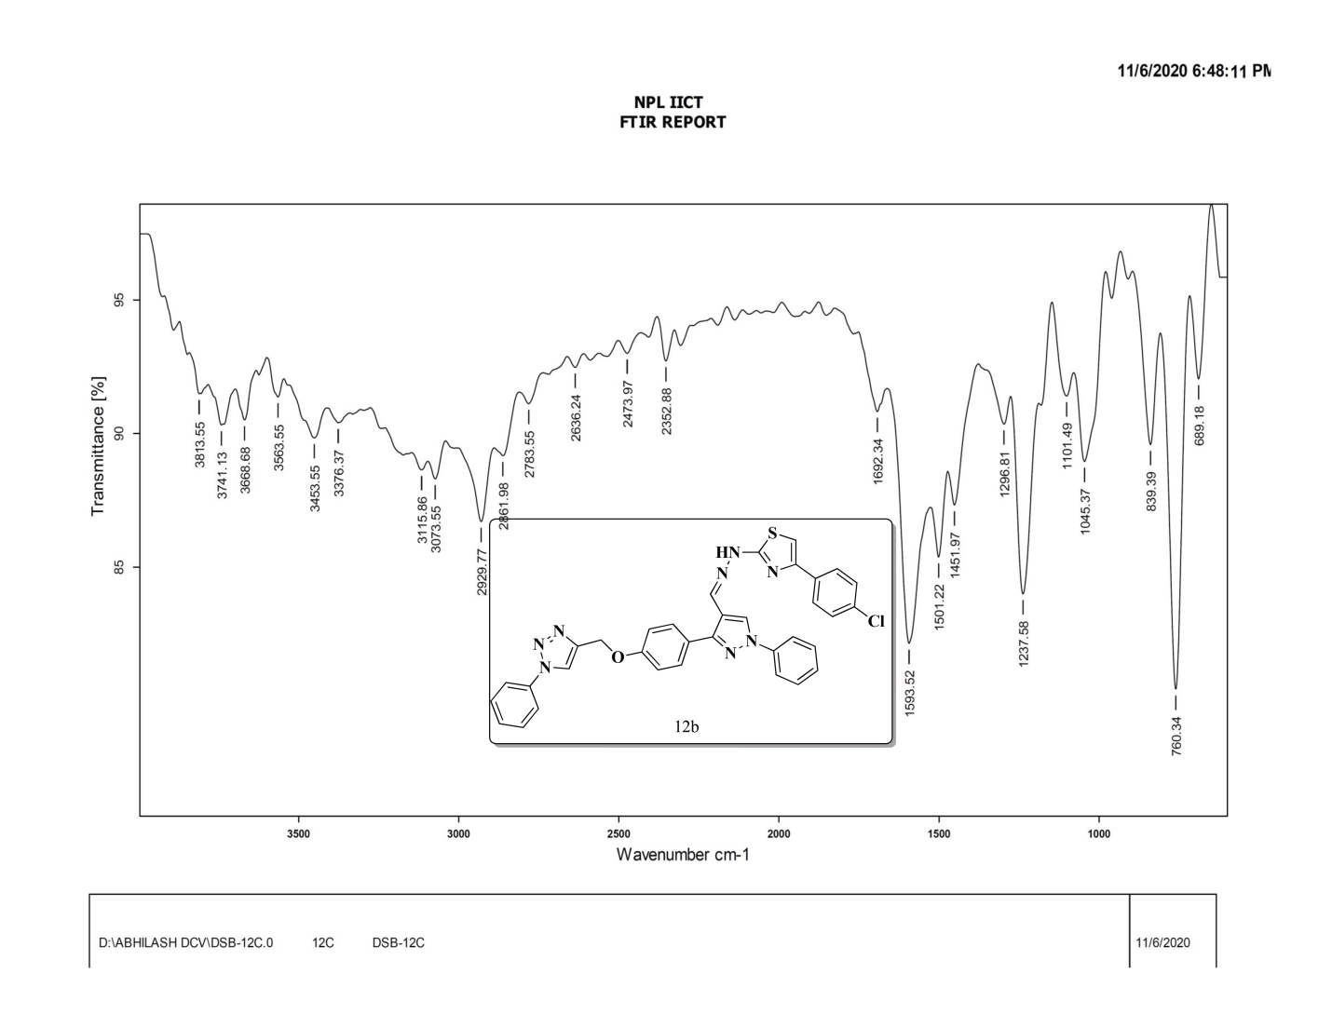
FT-IR Spectrum of compound 12b
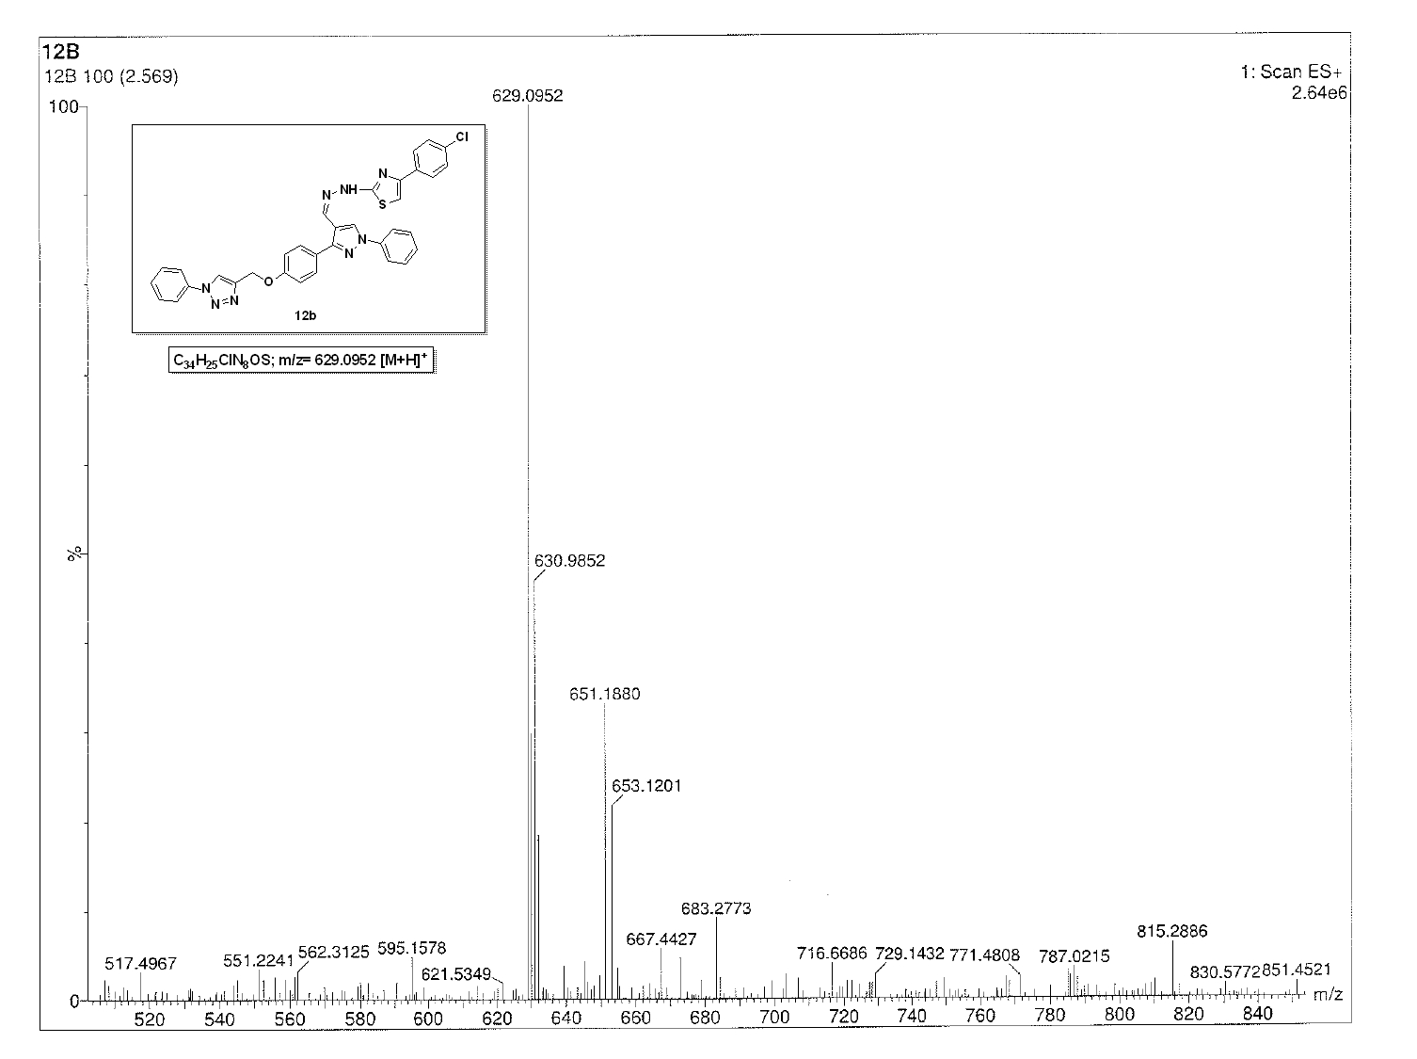
ESI-Mass Spectrum of compound 10b
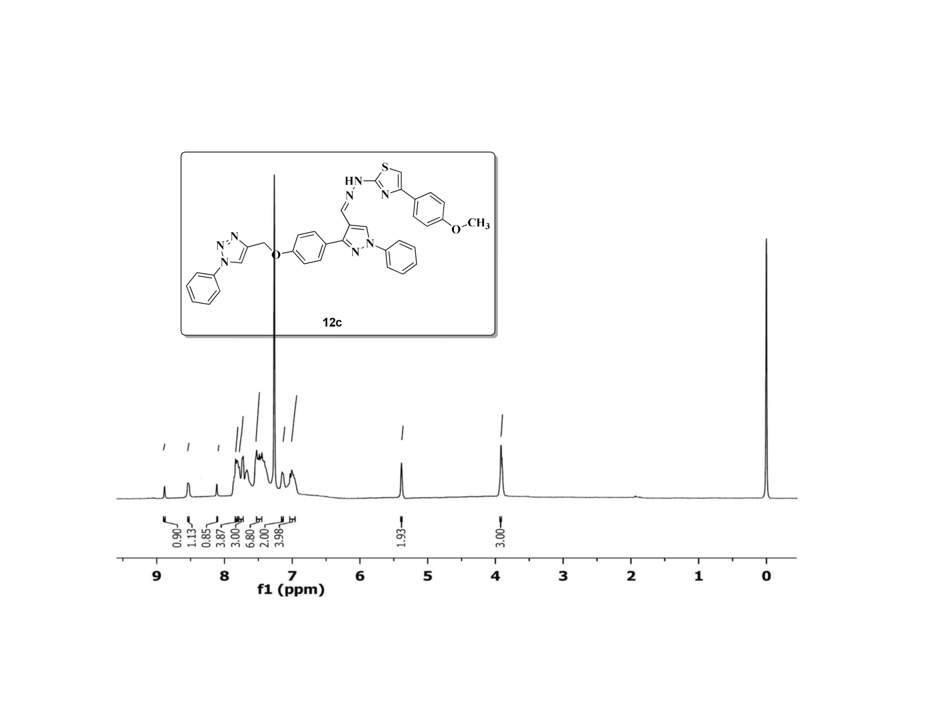
¹H NMR Spectrum of compound 12c (400 MHz, CDCl₃)
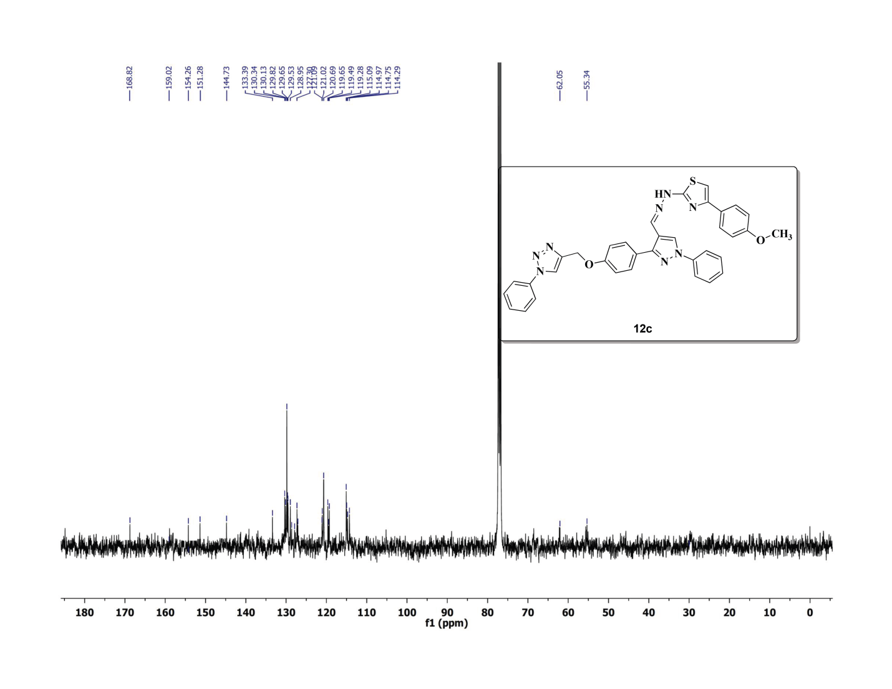
¹³C NMRSpectrum of compound 12c (100 MHz, CDCl₃)
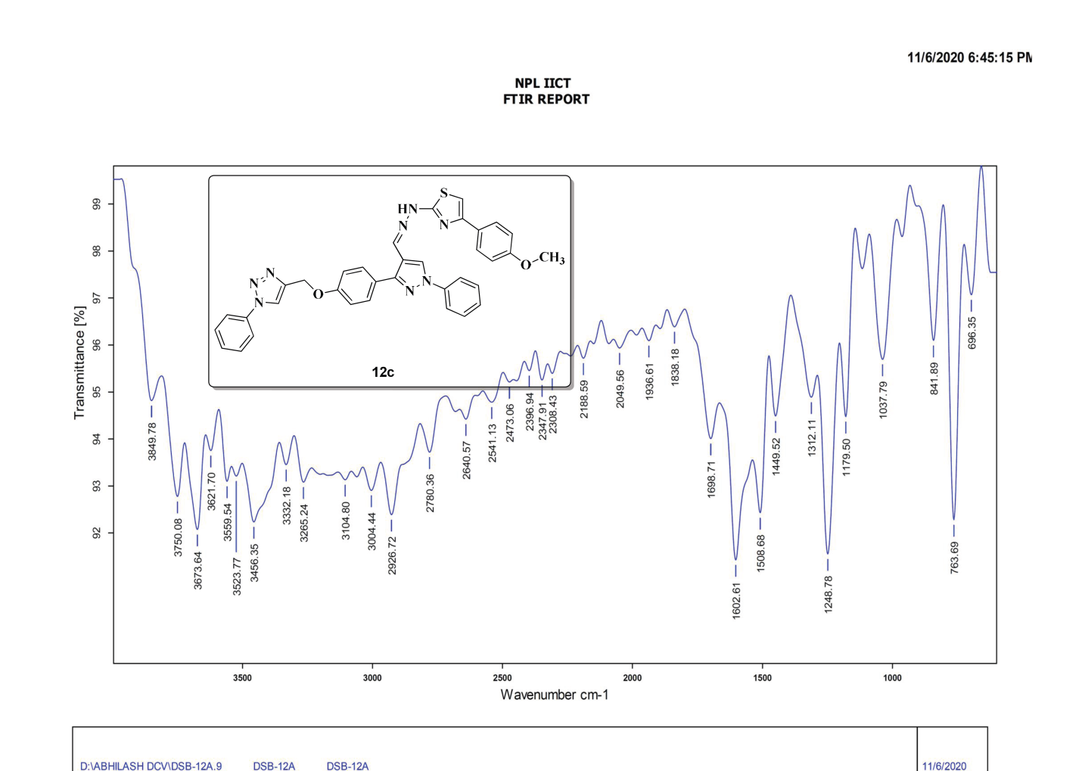
FT-IR Spectrum of compound 12c
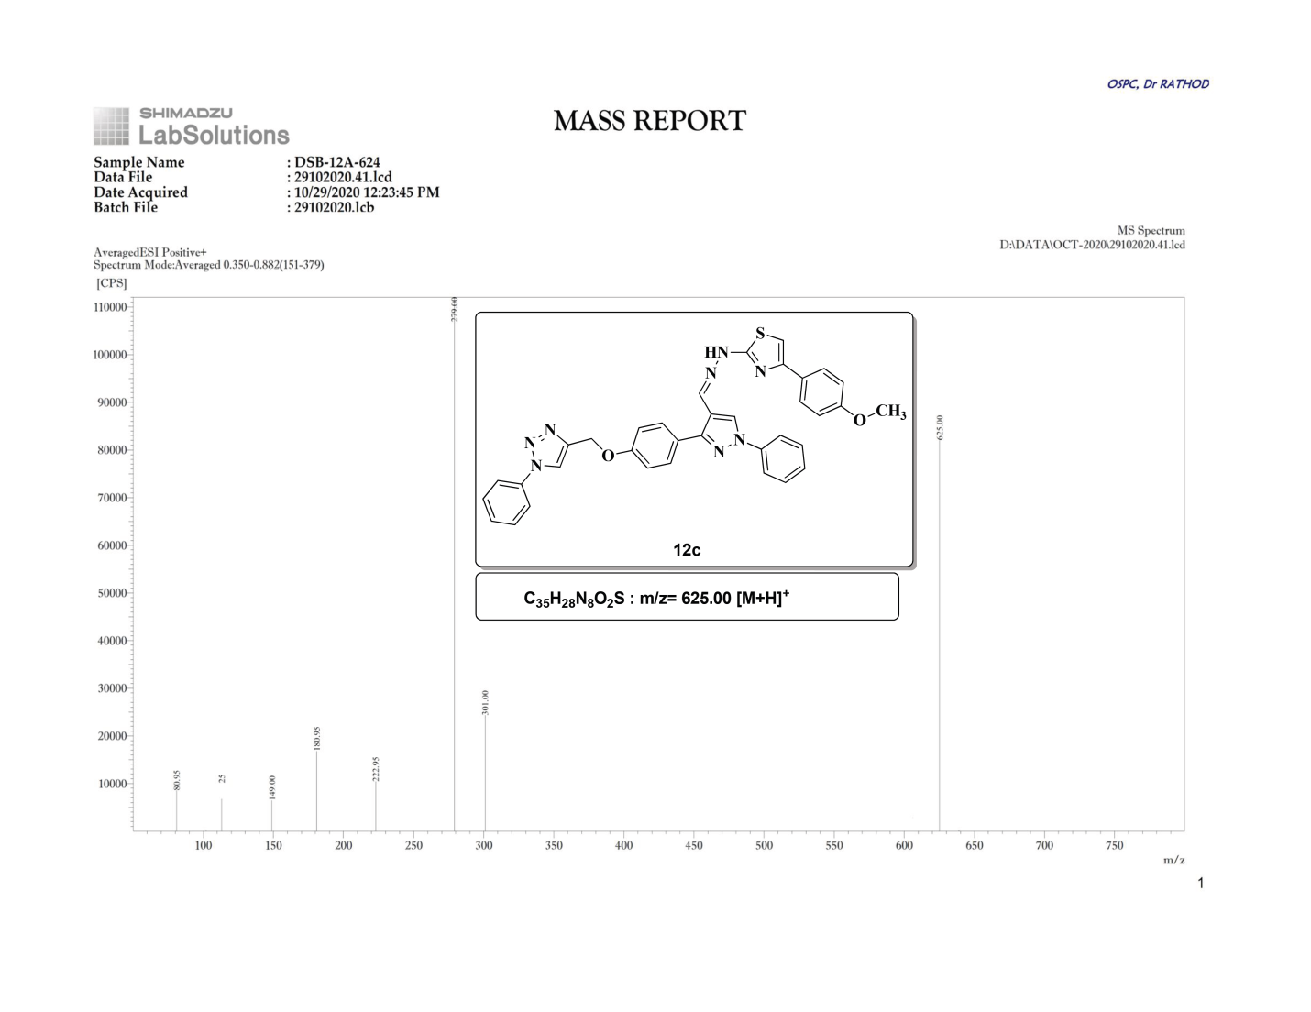
ESI-Mass Spectrum of compound 12c
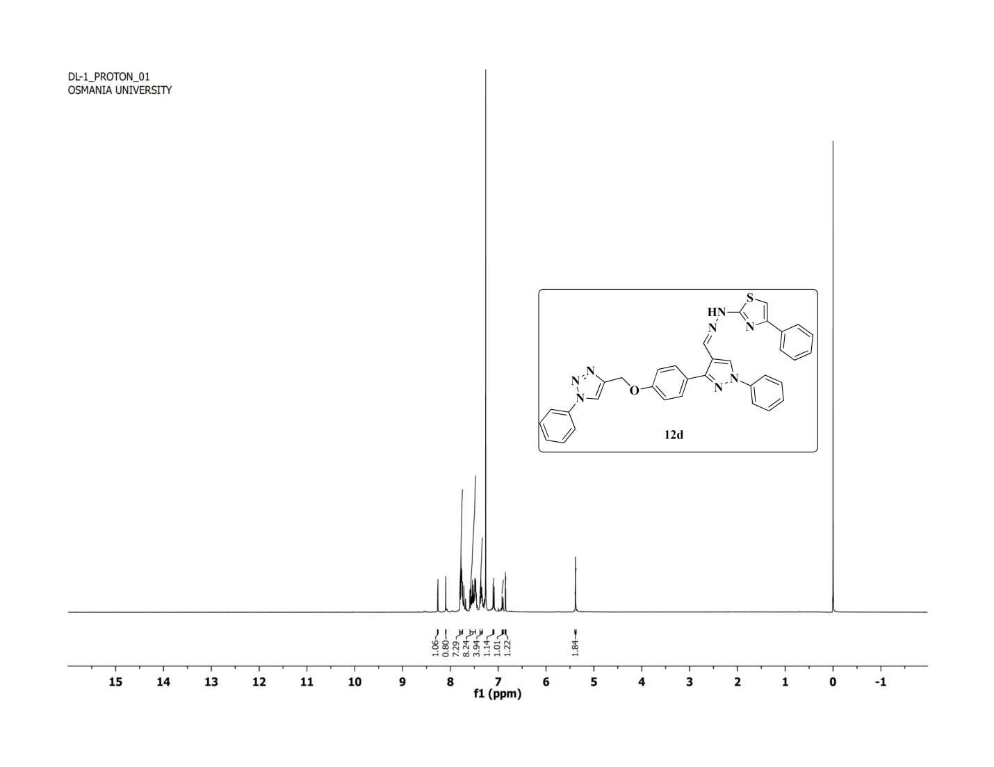
¹H NMR Spectrum of compound 12d (400 MHz, CDCl₃)
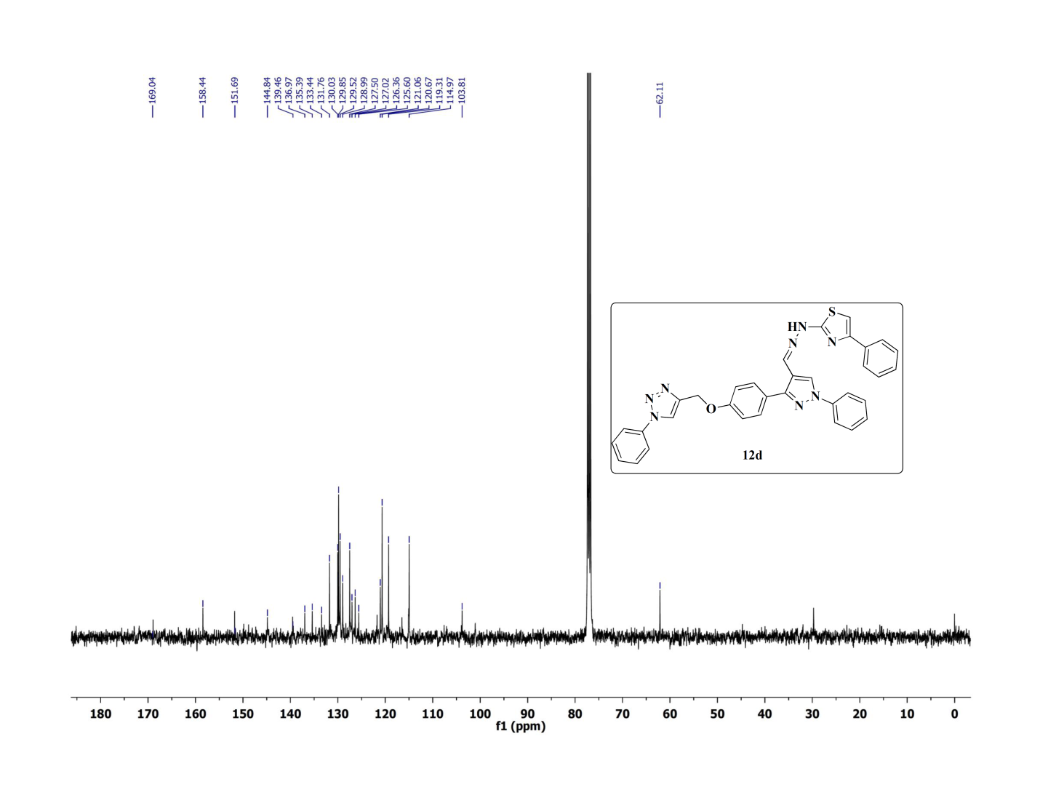
¹³C NMR Spectrum of compound 12d (100 MHz, CDCl₃)
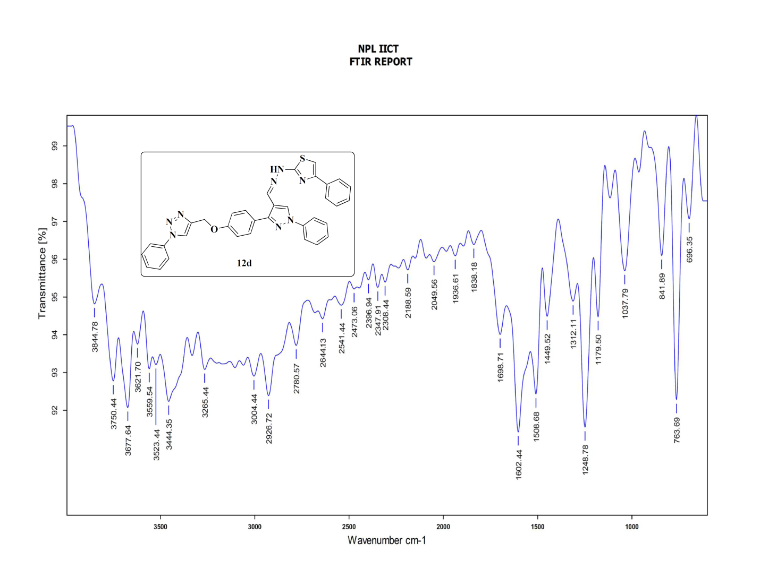

FT-IR Spectrum of compound 10d
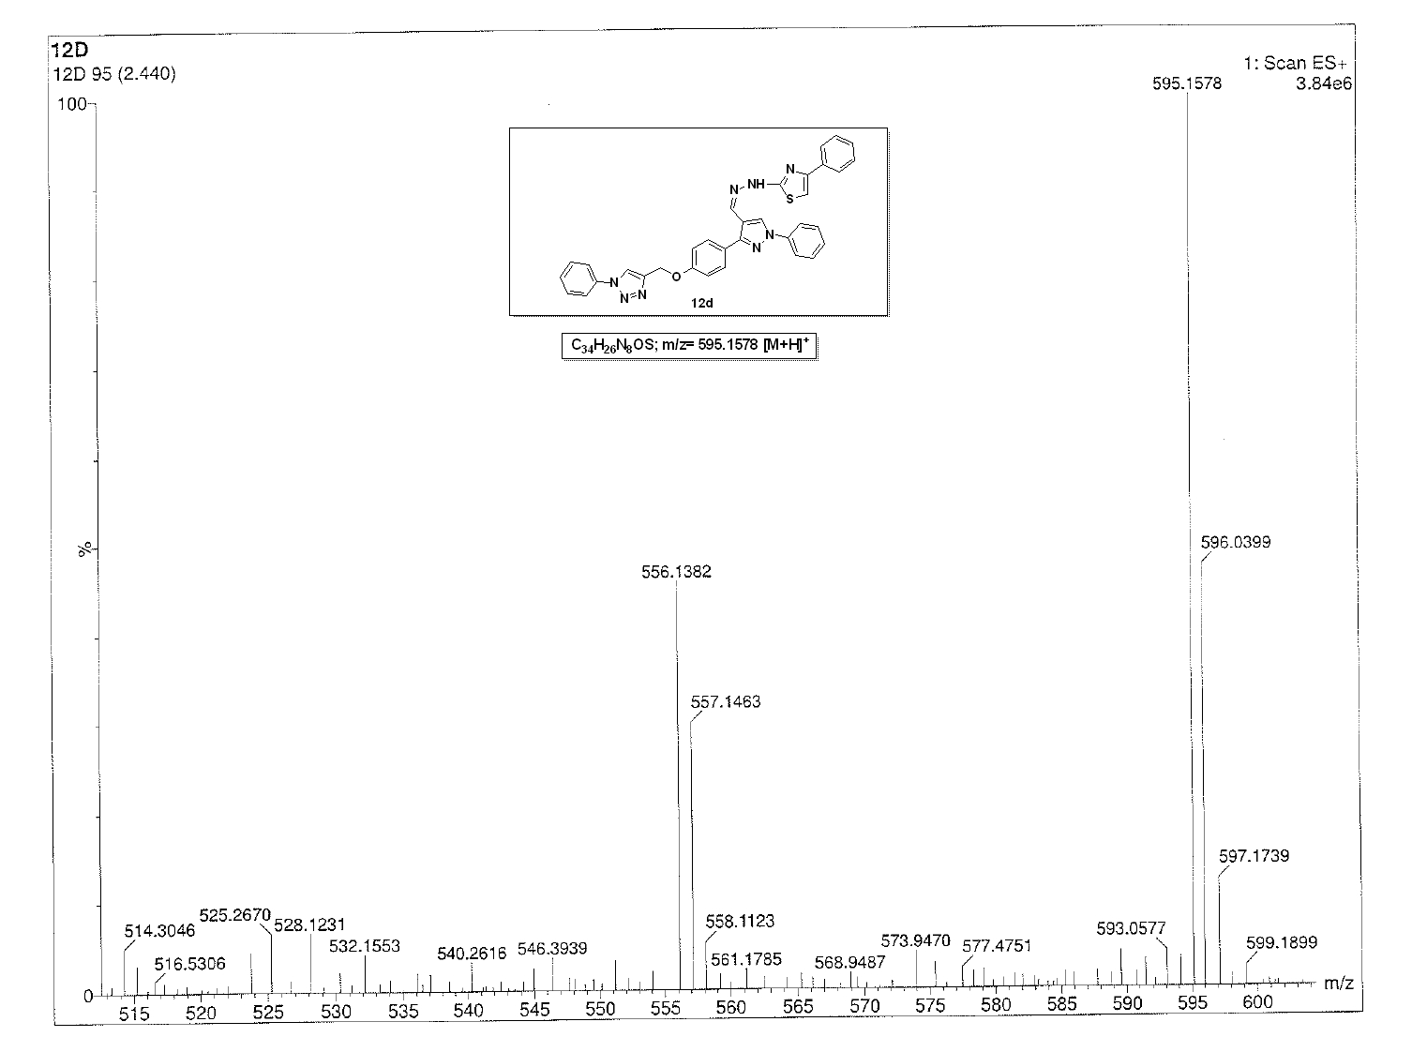
ESI-Mass Spectrum of compound 12d
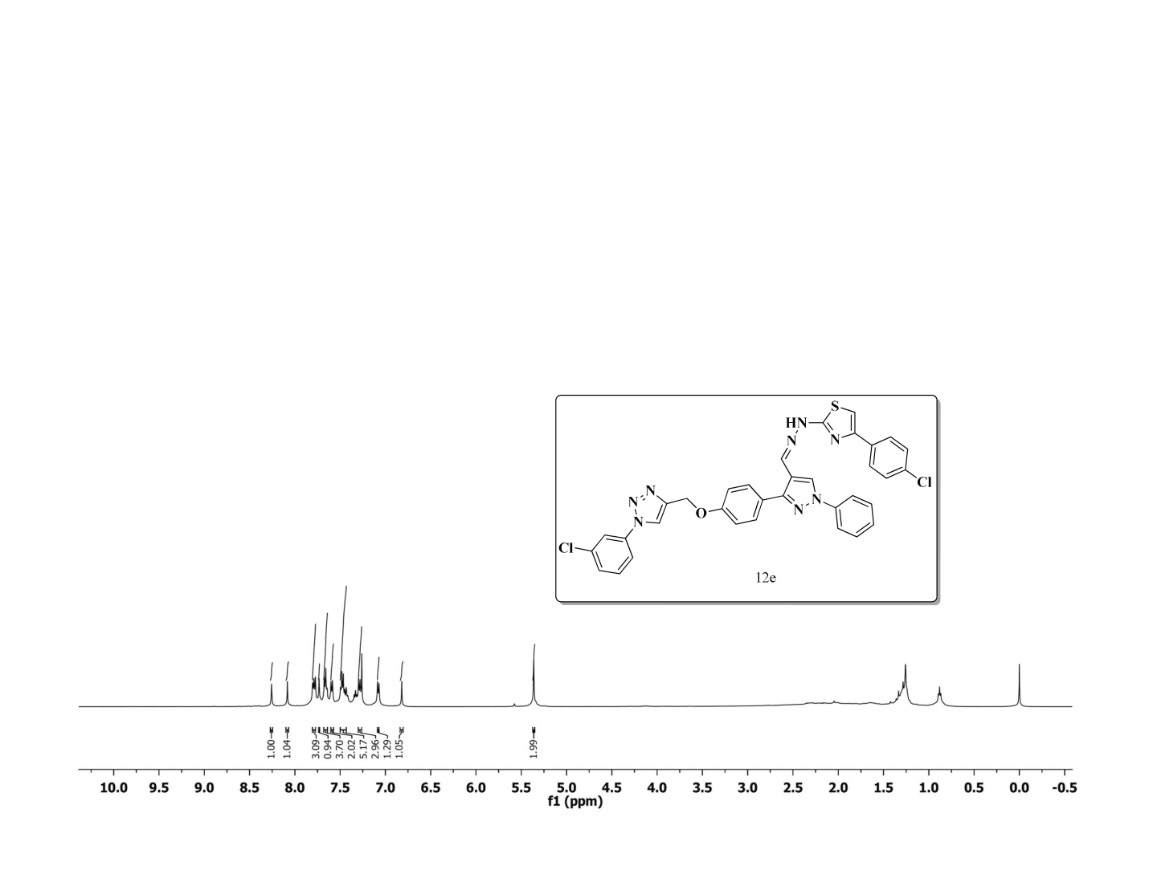
¹H NMR Spectrum of compound 12e (400 MHz, CDCl₃)
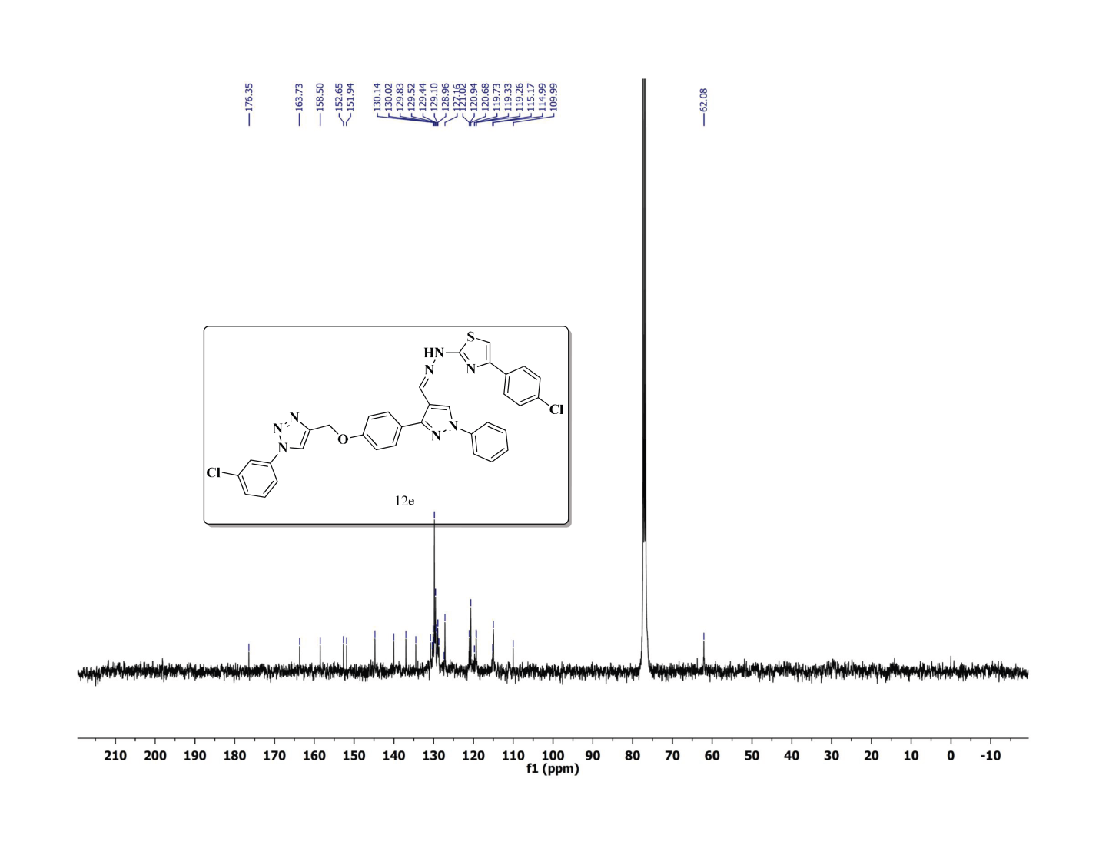
¹³C NMR Spectrum of compound 10e (100 MHz, CDCl₃)
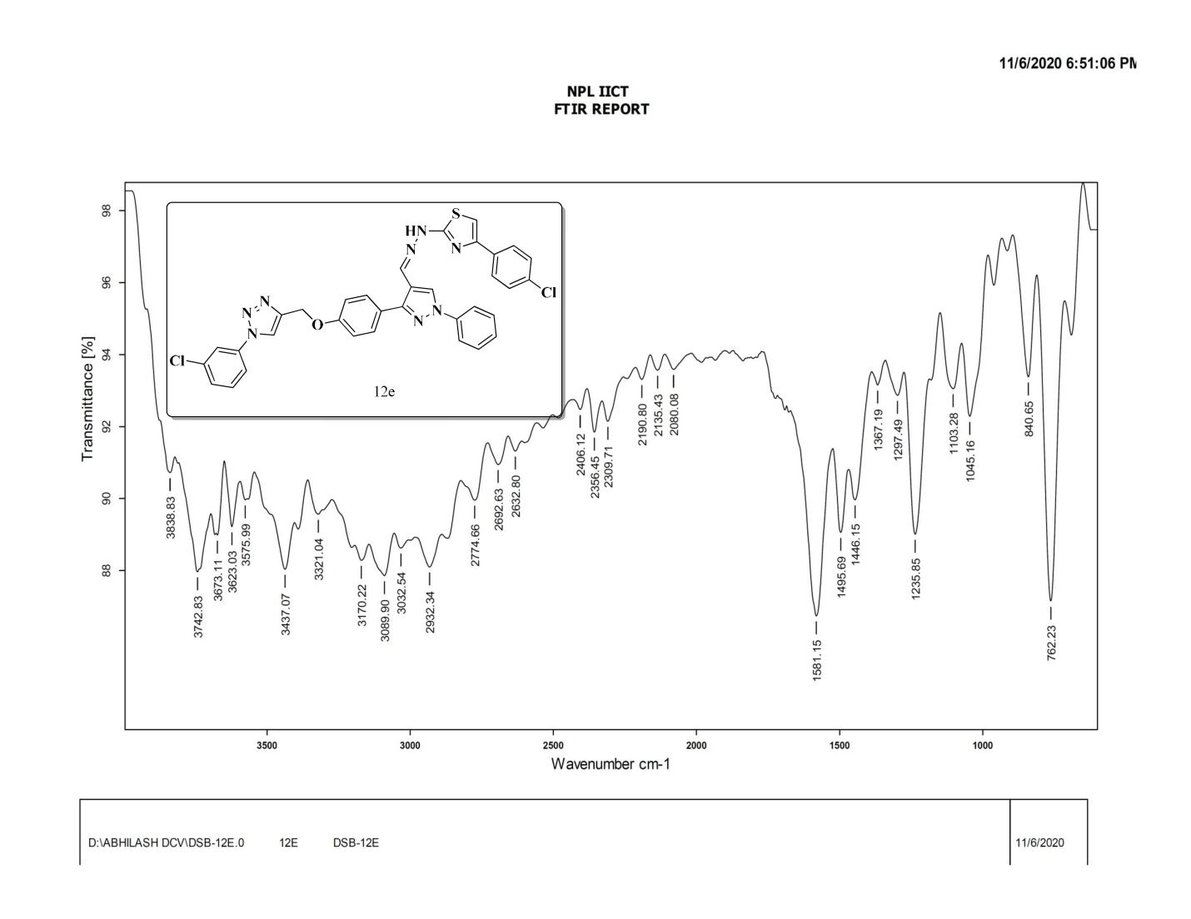

FT-IR Spectrum of compound 10e
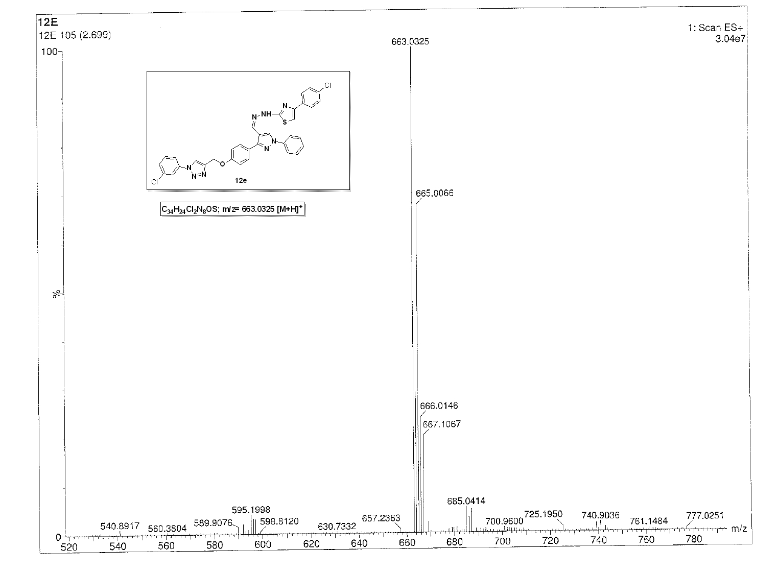
ESI-Mass Spectrum of compound 12e
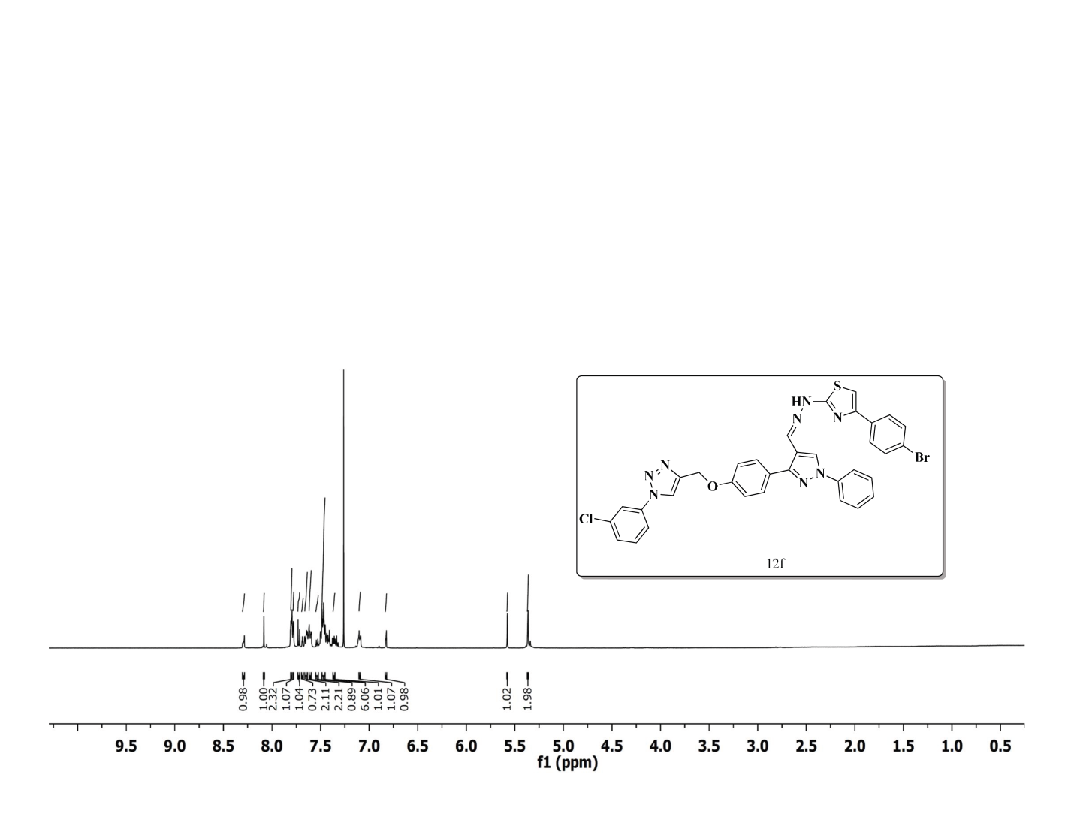
¹H NMR Spectrum of compound 12f (400 MHz, CDCl₃)
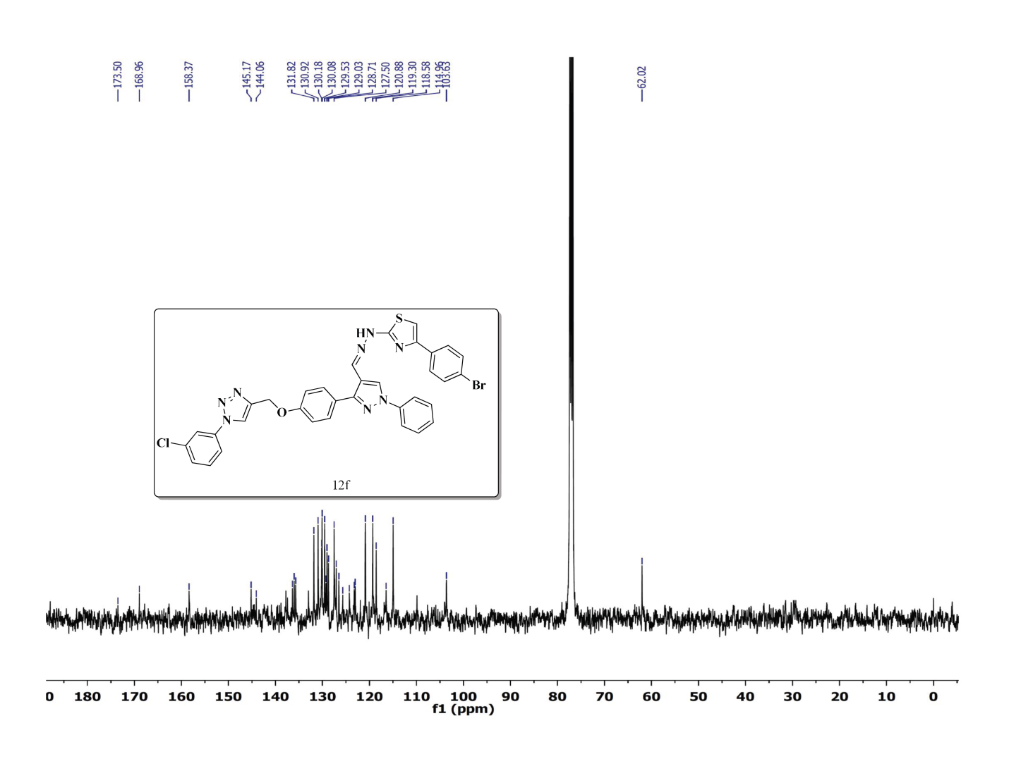
¹³C NMR Spectrum of compound 12f (100 MHz, CDCl₃)
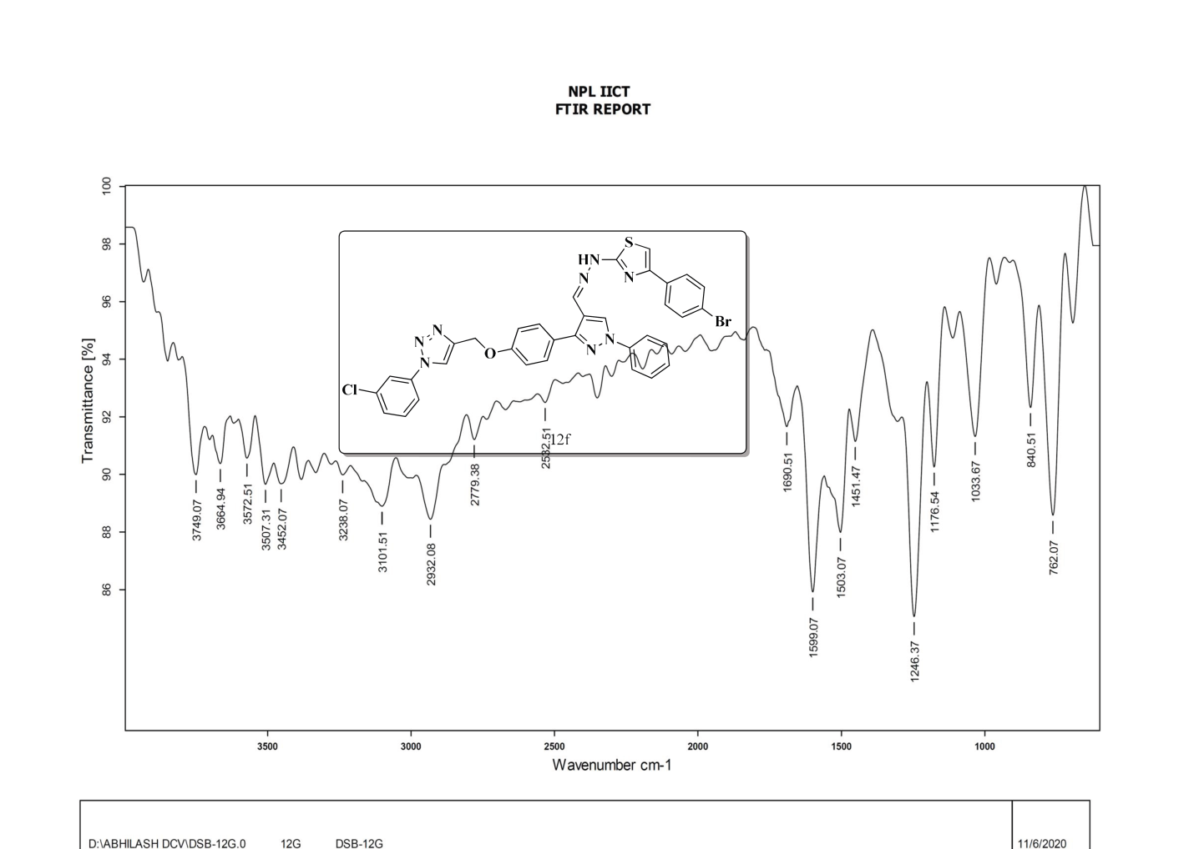
FT-IR Spectrum of compound 12f
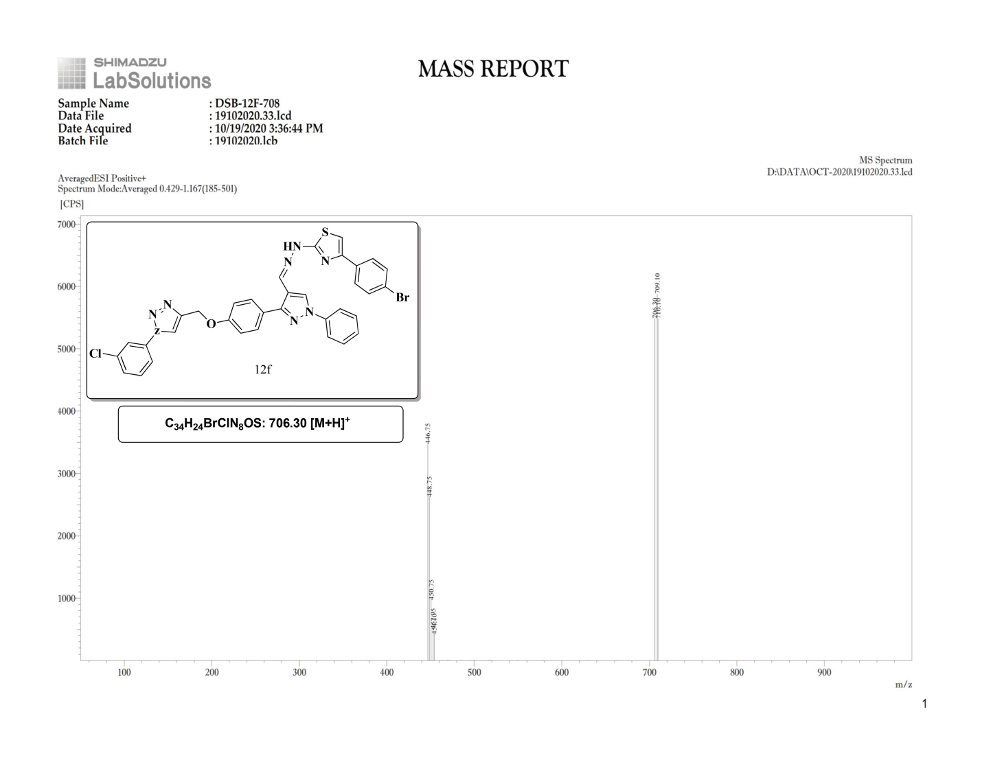
ESI-Mass Spectrum of compound 10f
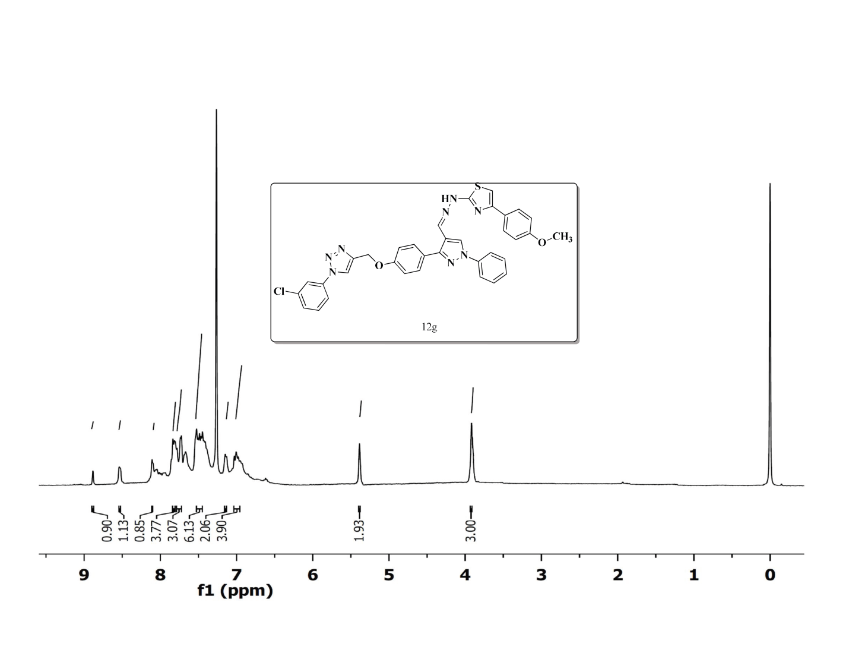
¹H NMR Spectrum of compound 12g (400 MHz, CDCl₃)
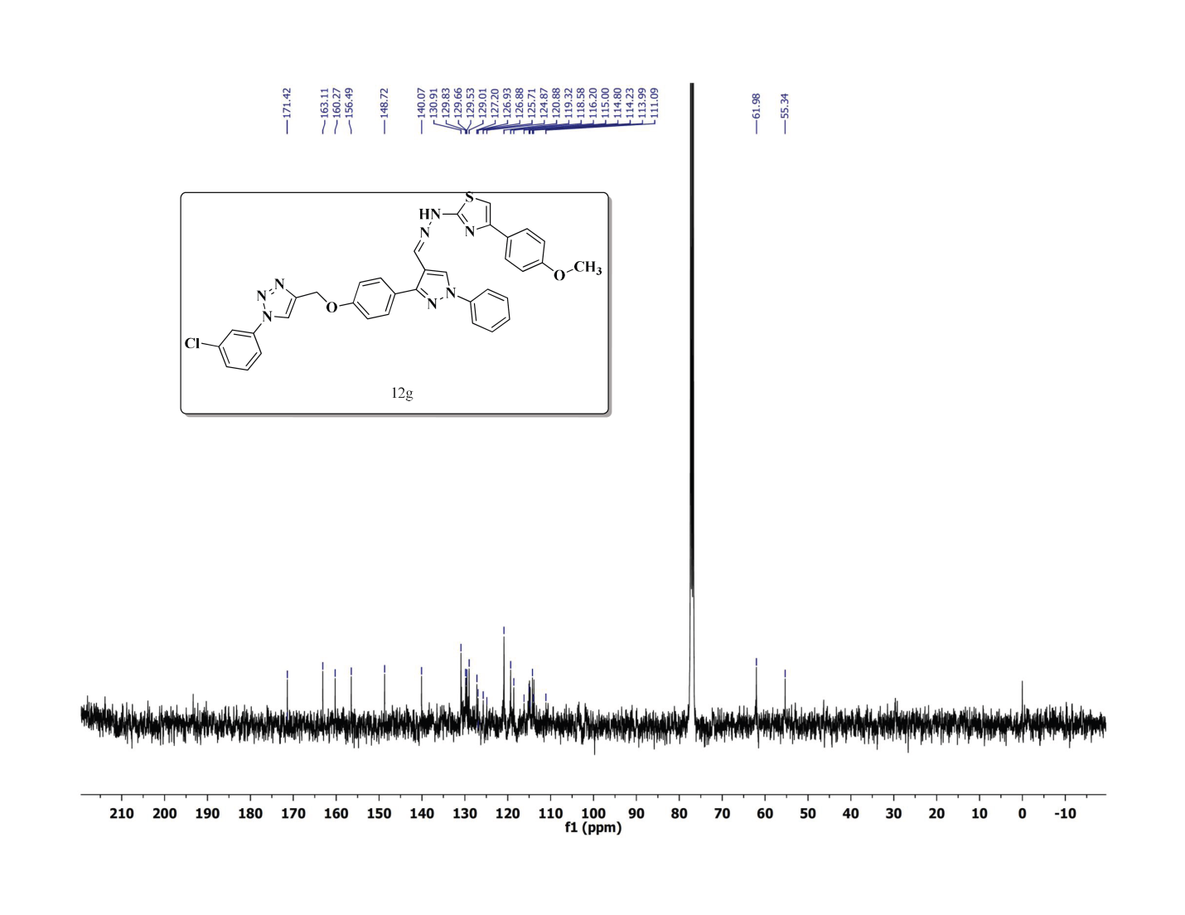
¹³C NMR Spectrum of compound 10g (100 MHz, CDCl₃)
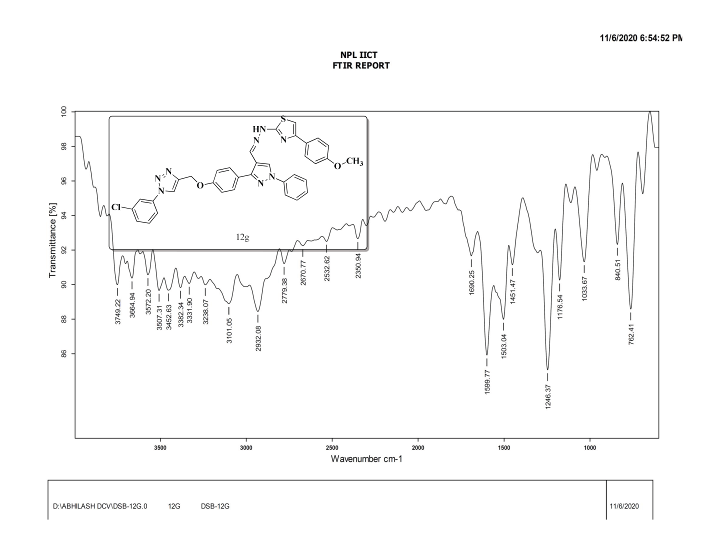
FT-IR Spectrum of compound 12g
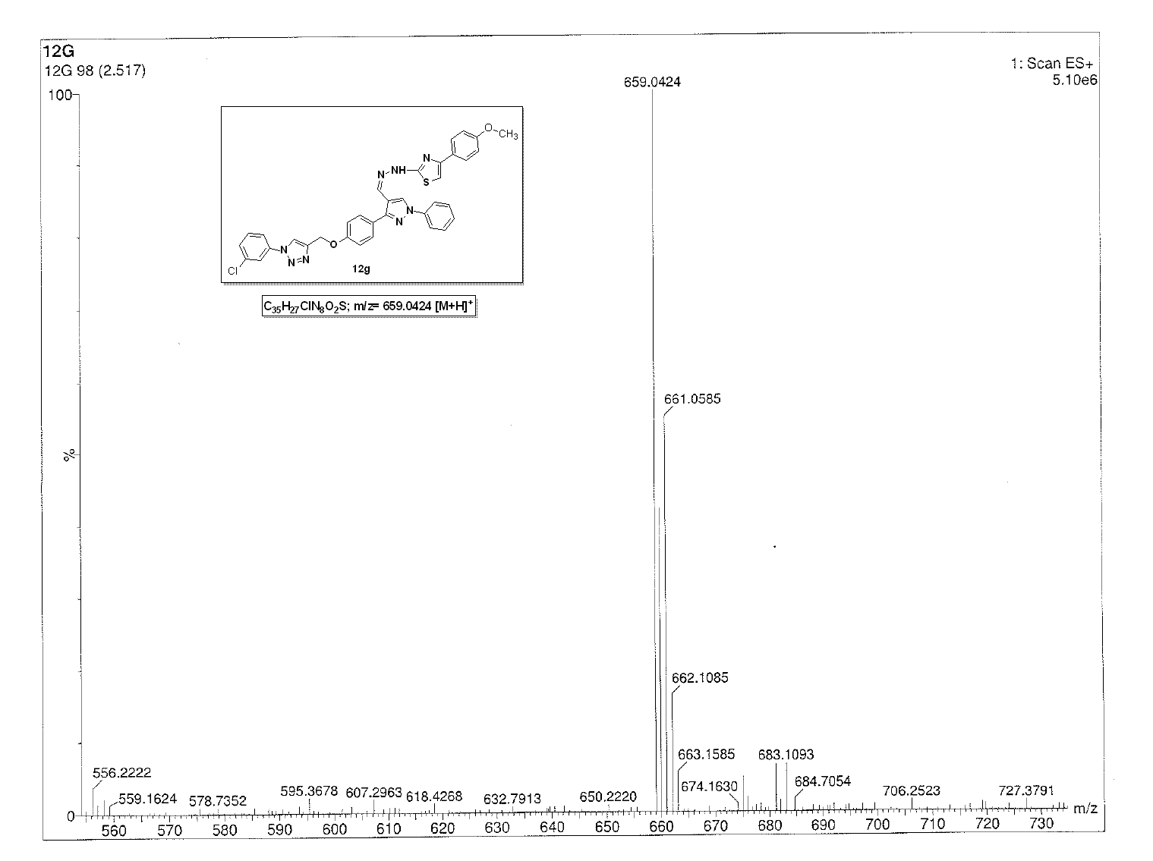

ESI-Mass Spectrum of compound 12g
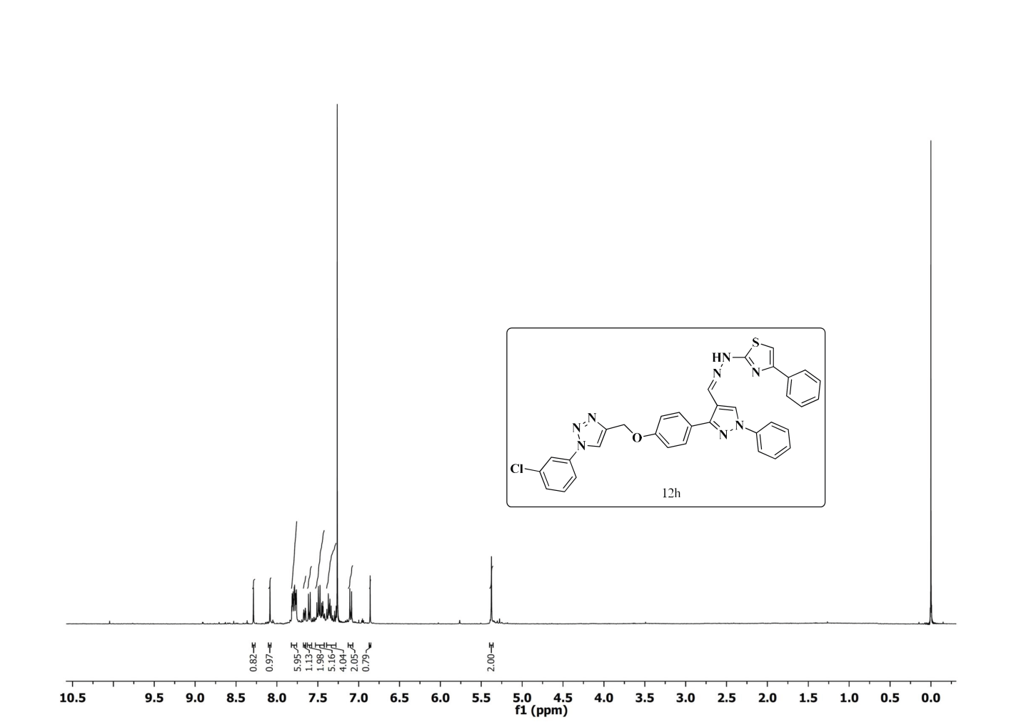

¹H NMR Spectrum of compound 12h (400 MHz, CDCl₃)
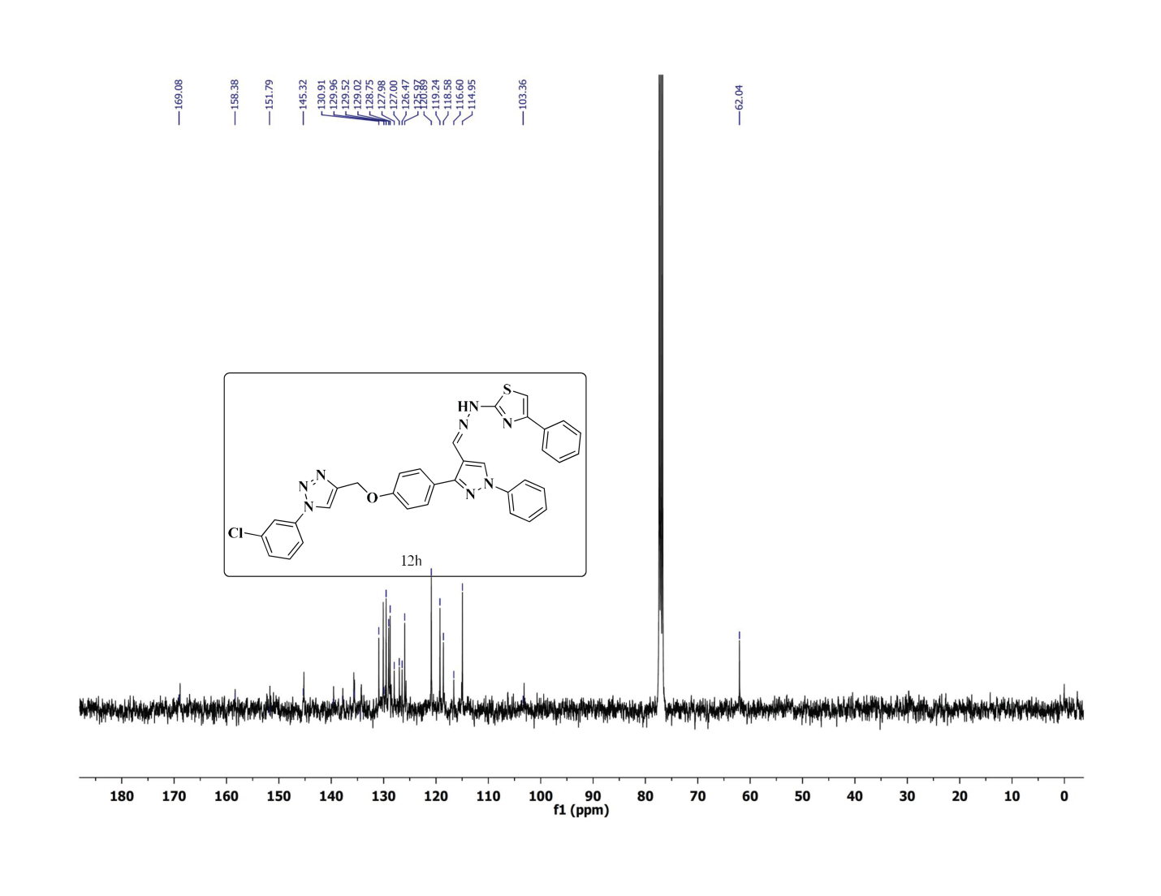
¹³C NMR Spectrum of compound 12h (100 MHz, CDCl₃)
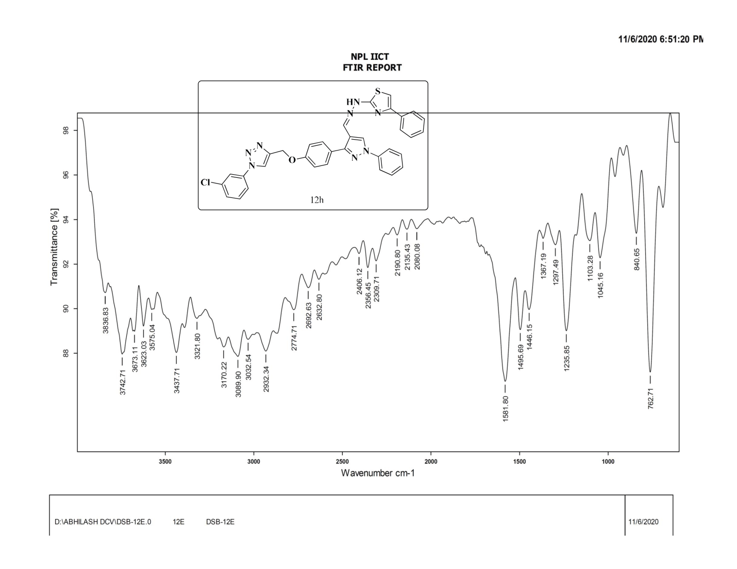
FT-IR Spectrum of compound 10h
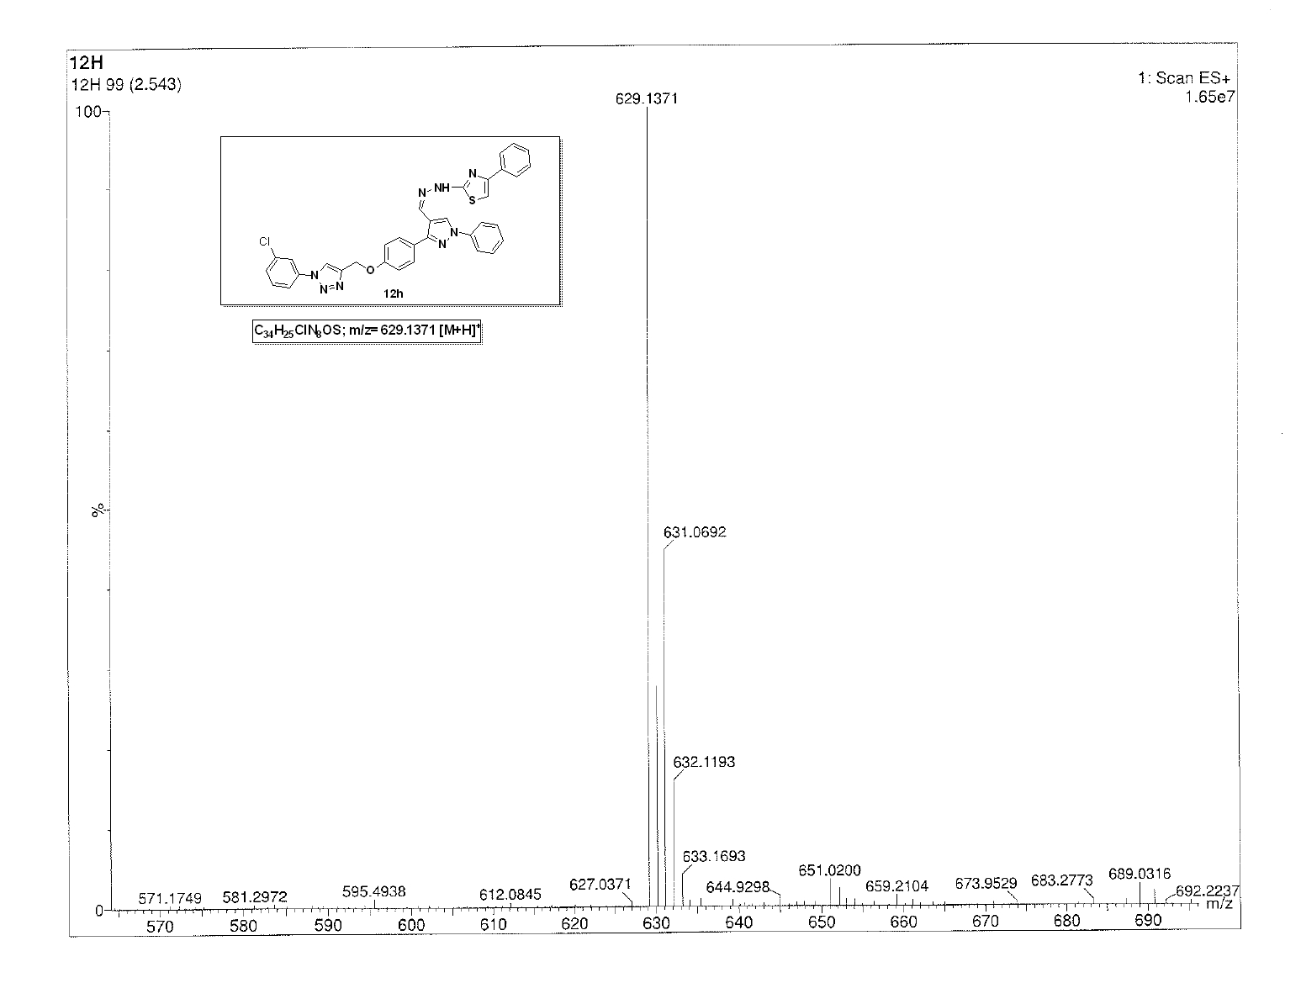
ESI-Mass Spectrum of compound 12h
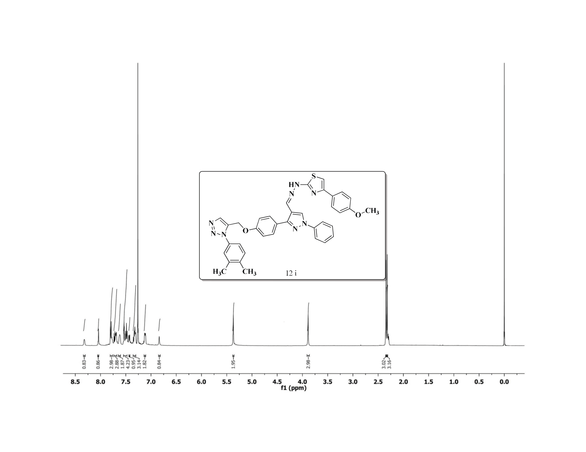
¹H NMR Spectrum of compound 12i (400 MHz, CDCl₃)
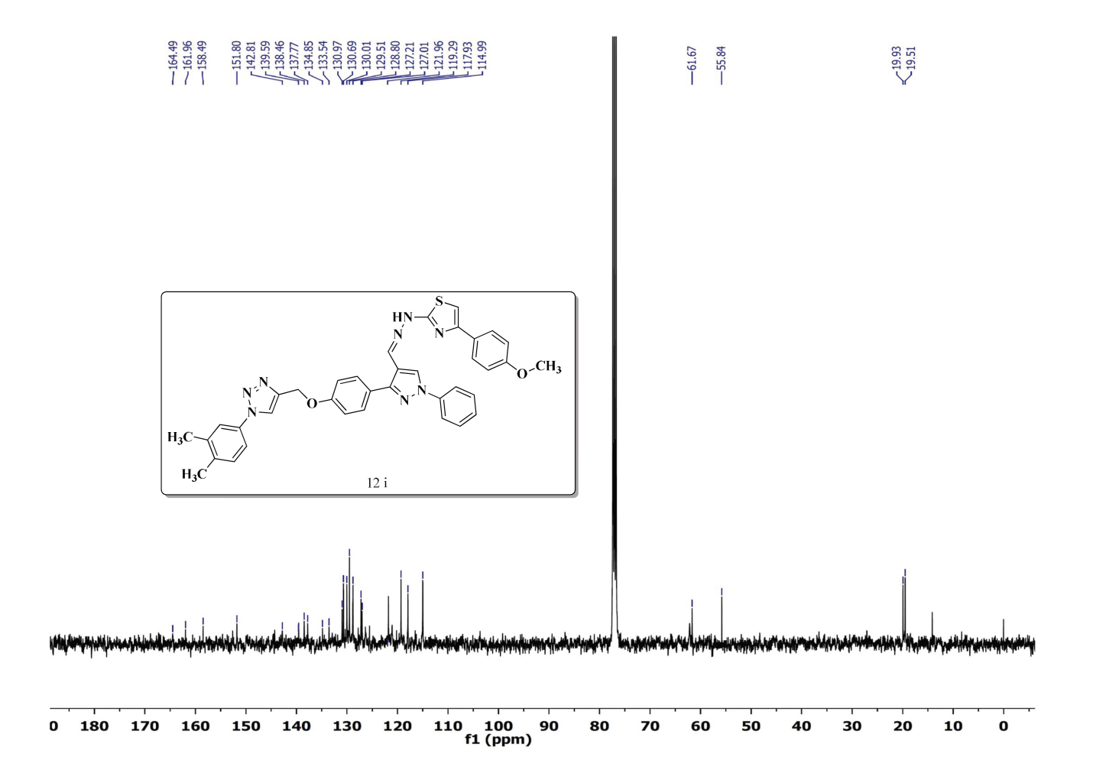

¹³C NMR Spectrum of compound 12i (100 MHz, CDCl₃)
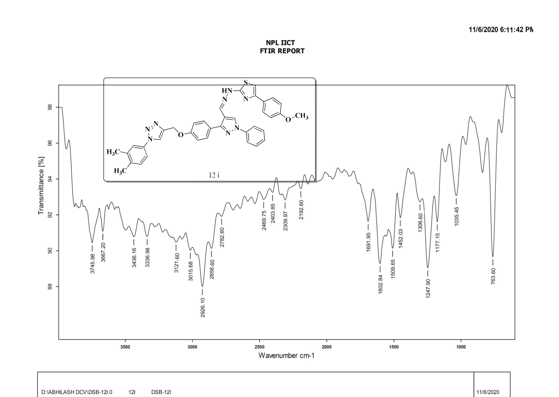
FT-IR Spectrum of compound 10i
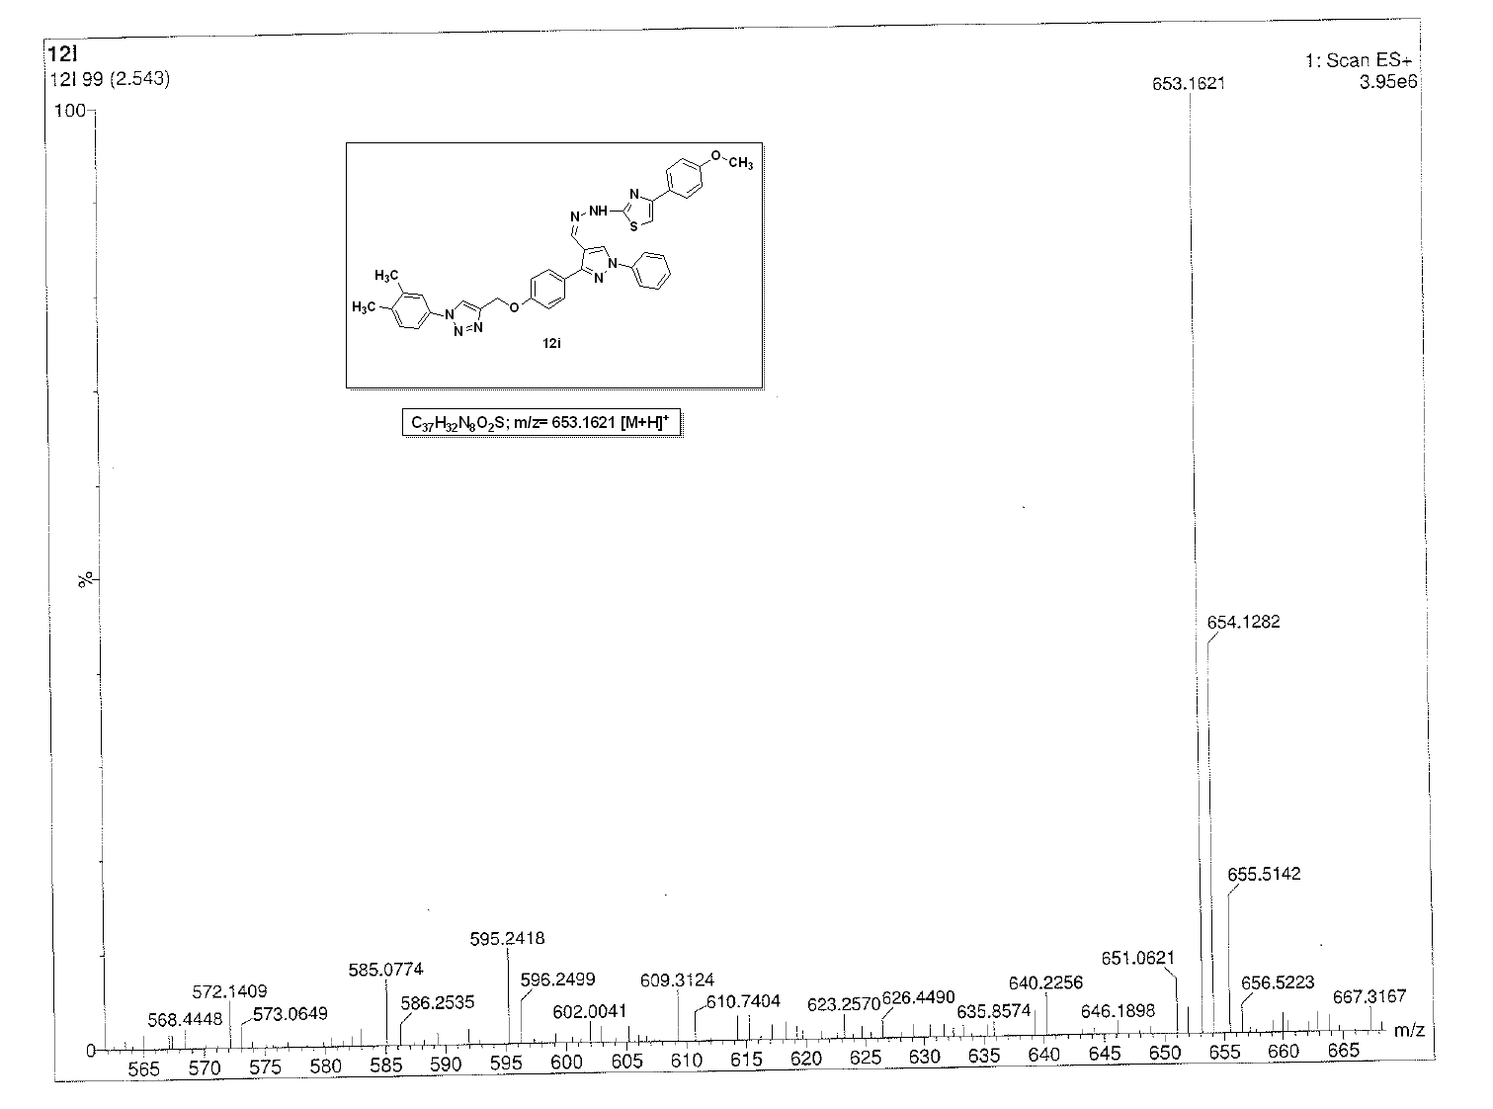
ESI-Mass Spectrum of compound 12i
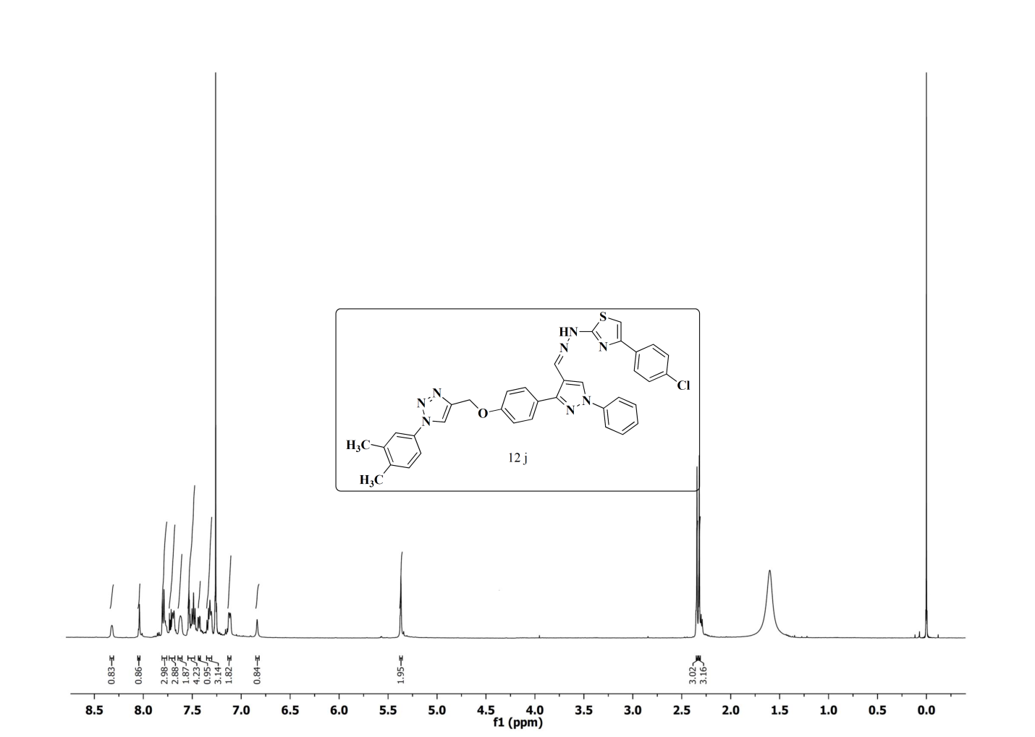
¹H NMR Spectrum of compound 12j (400 MHz, CDCl₃)
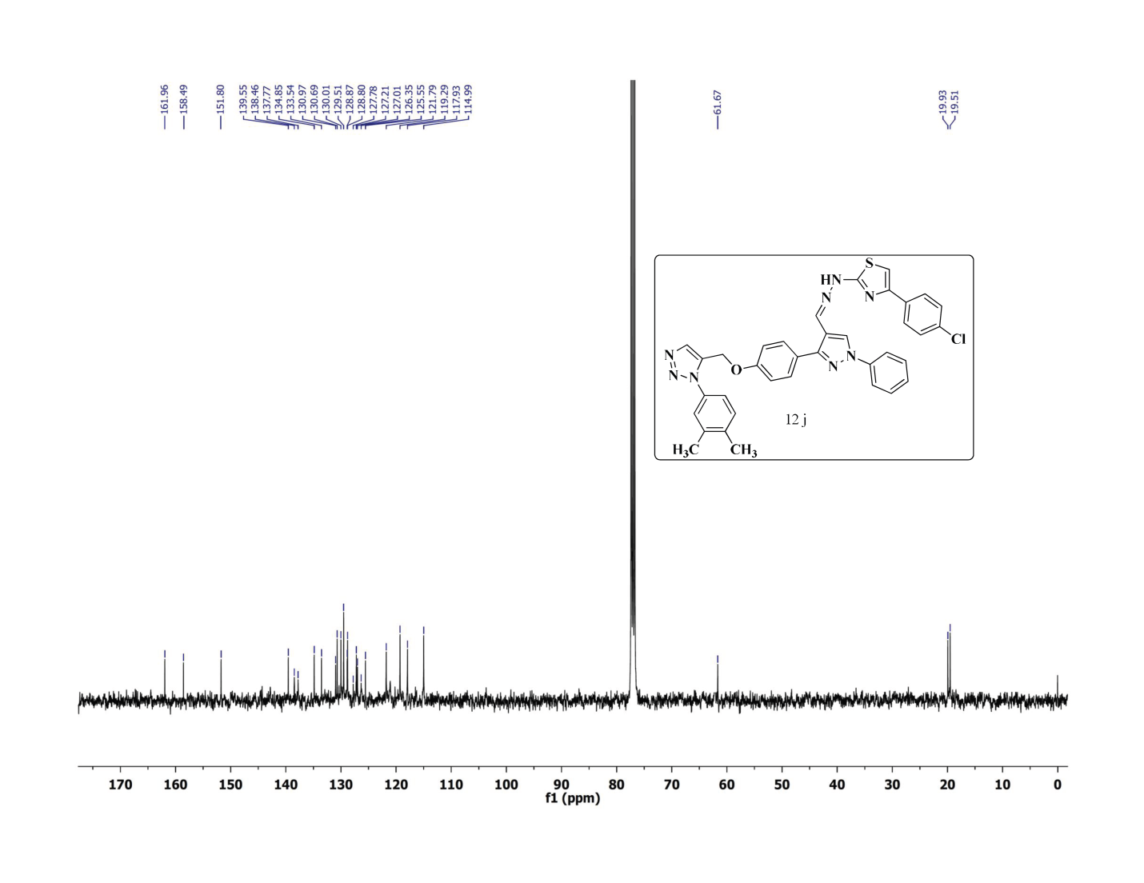
¹³C NMR Spectrum of compound 12j (100 MHz, CDCl₃)
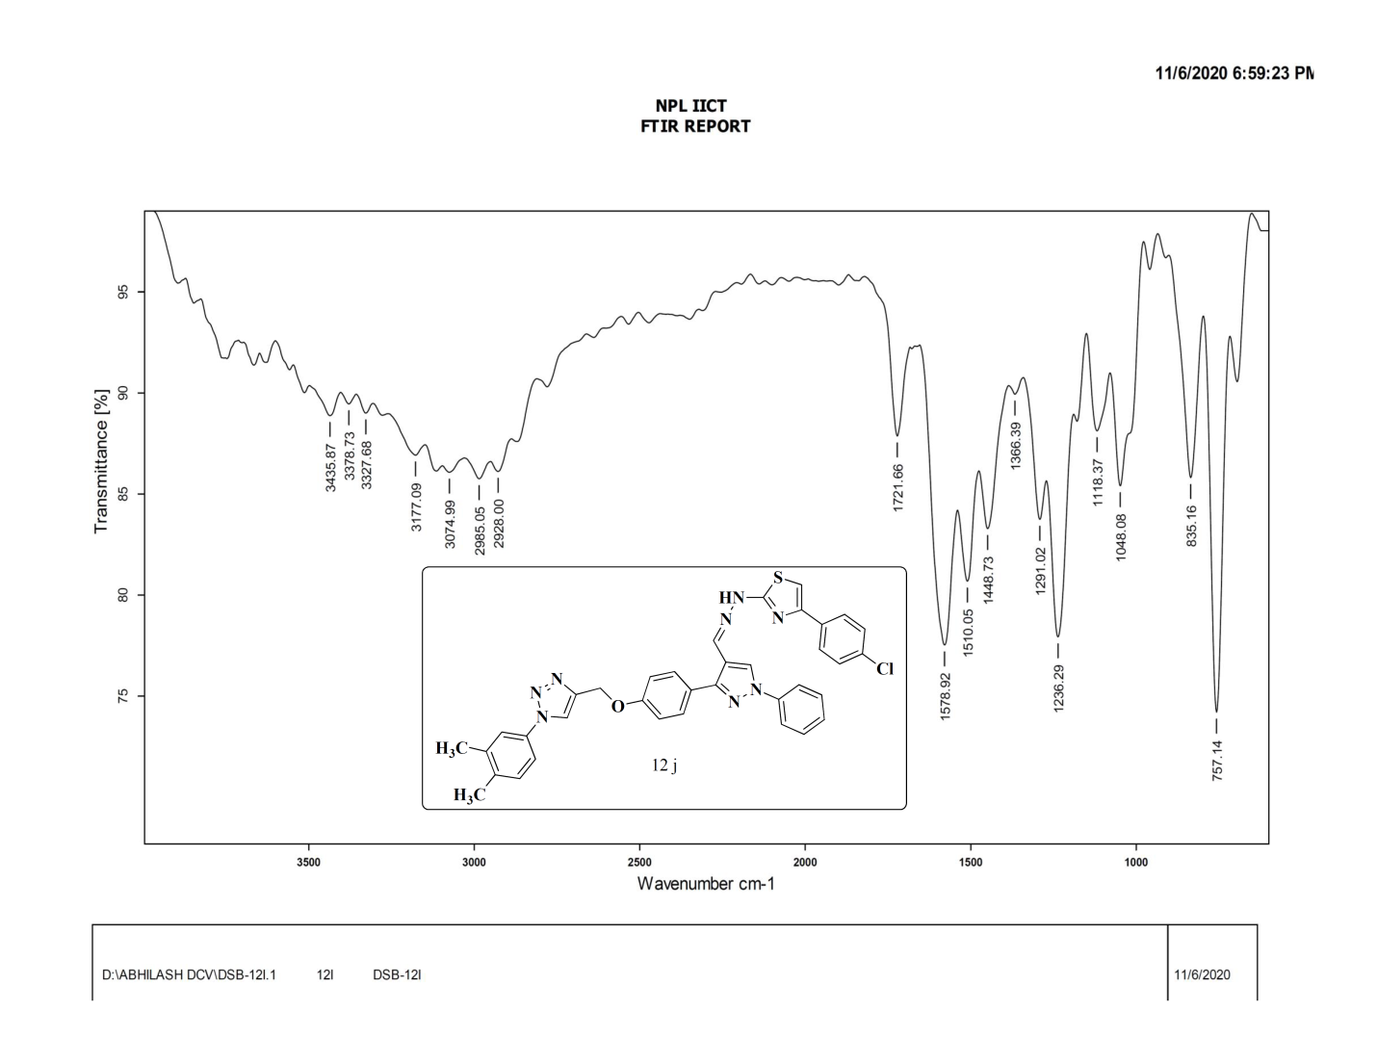
FT-IR Spectrum of compound 12j
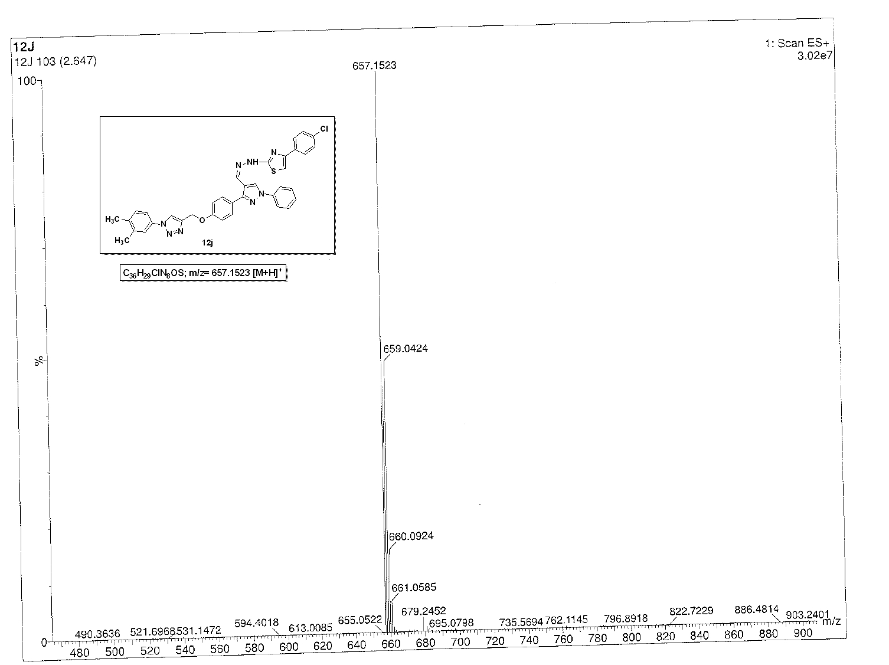
ESI-Mass Spectrum of compound 12j
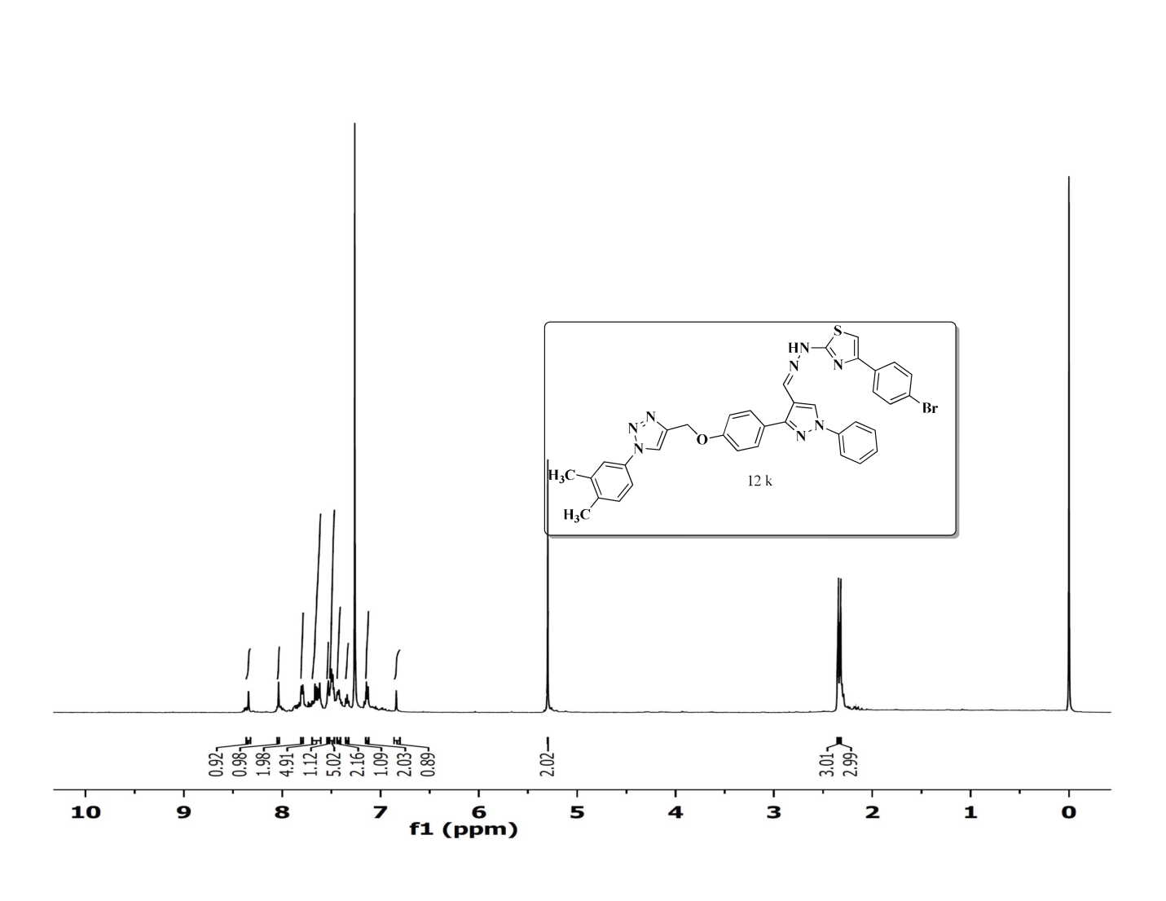
¹H NMR Spectrum of compound 12k (400 MHz, CDCl₃)
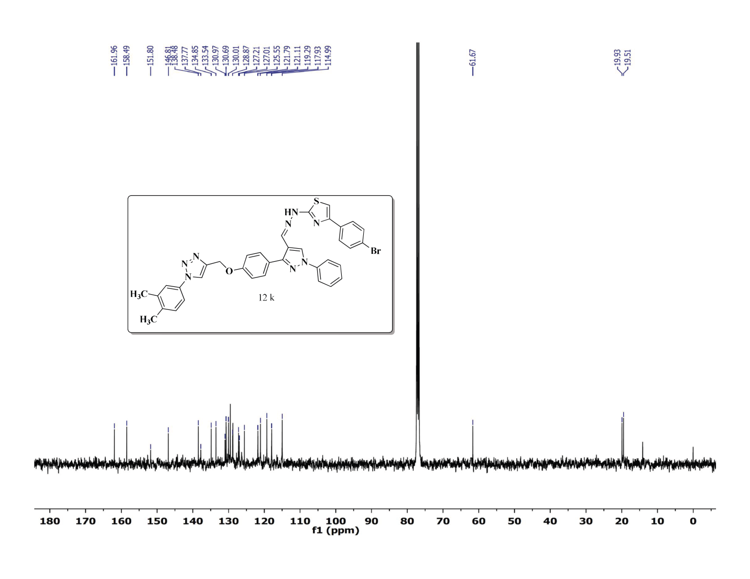
¹³C NMR Spectrum of compound 12k (100 MHz, CDCl₃)
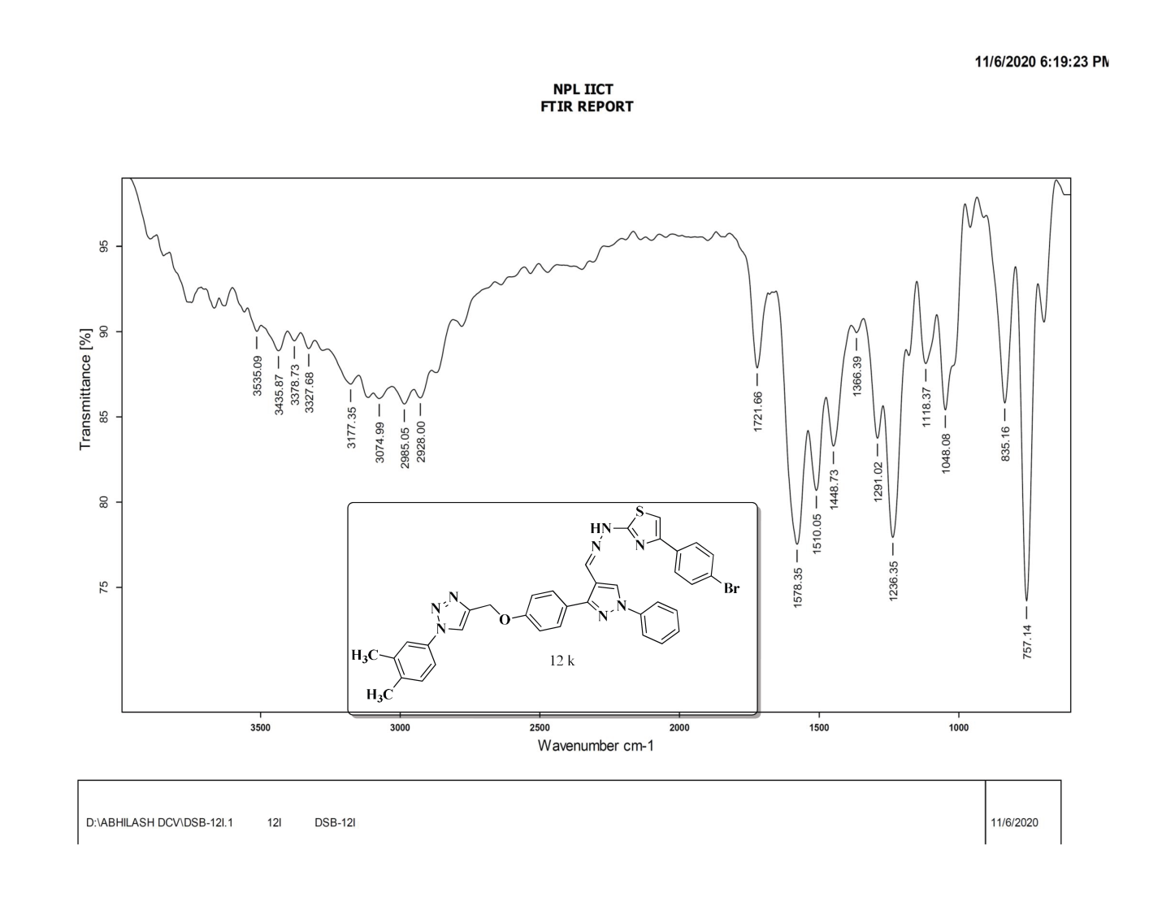
FT-IR Spectrum of compound 12k
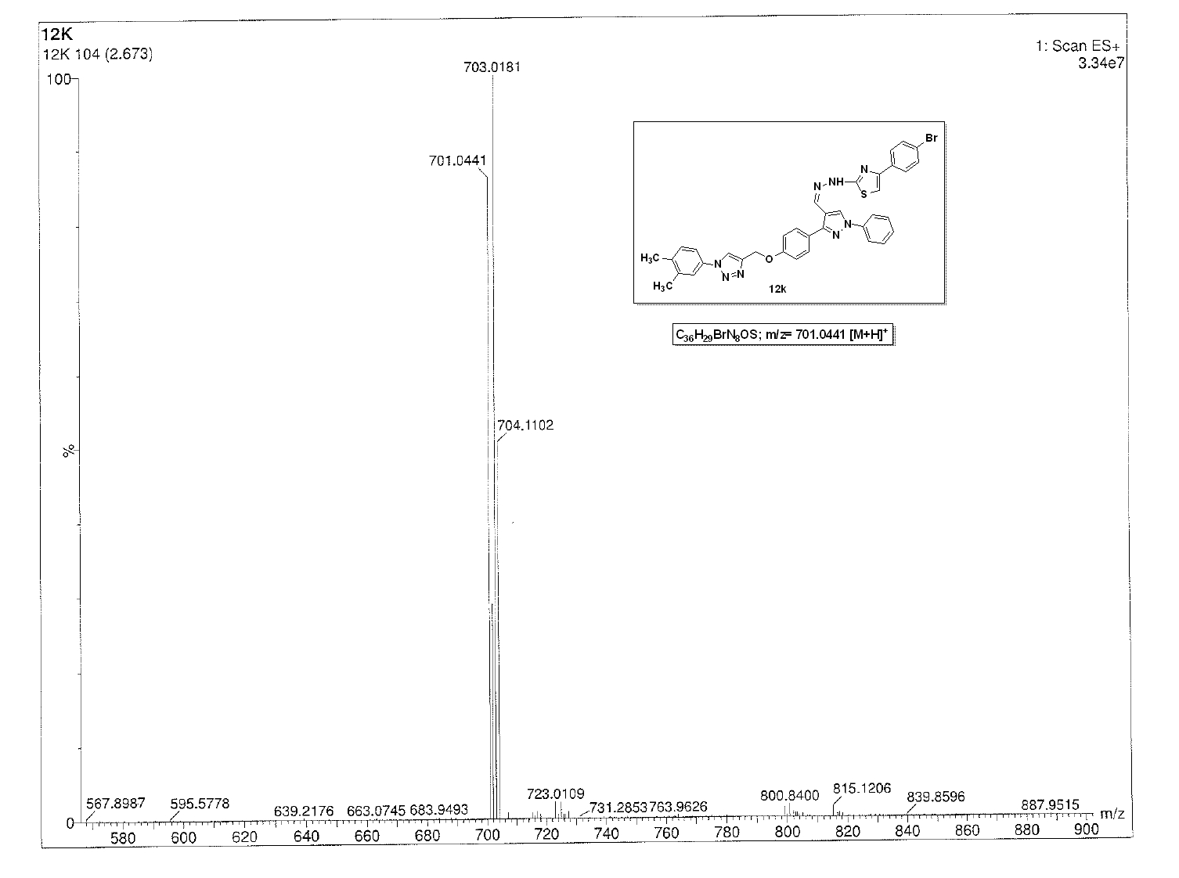
ESI-Mass Spectrum of compound 12k
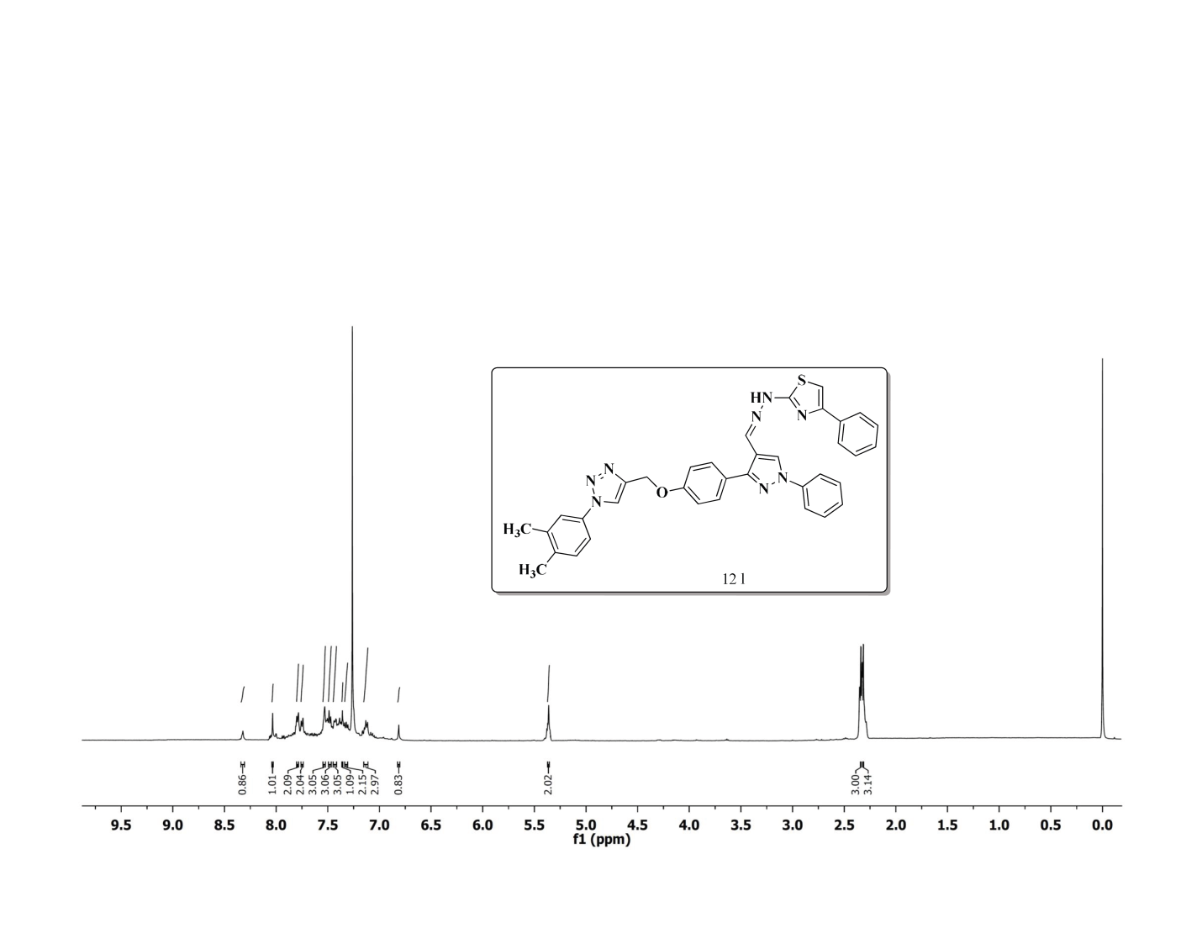
¹H NMR Spectrum of compound 12l (400 MHz, CDCl₃)
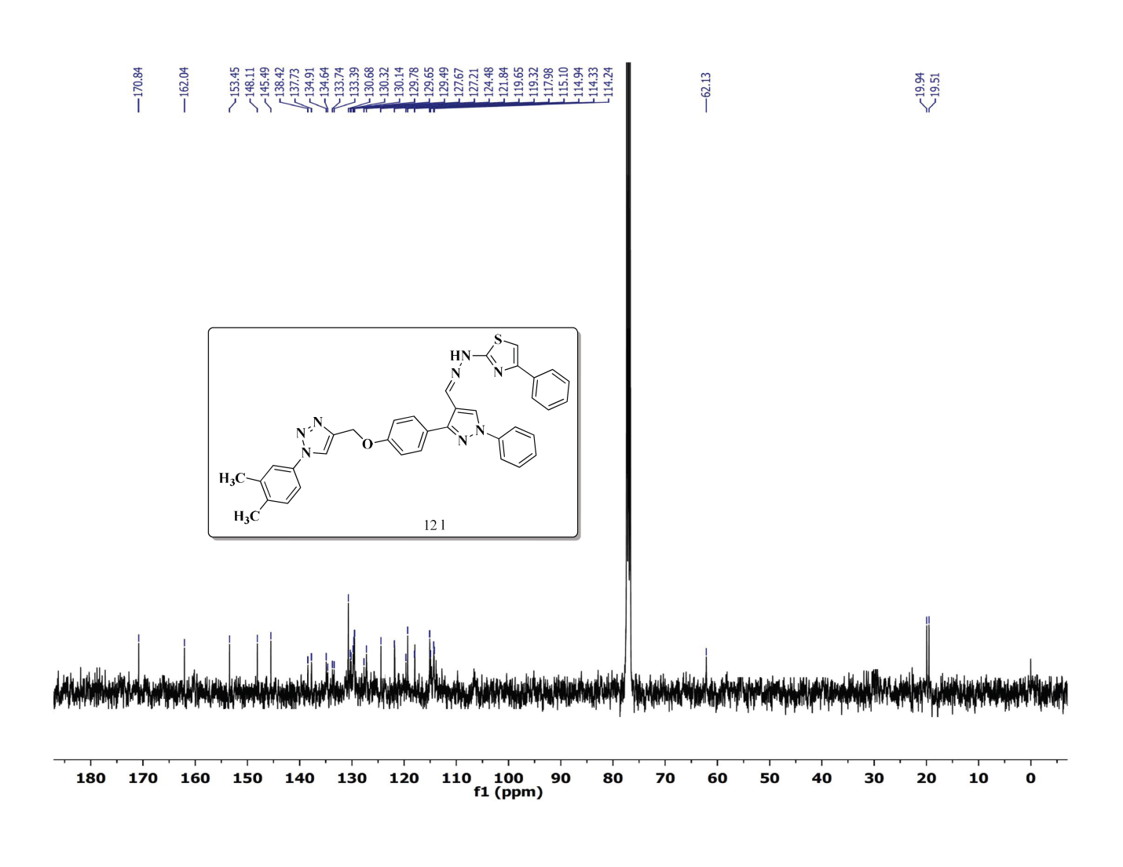
¹³C NMR Spectrum of compound 12l (100 MHz, CDCl₃)
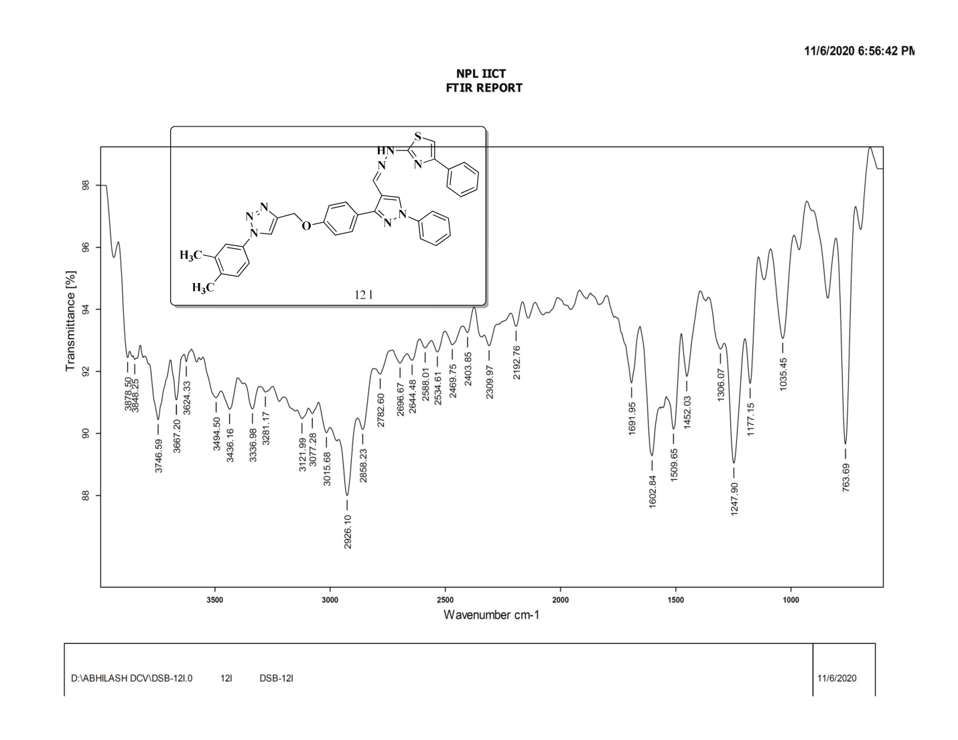
FT-IR Spectrum of compound 12l
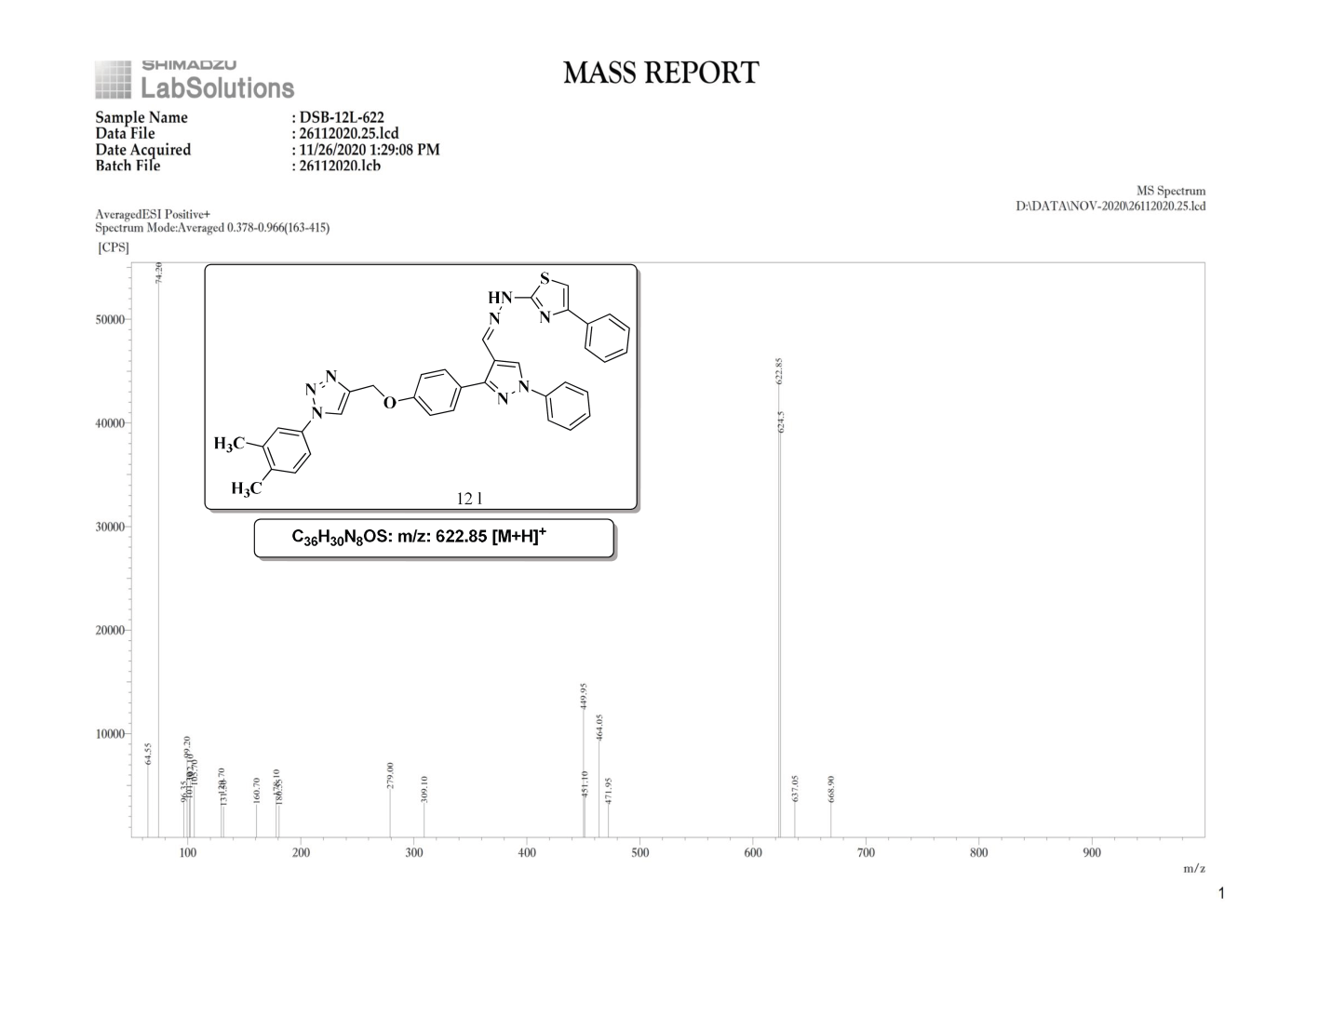
ESI-Mass Spectrum of compound 12l

