Supplementary Figure 1
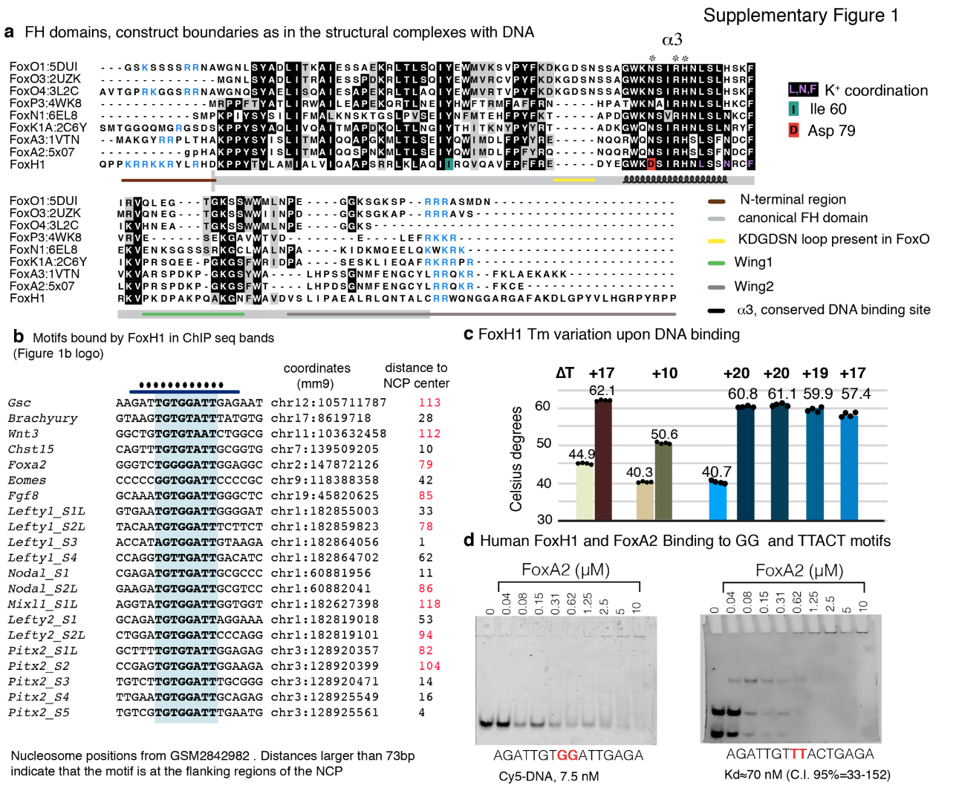
  - Sequence alignment of different FH domains whose structures have been characterized. PDB entries are included next to the protein name.
- Selected peaks bound by the FoxH1 protein in ChIP-seq assays (GSE125116, Aragon et al, 2019). The canonical motif and base pairs of Gsc that participate in specific contacts with the protein are highlighted. Coordinates and nucleosome positions (GSM2842982) are indicated. Distances larger than 73 bp indicate that the motif is at the flanking regions of the NCP.
- Differences in the melting temperatures determined for human and frog FH sequences and the GG site and for zebrafish FoxH1 induced by the presence of the same four DNAs shown in Figure 1d.
- Titration of two 16 bp labeled DNA molecules derived from the native Gsc sequence containing the FoxH1 GG motif (left) or the canonical TTACT FoxA2 site (right), followed by native electrophoretic mobility shift assay (EMSA) at 4ºC. Whereas FoxA2 binds well to its TTACT site, no binding is observed for the GG motif. Both experiments were run in parallel using the same purified FoxA2 batch.

Supplementary Figure 2
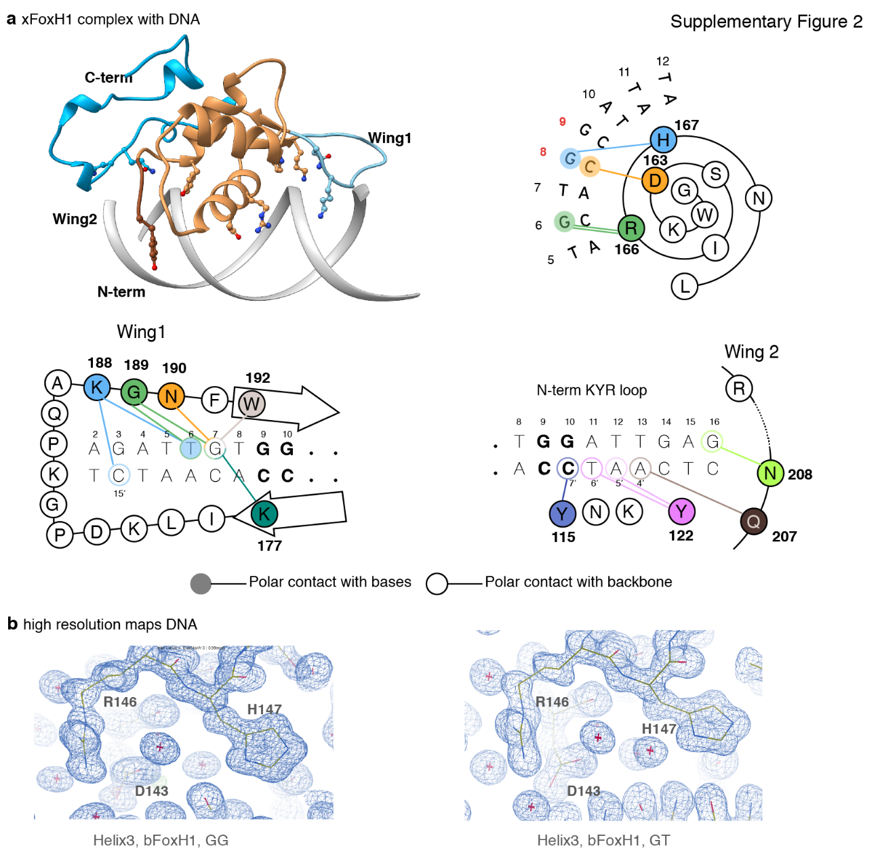
a. Structure of the Xenopus laevis FoxH1-DNA complex bound to the GG motif (crystallographic asymmetric unit). The contacts with the major and minor grooves are represented as cartoons.
b. Snapshots showing the high-resolution electron-density maps of the GG and GT complexes for regions covering the H3 region. 2Fo-Fc maps are contoured at 1.0 sigma.

Supplementary Figure 3
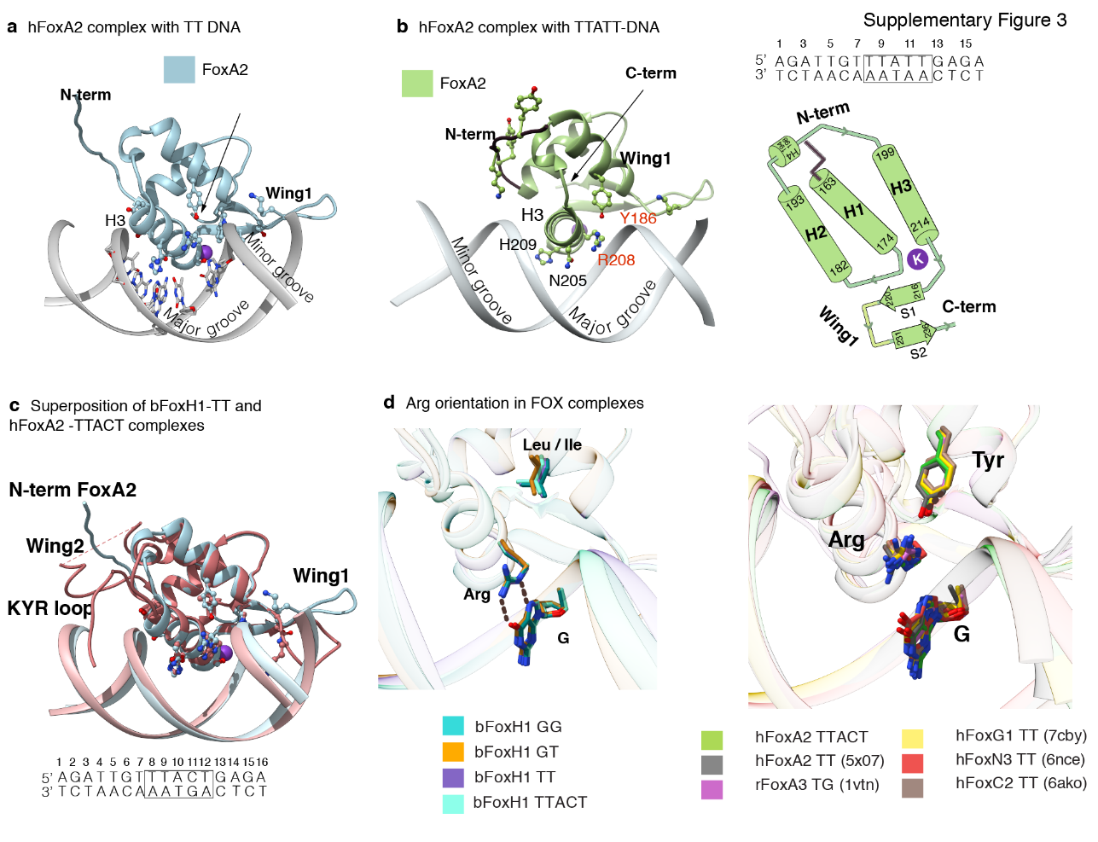

- Overview of the FoxA2-TTACT structure with secondary structural elements shown in light green. Although the construct used for the crystal structure is as long as that of FoxH1, only the core domain is ordered and interacts with the DNA. The N-terminal region is shown in dark brown and points away from the minor groove. Secondary structural elements are shown as cartoons.
- Overview of the FoxA2-TTATT complex and schematic drawing of the secondary structure elements and the K binding site. The DNA sequence is indicated. The folded region is almost identical to the complex shown in a. Only the relative orientation of the N-terminal loop is different. In both cases, the loop does not participate in specific contacts with either DNA or the protein domain.
- Superimposition of FoxA2 (blue) and FoxH1 (coral) complexes bound to TT sites.
- Different rotamers of the Arg residue in FoxH1 and in six FOX complexes (PDB entries indicated). In FoxH1, the Arg residue is close to the DNA and participates in direct contacts, whereas in the remaining complexes the side chain is rotated away.

Supplementary Figure 4

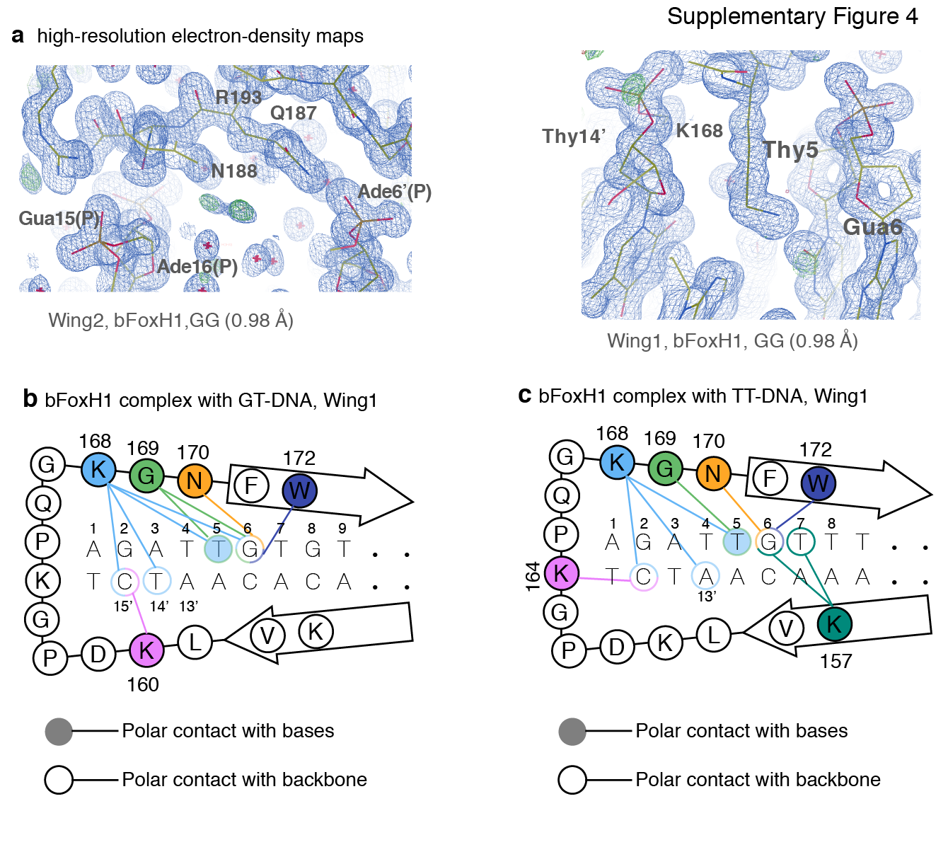
a. Snapshots showing the high-resolution electron-density maps for regions covering the Wing1 and Wing2 regions. All 2Fo-Fc maps are contoured at 1.0 sigma.
b, c. Schematic view of the conserved interactions between the N-terminal KYR loop and the GT and TT sites.

Supplementary Figure 5
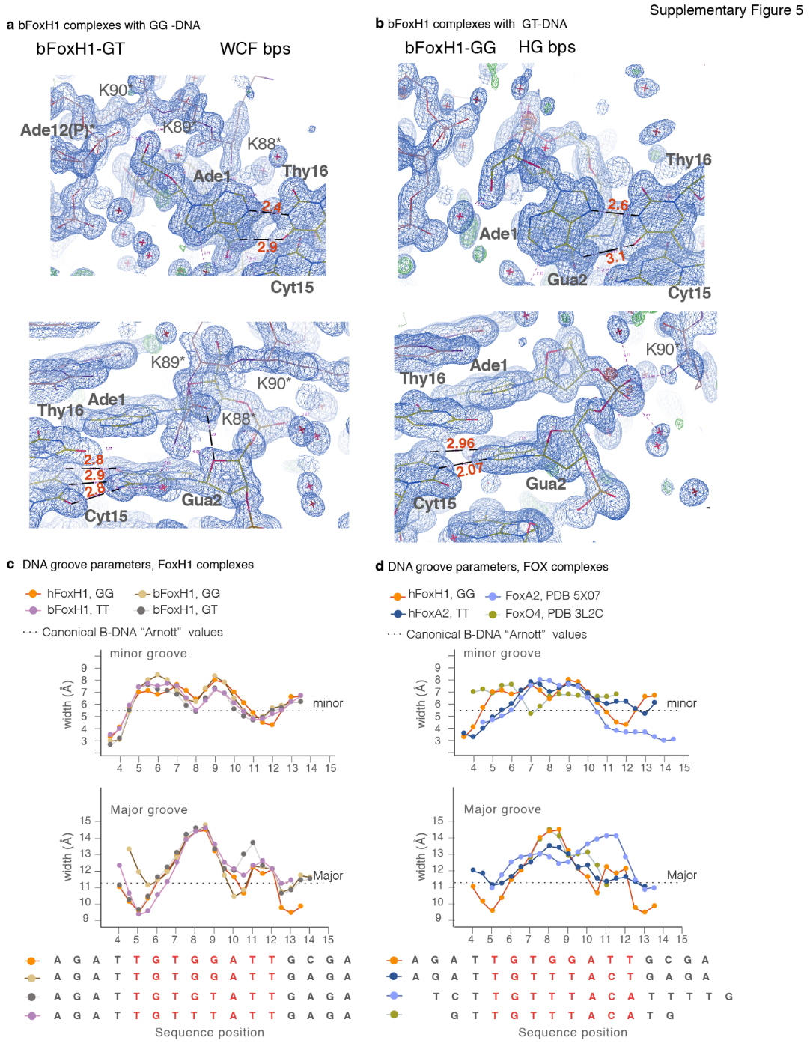

- Minor and major groove width analyses of the different FoxH1 complexes.
Comparison of the minor and major groove width values of FoxH1 GG complex (orange) to FoxA2 and FoxO4 structures (light and dark blue). All values were calculated using Curves+ ⁴⁴.
b. Snapshots showing the crystal environment surrounding the equivalent first two bps of the bFoxH1-GT and bFoxH1-GG structures, which form WCF and HG bps, respectively. On the left, Ade1:Thy16 and Gua2: Cyt15 form Watson-Crick-Franklin (WCF), and (HG) on the right. Polar contacts up to 3.3 Å are shown for Ade1 and Gua2. Both structures originate from crystals grown in similar conditions and identical space groups, and they have nearly identical cell units. The symmetry complex in the crystal is shown in grey-pink and its residues are labeled with an asterisk. In all cases, the 2Fo-Fc maps are contoured at 1.0 sigma.

Supplementary Figure 6
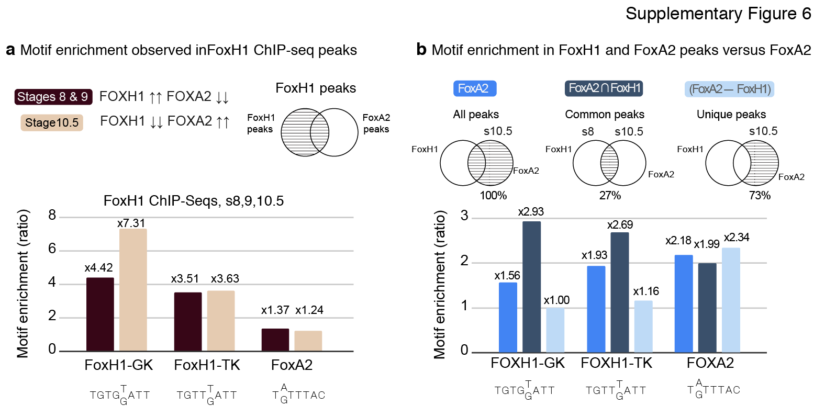
a. FoxH1 ChIP-seq peaks at stages 8/9 and stage 10.5. We find that the FoxH1 peaks with GK motifs are more enriched at stage 10.5 than at stage 8/9 (x7.31 enrichment vs. x4.42), while TK and canonical FoxA2 are not enriched. These indicate that at stage 10.5, when FoxH1 protein concentration is low, FoxH1 selects GK sites.
b. We divided FoxA2 stage 10.5 ChIP-seq peaks as those that also appeared in the FoxH1 at stage 8 (27% of the FoxA2 peaks, “common peaks”), and those that appeared only in FoxA2 (“unique peaks”). FoxA2 motif enrichment does not vary significantly. In contrast, FoxH1 motifs found in overlapped FoxH1 and FoxA2 bound regions show a decrease in FoxH1-specific sites compared to stage 8, as if FoxH1 uses FoxA2 motifs for binding to DNA in these common regions.

Supplementary Table 1. FoxH1 and FoxA2 melting temperatures and DNA stabilization.

H- FoxH1 free | 44.9 ± 0.2 ºC | X- FoxH1 free | 40.3 ± 0.1 ºC
H- FoxH1 + GG DNA | 62.1 ± 0.1 ºC | X- FoxH1 + GG DNA | 50.6 ± 0.1 ºC
H- FoxH1 + TT DNA | 59.3 ± 0.1 ºC | B- FoxH1∆Wing2 free | 40.5 ± 0.1 ºC
H- FoxH1 + GT DNA | 61.1 ± 0.1 ºC | B- FoxH1∆Wing2 +GG DNA | 40.2 ± 0.6 ºC
H- FoxH1 + TTACT DNA | 55.5 ± 0.1 ºC | H- FoxA2 free | 46.6 ± 0.3 ºC
B- FoxH1 free | 40.7 ± 0.4 ºC | H- FoxA2 + GG DNA | 44.7 ± 0.2 ºC
B- FoxH1 + GG DNA | 60.8 ± 0.3 ºC | H- FoxA2 + TT DNA | 54.4 ± 0.5 ºC
B- FoxH1 + TT DNA | 59.9 ± 0.2 ºC | H- FoxA2 + GT DNA | 50.8 ± 0.1 ºC
B- FoxH1 + GT DNA | 61.1 ± 0.2 ºC | H- FoxA2 + TTACT DNA | 56.4 ± 0.3 ºC
B- FoxH1 + TTACT DNA | 57.4 ± 0.3 ºC

H- Homo sapiens, B- Brachydanio rerio, X- Xenopus laevis.
Melting temperatures are indicated as mean ± s.d (n=4).

Supplementary Table 2

Oligonucleotides used for crystallization of FoxH1 and FoxA2 DBD-DNA complexes (canonical FoxH1 and FKH motifs underlined).
Structure | Oligonucleotides | dsDNA name
xFoxH1-GG | 5’-CAGATTGTGGATTGAG-3’  5’-CTCAATCCACAATCTG-3’ | bGSC-GG-16b
hFoxH1-GG | 5’-AGATTGTGGATTGCGA-3’  5’-TCGCAATCCACAATCT-3’ | hGSC-GG-16a
bFoxH1-GG | 5’-AGATTGTGGATTGAGA-3’  5’-TCTCAATCCACAATCT-3’ | bGSC-GG-16a
bFoxH1-GT | 5’-AGATTGTGTATTGAGA-3’  5’-TCTCAATACACAATCT-3’ | bGSC-GT-16a
bFoxH1-TT | 5’-AGATTGTTTATTGAGA-3’  5’-TCTCAATAAACAATCT-3’ | bGSC-TT-16a
hFoxA2-TT | 5’-AGATTGTTTATTGAGA-3’  5’-TCTCAATAAACAATCT-3’ | bGSC-TT-16a
hFoxA2-TTACT | 5’-AGATTGTTTACTGAGA-3’  5’-TCTCAGTAAACAATCT-3’ | FKH-TTACT-GSCflank

Supplementary Table 3. Buried solvent accessible surface area in the different DNA complexes.
Protein | DNA | PDB | Interactions* | BASA  [A²] | HBs  Total | VdW  Total | Hydrophobicity  Score (SAP)
hFoxH1 | TGTGGATT | 7YZB | 73 | 1581 | 31 | 158 | -1.239
bFoxH1 | TGTGGATT | 7YZ7 | 66 | 1481 | 31 | 146 | -1.460
bFoxH1 | TGTGTATT | 7YZA | 74 | 1667 | 35 | 162 | -1.110
bFoxH1 | TGTTTATT | 7YZC | 71 | 1553 | 28 | 154 | -1.117
xFoxH1 | TGTGGATT | 7YZG | 57 | 1346 | 24 | 109 | -1.368
hFoxA2 | TGTTTACT | 7YZE | 42 | 1012 | 13 | 72 | -0.524
hFoxA2 | TGTTTATT | 7YZF | 42 | 904 | 11 | 59 | -0.531
FoxA3 | GGTTGAC | 1vtn | 48 | 1181 | 15 | 102 | -1.334
FoxA2 | TGTTTAC | 5x07 | 39 | 941 | 12 | 66 | -0.578
FoxN1 | GCGTC | 6el8 | 37 | 818 | 13 | 74 | -0.928
FoxN3 | GCGTC | 6ncm | 41 | 815 | 12 | 70 | -0.568
FoxN3 | TGTTTAC | 6nce | 38 | 861 | 9 | 60 | -0.360
FoxM1 | TGTTTAT | 3g73 | 36 | 850 | 14 | 52 | -0.637
FoxO1 | TGTTTTG | 3coa | 37 | 847 | 13 | 61 | -0.619
FoxO1 | TGTTTAC# | 3co7 | 36 | 885 | 13 | 57 | -1.080
FoxO1 | TGTTTAC# | 3co6 | 39 | 856 | 14 | 62 | -0.597
FoxO4 | TGTTTAC | 3l2c | 39 | 831 | 18 | 71 | -1.091
FoxO3 | TGTTTAC | 2uzk | 40 | 988 | 11 | 72 | -1.323
FoxC2 | TGTTTAT | 6o3t | 42 | 888 | 14 | 80 | -0.757
FoxC2 | TGTTTAC | 6ako | 41 | 1053 | 14 | 82 | -1.218
FoxG1 | TGTTTAC | 7cby | 44 | 1009 | 14 | 70 | -0.716
FoxK2 | TGTTTAC | 2c6y | 48 | 1240 | 16 | 85 | -0.857

* Residue-nucleotide Interactions
# Other FKH motif flanking sequences
BASA: buried solvent accessible surface area

