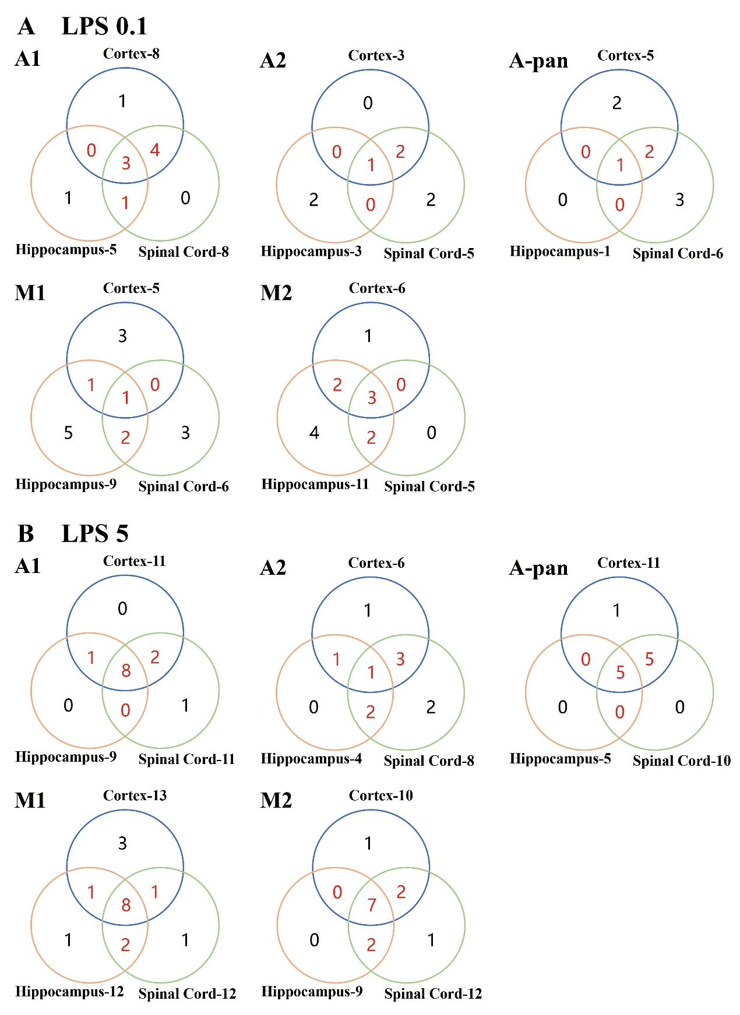
Supplementary Fig. 1 Venn diagrams showing the number of up-regulated genes in the CNTs under LPS 0.1 (A) and 5 (B) exposure. Gene expression of activated astrocytes and microglia in the cortex, hippocampus and spinal cord were analyzed via venn diagrams. Numbers listed besides the tissue represents the total number of up-regulated genes in each tissue [cortex (blue), hippocampus (orange), spinal cord (green)]. The intersections between tissues are marked as red; the other subsets are marked as black.

