Supplementary material – Online Resource 1
Invading bivalves replaced the native Levantine populations with negligible local effects on the benthic community
Rei Diga^{1,2}, Merav Gilboa¹, Raz Moskovich^{1,2}, Neomie Darmon¹, Tal Amit^{1,2} Jonathan Belmaker^{2,3}, Gitai Yahel¹

1- Faculty of Marine Sciences, Ruppin Academic Center, Michmoret, 402970, Israel
2- School of Zoology, George S. Wise Faculty of Life Sciences, Tel-Aviv University, Tel Aviv 6997801, Israel
3- Steinhardt Museum of Natural History, Tel-Aviv University, Tel Aviv 6997801, Israel
Corresponding author E-mail address: diga.boker@gmail.com

S1. Substrate, algae, and invertebrates (>1 cm) categories that were used during the SCUBA surveys along the rocky subtidal outcrops. Invertebrates were classified to high-level taxonomic grouping (phylum or class) to ensure consistency and avoid misidentification problems between samplers.
Group | Category
Substrate | Bare rock
 | Rock cover with loose sediment
Algae | Algae
Invertebrates | Bivalvia
 | Bryozoa
 | Cnidaria
 | Crustacea
 | Gastropoda
 | Porifera
 | Tunicata
 | Unidentified

S2. Algal growth rates in the three treatments (µg Chl-a m⁻² day⁻¹, mean ± 95% CI) in four experiments deployed during spring 2020, fall 2020, and spring 2021.
Deployment date | Duration (days) | Control | Poison | Removal | N
24/02/2020 | 41 | 43.8 ± 15.7 | 34.9 ± 11.3 | 43.6 ± 13 | 8,8,8
05/05/2020 | 22 | 12.5 ± 3.9 | 12.5 ± 3.9 | 16.2 ± 6.2 | 8,8,8
15/09/2020 | 22 | 100.8 ± 25 | 97.5 ± 29.9 | 99.7 ± 31.6 | 16,16,16
19/04/2021 | 22 | 129.7 ± 75.2 | 100.6 ± 23.1 | 196.1 ± 137.7 | 16,15,16

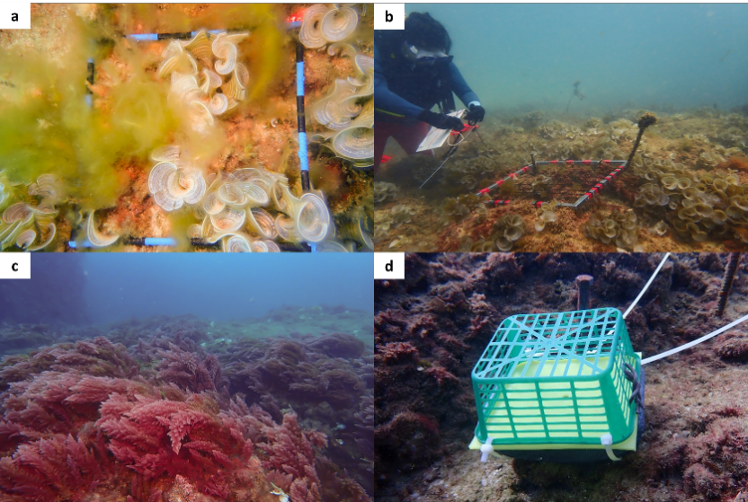
S3. Major macroalgae that were encountered in the experiment site (Gdor, Israel): a-b June-July of 2020 when seasonal algae such as Cladophora spp. (pale green filaments) and Padina spp. (white circular algae) proliferate and create dense meadows. c November 2020 when Asparagopsis sp. (pink with ramified thallus) proliferated and created dense meadows. d Settlement plate to measure macroalgal growth rate attached to the northeast peg of an experimental plot with the green mesh installed to exclude large grazers such as fish or urchins.

S4. Substrate type and algae genera categories that were used for the identification of algae in the photo-quadrat surveys. Identification was made using a designated `source` in the `CoralNet` platform (https://coralnet.ucsd.edu/; source name: Algal composition Michmoret).
Group | Category
Substrate | Bare rock
 | Rock cover with loose sediment
Invertebrate | Sessile invertebrates
Algae | Asparagopsis
 | Cladophora
 | Codium
 | Dictyoya
 | Ellisolandia
 | Halymenia
 | Jania
 | Lobophora
 | Padina
 | Crustose coralline algae
 | Spatoglossum
 | Taonia
 | Turf
 | Other
 | Acetabularia
 | Colpomenia
 | Gracilaria
 | Rhodymenia

S5. Summary statistics of the invertebrates abundance in the three surveys of the experimental plots (July 2020, November 2020, and April 2021). Values are the mean, total observations, and the number of occurrences of each taxon in each treatment. n=16 plots in each treatment.
Month | Taxon | Mean Control | Mean Poison | Mean Removal | Total obs. Control | Total obs. Poison | Total obs. Removal | Occurrence Control | Occurrence Poison | Occurrence Removal
Jul-20 | Aglaophenia sp. | 0 | 0 | 0.06 | 0 | 0 | 1 | 0 | 0 | 1
Jul-20 | Anomura | 0.44 | 0.5 | 0.75 | 7 | 8 | 12 | 3 | 6 | 7
Jul-20 | Aplysia dactylomela | 0 | 0 | 0 | 0 | 0 | 0 | 0 | 0 | 0
Jul-20 | Ascidian 1 | 1.69 | 1.25 | 1.06 | 27 | 20 | 17 | 11 | 10 | 8
Jul-20 | Botrylloides leachii | 0 | 0 | 0.06 | 0 | 0 | 1 | 0 | 0 | 1
Jul-20 | Botrylloides sp. | 1.31 | 0.62 | 0.56 | 21 | 10 | 9 | 8 | 4 | 6
Jul-20 | Bryozoa 2 | 0.25 | 0.12 | 0.38 | 4 | 2 | 6 | 3 | 1 | 5
Jul-20 | Bryozoa 3 | 0.06 | 0.06 | 0 | 1 | 1 | 0 | 1 | 1 | 0
Jul-20 | Bugula neritina | 0 | 0 | 0 | 0 | 0 | 0 | 0 | 0 | 0
Jul-20 | Calcaronea | 0.62 | 0.69 | 0.5 | 10 | 11 | 8 | 9 | 9 | 8
Jul-20 | Calcaronea 2 | 0 | 0 | 0 | 0 | 0 | 0 | 0 | 0 | 0
Jul-20 | Cerithium sp. | 0.25 | 0.38 | 0.25 | 4 | 6 | 4 | 3 | 3 | 3
Jul-20 | Chondrosia sp. | 0.25 | 0.06 | 0.12 | 4 | 1 | 2 | 2 | 1 | 1
Jul-20 | Clathrina sp. | 0 | 0 | 0 | 0 | 0 | 0 | 0 | 0 | 0
Jul-20 | Coryphellina rubrolineata | 0 | 0 | 0 | 0 | 0 | 0 | 0 | 0 | 0
Jul-20 | Crambe crambe | 0.06 | 0.12 | 0.06 | 1 | 2 | 1 | 1 | 1 | 1
Jul-20 | Cystodytes sp. purple | 1.44 | 1.31 | 1.25 | 23 | 21 | 20 | 7 | 8 | 5
Jul-20 | Didemnum orange | 0.06 | 0.62 | 0.19 | 1 | 10 | 3 | 1 | 4 | 2
Jul-20 | Didemnum white | 0.06 | 0.06 | 0.19 | 1 | 1 | 3 | 1 | 1 | 2
Jul-20 | Dysidea sp. | 0.31 | 0.56 | 0.56 | 5 | 9 | 9 | 4 | 6 | 5
Jul-20 | Ecteinascidia thurstoni | 0 | 0 | 0 | 0 | 0 | 0 | 0 | 0 | 0
Jul-20 | Goniobranchus obsoletus | 0.19 | 0 | 0 | 3 | 0 | 0 | 1 | 0 | 0
Jul-20 | Halocordyle sp. | 0.56 | 0.06 | 0.56 | 9 | 1 | 9 | 3 | 1 | 5
Jul-20 | Herdmania momus | 0.12 | 0.19 | 0.25 | 2 | 3 | 4 | 2 | 3 | 4
Jul-20 | Hermodice carunculata | 0.06 | 0 | 0 | 1 | 0 | 0 | 1 | 0 | 0
Jul-20 | Hypselodoris infucata | 0 | 0 | 0 | 0 | 0 | 0 | 0 | 0 | 0
Jul-20 | Levantiniella levantinensis | 0 | 0 | 0.12 | 0 | 0 | 2 | 0 | 0 | 2
Jul-20 | Liosina blastifera | 1 | 0.81 | 1.06 | 16 | 13 | 17 | 9 | 6 | 8
Jul-20 | Macrorhynchia sp. | 0 | 0.06 | 0 | 0 | 1 | 0 | 0 | 1 | 0
Jul-20 | Microcosmus exasperatus | 0.19 | 0.38 | 0.19 | 3 | 6 | 3 | 2 | 5 | 3
Jul-20 | Mycale sp. | 0.12 | 0.06 | 0 | 2 | 1 | 0 | 2 | 1 | 0
Jul-20 | Ophiuroidea | 0 | 0.06 | 0 | 0 | 1 | 0 | 0 | 1 | 0
Jul-20 | Other | 1.12 | 1 | 0.62 | 18 | 16 | 10 | 10 | 8 | 6
Jul-20 | Phallusia nigra | 0.12 | 0.25 | 0.06 | 2 | 4 | 1 | 2 | 4 | 1
Jul-20 | Phidiana militaris | 0.06 | 0 | 0 | 1 | 0 | 0 | 1 | 0 | 0
Jul-20 | Pycnocalvella communis | 0 | 0 | 0 | 0 | 0 | 0 | 0 | 0 | 0
Jul-20 | Pyura dura | 0 | 0 | 0 | 0 | 0 | 0 | 0 | 0 | 0
Jul-20 | Sabella sp. | 0.12 | 0.19 | 0.31 | 2 | 3 | 5 | 2 | 2 | 2
Jul-20 | Sarcotragus sp. | 0.31 | 0.19 | 0.25 | 5 | 3 | 4 | 5 | 3 | 4
Jul-20 | Schizoporella errata | 0.19 | 0.25 | 0.19 | 3 | 4 | 3 | 3 | 3 | 3
Jul-20 | Serpula sp. | 2.81 | 3.38 | 2.31 | 45 | 54 | 37 | 14 | 15 | 14
Jul-20 | Sponge 2 | 0.06 | 0 | 0 | 1 | 0 | 0 | 1 | 0 | 0
Jul-20 | Sponge 3 | 0 | 0 | 0 | 0 | 0 | 0 | 0 | 0 | 0
Jul-20 | Styela canopus | 0 | 0 | 0.06 | 0 | 0 | 1 | 0 | 0 | 1
Jul-20 | Symplegma bahraini | 0 | 0 | 0.06 | 0 | 0 | 1 | 0 | 0 | 1
Jul-20 | Tethya aurantium | 0.06 | 0.06 | 0 | 1 | 1 | 0 | 1 | 1 | 0
Jul-20 | Unidentified bryozoa | 0.12 | 0.12 | 0 | 2 | 2 | 0 | 1 | 2 | 0
Jul-20 | Unidentified sponge | 0.06 | 0.06 | 0.31 | 1 | 1 | 5 | 1 | 1 | 4
Jul-20 | Unidentified tunicata | 0.19 | 0.19 | 0 | 3 | 3 | 0 | 3 | 3 | 0
Nov-20 | Aglaophenia sp. | 0.19 | 0.19 | 0 | 3 | 3 | 0 | 3 | 3 | 0
Nov-20 | Anomura | 0.25 | 0.25 | 0.31 | 4 | 4 | 5 | 3 | 3 | 3
Nov-20 | Aplysia dactylomela | 0 | 0 | 0 | 0 | 0 | 0 | 0 | 0 | 0
Nov-20 | Ascidian 1 | 1.94 | 1.62 | 1.19 | 31 | 26 | 19 | 12 | 12 | 10
Nov-20 | Botrylloides leachii | 0 | 0 | 0.06 | 0 | 0 | 1 | 0 | 0 | 1
Nov-20 | Botrylloides sp. | 0 | 0 | 0 | 0 | 0 | 0 | 0 | 0 | 0
Nov-20 | Bryozoa 2 | 0 | 0.06 | 0.19 | 0 | 1 | 3 | 0 | 1 | 3
Nov-20 | Bryozoa 3 | 0 | 0.06 | 0 | 0 | 1 | 0 | 0 | 1 | 0
Nov-20 | Bugula neritina | 0 | 0 | 0 | 0 | 0 | 0 | 0 | 0 | 0
Nov-20 | Calcaronea | 1.75 | 1.31 | 1 | 28 | 21 | 16 | 13 | 10 | 6
Nov-20 | Calcaronea 2 | 0 | 0.06 | 0.06 | 0 | 1 | 1 | 0 | 1 | 1
Nov-20 | Cerithium sp. | 1.44 | 0.88 | 1.69 | 23 | 14 | 27 | 7 | 6 | 10
Nov-20 | Chondrosia sp. | 0.12 | 0 | 0 | 2 | 0 | 0 | 1 | 0 | 0
Nov-20 | Clathrina sp. | 0 | 0 | 0 | 0 | 0 | 0 | 0 | 0 | 0
Nov-20 | Coryphellina rubrolineata | 0 | 0 | 0 | 0 | 0 | 0 | 0 | 0 | 0
Nov-20 | Crambe | 0.12 | 0.06 | 0 | 2 | 1 | 0 | 2 | 1 | 0
Nov-20 | Cystodytes sp. purple | 1.44 | 1.94 | 1.06 | 23 | 31 | 17 | 7 | 7 | 6
Nov-20 | Didemnum orange | 0 | 0.06 | 0 | 0 | 1 | 0 | 0 | 1 | 0
Nov-20 | Didemnum white | 0.12 | 0.06 | 0.12 | 2 | 1 | 2 | 2 | 1 | 2
Nov-20 | Dysidea sp. | 0.19 | 0.19 | 0.19 | 3 | 3 | 3 | 3 | 2 | 2
Nov-20 | Ecteinascidia thurstoni | 0 | 0 | 0 | 0 | 0 | 0 | 0 | 0 | 0
Nov-20 | Goniobranchus obsoletus | 0 | 0 | 0 | 0 | 0 | 0 | 0 | 0 | 0
Nov-20 | Halocordyle sp. | 0.06 | 0.06 | 0 | 1 | 1 | 0 | 1 | 1 | 0
Nov-20 | Herdmania momus | 0 | 0 | 0 | 0 | 0 | 0 | 0 | 0 | 0
Nov-20 | Hermodice carunculata | 0 | 0 | 0 | 0 | 0 | 0 | 0 | 0 | 0
Nov-20 | Hypselodoris infucata | 0 | 0 | 0 | 0 | 0 | 0 | 0 | 0 | 0
Nov-20 | Levantiniella levantinensis | 0.25 | 0.12 | 0.12 | 4 | 2 | 2 | 4 | 2 | 2
Nov-20 | Liosina blastifera | 1.56 | 1.75 | 1.25 | 25 | 28 | 20 | 14 | 11 | 10
Nov-20 | Macrorhynchia sp. | 0.06 | 0.12 | 0.12 | 1 | 2 | 2 | 1 | 1 | 1
Nov-20 | Microcosmus exasperatus | 0.19 | 0.06 | 0.25 | 3 | 1 | 4 | 2 | 1 | 4
Nov-20 | Mycale sp. | 0 | 0.38 | 0.12 | 0 | 6 | 2 | 0 | 3 | 1
Nov-20 | Ophiuroidea | 0 | 0 | 0 | 0 | 0 | 0 | 0 | 0 | 0
Nov-20 | Other | 0 | 0 | 0 | 0 | 0 | 0 | 0 | 0 | 0
Nov-20 | Phallusia nigra | 0.25 | 0.69 | 0.12 | 4 | 11 | 2 | 3 | 7 | 2
Nov-20 | Phidiana militaris | 0.12 | 0 | 0 | 2 | 0 | 0 | 2 | 0 | 0
Nov-20 | Pycnocalvella communis | 0 | 0 | 0 | 0 | 0 | 0 | 0 | 0 | 0
Nov-20 | Pyura dura | 0.12 | 0.31 | 0.31 | 2 | 5 | 5 | 2 | 4 | 5
Nov-20 | Sabella sp. | 0.75 | 0.5 | 0.44 | 12 | 8 | 7 | 6 | 3 | 4
Nov-20 | Sarcotragus sp. | 0.38 | 0.12 | 0.31 | 6 | 2 | 5 | 6 | 2 | 5
Nov-20 | Schizoporella errata | 0.06 | 0.12 | 0.06 | 1 | 2 | 1 | 1 | 2 | 1
Nov-20 | Serpula sp. | 2.06 | 3 | 1.62 | 33 | 48 | 26 | 13 | 14 | 13
Nov-20 | Sponge 2 | 0 | 0 | 0 | 0 | 0 | 0 | 0 | 0 | 0
Nov-20 | Sponge 3 | 0.19 | 0.06 | 0.19 | 3 | 1 | 3 | 3 | 1 | 3
Nov-20 | Styela canopus | 0 | 0 | 0.06 | 0 | 0 | 1 | 0 | 0 | 1
Nov-20 | Symplegma bahraini | 0.5 | 0.06 | 0 | 8 | 1 | 0 | 3 | 1 | 0
Nov-20 | Tethya aurantium | 0 | 0 | 0 | 0 | 0 | 0 | 0 | 0 | 0
Nov-20 | Unidentified bryozoa | 0 | 0 | 0 | 0 | 0 | 0 | 0 | 0 | 0
Nov-20 | Unidentified sponge | 0.62 | 0.56 | 0.75 | 10 | 9 | 12 | 9 | 7 | 9
Nov-20 | Unidentified tunicata | 0.06 | 0.12 | 0.06 | 1 | 2 | 1 | 1 | 2 | 1
Apr-21 | Aglaophenia sp. | 0.88 | 0.94 | 0.69 | 14 | 15 | 11 | 13 | 12 | 11
Apr-21 | Anomura | 0.31 | 0.38 | 0 | 5 | 6 | 0 | 4 | 5 | 0
Apr-21 | Aplysia dactylomela | 0.06 | 0 | 0 | 1 | 0 | 0 | 1 | 0 | 0
Apr-21 | Ascidian 1 | 1.44 | 1.06 | 0.56 | 23 | 17 | 9 | 11 | 11 | 5
Apr-21 | Botrylloides leachii | 0 | 0 | 0 | 0 | 0 | 0 | 0 | 0 | 0
Apr-21 | Botrylloides sp. | 0 | 0 | 0 | 0 | 0 | 0 | 0 | 0 | 0
Apr-21 | Bryozoa 2 | 0.44 | 0.5 | 0.25 | 7 | 8 | 4 | 6 | 6 | 3
Apr-21 | Bryozoa 3 | 0.06 | 0 | 0 | 1 | 0 | 0 | 1 | 0 | 0
Apr-21 | Bugula neritina | 0.44 | 0.38 | 0.44 | 7 | 6 | 7 | 7 | 6 | 7
Apr-21 | Calcaronea | 3.31 | 5.06 | 2.44 | 53 | 81 | 39 | 14 | 12 | 12
Apr-21 | Calcaronea 2 | 0.44 | 0.25 | 0.12 | 7 | 4 | 2 | 5 | 3 | 2
Apr-21 | Cerithium sp. | 0.12 | 0.19 | 0.31 | 2 | 3 | 5 | 2 | 3 | 3
Apr-21 | Chondrosia sp. | 0.06 | 0 | 0.06 | 1 | 0 | 1 | 1 | 0 | 1
Apr-21 | Clathrina sp. | 1.94 | 2.06 | 1.06 | 31 | 33 | 17 | 10 | 10 | 9
Apr-21 | Coryphellina rubrolineata | 0 | 0.12 | 0.06 | 0 | 2 | 1 | 0 | 2 | 1
Apr-21 | Crambe | 0.06 | 0.19 | 0.06 | 1 | 3 | 1 | 1 | 2 | 1
Apr-21 | Cystodytes sp. purple | 2.06 | 1.88 | 1.38 | 33 | 30 | 22 | 8 | 11 | 6
Apr-21 | Didemnum orange | 0 | 0.44 | 0.12 | 0 | 7 | 2 | 0 | 2 | 2
Apr-21 | Didemnum white | 0 | 0.06 | 0 | 0 | 1 | 0 | 0 | 1 | 0
Apr-21 | Dysidea sp. | 0.31 | 0.69 | 0.19 | 5 | 11 | 3 | 4 | 8 | 3
Apr-21 | Ecteinascidia thurstoni | 0 | 0.06 | 0 | 0 | 1 | 0 | 0 | 1 | 0
Apr-21 | Goniobranchus obsoletus | 0 | 0 | 0 | 0 | 0 | 0 | 0 | 0 | 0
Apr-21 | Halocordyle sp. | 0 | 0 | 0 | 0 | 0 | 0 | 0 | 0 | 0
Apr-21 | Herdmania momus | 0 | 0 | 0 | 0 | 0 | 0 | 0 | 0 | 0
Apr-21 | Hermodice carunculata | 0 | 0 | 0 | 0 | 0 | 0 | 0 | 0 | 0
Apr-21 | Hypselodoris infucata | 0 | 0.06 | 0.06 | 0 | 1 | 1 | 0 | 1 | 1
Apr-21 | Levantiniella levantinensis | 0 | 0 | 0 | 0 | 0 | 0 | 0 | 0 | 0
Apr-21 | Liosina blastifera | 0.75 | 0.38 | 0.44 | 12 | 6 | 7 | 8 | 4 | 4
Apr-21 | Macrorhynchia sp. | 0 | 0 | 0.56 | 0 | 0 | 9 | 0 | 0 | 2
Apr-21 | Microcosmus exasperatus | 0.19 | 0.06 | 0 | 3 | 1 | 0 | 2 | 1 | 0
Apr-21 | Mycale sp. | 0 | 0 | 0.06 | 0 | 0 | 1 | 0 | 0 | 1
Apr-21 | Ophiuroidea | 0 | 0 | 0 | 0 | 0 | 0 | 0 | 0 | 0
Apr-21 | Other | 0 | 0 | 0 | 0 | 0 | 0 | 0 | 0 | 0
Apr-21 | Phallusia nigra | 0.06 | 0.25 | 0.06 | 1 | 4 | 1 | 1 | 3 | 1
Apr-21 | Phidiana militaris | 0.19 | 0 | 0.12 | 3 | 0 | 2 | 3 | 0 | 2
Apr-21 | Pycnocalvella communis | 0 | 0.19 | 0.31 | 0 | 3 | 5 | 0 | 2 | 4
Apr-21 | Pyura dura | 0 | 0 | 0 | 0 | 0 | 0 | 0 | 0 | 0
Apr-21 | Sabella sp. | 1.19 | 0.94 | 0.88 | 19 | 15 | 14 | 4 | 8 | 6
Apr-21 | Sarcotragus sp. | 0.12 | 0.06 | 0.06 | 2 | 1 | 1 | 2 | 1 | 1
Apr-21 | Schizoporella errata | 0.06 | 0.12 | 0.06 | 1 | 2 | 1 | 1 | 2 | 1
Apr-21 | Serpula sp. | 2 | 2.38 | 1.31 | 32 | 38 | 21 | 15 | 15 | 12
Apr-21 | Sponge 2 | 0 | 0 | 0 | 0 | 0 | 0 | 0 | 0 | 0
Apr-21 | Sponge 3 | 0 | 0.06 | 0 | 0 | 1 | 0 | 0 | 1 | 0
Apr-21 | Styela canopus | 0 | 0 | 0 | 0 | 0 | 0 | 0 | 0 | 0
Apr-21 | Symplegma bahraini | 0 | 0 | 0.06 | 0 | 0 | 1 | 0 | 0 | 1
Apr-21 | Tethya aurantium | 0.06 | 0.06 | 0 | 1 | 1 | 0 | 1 | 1 | 0
Apr-21 | Unidentified bryozoa | 0.12 | 0 | 0.06 | 2 | 0 | 1 | 2 | 0 | 1
Apr-21 | Unidentified sponge | 0.12 | 0.19 | 0.12 | 2 | 3 | 2 | 2 | 2 | 2
Apr-21 | Unidentified tunicata | 0.06 | 0.06 | 0 | 1 | 1 | 0 | 1 | 1 | 0

S6. The substrate, algae and invertebrates categories used during PIM surveys in the treatment plots.
Group | Category
Substrate | Bare rock
 | Rock cover with loose sediment
Algae | CCA
 | Algae < 2 cm
 | Algae > 2 cm
Invertebrates | Bivalvia
 | Bryozoa
 | Cnidaria
 | Crustacea
 | Gastropoda
 | Polychaeta
 | Porifera
 | Tunicata colony
 | Tunicata solitary
 | Unidentified

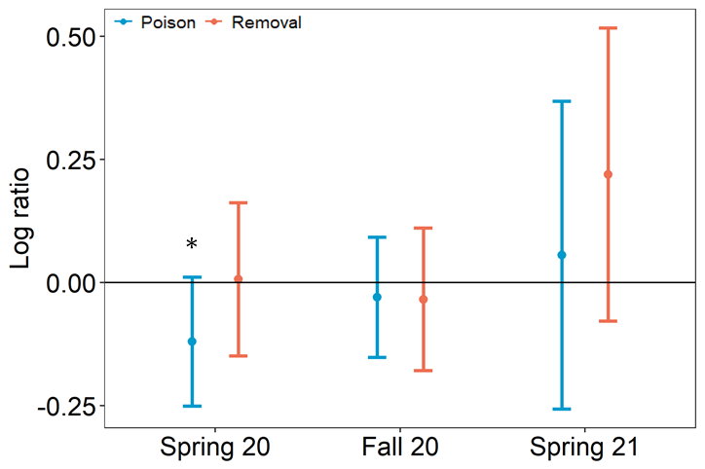
S7. Comparison of algae growth rates in poison (blue) and removal (red) treatments to the growth rate of the controls. Data are presented as the mean ± 95% CI of the log of the ratio of the treatment growth rate to the control of the same triplet. Means were calculated across all seasons. Black horizontal line represents the expected log of the ratio assuming no treatment effects (no difference between the treatment and the control). *- represents difference from control (Friedman test, p = 0.04).

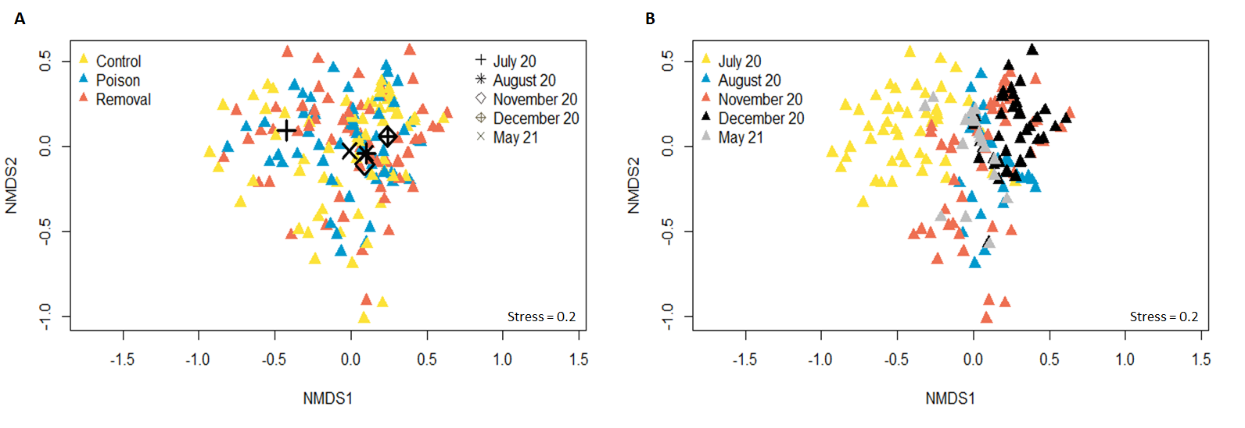 S8. nMDS ordinations of the macroalgae community in five different surveys. A. Colors represent the treatments: control (yellow), poisoning (blue), and removal (red). Black symbols represent the centroids of each month. B. Colors represent the months during which the survey was conducted. Data was log transformed and the similarity matrix was calculated using Bray Curtis index. k=2.

S9. Summary of SIMPER analysis of dissimilarities in the macroalgae community between three treatments (poison, removal, and control). On top left is the total average dissimilarity (%) between paired groups and below is the component of the analysis: average abundance in each group, average contribution (%) for the dissimilarity between groups, the consistency of a species contribution (average to Sd ratio), average contribution to the total dissimilarity, and cumulative contributors to dissimilarity (with a 95% cutoff).
Groups Poison & Removal
Average dissimilarity = 20.38
 | Group Poison | Group Removal
Species | Av.Abund | Av.Abund | Av.Diss | Diss/SD |  | Contrib% |  | Cum.%
Turf | 81.31 | 79.68 | 7.95 | 1.14 |  | 39.02 |  | 39.02
Cldph | 2.36 | 3.03 | 2.57 | 0.45 |  | 12.61 |  | 51.63
AspaTax | 2.49 | 2.42 | 2.41 |  | 0.36 |  | 11.82 |  | 63.44
Jania | 3.74 | 3.28 | 2.26 | 1.04 |  | 11.11 |  | 74.55
Padina | 1.74 | 2.71 | 2.04 | 0.57 |  | 10 |  | 84.55
Ellis | 1.8 | 1.49 | 1.53 | 0.52 |  | 7.49 |  | 92.05
Cod | 0.23 | 1.9 | 1.05 | 0.39 |  | 5.14 |  | 97.19
Groups Poison & Control
Average dissimilarity = 25.56
 | Group Poison | Group Control
Species | Av.Abund | Av.Abund | Av.Diss | Diss/SD |  | Contrib% |  | Cum.%
Turf | 81.31 | 72.06 | 10 | 1.09 |  | 39.13 |  | 39.13
AspaTax | 2.49 | 6.81 | 4.49 | 0.45 |  | 17.55 |  | 56.68
Cldph | 2.36 | 4.9 | 3.48 | 0.46 |  | 13.62 |  | 70.3
Jania | 3.74 | 5.39 | 2.84 | 1.02 |  | 11.12 |  | 81.43
Padina | 1.74 | 2.79 | 2.09 | 0.53 |  | 8.17 |  | 89.59
Ellis | 1.8 | 2.19 | 1.82 | 0.61 |  | 7.11 |  | 96.7
Groups Removal & Control
Average dissimilarity = 26.87
 | Group Removal | Group Control
Species | Av.Abund | Av.Abund | Av.Diss | Diss/SD |  | Contrib% |  | Cum.%
Turf | 79.68 | 72.06 | 10.2 | 1.08 |  | 37.96 |  | 37.96
AspaTax | 2.42 | 6.81 | 4.46 | 0.43 |  | 16.6 |  | 54.57
Cldph | 3.03 | 4.9 | 3.74 | 0.48 |  | 13.93 |  | 68.49
Jania | 3.28 | 5.39 | 2.75 | 1.02 |  | 10.25 |  | 78.75
Padina | 2.71 | 2.79 | 2.47 | 0.58 |  | 9.2 |  | 87.94
Ellis | 1.49 | 2.19 | 1.64 | 0.65 |  | 6.09 |  | 94.03
Cod | 1.9 | 0.27 | 1.07 | 0.4 |  | 3.99 |  | 98.02

S10. Estimated regression parameters, 95% confidence interval, and p-values for the percent cover GLM of major algae taxa. The response was the taxa percent cover and predictors were treatment and months. Plot id was used as random effects (to account for the repeated measure nature of the design). Negative values in the estimated parameter indicate a decline in treated plots compared to the control. Significant parameters are in bold. Superscript numerals represent cases where the model assumptions were violated: †- Kolmogorov-Smirnov normality test, ‡- homoscedasticity.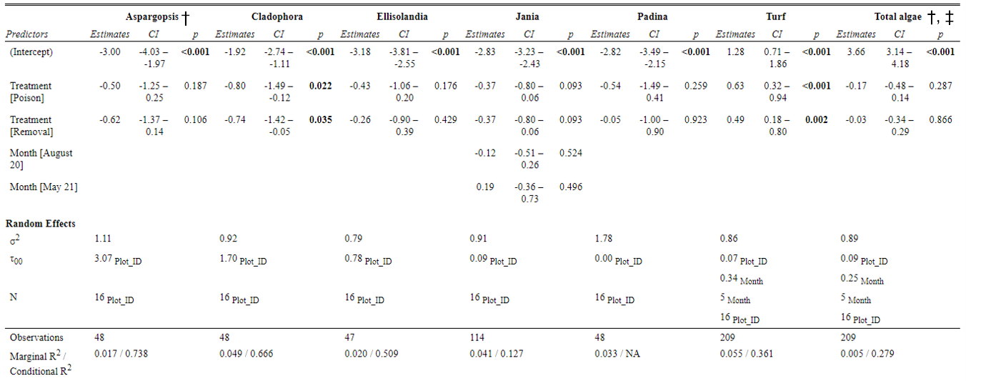

S11. Estimated regression parameters, 95% CI and p-values for invertebrate percent cover, richness, Shannon- Wiener diversity (H’), number of individual and multivariate dispersion index (MVDISP) extracted from GLM’s. Negative values in the estimate parameter indicate a decline in treated plots compared to the control. Significant parameters are in bold. †- indicate that the dispersion assumption was violated.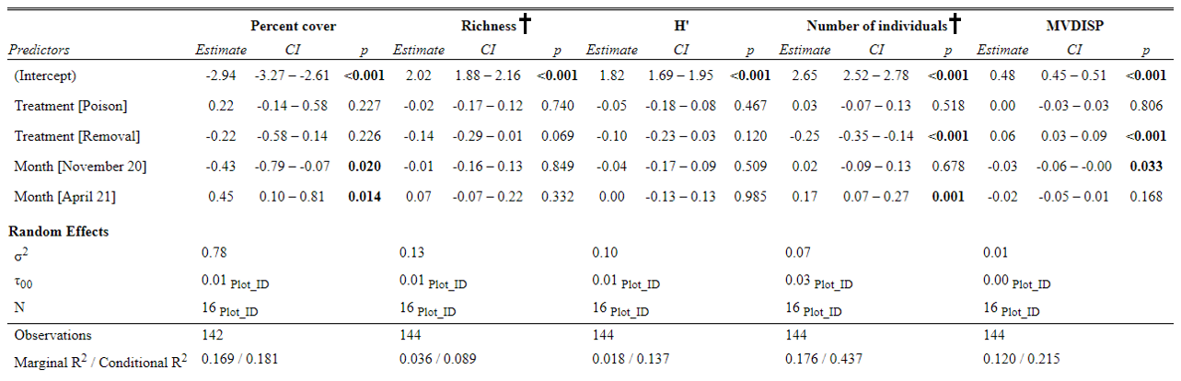
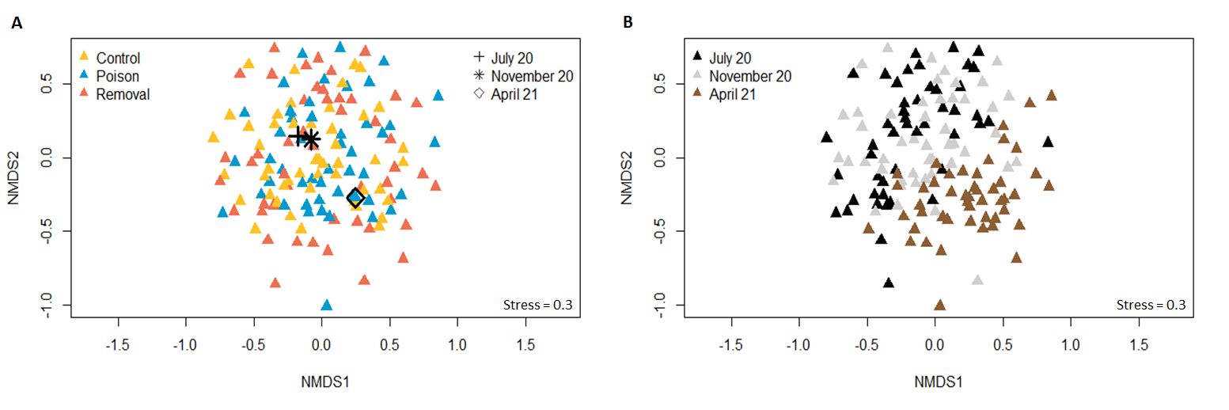

S12. nMDS ordinations of the invertebrates’ community in three different surveys. A. Colors represent the treatments: control (yellow), poisoning (blue), and removal (red). Black symbols represent the centroids of each survey. B. Colors represent the months that each survey was conducted. Data was log transformed and the similarity matrix was calculated using Bray Curtis index. k=2.

