Can humans become more random?
Sook Mun Wong^{1,2,4}, Garance Merholz^{1,7}, Uri Maoz^{1,2,3,5,6*},

¹ Department of Psychology, University of California Los Angeles, Los Angeles, CA, USA
² Institute for Interdisciplinary Brain and Behavioral Sciences, Chapman University, Irvine, CA
³ Department of Psychology, Crean College of Health and Behavioral Sciences, Chapman University, Orange, CA
⁴ Computational and Data Sciences, Schmid College of Science and Technology, Chapman University, Orange, CA
⁵ Anderson School of Management, University of California Los Angeles, Los Angeles, CA, USA
⁶ Biology and Bioengineering, California Institute of Technology, Pasadena, CA, USA
⁷ Université de Paris, CNRS, Integrative Neuroscience and Cognition Center, F-75006 Paris, France

* Corresponding Author:
Uri Maoz
Chapman University, One University Drive, Orange, CA 92866

Email address: maoz@chapman.edu

Supplementary Tables and Figures

Supplementary Table 1. OLS regression of average run-length on LZC score for all experiment parts and conditions combined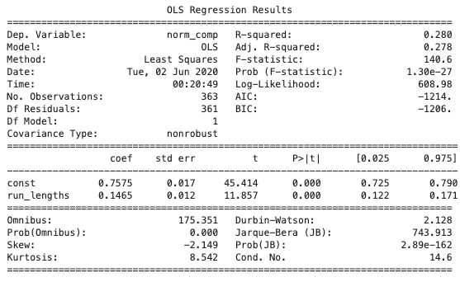
Supplementary Figure 1. Regression plot of average run-length on LZC score for all experiment parts and conditions combined
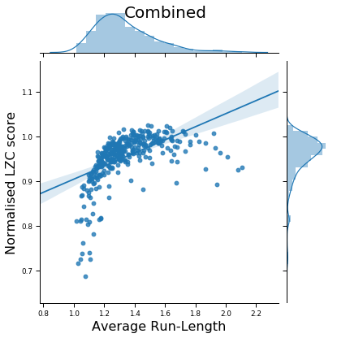

Supplementary Table 2. OLS regression of average run-length on LZC score for the pre-game part of the experiment.
Supplementary Figure 2. Regression plot of average run-length on LZC score for the pre-game part of the experiment.
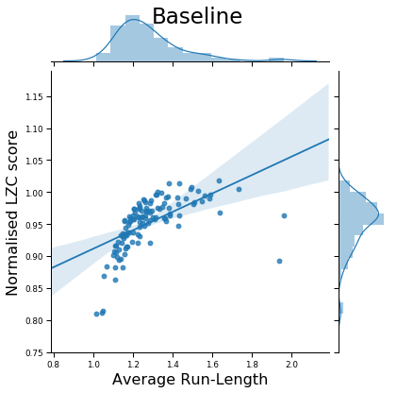
Supplementary Table 3. OLS regression of average run-length on LZC score for the game part of the experiment.
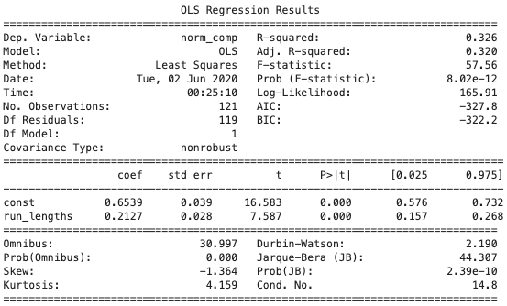
Supplementary Figure 3. Regression plot of average run-length on LZC score for the game part of the experiment.
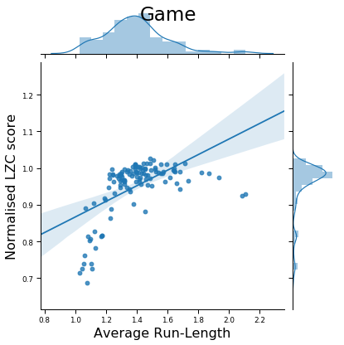

Supplementary Table 4. OLS regression of average run-length on LZC score for the game part of the experiment.
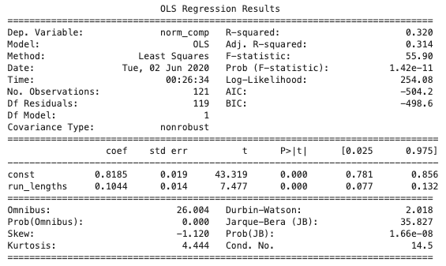

Supplementary Figure 4. Regression plot of average run-length on LZC score for the game part of the experiment.
