Supplementary Information

An Unprecedented Chalcogenide-cluster-based Semiconducting Nanotube Array with Oriented Photoconductive Behavior

Tang et al.

Experimental Section
All chemicals were analytical grade and purchased form Sinopharm Chemical Reagent Co., Ltd. Germanium dioxide (GeO₂, 99.99%), copper acetate hydrate (Cu(Ac)₂·H₂O, 99%), cadmium acetate dihydrate (Cd(Ac)₂·2H₂O, ≥98%), selenium powder (Se, ≥99.99%), deionized water (H₂O), (±)-2-amino-1-butanol (2-AB, 98%), 1,8-diazabicyclo[5.4.0]undec-7-ene (DBU, 99%), potassium sulfide (K₂S, 99%) and were all used without any further purification.
Synthesis of compound 1. Germanium dioxide (54 mg, 0.52 mmol), copper acetate hydrate (50 mg, 0.25 mmol), selenium powder (240 mg, 3.04 mmol), potassium sulfide (90 mg, 0.82 mmol), DBU (2.00 mL), (±)-2-amino-1-butanol (1.00 mL) and deionized water (1.00 mL) were mixed in a 25 mL Teflon-lining stainless steel and stirred for 30 min, then heated to 180 ºC for 9 days. After cooling down to room temperature, a small amount of red rod crystals was obtained by sonication treatment in ethyl alcohol (yield: < 1%, based on Cu element).
Synthesis of compound 2. Germanium dioxide (104 mg, 0.99 mmol), cadmium acetate dihydrate (72 mg, 0.27 mmol), selenium powder (180 mg, 2.28 mmol), potassium sulfide (90 mg, 0.82 mmol), DBU (2.00 mL), (±)-2-amino-1-butanol (1.00 mL) and deionized water (1.00 mL) were mixed in a 25 mL Teflon-lining stainless steel and stirred for 30 min, then heated to 180 ºC for 9 days. After cooling down to room temperature, a small amount of yellow rod crystals was obtained by sonication treatment in ethyl alcohol.
Single-Crystal X-ray Diffraction Characterization. The single-crystal X-ray diffraction measurements on compound 1 and 2 were performed on a Bruker Smart CPAD area diffractometer with nitrogen-flow temperature controller using graphite mono-chromated Mo-Kα (λ = 0.71073 Å) radiation at 120 K. The structure was solved by direct method using SHELXS-2014 and the refinement against all reflections of the compound was performed using SHELXL-2014. In these structures, some cations and free solvent molecules were highly disordered and could not be located. The diffuse electron densities resulting from these residual cations and solvent molecules were removed from the data set using the SQUEEZE routine of PLATON and refined further using the data generated.
Powder X-ray Diffraction Characterization. The Powder X-ray Diffraction (PXRD) data were collected on a desktop diffractometer (D2 PHASER, Bruker, Germany) using Cu-Kα (λ=1.54184 Å) radiation operated at 30 kV and 10 mA. The samples were ground into fine powders for several minutes before the test.
XPS Measurements. X-ray photoelectron spectroscopy (XPS) was collected with an ESCALAB 250Xi apparatus equipped with a monochromatic Al Kα X-ray source.
Elemental Analysis. Energy dispersive spectroscopy (EDS) analysis was performed on scanning electron microscope (SEM) equipped with energy dispersive spectroscopy detector. An accelerating voltage of 25 kV and 40 s accumulation time were applied. EDS results clearly confirmed the presence of Cu, Ge, K and Se elements. Elemental analysis (EA) of C, H, and N was performed on VARIDEL III elemental analyzer. (compound 1, Calc. (wt %): C 0, N 0, H 0.16; Found (wt %), C 0.73, N 0.09, H 0.36). The content deviation could be ascribed to some impurities formed in the solvothermal reaction.
Thermogravimetric Measurement. A Shimadzu TGA-50 thermal analyzer was used to measure the thermogravimetric (TG) curve by heating the sample from room temperature to 800 ℃ with heating rate of 10 ℃/min under N₂ flow.
UV–Vis Absorption. Room-temperature solid-state UV-Vis diffusion reflectance spectra of 1 and 2 were measured on a SHIMADZU UV-3600 UV-Vis-NIR spectrophotometer coupled with an integrating sphere by using BaSO₄ powder as the reflectance reference. The bandgap for 1 and 2 were calculated through the Kubelka–Munk function and the equation for which is given as
$$\frac{\text{K}}{\text{S}}\text{ = }\text{F}\left(\text{R}\right)\text{ = }\frac{{\text{(1 -}\text{ R}\text{)}}^{\text{2}}}{\text{2}\text{R}}$$
where K is the absorption coefficient, S is a scattering factor, R is the reflectance and F(R) is the KM function. The band gap for the 1 and 2 can be determined from the Tauc plot with [F(R) ×hυ]^{0.5} vs. hυ by extrapolating the linear region to the abscissa.

Supplementary Table 1. The structure refinement parameters on 1.
Compound | 1
Empirical formula | K₄Cu₂Ge₃Se₉(H₂O)
Formula weight | 1229.91
Crystal morphology | rod
Crystal system | Trigonal
Space group | R-3
Z | 18
T/K | 120.02
λ/Å | 0.71073
a/Å | 40.276(2)
b/Å | 40.276(2)
c/Å | 7.4318(5)
α/º | 90
β/º | 90
γ/º | 120
V/Å³ | 10440.3(13)
D (g/cm³) | 3.521
μ/mm^{‑1} | 20.469
F(000) | 9828.0
Collected reflections | 18706
Independent reflections | 4521
GOF on F² | 1.023
R₁, wR₂ (I>2σ(I)) | R₁ = 0.0561, wR₂ = 0.1560
R₁, wR₂ (all data) | R₁ = 0.0782, wR₂ = 0.1702

Supplementary Table 2. Summary of the detailed structure information of inorganic and inorganic-organic-hybrid crystalline nanotube arrays reported previously.
Cases | Framework Charge | Guest Units and Distribution |  | Inside Diameter (Å) | Ref.
 |  | In | Out
K₄Cu₂Ge₃Se₉(H₂O) | Negative | K⁺, H₂O | K⁺ | 12.9 × 19.9 | This work
Na₂V₃O₇ | Negative | Na⁺ | Na⁺ | ~5 | 1
K₅[(UO₂)₃(SeO₄)₅](NO₃)(H₂O)_{3.5} | Negative | K⁺, H₂O | K⁺, H₂O, NO₃⁻ | 7.4 | 2
(H₃O)₈[(H₃O)@([18]crown-6)]₂ [(UO₂)₁₄(SO₄)₁₉(H2O)₄](H₂O)_{20.5} | Negative | [(H₃O)@([18]  crown-6)]⁺, H₂O | [(H₃O)@([18]crown-6)]⁺, H₂O | 8.8 | 3
(H₃O)₂K[(H₃O)@([18]crown-6)] [(UO₂)₃(SeO₄)₅](H₂O)₄ | Negative | K⁺, H₂O | [(H₃O)@([18]crown-6)]⁺, H₂O | 7.4
(Pr₂DABCO)₂₁[Pb₁₈I₅₄(I₂)₉]-[Pb₂I₉]₂I₅·13H₂O | Negative | I⁻, H₂O | (Pb₂I₉)⁵⁻, H₂O, (Pr₂DABCO)²⁺ | 13.2 | 4
{(EMIm)₃[(H₂O)⊂Ti₆O₆(μ₂–OH)₃(SO₄)₆]}_{n} | Negative | H₂O | EMIm | 5 | 5
Ba₅[(UO₂)(PO₄)₃(B₅O₉)]·nH₂O | Negative | Ba²⁺, H₂O | - | 6 | 6
[Ni(1,2-PDA)₃]₂ (HOCH₂CH₂CH₂NH₃)₃(H₃O)₂ [Ge₇O₁₄X₃]₃ | Negative | - | [Ni(1,2-PDA)₃]²⁺, HOC₃H₆NH₃⁺, H₃O⁺ | 8.1 × 5.2 | 7
Na₂EuSiSe₄ | Negative | Na⁺ | Na⁺ | 4.05 | 8
(C₄H₁₂N)₁₄[(UO₂)₁₀(SeO₄)₁₇(H₂O)] | Negative | (C₄H₁₂N)⁺ | H₂O, (C₄H₁₂N)⁺ | 15.3 | 9
SbPS_{4-x}Se_{x} | Neutral | - | - | 2.3 × 3 | 10
Na_{1.515}EuGeS₄ | Negative | - | Na⁺ | 4.47 | 11
[H₂en]₄[Ni₅(OH)₃(trzS)₃(en)(H₂O)(B-α-PW₉O₃₄)]·6H₂O | Negative | [H₂en]²⁺ | - | 15 | 12
[{[Cd(apab)₂(H₂O)]₃-(MOH)·G}_{n}] | Neutral | - | - | 14 | 13
Mg₂(H₂O)₂(bptc) | Neutral | - | - | ~10 | 14
Zn₂(bptc)₂· (H₃NEt)₄·(H₂O)₇ | Negative | H₃NEt⁺, H₂O | - | 11.59
[(CH₃)₂NH₂][In(cdc)(thb)]·2DMF·9.5H₂O | Negative | [(CH₃)₂NH₂]⁺, H₂O | - | 22.85 | 15
[(CH₃)₂NH₂][In(cdc)(H-btc)]·2DMA·11H₂O | Negative | [(CH₃)₂NH₂]⁺, H₂O | - | 11.50

Supplementary Table 3. The structure refinement parameters on 2.
Compound | 2
Empirical formula | K₄CdGe₃Se₉(H₂O)_{n}
Formula weight | 2398.67
Crystal morphology | rod
Crystal system | Monoclinic
Space group | Cc
Z | 4
T/K | 120.08
λ/Å | 0.71073
a/Å | 12.9045(8)
b/Å | 17.6422(11)
c/Å | 20.9144(13)
α/º | 90
β/º | 98.894(2)
γ/º | 90
V/Å³ | 4704.2(5)
D (g/cm³) | 3.387
μ/mm^{‑1} | 19.304
F(000) | 4217.0
Collected reflections | 24204
Independent reflections | 8331
GOF on F² | 1.031
R₁, wR₂ (I>2σ(I)) | R₁ = 0.0590, wR₂ = 0.1463
R₁, wR₂ (all data) | R₁ = 0.0665, wR₂ = 0.1516

Supplementary Table 4. Summary of conductivity and activation energy of related materials previously reported.
Cases | Room temperature Conductivity (S·cm⁻¹) | Activation energy (eV) | Ref.
1 | 7.6 × 10⁻⁶ | 0.52 | This  work
2 | 1.89 × 10⁻⁹ | 0.64
[Pb₁₈I₅₄(I₂)₉][Pb₂I₉]₂I₅ | 8 × 10⁻¹⁰ | 0.54 | 4
[(H₂O)(Ti₆O₆(OH)₃(SO₄)₆] | 3.15 × 10⁻¹⁰ | 0.9 | 5
(AuAg)_{34n} | 1.49 × 10⁻⁷ | NAª | 16
IOS-1 | 3 × 10⁻⁹ | 0.34 | 17
(EDBE)[CuCl₄] | 1.8 × 10⁻⁹ | NA | 18
PhSeAg | 2.93 × 10⁻¹¹ | 0.63 | 19
Cu(SPh-OH) | 1.21×10⁻³ | NA | 20
Cu(SPh-COOH) | 4.58×10⁻⁹ | NA
Cu₃(HITP)₂ | 0.75 | 0.065 | 21
ª NA means not available

Supplementary Table 5. Summary of parameters of photodetectors at different wavelengths.
Wavelength (nm) | R_{λ}  (A W⁻¹ cm⁻²) | D*  (Jones) | EQE
400 | 1.92 × 10⁻⁴ | 8.06 × 10⁷ | 5.95 × 10⁻¹³
450 | 2.02 × 10⁻⁴ | 8.44 × 10⁷ | 5.57 × 10⁻¹³
500 | 2.22 × 10⁻⁴ | 9.10 × 10⁷ | 5.51 × 10⁻¹³
550 | 2.42 × 10⁻⁴ | 9.85 × 10⁷ | 5.46 × 10⁻¹³
600 | 2.62 × 10⁻⁴ | 1.05 × 10⁸ | 5.43 × 10⁻¹³
650 | 2.42 × 10⁻⁴ | 9.67 × 10⁷ | 4.62 × 10⁻¹³
700 | 2.19 × 10⁻⁴ | 8.79 × 10⁷ | 3.88 × 10⁻¹³

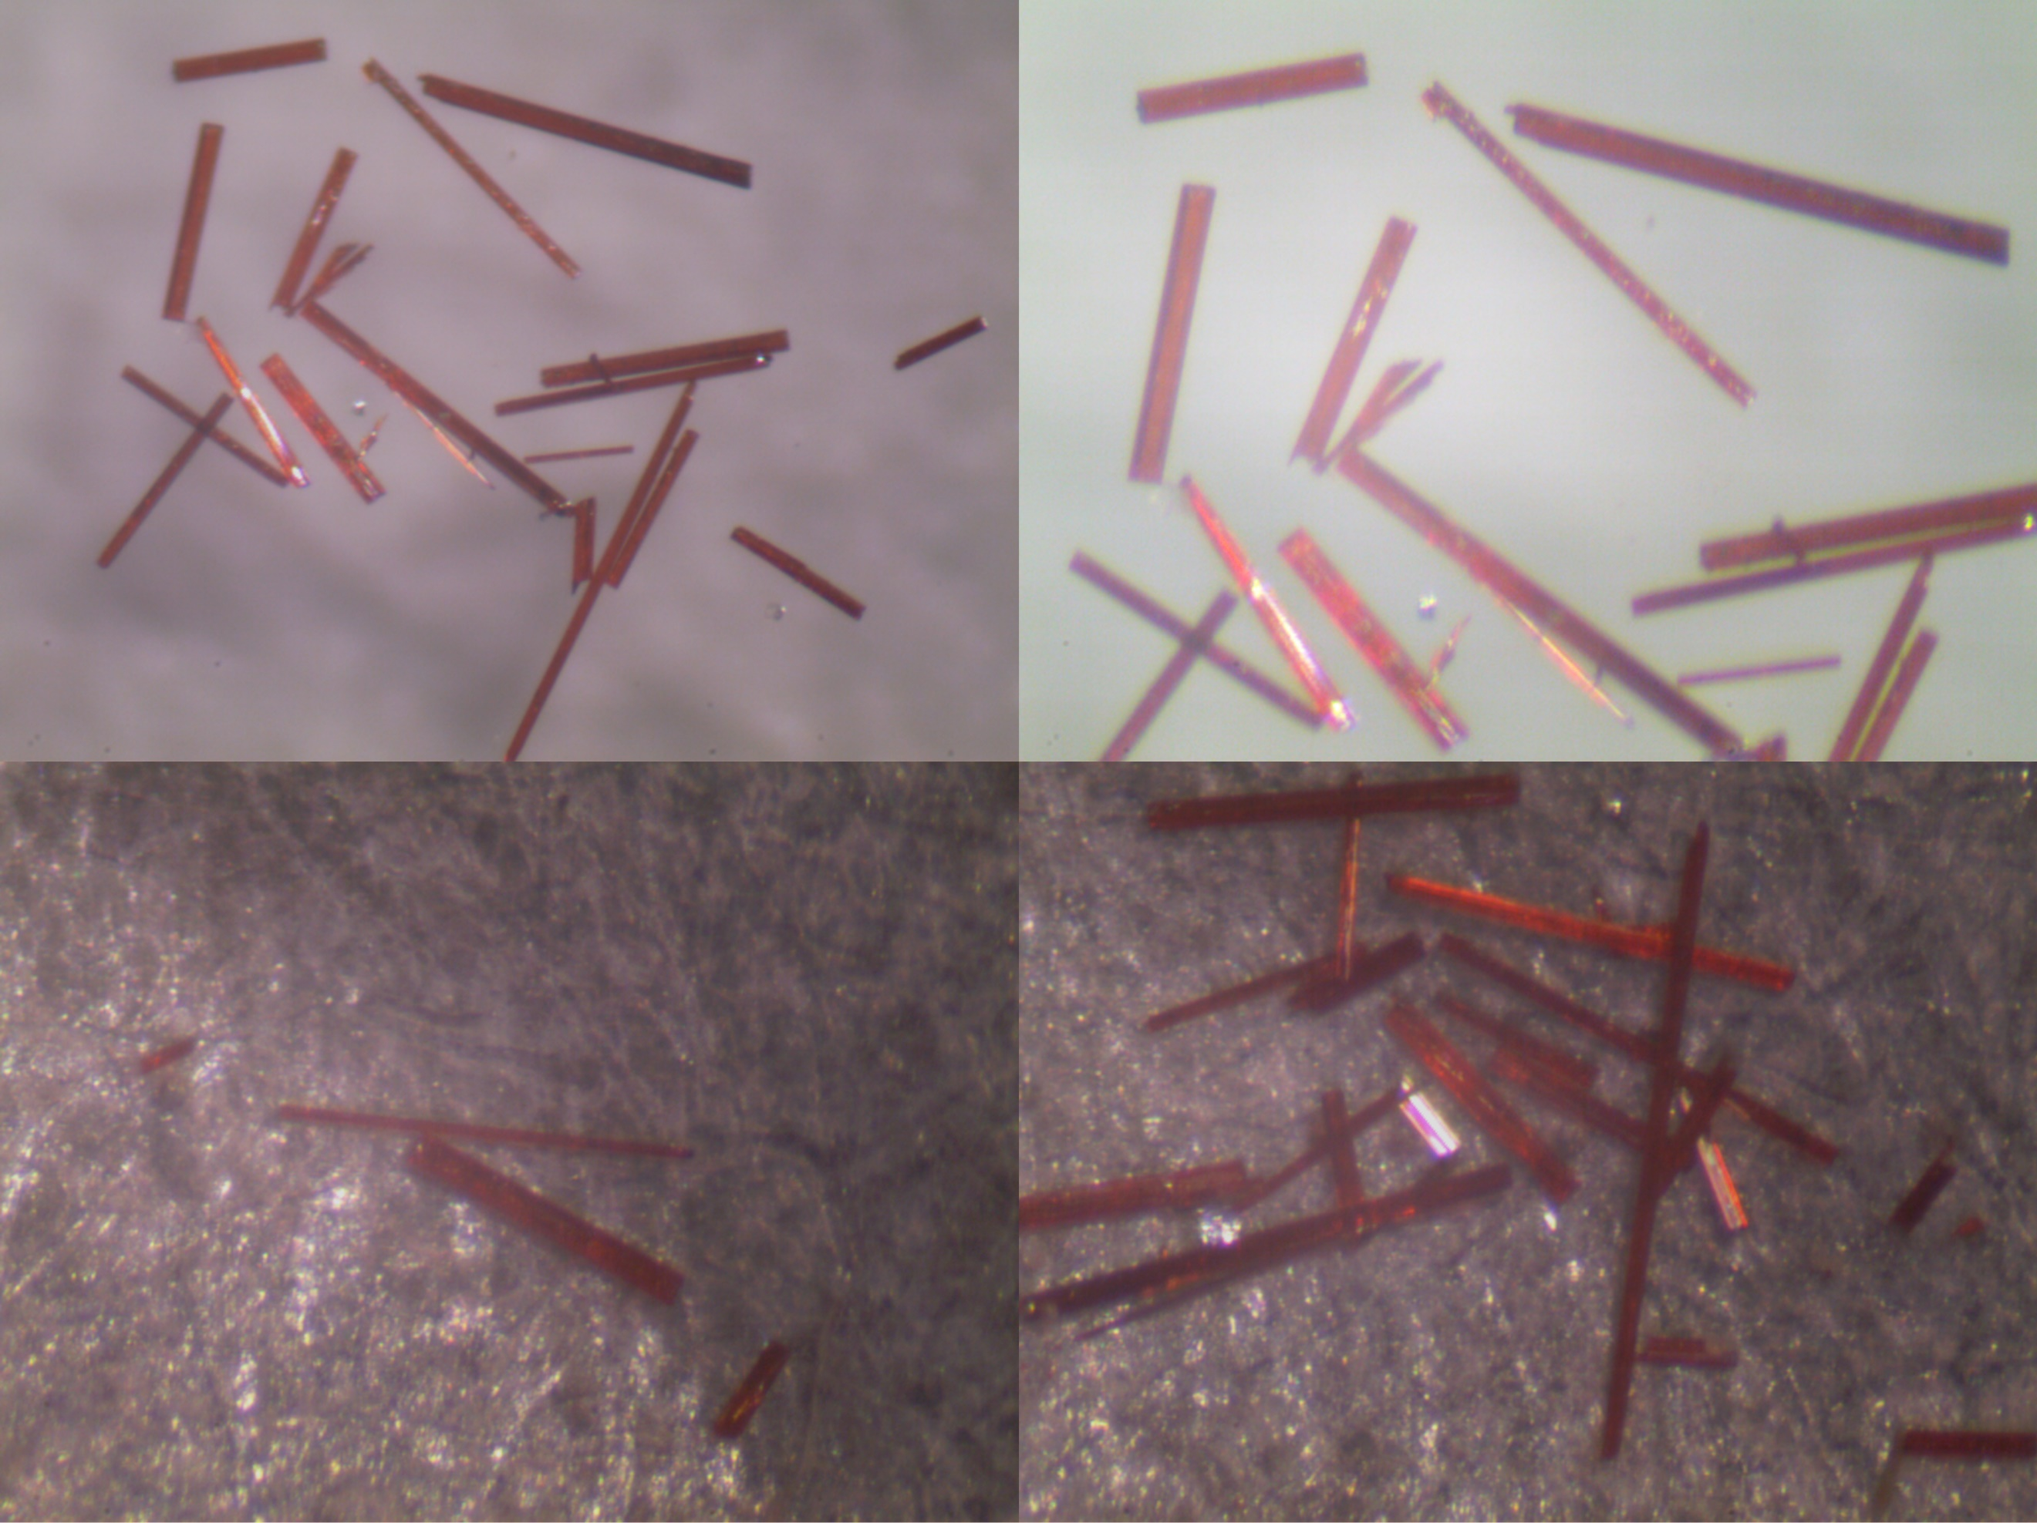
Supplementary Figure 1. Photographic images of crystal 1.

Supplementary Figure 2. The crystallographically asymmetric unit of 1.
Supplementary Figure 3. High resolution Cu 2p XPS spectrum of 1.

Supplementary Figure 4. Simulated and experimental PXRD patterns of 1.
Supplementary Figure 5. (a) SEM image of as-synthesized 1. (b) Corresponding EDS spectrum of 1. (EDS elemental analysis of a single crystal shows that the Ge/Cu atomic ratio in 1 is 1.54, which is in good agreement with the calculated value of 1.5).

Supplementary Figure 6. TGA curve of 1. The weight loss of 2.55% at the beginning of the TGA curve is related to the loss of water adsorbed from air and the weight loss of ~1.45% in the second stage is consistent with the loss of crystal water from the theoretical formula, as determined by SCXRD.

Supplementary Figure 7. Six T2-CuGeSe clusters connect end-to-end by six Cu(I) ions to form a novel giant hexagonal wheel-shaped cluster ([Cu₆(CuGe₃Se₁₀)₆]).

Supplementary Figure 8. The trigonal coordination mode of Cu⁺ with Se atoms in the coplanar [CuSe₃] unit with different bond lengths and bond angles.

Supplementary Figure 9. The 16-membered ring (16 MR) surface windows on the nanotube wall with a pore size of 3.59 × 6.47 Å, as calculated from the distance between the Se atoms across the window.

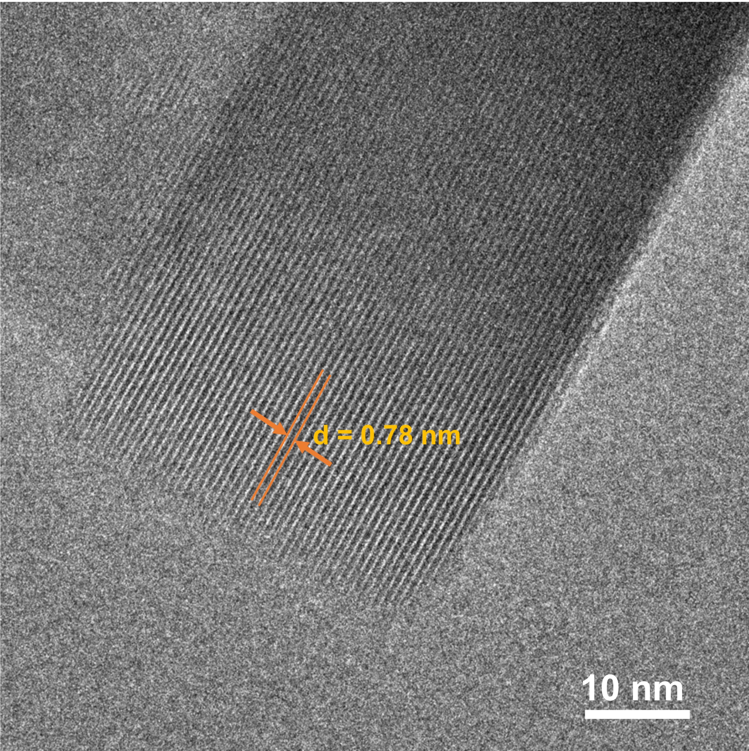
Supplementary Figure 10. HRTEM image of the ultrathin sectioned nanosheets of 1. The as-prepared 1 crystals were firstly embedded into ethoxyline resin, then cut into small slices with an average thickness of ~5 nm, which were subsequently dropped onto the surface of a micro grid for conducting subsequent measurements.
Supplementary Figure 11. Packing of 1 viewed along the c direction, highlighting the isolated K⁺ ions residing in the gap between the nanotubes and the hydrated K⁺ ions filled in the nanotubes to interact with the negatively charged nanotubes via electrostatic interactions and H-bonding.

Supplementary Figure 12. The end-to-end co-assembly of six 1D T2-CuGeSe chains with six Cu⁺ ions to form the nanotube.
Supplementary Figure 13. The structure of the 1D T2-CdGeSe chain.

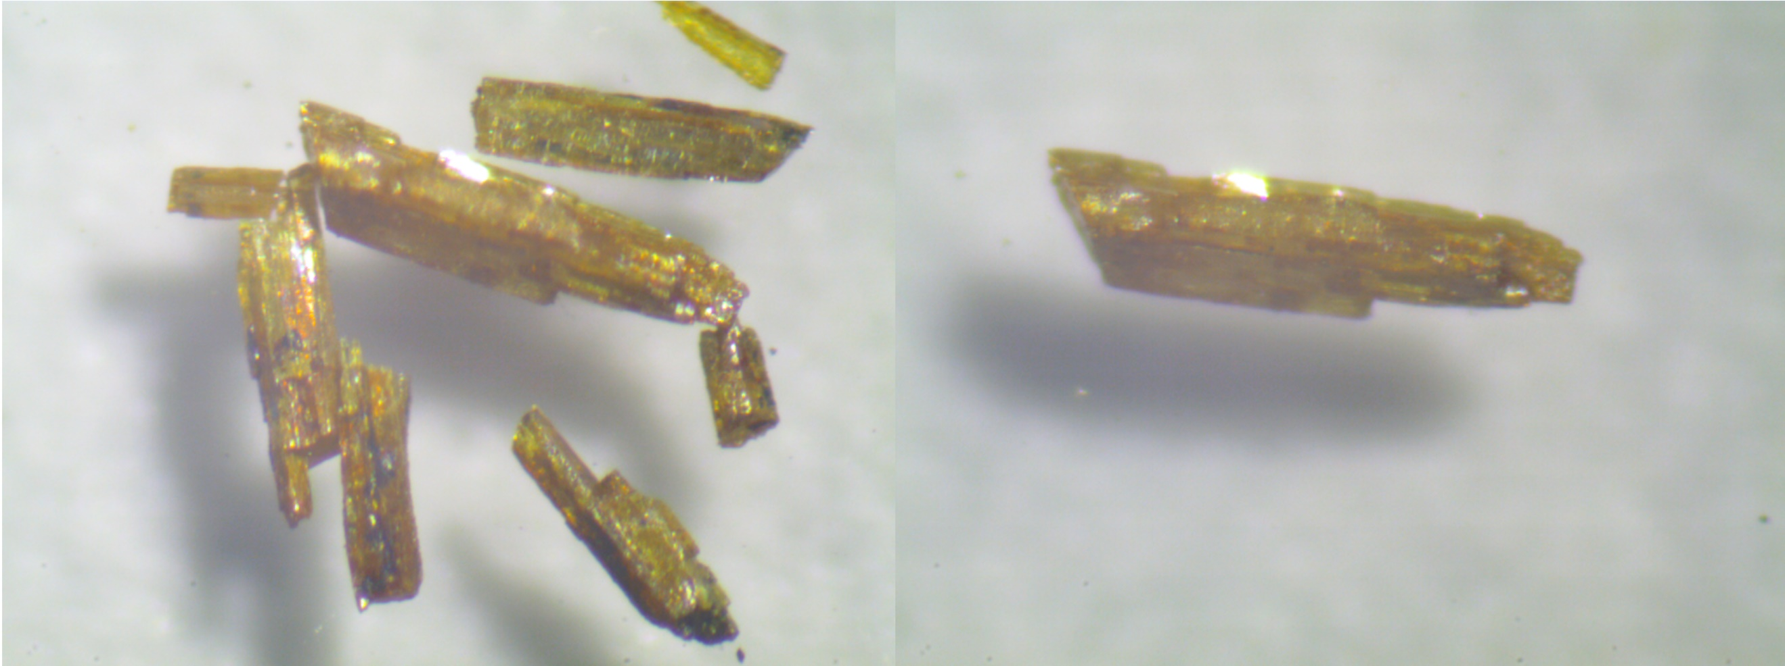
Supplementary Figure 14. Photographic images of the as-synthesized 2.

Supplementary Figure 15. The crystallographically asymmetric unit of 2.

Supplementary Figure 16. Simulated and experimental PXRD patterns of 2.

Supplementary Figure 17. (a) SEM image and (b) the corresponding EDS spectrum of the as-synthesized 2.
Supplementary Figure 18. TGA curve of 2.

Supplementary Figure 19. (a) Solid-state UV−Vis absorption spectra of 1 and 2. (b) Tauc plots of 1 and 2 derived from the solid-state UV-Vis diffuse reflection spectra.
Supplementary Figure 20. (a) Time-dependent photocurrent response curves of 1 under illumination with different light intensities. (b) Corresponding responsivity and detectivity of 1 under different light intensities.

Supplementary Figure 21. (a) Temperature-dependent I–V curves and (b) corresponding Arrhenius plots for 2.

Supplementary Figure 22. Time-dependent photocurrent response curves of 2 under the illumination of different light wavelengths.

Supplementary Figure 23. Atomic-orbital projected band structures (a) Cu 3d, (b) Ge 4s, and (c) Se 4p for 1. Note the diameters of the spheres are proportional to the magnitudes of the orbital contributions. Importantly, the atomic-orbital projected band structures clearly indicate that the VBM primarily originates from the hybridization of the 3d orbitals of copper and the 4p orbitals of selenium, while the CBM primarily originates from the hybridization of the 4s orbitals of germanium and the 4p orbitals of selenium.
Reference
1. Millet P, Henry JY, Mila F, Galy J. Vanadium(IV)–Oxide Nanotubes: Crystal Structure of the Low-Dimensional Quantum Magnet Na₂V₃O₇. Journal of Solid State Chemistry 147, 676-678 (1999).
2. Krivovichev SV, Kahlenberg V, Kaindl R, Mersdorf E, Tananaev IG, Myasoedov BF. Nanoscale Tubules in Uranyl Selenates. Angewandte Chemie International Edition 44, 1134-1136 (2005).
3. Alekseev EV, Krivovichev SV, Depmeier W. A Crown Ether as Template for Microporous and Nanostructured Uranium Compounds. Angewandte Chemie International Edition 47, 549-551 (2008).
4. Wang G-E, Xu G, Liu B-W, Wang M-S, Yao M-S, Guo G-C. Semiconductive Nanotube Array Constructed from Giant [Pb^{II}₁₈I₅₄(I₂)₉] Wheel Clusters. Angewandte Chemie International Edition 55, 514-518 (2016).
5. Chintakrinda K, et al. Atomically Precise Titanium-Oxo Nanotube with Selective Water Adsorption and Semiconductive Behaviors. CCS Chemistry 2, 209-215 (2020).
6. Wu S, et al. Complex clover cross-sectioned nanotubules exist in the structure of the first uranium borate phosphate. Chemical Communications 48, 3479-3481 (2012).
7. Pan Q, et al. [Ni(1,2-PDA)₃]₂(HOCH₂CH₂CH₂NH₃)₃(H₃O)₂ [Ge₇O₁₄X₃]₃ (X = F, OH): A New 1D Germanate with 12-Ring Hexagonal Tubular Channels. Chemistry of Materials 20, 370-372 (2008).
8. Choudhury A, Dorhout PK. An Ordered Assembly of Filled Nanoscale Tubules of Europium Seleno-silicate in the Crystal Structure of a Quaternary Compound. Journal of the American Chemical Society 129, 9270-9271 (2007).
9. Krivovichev SV, Kahlenberg V, Tananaev IG, Kaindl R, Mersdorf E, Myasoedov BF. Highly Porous Uranyl Selenate Nanotubules. Journal of the American Chemical Society 127, 1072-1073 (2005).
10. Malliakas CD, Kanatzidis MG. Inorganic Single Wall Nanotubes of SbPS4-xSex (0 ≤ x ≤ 3) with Tunable Band Gap. Journal of the American Chemical Society 128, 6538-6539 (2006).
11. Choudhury A, Grandjean F, Long GJ, Dorhout PK. Na_{1.515}EuGeS₄, A Three-Dimensional Crystalline Assembly of Empty Nanotubules Constructed with Europium(II/III) Mixed Valence Ions. Inorganic Chemistry 51, 11779-11786 (2012).
12. Cao G-J, Liu J-D, Zhuang T-T, Cai X-H, Zheng S-T. A polyoxometalate–organic supramolecular nanotube with high chemical stability and proton-conducting properties. Chemical Communications 51, 2048-2051 (2015).
13. Luo T-T, et al. Self-Assembled Arrays of Single-Walled Metal–Organic Nanotubes. Angewandte Chemie International Edition 48, 9461-9464 (2009).
14. Lin Q, Wu T, Zheng S-T, Bu X, Feng P. A chiral tetragonal magnesium-carboxylate framework with nanotubular channels. Chemical Communications 47, 11852-11854 (2011).
15. Lin Q, et al. High proton conductivity in metalloring-cluster based metal-organic nanotubes. Nano Research 14, 387-391 (2021).
16. Yuan P, et al. Solvent-mediated assembly of atom-precise gold–silver nanoclusters to semiconducting one-dimensional materials. Nature Communications 11, 2229 (2020).
17. Yang H, et al. The Largest Supertetrahedral Oxychalcogenide Nanocluster and Its Unique Assembly. Journal of the American Chemical Society 140, 11189-11192 (2018).
18. Jaffe A, Lin Y, Mao WL, Karunadasa HI. Pressure-Induced Conductivity and Yellow-to-Black Piezochromism in a Layered Cu–Cl Hybrid Perovskite. Journal of the American Chemical Society 137, 1673-1678 (2015).
19. Huang Q-Q, et al. Single-Component MLCT-Active Photodetecting Material Based on a Two-Dimensional Coordination Polymer. CCS Chemistry 2, 655-662 (2020).
20. Li Y, et al. Coordination assembly of 2D ordered organic metal chalcogenides with widely tunable electronic band gaps. Nature Communications 11, 261 (2020).
21. Chen T, et al. Continuous Electrical Conductivity Variation in M₃(Hexaiminotriphenylene)₂ (M = Co, Ni, Cu) MOF Alloys. Journal of the American Chemical Society 142, 12367-12373 (2020).

