Dephenolization pyrolysis fluid improved physicochemical properties and microbial community structure of saline-alkali soils

Shuai Wang ª, Hanyu Chang ª, Zhenfei Dong ª,Yansen Ren ª, Tianle Tan ª, Hui Deng ^{a, b, *}

ª School of Chemistry and Chemical Engineering/Key Laboratory of Environmental Monitoring and Pollutant Control of Xinjiang Bingtuan, Shihezi University, Shihezi 832003, China

^{b} Key Laboratory for Green Processing of Chemical Engineering of Xinjiang Bingtuan, School of Chemistry and Chemical Engineering, Shihezi University, Shihezi, 832003, Xinjiang, China

*Corresponding author
E-mail addresses: huid@163.com

Table S1 Basic physicochemical properties of pyrolysis fluids at different temperatures
Temperature（℃） | 300 | 400 | 500 | 600 | 700
pH  Density（g/cm³）  Yield（%）  Water content（%）  Calorific value（k J/g） | 3.15  1.070  35.12±1.69  55.95±0.26  10.12 | 3.38  1.062  38.82±0.51  58.59±0.61  9.22 | 3.56  1.051  41.29±0.92  63.91±0.34  8.39 | 3.68  1.058  36.28±1.13  59.12±0.15  8.98 | 3.70  1.069  34.79±0.37  57.96±0.55  9.75

Table S2 Analysis results of pyrolytic liquids at different pyrolysis temperatures by GC‒MS
Organic compounds | Relative content (%)
 | 300℃ |  |  | 400℃ |  |  |  | 500℃ | 600℃ | 700℃
Acetic acid | 26.87 |  |  |  | 23.85 |  |  | 21.93 | 21.12 |  | 20.35
Furfural | 5.90 |  |  |  | 4.90 |  |  | 3.94 | 3.96 |  | 3.89
1, 2, 3-trimethoxybenzene | ‒ |  |  |  | 2.15 |  |  | 2.14 | 2.21 |  | ‒
Total phenols | 17.01 |  |  |  | 18.19 |  |  | 20.57 | 21.23 |  | 22.48
O-methoxy-phenol | 6.41 |  |  |  | 6.17 |  |  | 5.96 | 5.72 |  | 5.56
2,6-methoxy-Phenol | 3.69 |  |  |  | 3.97 |  |  | 4.20 | 4.64 |  | 4.62
3-methyl catechol | 2.49 |  |  |  | ‒ |  |  | 3.48 | 0.24 |  | 0.61
4-propoxyphenol | 2.39 |  |  |  | 2.22 |  |  | 2.14 | 2.18 |  | 2.18
4-ethyl-2-methoxy phenol | 2.05 |  |  |  | 3.52 |  |  | 0.56 | 3.47 |  | 3.34
Catechol | ‒ |  |  |  | 2.62 |  |  | 4.11 | 3.98 |  | 2.91
Total alcohol | 11.95 |  |  |  | 10.61 |  |  | 8.82 | 10.03 |  | 11.16
2-furanmethanol | 11.86 |  |  |  | 8.43 |  |  | 8.80 | 7.65 |  | 8.75
Wood tar alcohol | ‒ |  |  |  | 2.14 |  |  | ‒ | 2.31 |  | 2.32
Total ketone | 7.2 |  |  |  | 6.6 |  |  | 9.5 | 13.2 |  | 9.3
3-methyl cyclopentane -1,2-dione | 3.54 |  |  |  | 3.97 |  |  | 3.92 | 4.49 |  | 4.42
3-ethyl-2-hydroxyl-2-cyclopentene-1-ketone | ‒ |  |  |  | 2.61 |  |  | 2.68 | 2.36 |  | 2.37
3-methyl-2-cyclopentene-1-ketone | ‒ |  |  |  | ‒ |  |  | ‒ | 2.76 |  | ‒
1-hydroxyl-2-butanone | 3.66 |  |  |  | ‒ |  |  | 2.86 | 3.55 |  | 2.55

Figure S1 Trends in the relative content of organic compounds measured by GC-MS

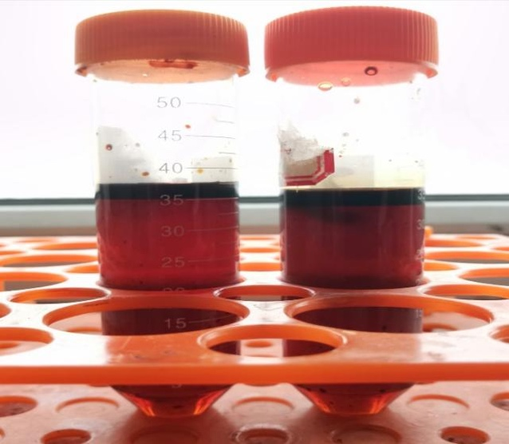
Figure S2 BPF of cotton straw after salting‒out extraction
Figure S3 Mechanism diagram of PF by salting-out extraction

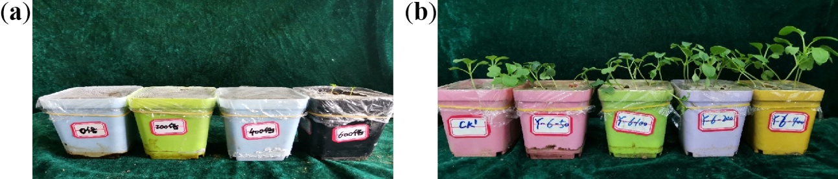
Figure S4 (a) Effects of BPF on seed germination (diluted 0, 200, 400, 600 times from left to right); (b) Effects of LP on growth of pakchoi (CK, dilution 50, 100, 200 and 400 times, respectively, from left to right).

