Supporting Information

Highly efficient ion sieving through angstrom-scale channels embedded with supramolecular coordination complexes

Yue Sun^{1*}, Run-Hao Li², Shi-Qi Cheng², Zhao Chen³, Yao Xu⁴, Fan Yi², Huan Qin², Xiao-Cui Liang², and Yi Liu^{1*}
¹State Key Laboratory of Separation Membrane and Membrane Process & Tianjin Key Laboratory of Green Chemical Technology and Process Engineering, School of Chemistry, Tiangong University, Tianjin 300387
²Hubei Key Laboratory of Catalysis and Materials Science, College of Chemistry and Material Sciences, South-Central University for Nationalities, Wuhan 430074
³Jiangxi Key Laboratory of Organic Chemistry, Jiangxi Science and Technology Normal University, Nanchang 330013
⁴Warshel Institute for Computational Biology, School of Life and Health Science, the Chinese University of Hong Kong, Shenzhen 518172

Corresponding author: sunyue@tiangong.edu.cn (Yue Sun); yiliuchem@whu.edu.cn (Yi Liu)

Table of Contents
- Experimental Procedures
- Synthesis and characterization of SCCs 1
- The characterization of membranes
- Ion selectivity of cations based on ion currents
- Density functional theory (DFT) simulations
- Molecular dynamics (MD) simulations
- Potential of mean force (PMF) for cation migration
- References

- Experimental Procedures
Materials
Potassium nitrate (KNO₃), sodium nitrate (NaNO₃), lithium nitrate (LiNO₃), calcium nitrate (Ca(NO₃)₂), magnesium nitrate (Mg(NO₃)₂), formic acid (HCOOH), sodium hydroxide (NaOH), dimethyl sulfoxide (DMSO) and ethanol were purchased from Sinopharm Chemical Reagent Shanghai Co., Ltd. (SCRC, China). All electrolyte solutions were formed in MilliQ water. Poly (ethylene terephthalate) (PET, 12 μm thick) membranes were irradiated with heavy ion (Au) of energy 11.4 MeV/nucleon at UNILAC linear accelerator (GSI, Darmatadt, Germany).
- Synthesis and characterization of SCCs 1
Compounds 3 was prepared according to the literature procedures.¹ Compounds 2 (5 mg, 0.008 mmol) and 3 (20.76 mg, 0.016 mmol) were in dimethyl sulfoxide (3 mL) dissolved in a vial, and reacted at room temperature for 24 h. The resulting solution was added with toluene and diethyl ether to precipitate the product, separated and dried under vacuum (15.8mg, 61.3%).
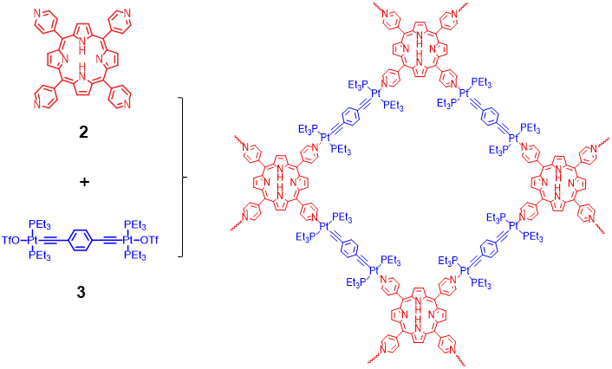
Scheme S1. The synthesis SCCs 1.

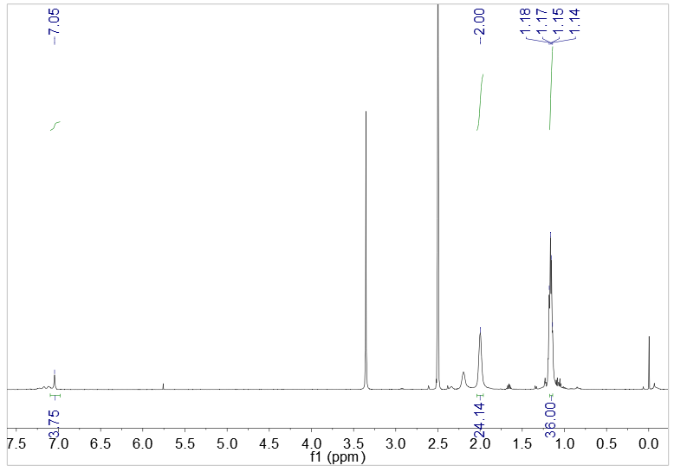
Figure S1. ¹H NMR spectrum (DMSO-d₆, 400 MHz, 298 K) recorded for ligand 3.

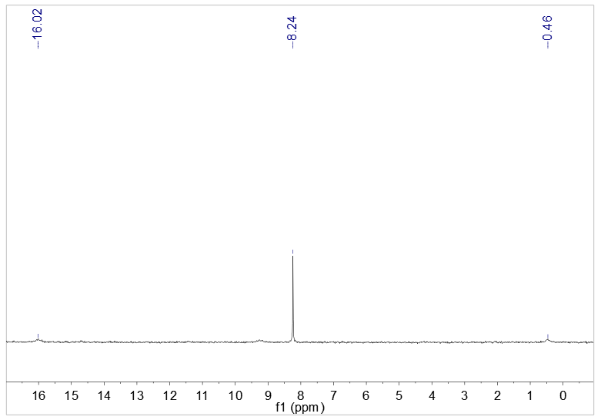
Figure S2. ³¹P NMR spectrum (DMSO-d₆, 121.4 MHz, 298 K) recorded for ligand 3.

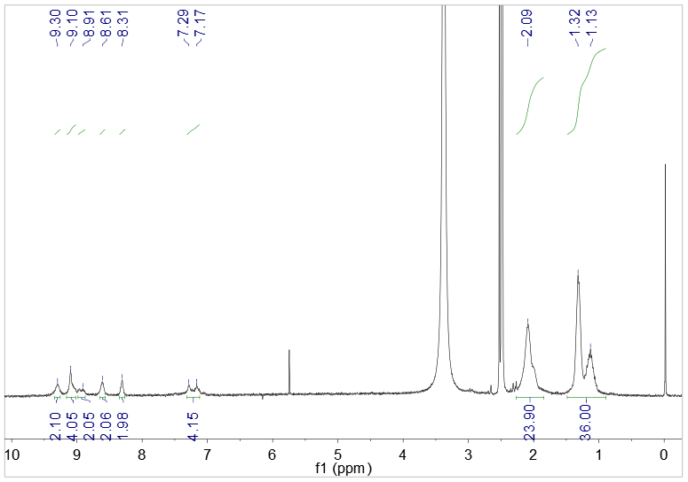
Figure S3. ¹H NMR spectrum (DMSO-d₆, 400 MHz, 298 K) recorded for SCCs 1.

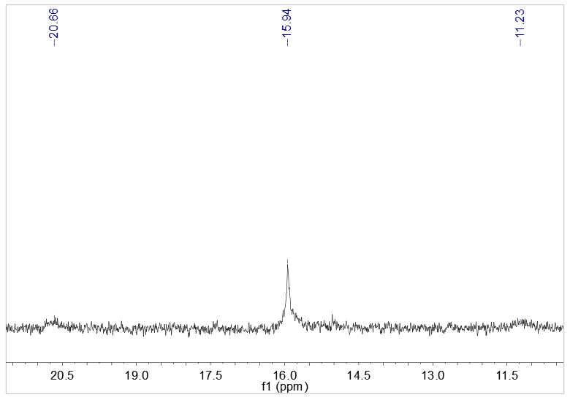
Figure S4. ³¹P NMR spectrum (DMSO-d₆, 121.4 MHz, 298 K) recorded for SCCs 1.

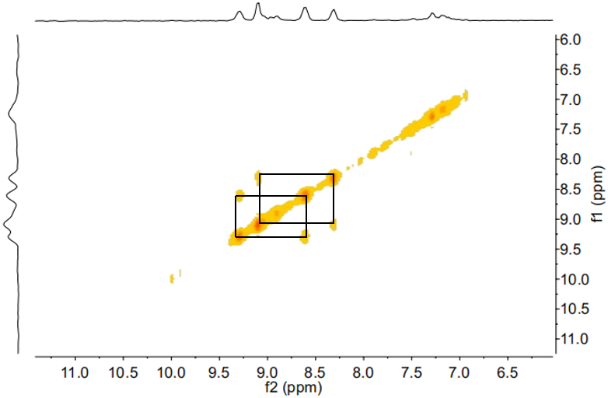
Figure S5. 2D COSY NMR spectrum (DMSO-d₆, 400 MHz, 298 K) recorded for SCCs 1.

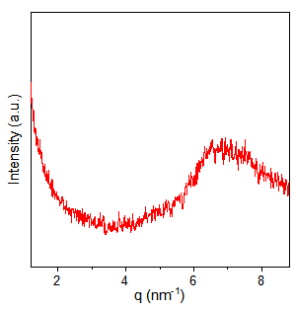
Figure S6. Small angle x-ray scattering pattern of SCCs 1. The d-spacing corresponding to the peak at 7 nm⁻¹ is ~0.9 nm.

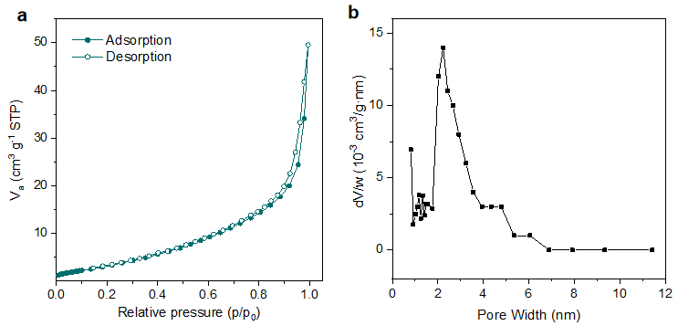
Figure S7. N₂ adsorption-desorption isotherms (a) and pore size distribution profiles (b) of SCCs 1 at 77K.

- The characterization of membranes
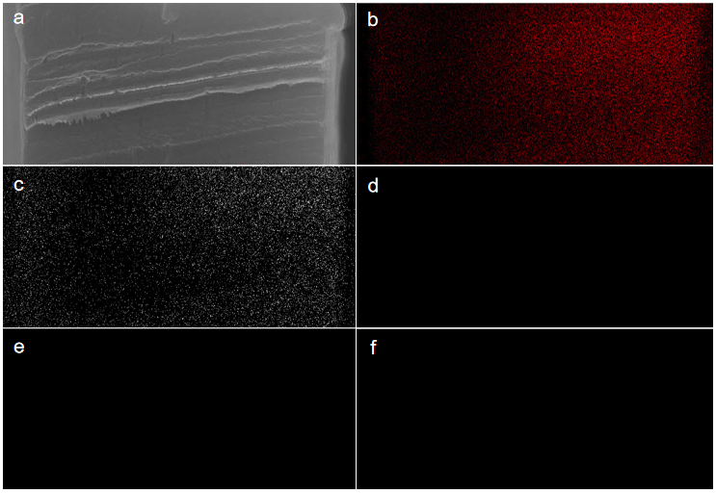
Figure S8. EDS mapping of cross section of bare membrane. a, SEM image of cross section of bare membrane. b-f, the cross-sectional images of SEM and C, O, P, S and Pt mapping of bare membrane, respectively.

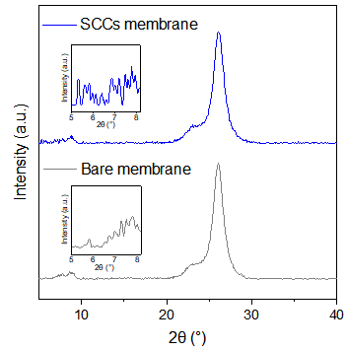
Figure S9. XRD patterns of the bare membrane and the SCCs membrane, the inserts are XRD patterns of 2θ values between 5 and 8 degree.
- Ion selectivity of cations based on ion currents
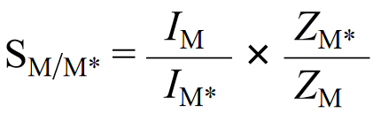 (S1)
The ion selectivity (S_{M/M*}) of metal ions is calculated from the transmembrane ion currents. According to the equation, I_{M} and I_{M*} are the corresponding current values of metal ions M and M* at the same transmembrane voltage in channel, respectively. Z_{M} and Z_{M*} are the corresponding valences of metal ions.
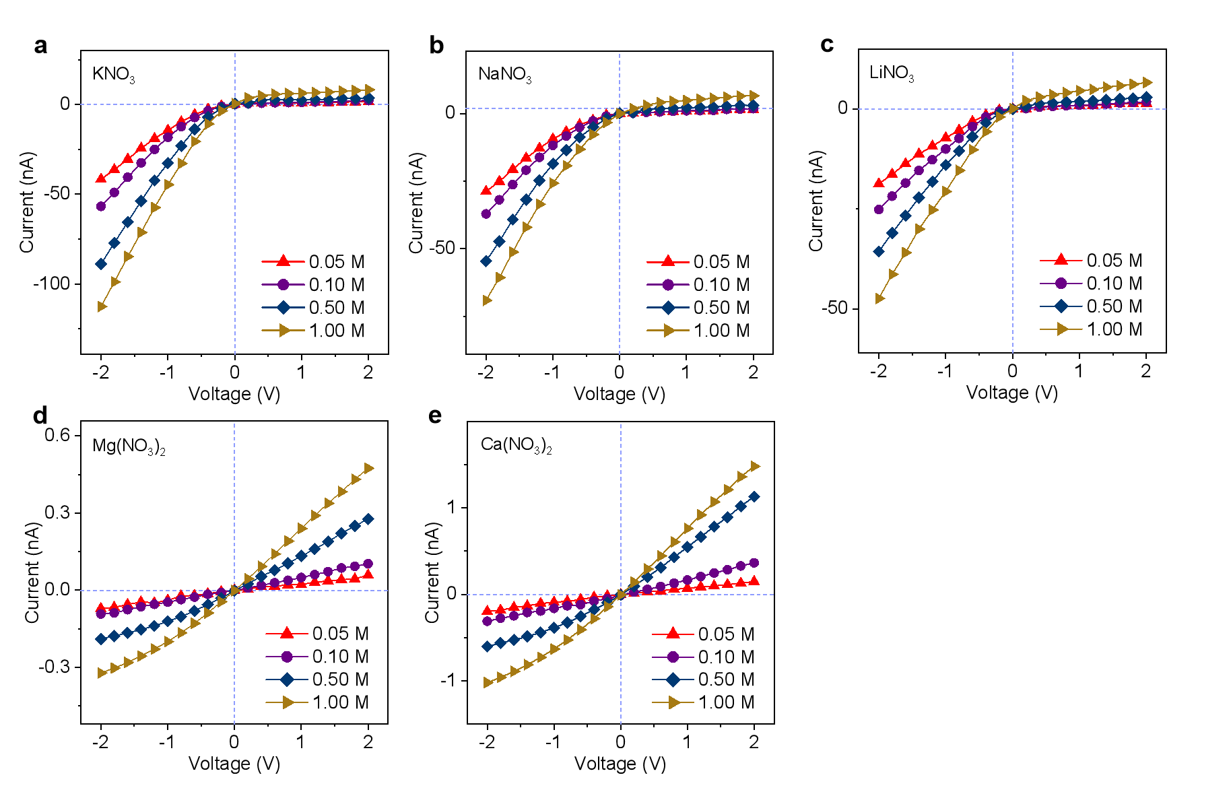
Figure S10. I‒V curves of the SCCs 1 based hybrid membrane for KNO₃ (a), NaNO₃ (b), LiNO₃ (c), Mg(NO₃)₂ (d) and Ca(NO₃)₂ (e) with concentration from 0.05 M to 1.00 M, respectively.

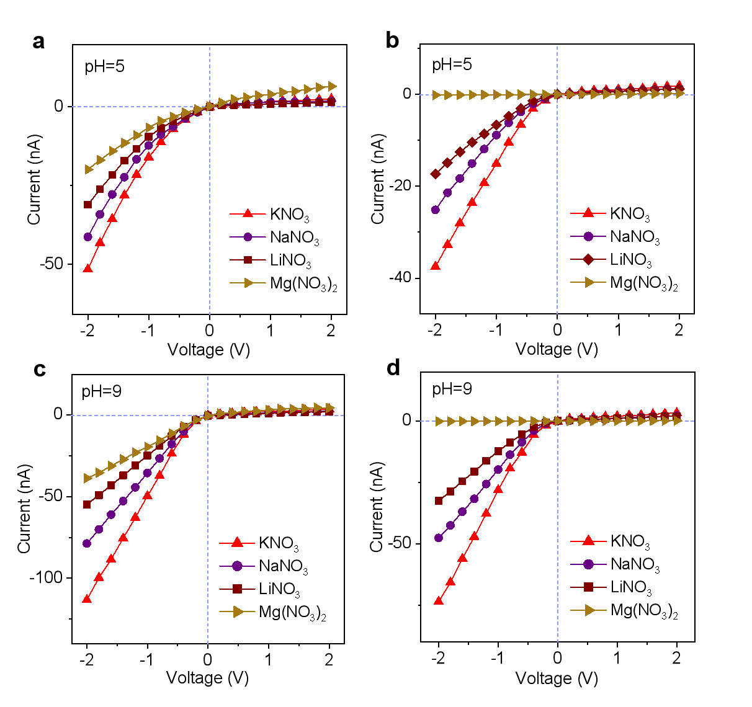
Figure S11. a,c. I-V curves of the bare channel at pH values of 5 (a) and 9 (c), respectively; b,d. I-V curves of the SCCs channel at pH values of 5 (b) and 9 (d), respectively. (Notably, the concentration of Ca²⁺ in aqueous solution is very low in alkaline environment, and that is why we didn't test the effect of pH on Ca²⁺ transport in channel).

Table S1. Monovalent/divalent metal ion selectivity (K⁺/Mg²⁺) and K⁺ conductivity of various artificial channels.
Artificial channel | Thickness (μm) | Ion selectivity (K⁺/Mg²⁺) | K⁺ conductivity  (S m⁻¹) | Driving force | Ref.
SCCs | 12 | 1015.5 | 27.88 | U=2V | This work
MOF (UIO-66) | 12 | 822.3 | 1.9 | U=1V | 9
PSS/MOF (HKUST-1) | 8 | 27.1 | 5.6×10⁻⁴ | U=0.4V | 10
PET | 2 | 134.6 | 0.19 | U=10V | 11
Graphene | 6×10⁻⁴ | 4 | 1.14 | U=0.15V | 12
FRGO | 2.16 | 120 | n/a | ΔC | 13
Graphene oxide (GO) | 0.2 | 90.3 | n/a | ΔC | 14
MoS₂ | 6.5×10⁻⁴ | 1.3 | 17.8 | U=0.8V | 15
Graphite/MoS₂ | 7 | 2.3 | 1.2 | U=0.2V | 16
MXene (Ti₃C₂) | 1.5 | 5.9 | n/a | ΔC | 17
GO/MXene | ~4.3 | 1.7 | n/a | U=0.04V | 18

- Density functional theory (DFT) simulations
Binding energy of metal ions and porphyrin groups on the SCC 1 was examined by DFT simulations. The primary simulation structures of ligand 2 containing porphyrin groups were constructed by material Studio 8.0, and the five metal ions were added in the center of porphyrin groups, respectively. Then the final simulation structures that to be DFT calculated were obtained through geometric optimization. The resulting simulation structures were calculated at B3LYP/LANL2DZ levels using Gaussian 09. Moreover, it is necessary to calculated the energy of the metal ions without any interaction with the ligand 2. Finally, the binding energies were calculated by comparing the energy difference between the two DFT simulation results. As a result, the calculated binding energy order of metal ions with the porphyrin groups on the SCC 1 is K⁺ (−1.293 eV) < Na⁺ (−2.012 eV) < Li⁺ (−3.192 eV) < Ca²⁺ (−6.985 eV) < Mg²⁺ (−11.197 eV) (Table S1). Negative values of binding energy demonstrate that it is favorable to the binding of metal ions with porphyrin groups. The high binding energy of divalent metal ions with porphyrin groups reveal their low mobility in the SCCs channel.

Table S2. Properties of the metal ions.
Electrolyte species | Bare diameter  (Å) | Hydrated diameter (Å) | Hydration energy (KJ mol⁻¹)
K⁺ | 1.20 | 6.62 | -295
Na⁺ | 1.90 | 7.16 | -365
Li⁺ | 2.66 | 7.64 | -475
Ca²⁺ | 1.98 | 8.24 | -1505
Mg²⁺ | 1.30 | 8.56 | -1830

Table S3. The binding of metal ions with porphyrin groups on the SCCs 1 were examined by DFT calculations at B3LYP/LANL2DZ levels using Gaussian 09.
Metal ion | Binding energy (eV)
K⁺ | -1.293
Na⁺ | -2.012
Li⁺ | -3.192
Ca²⁺ | -6.985
Mg²⁺ | -11.197

- Molecular dynamics (MD) simulations
SCC 1 periodic supercell was used as the MD simulation model for the investigation of ion transport (Fig. S13). To describe the flexibility of the framework, we employed the consistent valence force field (CVFF)² for SCC 1 model. The force model was used for bonded and non-bonded interactions. The non-bonded interactions include van der Waals interactions, which are modelled by the classic 12-6 Lennard Jones (LJ) potential, and Coulombic interaction (equation S2). The particle-particle particle-mesh (PPPM) solver with an accuracy of 1e⁻⁴ eV was used to treat the long-range Coulombic interactions.
The atom types in the SCC 1 are marked in Fig. S14. The LJ parameters between different atoms were determined by Lorentz-Berthelot mixing rule³. Table S3 summarizes the LJ parameters and partial charges for different types of atoms. All the LJ interactions were calculated with a cutoff radius of 12.0 Å.
In order to simulate the bonding characteristics of SCC 1, We must establish a framework model of complex three-dimensional atomic connectivity, including the bond, angle, dihedral and improper interactions (equation S3-S6).
In our MD simulations, we used the TIP3P model for water molecules⁴. The LJ parameters of electrolyte ions are listed in Table S3. To determine the ion transport mobility, we applied a constant electric field of 0.085 V/Å along the [111] crystal direction in our MD simulations. The electro-kinetic mobility of ions inside the SCC framework was derived from the displacement of ions along the [111] crystal direction under the E-fields.
All the MD simulations were performed with LAMMPS software⁵. The ion displacements were averaged from 5 independent simulations with different initial configuration. The simulations were conducted in NVT ensemble at 298 K with time step of 2 fs, ran MD simulations for 5 ns under the E-fields. The results of ion drift in the last 3 ns were used to calculate the ion mobility. To prevent the possible drift of the simulated SCC structure, the framework was frozen and the linear momentum was set to zero. Note that the triethyl phosphorous groups as the branched chains of SCC model and the H atoms on the framework were flexible.
${\text{V}}_{\text{ij}}^{\text{ Non-bond}}\text{ = 4}{\text{ε}}_{\text{ij}}\left[{\left(\frac{{\text{σ}}_{\text{ij}}}{{\text{r}}_{\text{ij}}}\right)}^{\text{12}}\text{-}{\left(\frac{{\text{σ}}_{\text{ij}}}{{\text{r}}_{\text{ij}}}\right)}^{\text{6}}\right]\text{+ }k\frac{{\text{q}}_{\text{i}}{\text{q}}_{\text{j}}}{{\text{r}}_{\text{ij}}}$ (S2)
${\text{V}}_{\text{ij}}^{\text{ Non-bond}}\text{ = }\frac{\text{1}}{\text{2}}k_{\text{ij}}{\left({\text{r}}_{\text{ij }}\text{-}{\text{ r}}_{\text{0}}\right)}^{\text{2}}$ (S3)
${\text{V}}_{\text{ij}}^{\text{ Angle}}\text{ =}\frac{\text{1}}{\text{2}}k_{\text{ijk}}{\left(θ_{\text{ij }}\text{-}θ_{\text{0}}\right)}^{\text{2}}$ (S4)
${\text{V}}_{\text{ijk}}^{\text{ Dihedral}}\text{ =}k_{\text{ijkl}}\left[\text{1+}\text{cos}\left(\text{n}{\text{ϕ}}_{\text{ijkl }}\text{-}{\text{ϕ}}_{\text{0}}\right)\right]$ (S5)
${\text{V}}_{\text{ijk}}^{\text{ Improper}}\text{ =}k_{\text{ijkl}}\left[\text{1+}\text{cos}\left(\text{n}{\text{ϕ}}_{\text{ijkl }}\text{-}{\text{ϕ}}_{\text{0}}\right)\right]$ (S6)

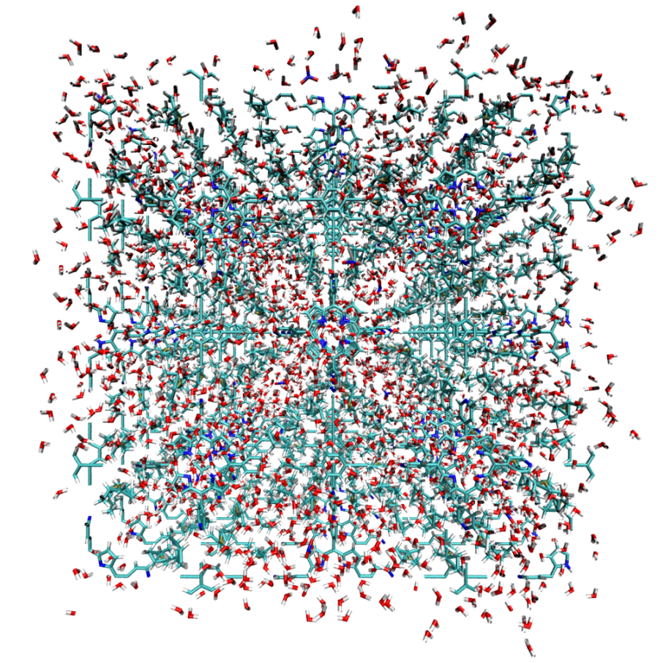
Figure S12. periodic supercell of SCCs 1 used as the MD simulation model.

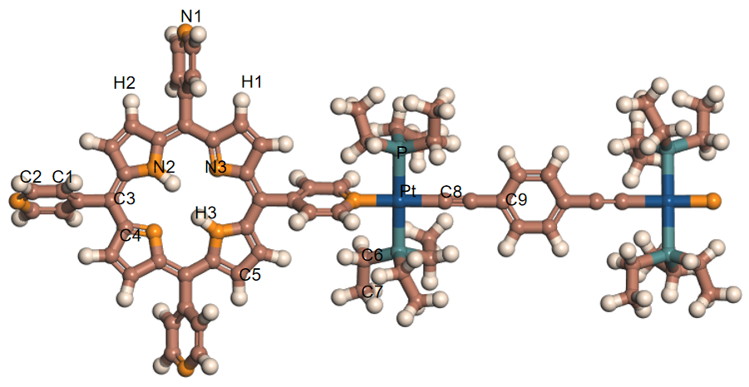
Figure S13. Structural connector of SCCs 1 assembled by organic ligand 2 and metal ligand 3, and the atomic types of the structural model used in MD simulation. Blue ball stands for Pt; cyan ball for P; orange ball for N; light brown ball for C and light magenta ball for H.
- Potential of Mean Force (PMF) for cation migration
To estimate the energy barrier for different ions transport through the nanochannel, the potential of mean force (PMF) for ions was studied (free energy). The PMF were determined in umbrella sampling (US) calculations. The reaction coordinate going along the center of the nanochannel was partitioned into 20 windows of 1 Å widths. Confinement potentials were introduced in the form of harmonic restraints with a force constant of k = 5 Kcal/(mol·Å²), and each window was run for 1 ns. The weighted histogram analysis method (WHAM) was used to reconstruct the PMF. Monte Carlo bootstrap error analysis was performed with the WHAM algorithm (with num MC trials set to 5). The histograms of the US windows used to reconstruct the PMF were examined and had an appropriate overlap.

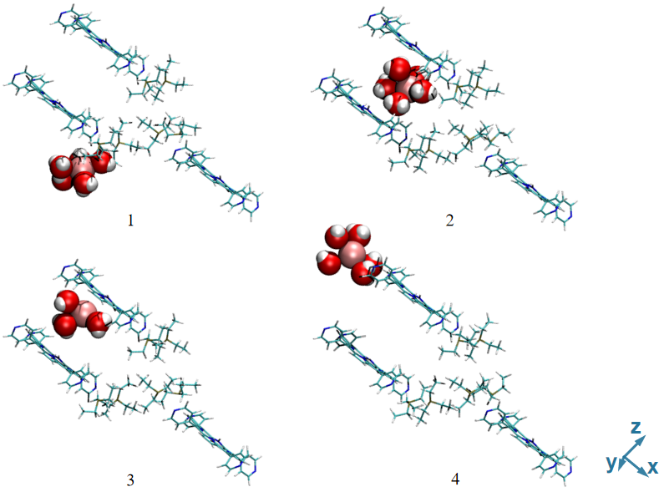
Figure S14. Side view graphs showing the migration of metal ions along the interlayer slits to better display the way ions pass through the edge of the channel.

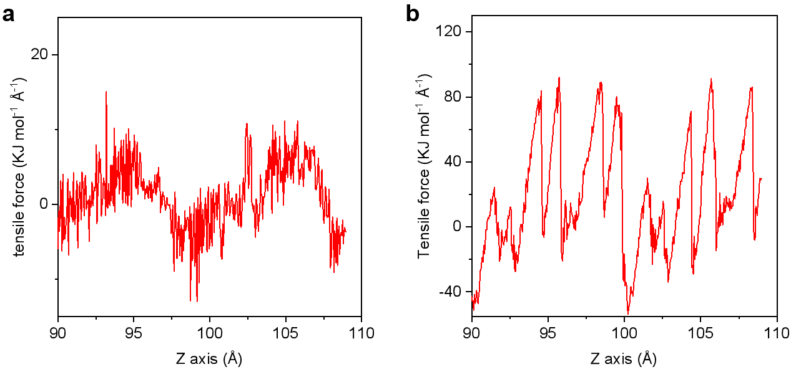
Figure S15. Tensile force of the K⁺ (a) and Mg²⁺ (b) migrating through the SCCs channel.

Table S4. Lennard-Jones potential parameters and partial charges of all types of atoms in SCC 1 model.
Symbol | σ (Å) | ε (kcal/mol) | q (e)
Pt | 2.542 | 15.718 | 3.943
P | 3.742 | 0.200 | 0.179
N1 | 3.501 | 0.167 | -0.277
N2 | 3.501 | 0.167 | -0.617
N3 | 3.501 | 0.167 | -0.337
C1 | 3.617 | 0.148 | -0.157
C2 | 3.617 | 0.148 | -0.047
C3 | 3.617 | 0.148 | -0.057
C4 | 3.617 | 0.148 | 0.083
C5 | 3.617 | 0.148 | -0.187
C6 | 3.875 | 0.039 | -0.335
C7 | 3.875 | 0.039 | -0.357
C8 | 3.617 | 0.148 | -0.057
C9 | 3.617 | 0.148 | 0.028
H1 | 2.450 | 0.038 | 0.043
H2 | 2.450 | 0.038 | 0.073
H3 | 0.0 | 0.0 | 0.223
K^{+ [a]} | 3.528 | 0.087 | 1
Na^{+ [a]} | 2.822 | 0.047 | 1
Li^{+ [a]} | 1.506 | 0.690 | 1
Ca^{2+ [b]} | 2.723 | 0.048 | 2
Mg^{2+ [b]} | 2.288 | 0.004 | 2
N (NO₃⁻) ^{[c]} | 3.150 | 0.170 | 0.794
O (NO₃⁻) ^{[c]} | 2.860 | 0.210 | -0.598

^{[a], [b], [c]} take from the previous work for monovalent metal ions⁶, divalent metal ions⁷ and nitrate ions⁸.
- References
- Olenyuk, B.; Levin, M. D.; Whiteford, J. A.; Shield, J. E.; Stang, P. J. Self-Assembly of Nanoscopic Dodecahedra from 50 Predesigned Components. J. Am. Chem. Soc. 1999, 121, 10434-10435.
- Maple, J. R; Hwang, M-J.; Stockfisch, T. P.; Dinur, U.; Waldman, M.; Hagler, E. A. T. Derivation of class II force fields. I. Methodology and quantum force field for the alkyl functional group and alkane molecules. J. Comput. Chem. 1994, 15, 162-182.
- Delhommelle, J.; MilliÉ, P. Inadequacy of the Lorentz-Berthelot combining rules for accurate predictions of equilibrium properties by molecular simulation. Mol. Phys. 2001, 99, 619-625.
- Jorgensen, W. L.; Chandrasekhar, J.; Madura, J. D.; Impey, R. W.; Klein, M. L. Comparison of simple potential functions for simulating liquid water. J. Chem. Phys. 1983, 79, 926-935.
- Plimpton, S. Fast Parallel Algorithms for Short-Range Molecular Dynamics. J. Comput. Phys. 1995, 117, 1-19.
- MacKerell, A. D; Bashford, D.; Bellott, M.; Dunbrack, R. L.; Evanseck, J. D.; Field, M. J.; Fischer, S.; Gao, J.; Guo, H.; Ha, S.; Joseph-McCarthy, D.; Kuchnir, L.; Kuczera, K.; Lau, F. T. K.; Mattos, C.; Michnick, S.; Ngo, T.; Nguyen, D. T.; Prodhom, B.; Riher, W. E.; Roux, B.; Schlenkrich, M.; Smith, J. C.; Stote, R.; Straub, J.; Watanabe, M.; Wio´rkiewicz-Kuczera, J.; Yin, D.; Karplus, M. All-atom empirical potential for molecular modeling and dynamics studies of proteins. J. Phys. Chem. B. 1998, 102, 3586-3616.
- Li, P.; Roberts, B. P.; Chakravorty, D. K.; Merz, K. M. Rational Design of Particle Mesh Ewald Compatible Lennard-Jones Parameters for +2 Metal Cations in Explicit Solvent. J. Chem. Theory Comput. 2013, 9, 2733-2748.
- Mosallanejad, S.; Oluwoye, I.; Altarawneh, M.; Gore, J.; Dlugogorski, B. Z. Interfacial and bulk properties of concentrated solutions of ammonium nitrate. Phys. Chem. Chem. Phys. 2020, 22, 27698-27712.
- Lu, J.; Zhang, H.; Hou, J.; Li, X.; Hu, X.; Hu, Y.; Easton, C. D.; Li, Q.; Sun, C.; Thornton, A. W.; Hill, M. R.; Zhang, X.; Jiang, G.; Liu, J. Z.; Hill, A. J.; Freemann, B. D.; Jiang, L.; Wang, H. Efficient metal ion sieving in rectifying subnanochannels enabled by metal–organic frameworks. Nat. Mater. 2020, 19, 767-774.
- Guo, Y.; Ying, Y.; Mao, Y.; Peng, X.; Chen, B. Polystyrene Sulfonate Threaded through a Metal–Organic Framework Membrane for Fast and Selective Lithium-Ion Separation. Angew. Chem. Int. Ed. 2016, 55, 15120-15124.
- Wang, P.; Wang, M.; Liu, F.; Ding, S.; Wang, X.; Du, G.; Liu, J.; Apel, P.; Kluth, P.; Trautmann, C.; Wang, Y. Ultrafast ion sieving using nanoporous polymeric membranes. Nat. Commun. 2018, 9, 569.
- Rollings, R. C.; Kuan, A. T.; Golovchenko, J. A. Ion selectivity of graphene nanopores. Nat. Commun. 2016, 7, 11408.
- Xi, Y.-H.; Liu, Z.; Ji, J.; Wang, Y.; Farj, Y.; Zhu, Y.; Xie, R.; Ju, X. J.; Wang, W.; Lu, X.; Chu, L. Y. Graphene-based membranes with uniform 2D nanochannels for precise sieving of mono-/multi-valent metal ions. J. Membr. Sci. 2018, 550, 208-218.
- Qian, Y.; Shang, J.; Liu, D.; Yang, D.; Yang, G.; Wang, X.; Chen, C.; Kou, L.; Lei, W. Enhanced Ion Sieving of Graphene Oxide Membranes via Surface Amine Functionalization. J. Am. Chem. Soc. 2021, 143, 5080-5090.
- Feng, J.; Liu, K.; Graf, M.; Dumcenco, D.; Kis, A.; Ventra, M. D.; Radenovic, A. Observation of ionic Coulomb blockade in nanopores. Nat. Mater. 2016, 15, 850-855.
- Esfandiar, A.; Radha, B.; Wang, F. C.; Yang, Q.; Hu, S.; Garaj, S.; Nair, R. R.; Geim, A. K.; Gopinadhan, K. Size effect in ion transport through angstrom-scale slits. Science 2017, 358, 511-513.
- Ren, C. E.; Hatzell, K. B.; Alhabeb, M.; Ling, Z.; Mahmoud, K. A.; Gogotsi, Y. Charge- and Size-Selective Ion Sieving Through Ti3C2Tx MXene Membranes. J. Phys. Chem. Lett. 2015, 6, 4026-4031.
- Xin, W.; Lin, C.; Fu, L.; Kong, X. Y.; Yang, L.; Qian, Y.; Zhu, C.; Zhang, Q.; Jiang, L.; Wen, L. Nacre-like Mechanically Robust Heterojunction for Lithium-Ion Extraction. Matter 2021, 4, 737-754.

