**Extended Data**

**Figures**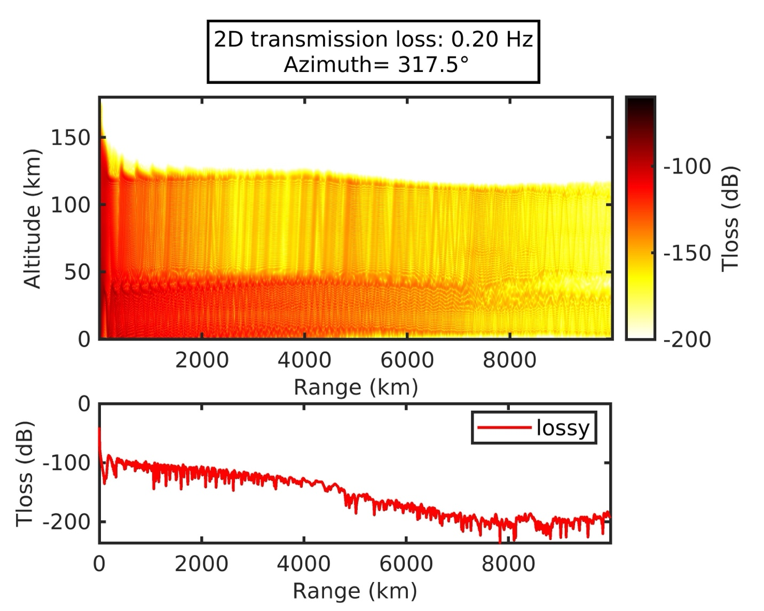

**Extended Data Fig. A1.** The 2D-transmission loss simulation by the parabolic range-dependent propagation method in the direction of the KUT sensors network (Azimuth =317.5).



**Extended Data Fig. A2.**  Vertical profile of basic state atmospheric temperature specified in the numerical experiment on the atmosphere-tsunami coupled system.

**Table**

|  |  |  |  |  |
| --- | --- | --- | --- | --- |
| Site | Yield (Megaton) | Distance (km) | Pressure (Pa) | Duration (s) |
| FUNA | 63.9 | 1452 | 540 | 1650 |
| AFI | 42.3 | 829 | 590 | 1560 |
| MSVF | 63.1 | 756 | 660 | 2040 |
| SNZO | 53.9 | 2484 | 380 | 1660 |
| GUMO | 47.4 | 5759 | 240 | 1700 |
| TARA | 46.1 | 2737 | 350 | 1560 |
| MAJO | 29.9 | 7980 | 180 | 1630 |

**Extended Data Tab. A1.** The estimated yield from barometric observations within 8,000 km from Tonga.