Analysis of the benefits of imputation models over traditional QSAR models for toxicity prediction

Moritz Walter¹, Luke N Allen¹, Antonio de la Vega de León¹, Samuel J Webb², Valerie J Gillet¹
1 Information School, University of Sheffield, 211 Portobello, Sheffield S1 4DP, United Kingdom
2 Lhasa Limited, Granary Wharf House, 2 Canal Wharf, Leeds LS11 5PS, United Kingdom

Table of content
Table S1. Random Forest hyperparameters considered in optimization.
Table S2. XGBoost hyperparameters considered in optimization.
Table S3. Deep Neural Network hyperparameters considered in optimization.
Table S4. Macau hyperparameters considered in optimization.
Table S5. Median ROC-AUC values and interquartile ranges for assay-based splits.
Table S6. Selected auxiliary assays for TOX21-Aromatase-Inhibition
Figure S1. Performance of imputation models on the small datasets evaluated using ROC-AUC.
Figure S2. Performance of imputation models on the ToxCast dataset using ROC-AUC.
Figure S3. Performance of the imputation models using the GHOST approach
Figure S4. Ratio of Mutual Information (MI) and entropy of the target assay for Ames and Tox21 assays.

The tables S1-S4 provide the hyperparameters considered for optimization in a grid search. The optimal values found for each combination of split type, algorithm and assay can be found in the code repository (https://github.com/mowal/Imputation_Paper).

Table S1. Random Forest hyperparameters considered in optimization.
For each hyperparameter modified in the grid search of Random Forest models, a brief explanation is provided alongside the values tested during the grid search.
Hyperparameter | Explanation | Grid search values
n_estimators | Number of trees in the Random Forest model | 100, 500
class_weight | Assigns weights to instances of different classes | None, balanced, balanced_subsample
max_features | Number of randomly selected features that are considered to find the best split | sqrt, 0.25

Table S2. XGBoost hyperparameters considered in optimization.
For each hyperparameter modified in the grid search of XGBoost models, a brief explanation is provided alongside the values tested during the grid search.
Hyperparameter | Explanation | Grid search values
Num_round | Number of sequential trees that are trained | 300, 700
eta | Learning rate that shrinks the size of the update of predictions after each boosting step | 0.1, 0.3, 0.5
Colsample_bytree | Proportion of features used within each individual tree | 0.5, 0.7
Alpha | Strength of L1 regularization of the weights per leaf | 0, 1
lambda | Strength of L2 regularization of the weights per leaf | 1, 10
Scale_pos_weight | Assign weights to instances of different classes | 1, weighted

Table S3. Deep Neural Network hyperparameters considered in optimization.
For each hyperparameter modified in the grid search of Deep Neural Network models, a brief explanation is provided alongside the values tested during the grid search. ST: single task, MT: multi-task
Hyperparameter | Explanation | Grid search values
Hidden layers | Number of hidden layers in the network | 1, 2, 3
Nodes per hidden layer | Number of nodes in each hidden layer | 1024, 2048
Learning rate | Size of the updates to the network parameters per training step | 0.0003, 0.001, 0.003
Dropout | Proportion of neurons randomly removed in each training step | 0, 0.2
L2 regularization | Strength of L2 regularization on the weights per node | 0.0001, 0.001
Batch size | Size of batches used for each update of weights with the Adam optimizer | 10, 50
Number of epochs | Number of epochs (each data point is used once for training per epoch) | 3, 5, 10
Class weight | Assigns weights to instances of different classes | 1, weighted [ST]  1, 3, 5, 15 [MT]

Table S4. Macau hyperparameters considered in optimization
For each hyperparameter modified in the grid search of Macau models, a brief explanation is provided alongside the values tested during the grid search.
Hyperparameter | Explanation | Grid search values
Num_latent | Number of dimensions used for the latent space | 16, 32, 64
nsamples | Number of samples drawn from the Gibbs sampler | 800, 1600, 3200
burnin | Number of burn-in samples from the Gibbs sampler that are discarded | 200, 400, 800

Table S5 Median ROC-AUC values and interquartile ranges for assay-based splits. Single task models are included as a benchmark. Median scores and interquartile ranges for each technique and dataset across 20 different random seeds. Before computing the median, the mean across the different assays for a single run was calculated. The best model for each dataset is in bold.
 |  | Ames | Tox21
Single task | RF | 0.848 (0.846-0.849) | 0.817 (0.815-0.818)
 | XGB | 0.848 (0.846-0.848) | 0.805 (0.804-0.807)
 | ST-DNN | 0.831 (0.829-0.833) | 0.780 (0.778-0.783)
Multi-task | XGB-FN | 0.923 (0.923-0.924) | 0.866 (0.865-0.867)
 | MT-DNN | 0.935 (0.934-0.938) | 0.867 (0.864-0.870)
 | Macau | 0.944 (0.943-0.945) | 0.888 (0.887-0.888)

Table S6 Selected auxiliary assays for TOX21-Aromatase-Inhibition. Assays were either selected according to their MI-entropy ratio or randomly.
Assays selected according to MI-entropy ratio | MI-entropy ratio | Randomly selected assays | MI-entropy ratio
TOX21_TR_LUC_GH3_Antagonist | 0.369 | ATG_RARb_TRANS_dn | 0.018
TOX21_AR_BLA_Antagonist_ratio | 0.308 | TOX21_MMP_ratio_up | 0.019
BSK_SAg_CD40_down | 0.295 | ATG_Oct_MLP_CIS_up | 0.124
BSK_SAg_CD69_down | 0.289 | ATG_DR4_LXR_CIS_dn | 0.136
TOX21_AR_LUC_MDAKB2_Antagonist2 | 0.287 | ATG_HSE_CIS_dn | 0.003
TOX21_AR_LUC_MDAKB2_Antagonist | 0.284 | OT_ER_ERaERa_1440 | 0.007
BSK_LPS_SRB_down | 0.279 | ATG_Ets_CIS_dn | 0.048
BSK_4H_Pselectin_down | 0.276 | BSK_3C_HLADR_down | 0.253
BSK_3C_Proliferation_down | 0.270 | BSK_KF3CT_IP10_down | 0.209
BSK_3C_Vis_down | 0.270 | BSK_hDFCGF_TIMP1_down | 0.206
NCCT_HEK293T_CellTiterGLO | 0.269 | TOX21_HSE_BLA_agonist_ch2 | 0.043
BSK_SAg_SRB_down | 0.267 | TOX21_VDR_BLA_agonist_ch2 | 0.004
BSK_3C_SRB_down | 0.267 | NVS_ADME_hCYP19A1 | 0.073
TOX21_FXR_BLA_antagonist_ratio | 0.267 | APR_HepG2_MicrotubuleCSK_24h_dn | 0.047
BSK_CASM3C_Proliferation_down | 0.265 | BSK_SAg_MIG_down | 0.246
BSK_SAg_CD38_dow | 0.261 | BSK_LPS_MCP1_down | 0.261
BSK_LPS_MCP1_dow | 0.261 | ATG_NRF2_ARE_CIS_up | 0.121
BSK_3C_IL8_down | 0.261 | BSK_3C_uPAR_down | 0.214
BSK_SAg_IL8_down | 0.257 | NHEERL_ZF_144hpf_TERATOSCORE_up | 0.131
BSK_SAg_MCP1_down | 0.256 | TOX21_PPARd_BLA_Antagonist_ch1 | 0.012

Figure S1 Performance of imputation models on the small datasets evaluated using ROC-AUC. A: Ames dataset. B: Tox21 dataset. Each box summarizes the ROC-AUC scores of 20 independent runs of the model on the test set with identical hyperparameters but different random seeds. The XGB models (best performing single task QSAR model based on MCC) are included as a benchmark. Only the best performing Feature Net model (XGB-FN) is included in this plot

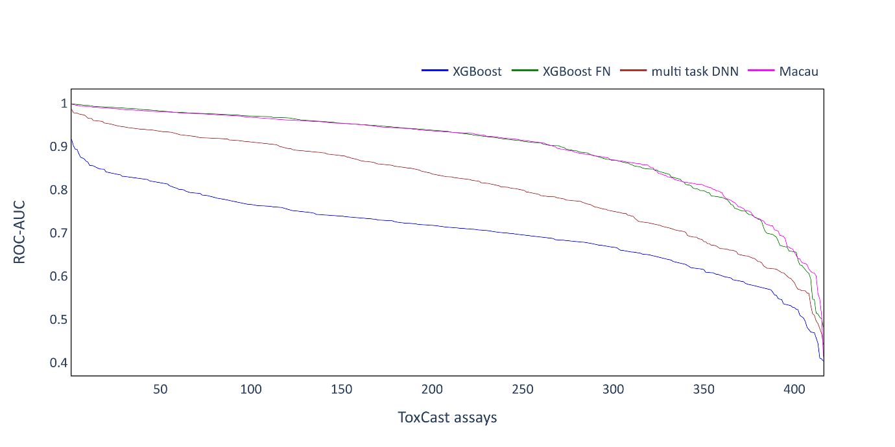
Figure S2 Performance of imputation models on the ToxCast dataset using ROC-AUC. ROC-AUC scores obtained for the individual assays are sorted in descending order and plotted as a line.

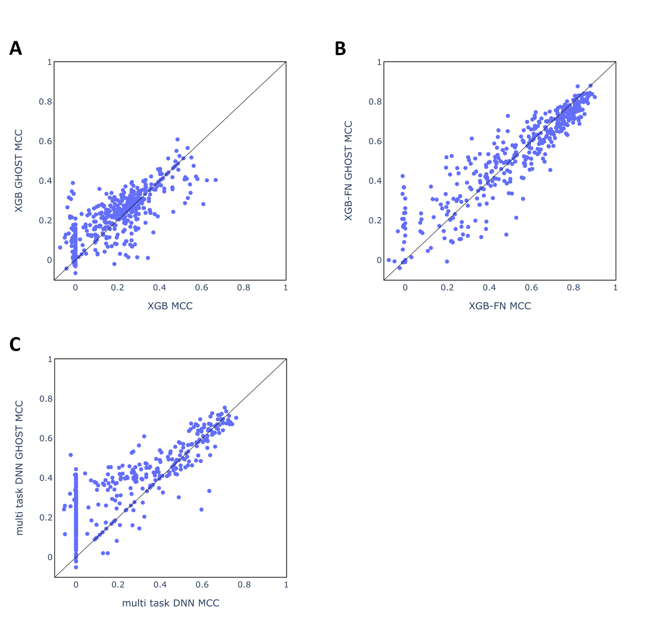
Figure S3 Performance of the imputation models using the GHOST approach. Scatter plots contrasting MCC scores with or without the GHOST approach for single assays of the ToxCast dataset. A: XGB, B: XGB-FN, C: multi-task-DNN. The scatter plot for Macau is depicted in Figure 7B.
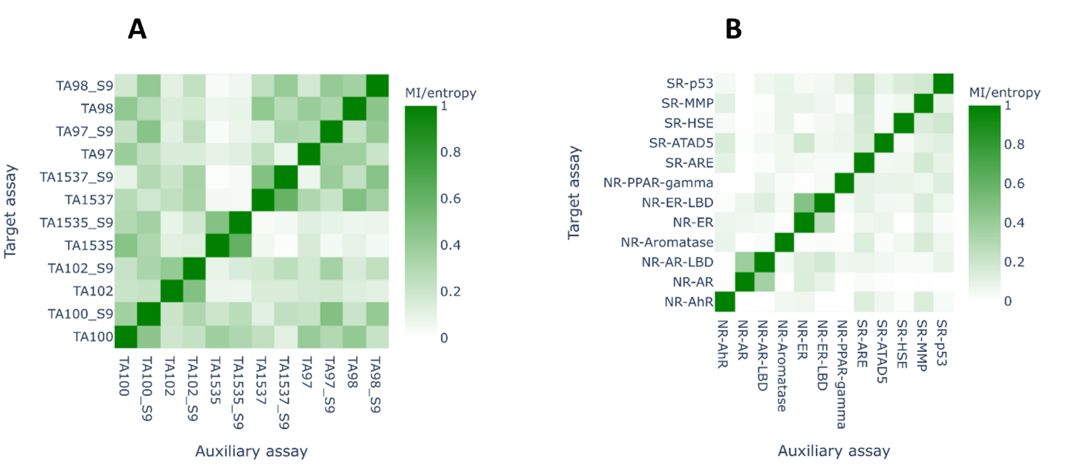
Figure S4. Ratio of Mutual Information (MI) and entropy of the target assay for Ames (A) and Tox21 (B) assays.

