Different host plants alter structure, diversity, and function of gut bacterial communities in larval instars of Spodoptera frugiperda
Yanping Wang ^{1,2}, Chunyan Yi ^{1,2}, Xingyu Chen³, Jingwei Guo^{1,2}, Changhua Liu ^{1,2}, Cuicui Zhang ^{1,2}, Qingdong Chen ^{1,2}, Song Chen ^{1,2}, Hongling Liu ^{1,2}and Xu Liu ^{1,2,}*

Table S1: Statistics of valid Tags and operational taxonomic unit (OTU) clustering of 5th and 6th instar larvae sample.
Sample_Name | Total_tag | Taxon_Tag | Unclassified_Tag | Unique_Tag | Unique_OTU | OTU_num
HvL1.1 | 16712 | 16341 | 0 | 366 | 5 | 9
HvL1.2 | 12297 | 12046 | 0 | 224 | 27 | 20
HvL1.3 | 10472 | 9942 | 0 | 522 | 8 | 9
HvL1.4 | 14725 | 14372 | 0 | 343 | 10 | 15
SbL1.1 | 14668 | 14490 | 0 | 164 | 14 | 28
SbL1.2 | 18538 | 17827 | 0 | 630 | 81 | 45
SbL1.3 | 19666 | 19343 | 0 | 300 | 23 | 21
SbL1.4 | 21067 | 20865 | 0 | 189 | 13 | 19
ZmL1.1 | 15895 | 15063 | 0 | 793 | 39 | 48
ZmL1.2 | 9020 | 6592 | 0 | 2028 | 400 | 77
ZmL1.3 | 10831 | 9139 | 0 | 1306 | 386 | 82
ZmL1.4 | 12007 | 11554 | 0 | 425 | 28 | 41
CrB1.1 | 23292 | 23128 | 0 | 153 | 11 | 22
CrB1.2 | 20542 | 20320 | 0 | 209 | 13 | 24
CrB1.3 | 16033 | 15528 | 0 | 474 | 31 | 32
CrB1.4 | 12932 | 12924 | 0 | 4 | 4 | 6
Total | 248697 | 239474 | 0 | 8130 | 1093 | 498

Table S1: Statistics of valid Tags and operational taxonomic unit (OTU) clustering of 6th instar larvae sample.
Sample_Name | Total_tag | Taxon_Tag | Unclassified_Tag | Unique_Tag | Unique_OTU | OTU_num
HvL2.1 | 11046 | 9715 | 0 | 1178 | 153 | 70
HvL2.2 | 13924 | 13300 | 0 | 594 | 30 | 37
HvL2.3 | 21263 | 20423 | 0 | 818 | 22 | 24
HvL2.4 | 19133 | 18797 | 0 | 329 | 7 | 16
SbL2.1 | 13452 | 12641 | 0 | 768 | 43 | 26
SbL2.2 | 14028 | 13115 | 0 | 792 | 121 | 91
SbL2.3 | 16365 | 15706 | 0 | 575 | 84 | 52
SbL2.4 | 22426 | 22113 | 0 | 290 | 23 | 27
ZmL2.1 | 11205 | 11154 | 0 | 46 | 5 | 17
ZmL2.2 | 17006 | 15563 | 0 | 1306 | 137 | 42
ZmL2.3 | 16464 | 16087 | 0 | 350 | 27 | 33
ZmL2.4 | 12090 | 11153 | 0 | 849 | 88 | 37
CrB2.1 | 21817 | 21200 | 0 | 593 | 24 | 25
CrB2.2 | 11940 | 11614 | 0 | 312 | 14 | 21
CrB2.3 | 14615 | 13592 | 0 | 973 | 50 | 31
CrB2.4 | 20180 | 19961 | 0 | 215 | 4 | 13
Total | 256954 | 246134 | 0 | 9988 | 832 | 562

Table S2. Relative abundance of the most predominant taxa of gut bacteria in different treatment (a) the phylum level.
Taxonomy | HvL1 | SbL1 | ZmL1 | CrB1 | Average | HvL2 | SbL2 | ZmL2 | CrB2 | Average | Tax_detail
Firmicutes | 0.9991 | 0.8462 | 0.7386 | 0.5554 | 0.7848 | 0.8612 | 0.8692 | 0.9376 | 0.9623 | 0.9076 | k__Bacteria;p__Firmicutes;
Proteobacteria | 0.0007 | 0.1422 | 0.2274 | 0.4404 | 0.2027 | 0.1187 | 0.1113 | 0.0446 | 0.0284 | 0.0757 | k__Bacteria;p__Proteobacteria;
Bacteroidetes | 0 | 0.0005 | 0.0028 | 0.0004 | 0.0009 | 0.0183 | 0.0051 | 0.0029 | 0.0003 | 0.0066 | k__Bacteria;p__Bacteroidetes;
Actinobacteria | 0.0002 | 0.0108 | 0.0232 | 0.0035 | 0.0094 | 0.0018 | 0.0144 | 0.0148 | 0.009 | 0.01 | k__Bacteria;p__Actinobacteria;
Cyanobacteria | 0 | 0 | 0.0038 | 0 | 0.001 | 0 | 0 | 0 | 0 | 0 | k__Bacteria;p__Cyanobacteria;
Acidobacteria | 0 | 0 | 0.0007 | 0 | 0.0002 | 0 | 0 | 0 | 0 | 0 | k__Bacteria;p__Acidobacteria;
Verrucomicrobia | 0 | 0.0002 | 0 | 0 | 0.0001 | 0 | 0 | 0 | 0 | 0 | k__Bacteria;p__Verrucomicrobia;
unidentified_Bacteria | 0 | 0.0001 | 0.0002 | 0.0003 | 0.0001 | 0.0001 | 0 | 0.0002 | 0 | 0.0001 | k__Bacteria;p__unidentified_Bacteria;
Chloroflexi | 0 | 0 | 0 | 0 | 0 | 0 | 0 | 0 | 0 | 0 | k__Bacteria;p__Chloroflexi;
Others | 0 | 0 | 0.0034 | 0 | 0.0008 | 0 | 0 | 0 | 0 | 0 | Others

Table S2. Relative abundance of the most predominant taxa of gut bacteria in different treatment (b) the genus level.
Taxonomy | HvL1 | SbL1 | ZmL1 | CrB1 | Average | HvL2 | SbL2 | ZmL2 | CrB2 | Average | Tax_detail
Enterococcus | 0.9989 | 0.8460 | 0.7384 | 0.5470 | 0.7826 | 0.8605 | 0.8661 | 0.9329 | 0.9623 | 0.9054 | k__Bacteria;p__Firmicutes;c__Bacilli;o__Lactobacillales;f__Enterococcaceae;g__Enterococcus;
Ralstonia | 0.0005 | 0.1236 | 0.0644 | 0.4333 | 0.1554 | 0.0154 | 0.0006 | 0.0003 | 0.0009 | 0.0043 | k__Bacteria;p__Proteobacteria;c__Gammaproteobacteria;o__unidentified_Gammaproteobacteria;f__Burkholderiaceae;g__Ralstonia;
Pseudochrobactrum | 0.0000 | 0.0001 | 0.0657 | 0.0000 | 0.0164 | 0.0008 | 0.0001 | 0.0260 | 0.0003 | 0.0068 | k__Bacteria;p__Proteobacteria;c__Alphaproteobacteria;o__Rhizobiales;f__Rhizobiaceae;g__Pseudochrobactrum;
Enterobacter | 0.0000 | 0.0003 | 0.0002 | 0.0002 | 0.0002 | 0.0471 | 0.0665 | 0.0001 | 0.0004 | 0.0285 | k__Bacteria;p__Proteobacteria;c__Gammaproteobacteria;o__Enterobacteriales;f__Enterobacteriaceae;g__Enterobacter;
Klebsiella | 0.0000 | 0.0001 | 0.0000 | 0.0000 | 0.0000 | 0.0268 | 0.0378 | 0.0000 | 0.0003 | 0.0162 | k__Bacteria;p__Proteobacteria;c__Gammaproteobacteria;o__Enterobacteriales;f__Enterobacteriaceae;g__Klebsiella;
Ochrobactrum | 0.0000 | 0.0151 | 0.0306 | 0.0003 | 0.0115 | 0.0004 | 0.0024 | 0.0015 | 0.0188 | 0.0058 | k__Bacteria;p__Proteobacteria;c__Alphaproteobacteria;o__Rhizobiales;f__Rhizobiaceae;g__Ochrobactrum;
Alcaligenes | 0.0000 | 0.0002 | 0.0086 | 0.0000 | 0.0022 | 0.0118 | 0.0003 | 0.0032 | 0.0010 | 0.0041 | k__Bacteria;p__Proteobacteria;c__Gammaproteobacteria;o__unidentified_Gammaproteobacteria;f__Burkholderiaceae;g__Alcaligenes;
Myroides | 0.0000 | 0.0000 | 0.0018 | 0.0000 | 0.0004 | 0.0102 | 0.0000 | 0.0008 | 0.0001 | 0.0028 | k__Bacteria;p__Bacteroidetes;c__Bacteroidia;o__Flavobacteriales;f__Flavobacteriaceae;g__Myroides;
Achromobacter | 0.0000 | 0.0000 | 0.0086 | 0.0000 | 0.0021 | 0.0001 | 0.0001 | 0.0001 | 0.0009 | 0.0003 | k__Bacteria;p__Proteobacteria;c__Gammaproteobacteria;o__unidentified_Gammaproteobacteria;f__Burkholderiaceae;g__Achromobacter;

Table S3: Alpha diversity indices of gut bacterial communities in different treatment.
group | observed_species | shannon | simpson | chao1 | goods_coverage | PD_whole_tree
CrB1 | 16 | 0.882 | 0.306 | 21.208 | 0.999 | 3.042
CrB2 | 24 | 1.351 | 0.484 | 31.179 | 0.999 | 2.579
HvL1 | 8 | 0.899 | 0.387 | 11.45 | 1 | 1.12
HvL2 | 27 | 1.645 | 0.554 | 33.156 | 0.999 | 2.673
SbL1 | 24 | 1.152 | 0.403 | 29.936 | 0.999 | 2.962
SbL2 | 40 | 1.685 | 0.588 | 60.073 | 0.998 | 4.845
ZmL1 | 52 | 2.153 | 0.654 | 108.34 | 0.997 | 4.724
ZmL2 | 24 | 1.14 | 0.399 | 27.844 | 0.999 | 2.998

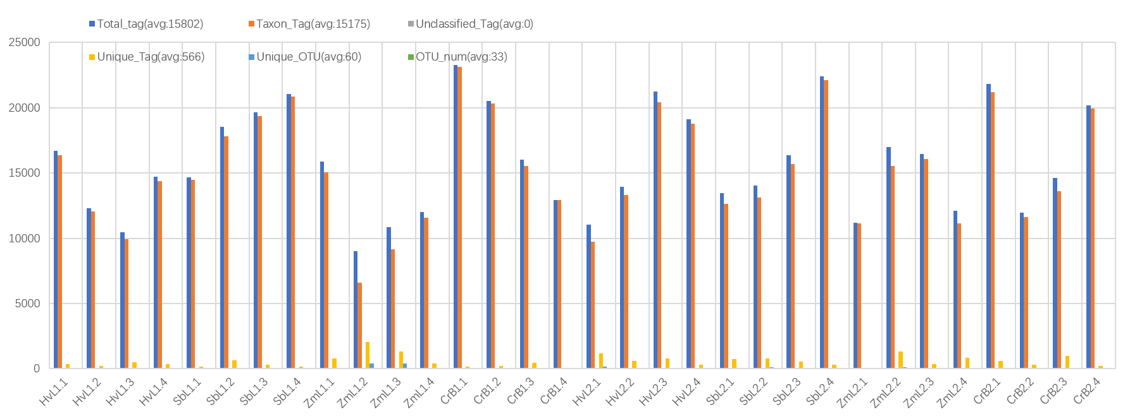
Figure S1: Statistics of valid Tags and operational taxonomic unit (OTU) clustering of each sample

